**Megha Sharma**

**16148393**

**GitHub account:mszzf**

**ScrumDo account:mszzf**

**Lab-1 Report**

1) Design the Class Diagram/Sequence Diagram using Visio for the InClass Exercise .

Class Diagram

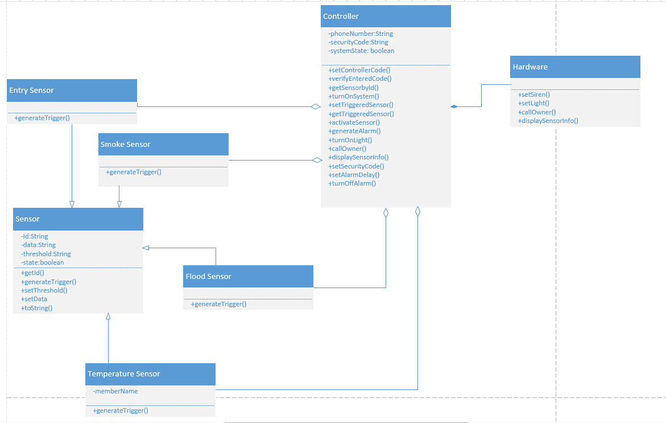

* There is an inheritance relationship between the base class Sensor and the various sensors.
* Sensor is the base Class from which Temperature, Smoke,Flood and Entry Sensors classes have been derived since they all share the same functionality.
* Each sensor has attributes sensor id, sensed data, set threshold and state of the sensor which they derived from the base class Sensor.
* Each sensor has operation to get Id , set threshold etc which are common for all sensors.
* The sensors override generate trigger method which performs computation based on sensed data and threshold and generate a trigger for the controller.
* The Controller class maintains attributes security code,contact info,state of the system.
* All these attributes and sensor properties can be set by the operator using the methods provided in the controller class.
* The controller gets the sensor information using the id provided during trigger and triggers respective alarms.
* There is a composition relation between the controller and the hardware system.

Class Sequence Diagram

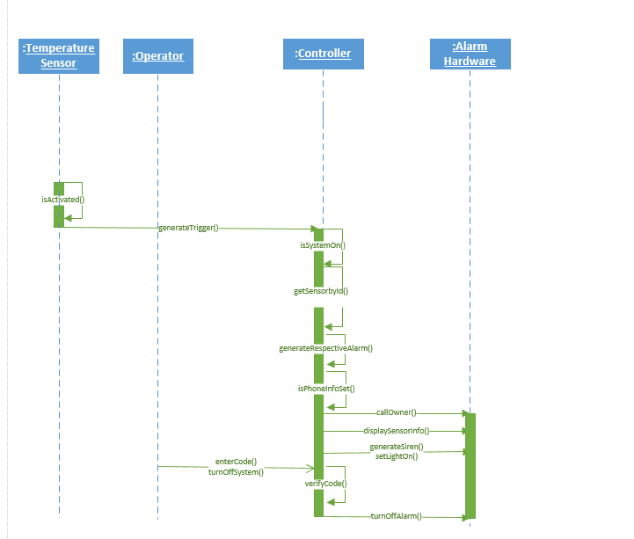

2) Create a GitHub account and post GitHub ID to the Lab 1 site.

Create GitHub Account

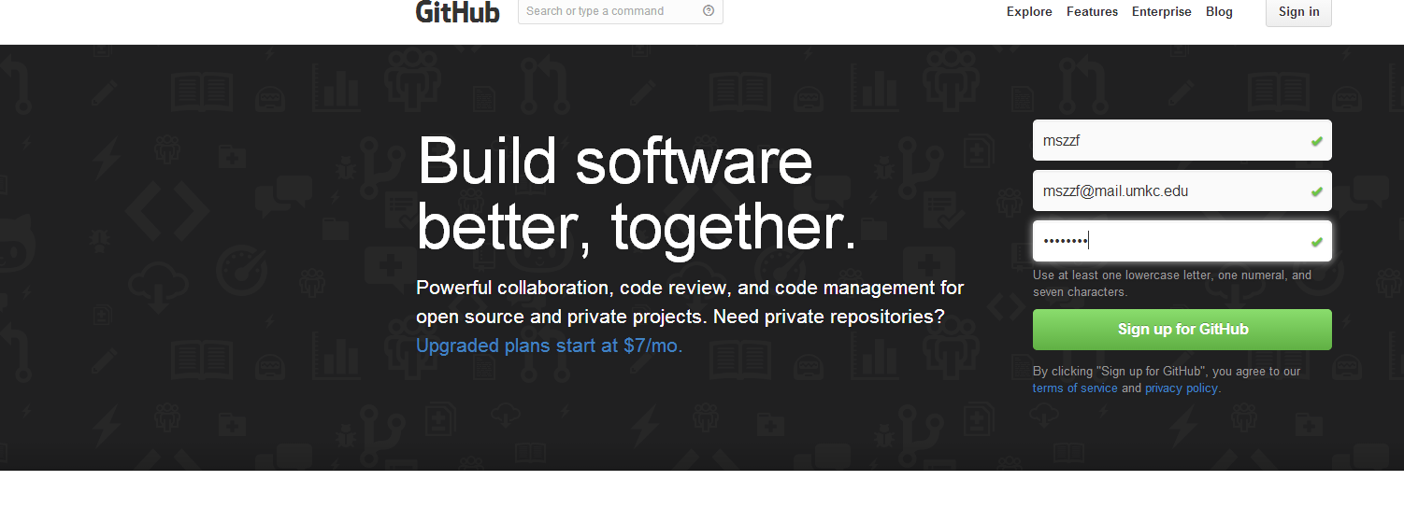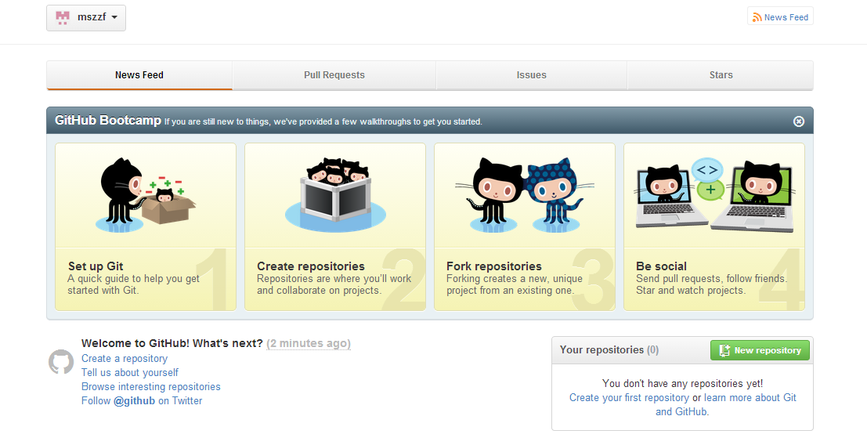

Create Repository in Remote GitHub 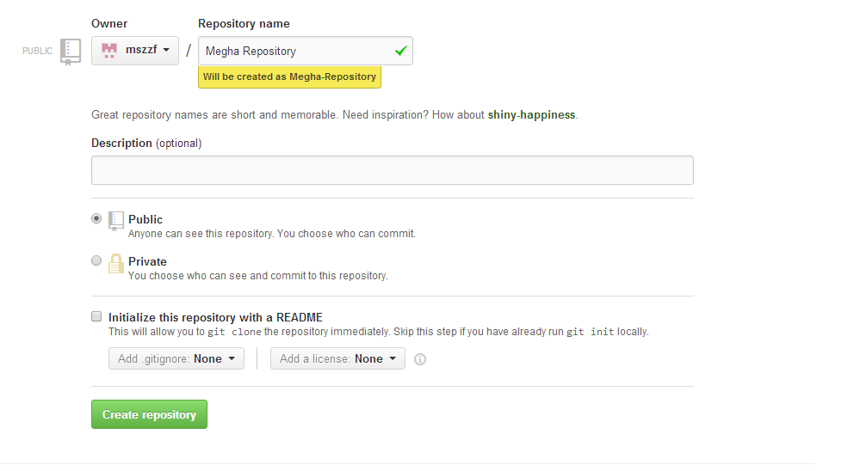

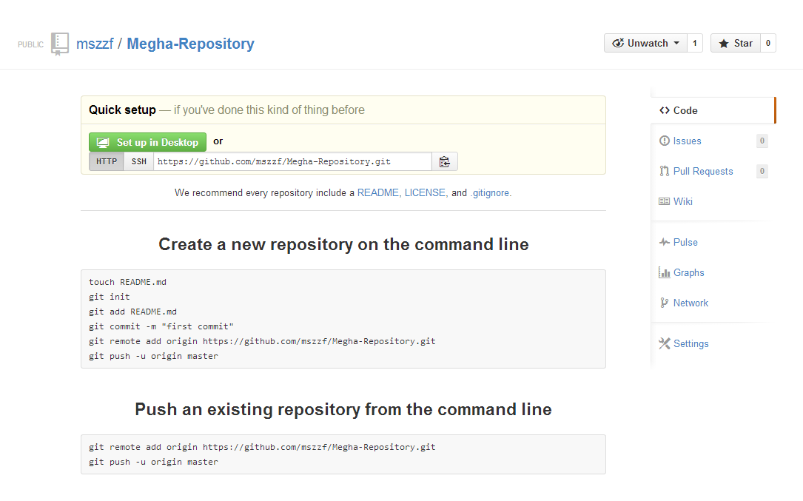

Install GitHub on local machine

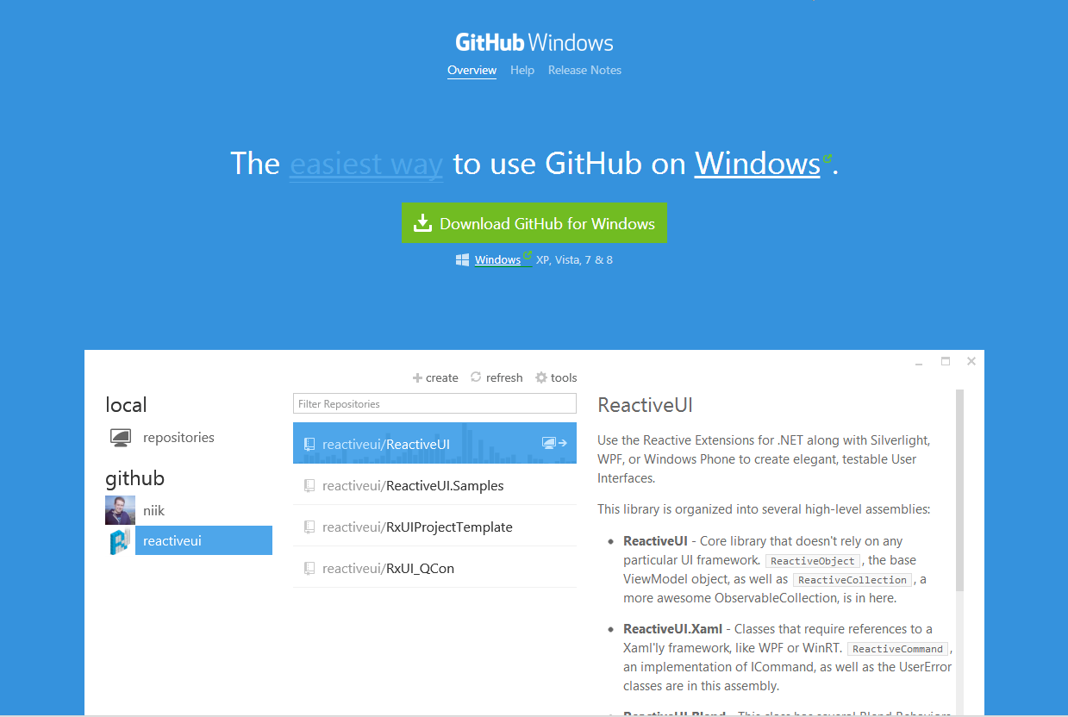

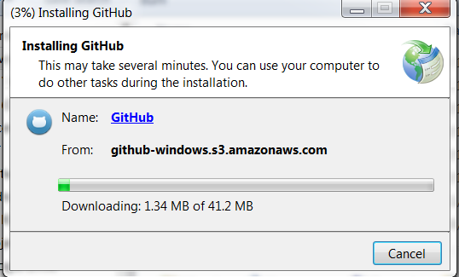

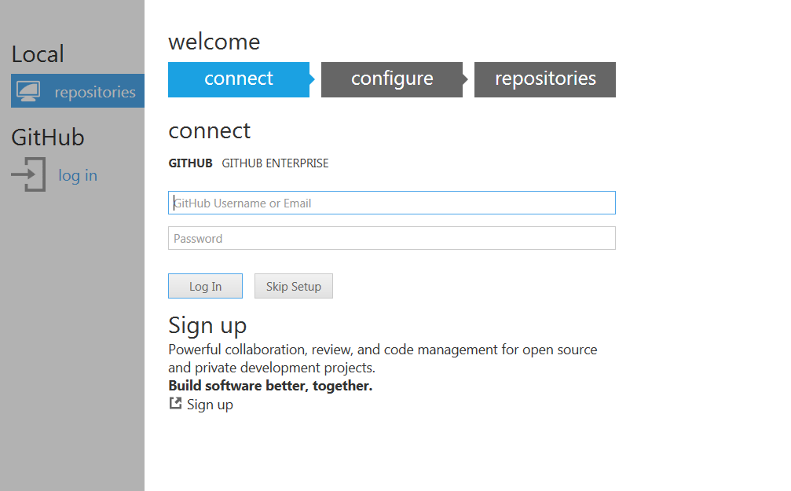

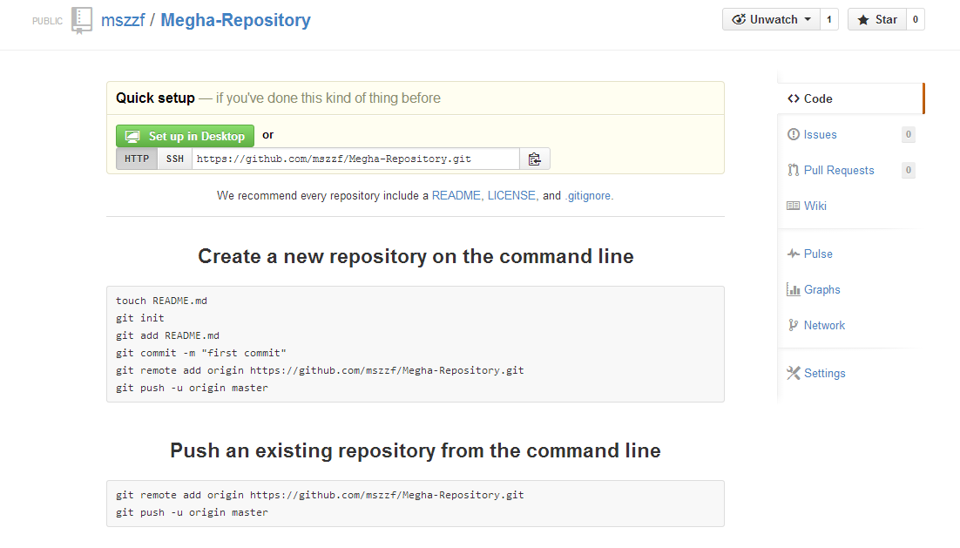

Go to Remote GitHub and click on Clone in Desktop. This will create the same repository in local machine.

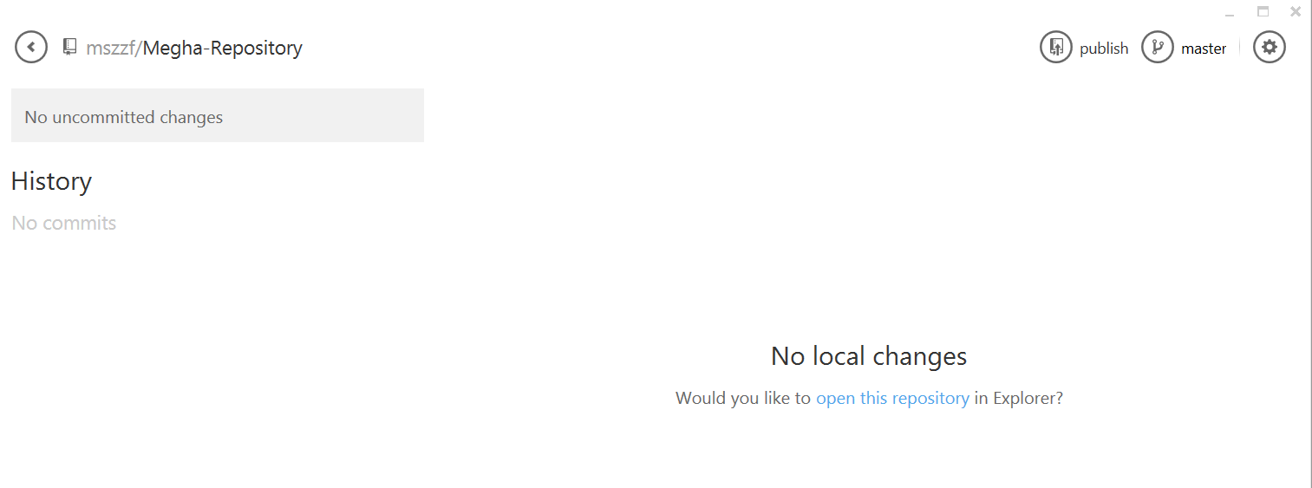

After making changes in the file on Desktop, go to the GitHub desktop application and Commit the changes.

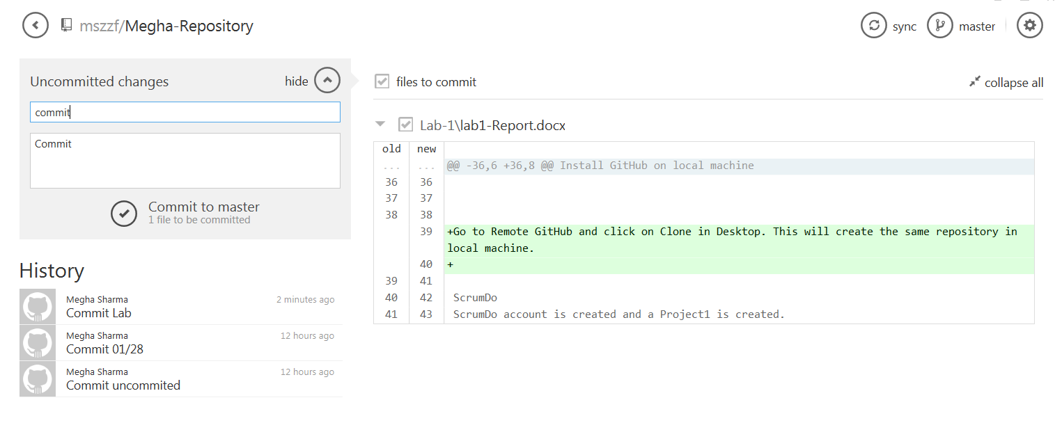

This will commit the changes and then click on sync. The changes will appear in Remote GitHub.

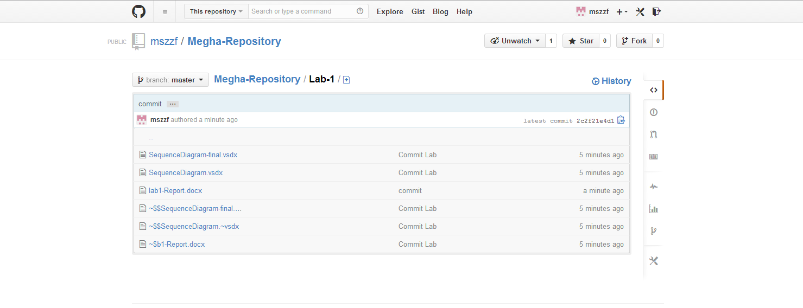

3) Create a ScrumDo account and define task/plan/delivery for your lab 1 assignment. Also post your ScrumDo ID to the Lab 1 site.

Steps below:

1. ScrumDo account and Project1 have been created in ScrumDo.

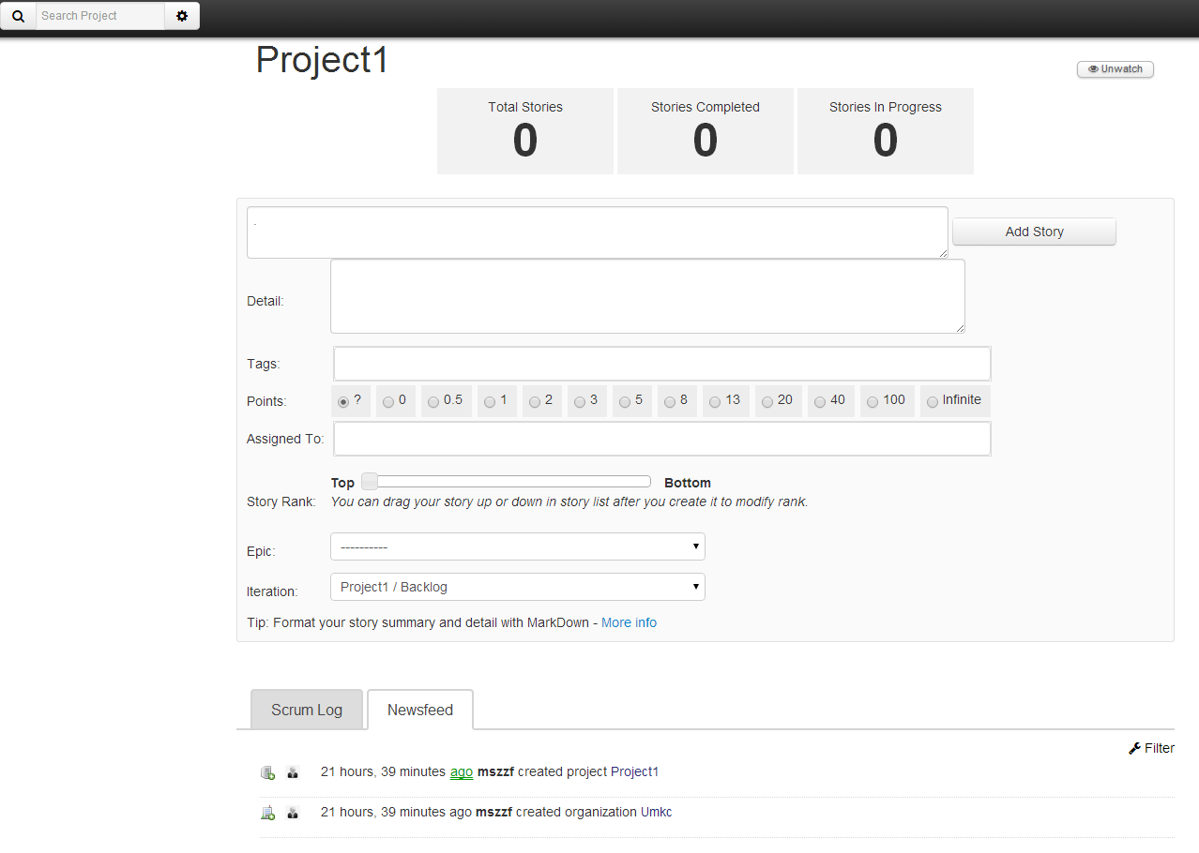

1. Iteration 1 has been created under this project.

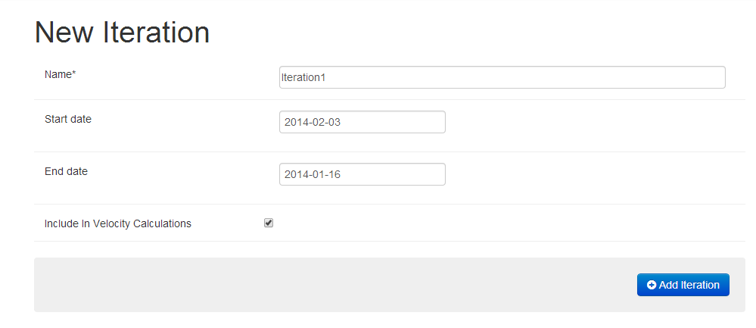

1. Now add a story to the Iteration.

The below story Story1 has been created in Iteration1.

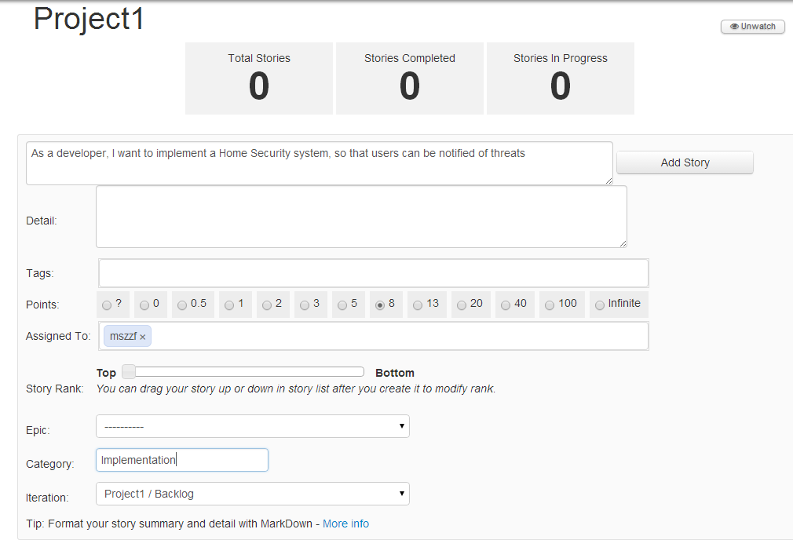

Similarly, Iteration 2 and Iteration 3 are created and stories are added to them.

4) Now Tasks are added to the stories.

The overall project structure looks like this.

**Iteration1**

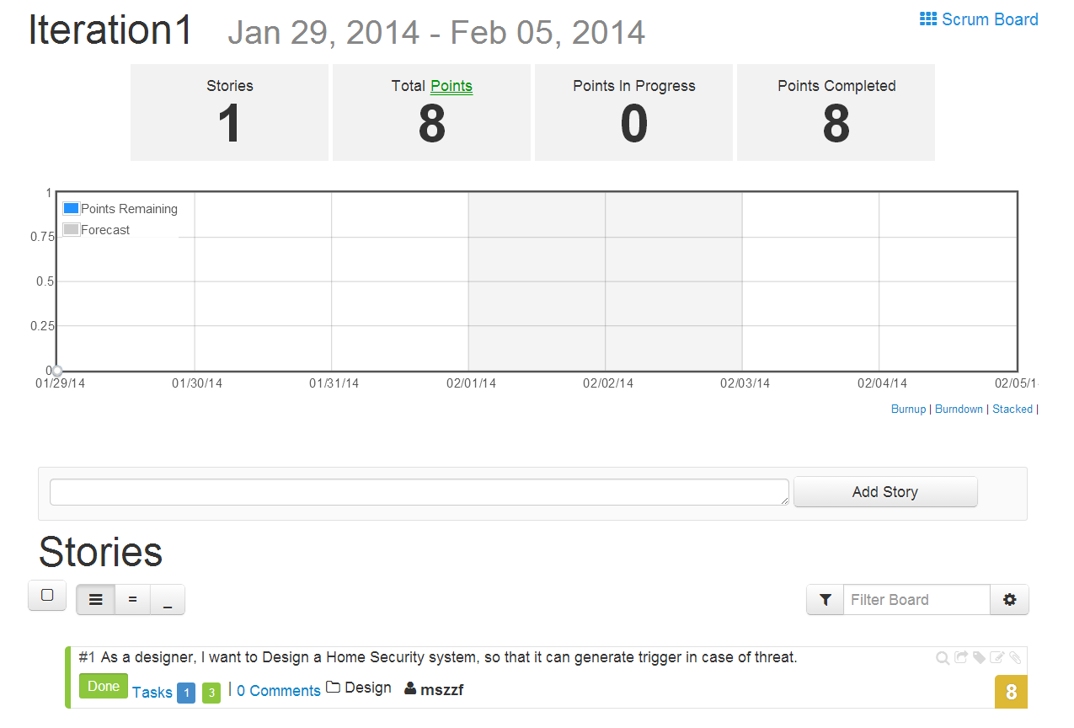

**Story 1**: As a designer, I want to Design a Home Security system, so that it can generate trigger in case of threat.

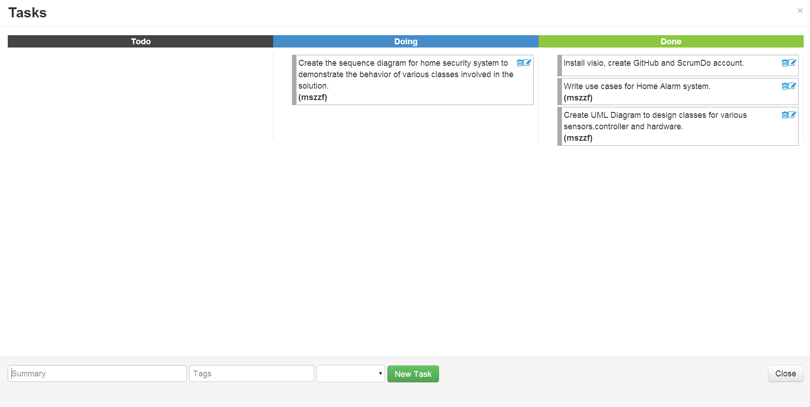

**Iteration2**

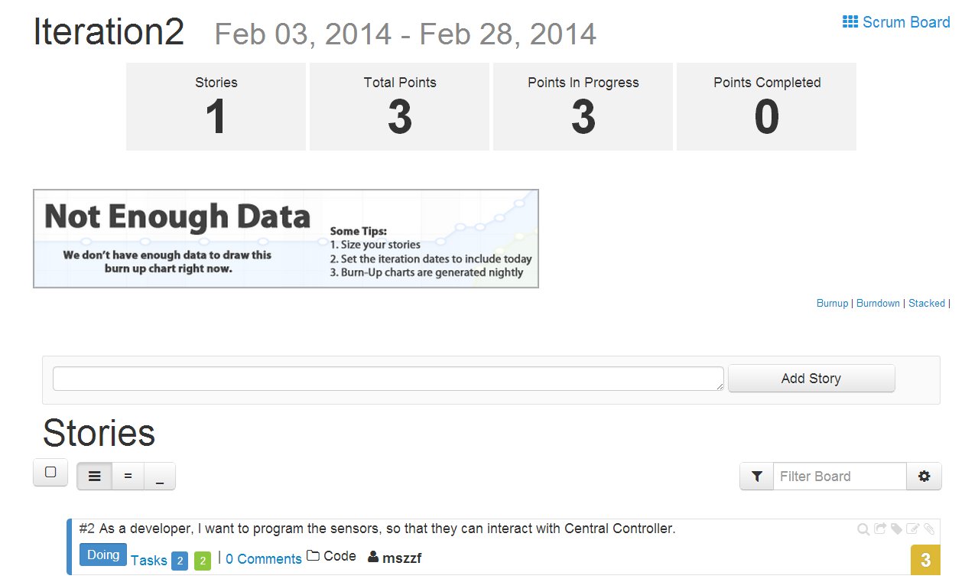

**Story2**: As a developer, I want to program the sensors, so that they can interact with Central Controller.

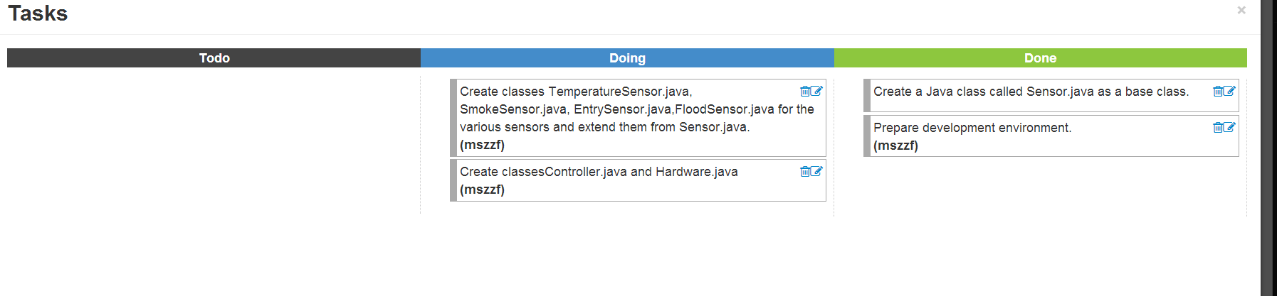

**Iteration3**

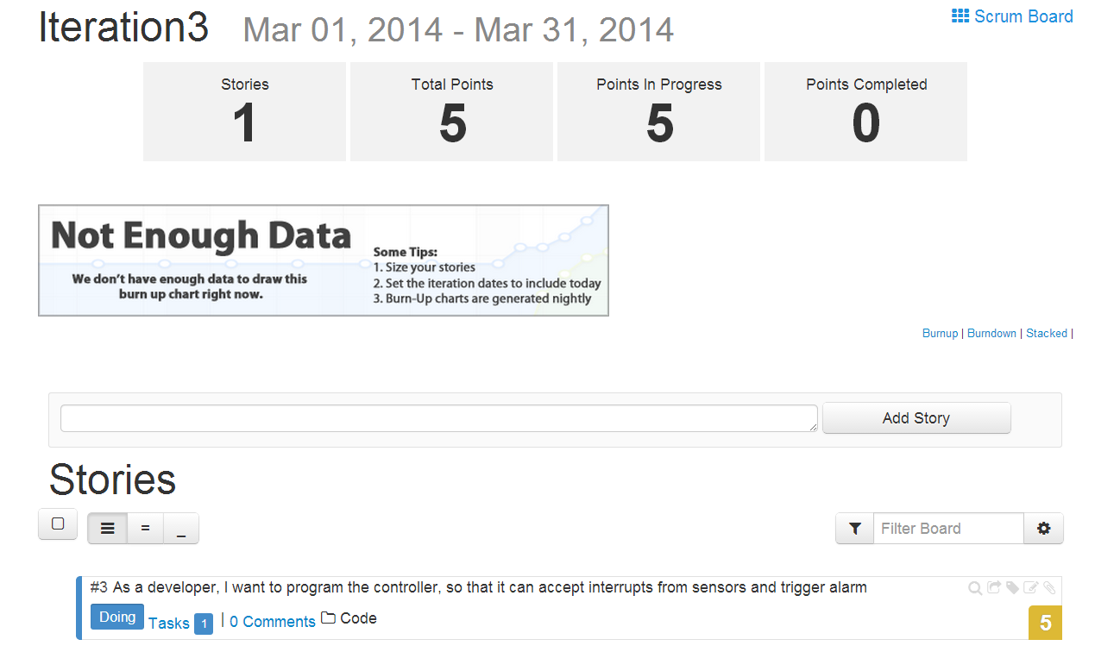

**Story3:** As a developer, I want to program the controller, so that it can accept interrupts from sensors and trigger alarm.

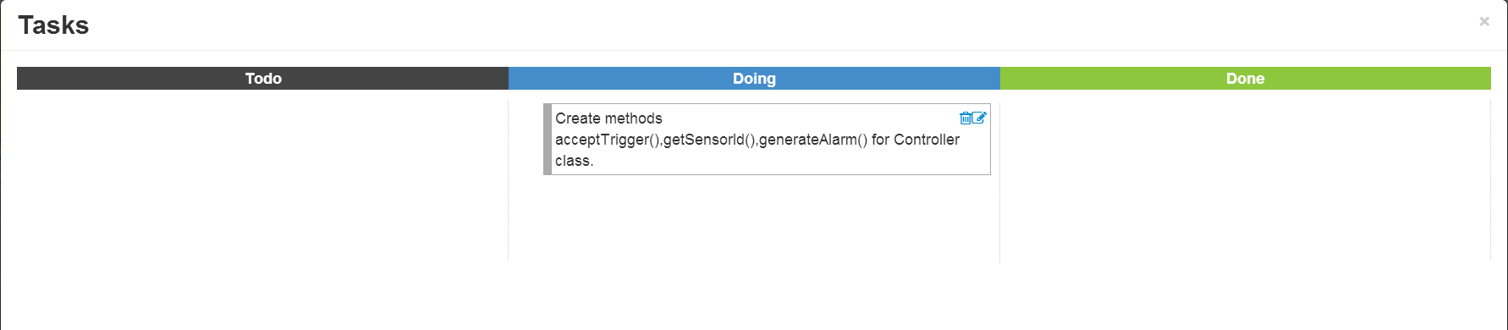

**Backlog**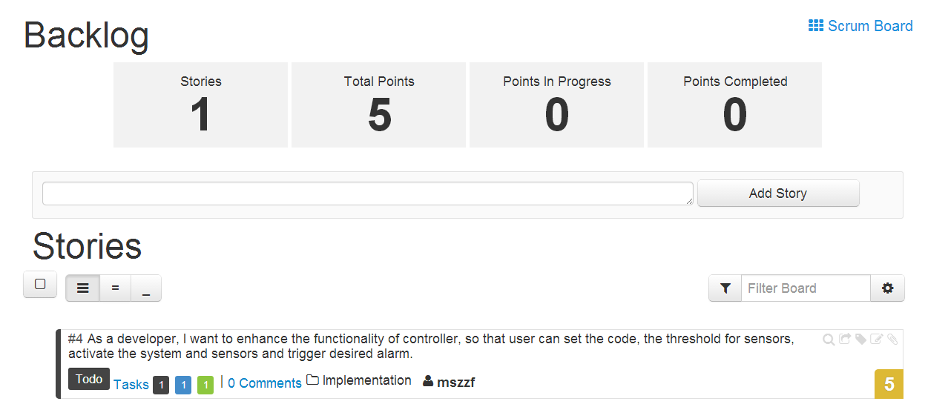

**Story4:** As a developer, I want to enhance the functionality of controller, so that user can set the code, the threshold for sensors, activate the system and sensors and trigger desired alarm.

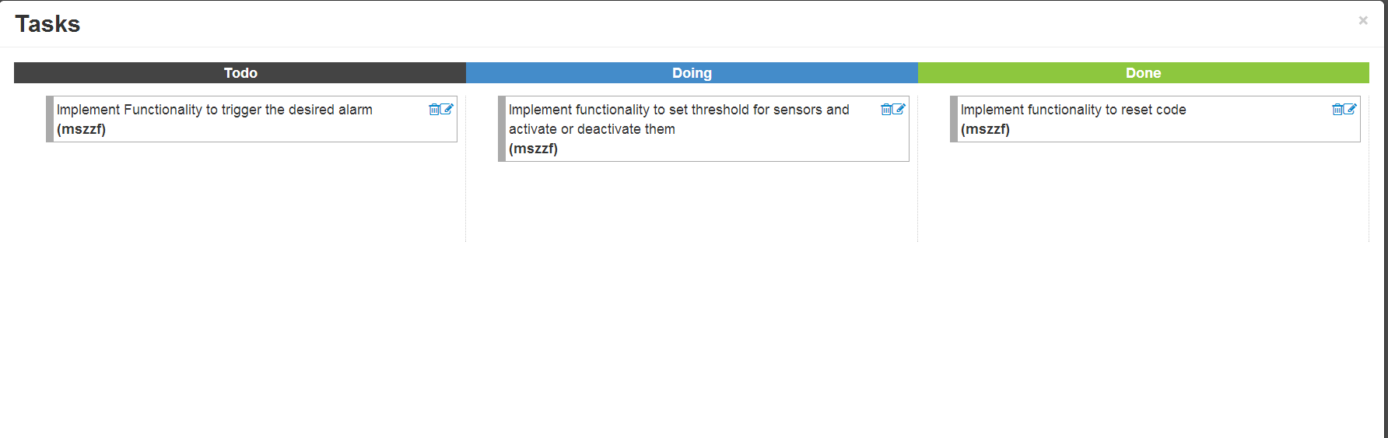

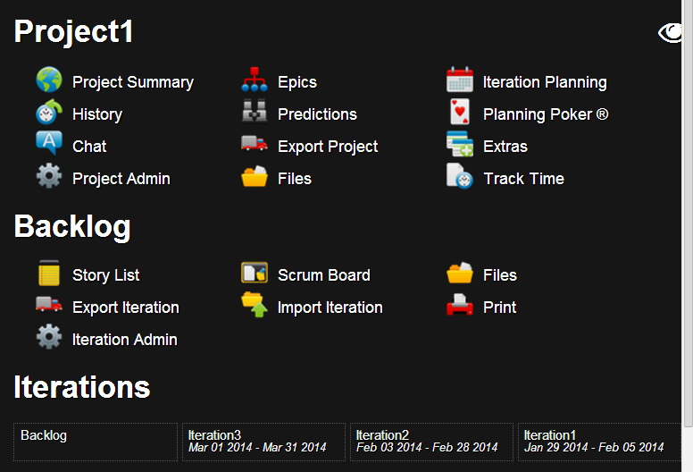

Now we check Scrum Board for the iterations and arrange the stories.

Scrum Board for Iteration 1

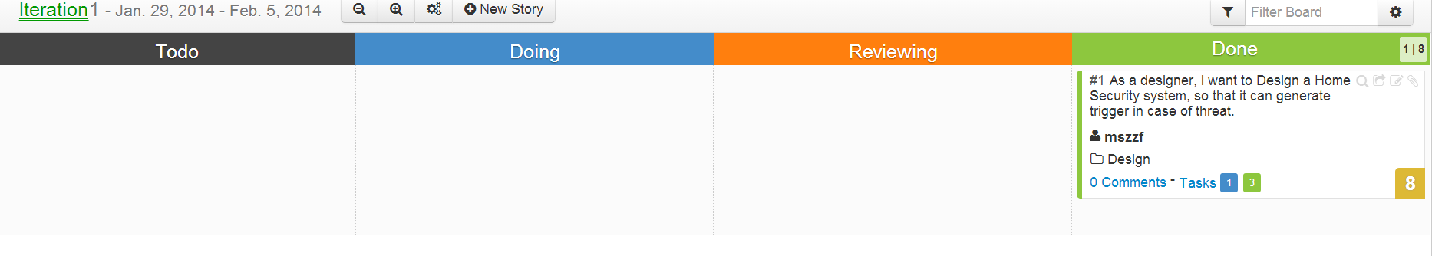

Iteration 2

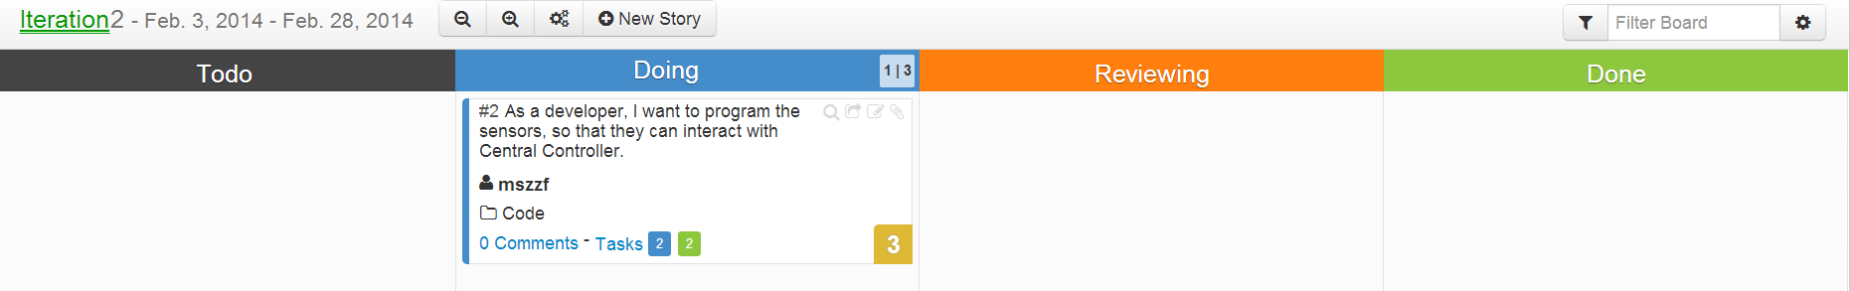

Iteration 3

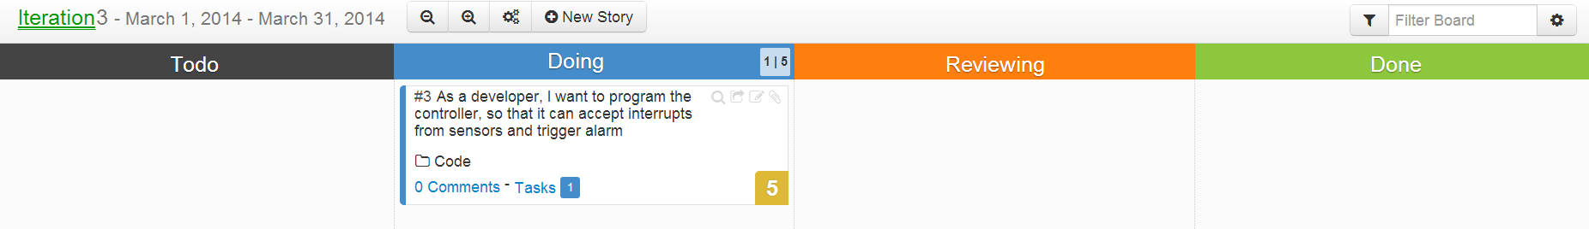

Backlog

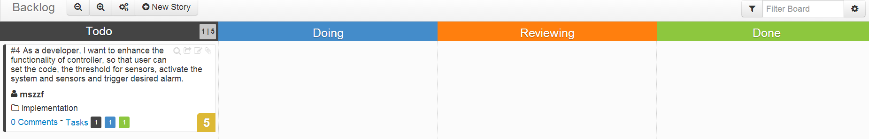

Now we plan our iterations using Iteration Planning

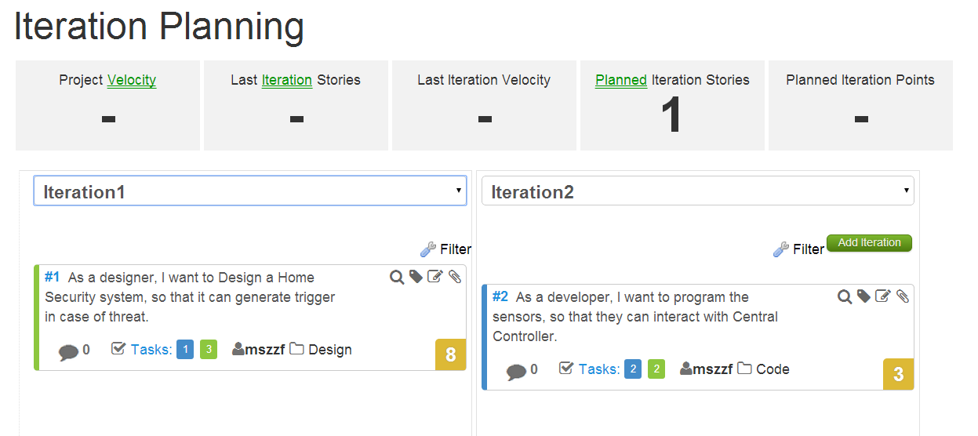

Next we create a release called Release1 and add our Project1 to this release.

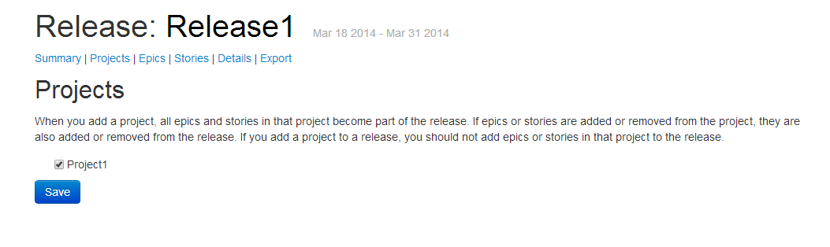

Below is the status of the release Release1.

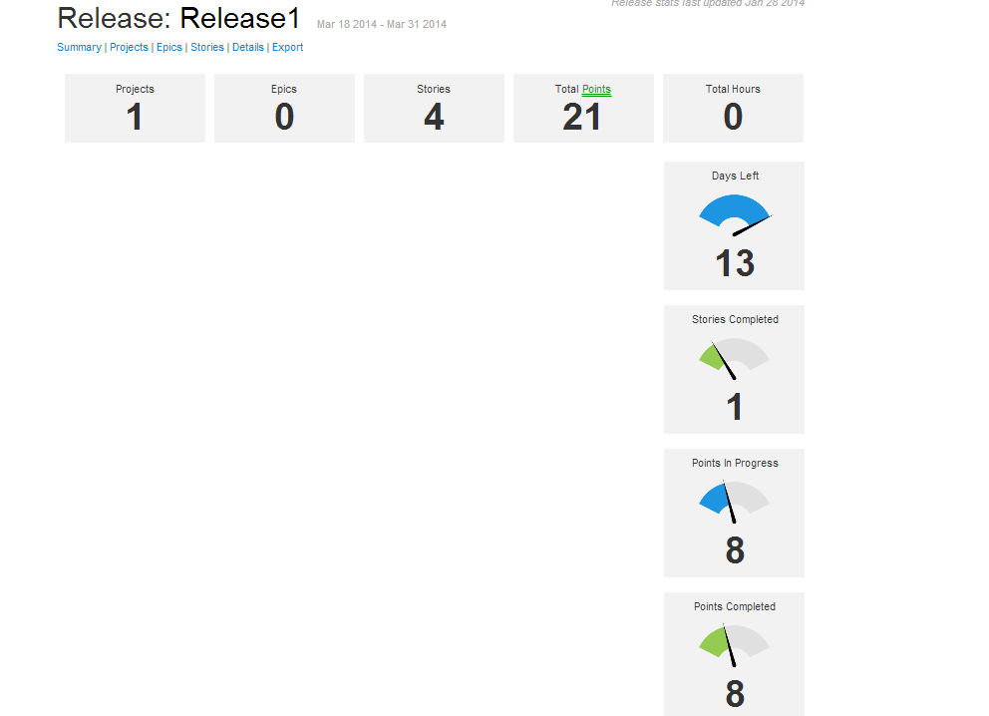

Below are the four Stories created for Release 1 in different iterations.

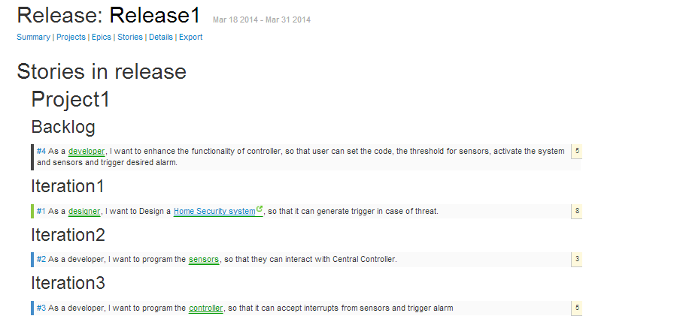ScrumDo Project can be accessed at the below link.

http://www.scrumdo.com/projects/project/project184/