**Megha Sharma**

**16148393**

**Report Lab-2**

The following Google APIs have been used to develop the Mobile Web App:

* Google Geocode API to get the Current Location of the user
* Google Direction Service API to show direction from source to destination along with written instructions.
* Google Weather API to get the weather conditions in the vicinity of the current location of user.
* Google Places Service API to get the nearby places based on the place selection of the user.

This Mobile App provides offers the following features.

1. Finding the current location of the user.
2. Direction service based on the source and destination supplied to the app.
3. Locating nearby places based on the selection of the place (Restaurant, Gas Station etc) .
4. Providing weather information of the areas in the vicinity of the user.

The emulator for Samsumg Galaxy S III has been used to test the Web Client Application

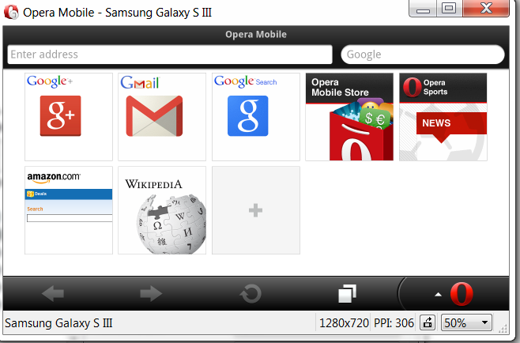

Enter the URL of the Web Client and press Go. The URL of the app is the location of the index.html file on my local machine. The javascript and stylesheet have been linked to this index.html file.

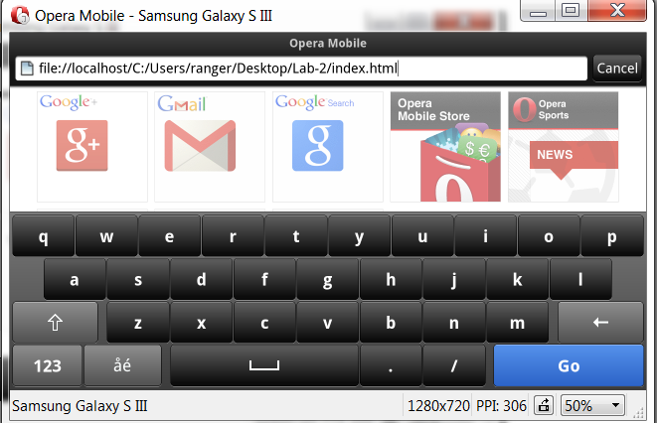

Below is the Homepage of the application containing 3 tabs: Home, Options and Information. Click on the Options tab to see the list of options available.

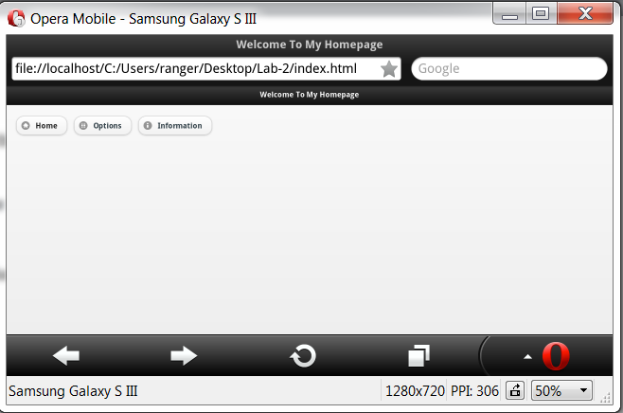

(tab Home is not functional in this release)

The following screen opens up with more options and a Go back button.

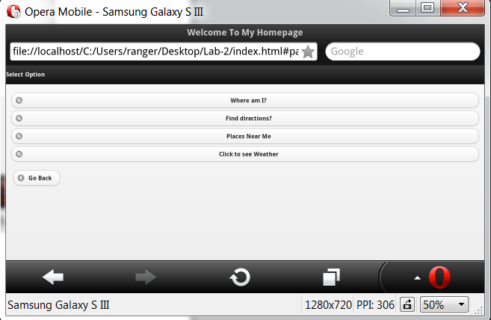

Click on the first tab **“Where am I?”** which gives the current location of the user.

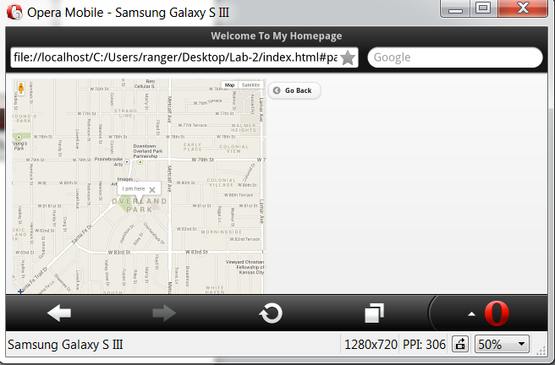

Clicking on Go Back takes you back to the Selection screen. Now, click on **“Find Directions”**.

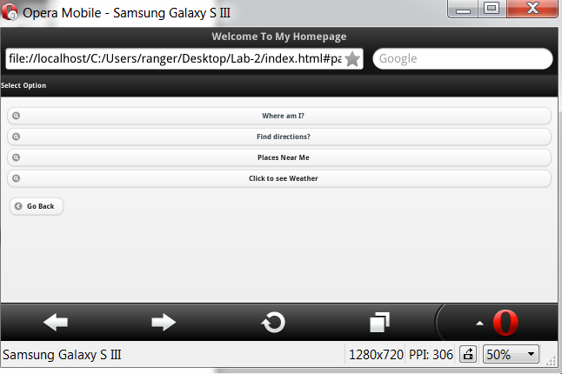

Enter Source and Destination in the page that opens up.

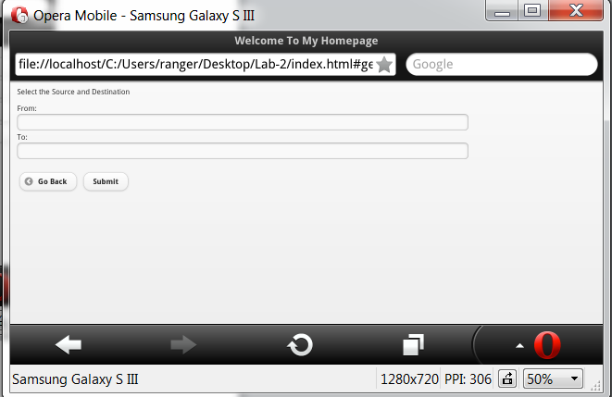

After entering the source and destination click on Submit.

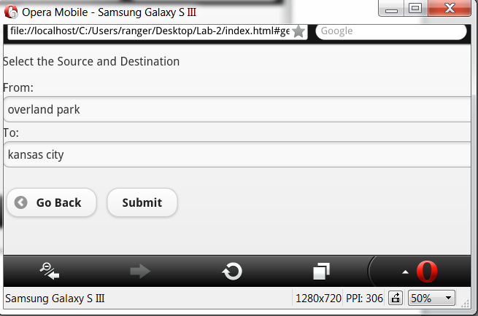

The next screen gives you the directions between the entered source and destination. The directions are shown on map along with written directions next to the map.

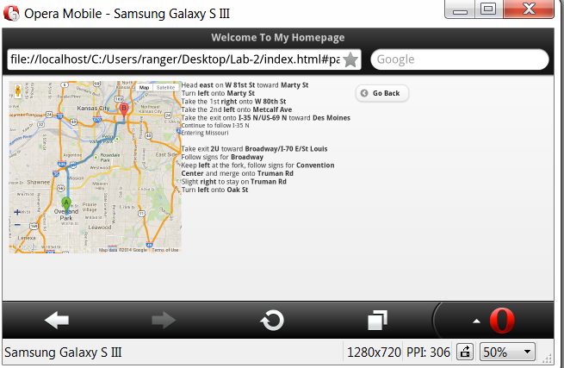

Click Go Back for the Selection screen.

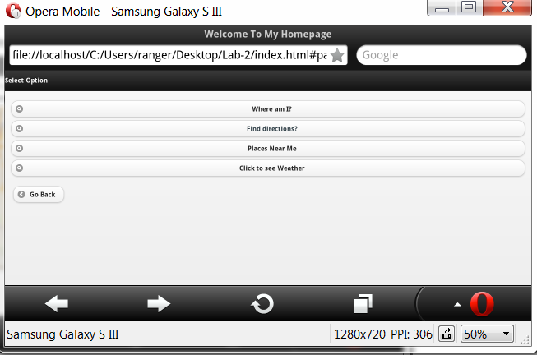

Select Places Near me to see the nearby joints. It gives the list of places.

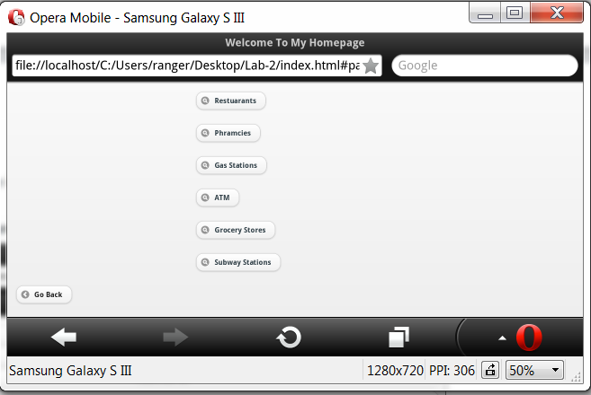

Click on Restaurants to see all the nearby Restaurants

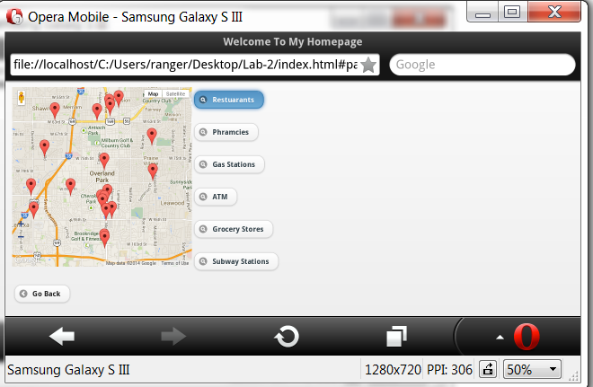

Click Pharmacies to see all the nearby pharmacies.

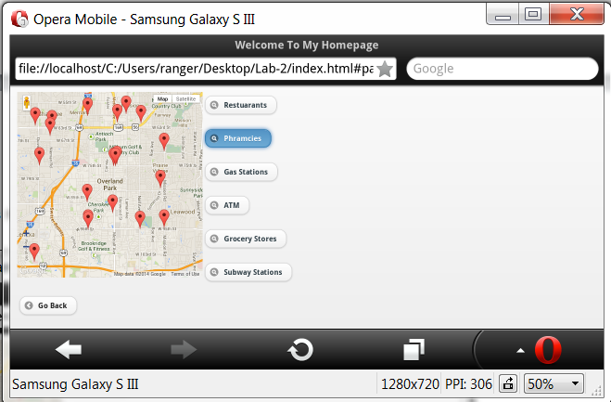

All nearby Gas Stations can be checked by clicking on Gas Stations.

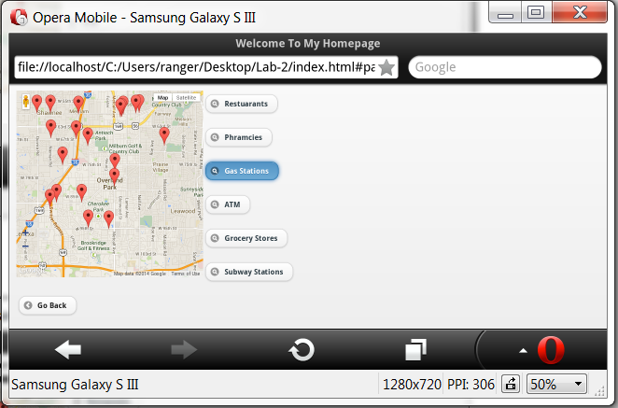

Similarly, the nearby functionality can be used to see nearby ATMs, Grocery Stores and Subway Stations.

Click on Go Back to go to the Selection Page and select Weather

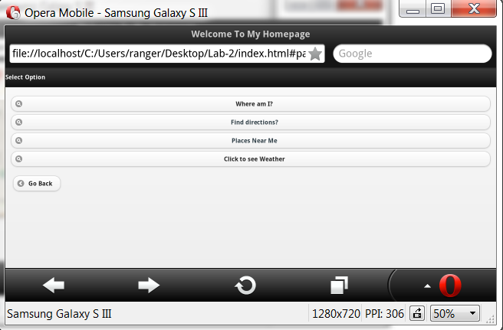

It gives the Weather Information using the current location of the user

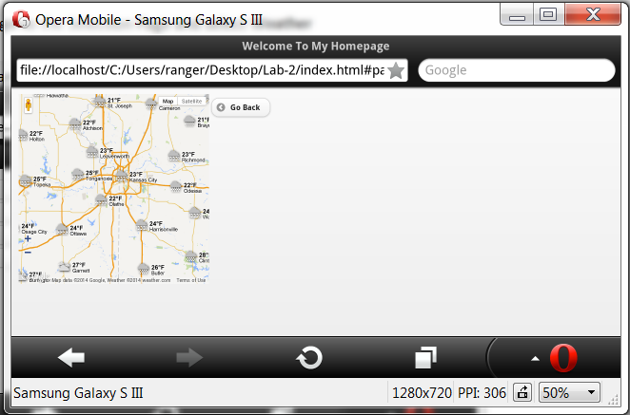

Click Go Back to get the Selection Screen

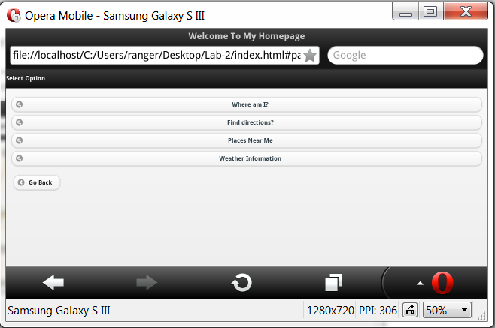

Click Go Back to get the Home Page

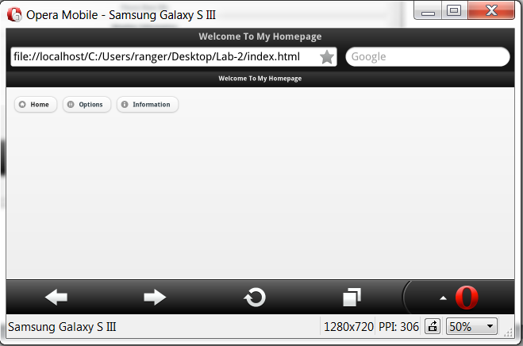

Click on Information to see the App Information.

