**6) Dicussion Board**

**Webservices/API:**

* The geocode function supported by the browser has been used to detect user’s current location.
* The “google.visualization.Gauge” has been used to create pie charts for the appliance utilization .
* SOAP Webservices have been used to populate forums and store user replies and create new threads.

**Design & Implementation details:**

User Clicks on the Dicussion Board image on homepage.

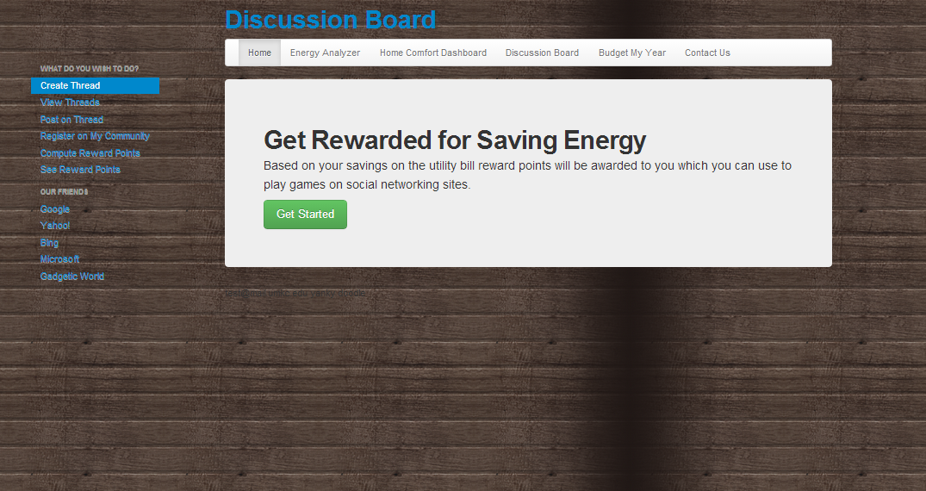

User clicks on View Threads to see all the forums talking about energy, SOAP webservice is used to pull all the related forums.

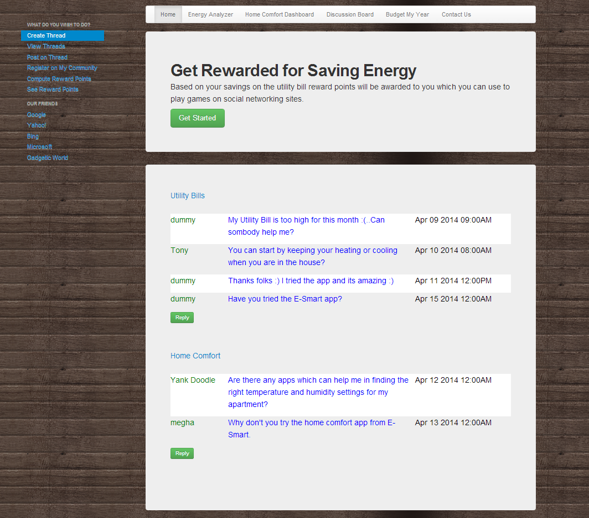

On clicking reply to a post user gets the below screen.

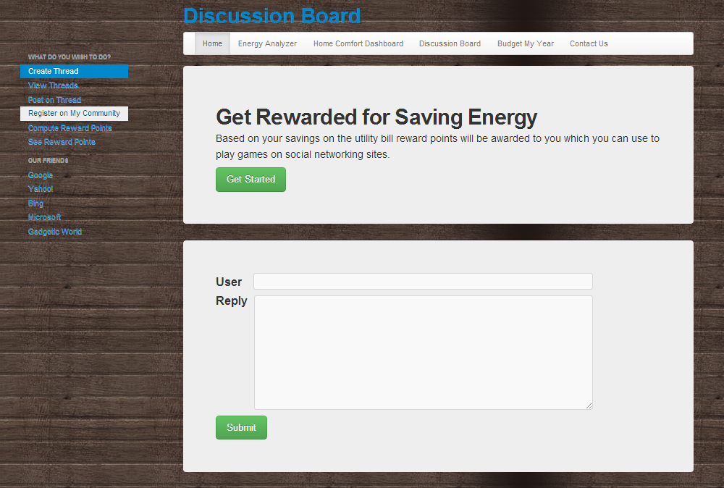

On clicking Submit the message is added to the forum in the database.

User can also create new forums by clicking on create Thread. On clicking submit the forum gets added to the database.

