June–August 2018 Forecast

## 

### Temperature

The summer outlook for temperature is warmer than normal across western and central portions of the state. If the warmer temperatures occur as forecasted, they will contribute to increased evapotranspiration and the potential dry down of spring soil moisture reserves. The forecast is less certain in eastern portions of the state with equal chances of above, below, or normal summer temperatures

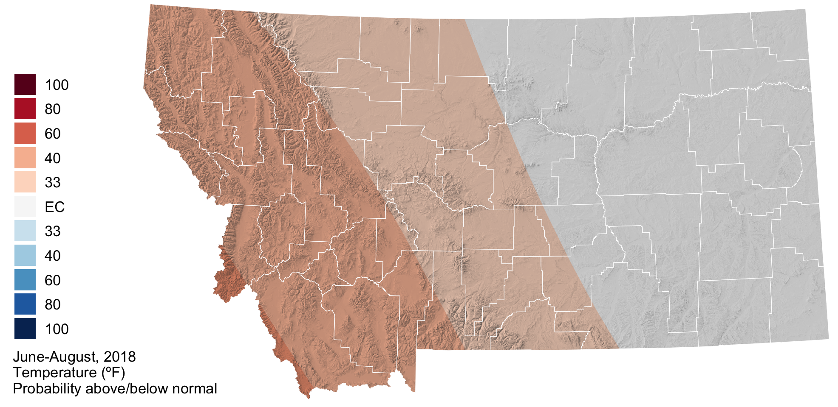

### Precipitation

The summer outlook for precipitation is drier than normal across northwestern, southwestern, and northcentral portions of the state. There may be potential for the development of drought conditions as the summer progresses in these regions if we do indeed experience drier than normal conditions in conjunction with above normal temperatures (above). The forecast is less certain in eastern portions of the state with equal chances of above, below, or normal summer precipitation.

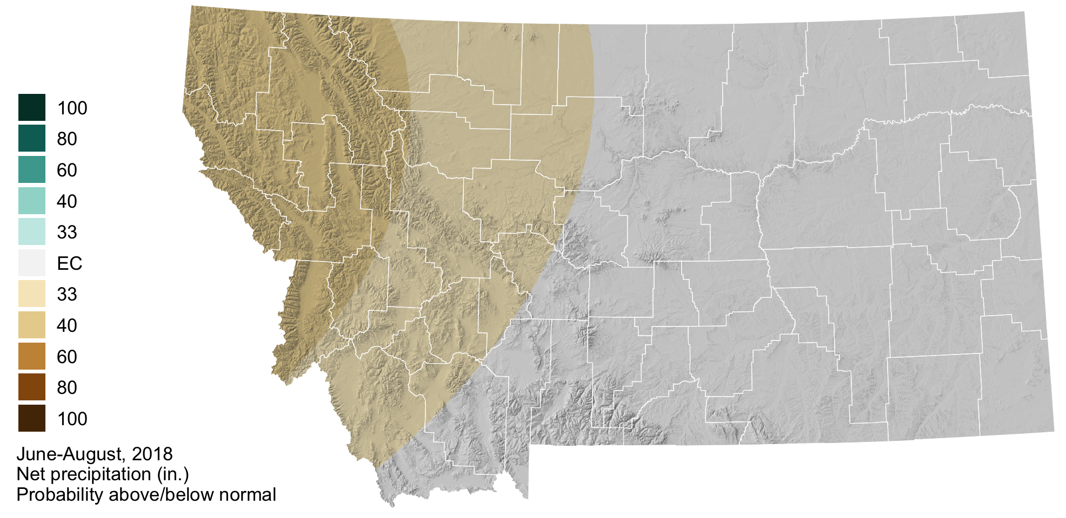

### Drought

