Lab 1: DDL statements

Create Table, insert, update, alter, drop, delete
Create database “Shopping” as;
Create database shopping; // database create

Use database
Use shopping;

Create table customer
create table Customer
(
CustomerID int NOT NULL AUTO_INCREMENT PRIMARY KEY,
CustFirstName varchar(25),
CustMidName varchar(10),
CustLastName varchar(25)
);

To get the description of customer table
Desc customer;

Create table salesorder with foreign key
create table SalesOrder
(
OrderID int NOT NULL AUTO_INCREMENT PRIMARY KEY,
OrderDate date,
CustomerID int,
FOREIGN KEY (CustomerID) REFERENCES Customer(CustomerID)
) engine=innodb;

Create table product

create table Product
(
ProductID int NOT NULL AUTO_INCREMENT PRIMARY KEY,
ProductName varchar(25),
UnitPrice decimal,
NumberInStock int
)engine=innodb;

Create table orderline

create table OrderLine
(OrderLineID int NOT NULL AUTO_INCREMENT PRIMARY KEY,
OrderID int,
ProductID int,
QuantityOrdered varchar(15),
FOREIGN KEY (OrderID) REFERENCES SalesOrder(OrderID),
FOREIGN KEY (ProductID) REFERENCES Product(ProductID)
)engine=innodb;

Insert values
INSERT INTO Customer (CustFirstName, CustLastName)
VALUES ('John', 'Doe');

INSERT INTO Customer (CustFirstName, CustMidName, CustLastName)
VALUES ('Bob', 'R.', 'Travis');

Multiple inserts

INSERT INTO Customer (CustFirstName, CustMidName, CustLastName) VALUES ('Ramesh', 'Sing', 'Saud'), (‘Bhoj’, 'Raj', 'Joshi');

Select * from Customer;

Insert into Product Table
INSERT INTO Product (ProductID, ProductName, UnitPrice, NumberInStock)
VALUES (1, 'Strawberry', 4.99, 16);

select * from Product;

Altering the table
alter table Product
modify UnitPrice decimal (5, 2);

Update table
UPDATE Product
SET UnitPrice =4.99 WHERE ProductID =1;

Inserting data SalesOrder
INSERT INTO SalesOrder (OrderDate, CustomerID)
VALUES (DATE '2006-10-11', 1);

Select from SalesOrder
select * from SalesOrder;

Insert data into OrderLine
INSERT INTO OrderLine (OrderLineID, OrderID, ProductID, QuantityOrdered)
VALUES (1,1,1,’3kg’);

Create table using select query
create table Customer2 as select * from Customer;

Drop Table
Drop table customer2;

Alter table add primary key

CREATE TABLE pkdemos(
id INT,
title VARCHAR(255) NOT NULL
);

ALTER TABLE pkdemos
ADD PRIMARY KEY(id);

Setting Not Null

CREATE TABLE tasks (
id INT AUTO_INCREMENT PRIMARY KEY,
title VARCHAR(255) NOT NULL,
start_date DATE NOT NULL,
end_date DATE
);

INSERT INTO tasks(title ,start_date, end_date)
VALUES('Learn MySQL NOT NULL constraint', '2017-02-01','2017-02-02'),
('Check and update NOT NULL constraint to your database', '2017-02-01',NULL);

INSERT INTO tasks(title ,start_date, end_date)
VALUES('Learn MySQL NOT NULL constraint', NULL, NULL);

SELECT *
FROM tasks
WHERE end_date IS NULL;

UPDATE tasks
SET
end_date = start_date + 7
WHERE
end_date IS NULL;

Setting Foreign Keys

CREATE TABLE categories(
categoryId INT AUTO_INCREMENT PRIMARY KEY,
categoryName VARCHAR(100) NOT NULL
) ENGINE=INNODB;

Setting Foreign Keys with Constraint Names

CREATE TABLE products(
productId INT AUTO_INCREMENT PRIMARY KEY,
productName varchar(100) not null,
categoryId INT,
CONSTRAINT fk_category
FOREIGN KEY (categoryId)
REFERENCES categories(categoryId)
) ENGINE=INNODB;

INSERT INTO categories(categoryName)
VALUES
('Smartphone'),
('Smartwatch');

SELECT * FROM categories;

INSERT INTO products(productName, categoryId)
VALUES('iPhone',1);

INSERT INTO products(productName, categoryId)
VALUES('iPad',3);

MySQL issued the following error:
Error Code: 1452. Cannot add or update a child row: a foreign key constraint fails
UPDATE categories
SET categoryId = 100
WHERE categoryId = 1;

You will see the category id set to null for the product in products where category id =1

Create the products table with the ON UPDATE CASCADE and ON DELETE CASCADE options for the foreign key:

CREATE TABLE products(
productId INT AUTO_INCREMENT PRIMARY KEY,
productName varchar(100) not null,
categoryId INT NOT NULL,
CONSTRAINT fk_category
FOREIGN KEY (categoryId)
REFERENCES categories(categoryId)
ON UPDATE CASCADE
ON DELETE CASCADE
) ENGINE=INNODB;

INSERT INTO products(productName, categoryId)
VALUES
('iPhone', 1),
('Galaxy Note',1),
('Apple Watch',2),
('Samsung Galary Watch',2);

UPDATE categories
SET categoryId = 100
WHERE categoryId = 1;

SELECT * FROM products;

You WILL SEE CHANGE IN CATEGORY ID IN PRODUCTS

DELETE FROM categories
WHERE categoryId = 2;

SELECT * FROM products;

All products with categoryId 2 from the products table were automatically deleted because of the ON DELETE CASCADE action.

SET NULL action

These steps illustrate how the ON UPDATE SET NULL and ON DELETE SET NULL actions work.

- Drop both categories and products tables:

DROP TABLE IF EXISTS categories;
DROP TABLE IF EXISTS products;

- Create the categories and products tables:

CREATE TABLE categories(
categoryId INT AUTO_INCREMENT PRIMARY KEY,
categoryName VARCHAR(100) NOT NULL
)ENGINE=INNODB;

CREATE TABLE products(
productId INT AUTO_INCREMENT PRIMARY KEY,
productName varchar(100) not null,
categoryId INT,
CONSTRAINT fk_category
FOREIGN KEY (categoryId)
REFERENCES categories(categoryId)
ON UPDATE SET NULL
ON DELETE SET NULL
)ENGINE=INNODB;

- The foreign key in the products table changed to ON UPDATE SET NULL and ON DELETE SET NULL options.
- Insert rows into the categories table:

INSERT INTO categories(categoryName)
VALUES ('Smartphone'), ('Smartwatch');

- Insert rows into the products table:

INSERT INTO products(productName, categoryId)
VALUES
('iPhone', 1),
('Galaxy Note',1),
('Apple Watch',2),
('Samsung Galary Watch',2);

- Update categoryId from 1 to 100 in the categories table:

UPDATE categories
SET categoryId = 100
WHERE categoryId = 1;

- Verify the update:
SELECT * FROM categories;
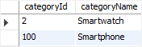
- Select data from the products table:
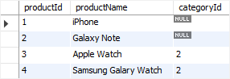
- The rows with the categoryId 1 in the products table were automatically set to NULL due to the ON UPDATE SET NULL action.

- Delete the categoryId 2 from the categories table:
DELETE FROM categories
WHERE categoryId = 2;
- Check the products table:
SELECT * FROM products;
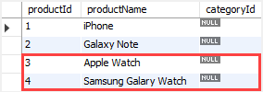
- The values in the categoryId column of the rows with categoryId 2 in the products table were automatically set to NULL due to the ON DELETE SET NULL action.

UNIQUE constraint

First, creates a new table named suppliers with the two UNIQUE constraints:

CREATE TABLE suppliers (
supplier_id INT AUTO_INCREMENT,
name VARCHAR(255) NOT NULL,
phone VARCHAR(15) NOT NULL UNIQUE,
address VARCHAR(255) NOT NULL,
PRIMARY KEY (supplier_id),
CONSTRAINT uc_name_address UNIQUE (name , address)
);

INSERT INTO suppliers(name, phone, address)
VALUES( 'ABC Inc', '(408)-908-2476', '4000 North 1st Street');

INSERT INTO suppliers(name, phone, address)
VALUES( 'XYZ Corporation','(408)-908-2476','3000 North 1st Street');

MySQL issued an error:
Error Code: 1062. Duplicate entry '(408)-908-2476' for key 'phone'

Multiple Primary Keys

CREATE TABLE IF NOT EXISTS author(
aut_id varchar(8) NOT NULL ,
aut_name varchar(50) NOT NULL,
country varchar(25) NOT NULL,
home_city varchar(25) NOT NULL,
PRIMARY KEY (aut_id, home_city));

Check Constraint

CREATE TABLE IF NOT EXISTS newauthor
(aut_id varchar(8) NOT NULL ,
aut_name varchar(50) NOT NULL,
country varchar(25) NOT NULL CHECK (country IN ('USA','UK','Nepal')),
home_city varchar(25) NOT NULL,
PRIMARY KEY (aut_id, home_city))

INSERT into newauthor(aut_id, aut_name,country,home_city)VALUES(11,"Ram","Nepal","KTM")



INSERT into newauthor(aut_id, aut_name,country,home_city)VALUES(12,"Shyam","India","Delhi")

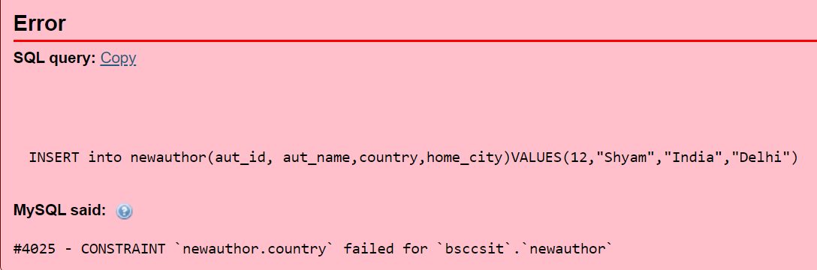

Alter Table

CREATE TABLE vehicles (
vehicleId INT,
year INT NOT NULL,
make VARCHAR(100) NOT NULL,
PRIMARY KEY(vehicleId)
);

Add a column to a table
To add a column to a table, you use the ALTER TABLE ADD syntax:

ALTER TABLE vehicles
ADD model VARCHAR(100) NOT NULL;

Add Multiple Columns

ALTER TABLE vehicles
ADD color VARCHAR(50),
ADD note VARCHAR(255);

To Modify A column

ALTER TABLE vehicles
MODIFY note VARCHAR(100) NOT NULL;

To Modify multiple columns

ALTER TABLE vehicles
MODIFY year SMALLINT NOT NULL,
MODIFY color VARCHAR(20) NULL AFTER make;

In this example:
- First, modify the data type of the year column from INT to SMALLINT
- Second, modify the color column by setting the maximum length to 20, removing the NOT NULL constraint, and moving it to a position after the make column.

Renaming Columns

ALTER TABLE vehicles
CHANGE COLUMN note vehicleCondition VARCHAR(100) NOT NULL;

Dropping Column

ALTER TABLE vehicles
DROP COLUMN vehicleCondition;

Renaming Table
ALTER TABLE vehicles
RENAME TO cars;

Few more examples for Create table

Create database testDB

- Create table person using not null

CREATE TABLE Persons (
ID int NOT NULL PRIMARY KEY,
LastName varchar(255) NOT NULL,
FirstName varchar(255),
Age int
);

- Create Table Orders with foreign key

CREATE TABLE Orders (
OrderID int NOT NULL,
OrderNumber int NOT NULL,
PersonID int,
PRIMARY KEY (OrderID),
FOREIGN KEY (PersonID) REFERENCES Persons(PersonID)
);

Or,
CREATE TABLE Orders (
OrderID int NOT NULL,
OrderNumber int NOT NULL,
PersonID int,
PRIMARY KEY (OrderID),
CONSTRAINT FK_PersonOrder FOREIGN KEY (PersonID)
REFERENCES Persons(PersonID)
);

- Alter and add foreign key
ALTER TABLE Orders
ADD FOREIGN KEY (PersonID) REFERENCES Persons(PersonID);

- Drop foreign key constraint
ALTER TABLE Orders
DROP FOREIGN KEY FK_PersonOrder;

