First unit test (validate time)
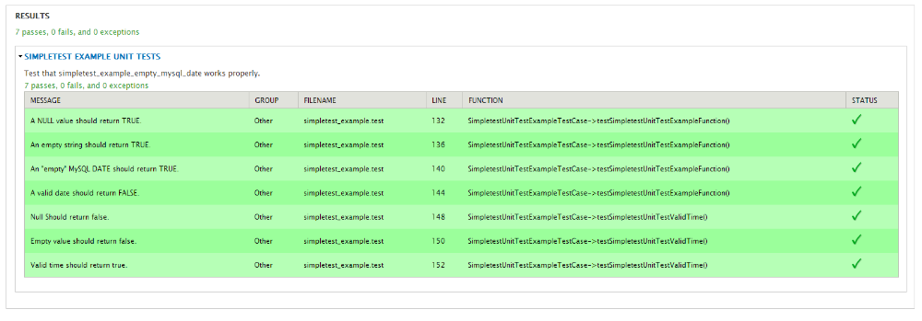
Second unit test (failed) (Matching D-M-Y)
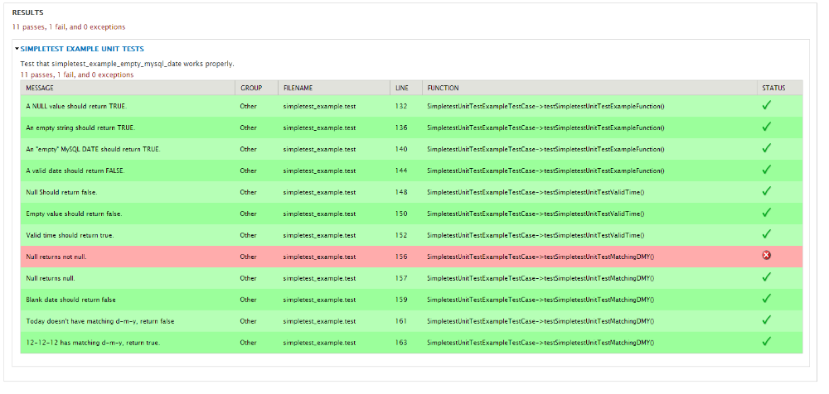
Third unit test (failed) (Is even)
