2026-09-30
Quick Start Guide: Running the App
- Unzip the App Folder:
First of all, unzip the app folder (MT_Global_Lipidomic_Explorer_Shared_26_09_30) on your computer.

- Open the Project:
Double-click the MT_Global_Lipidomic_Explorer.Rproj file (the file selected in the image below).
Note: R (>= 4.4.0) and RStudio Desktop must be installed on your computer.
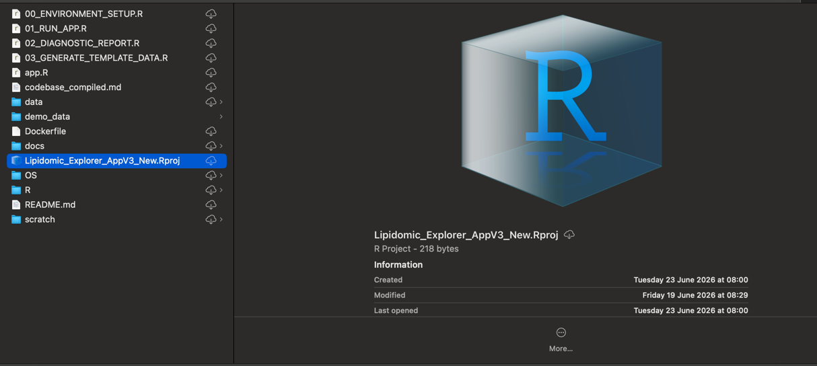
- Locate the OS Folder:
Once RStudio is open, you’ll see the contents of the app folder in the bottom-right panel (Files tab). Locate the OS folder (squared in green below), and double-click to open it.

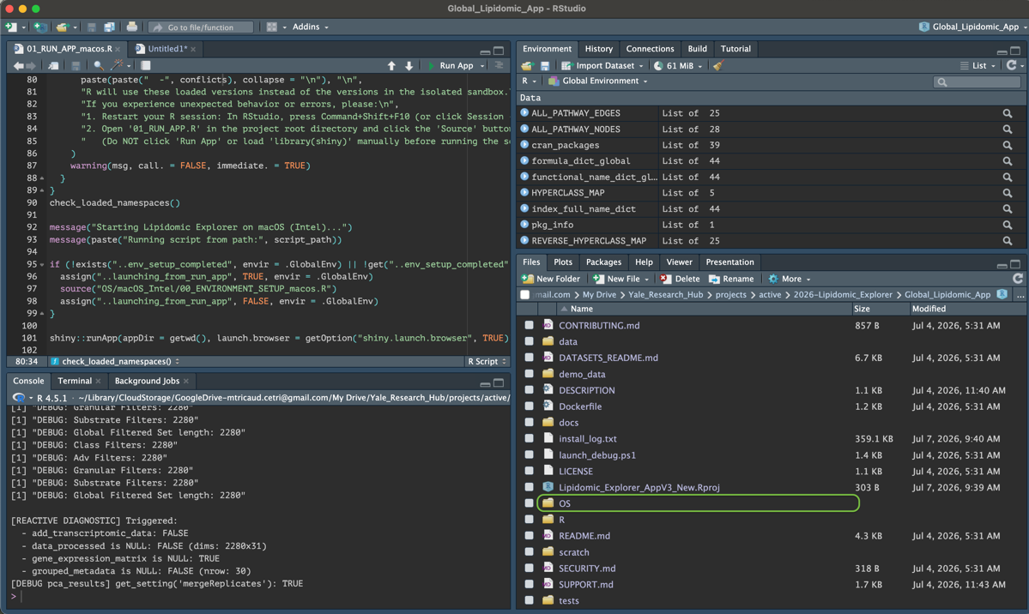
- Select Your Operating System:
Navigate to the folder representing the operating system you are running:
• Windows
• macOS Apple Silicon (if you have an M1, M2, M3, M4... chip)
• macOS Intel (if you have an older Macbook with an i5, i7, or i9 chip)
• Linux
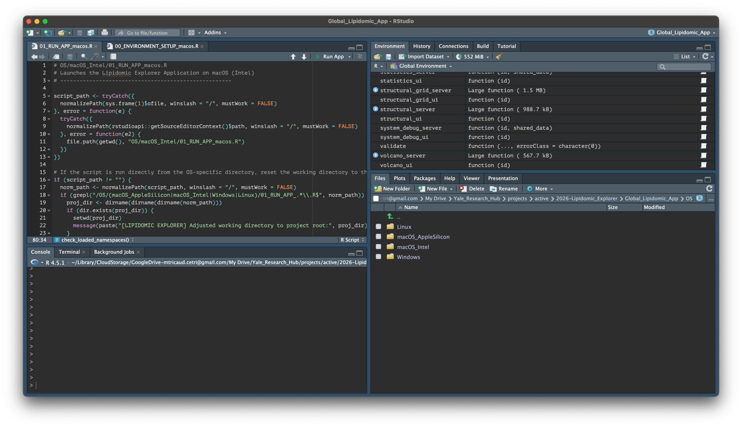
- Open the Runner Script:
Double-click the 01_RUN_APP... script inside your OS folder (squared in blue below) to open it in the code editor.

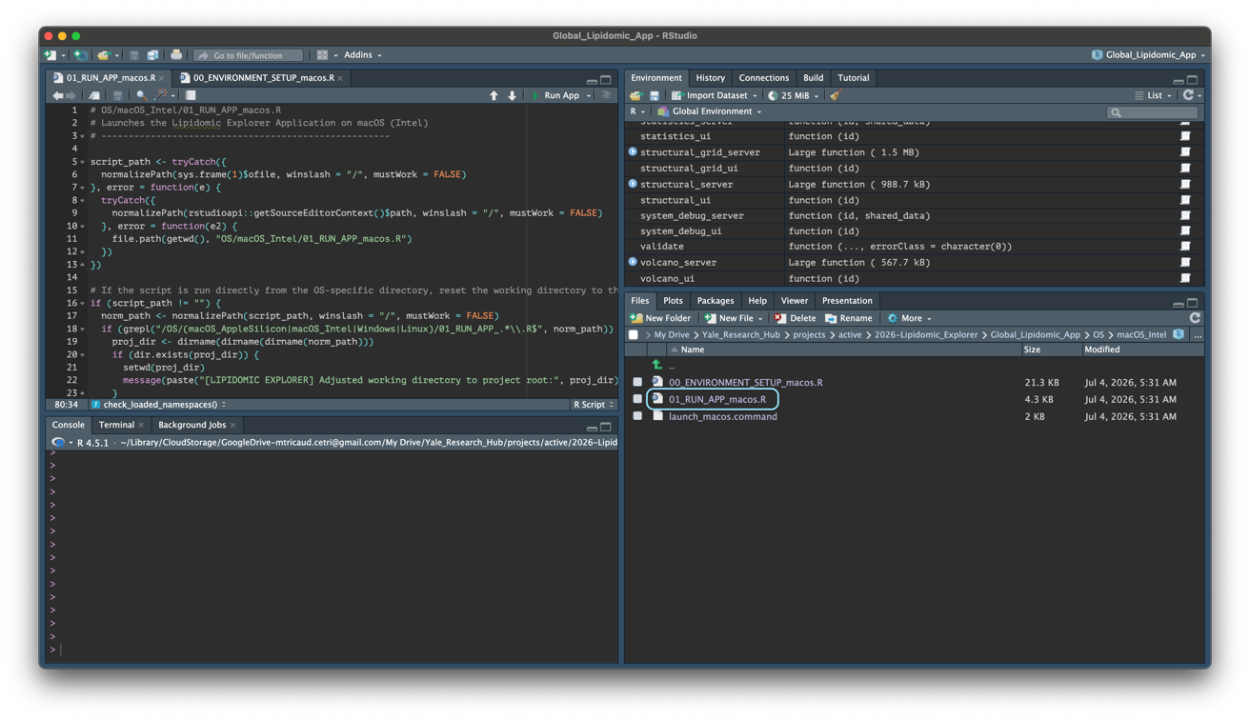

- Launch the Application:
Once the script opens in the code editor (top-left panel of the interface), click the "Run App" button at the top of the editor window (highlighted below in purple), or click "Source".
First-Time Setup Note: The application operates within an isolated sandbox to protect your personal R library. On your very first run, it will automatically check and install all required dependencies into this sandbox. This initial setup takes a few minutes, after which subsequent launches will run directly.

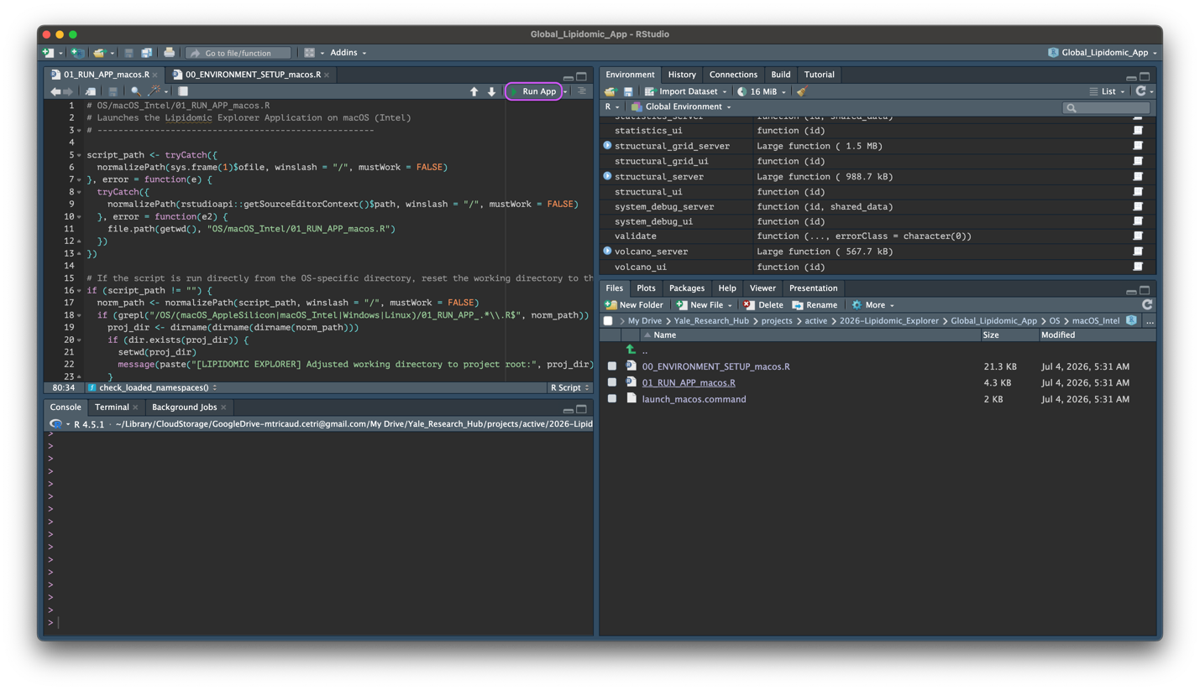

- Start Your Analysis:
The application will launch. You will see configuration logs scrolling in the RStudio Console (bottom-left panel), and the interactive Shiny app window will open in your browser (or RStudio Viewer). From there, you can follow the interactive "Onboarding" mode inside the application, which guides you step-by-step through uploading your own dataset, verifying that it is properly formatted (or formatting it directly within the app's interface), and configuring metadata so it can be seamlessly read and processed for statistical modeling and calculations.
Key Analytical Modules:
• Longitudinal Trajectory Analysis: Multi-timepoint tracking across patient cohorts with custom pairing filters, timecourse grid views, and automated multiline tick wrapping.
• Single-Lipid Targeted Analysis: Seamless focus on individual lipid species with automated class-filtering guidance notices.
• Structural & Quantitative Violins: Log2 vs Linear scales, and baseline references.
• Core Exploration & Pathways: Quality Control & PCA, Differential Volcano & Heatmaps, LSEA Pathway Enrichment, and Organelle Stress Indices.
NB: Always remember to use the "Export Session" feature if you are going to leave the application idle for a while. Because RStudio will automatically close the application connection after a period of inactivity, exporting your session ensures you can reload it later with all your custom filters, colors, and toggles completely intact.
Both the "Export Session" button and the "Import Session (.zip)" tool are located at the bottom of the left sidebar (under "1. Input & Run Analysis", within the "Session Persistence" section). Whenever you reach a key analytical checkpoint, don't hesitate to save! To restore your workspace later, upload your saved ZIP archive via "Import Session (.zip)" at the bottom of the sidebar to reload your analytical state.

Finally, if any error message appears in the RStudio Console (bottom-left panel) accompanied by the impossibility to run the application, in order to help improve application deployment, you can send me the console text output along with the details of the machine used (operating system and processor type) and any relevant screenshots at maxence.tricaud.1@ulaval.ca.

