Project 1
MSE 5280x: Data Analytics and Machine Learning in Materials Research

Used Dataset: LIG Resistance Data
- Data Extraction
Data are extract from git-hub repository. The dataset of laser-induced graphene (LIG) parameters was extracted using the following code from an Excel file, specifically focusing on variables like laser power, speed, and DPI. It then converts these individual columns into NumPy arrays and displays the first five rows to verify the LIG’s electrical properties, such as sheet resistance and conductance.
Code
import pandas as pd
import numpy as np
url = 'https://github.com/mta-phy/5820x/raw/main/HWs/LIG_DATA.xlsx'
Data = pd.read_excel(url)
Power = Data.iloc[:, 0].to_numpy();
Speed = Data.iloc[:, 1].to_numpy();
DPI = Data.iloc[:, 2].to_numpy();
Defocus = Data.iloc[:, 3].to_numpy();
Sheet_resistance= Data.iloc[:, 4].to_numpy();
Sheet_conductance= Data.iloc[:, 5].to_numpy();
Data.head(5)

Output

index | Power (W) | Speed (cm/s) | DPI | Defocus (inch) | Sheet Resistance (ohm) | Sheet Conductance (1/ohm)
0 | 58 | 19 | 400 | -0.1 | 7.1757 | 0.13935922627757572
1 | 60 | 18 | 200 | 0.2 | 7.1757 | 0.13935922627757572
2 | 50 | 17 | 600 | -0.1 | 8.8641 | 0.11281461174851366
3 | 56 | 18 | 300 | -0.1 | 10.9746 | 0.09111949410456872
4 | 55 | 16 | 400 | -0.2 | 11.3967 | 0.08774469802662173

- Statistical Breakdown
The output of the following code provides a statistical breakdown of 104 samples, highlighting some extreme variability in your material properties.
Code
Data.describe()

Output

 | Power (W) | Speed (cm/s) | DPI | Defocus (inch) | Sheet Resistance (ohm) | Sheet Conductance (1/ohm)
count | 104.0000 | 104.0000 | 104.0000 | 104.0000 | 1.040000e+02 | 104.0000
mean | 50.5288 | 21.5385 | 369.9519 | 0.0394 | 4.302204e+06 | 0.0345
std | 12.4845 | 7.8739 | 164.4858 | 0.1573 | 8.421074e+06 | 0.0312
min | 10.0000 | 10.0000 | 75.0000 | -0.3000 | 7.175700e+00 | 0.0000
25% | 45.0000 | 16.0000 | 300.0000 | -0.1000 | 1.762270e+01 | 0.0092
50% | 52.5000 | 20.0000 | 300.0000 | 0.0000 | 3.651160e+01 | 0.0274
75% | 59.0000 | 25.0000 | 400.0000 | 0.2000 | 1.090073e+02 | 0.0568
max | 70.0000 | 49.0000 | 1200.0000 | 0.3000 | 2.110500e+07 | 0.1394

- Probability Density
These plots show the probability density distributions for the laser parameters and the resulting electrical properties of the graphene. While Lasing Power and Speed follow roughly normal distributions, the Sheet Resistance is heavily bimodal and skewed, with a large cluster of low-resistance samples and a smaller group of extremely high-resistance outliers.
Consequently, the Sheet Conductance distribution is more spread out and right-skewed, indicating that most experimental trials resulted in relatively low conductance with only a few highly efficient samples.
Code
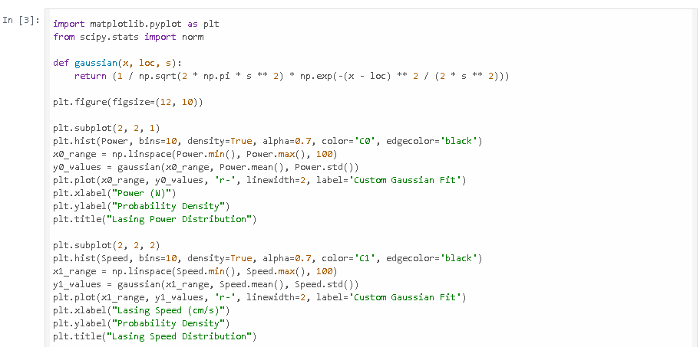
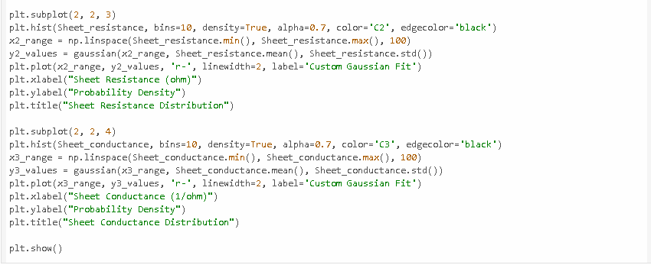

Output

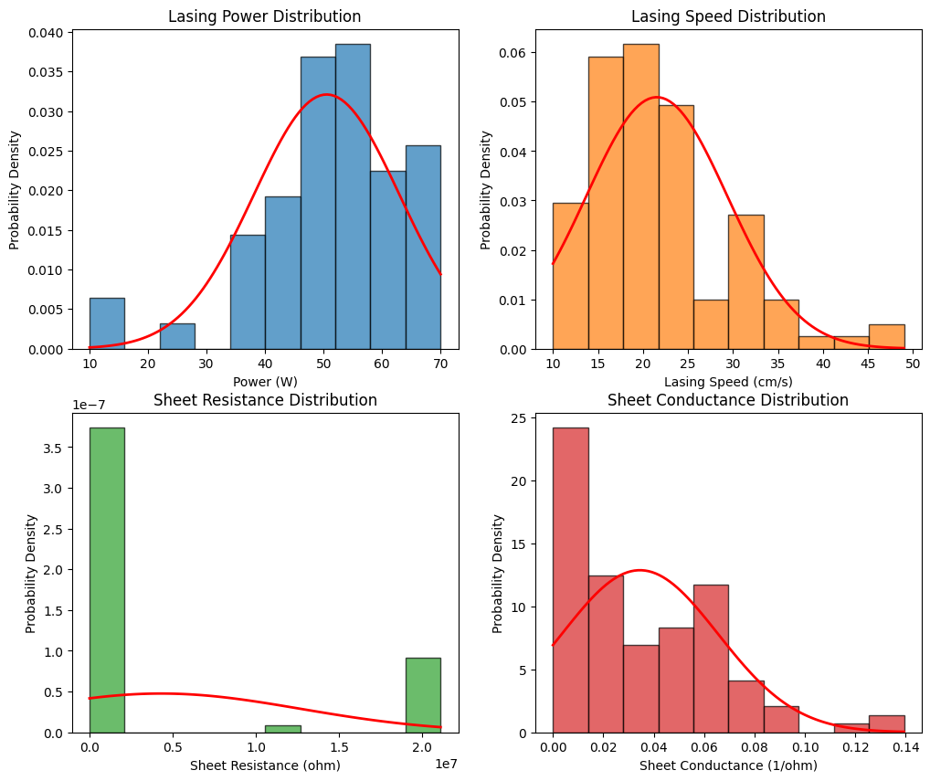
Scatter plots show how variables like Power and Speed interact to influence Sheet Conductance; clusters indicate specific power-speed combinations that yield higher conductivity. Color coding reveals that different DPI levels (from 200 to 1200) shift the distributions, particularly in the Defocus and Conductance plots, suggesting pixel density is a significant factor in material quality.

- Pairplot
The pair plot (or corner plot) visualizes the multidimensional relationships and distributions between laser processing parameters and the resulting graphene properties, categorized by DPI.
Code
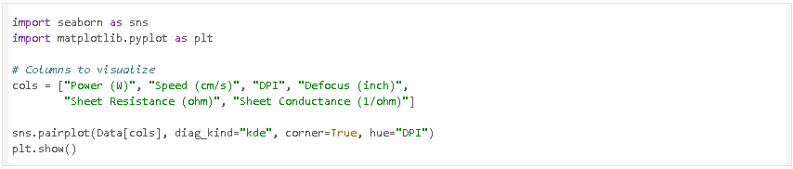

Output
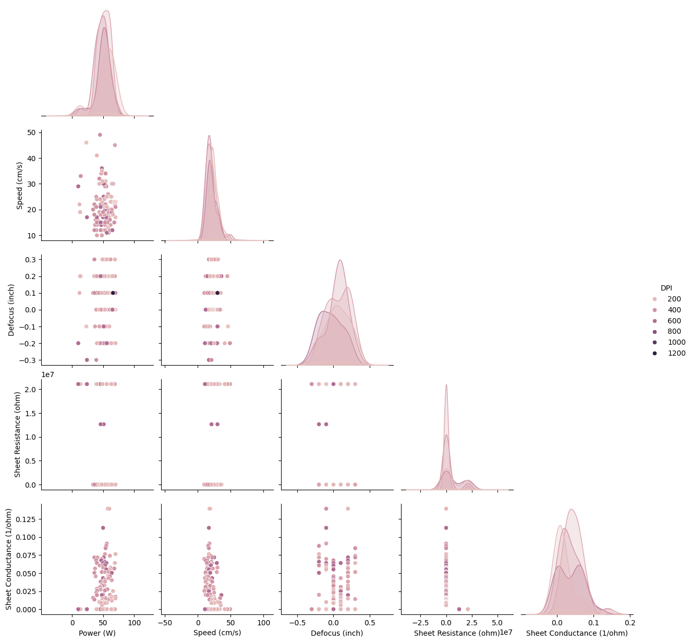

- Three Variable Scattered Relation
The Power vs Speed plot shows a central cluster of high conductance (red/green) typically between 50W–65W and 15–20 cm/s. In the Power vs DPI and Speed vs DPI plots, the highest conductance values appear concentrated around 300–400 DPI. he Power vs Defocus plot indicates that the most conductive samples occur within a narrow window of defocus (near -0.1 to 0.1). Deviating too far from the focal plane disperses the laser energy, leading to the blue/purple low-conductance results.
Code
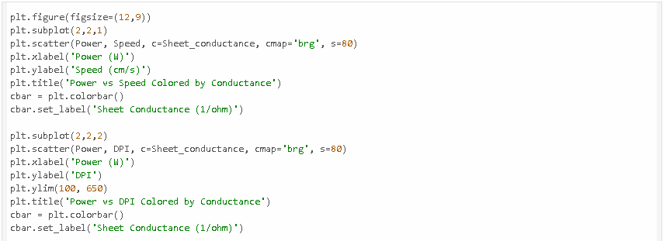
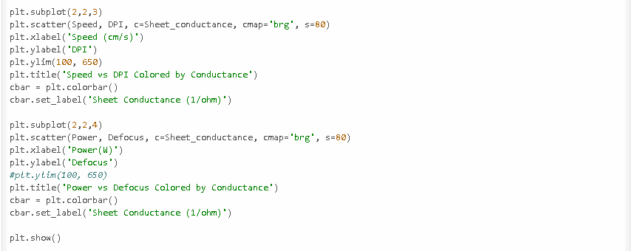

Output
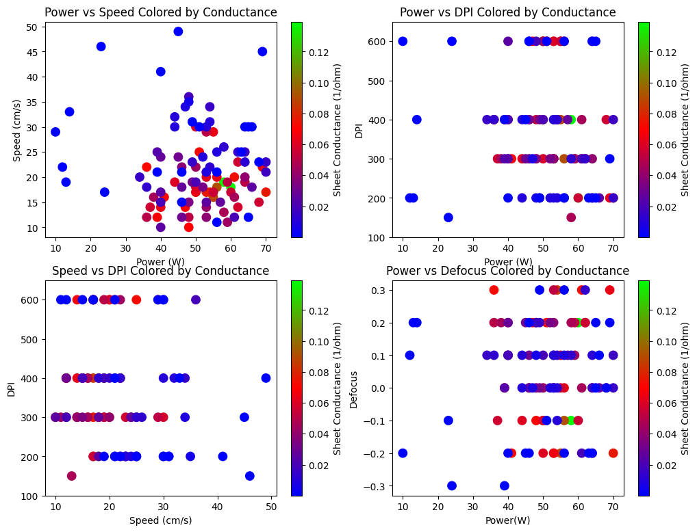
import matplotlib.pyplot as plt
fig = plt.figure(figsize=(12, 9))
ax = fig.add_subplot(111, projection='3d')
# Map the 4th variable (Conductance) to the color argument 'c'
# We use the variables you extracted in your previous code
img = ax.scatter(DPI, Speed, Power,
c=Sheet_conductance,
cmap='plasma',
s=80,
edgecolor='w',
alpha=0.8)
# Add a colorbar to decode the 4th dimension
cbar = fig.colorbar(img, ax=ax, shrink=0.5, aspect=10)
cbar.set_label('Sheet Conductance (1/ohm)', fontsize=12)
ax.set_xlim(150, 600)
# Set labels for the 3 spatial axes
ax.set_xlabel('DPI')
ax.set_ylabel('Speed (cm/s)')
ax.set_zlabel('Power (W)')
ax.set_title('4D Visualization of Graphene Quality', pad=20)
plt.show()
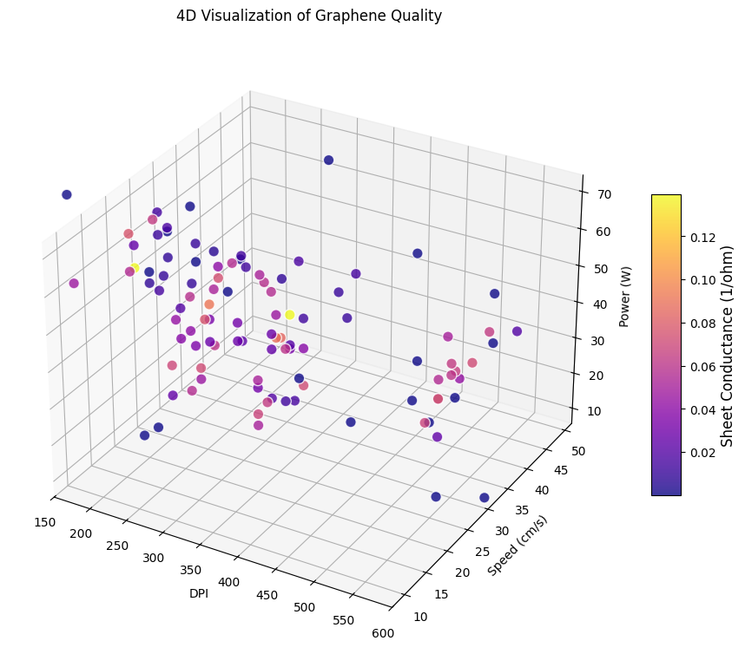
import seaborn as sns
import matplotlib.pyplot as plt
plt.figure(figsize=(8, 6))
sns.violinplot(
data=Data,
x="DPI",
y="Sheet Conductance (1/ohm)",
inner="box",
linewidth=1.2,
color="#AAB000"
)
plt.title("Sheet Conductance Distribution Across DPI Settings")
plt.tight_layout()
plt.show()
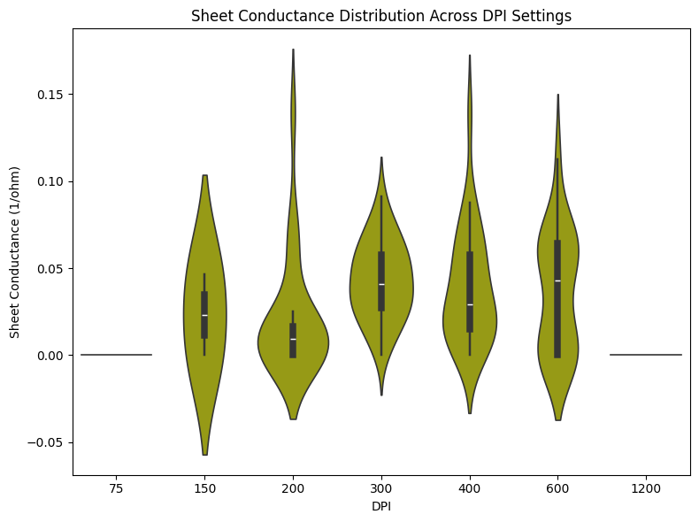
from sklearn.ensemble import RandomForestRegressor
X = Data[["Power (W)", "Speed (cm/s)", "DPI", "Defocus (inch)"]]
y = Data["Sheet Conductance (1/ohm)"]
rf = RandomForestRegressor(n_estimators=500, random_state=0)
rf.fit(X, y)
labels = X.columns
sizes = rf.feature_importances_
plt.figure(figsize=(7,7))
plt.pie(
sizes,
labels=labels,
autopct="%1.1f%%",
startangle=140,
colors=["#AB0000", "#323BFA", "#AAB000", "#23C1DE"]
)
plt.title("Feature Importance for Predicting Sheet Conductance")
plt.tight_layout()
plt.show()
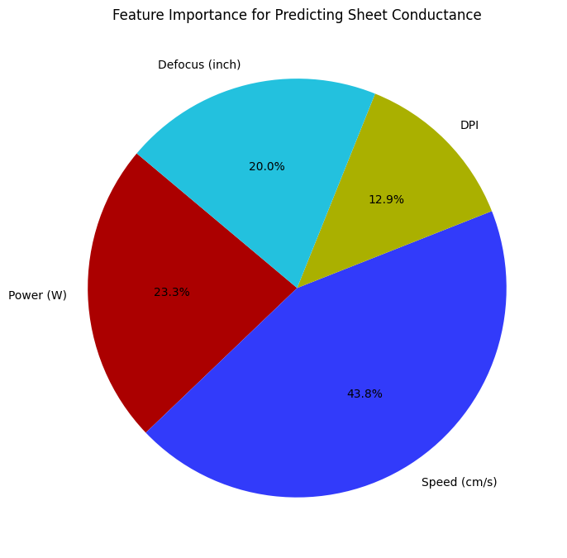
cor = np.corrcoef(Data.iloc[:, 0:6], rowvar=False)
# Print correlation matrix
print("Correlation Matrix:\n", cor)
Correlation Matrix:
[[ 1. -0.08243027 -0.04844783 0.0402033 -0.24559442 0.19143038]
[-0.08243027 1. -0.06834557 -0.00868319 0.38314103 -0.43226255]
[-0.04844783 -0.06834557 1. -0.16203456 0.11864047 0.0586956 ]
[ 0.0402033 -0.00868319 -0.16203456 1. -0.17260026 0.01304684]
[-0.24559442 0.38314103 0.11864047 -0.17260026 1. -0.571413 ]
[ 0.19143038 -0.43226255 0.0586956 0.01304684 -0.571413 1. ]]
plt.figure(figsize=(8,8))
feature_names=['Power','Speed','DPI','Defocus','Sheet Resistance','Sheet Conductance']
# Create the heatmap
im = plt.imshow(cor, vmin=-1, vmax=1, cmap='terrain') # vmin=-1 better shows negative correlations
plt.colorbar(im, label="Correlation coefficient")
# --- ADDING THE VALUES ---
for i in range(len(feature_names)):
for j in range(len(feature_names)):
# Displaying the value rounded to 2 decimal places
# 'ha' and 'va' ensure the text is perfectly centered
text = plt.text(j, i, f"{cor[i, j]:.2f}",
ha="center", va="center", color="black",
fontweight='bold')
# Formatting the axes
plt.xticks(range(len(feature_names)), feature_names, rotation=45)
plt.yticks(range(len(feature_names)), feature_names)
plt.title("Correlation Matrix with Values")
plt.tight_layout()
plt.show()
