Device-Guided Calibration of the Stanford RRAM Model: Generalization, Identifiability, and Deposition Trends in Sputter-Deposited TaO$_x$ Devices
Md Tawsif Rahman Chowdhury, Alireza Moazzeni, and Gozde Tutuncuoglu
Department of Electrical and Computer Engineering, Wayne State University, Detroit, MI 48202 USA
Resistive RAM (RRAM) is a leading candidate for embedded nonvolatile memory and in-memory computing, and almost every circuit- or process-level study of it eventually has to turn a measured current–voltage (I–V) switching loop into a set of compact-model parameters. The Stanford–PKU model is the usual target: it describes bipolar filamentary switching with a single “gap” state variable, a sinh-shaped tunneling current, and a thermally accelerated gap growth/rupture law. The standard way to report such a calibration is to overlay one simulated curve on one measured loop and show that the two match. That picture is necessary but not sufficient. A good overlay does not establish two things a device or process engineer actually needs: (i) that the extracted parameters describe the whole device — every measured cycle — rather than only the single loop that was fitted, and (ii) that each individual number is genuinely pinned down by the data rather than being one of many values that fit equally well. We call the first question generalization and the second identifiability. Both are simple, but they are rarely reported alongside RRAM parameter sets.
We built an automated, device-guided extraction flow for the Stanford model and applied it uniformly to twelve sputter-deposited TaOₓ conditions spanning 20–35% oxygen in the sputter ambient and 75–250 W RF power (a face-centered factorial design with four repeated center points; Table I). The flow makes four contributions, which are the novel content of this work. First, it reads the device physics before fitting: every part of the measured loop is classified by conduction mechanism, and that map both guides the fit and flags the regions the Stanford current law physically cannot reproduce. Second, it tests generalization directly, by scoring a fit made on one representative cycle against every other measured cycle of the same device. Third, it audits identifiability, reporting which parameters are repeatable enough to carry physical meaning. Fourth, it uses only those trustworthy parameters to extract deposition trends, and in doing so exposes a device-physics limit of the Stanford model for TaOₓ.
The devices are 4-µm cross-point TaOₓ cells with the standard asymmetric Ta-oxide bilayer stack, measured under DC bipolar switching on a Keysight B1500. Each device contributes tens of measured cycles; an automated quality screen removes shorted, open, incomplete, or noise-floor sweeps before any fitting (for the representative S1 device, all 40 cycles pass, mean quality 8.9/10). For each condition the flow then picks one representative cycle automatically — the medoid, the single measured loop closest to the typical (median) behavior of all the cycles — instead of letting a person choose a good-looking trace by eye. Using a real measured loop, rather than an averaged synthetic curve, preserves the true hysteresis order, the switching kinks, and the compliance-limited plateau that the model must reproduce. The remaining cycles are set aside for the generalization and repeatability tests below.
Before any fitting, each resistance-state segment of the representative loop is classified as ohmic, Poole–Frenkel, Schottky, or Fowler–Nordheim conduction (Fig. 1). Because some of these signatures look almost identical over a short voltage span, we add a physical sanity check: the measured slope is converted into an effective dielectric constant, and a label is accepted only if that value is physically reasonable for the 7-nm oxide. The model itself — the Stanford Verilog-A description — is then simulated in HSPICE, and its parameters are tuned to match the measured loop on a logarithmic current scale (the sweep spans several decades of current, so a log scale gives all of them fair weight). The search uses Bayesian optimization, a guided search that learns from each trial which parameter values to try next, so it reaches a good fit in a few hundred simulations instead of scanning a grid, followed by a short local polish. Importantly, the parts of the curve the Stanford law cannot represent (the Schottky/FN regions) are down-weighted during fitting so they cannot distort the parameters the model can represent, but they are restored to full weight when we report the final error so the mismatch stays visible.
Across all twelve conditions the fits reproduce the measured butterfly curves with a typical error of 0.530 current decades for SET and 0.761 for RESET (Table II). (“Error” here is the root-mean-square gap between simulated and measured current along the sweep; one decade is a factor of ten, so 0.5 decade means the simulated current is typically within about a factor of three of the measurement.) The fits capture the hysteresis order, both switching transitions, the compliance plateau, and the LRS return branch. The leftover error is not random scatter: a simple residual test — the Durbin–Watson statistic, which detects whether the error drifts smoothly along the sweep rather than jittering point to point — shows it is systematic. That is the signature of a missing physical term, not of optimizer failure, and the regime map tells us which term: the high-resistance state (HRS) is interface-limited Schottky conduction in 92.5–100% of cycles for every condition (Fig. 2), a mechanism the Stanford bulk current law does not contain. A controlled ablation (Table III) makes the same point from the optimization side: removing the search nearly triples the RESET error, yet the three optimized variants land within a few hundredths of a decade of each other, so a low overlay error by itself cannot single out the right physics.
The most important check is whether a fit made on one cycle describes the cycles it never saw. We score the fitted curve, point by point, against every measured cycle of the device. Averaged over conditions, this held-out error is 0.542 (SET) and 0.800 (RESET) decades, versus the in-sample 0.530 and 0.761 — a gap of only about 0.01–0.04 decade (Fig. 3). For every condition the fitted-cycle value sits inside the spread of the held-out cycles, and the fitted S1 curve stays within the measured cycle-to-cycle envelope along almost the entire sweep, departing only at the SET transition and the Schottky-limited HRS approach (Fig. 4). In other words, the representative cycle is simply the most central member of a population the model reproduces uniformly: the calibration is a property of the device, not an artifact of which loop we happened to fit.
A fit that generalizes can still hide parameters that the data do not actually determine. To find them we resample the measurement: we repeatedly draw random subsets of the measured cycles, refit each time, and watch how much each parameter moves — a procedure called the bootstrap. We report each parameter as the bootstrap median with a percentile interval, so the quoted value always sits inside its own error bar, and we flag any parameter whose error bar is set by the prior search box rather than by the data. The branch voltage scales are the most repeatable coordinates (CV ≈ 0.28), consistent with the curvature of the switching branch directly fixing them. In contrast, series resistance is the extreme case of a box-limited parameter: every single bootstrap refit rails against the edge of the search box (100% pinned), so its one-to-two-decade interval reflects the box, not the device (Fig. 5). A purely local sensitivity calculation (a Fisher analysis; Fig. 6) can be misleading here: it makes series resistance look well determined at a single fit, yet that same parameter wanders the most under resampling. Decomposing the Fisher information into its natural directions makes the situation precise (Fig. 9): the sensitivity spectrum spans on average about 37 orders of magnitude, with a single dominant well-determined direction — a textbook ‘sloppy’ model. The honest conclusion is that DC butterfly data constrain one or two effective combinations far better than they constrain a unique split into current prefactor, gap size, activation energy, and kinetic prefactor.
This directly tells a process engineer which extracted numbers may be plotted against deposition — and we test the trends formally rather than by eye. Because the deposition design is a face-centered factorial with four repeated center points, we fit a response surface to each admissible parameter and use the repeats as a built-in noise estimate (a lack-of-fit test). Only the SET voltage scale passes: it rises with oxygen and falls with power, both statistically significant, with no significant lack-of-fit (Fig. 7). The RESET voltage scale shows the same oxygen sign but does not reach significance, and series resistance shows no significant trend at all — so, of the whole Stanford parameter table, exactly one column is currently a defensible process response. The four repeated center-point devices also let us separate cycle-to-cycle from device-to-device scatter: for every parameter the cycle-to-cycle spread is the larger of the two (Fig. 10), so the cycle bootstrap captures the dominant uncertainty and the device-to-device differences are mostly cycling, not fabrication. Finally, the regime classifier yields a process-facing observable that is not a fitting knob at all: the effective dielectric constant of the post-RESET Schottky barrier, now measured on every cycle. Its per-condition median lands between about 5 and 25 — physically reasonable — for all twelve conditions, each with a cycle-bootstrap error bar (Fig. 8), confirming interface-limited Schottky emission across the entire process window. Crucially this observable stays meaningful exactly where the compact-model parameters do not, because it is read from the data, not fitted.
In summary, for sputter-deposited TaOₓ the Stanford compact model can be calibrated to within about half a current decade, and — more importantly — that calibration generalizes from one representative cycle to the full measured-cycle population of the device. But the fitted parameter table must not be read uniformly: the parameterization is profoundly sloppy, and of all its columns only the SET voltage scale passes a formal deposition-trend test, while series resistance, velocity prefactors, activation energies, and gap geometry behave as numerical fitting knobs rather than process outputs from DC sweeps alone. The same analysis pinpoints the model's physical limitation — the post-RESET HRS is Schottky-limited in nearly every cycle of every condition, a mechanism the Stanford bulk current law lacks. The practical recommendation is therefore to report an RRAM compact-model calibration as four items together — fit quality, cycle-to-cycle generalization, parameter identifiability, and conduction-mechanism validity — rather than a single overlay plot, so a reader can tell which extracted numbers are measurements of the device and which are merely well-fitting knobs.

Tables and Figures
TABLE I. Deposition design of experiments. The center point (27.5%, 162.5 W) is replicated four times (S9–S12).
Sample | O₂ (%) | Power (W)
S1 | 20 | 75
S2 | 20 | 250
S3 | 35 | 75
S4 | 35 | 250
S5 | 20 | 162.5
S6 | 35 | 162.5
S7 | 27.5 | 75
S8 | 27.5 | 250
S9–S12 | 27.5 | 162.5
TABLE II. Validation fit quality per condition: unweighted RMSE of log₁₀|I| (decades) and Durbin–Watson (DW) statistics.
Cond. | RMSE(SET) | RMSE(RESET) | DW(SET) | DW(RESET)
S1 | 0.500 | 0.689 | 0.86 | 0.85
S2 | 0.772 | 1.016 | 0.46 | 0.56
S3 | 0.566 | 0.659 | 0.72 | 0.98
S4 | 0.514 | 0.730 | 0.82 | 0.90
S5 | 0.508 | 0.805 | 0.85 | 0.74
S6 | 0.468 | 0.650 | 0.94 | 0.93
S7 | 0.477 | 0.726 | 1.04 | 0.91
S8 | 0.495 | 1.001 | 1.03 | 0.54
S9 | 0.510 | 0.700 | 0.92 | 1.04
S10 | 0.508 | 0.718 | 1.00 | 0.98
S11 | 0.494 | 0.753 | 0.92 | 0.88
S12 | 0.548 | 0.681 | 0.96 | 1.01
Mean | 0.530 | 0.761 | — | —
TABLE III. Ablation over all 12 conditions: unweighted validation RMSE (decades), mean ± standard deviation across conditions.
Variant | RMSE(SET) | RMSE(RESET)
Regime-conditioned + weighting | 0.530 ± 0.081 | 0.761 ± 0.123
Physics priors + BO | 0.546 ± 0.077 | 0.756 ± 0.124
Uninformative priors + BO | 0.537 ± 0.076 | 0.755 ± 0.126
Physics priors, no BO | 0.571 ± 0.115 | 1.528 ± 0.434

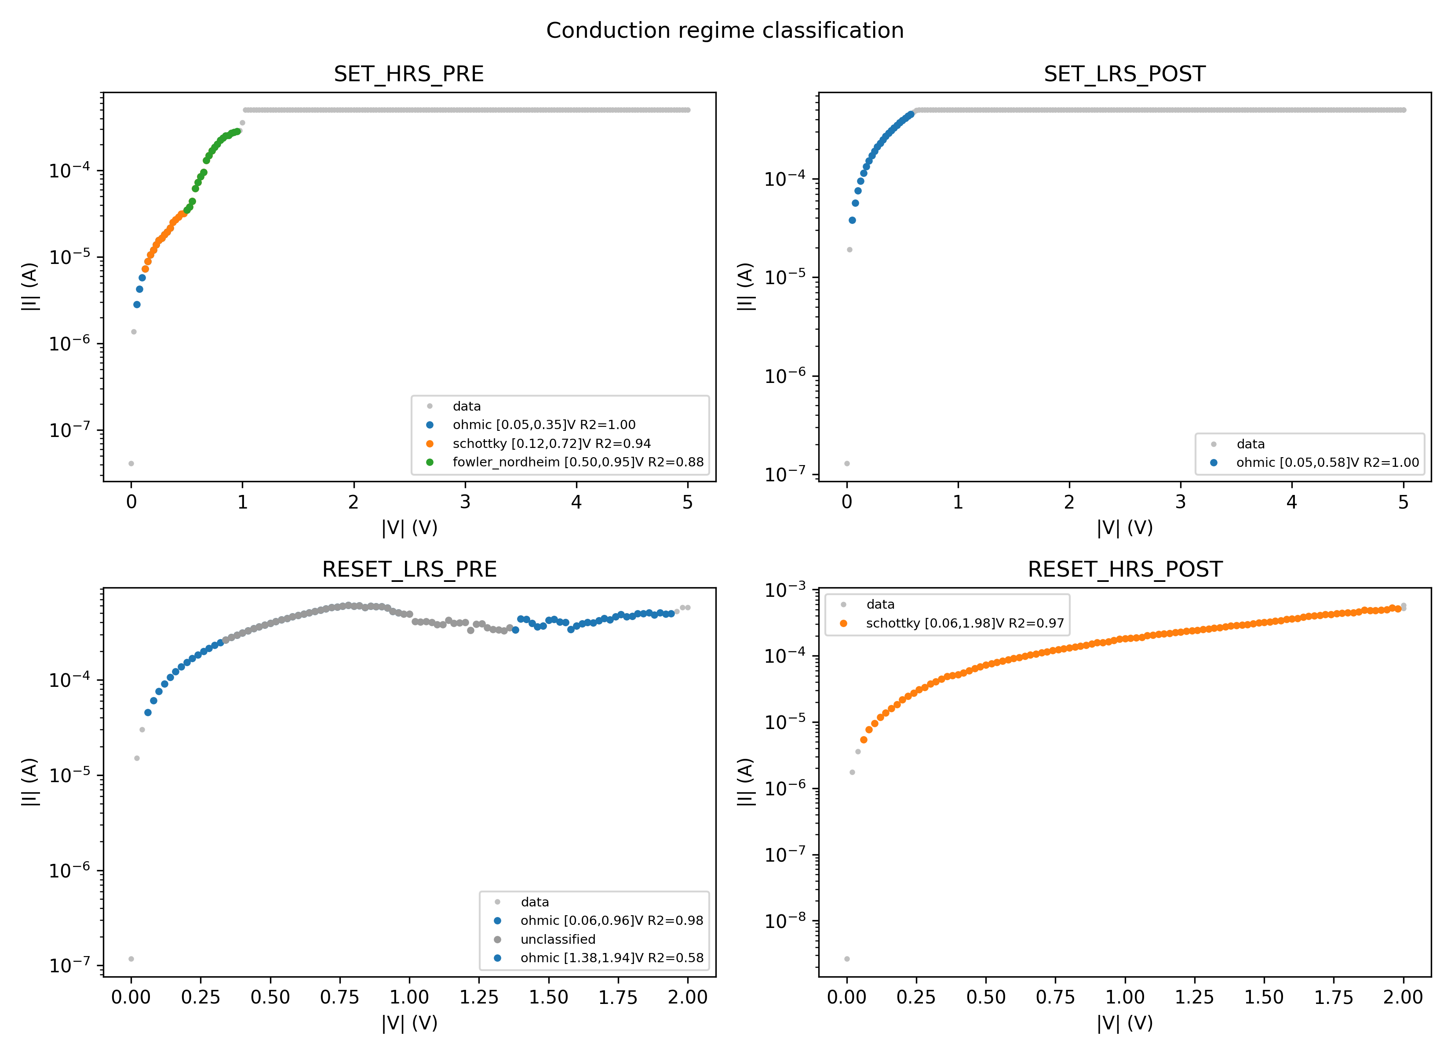  Fig. 1. Conduction-regime classification of the four resistance-state segments of a representative S1 cycle. The two low-resistance (LRS) segments are ohmic (R²≥0.98); the two high-resistance (HRS) segments are Schottky-limited, with a Fowler–Nordheim window near the SET transition. This map tells the fitter where the Stanford bulk current law can and cannot follow the data. | 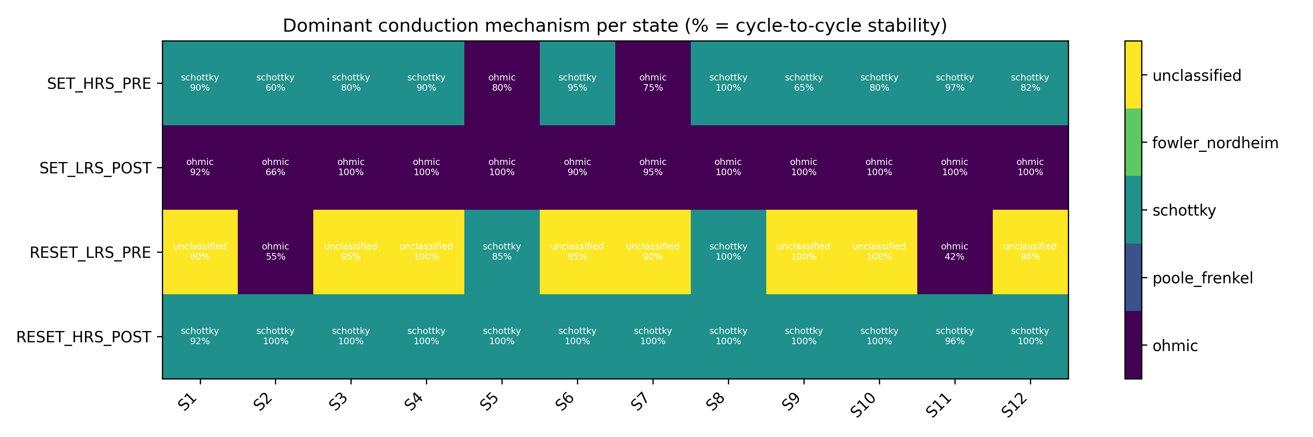  Fig. 2. Dominant conduction mechanism and its cycle-to-cycle stability for every resistance-state segment and all twelve conditions. The post-SET LRS is consistently ohmic; the post-RESET HRS is Schottky-dominant in 92.5–100% of cycles everywhere.
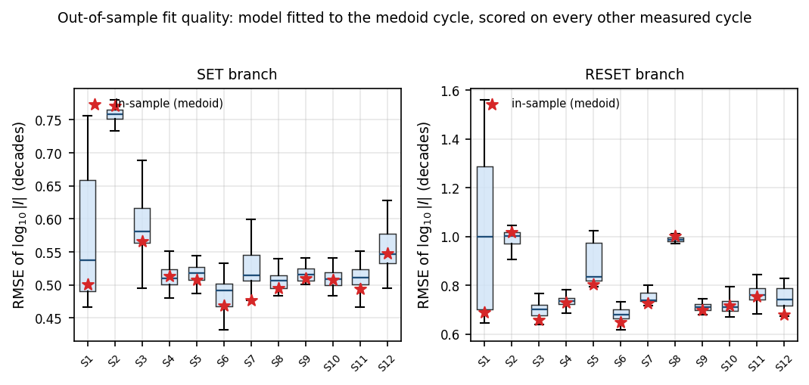  Fig. 3. Out-of-sample test. Box plots show the error (in current decades) when the model fitted to one representative cycle is scored against every other measured cycle of the same device; stars mark the in-sample value. The two are nearly equal — the fit describes the whole device, not just the loop it was trained on. | 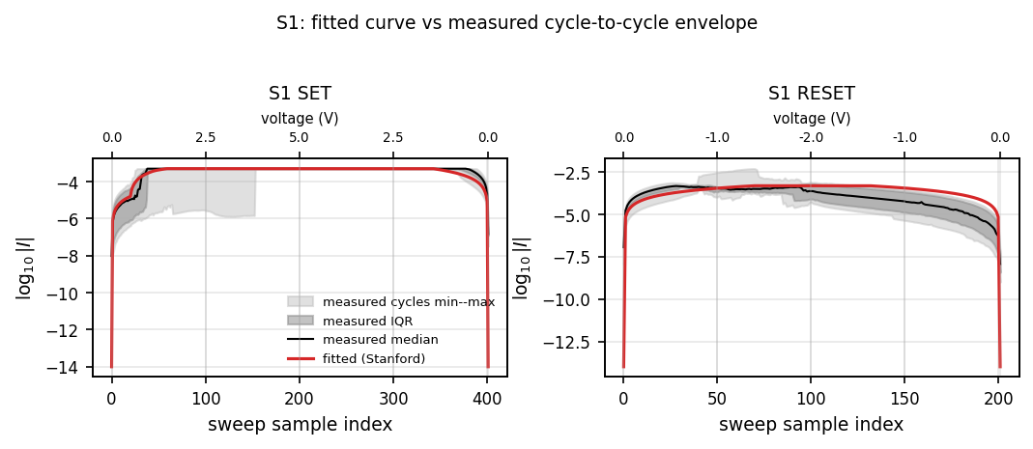  Fig. 4. S1 fitted curve (red) against the measured cycle-to-cycle envelope (min–max and interquartile bands, with the measured median) along the sweep; the secondary axis marks voltage. The fit stays inside the measured spread except at the SET transition and the HRS approach.
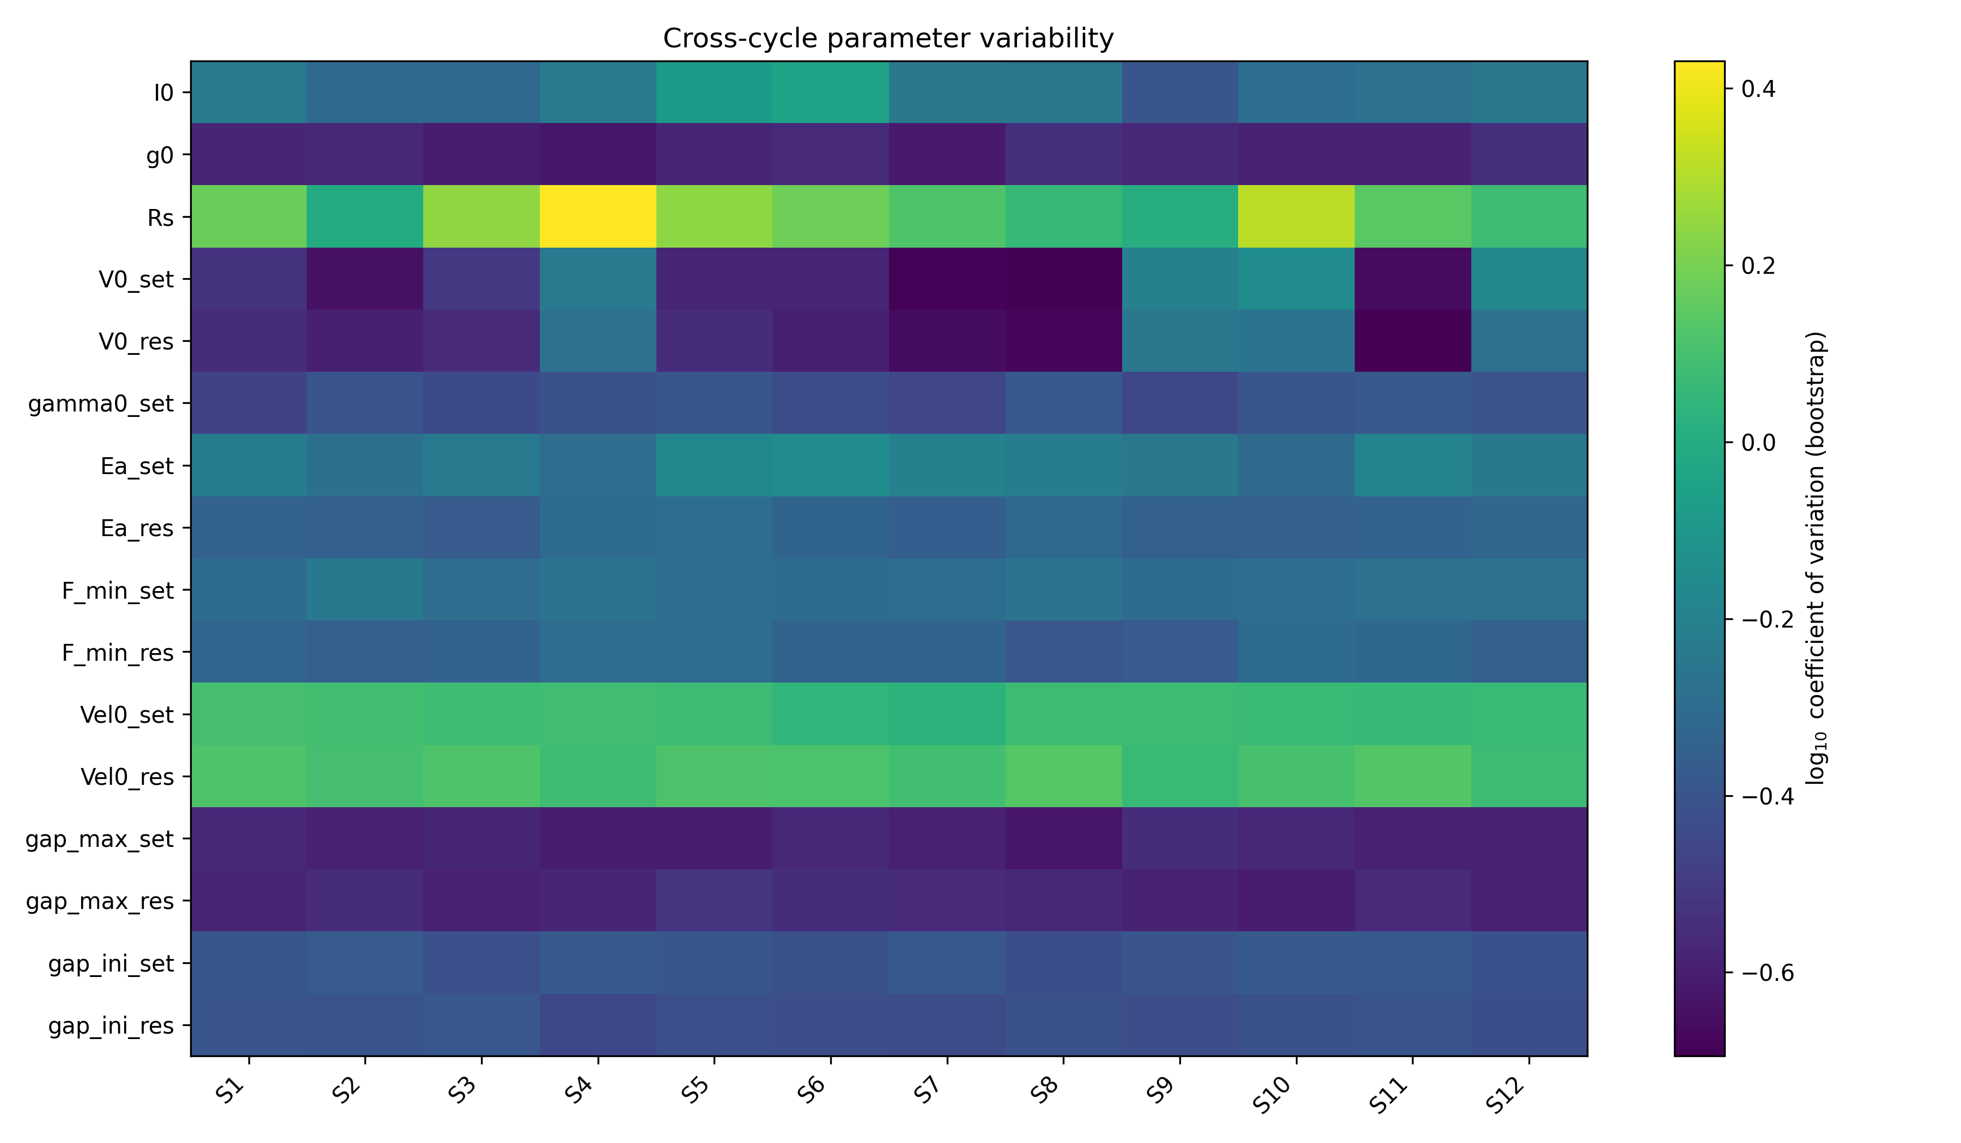  Fig. 5. Repeatability of each fitted parameter across 200 bootstrap refits per condition (color = log of the coefficient of variation; bluer = more repeatable). Branch voltage scales are repeatable; series resistance and the velocity prefactors are not. This is our primary identifiability evidence. | 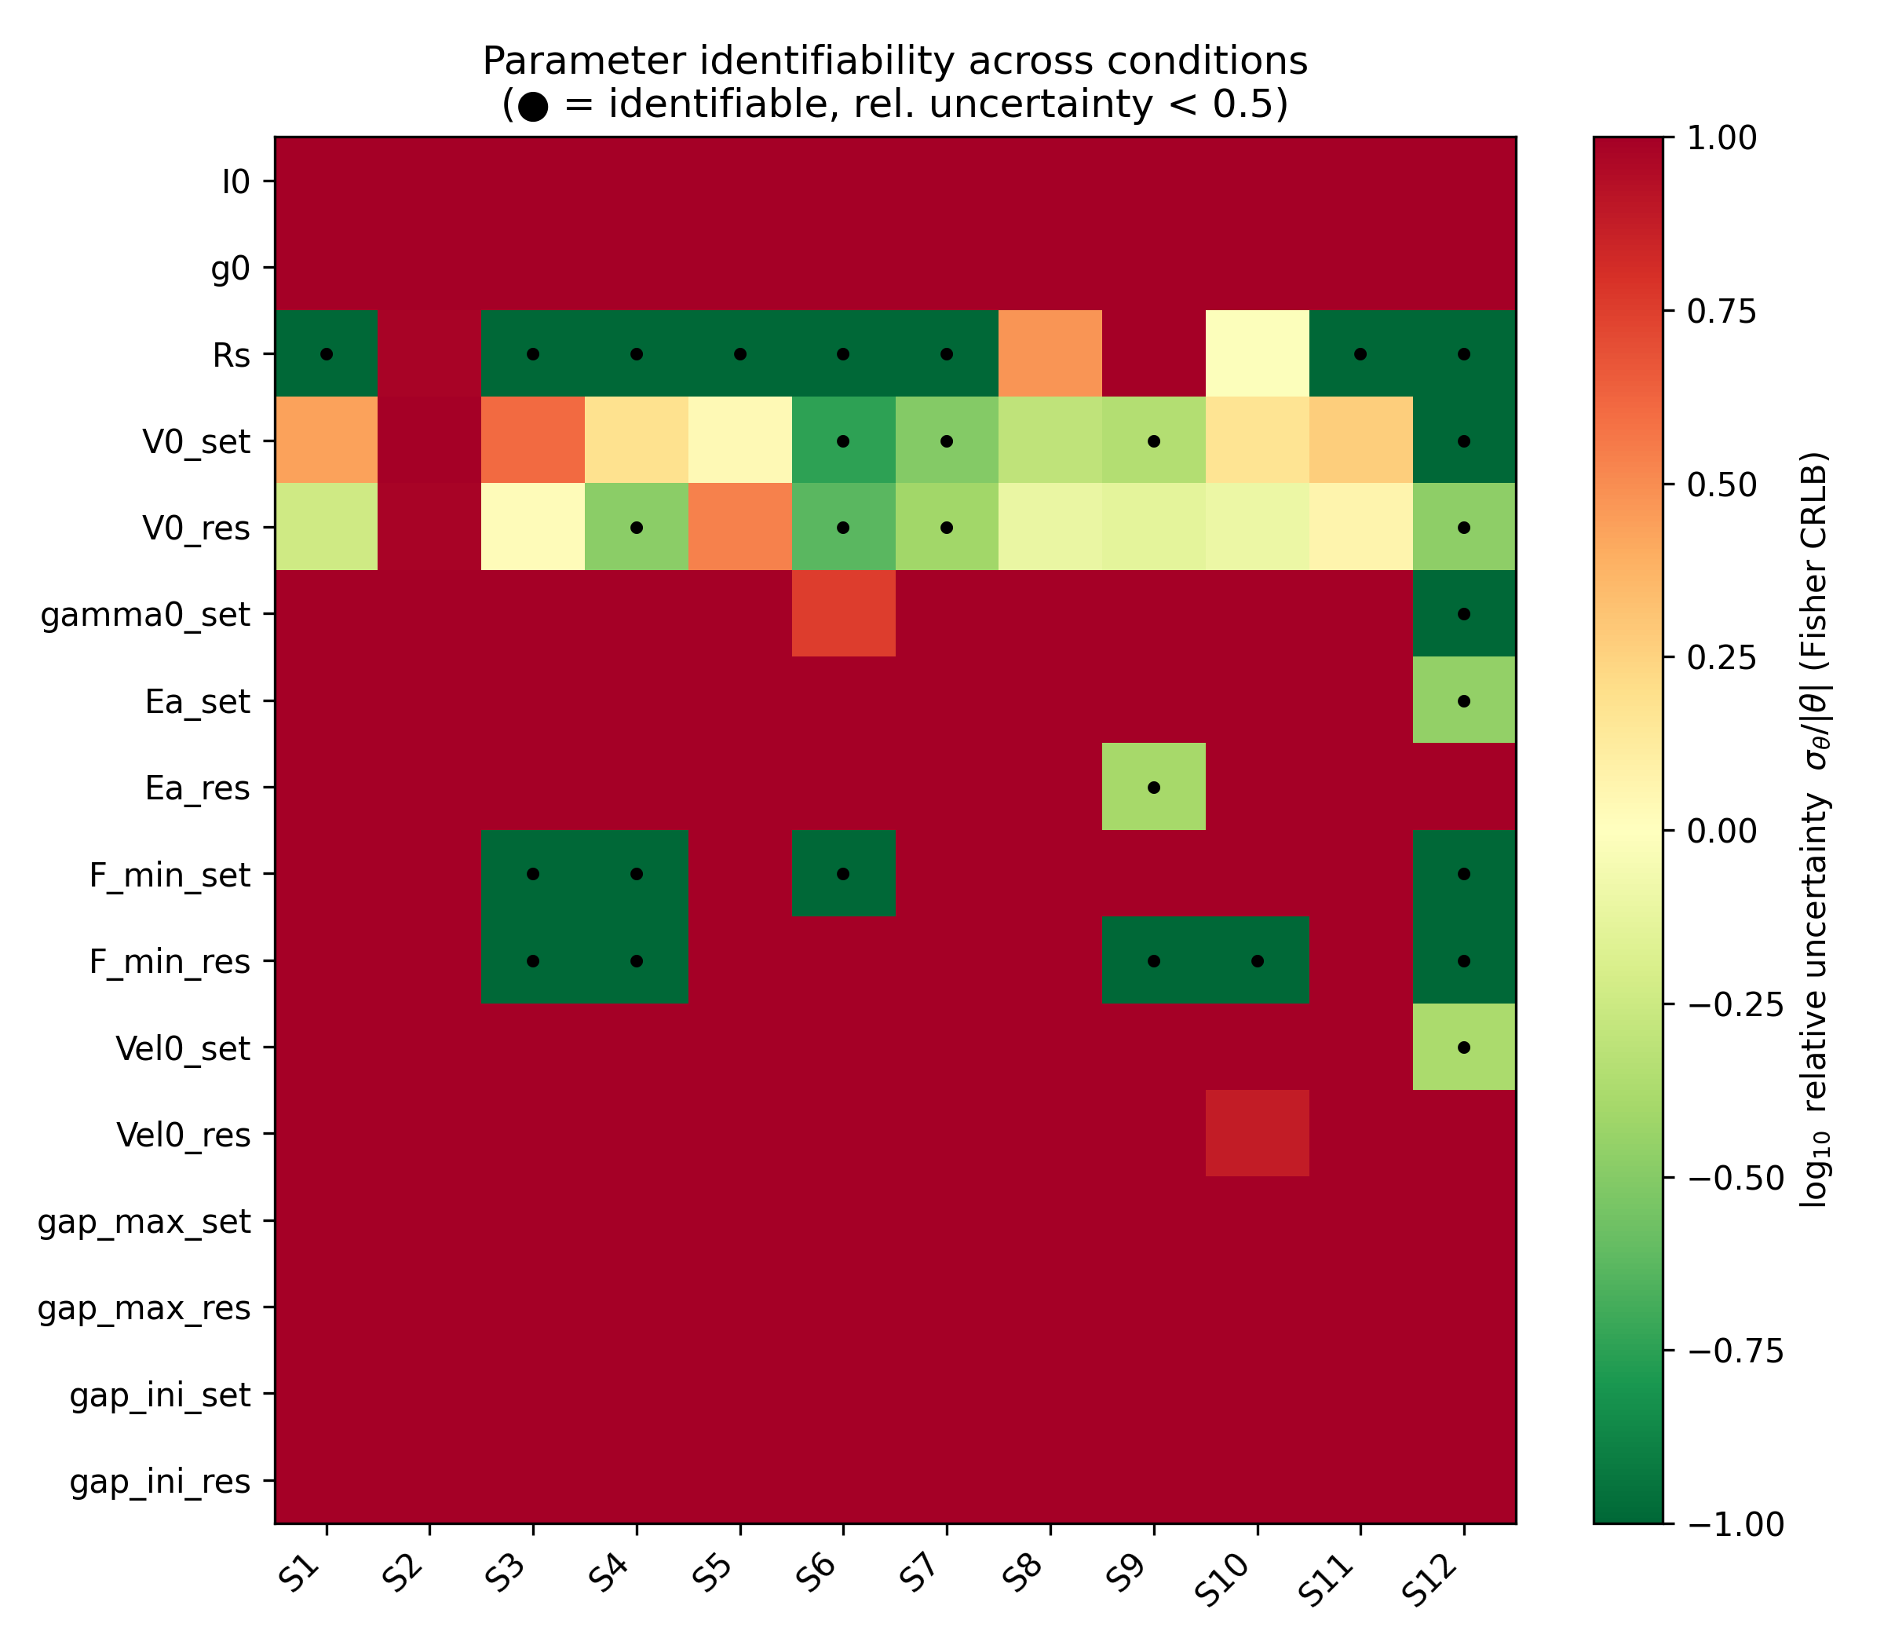  Fig. 6. Local Fisher (one-point sensitivity) relative uncertainty for the 16 active parameters across the twelve conditions, shown only as a cross-check. The extreme condition numbers (10¹⁸–10⁶⁶) prevent certifying individual parameters from this map alone; conclusions are drawn only where it agrees with Fig. 5.
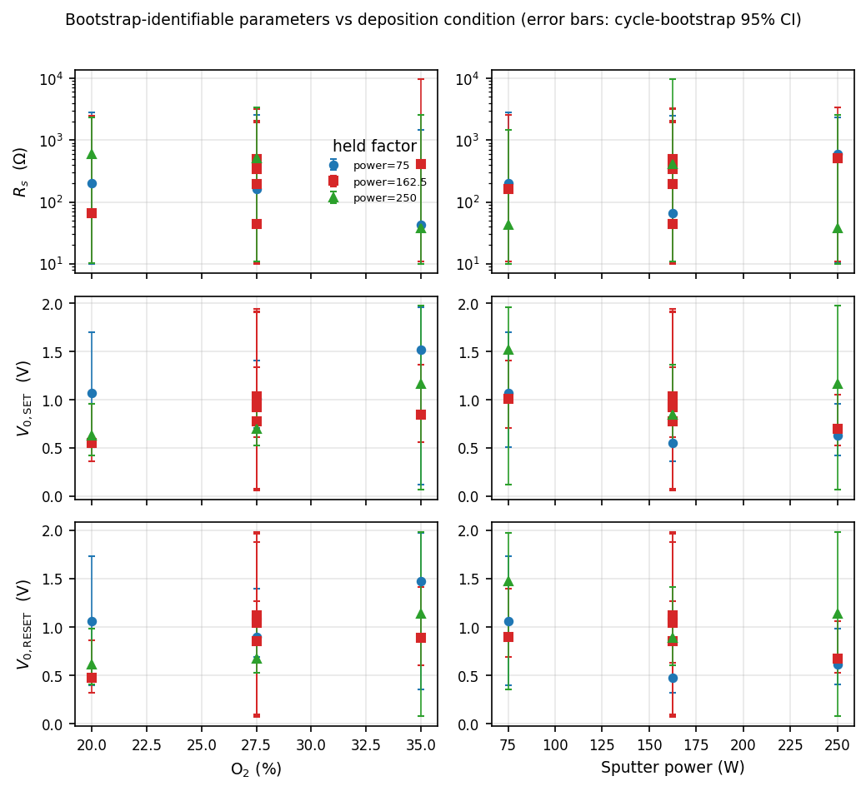  Fig. 7. Process trends for the repeatable parameters (points: bootstrap median; error bars: cycle-bootstrap 95% interval). A formal response-surface test (center points as pure error) finds only the SET voltage scale significant in oxygen and power; series resistance (top) spans up to two decades and is not a process output. | 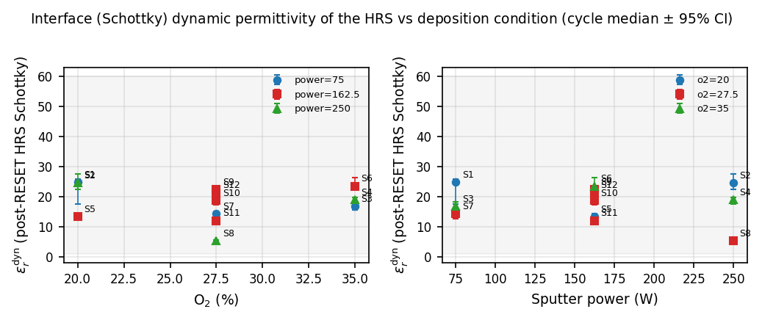  Fig. 8. Effective dielectric constant of the post-RESET Schottky window, now measured on every cycle and shown as the per-condition median with a cycle-bootstrap 95% interval. The shaded band is the physically admissible range; all twelve medians fall inside it, confirming interface-limited HRS conduction across the entire process window.
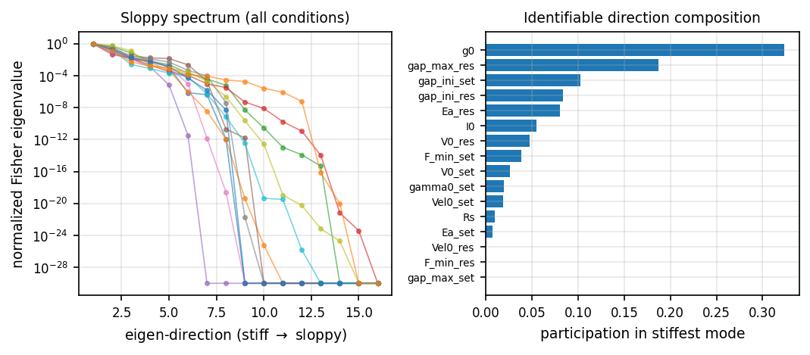  Fig. 9. Sloppiness of the Stanford parameterization. Left: normalized sensitivity (Fisher eigenvalue) spectra for all twelve conditions, falling over tens of decades. Right: how much each parameter participates in the single best-determined direction — a coupled current-scale/gap combination, not any one microscopic parameter. | 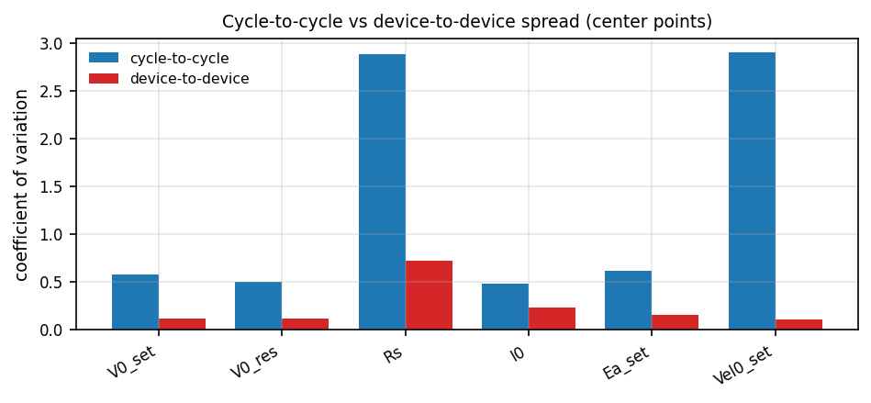  Fig. 10. Cycle-to-cycle vs. device-to-device spread from the four repeated center-point devices (S9–S12). For every parameter the cycle-to-cycle spread dominates, so the scatter among nominally identical devices is mostly cycling, not fabrication.

