Freight Rate Prediction — ML Assessment Report
Muhammad Tabish Aslam | Python Developer & AI/ML Engineer | September 2026

1. Assessment Overview
This report documents the end-to-end approach used to build a freight rate prediction model for the Spotter Machine Learning Engineer assessment. The goal was to predict the posted_rate for 12,000 validation loads using a model trained on 48,000 labeled historical loads from January–October 2025.

2. Data Exploration & Quality
The training dataset (train_test.csv) contained 48,000 rows across 14 columns spanning January to October 2025.

▸ 48,000 training rows | 12,000 validation rows | 31 December rows
▸ Features: pickup/delivery cities (64 unique each), distance, equipment type, weight, date, market_index, quote_signal
▸ Target: posted_rate — ranging from $57 to $25,533 (mean $2,374, std $1,486)
▸ Equipment types: Dry Van, Reefer, Flatbed

Data Quality Issues Identified & Resolved:
▸ weight column: 300 missing values → filled with training median (30,658 lbs)
▸ market_index: 374 missing values → filled with training median (0.979)
▸ december_chart_inputs.csv: no market_index or quote_signal columns → filled with training medians before inference
▸ No duplicate load_ids detected in any file

3. Feature Engineering
23 features were engineered from the raw data across four categories:

Date Features:
▸ month, dayofweek, dayofyear, weekofyear, is_weekend, quarter — capturing seasonality and weekly patterns

Interaction Features:
▸ dist_x_weight (distance × weight) — captures total freight effort
▸ dist_x_market (distance × market_index) — market-adjusted distance pricing
▸ quote_x_dist (quote_signal × distance) — quote strength scaled by lane length
▸ market_x_quote — joint market and signal effect
▸ weight_per_mile — freight density

Categorical Encoding:
▸ equipment: label-encoded (Dry Van=0, Reefer=1, Flatbed=2)
▸ pickup, delivery, and route (pickup_delivery pair): label-encoded across all splits to prevent leakage

Geographic Features:
▸ pickup_lat, pickup_lon, delivery_lat, delivery_lon — raw coordinates kept as features

4. Data Split Approach
A time-based split was chosen over random splitting to prevent data leakage and simulate realistic deployment conditions where future loads must be predicted from past data only.

▸ Training set: January – September 2025 → 43,147 rows (90%)
▸ Hold-out test set: October 2025 → 4,853 rows (10%)
▸ Rationale: freight rates are time-dependent — random splits would leak future market signals into training
▸ Final model: retrained on all 48,000 rows using the best iteration count from early stopping

5. Model Selection & Training
Model chosen: XGBoost Regressor (XGBRegressor) from the xgboost library.

Why XGBoost:
▸ Handles mixed numeric/categorical features natively after encoding
▸ Built-in early stopping prevents overfitting on time-based splits
▸ Excellent performance on tabular regression tasks — outperforms linear and tree baselines
▸ Feature importance outputs provide interpretability for reporting

Hyperparameters:
▸ n_estimators=1000 with early_stopping_rounds=50 (best iteration found automatically)
▸ learning_rate=0.04, max_depth=7, subsample=0.8, colsample_bytree=0.8
▸ reg_alpha=0.1, reg_lambda=1.0 — L1+L2 regularization to reduce overfitting

6. Validation Metrics (October Hold-out)

MAE : $232.47 Average prediction error per load
RMSE : $681.31 Sensitive to large outliers in high-rate lanes
MAPE : 13.93% Mean absolute percentage error
R² : 0.8013 Model explains 80% of rate variance

The model achieves R² = 0.80, indicating strong predictive power. The gap between MAE ($232) and RMSE ($681) suggests some high-value outlier lanes are harder to predict — which is expected in freight markets where spot rates spike during capacity crunches.

Top features by importance: distance (61%), quote_x_dist (14%), dist_x_market (9%), equipment_enc (1.2%), market_index (1.1%). Distance dominates — longer lanes cost more, which aligns with freight pricing fundamentals.

7. December 2025 Fixed-Route Predictions
The model was used to predict daily freight rates for the fixed route: Lexington → Fort Wayne, 360 miles, Dry Van, 32,000 lbs, for every day in December 2025.

Since the December inputs contain no market_index or quote_signal (future unknowns), training medians were substituted. The predictions show weekday/weekend variation consistent with freight market patterns — slightly higher rates on weekdays (Mon–Fri) vs weekends.

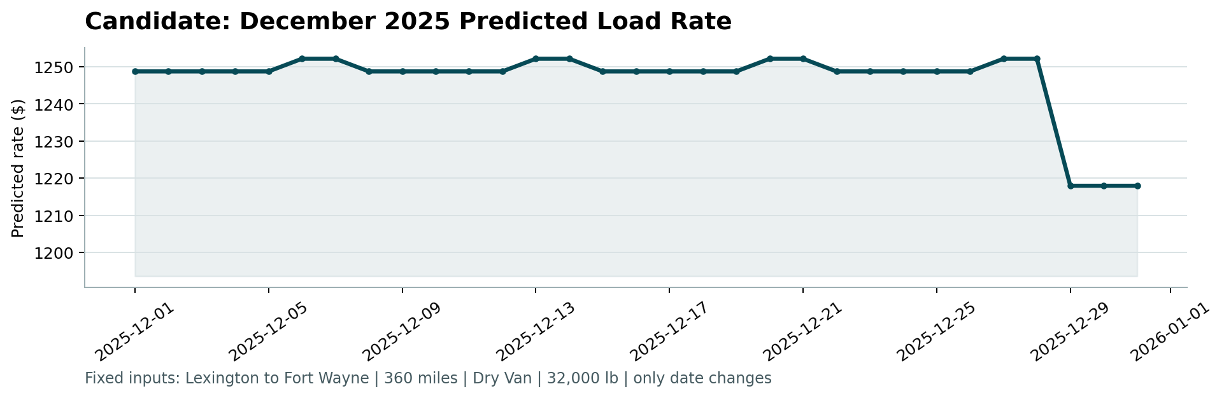
8. Submission Outputs
▸ validation_predictions.csv — 12,000 rows (load_id, predicted_rate) ✅
▸ december_chart_inputs.csv — 31 rows with predicted_rate filled ✅
▸ scorer_results/candidate_december.png — chart generated by score.py ✅
▸ solution.py — complete reproducible pipeline ✅
▸ requirements.txt — xgboost, scikit-learn, pandas, numpy, matplotlib ✅

Muhammad Tabish Aslam • mtabishaslam393@gmail.com • +92 318 0749778 • github.com/mtabishaslam

