Lab 2 Design Record – Group 8

Students: Nabeel Amjad, Tahseen Intesar, Michael Tagg

RTL Viewer

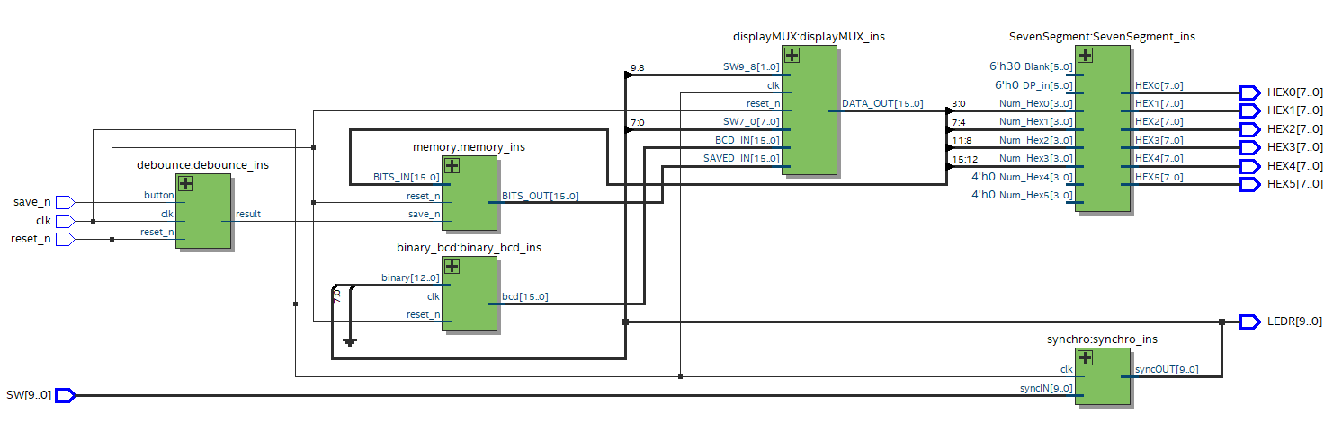

ERRORMESSAGES

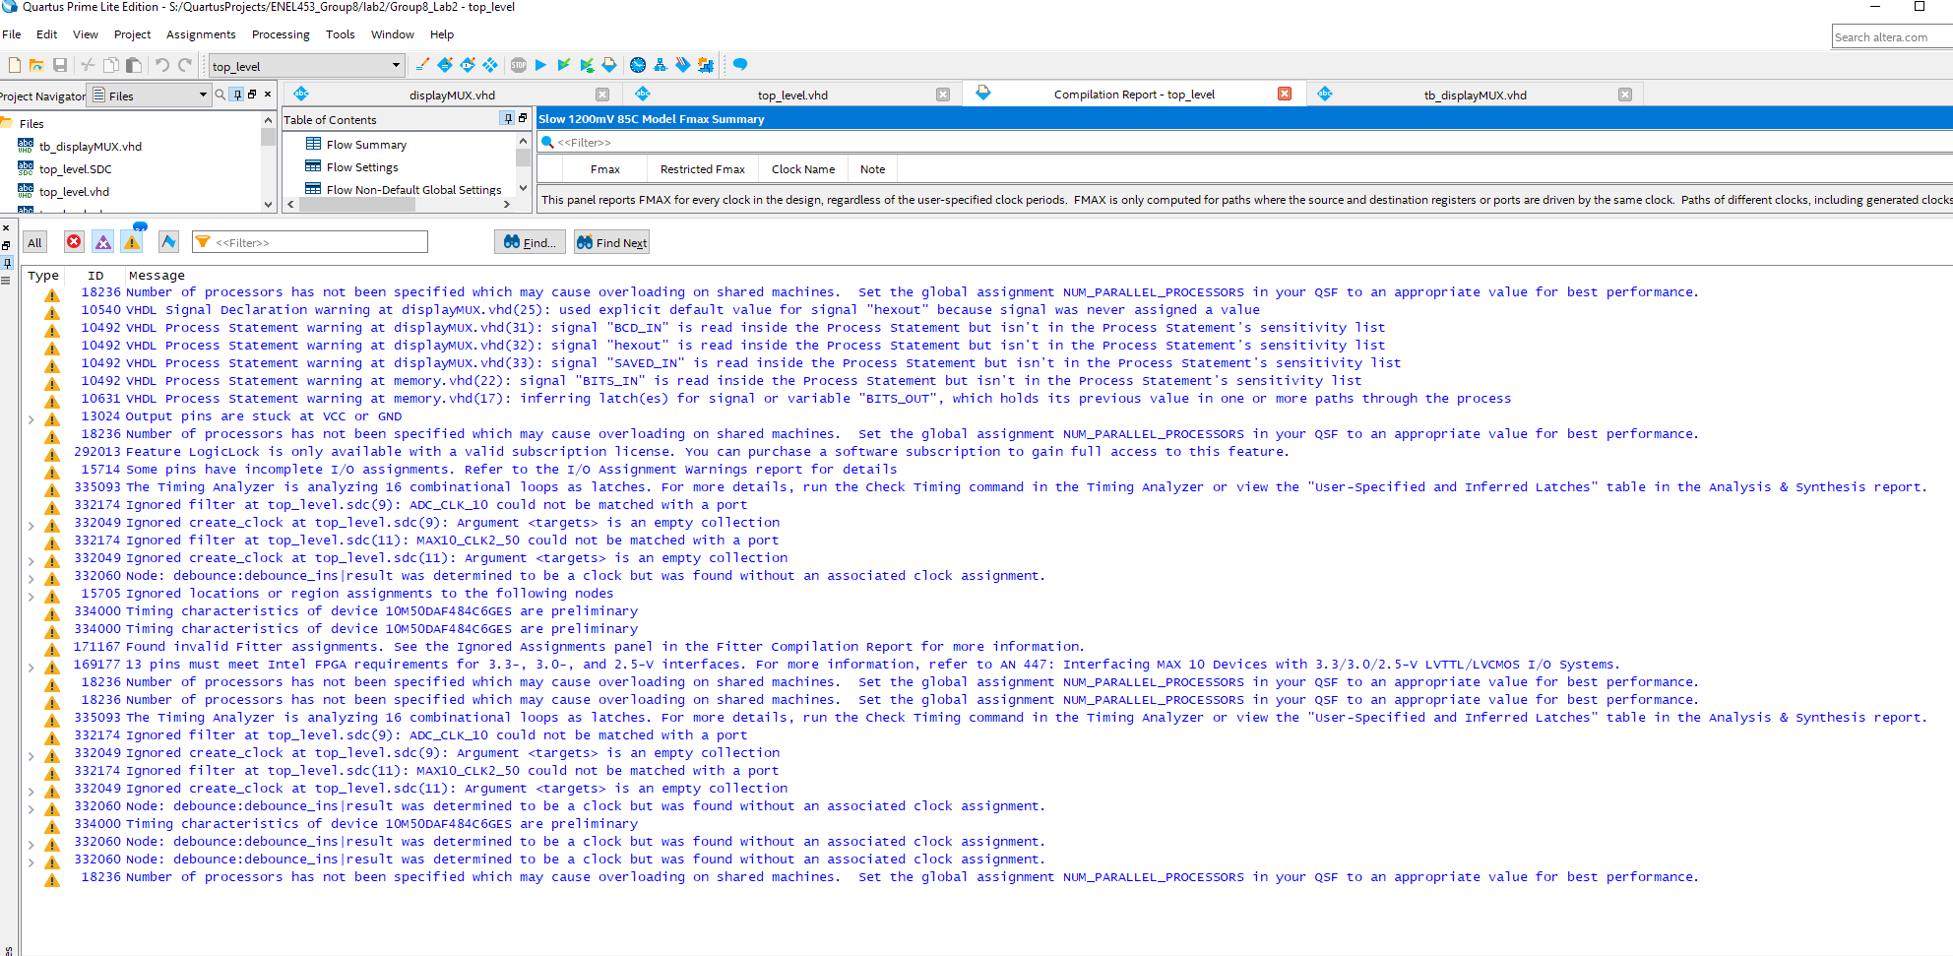

TIMING@85C

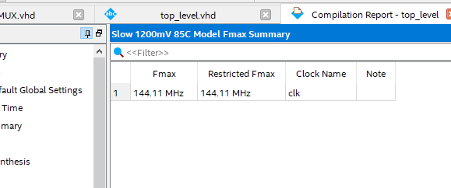

SIMULATIONS

**TOP LEVEL**

**4:1 MULTIPLEXER**

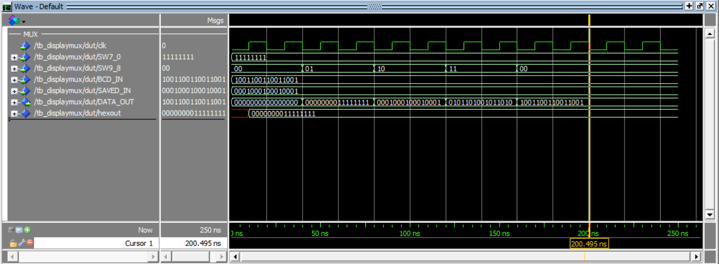

**MEMORY REGISTERS**

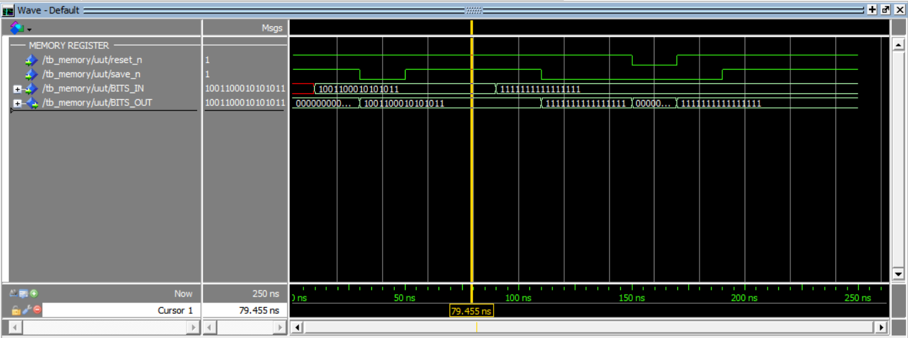

**SYNCHRONIZER**

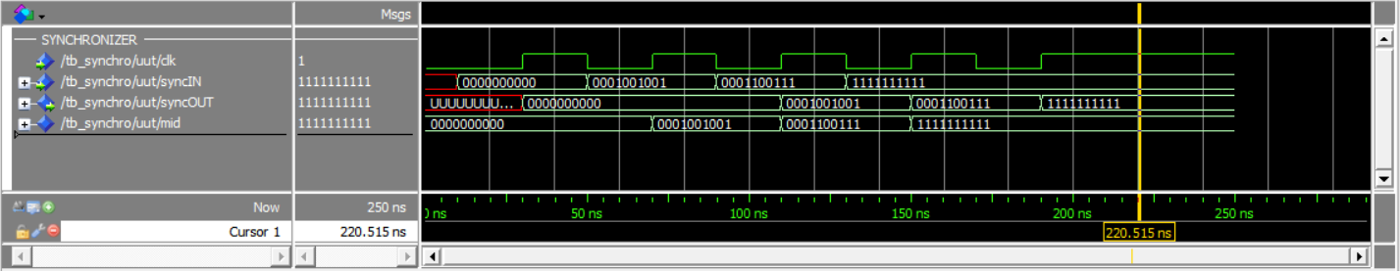

**DEBOUNCER**

