Lab 3 Design Record – Group 8

Students: Nabeel Amjad, Tahseen Intesar, Michael Tagg

RTL Viewer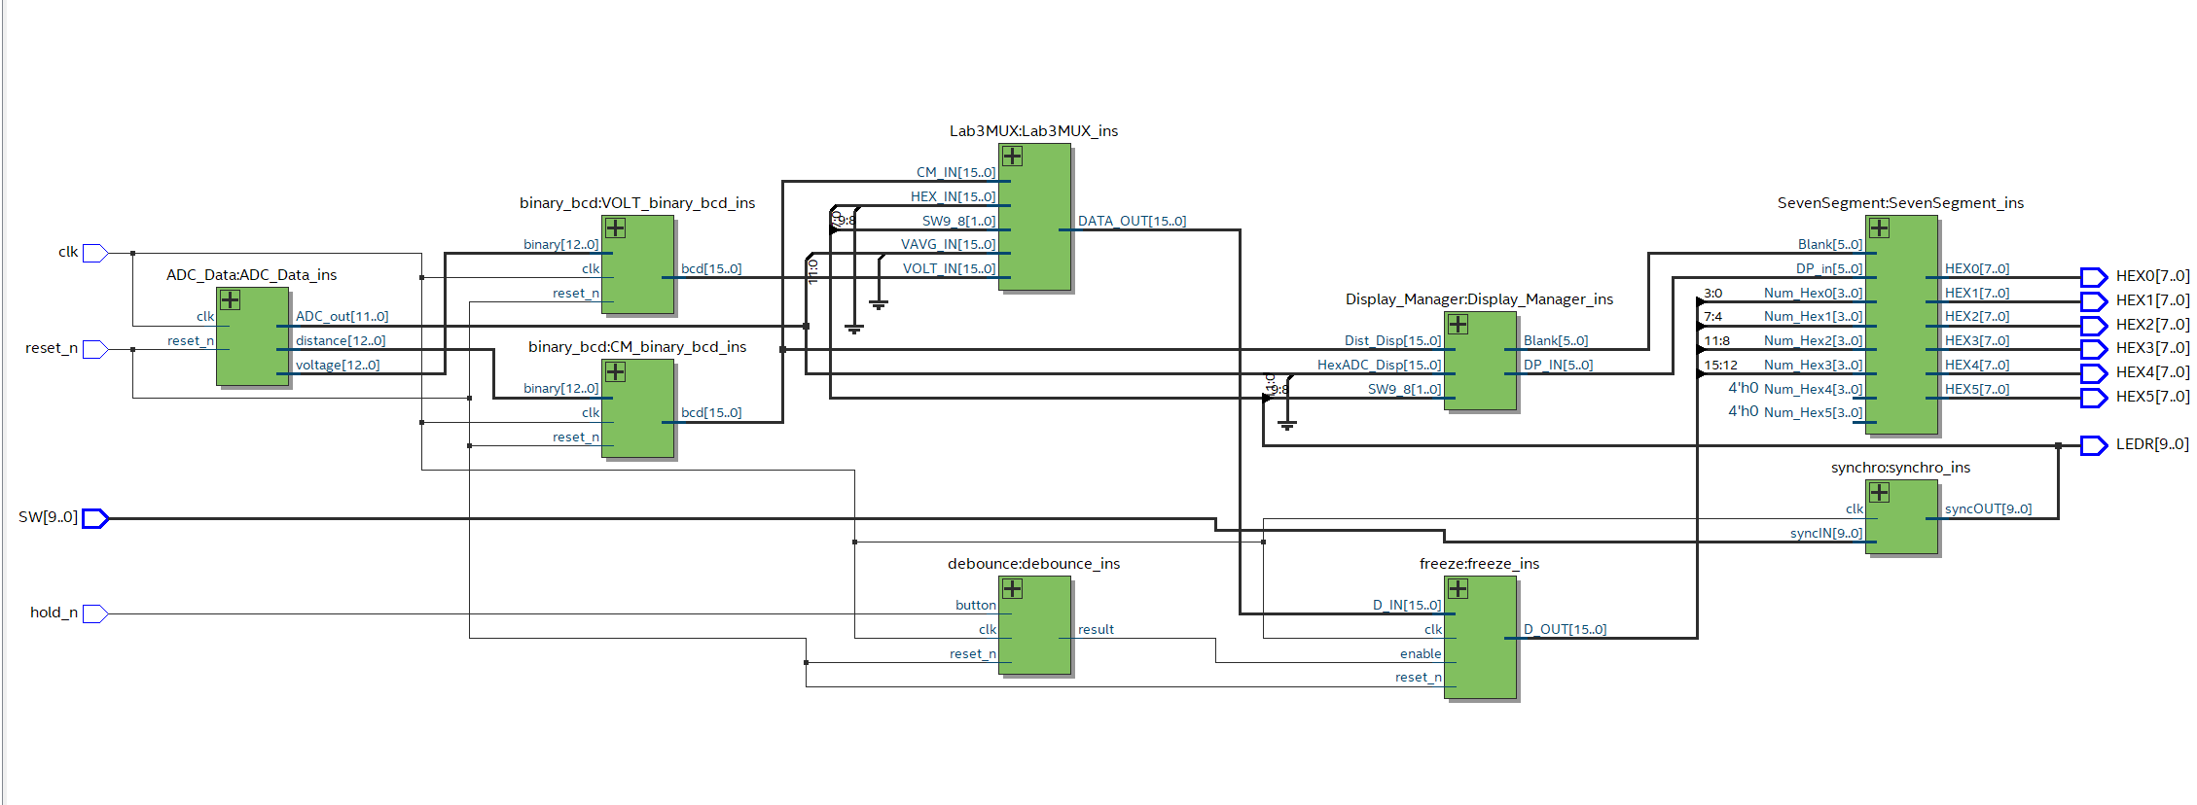

ERRORMESSAGES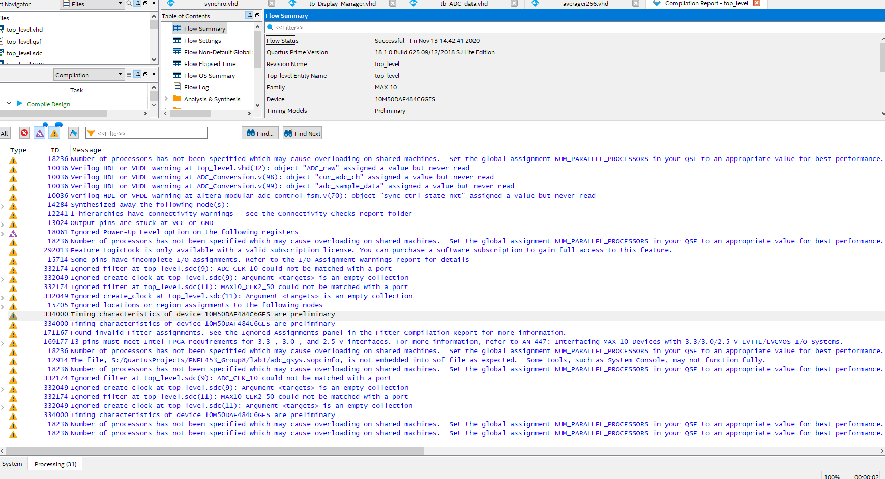TIMING@85C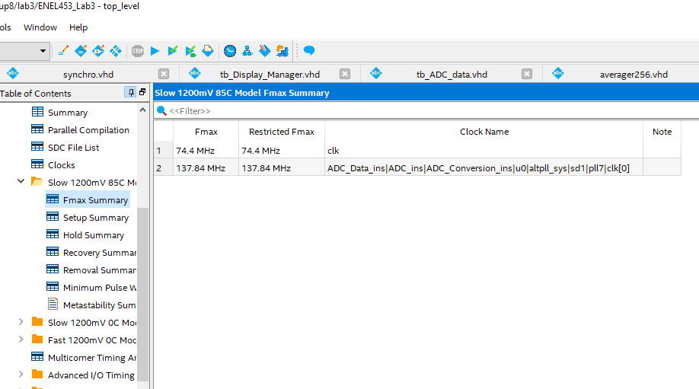

**SIMULATIONS**

**Tb_Top_Level.vhd**

**Tb_Display_Manager.vhd**

**Tb_Lab3mux.vhd**

**Tb_Freeze.vhd**

**Tb_ADC_Data.vhd**

**Tb_Averager256.vhd**