Lab 4 Design Record – Group 8

Students: Nabeel Amjad, Tahseen Intesar, Michael Tagg

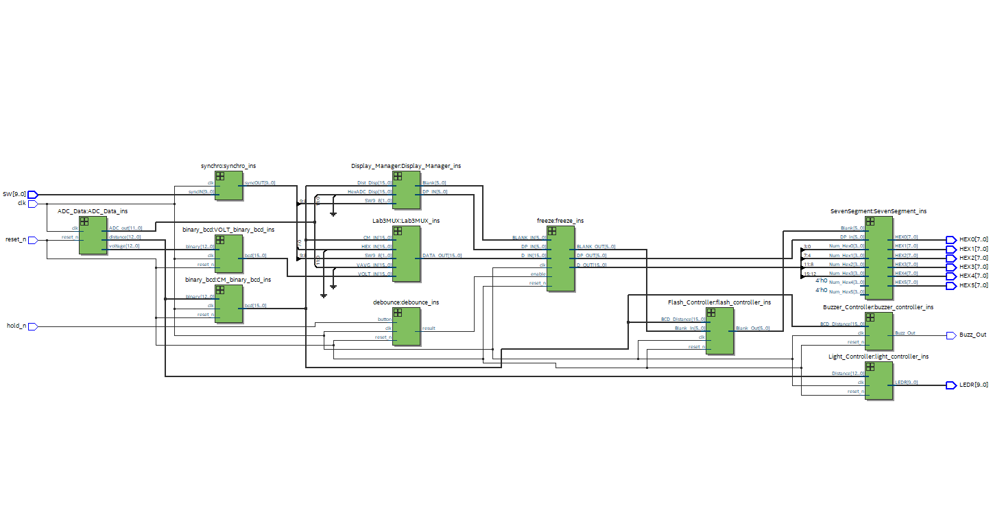**RTL Viewer**

**ERRORMESSAGES**

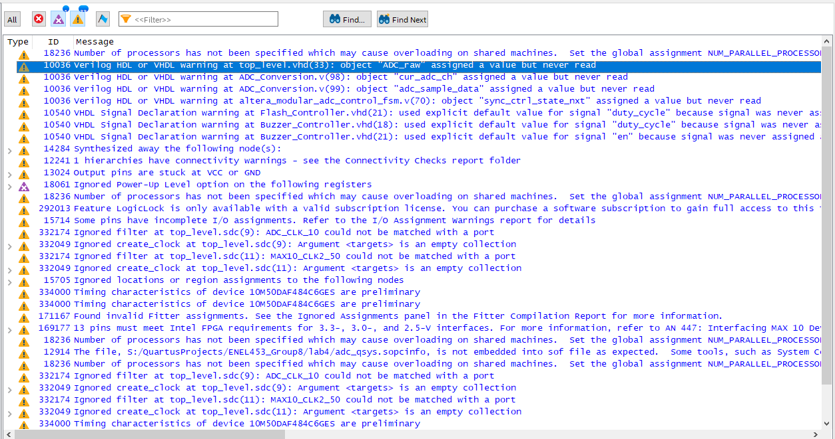

**TIMING@85C**

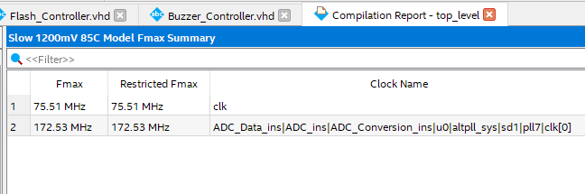

**SIMULATIONS**

**tb_top_level.vhd**

**tb_Display_Manager.vhd**

**tb_Lab3mux.vhd**

**tb_Freeze.vhd**

**tb_ADC_data.vhd**

**tb_averager256.vhd**