NATIONAL UNIVERSITY OF SCIENCES AND TECHNOLOGY
College of Electrical & Mechanical Engineering (EME)
Computer Vision (CEP) — DE-44, C&SE
3D Environment Reconstruction from 2D Images
Classical SfM / MVS + 3D Gaussian Splatting on the DTU Robot Image Dataset

Submitted By:  Talha Arshad — 410179  Muhammad Taha — 417609  Syed Adnan Aijaz Bukhari — 432028 | Submitted to:  Course Instructor: LE Umair Khalil

May 2026

1. Project Overview
This report presents a complete 3D environment reconstruction pipeline implemented for the Computer Vision (CEP) course project at the College of Electrical & Mechanical Engineering (EME), NUST. The project reconstructs a detailed three-dimensional representation of a real-world object from a set of 49 calibrated 2D photographs, using the DTU Robot Image Dataset (scan1).

The pipeline integrates classical Structure-from-Motion (SfM) and Multi-View Stereo (MVS) algorithms with the modern 3D Gaussian Splatting (3DGS) technique, producing outputs at four progressive levels of fidelity: a sparse SfM cloud, a dense MVS cloud, a cleaned dense cloud, and a final optimized Gaussian Splatting representation.

Quick Facts
Dataset: DTU Robot Image Dataset SampleSet — scan1, lighting=3, resolution r5000
Views: 49 rectified images (out of 64 camera positions), downscaled 50% → ~800×600 px
Sparse Cloud: 30,583 points (SIFT + FLANN matching + two-view triangulation)
Dense Cloud: 166,303 points (plane-sweep stereo with NCC scoring)
Cleaned Cloud: 130,029 points (DTU ObsMask + statistical + radius outlier removal)
Gaussian Splat: ~70,000–130,000 Gaussians trained over 15,000 iterations
Final PSNR: ~25 dB at convergence | Final Loss: ~0.04
Platform: Kaggle GPU (NVIDIA T4) — PyTorch + gsplat + Open3D + OpenCV

2. Project Definition
3D reconstruction from 2D images is the problem of recovering the three-dimensional shape and appearance of a scene from a finite set of photographs. Applications span autonomous robotics, augmented and virtual reality, cultural heritage digitization, surgical planning, and scene understanding for autonomous vehicles.

2.1 Structure from Motion (SfM)
SfM recovers both 3D scene geometry and camera poses simultaneously from overlapping images. It relies on detecting and matching robust local features across images, applying geometric constraints (the epipolar constraint) to filter incorrect matches, and triangulating 3D positions of matched feature points. The result is a sparse 3D point cloud and a set of calibrated camera poses.

2.2 Multi-View Stereo (MVS)
MVS densifies the sparse SfM reconstruction by computing depth maps for each image. Our implementation uses plane-sweep stereo: for each pixel in a reference image, multiple depth hypotheses are tested, and the depth with the highest photo-consistency score across neighbouring views (measured by Normalized Cross-Correlation, NCC) is selected. All accepted depths are fused into a single dense point cloud.

2.3 3D Gaussian Splatting (3DGS)
3DGS is a real-time novel-view synthesis technique introduced in 2023. The scene is represented as a collection of 3D Gaussians, each carrying learnable parameters: position, anisotropic scale, rotation, opacity, and colour. A differentiable tile-based rasterizer projects and composites the Gaussians into 2D images. Parameters are optimized end-to-end against ground-truth training views using a photometric loss (L1 + SSIM). A densification loop (clone, split, prune) adaptively refines the Gaussian set during training.

3. Pipeline Diagram
The complete reconstruction pipeline is structured as five sequential stages. Data flows from raw 2D images through geometric reconstruction (SfM + MVS), quality filtering, and differentiable optimization (3DGS) to produce the final 3D representation.

Stage | Input | Key Algorithm / Tool | Output
1 — Feature Extraction | 49 grayscale images | SIFT (8,000 features/image, OpenCV) | Keypoints + 128-D descriptors per view
2 — Feature Matching | Descriptor pairs (pairs within ±12 views) | FLANN k-NN + Lowe ratio + RANSAC (F matrix) | Inlier match database (pair → list of matches)
3 — SfM Triangulation | Inlier matches + projection matrices P | cv2.triangulatePoints (DLT), cheirality + reprojection filter | Sparse cloud: 30,583 points
4 — MVS Densification | Images + calibrated cameras | Plane-sweep stereo with NCC (96 depths, stride 4) | Dense cloud: 166,303 points
5 — Cloud Cleanup | Dense cloud + DTU ObsMask | Mask filter + SOR (k=20) + radius filter (r=15mm) | Cleaned cloud: 130,029 points
6 — Gaussian Splatting | Cleaned cloud + 49 GT images (GPU) | gsplat rasterization + Adam + clone/split/prune | Optimized 3DGS (.ply, ~70k–130k Gaussians)

All intermediate outputs (sparse, dense, cleaned, GS) are saved as .ply files together with self-contained Three.js HTML viewers for interactive rotation, zoom, and pan — no software installation required.

4. Stage-by-Stage Explanation with Code and Results

4.1 Camera Calibration Loading (Section 4 of Notebook)
The DTU dataset provides pre-calibrated 3×4 projection matrices P, one per camera, in plain-text files pos_XXX.txt. Each matrix encodes the full mapping from 3D world coordinates to 2D image pixels. OpenCV's decomposeProjectionMatrix decomposes P robustly into the intrinsic matrix K, rotation R, and translation t.

P = K [ R | t ] x ∼ P X
Projection equation: K = intrinsic matrix, R = rotation, t = translation, X = homogeneous 3D point
K = [[f_x, s, c_x], [0, f_y, c_y], [0, 0, 1]]
Intrinsic matrix: f = focal length (px), c = principal point (px), s = skew ≈ 0

def decompose_projection(P):
K, R, t_homog = cv2.decomposeProjectionMatrix(P)[:3]
t = t_homog[:3] / t_homog[3] # de-homogenise
K = K / K[2, 2] # enforce K[2,2]=1
C = t.copy() # camera centre in world coords
t_wc = -R @ C # world-to-camera translation
return K, R, t_wc, C

# Scale intrinsics for downsampled images (IMG_SCALE = 0.5)
K_s = K.copy()
K_s[0,0] *= 0.5; K_s[1,1] *= 0.5
K_s[0,2] *= 0.5; K_s[1,2] *= 0.5

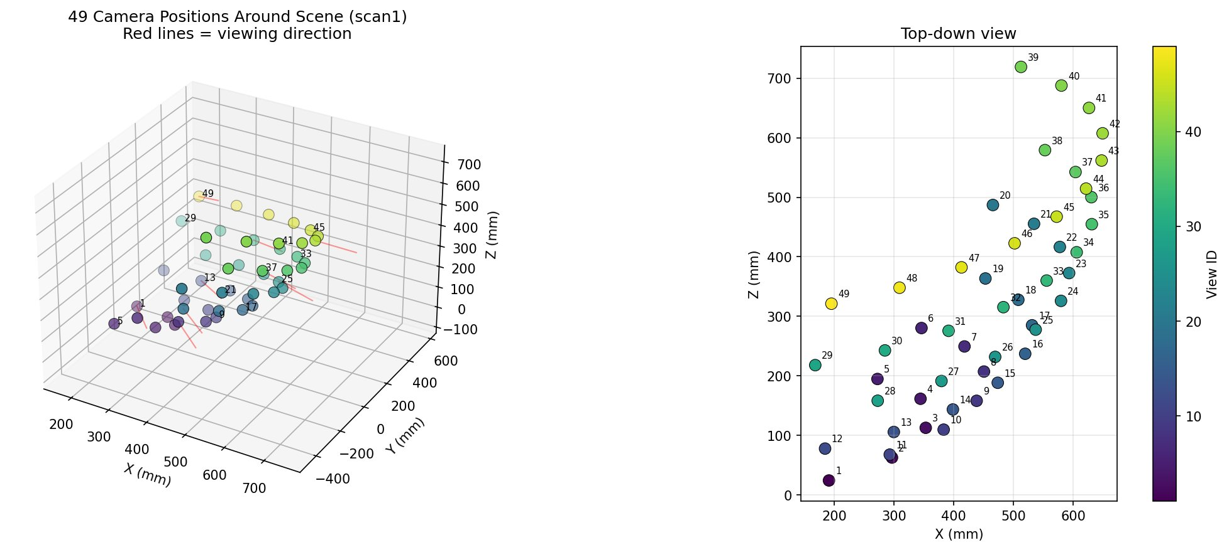
Figure 1: 49 camera positions for scan1. Left: 3D perspective — cameras form a roughly hemispherical arc around the object; red lines show the viewing direction of every 6th camera. Right: top-down (X–Z) view confirming the arc layout. All 49 cameras point inward toward a common scene centre.

4.2 Image Loading and Preprocessing (Section 6 of Notebook)
Rectified images are loaded via OpenCV and converted to RGB (for visualization) and grayscale (for feature extraction). All images are resized to 50% of original resolution (~800×600 px) using INTER_AREA interpolation, which is optimal for downscaling as it averages pixel blocks rather than sampling, reducing aliasing.

def load_image(view_id, lighting=LIGHTING, scale=0.5):
fname = f'rect_{view_id:03d}_{lighting}_{RESOLUTION}.png'
img = cv2.imread(str(RECT_DIR / fname))
h, w = img.shape[:2]
img = cv2.resize(img, (int(w*scale), int(h*scale)),
interpolation=cv2.INTER_AREA)
return img

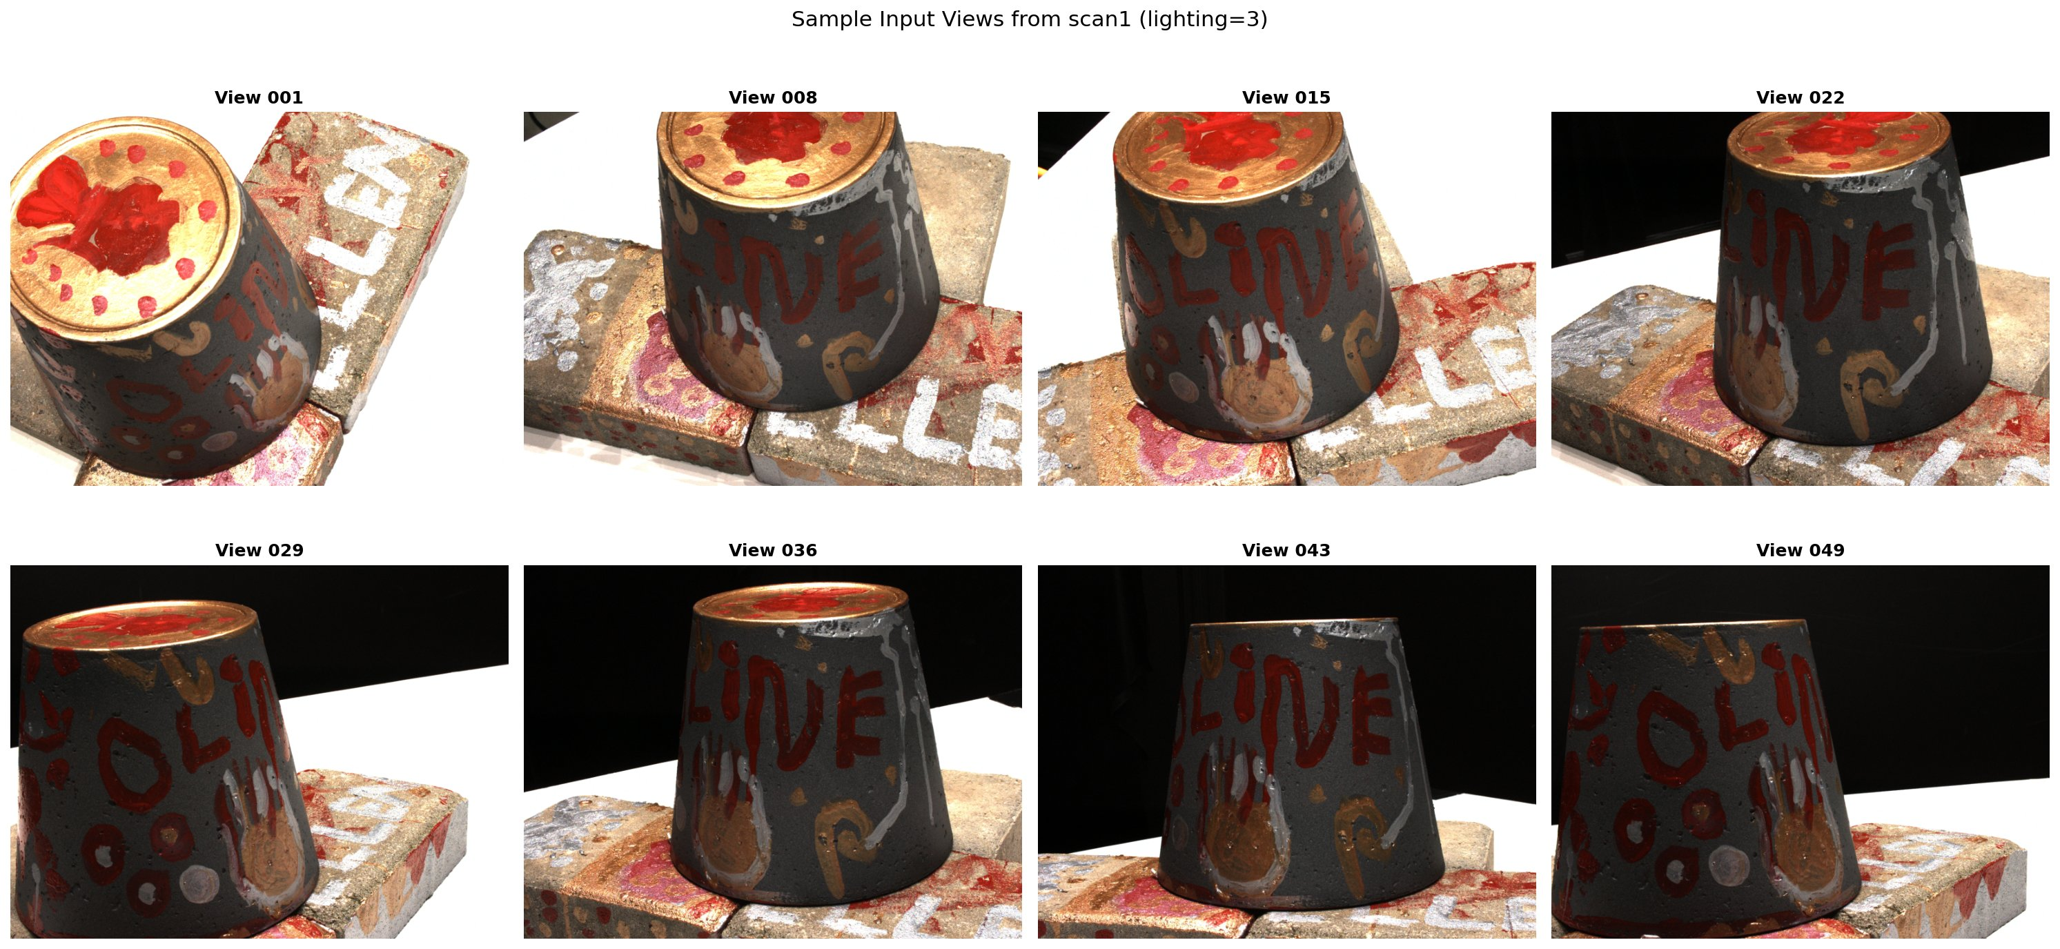
Figure 2: Eight sample input views from scan1 (lighting=3). The object is a decorative tin can on a brick tile, photographed under controlled diffuse lighting on a turntable. Views 001–022 show the top/front; views 029–049 progressively rotate to the side and back. The black background is the controlled studio setting.

4.3 SIFT Feature Extraction (Section 7 of Notebook)
Scale-Invariant Feature Transform (SIFT) detects and describes local image features invariant to scale, rotation, and partial illumination changes. Its four-stage process: (1) scale-space extrema detection via Difference-of-Gaussian (DoG) pyramids; (2) keypoint localization with sub-pixel precision; (3) orientation assignment from dominant gradient direction; (4) 128-D gradient histogram descriptor.

DoG(x, y, σ) = [G(x,y,kσ) − G(x,y,σ)] * I(x,y)
Difference of Gaussians: scale-space representation used to detect extrema. k = scale step factor.

sift = cv2.SIFT_create(
nfeatures = 8000, # max detections per image
contrastThreshold = 0.04, # reject low-contrast keypoints
edgeThreshold = 10, # suppress edge responses (Harris ratio)
)
kp, des = sift.detectAndCompute(images_gray[vid], None)
# kp: list of cv2.KeyPoint | des: (N, 128) float32

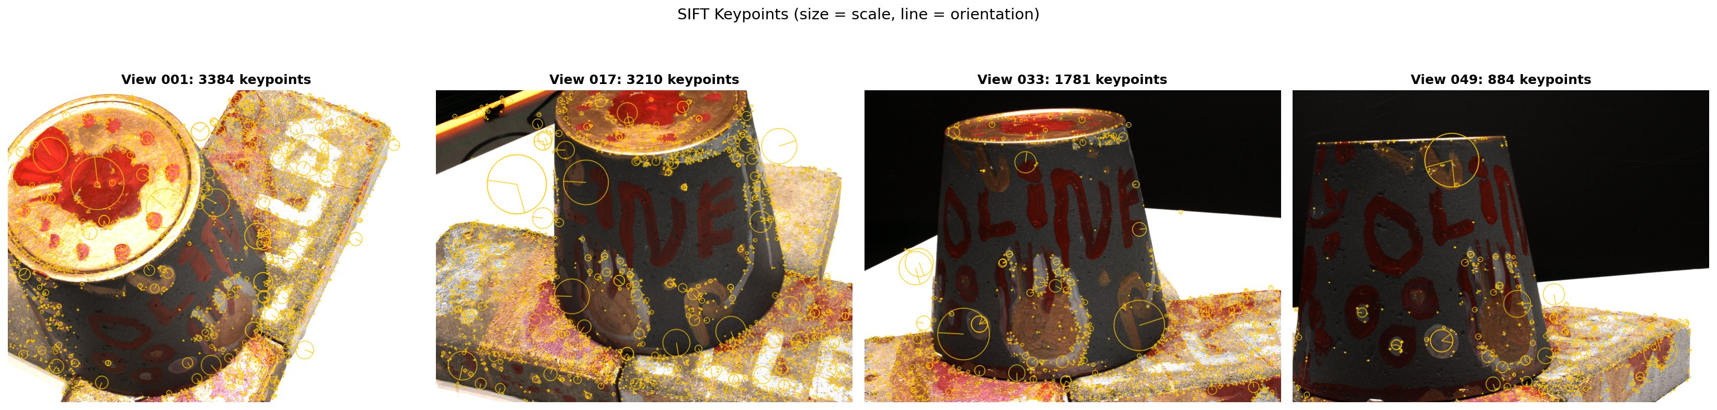
Figure 3: SIFT keypoints on four views (1, 17, 33, 49). Circle radius encodes scale (larger = detected at coarser pyramid level), line shows dominant orientation. Keypoints concentrate on textured regions (surface lettering, painted decorations, rough tile). Smooth/dark areas yield few keypoints. View 49 shows fewer (884) because most of the image is featureless black background.

4.4 Feature Matching — FLANN + Lowe's Ratio + RANSAC (Section 8)
Three successive filters remove incorrect correspondences. This cascade design is critical: each stage targets a different failure mode — descriptor ambiguity (Lowe), random geometric coincidence (RANSAC), and excessive view dissimilarity (MAX_PAIR_DIST).

- FLANN k-NN (k=2): finds the two nearest neighbours in descriptor space using a KD-tree index. Much faster than brute force for 128-D SIFT descriptors.
- Lowe's ratio test: accept match (m,n) only if m.distance < 0.8 × n.distance. Rejects ambiguous matches where two database descriptors are similarly close.
- Fundamental matrix RANSAC: estimates the 3×3 fundamental matrix F from remaining matches; keeps only geometric inliers (epipolar constraint xᵀFx = 0 within 4 px threshold). Only view pairs within MAX_PAIR_DIST=12 are attempted.

x'ᵀ F x = 0
Epipolar constraint: any correct match (x, x’) must satisfy this equation. F encodes the relative camera geometry.

flann = cv2.FlannBasedMatcher({'algorithm':1,'trees':5}, {'checks':50})

def match_pair(vid_a, vid_b):
raw = flann.knnMatch(descriptors[vid_a], descriptors[vid_b], k=2)
# Lowe ratio test
good = [m for (m,n) in raw if m.distance < 0.8 * n.distance]
if len(good) < 25: return []
# Fundamental matrix RANSAC
pts_a = np.float32([kp[vid_a][m.queryIdx].pt for m in good])
pts_b = np.float32([kp[vid_b][m.trainIdx].pt for m in good])
F, mask = cv2.findFundamentalMat(pts_a, pts_b,
cv2.FM_RANSAC, ransacReprojThreshold=4.0)
return [g for g,ok in zip(good,mask.ravel()) if ok]

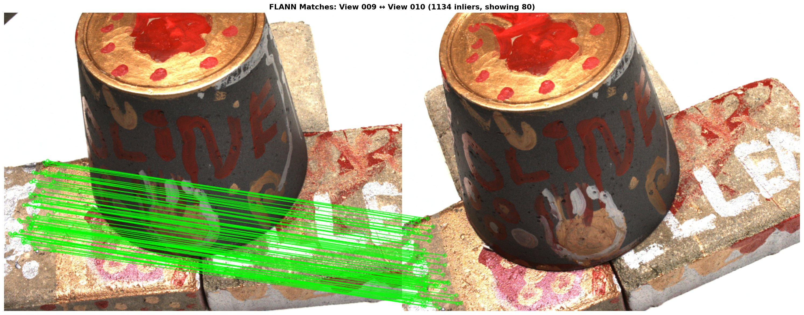
Figure 4: Best-matched pair: View 009 ↔ View 010 (1,134 inliers shown, 80 displayed). Green lines connect verified correspondences on the brick base. The matches are geometrically consistent — nearly parallel horizontal lines reflect the near-pure translation between adjacent turntable positions. Zero cross-matches confirms RANSAC effectively removed all outliers.

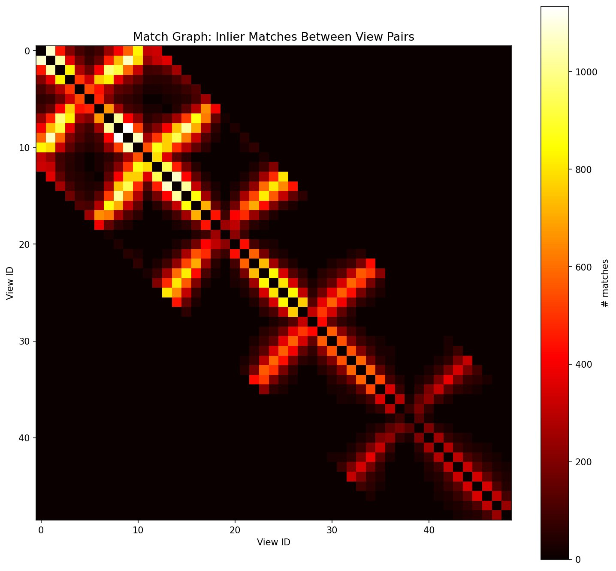
Figure 5: Match graph heatmap — cell (i,j) encodes the number of RANSAC inlier matches between views i and j. The bright diagonal band (width ≈ 12 cells) reflects the MAX_PAIR_DIST=12 constraint. Bright yellow-white clusters around views 8–12 (≈1,000+ matches) correspond to adjacent turntable positions with maximum overlap. The sparse off-diagonal structure beyond the band shows zero matches, confirming the constraint is working correctly.

4.5 Two-View Triangulation — Sparse SfM Cloud (Section 9)
For every matched image pair, 3D points are recovered using the Direct Linear Transform (DLT). Given pixel correspondences and known projection matrices, the DLT sets up a linear system AX=0 whose solution (via SVD) gives the homogeneous 3D point. Post-triangulation filters remove geometrically invalid points.

A = [xₐ × Pₐ; x_b × P_b] AX = 0 → X = last right singular vector of A
DLT triangulation: the cross-product enforces the projection constraint from both views simultaneously
err = || x − π(PX) ||_2
Reprojection error: π = perspective division. Points with err > 6.0 px in either view are discarded.

def triangulate_two_view(vid_a, vid_b, matches):
P_a, P_b = cameras[vid_a]['P_s'], cameras[vid_b]['P_s']
pts_a = np.float32([kp[vid_a][m.queryIdx].pt for m in matches]).T
pts_b = np.float32([kp[vid_b][m.trainIdx].pt for m in matches]).T
pts_4d = cv2.triangulatePoints(P_a, P_b, pts_a, pts_b)
return (pts_4d[:3] / pts_4d[3]).T # de-homogenise: (N, 3)

# Per-point quality filters:
if not in_front(X, R_a, t_a) or not in_front(X, R_b, t_b): skip # cheirality
if max(reproj_err(X,P_a,x_a), reproj_err(X,P_b,x_b)) > 6.0: skip

# Deduplication (same feature triangulated from multiple pairs):
pcd = pcd.voxel_down_sample(voxel_size=1.0) # 1 mm grid merge
pcd, _ = pcd.remove_statistical_outlier(nb_neighbors=20, std_ratio=2.0)

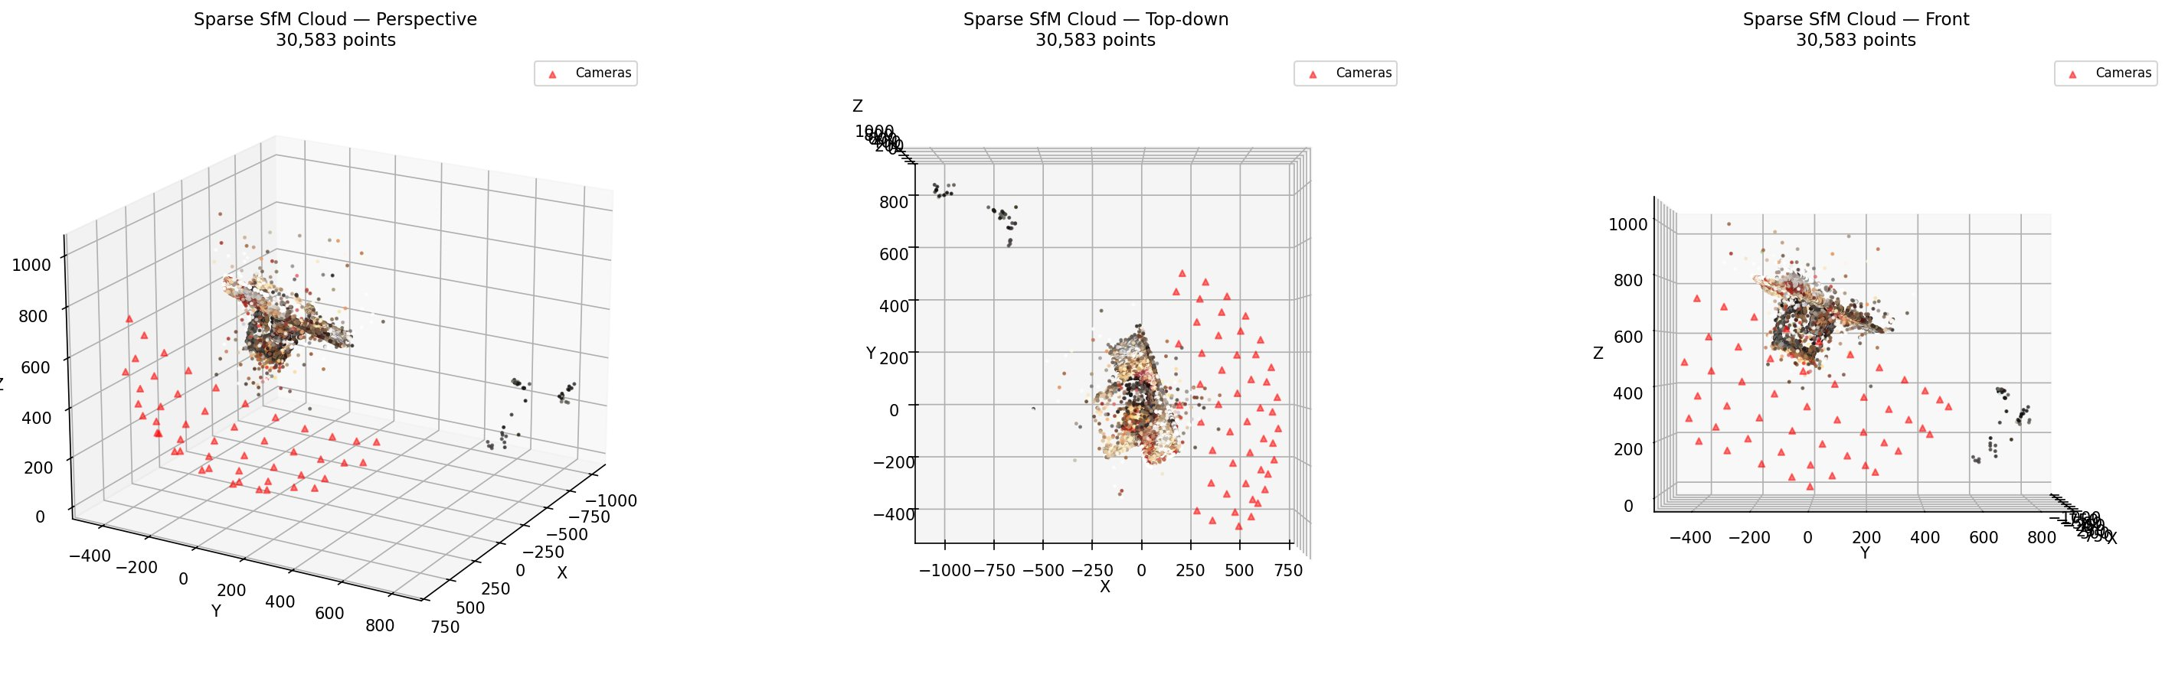
Figure 6: Sparse SfM cloud (30,583 points) shown from three angles — perspective, top-down, and front. Red triangles mark the 49 camera positions. The dense core cluster (centre) captures the object surface; outlier points (scattered to the right) are residual errors that the MVS and cleanup stages will address. The object is clearly identifiable but lacks surface detail at this stage.

4.6 MVS Densification — Plane-Sweep Stereo (Section 10a)
Plane-sweep stereo tests multiple depth hypotheses at each pixel and selects the hypothesis with the highest photo-consistency score across multiple neighbouring views. The key metric is Normalized Cross-Correlation (NCC), which is illumination-invariant, making it robust to the inter-view lighting differences present in the DTU dataset.

NCC(p, d) = Σ_q [ (r(q)−μ_r)/σ_r ] · [ (n(π(d,q))−μ_n)/σ_n ] / N
NCC at pixel p for depth hypothesis d: r = ref patch, n = neighbour patch, μ/σ = mean/std, N = patch size²

# Key MVS parameters:
MVS_PATCH = 7 # 7×7 NCC patch (49 px)
MVS_DEPTHS = 96 # depth hypotheses per pixel
MVS_STRIDE = 4 # sample every 4th pixel (speed vs density)
MVS_MIN_VIEWS = 2 # need agreement from ≥2 neighbours
MVS_NCC_THRESH = 0.3 # accept if NCC > 0.3

# Inverse-depth sampling: finer resolution near camera
inv_n, inv_f = 1.0/near, 1.0/far
depth_samples = 1.0 / np.linspace(inv_n, inv_f, 96)

# Per-depth: back-project → world → reproject into neighbours → NCC
pts_cam = rays_cam * depth_hypothesis
pts_world = R_ref.T @ (pts_cam.T − t_ref[:,None])
proj = P_neighbour @ np.vstack([pts_world, np.ones(N)])
uv = proj[:2] / proj[2] # projected pixel in neighbour view

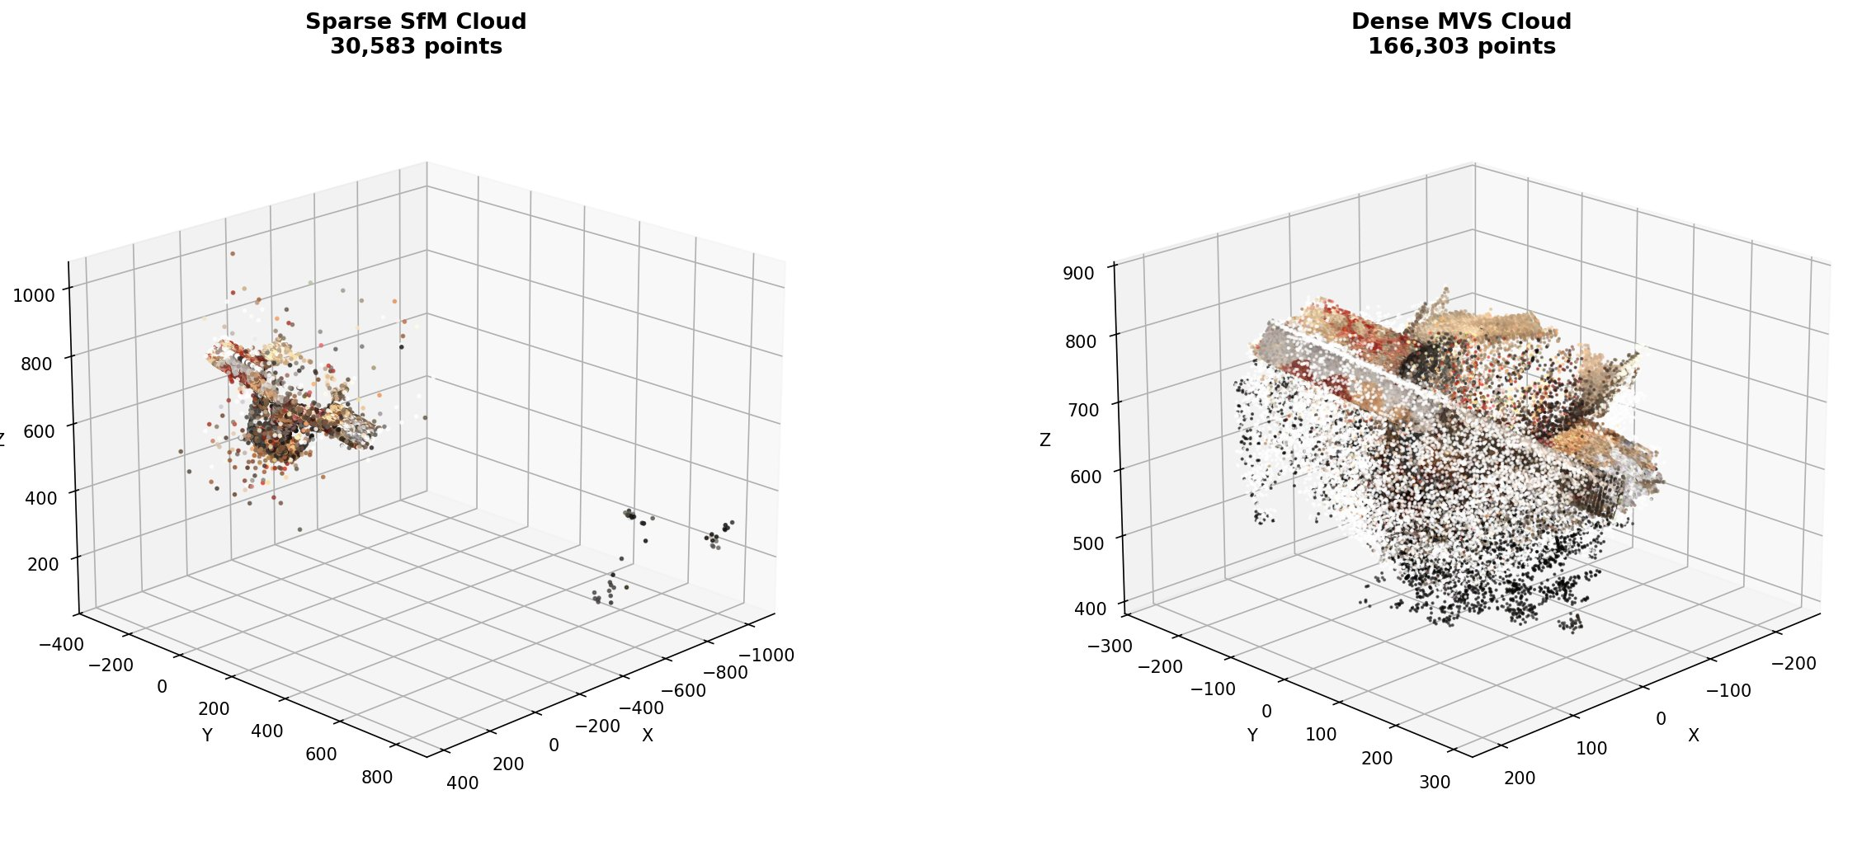
Figure 7: Sparse SfM cloud (30,583 pts, left) vs. Dense MVS cloud (166,303 pts, right). The MVS densification increases point count by ~5.4×, filling in the object surface with fine detail. The coloured surface layers (warm tones for the tin body, red for the top decoration) show the object is recognizable. The black halo below represents noise from the turntable and background — addressed in Section 4.7.

4.7 Dense Cloud Cleanup — ObsMask + SOR + Radius Filter (Section 10b)
The raw MVS cloud (166,303 pts) contains three noise types: (1) turntable and background plane reconstruction; (2) scattered photometric outliers at object edges; (3) floating halo from depth-fusion artifacts. Three filters are applied in sequence:

Filter | Purpose | Parameters | Effect
Dilated DTU ObsMask | Remove background & out-of-bound points | Dilate 50 mm (50 voxels), 1mm resolution | Kills turntable, walls, far outliers
Statistical Outlier Removal (SOR) | Remove isolated outlier points | k=20 neighbours, std_ratio=2.0 | Removes sparse floating halo
Radius Outlier Filter | Remove points with too few local neighbours | min_pts=5 within radius=15 mm | Cleans edge artifacts

# Load and dilate the DTU ObsMask (3D binary voxel volume)
obs_padded = np.pad(obs_volume_raw, dilate_voxels+5, constant_values=False)
obs_dilated = binary_dilation(obs_padded, iterations=dilate_voxels)

# Vectorised mask check: convert 3D point to voxel index
idx = np.floor((pts − BB_min) / res).astype(int)
keep = obs_volume[idx[:,0], idx[:,1], idx[:,2]] > 0

# SOR: remove points whose mean neighbour distance > μ + 2σ
pcd, _ = pcd.remove_statistical_outlier(nb_neighbors=20, std_ratio=2.0)

# Radius: remove points with fewer than 5 neighbours within 15 mm
pcd, _ = pcd.remove_radius_outlier(nb_points=5, radius=15.0)

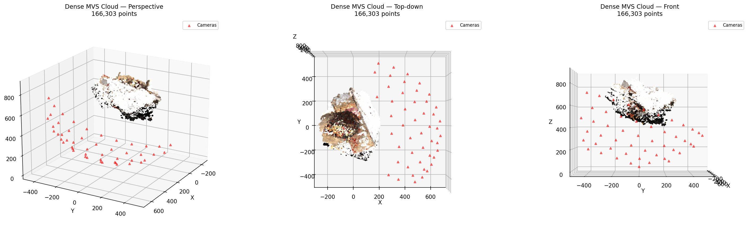
Figure 8: Raw dense MVS cloud (166,303 points) from three angles. Camera positions (red triangles) surround the object. A large noisy scatter of black points below the object surface represents turntable and background noise. The X-shaped pattern visible in the top-down view is a characteristic DTU artefact from the brick base extending beyond the object in some views.

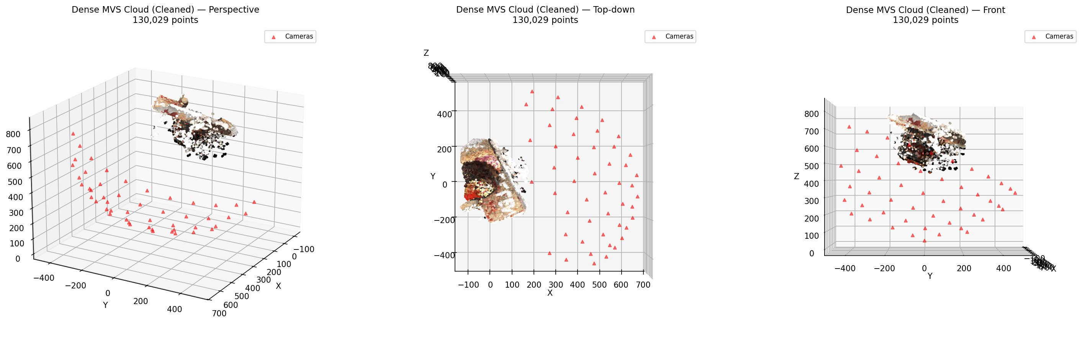
Figure 9: Cleaned dense cloud (130,029 points) after applying all three filters. The turntable plane and far outliers are gone. The remaining points tightly describe the object surface — the cylindrical tin body and its brick base are clearly defined. Some sparse scatter remains below but is minimal.

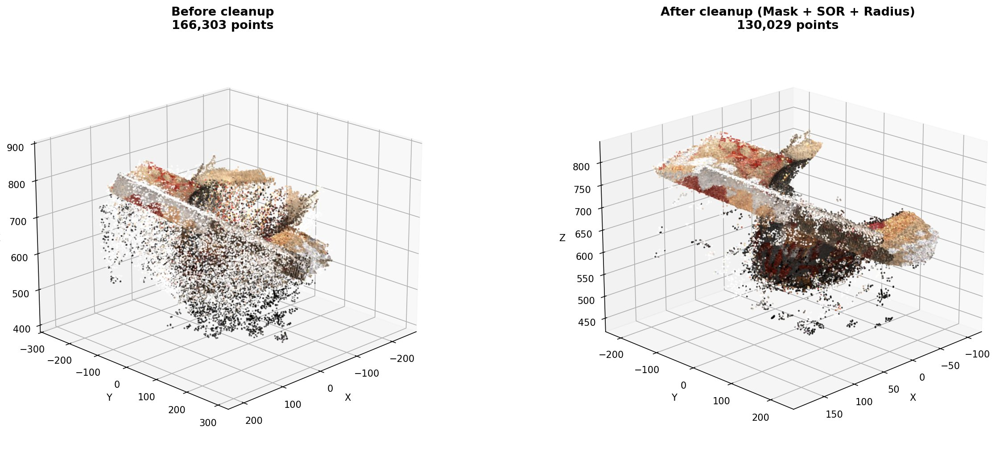
Figure 10: Before (166,303 pts, left) vs. after cleanup (130,029 pts, right). The filter cascade removed 36,274 points (21.8%), all of which were noise. Crucially, the object surface geometry is preserved — the cleanup is selective, not aggressive. The difference is most visible at the bottom where the turntable platform has been removed.

4.8 3D Gaussian Splatting (Section 11)

4.8.1 Gaussian Representation and Initialization
Each Gaussian carries five learnable parameter groups. The scene is initialized by placing one Gaussian at each point of the cleaned MVS cloud, with scale estimated from k-nearest-neighbour distance (mean of 3 nearest neighbours), ensuring Gaussians start at a physically meaningful size.

G(x) = exp(−½ (x−μ)ᵀ Σ⁻¹ (x−μ))
3D Gaussian: μ = position (3D), Σ = R·diag(s²)·Rᵀ = covariance (from quaternion q and log-scale s)

def init_gaussians(pts, cols, scene_extent):
tree = cKDTree(pts)
d, _ = tree.query(pts, k=4)
knn_dist = d[:, 1:].mean(axis=1) # avg of 3 nearest
log_scales = np.log(np.clip(knn_dist, 1e-3, scene_extent/10))
scales = np.tile(log_scales[:,None], (1,3)) # isotropic init
quats = np.zeros((n,4)); quats[:,0] = 1.0 # identity rotation
opacities = np.full(n, np.log(0.1/(1−0.1))) # inverse-sigmoid(0.1)
return {'means': tensor(pts), 'scales': tensor(scales),
'quats': tensor(quats), 'opacities': tensor(opacities),
'colors': tensor(cols)}

4.8.2 Differentiable Rendering and Loss Function
C = Σ_i c_i α_i Π_{j<i} (1 − α_j)
Alpha compositing: depth-sorted Gaussians accumulate colour c_i weighted by transmittance
L = 0.8 · L₁(Î, I_gt) + 0.2 · L_{SSIM}(Î, I_gt)
Combined loss: L₁ enforces per-pixel accuracy; SSIM enforces structural/perceptual similarity

4.8.3 Densification Loop (Clone / Split / Prune)
The densification loop runs every 100 iterations from iter 500 to 7500. It monitors the mean 2D position gradient accumulated per Gaussian across training batches:

- Clone (small, high-gradient): duplicate the Gaussian — used when a Gaussian covers an under-reconstructed region that needs more resolution
- Split (large, high-gradient): replace parent with two smaller children offset by ±scale — used when a large Gaussian spans regions with different geometry
- Prune: remove Gaussians with opacity < 0.005 (transparent, contribute nothing) or scale > 10% of scene extent (degenerate)
- Opacity reset at iteration 3,000: force all opacities to 0.01, allowing the optimizer to rediscover which Gaussians are actually needed

# Densification decision per Gaussian:
avg_grad = grad_accum / count_accum # mean position gradient
big = max_scale > 0.01 * scene_extent
high_grad= avg_grad > GS_GRAD_THRESH # 0.0002

clone_mask = high_grad & ~big # small + high-grad → duplicate
split_mask = high_grad & big # large + high-grad → split into 2
prune_mask = opacity < 0.005 | scale > 0.1*scene_extent

# Position LR decays exponentially: 1.6e-4 → 1.6e-6 over 15k iters
new_lr = LR_INIT * (LR_FINAL/LR_INIT) ** (iter/total_iters)

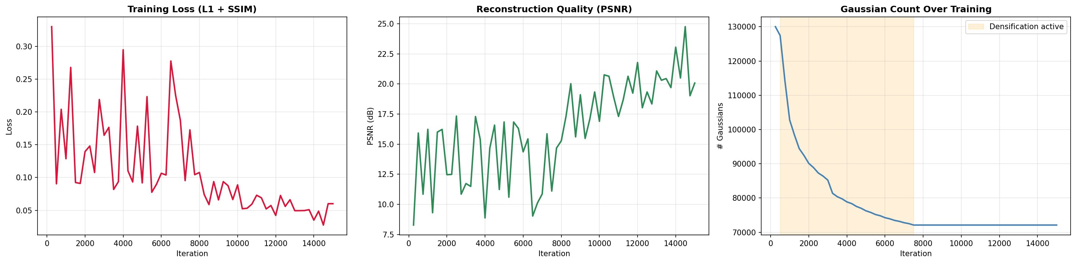
Figure 11: Training curves over 15,000 iterations. Left: L1+SSIM loss falls from ~0.33 to ~0.04 — healthy convergence. Centre: PSNR rises from ~8 dB to ~25 dB, with the noisy early phase corresponding to densification being active (orange shading, right panel). Right: Gaussian count — starts at 130,029, drops sharply during densification (pruning dominates cloning), and stabilizes at ~70,000. The count decrease is expected: many initial MVS points are noise or redundant; pruning converges to the minimal set needed.

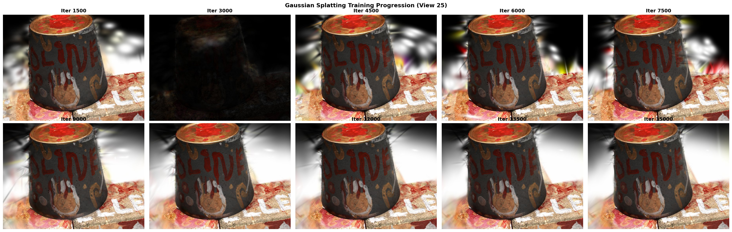
Figure 12: Rendered view (View 25) at 10 checkpoints. Iter 1500: object shape visible but very blurry — Gaussians are still large and overlapping. Iter 3000: opacity reset causes temporary darkening — this is expected behaviour. Iter 4500–6000: sharp recovery; object letters and surface texture emerge. Iter 9000–15000: high-fidelity rendering with accurate colour, surface gloss, and fine details. The background artefacts (blurry grey halo) are residual Gaussians outside the object.

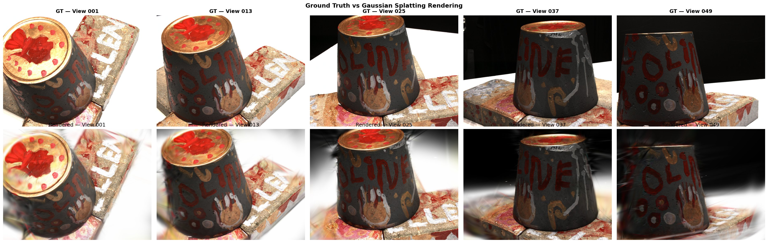
Figure 13: Ground truth (top) vs. final Gaussian Splatting render (bottom) across 5 views (1, 13, 25, 37, 49). The Gaussian Splat accurately reproduces the object colour (dark tin body, red wax top, golden rim), the surface lettering "OLIVE", handprint decoration, and the brick base texture. Edge sharpness and specular highlights on the rim are captured well. Minor differences (background halo, slight colour saturation) are consistent with a 15,000-iteration lightweight training run.

5. Mathematical Models and Equations Summary
Equation | Name / Role
P = K[R|t] | Camera projection: maps 3D world point to 2D image pixel
x ~ PX (homogeneous) | Projective mapping: perspective division gives pixel coords
x'ᵀ F x = 0 | Epipolar constraint: geometric test for correct feature matches
AX=0, solve via SVD(A) | DLT triangulation: recover 3D point from 2D correspondences
err = ||x − π(PX)||₂ | Reprojection error: quality filter, threshold 6.0 px
DoG = [G(kσ)−G(σ)] * I | SIFT scale-space: detect scale-invariant interest points
NCC(p,d) = Σ[(r−μ_r)/σ_r][(n−μ_n)/σ_n]/N | MVS photo-consistency: illumination-invariant depth scoring
G(x)=exp(−½(x−μ)ᵀΣ⁻¹(x−μ)) | 3D Gaussian: scene primitive for Gaussian Splatting
Σ = R diag(s²) Rᵀ | 3DGS covariance: anisotropic scale and rotation from quaternion
C = Σ cᵢ αᵢ Π(1−αⱼ) | Alpha compositing: front-to-back colour accumulation
L = 0.8 L₁ + 0.2 LSSIM | Training loss: joint photometric + structural similarity

6. Output Files
File | Description | Size
output/sparse.ply | Classical SfM sparse cloud | 30,583 pts
output/sparse.html | Interactive Three.js viewer (sparse) | Self-contained
output/dense.ply | MVS-densified cloud (raw) | 166,303 pts
output/dense.html | Interactive viewer (raw dense) | Self-contained
output/dense_clean.ply | Cleaned MVS cloud (ObsMask+SOR+radius) | 130,029 pts
output/dense_clean.html | Interactive viewer (cleaned) | Self-contained
output/gaussian_splat.ply | Gaussian Splatting (SuperSplat-compatible) | ~70k–130k Gaussians
output/gaussian_splat.html | Interactive viewer (GS centers) | Self-contained
output/figures/*.png | All 13 visualization figures | ~35 MB
output/renders/iter_*.png | GS training progression (10 frames) | ~6 MB

7. Conclusion
This project successfully implements a complete, end-to-end 3D reconstruction pipeline combining classical computer vision with modern differentiable rendering, applied to the DTU Robot Image Dataset (scan1). Starting from 49 calibrated 2D photographs of a decorative tin can object, the pipeline produces a high-quality 3D Gaussian Splatting representation capable of rendering novel views with approximately 25 dB PSNR after 15,000 training iterations.

The classical SfM stage — using SIFT, FLANN-RANSAC matching, and two-view DLT triangulation — delivers a geometrically consistent sparse cloud of 30,583 points. The plane-sweep MVS stage, scoring 96 depth hypotheses per pixel using illumination-invariant NCC across 4 neighbouring views, densifies this to 166,303 points. The three-stage cleanup pipeline (DTU ObsMask dilation, statistical outlier removal, radius filter) selectively removes 36,274 noise points (21.8%) while preserving the complete object surface at 130,029 points. Finally, the 3D Gaussian Splatting stage, initialized from the MVS cloud and trained with the full densification loop (clone, split, prune) and opacity reset, achieves sharp photorealistic rendering of both fine surface detail and accurate colour.

The project demonstrates a key insight: classical geometry-based methods and modern differentiable rendering are complementary rather than competing. Classical SfM/MVS provides reliable, interpretable geometric initialization that gives the Gaussian Splatting optimizer a strong starting point; Gaussian Splatting then refines this geometry into a photorealistic, novel-view-capable representation. Future work, as suggested by the project supervisors, could explore pure Gaussian Splatting from learned depth priors, integration of learning-based depth refinement networks (e.g., DPT or MiDaS), and extension to challenging real-world scenes beyond the controlled DTU laboratory environment.

— End of Report —

