Learning Management System

Documentation
Muhammad Taha Nazeef
2024

Contents
System Overview 0
Architecture Design 0
Class Documentation 0
User Guide 3
Technical Specifications 4
File Structure 5
Troubleshooting 0

System Overview
Purpose
The Learning Management System (LMS) is a comprehensive C++ application designed to facilitate online education management for universities. It provides distinct interfaces for Students, Teachers, and Administrators with role-specific functionalities.
Key Features
- Multi-user Role System (Student, Teacher, Administrator)
- Course Management with lecture notes and assignments
- Attendance Tracking
- GPA Calculation
- Student Record Management
- File-based Data Storage
Supported User Roles
- Students: Access course materials, view timetable, check attendance, calculate GPA
- Teachers: Upload lecture notes, manage assignments
- Administrators: Manage student records, view system data

Architecture Design
System Architecture

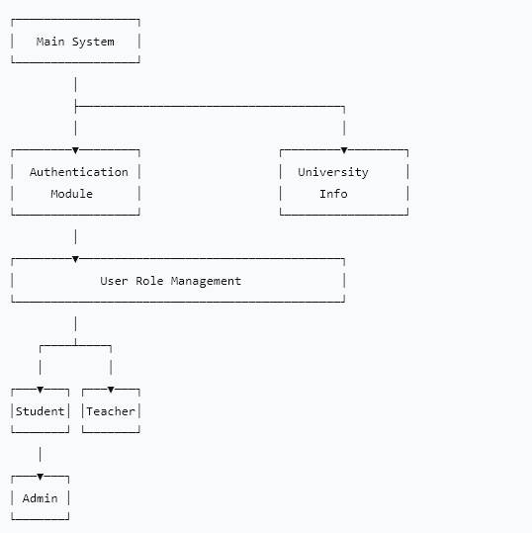

Class Hierarchy
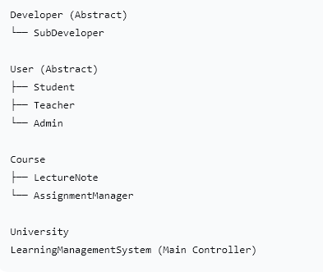

Class Documentation
1. Developer Class (Abstract)
Purpose: Base class for developer information display
Methods:
- virtual void display() = 0 - Pure virtual function to show developer info
2. SubDeveloper Class
Inherits: Developer
Methods:
- void display() - Shows developer team information and loading screen
3. University Class
Purpose: Manages university campus information
Methods:
- University() - Constructor that collects campus information
- displayHeader() - Shows university header
- getCampusInput() - Validates campus input
4. User Class (Abstract)
Purpose: Base class for all user types
Attributes:
- string name - User's name
- string id - User's ID
- int semester - Academic semester
Methods:
- virtual void menu() = 0 - Pure virtual for role-specific menus
5. Student Class
Inherits: User
Methods:
- Student() - Constructor with authentication
- void menu() - Student main menu
- bool validateStudentId() - Validates student credentials
- displayTimeTable() - Shows class schedule
- displayAttendance() - Shows attendance records
- calculateGPA() - Calculates grade point average
- showLectureNotes() - Displays course materials
- showAssignments() - Manages assignments
6. Teacher Class
Inherits: User
Methods:
- Teacher() - Constructor with authentication
- void menu() - Teacher main menu
- uploadLectureNotes() - Uploads course materials
- manageAssignments() - Manages student assignments
7. Admin Class
Inherits: User
Methods:
- Admin() - Constructor with authentication
- void menu() - Administrator main menu
- manageStudentRecords() - Manages student data
- addStudentRecord() - Adds new students
- displayStudentRecords() - Views all student records
8. Course Class
Purpose: Base class for course management
Attributes:
- string courseCode - Course identifier
- string courseName - Course title
- vector<string> lectureFiles - List of course files
Methods:
- displayContent() - Shows course materials
- displayFileContent() - Displays file contents
9. LectureNote Class
Inherits: Course
Methods:
- LectureNote() - Constructor for lecture management
- showAvailableCourses() - Displays course list
- processSelection() - Handles user course selection
10. AssignmentManager Class
Inherits: Course
Methods:
- AssignmentManager() - Constructor for assignment management
- downloadAssignment() - Downloads assignment files
- submitAssignment() - Submits completed assignments
11. LearningManagementSystem Class
Purpose: Main application controller
Methods:
- run() - Starts the application
- mainMenu() - Displays main navigation
- processUserChoice() - Handles user role selection

User Guide
For Students
Login Credentials:
- Username: Student
- ID: Any valid student ID from records
Features Available:
- View Timetable - Complete class schedule
- Check Attendance - Course-wise attendance percentage
- Calculate GPA - Grade point average calculator
- Access Lecture Notes - Course materials for:
  - Object Oriented Programming
  - Communication Skills
  - OOP Lab
- Manage Assignments - Download and submit assignments
For Teachers
Login Credentials:
- Username: RIAZ
- ID: 100
Features Available:
- Upload Lecture Notes - Add new course materials
- Manage Assignments - Create and manage student assignments
For Administrators
Login Credentials:
- Username: RIAZ
- ID: 100

Features Available:
- Manage Student Records - Add new students
- View Student Records - Display all registered students

Technical Specifications
Programming Language
- Language: C++
Required Libraries
#include <iostream> // Input/output operations
#include <string> // String manipulation
#include <vector> // Dynamic arrays
#include <memory> // Smart pointers
#include <conio.h> // Console input (Windows)
#include <windows.h> // Windows API functions
#include <fstream> // File operations
#include <exception> // Exception handling
#include <iomanip> // Output formatting
#include <algorithm> // Algorithm functions
File Dependencies
StudentRecord.txt - Student database
OOP.txt - Object Oriented Programming notes
CS.txt - Communication Skills notes
OOP-LAB.txt - OOP Lab materials
D-ASS.txt - Programming assignments
U-ASS.txt - Communication assignments

File Structure
Source Code Organization
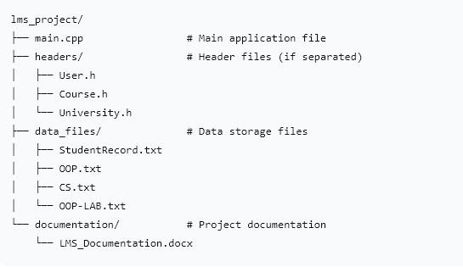

Troubleshooting
Common Issues
- File Not Found Errors
  - Ensure all data files exist in the executable directory
  - Check file names match exactly with code constants
- Compilation Errors
  - Verify C++11 standard is enabled
  - Ensure all required headers are available
- Login Issues
  - Check username and ID case sensitivity
  - Verify student IDs exist in StudentRecord.txt
- Display Issues
  - Ensure terminal supports ANSI escape codes for colors
  - Use a compatible console application

