Research Methodology for the One Year Keratoconus Cohort Study
TG-PRK plus accelerated corneal cross-linking versus accelerated corneal cross-linking alone
This document converts the approved IRB protocol into a clear, manuscript-ready methodology and a figure-ready study workflow. It preserves the protocol's retrospective design, sample, eligibility criteria, follow-up window, outcomes, and confidentiality requirements.

Study at a glance
Design | Exclusively retrospective, comparative cohort study
Setting | Anterior Segment Clinic, King Khaled Eye Specialist Hospital, Riyadh, Saudi Arabia
Record period | January 2020 to January 2025
Sample | 60 eyes: 30 treated with TG-PRK plus ACXL and 30 treated with ACXL alone
Endpoint | One year after treatment, using an allowable 10- to 14-month visit window
Main outcomes | UDVA, CDVA, refraction, flat K, steep K, Kmax, corneal stability, and complications

Research question and hypothesis
Research question. Among adults with progressive keratoconus treated at KKESH, are one-year visual, refractive, and keratometric outcomes better after combined TG-PRK plus ACXL than after ACXL alone, without a clinically important reduction in safety or corneal stability?
Hypothesis. The combined procedure will provide greater visual rehabilitation than ACXL alone while maintaining acceptable safety and corneal stability at one year.

Study design and setting
The study is an exclusively retrospective cohort study based on existing medical records. It will include eligible eyes treated at the Anterior Segment Clinic of King Khaled Eye Specialist Hospital in Riyadh between January 2020 and January 2025. Treatment was determined during routine clinical care; the study does not assign treatment or introduce additional procedures. The anticipated research duration is 12 months from initiation to publication.

Study population and sampling
The study population consists of patients aged 18 years or older with a confirmed diagnosis of progressive keratoconus who underwent either combined TG-PRK plus ACXL or ACXL alone and had suitable follow-up data. The protocol specifies a fixed convenience sample of 60 eyes selected from available eligible records, with 30 eyes in each treatment cohort.

Eligibility criteria

Inclusion criteria
- Confirmed progressive keratoconus.
- Age 18 years or older.
- Sufficient corneal thickness for the treatment received.
- No previous corneal surgical procedure.
- No systemic or ocular contraindication to corneal cross-linking.

Exclusion criteria
- Previous keratoplasty or laser vision correction.
- Ocular pathology other than keratoconus.
- Uncontrolled diabetes mellitus, defined in the protocol as HbA1c greater than 8.0% or a recent history of ketoacidosis.
- Active autoimmune connective-tissue disease associated with corneal melting, including rheumatoid arthritis or systemic lupus erythematosus.
- Pregnancy, lactation, or intention to become pregnant during the study period, as stated in the eligibility section of the protocol.

Exposure groups
Cohort | Treatment | Planned sample
Combined | Topography-guided photorefractive keratectomy plus accelerated corneal collagen cross-linking | 30 eyes
Comparator | Accelerated corneal collagen cross-linking alone | 30 eyes

Data source and collection procedures
- Identify potentially eligible records from the defined clinic and treatment period.
- Apply all inclusion and exclusion criteria consistently to each eye.
- Assign eligible eyes to the cohort corresponding to the treatment already received.
- Extract baseline characteristics, treatment details, follow-up measurements, and recorded complications using a standardized data-collection sheet.
- Replace direct identifiers with a study code and perform the analysis using de-identified data.
- Use the visit nearest to 12 months when it falls within the prespecified 10- to 14-month window.

Follow-up definition
The primary endpoint is the one-year follow-up assessment. The protocol permits visits occurring 10 to 14 months after the procedure. When more than one visit is available within this interval, the visit closest to 12 months should be selected. Visits outside this interval are excluded from the primary endpoint analysis but may be used for secondary or exploratory analyses if the analysis is prespecified and clearly reported.

Study outcomes
Domain | Measures | Purpose
Visual | UDVA and CDVA | Assess functional visual change from baseline to one year
Refractive | Refraction | Compare refractive change between treatment cohorts
Keratometric | Flat K, steep K, and Kmax | Assess corneal shape and stability
Safety | Corneal haze, delayed epithelial healing, infection, and other recorded complications | Compare procedure-related adverse outcomes
Exploratory | Baseline pachymetry, cone location, and other available corneal parameters | Explore associations with postoperative outcomes

Statistical analysis
The approved protocol specifies IBM SPSS Statistics version 26.0. Continuous variables will be summarized using means and standard deviations when approximately normally distributed, or medians and appropriate spread measures when distributions are skewed. Categorical variables will be presented as frequencies and percentages. All analyses will use de-identified data.
Recommended analytic extension for biostatistical confirmation. The final analysis plan should name the between-group tests for baseline characteristics and one-year outcomes, report effect estimates with 95% confidence intervals, and specify how baseline outcome values and potential confounders will be handled. If both eyes from any participant are included, the analysis must account for within-participant correlation, for example with a mixed-effects model or generalized estimating equations. A two-sided significance threshold of 0.05 is consistent with the protocol's sensitivity calculation.

Research workflow
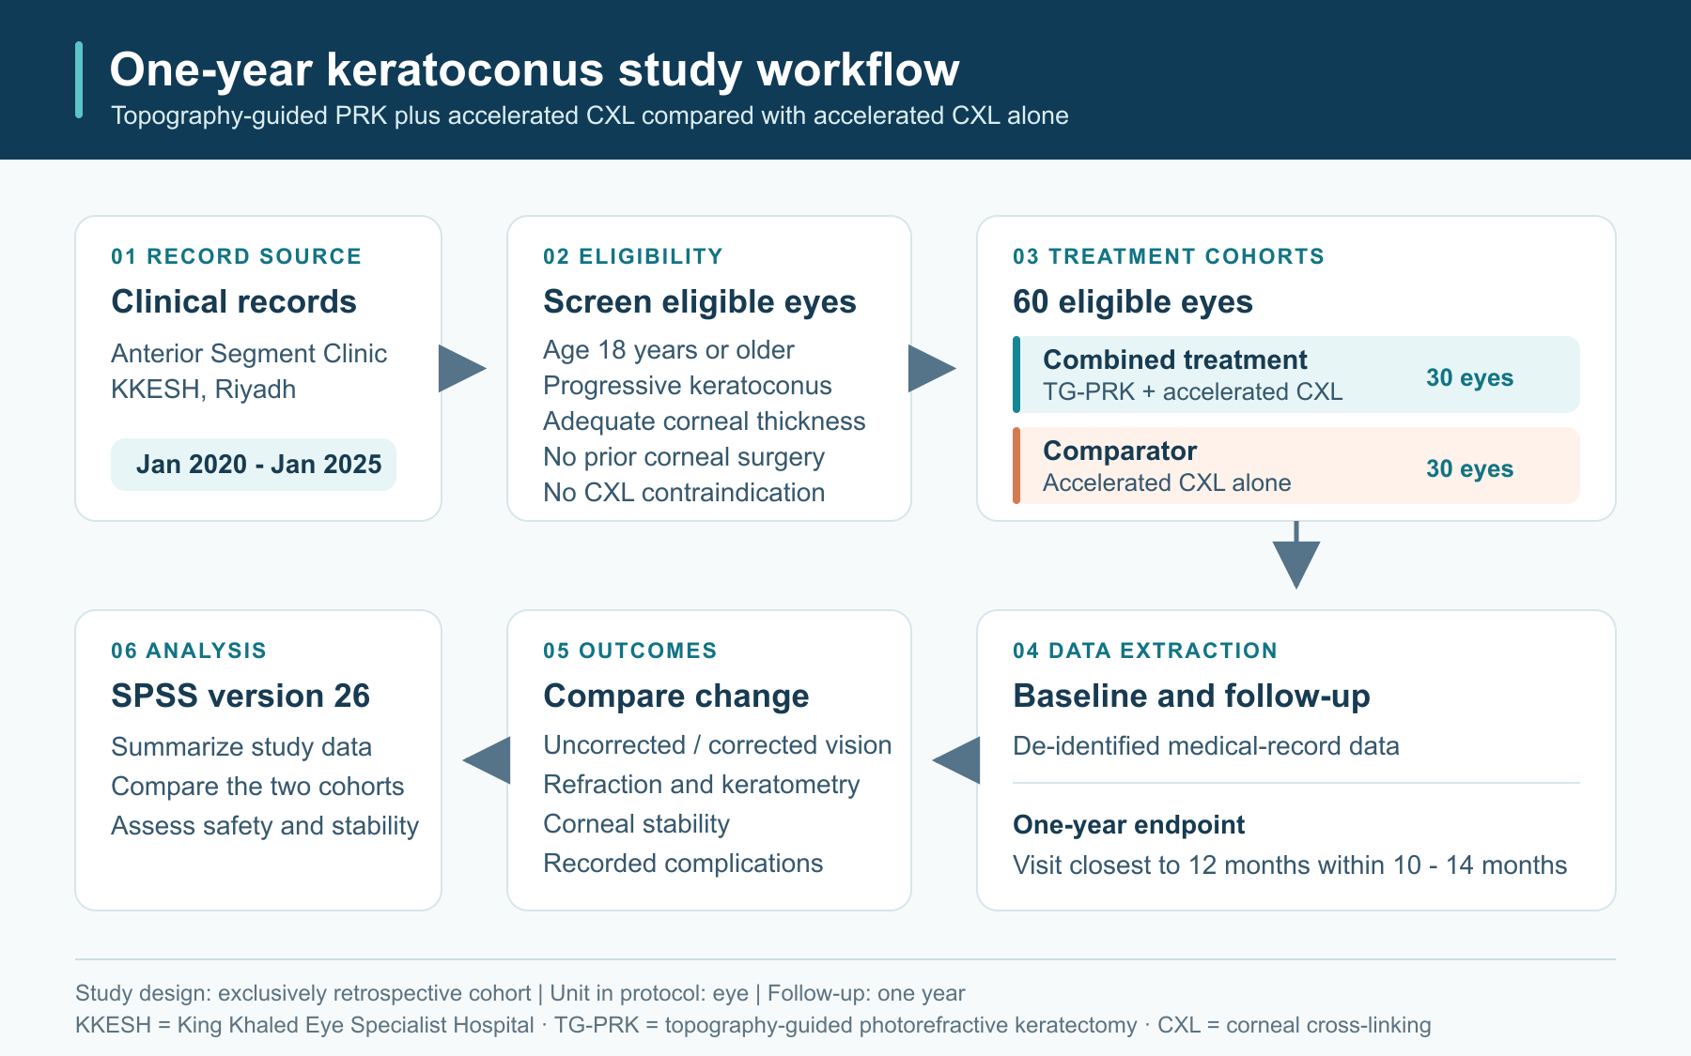
Figure 1. Retrospective cohort workflow from clinical-record screening to comparison of one-year outcomes.

Bias and data-quality controls
- Use the same eligibility definitions and endpoint window in both treatment cohorts.
- Define progressive keratoconus operationally before screening records.
- Use a standardized data dictionary and data-collection sheet.
- Record reasons for exclusion and missing outcome data.
- Check ranges, units, duplicate records, and internal consistency before analysis.
- Interpret results as associations because treatment was not randomized and confounding by indication may remain.

Ethics and confidentiality
The project is an IRB-reviewed retrospective medical-record study. The source form selects a waiver of consent and states that no additional clinical risk, participant recruitment, or study-specific intervention is introduced. Access to records should be restricted to authorized study personnel. Direct identifiers must be removed from the analysis dataset, passwords and system credentials must not be shared, workstations and files must be secured, and study data must be retained and handled in accordance with KKESH and IRB requirements.

Sample-size rationale
The protocol uses a fixed retrospective sample of 60 eyes based on record availability. Its sensitivity calculation states that, with 30 eyes per group, a two-sided alpha of 0.05, and 80% power, the study can detect a standardized mean difference of approximately 0.73. Assuming a postoperative UDVA standard deviation of 0.20 LogMAR, this corresponds to an approximate between-group difference of 0.15 LogMAR. Because the calculation depends on independence of observations, it should be revisited if both eyes from a participant are included.

Protocol points requiring confirmation
These items should be resolved with the principal investigator and biostatistician before data extraction or final manuscript submission:
- Participant versus eye as the unit of analysis, including the rule for selecting one eye or handling two eyes from the same participant.
- The exact operational definition of progressive keratoconus and the minimum evidence required in the record.
- The primary outcome and the precise method for calculating change from baseline.
- The inferential statistical tests, covariate-adjustment strategy, missing-data plan, and multiplicity approach.
- A contradiction in the IRB form: pregnancy is marked as not excluded in one checkbox section but is listed as an exclusion criterion later.
- A contradiction in the consent section: narrative text says participants will sign consent, while the consent-waiver option is selected for the retrospective review.
- A likely wording error in the confidentiality checklist stating that no staff are trained on data-entry security, although the item is checked as a safeguard.
- Whether the 10- to 14-month endpoint window supersedes the separate statement requiring a minimum 12-month follow-up.

