|  |  |  |
| --- | --- | --- |
| **Tahir** Afzal  Senior Front-End Developer  *Mobile:* +92 321 7834068  *Email:* [mistertahirafzal@gmail.com](mailto:mistertahirafzal@gmail.com)  *LinkedIn:* [*https://www.linkedin.com/in/tahir-afzal-ab28b322/*](https://www.linkedin.com/in/tahir-afzal-ab28b322/) | |  |
|  |

My name is **Muhammad Tahir Afzal**. I am working in **ZEPTO Systems** as a **Lead Front-end Developer**. I am serving the organization with a key role of modern Front-end Development, Agile (Jira) is integrated here for managing large scale products. I am also able to work in UX, User Experience and product interface designing, and also prototyping using **Photoshop, XD, Figma** and **invisionapp** & **Zipline.**

Technical Skills

* Knowledge of Agile base projects using **Jira**, **Basecamp, Trello**.
* UX/UI and Product Designing, Prototyping, **Photoshop**, **Illustrator**, Animated Gifs.
* Strong Knowledge of Figma, **invasion** and [**zeplin**](https://zeplin.io/), [**sketch**](https://www.sketchapp.com/) for Prototyping perfections.
* Expert in HTML5, CSS3, SASS, JavaScript (browser level), and jQuery.
* Front-end Frameworks **Bootstrap**, **Semantic UI**.
* Capable to work in MVC base Projects **Angular.js** as Front-end Developer.
* Git, SVN, for committing the code on to the server, VMware, Virtual Box, Vagrant base Development environment
* VS code, Sublime, Dreamweaver
* Core PHP, MySQL, phpMyAdmin, SQLyog, navicat. Flexile for exploring the server side.
* **WordPress Development**, Able to create theme from Scratch HTML, Custom Fields, Custom Functions, Plugin Customization, Redesign existing WordPress sites. PSD to WordPress, WooCommerce integration for E-Commerce stores.
* W3c Validation, Website Optimization, Google Page Speed Insights,
* Zend, Laravel, Node.js as a contributor as a Front-end developer.
* Integration of APIs, and web services using WordPress and Core PHP.
* VM ware, Virtual box, simulators for Front-end cross device/browser testing.

Work EXPERIENCE (Post Greaduate EXPERIENCE 10 Years)

**ZEPTO** Systems - Islamabad

**Lead Front-end Developer**

Fab-2014 – present

I am currently serving [ZEPTO Systems](http://www.zeptosystems.com/) as a key role of senior web developer. I am also leading a front-end team to managing Jira based projects, here I am working in WordPress / Drupal projects, also using Extended Bootstrap (framework) with Less/Sass/Compass with Ruby on Rays, Pure (framework), Angular (framework), jQuery, Responsive, Adaptive, and Fluid Designs. Mobile first technique.

**Digital Solutions INC** - Faisalabad

**WordPress Developer**

Feb 2011 - Jan 2014

I served [Digital Solutions / KtechSol](http://www.ktechsol.com/) as a key post of senior web developer. Here I worked in WordPress development, Mobile Application User Interface Designs, UX/UI, Product Designer, PSD to Bootstrap, Responsive Website Development using frame works and with CSS html.

**INICSOL** - Faisalabad

**Front-end Developer**

Jan 2008 - Jan 2011

I served InicSol as WordPress / Front-end developer. I learnt Advanced development using Core php, MySQL, phpMyAdmin, And Modern website development using HTML5, CSS3, Bootstrap, Custom JavaScript writing, jQuery.

**CONSDEV** - Faisalabad

**Front-end Developer**

June 2005 - Jan 2007

I start my first job here and I learn web standards, Photoshop, Dream Viewer, HTML, CSS, Flash (animations), graphic and website designing/development. vCard designing, and other graphics tasks.

Education - 2009

During my job I complete my graduation from Punjab University Lahore.  
Online Certification PHP, JavaScript, HTML, CSS

Professional Skills

|  |  |  |  |
| --- | --- | --- | --- |
| HTML/CSS | WebPack/Gulp | Bootstrap /SASS | JavaScript |
| TypeScript ES5/6 | React Js | AngularJS | Photoshop/xd/figma |
| Bootstrap | Git | WordPress Theme Development | Domain Hosting & Server Handling |
| NPM/bundler | Material Design | Core PHP, MySQL |  |
|  |  |

**UI Designs Portfolio**

[**https://invis.io/RXOSCD8V6B7**](https://invis.io/RXOSCD8V6B7)( 110 screen slideshow)  
  
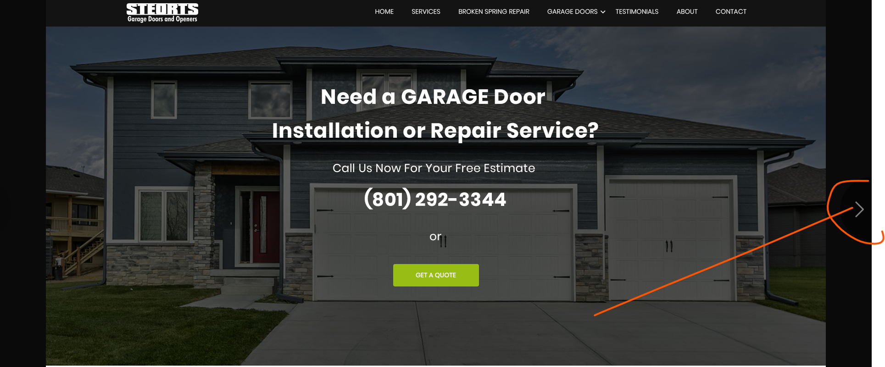  
Navigate for all the screens

**Short List of Projects**

* [Topmba.com](http://goo.gl/BrKij8) // Drupal, Bootstrap, Sass, Compass … Current Project
* [Topuniversities.com](http://goo.gl/8GlC) // Drupal, Bootstrap, Sass, Compass… Current Project
* 110autosales.com/ / 2021, WordPress, Bootstrap, Sass, Compass
* <https://simtecglobal.com/> 2021, WordPress, Bootstrap, Sass, Compass
* <https://projects.invisionapp.com/d/main?origin=v7#/console/13335689/397851742/preview?scrollOffset=918> // WordPress Theme
* <http://americansundayplate.com> // 2019, WordPress.
* <https://www.1001vouchercodes.co.uk/> // 2020, WordPress.
* <https://steorts.com/> // 2019, WordPress, Theme Development
* <https://getbonedry.com/> // 2019, WordPress, Theme Development
* <http://pro.woodrefinisher.net/> // 2019, WordPress, Theme Development
* <https://cleanwithcloud.com/> // 2019, WordPress, Theme Development
* <https://healingintuitive.net/> // 2019, WordPress, Theme Development
* <https://puremoldfree.com/> // 2019, WordPress, Theme Development
* <https://blog.trainerswarehouse.com> // 2018, Drupal, Bootstrap, Sass, Compass
* <https://easecarpetcleaning.com/> // 2018, Drupal, Bootstrap, Sass, Compass
* <https://utahdisasterteam.com/> // 2018, Drupal, Bootstrap, Sass, Compass
* <https://edwincompany.com> // 2020, Drupal, Bootstrap, Sass, Compass
* [qscourses.com](http://goo.gl/adPQe4) // 2020, Zend, Bootstrap, Sass, Compass
* [qa.qspartnersnetwork.com](http://goo.gl/TmJCuX) // 2015, Zend, Bootstrap, Sass, Compass
* [abqexterminator.com](https://goo.gl/zKvPpb) // 2017, UI/UX, WordPress, Bootstrap
* [cleanwithcloud.com](https://goo.gl/Pk3Sfz) // 2017, UI/UX, WordPress, Bootstrap
* [vipballers.com](https://goo.gl/FMy5SC) // 2017, UI/UX, WordPress, Bootstrap, Sass, Compass
* [fidgets.com](https://goo.gl/wYiDkk) // 2017, UI/UX, WordPress, Bootstrap
* [trainerswarehouse.com](http://www.trainerswarehouse.com/) // 2017, UI/UX, WordPress, Bootstrap, Sass, Compass
* [japosid.com](https://goo.gl/buqnLW) // 2017, UI/UX, WordPress, Bootstrap, Sass, Compass
* [dachsanierer.com](https://goo.gl/JgdJm4) // 2017, UI/UX, WordPress, Bootstrap, Sass, Compass
* [mrkeyservice.de](https://goo.gl/NC5MKU) // 2017, UI/UX, WordPress, Bootstrap, Sass, Compass
* [beautyandbloom.com](https://goo.gl/MxAxZA) // 2017, UI/UX, WordPress, Bootstrap, Sass, Compass
* [thedenconcept.com/](https://goo.gl/g49rBp) // 2017, UI/UX, WordPress, Bootstrap, Sass, Compass
* [inicsol.com](http://inicsol.com) // 2014, Core Php, Design, HTML5, CSS3
* [comsdev.com](http://comsdev.com) // 2006, Core Php, Design, HTML5, CSS3
* [ktechsol.com](http://goo.gl/7ai0F9) // 2012, WordPress, Design, Bootstrap, HTML5, CSS3
* [fechemicals.com](http://goo.gl/xeLwk2) // 2012, WordPress, Design, Bootstrap, HTML5, CSS3
* [chemitex.com](http://goo.gl/KtgjSQ) // 2012, WordPress, Design, Bootstrap, HTML5, CSS3
* [careprovider.org](http://goo.gl/sChouG) // 2006, Core Php, Design, HTML5, CSS3
* [racsuccess.com](http://goo.gl/EV2fcx) // 2009, Core Php, Design, HTML5, CSS3
* [optionenchef.de](http://goo.gl/ESdLGt) // 2010, Core Php, Design, HTML5, CSS3
* [weinturm.at](http://goo.gl/Pw0xNZ) // 2008, Core Php, Design, HTML5, CSS3
* [relationshusetgekko.dk](http://goo.gl/YQpYrV) // 2008, Core Php, Design, HTML5, CSS3
* [pruettsjewelry.com](http://goo.gl/3VEnNE) // 2012, Design, HTML5, CSS3
* [mmco.net](http://goo.gl/FzymZz) // 2013, Core Php, Design, HTML5, CSS3
* [saltproduct.com](http://goo.gl/M84ZJm) // 2013, WordPress, Design, HTML5, CSS3
* [dplit.com](http://goo.gl/1chmqr) // 2013, Core Php, Design, HTML5, CSS3
* [karmora.com](http://goo.gl/kgVfFo) // 2013, Design, HTML5, CSS3
* [autobytel.com](http://goo.gl/QI4Yj) // 2013, Design, HTML5, CSS3
* [askforseo.com](http://goo.gl/WdvenE) // 2013, Design, HTML5, CSS3