How the knee model decides
Activations, attention, scores and the 0.56 million numbers, explained with examples
RSNA Knee Abnormality Detection · the CoAtNet model with one attention per finding (B72 to B90) · 8 October 2026
Contents
1. The model at a glance (the schematic)
2. Activation functions (and GELU, with its graph)
3. Where the 0.56 million numbers come from
4. What attention means
5. The 256 "questions"
6. The parts V, U and W
7. The score, defined
8. Softmax, and why a score may be negative
9. A worked example with numbers

1. The model at a glance
The model reads one knee at a time. It has two parts: a picture reader (CoAtNet, about 74 million learned numbers) and a decision part (about 0.56 million learned numbers) that turns the pictures into 12 answers, one per finding.
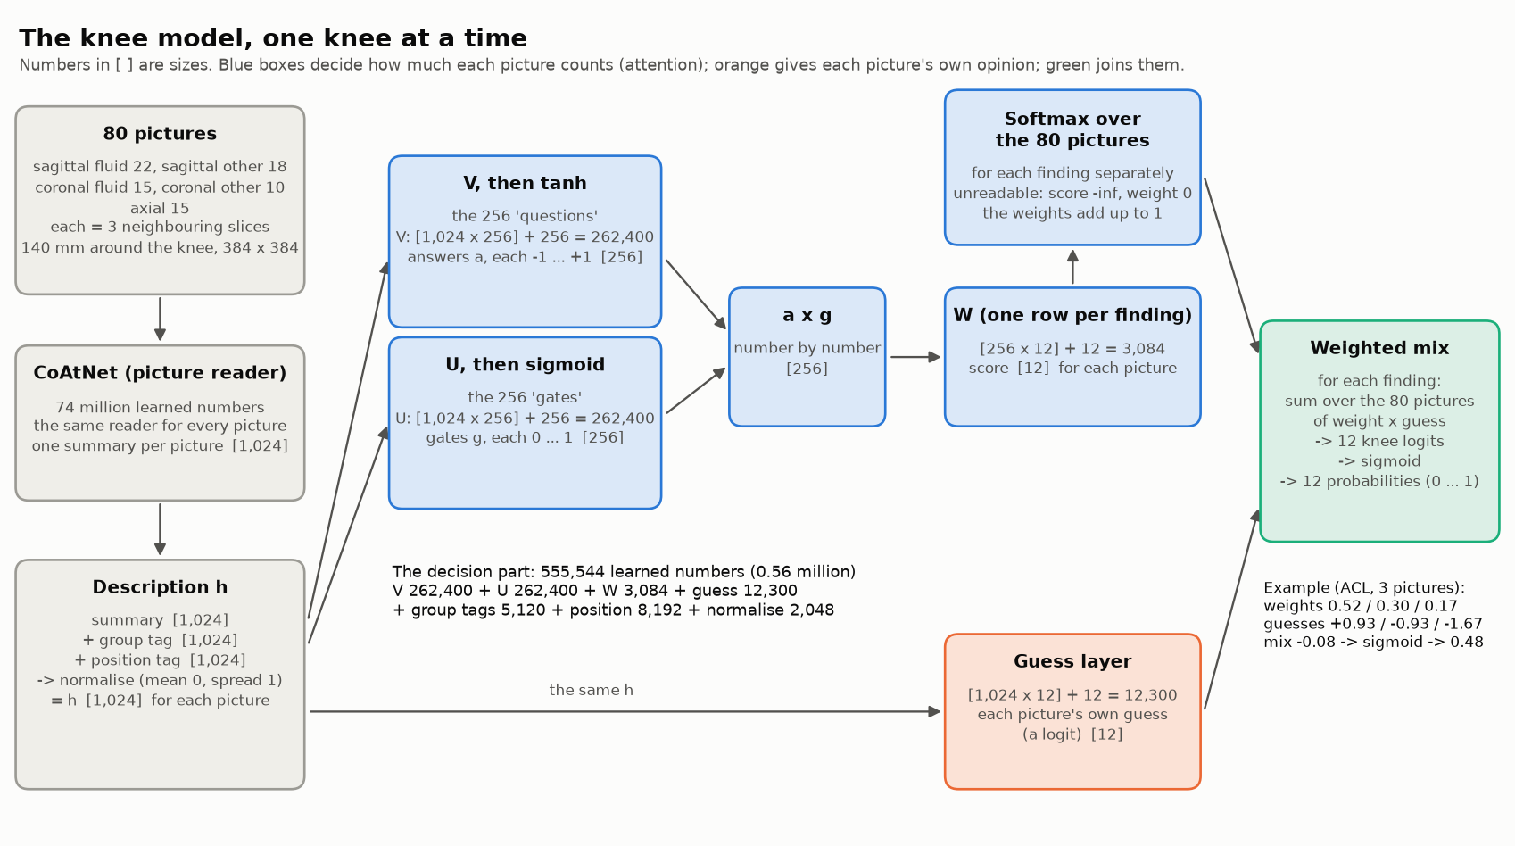
Figure 1. The knee model. Blue: how much each picture counts (attention). Orange: each picture's own opinion. Green: the two joined into the knee's answers.
Reading the figure from left to right:
- Grey: the input and the picture reader. 80 pictures of one knee in five groups, each picture three neighbouring slices, cropped to 140 mm around the knee. CoAtNet reads every picture the same way and writes a summary of 1,024 numbers. The summary plus a group tag and a position tag, normalised, is the picture's description h.
- Blue: attention. From h, the parts V, U and W give each picture a score for each of the 12 findings. For each finding, a softmax turns the 80 scores into weights that add up to 1. An unreadable picture gets weight 0.
- Orange: the guess layer. From the same h, each picture gives its own guess for each finding.
- Green: the weighted mix. For each finding, the guesses are added up with their weights, and a sigmoid turns the result into the knee's probability (0 to 1).

2. Activation functions
Without activations a neural network only multiplies and adds, so it can only learn straight-line rules. An activation adds a bend after a layer. With many bends the network can learn complicated patterns, such as the shape of a torn meniscus.

The activations in our model
Where | Activation | In simple words
Picture reader: convolution stages (first half) | SiLU | a smooth "keep positives, cut negatives"
Picture reader: channel gates | Sigmoid | squeezes a number to 0 ... 1, to turn a feature up or down
Picture reader: transformer stages (second half) | GELU | a smooth "keep positives" bend (below)
Picture reader: position helper ("rmlp") | ReLU | "cut negatives to zero"
Decision part: attention gate | tanh × sigmoid | how much each picture matters (sections 5 and 6)
Decision part: across the 80 pictures | softmax | scores into weights that add up to 1 (section 8)
Decision part: final answer | sigmoid | each finding's own probability, 0 ... 1

GELU, in two steps
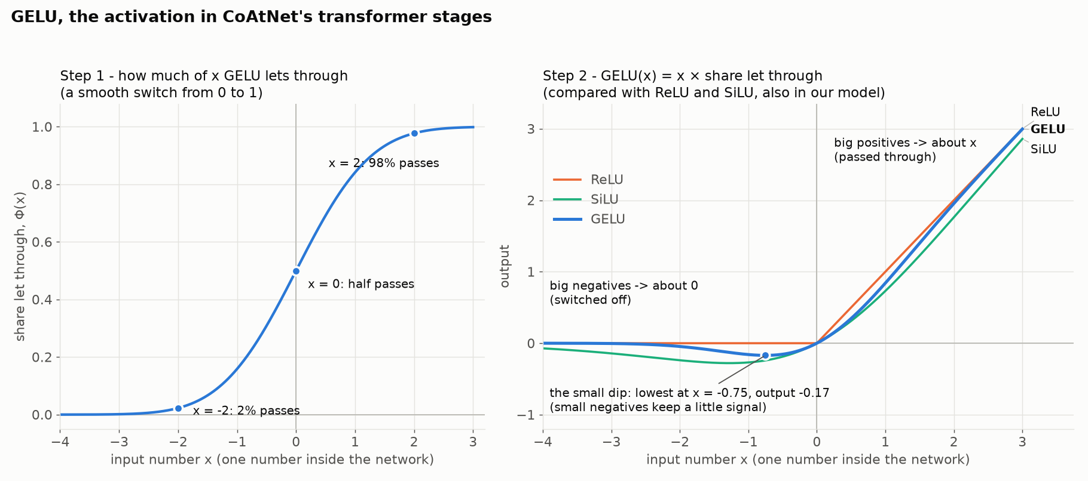
Figure 2. GELU: how much of each number passes (left), and the result beside ReLU and SiLU (right).
- Decide how much of x to let through, with a smooth switch from 0 to 1: at x = −2 only 2% passes, at x = 0 half passes, at x = +2 98% passes.
- Multiply: GELU(x) = x × (the share let through). Big positive numbers pass almost unchanged (2 becomes 1.95); big negative numbers become about 0 (−3 becomes −0.004); small negative numbers keep a little signal (the lowest point is at x = −0.75, output −0.17).
x | ReLU | GELU | SiLU
−3 | 0 | −0.004 | −0.14
−1 | 0 | −0.16 | −0.27
0.5 | 0.50 | 0.35 | 0.31
1 | 1.00 | 0.84 | 0.73
2 | 2.00 | 1.95 | 1.76

ReLU has a sharp corner at 0: everything negative becomes exactly 0, and a number below 0 stops learning (its slope there is 0). GELU and SiLU bend gently and keep a small slope for small negatives, which makes training a little smoother.

Why we do not change them
- The picture reader's ImageNet weights were learned together with these exact activations. Swapping one (for example GELU for ReLU) would break what it learned, like replacing the gears of a working clock.
- The gated attention (tanh × sigmoid) is the standard design for "many pictures, one answer"; the public 0.949 recipe uses it too.
- The final sigmoid is required: a knee can have several findings at once, so each finding needs its own yes/no probability (a softmax over the findings would wrongly make them compete).
- Every large gain so far came from pictures, training and labels; nobody has reported a gain from changing activations in this competition.

3. Where the 0.56 million numbers come from
The decision part's pieces, counted exactly from the model:
Piece | What it does | Size | Numbers
Group tag | one 1,024-number tag per picture group | 5 × 1,024 | 5,120
Position | turns "where in the series" (8 numbers) into 1,024 | 8 × 1,024 | 8,192
Normalisation | keeps the description's numbers at a steady size | 1,024 + 1,024 | 2,048
Attention part V | 256 "questions" about each picture | 1,024 × 256 + 256 | 262,400
Attention part U | 256 "gates" (how much each question counts) | 1,024 × 256 + 256 | 262,400
Attention part W | the 256 gated answers into a score per finding | 256 × 12 + 12 | 3,084
Guess layer | each picture's own guess for the 12 findings | 1,024 × 12 + 12 | 12,300
Total |  |  | 555,544 ≈ 0.56 million

Almost all of it (about 525,000) is V and U, because each connects 1,024 description numbers to 256 questions. In B89 and B90 this decision part is what L-BFGS tunes; the picture reader stays frozen.

4. What attention means
A knee has 80 pictures, but for each finding only a few really matter. An ACL tear is seen in a few sagittal slices through the middle of the knee; an effusion in many pictures. Attention is how the model decides, for each finding separately, how much to listen to each picture. It is like a teacher marking a group project, who trusts most the students who looked at the right thing.

The steps, for one finding (ACL)
- Each picture gives its own guess: how likely an ACL tear is, according to that picture.
- Each picture gets an importance score: how useful it is for ACL (V, U and W; sections 5 to 7).
- The scores become weights that add up to 1 (softmax; section 8).
- The knee's answer is the weighted mix of the guesses. The guesses are mixed as raw scores ("logits": a probability of 0.90 is +2.20, 0.50 is 0, 0.10 is −2.20) and a sigmoid turns the mix into a probability at the end.

A small example with 3 pictures
Picture | Its ACL guess (probability, logit) | Score | Weight
sagittal, middle of the knee | 0.90 (+2.20) | 3 | 0.84
sagittal, side | 0.20 (−1.39) | 1 | 0.11
axial | 0.10 (−2.20) | 0 | 0.04

ACL mix = 0.844 × (+2.20) + 0.114 × (−1.39) + 0.042 × (−2.20) = +1.60
ACL answer = sigmoid(+1.60) = 0.83

equal trust: (2.20 − 1.39 − 2.20) / 3 = −0.46 -> sigmoid -> 0.39
With equal trust the one picture that shows the tear would be drowned out (0.39). Attention lets the clear picture win (0.83). Each finding has its own attention: ACL listens to the middle sagittal slices, MCL to the inner side on coronal pictures, effusion spreads its trust over many pictures.

5. The 256 "questions"
"Questions" is only a picture in words. In the model, each question is a list of 1,024 learned weights, one for each number in a picture's description. To ask it, multiply each of the picture's 1,024 numbers by the question's 1,024 weights, add everything up and add one extra number (the bias). The result is one number: how strongly the picture matches that question. 256 questions give 256 numbers per picture.
Nobody writes them. They start random and are changed, little by little during training, in whatever way makes the 12 answers more correct. They cannot be read directly. If they could be translated, some might mean "does this picture show bright fluid?", "is this a slice through the middle of the knee?" or "is this picture blurred or empty?"; in reality each is usually a mixture of many such things.

A tiny example: a description of 4 numbers and 2 questions
picture description [ 2.0, 0.0, 1.0, -1.0 ]

question 1 (V) weights [ 0.5, 0.1, 0.0, 0.2 ] -> 2.0×0.5 + (-1.0)×0.2 = 0.8 -> tanh -> 0.66
its gate (U) weights [ 0.3, 0.0, 0.4, 0.0 ] -> 2.0×0.3 + 1.0×0.4 = 1.0 -> sigmoid -> 0.73
gated answer: 0.66 × 0.73 = 0.48
question 2 (V) weights [-0.2, 0.0, 0.1, 0.3 ] -> -0.4 + 0.1 - 0.3 = -0.6 -> tanh -> -0.54
its gate (U) weights [ 0.0, 0.5, 0.0, 0.0 ] -> 0.0 -> sigmoid -> 0.50
gated answer: -0.54 × 0.50 = -0.27

ACL's W weights [ 2.0, -1.0 ] -> 2.0×0.48 + (-1.0)×(-0.27) = 1.23 = ACL importance score

6. The parts V, U and W
V, U and W are three layers of the decision part; in the code attention_v, attention_u and attention_w (model/slot_model.py). Each is a table of learned numbers:
Part | Table | Applied to a picture gives | Squashed by | Its job
V | 1,024 × 256 + 256 biases | 256 numbers | tanh, −1 ... +1 | what the picture shows: the 256 answers
U | 1,024 × 256 + 256 biases | 256 numbers | sigmoid, 0 ... 1 | how much each answer counts: the 256 gates
W | 256 × 12 + 12 biases | 12 numbers (from V × U) | (softmax later) | the importance of the picture for each finding

Think of a mixing desk with 256 channels: V sets what each channel plays (loud, quiet or the opposite), U is each channel's volume knob (0 muted, 1 full), and W is a separate mix for each of the 12 findings (which channels that finding listens to).
The letters come from the research paper this design follows: Ilse, Tomczak and Welling (2018), “Attention-based Deep Multiple Instance Learning”, where the importance of picture k is
importance_k = w · ( tanh(V · h_k) × sigmoid(U · h_k) )
Why two tables, not one? With V alone, tanh behaves almost like a straight line for small numbers, which limits what the model can express. Multiplying by the U gate lets it switch parts of the answer on or off for each picture (for example ignore a "ligament" answer on a picture that does not show the ligament). In the paper the gated version worked better than V alone.

7. The score, defined
The score is one number for each picture and each finding: how much that finding should listen to that picture, compared with the knee's other pictures. With 80 pictures and 12 findings a knee gets 80 × 12 = 960 scores.

How one score is made: picture k, finding f
1. description h_k = normalise( summary_k + group tag + position tag ) 1,024 numbers
2. the 256 answers a_k = tanh( V · h_k + bias_V ) 256 numbers, -1 ... +1
3. the 256 gates g_k = sigmoid( U · h_k + bias_U ) 256 numbers, 0 ... 1
4. gated answers a_k × g_k (number by number) 256 numbers
5. the score score_k,f = W_f · (a_k × g_k) + bias_W,f 1 number, any value

What happens to the scores afterwards
6. unreadable picture -> score = minus infinity (its weight will be exactly 0)
7. weights weight_k,f = e^score_k,f / (sum over the knee's pictures of e^score_j,f)
8. the knee's answer answer_f = sigmoid( sum over pictures of weight_k,f × guess_k,f )

Score and guess: two different numbers per picture and finding
 | What it says | Made by | Used for
score | how much should this finding listen to this picture? | V, U and W (the attention) | the weights (step 7)
guess | how likely is the finding, according to this picture? | the guess layer (1,024 × 12) | the weighted mix (step 8)

So each picture both gives its own opinion (the guess) and is told how much its opinion counts (the score).

8. Softmax, and why a score may be negative
A score can be any number: negative, zero or positive. The softmax still turns any scores into positive weights that add up to 1:
- Take e to the power of each score (e ≈ 2.718). The result is always positive: e^(+2) = 7.39, e^0 = 1, e^(−1) = 0.37, e^(−3) = 0.05.
- Divide each by the total, so the weights add up to 1.

Three pictures, all with negative scores
Picture | Score | e^score | Weight
A | −1.0 | 0.368 | 0.844
B | −3.0 | 0.050 | 0.114
C | −4.0 | 0.018 | 0.042
total |  | 0.436 | 1.000

These are exactly the weights of section 4 (scores +3, +1, 0), because only the differences between the scores matter: adding or subtracting the same amount from every score changes nothing. "−1 against −3" means the same as "+3 against +1". A negative score does not mean "bad picture"; only its place among the knee's other scores for the same finding counts. A picture from a missing or unreadable series gets minus infinity: e^(−∞) = 0, so its weight is exactly 0.

With realistic decimal scores
The whole numbers above were only chosen to make the sums easy to follow. The real scores are decimals and are treated exactly the same way:
Picture | Score | e^score | Weight | Its ACL guess (probability, logit)
A | +0.83 | 2.293 | 0.525 | 0.91 (+2.31)
B | −0.41 | 0.664 | 0.152 | 0.35 (−0.62)
C | −1.27 | 0.281 | 0.064 | 0.08 (−2.44)
D | +0.12 | 1.127 | 0.258 | 0.62 (+0.49)
total |  | 4.365 | 1.000

ACL mix = 0.525×2.31 + 0.152×(−0.62) + 0.064×(−2.44) + 0.258×0.49 = +1.09 -> sigmoid -> 0.75

9. A worked example with numbers
One knee, worked through with invented numbers, made small so it can be followed by hand: descriptions of 4 numbers (instead of 1,024), 3 questions (instead of 256), 2 findings (ACL and MCL, instead of 12) and 3 pictures (instead of 80).

Picture A (sagittal, middle of the knee), step by step
Step 1 summary [ 2.0 0.5 1.0 -0.5 ]
+ group tag [ 0.2 0.0 0.0 0.1 ] (sagittal fluid)
+ position tag [ 0.1 0.0 0.1 0.0 ] (middle of the series)
= x [ 2.3 0.5 1.1 -0.4 ]
normalise (minus the mean 0.875, divided by the spread 0.98):
h = [ 1.45 -0.38 0.23 -1.30 ]

Step 2 V·h + bias = [ 1.02 0.18 -1.13 ] -> tanh -> answers a = [ 0.77 0.17 -0.81 ]
Step 3 U·h + bias = [ 0.86 -0.52 0.00 ] -> sigmoid -> gates g = [ 0.70 0.37 0.50 ]
Step 4 a × g = [ 0.54 0.07 -0.41 ]

Step 5 W for ACL = [ 1.5 -0.5 0.2 ] -> score ACL = 1.5×0.54 + (-0.5)×0.07 + 0.2×(-0.41) ≈ +0.70
W for MCL = [-0.3 0.8 1.0 ] -> score MCL = (-0.3)×0.54 + 0.8×0.07 + 1.0×(-0.41) ≈ -0.52
The same picture gets a high score for ACL and a low one for MCL.

Pictures B and C, the same steps
Picture | a × g | Score ACL | Score MCL | ACL guess (probability, logit)
A (sagittal, middle) | [ 0.54, 0.07, −0.41] | +0.70 | −0.52 | 0.72 (+0.93)
B (sagittal, side) | [ 0.01, −0.30, −0.05] | +0.15 | −0.29 | 0.28 (−0.93)
C (axial) | [−0.27, 0.20, 0.38] | −0.42 | +0.62 | 0.16 (−1.67)

From the scores to the ACL answer
Picture | Score | e^score | Weight
A | +0.70 | 2.006 | 0.524
B | +0.15 | 1.168 | 0.305
C | −0.42 | 0.654 | 0.171
total |  | 3.828 | 1.000

ACL mix = 0.524 × (+0.93) + 0.305 × (−0.93) + 0.171 × (−1.67) = −0.08
ACL answer = sigmoid(−0.08) = 0.48

equal trust: (0.93 − 0.93 − 1.67) / 3 = −0.56 -> sigmoid -> 0.36
Attention moved the answer towards picture A, the one through the middle of the knee where the ACL is. For MCL the same three pictures get the weights 0.19 / 0.23 / 0.58: MCL listens mostly to picture C. Each finding chooses its own pictures.
The real model does exactly these steps, only larger: 1,024 description numbers, 256 questions, 12 findings and 80 pictures, with V, U and W learned during training instead of made up.

