Corporate Partners Analysis Report

1. Project Overview
This report presents the findings and methodology of the Corporate Partnerships Analysis project. The goal was to examine the structure and composition of corporate partnership programs at top engineering universities, focusing on Purdue University, Stanford University, and comparable peers. The dataset, analysis code, and visualizations are consolidated into a GitHub repository for reproducibility.
Repository Contents:
• README.md – Summarizing project objectives and overview of Github
• Corporate Partners_Dataset.xlsx – Dataset with Tiers and Partners tables.
• Code.py– Python File containing data visualization code.
• Report.docx – This report document summarizing findings.
• Reference List – A text file containing all the different universities website links.

2. Dataset Description
The dataset consists of two main tables: Tiers and Partners. Each was compiled through a combination of web research and manual data entry.

A. Tiers Table
The Tiers table captures the partnership structure, including membership levels, fees, and associated benefits.
Column | Description
University | Name of the institution (e.g., Purdue, Stanford)
Program Office | Department or center managing the corporate program
Tier Name | Partnership level (e.g., Black, Gold, Bronze)
Annual Fee (if published) | Membership cost per year
Benefits Summary | Key benefits offered to corporate partners

B. Partners Table
The Partners table lists corporations affiliated with each program and the industries they represent.
Column | Description
University | Name of the institution
Department | School or department managing the partnership
Program Office | Specific initiative managing the partnership
Partner Company | Name of the company
Technology Sector | General industry classification (e.g., Semiconductor, AI, Energy)
Data was collected through semi-manual web scraping from official university partnership pages. Tier structures, partner names, and membership fees were extracted, normalized, and combined into a single dataset.

3. Importing Libraries and Data Setup
The Python Code uses Python libraries including pandas, matplotlib, and seaborn to process and visualize the data.

4. Visualizations and Insights

Visualization 1 – Partner Distribution by University
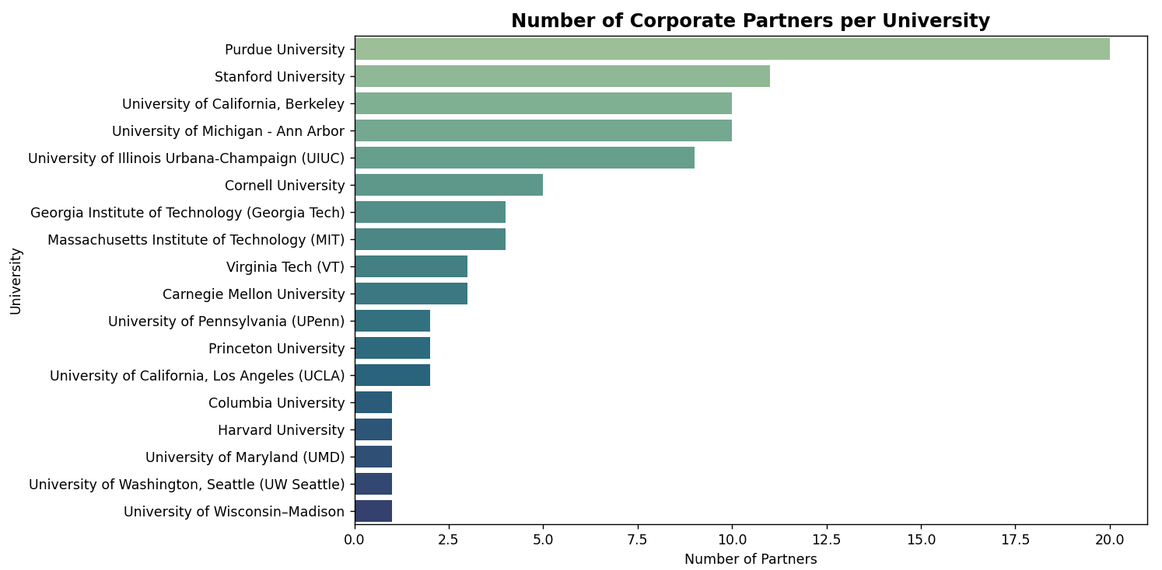
A horizontal bar chart showing the number of partner companies for each university.

Visualization 2 – Technology Sector Breakdown (Donut Chart)
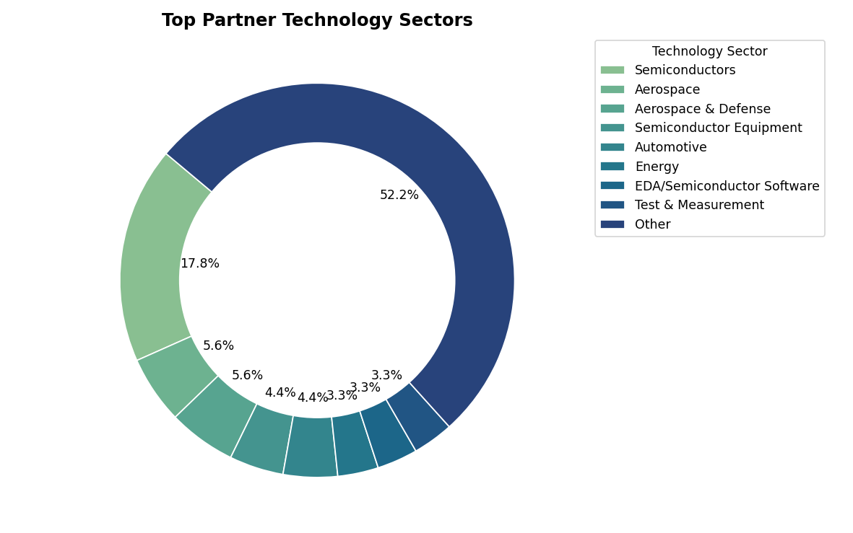
A donut pie chart depicting the proportion of partners across technology sectors.

Visualization 3 – Tier Comparison: Purdue vs Stanford
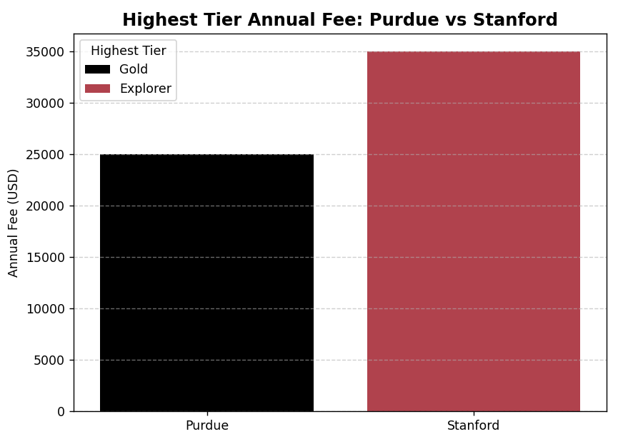

A simple bar chart comparing the annual cost of the highest tier memberships at Purdue and Stanford.

Visualization 4 – University & Sector Engagement Heatmap

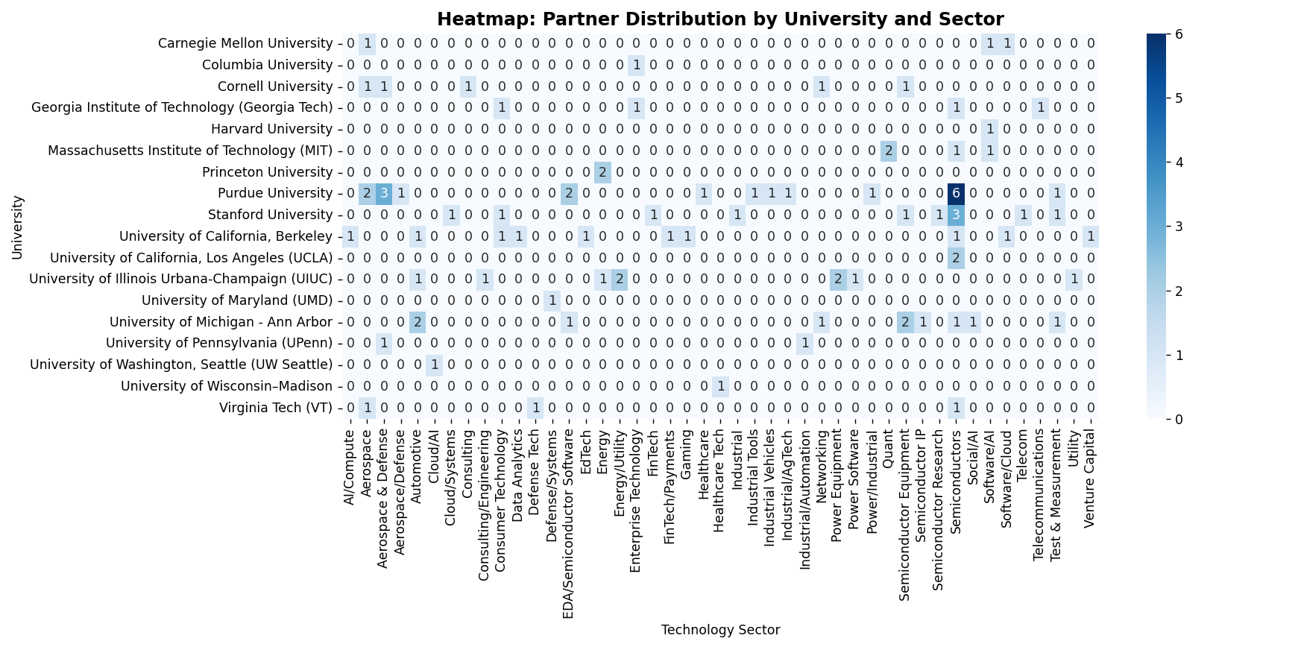
The heatmap highlights which universities engage most heavily with specific sectors.

5. Summary and Future Scope
This analysis provides a foundational understanding of corporate partnership programs in academia. It highlights industry engagement patterns and partnership tier structures. Future work may include dynamic scraping of additional institutions, cross-sector comparisons, and time-series analysis.

