Instructions

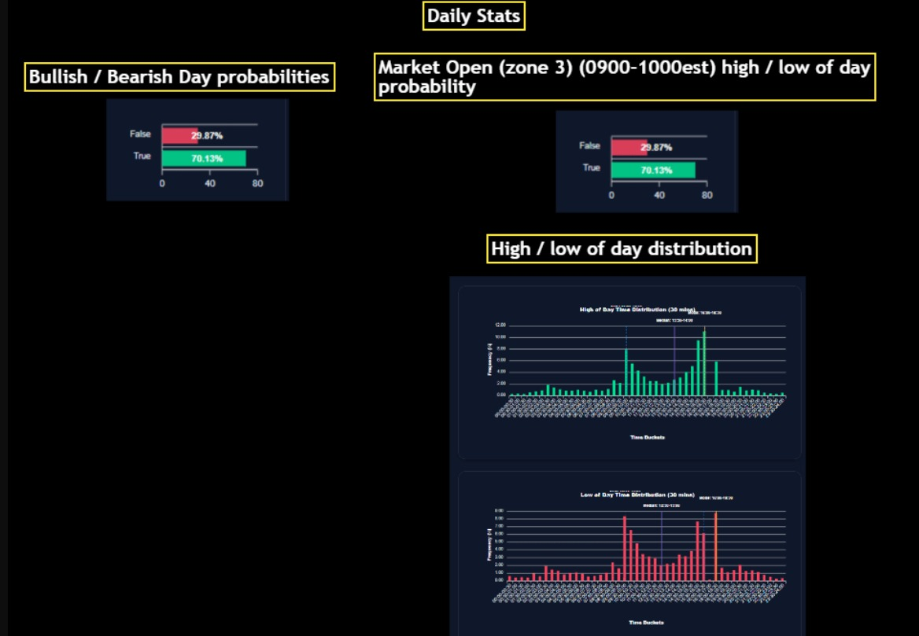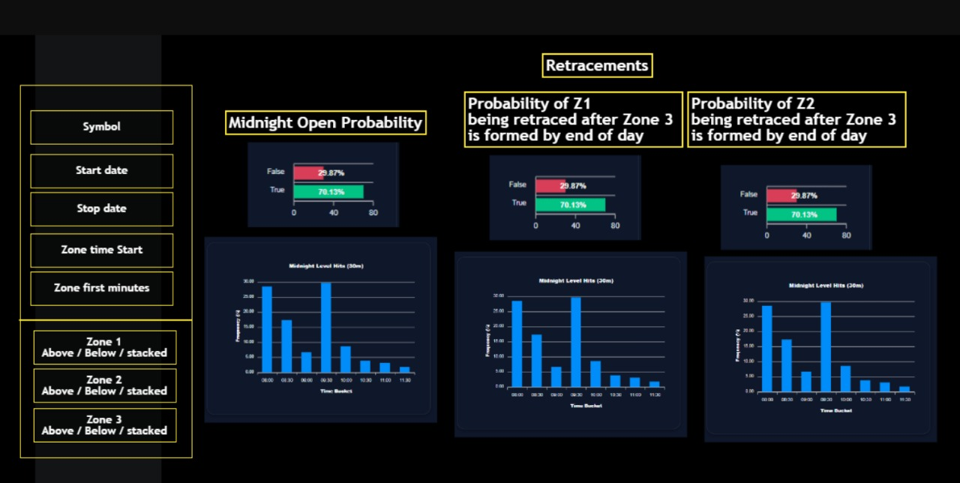

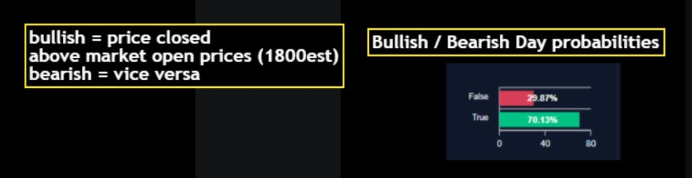

available table: f_ohlcv:

• ts_event (timestamp with time zone)

• rtype (integer)

• publisher_id (integer)

• instrument_id (integer)

• open (double precision)

• high (double precision)

• low (double precision)

• close (double precision)

• volume (bigint)

• symbol (text)

• category (text)

• minute (numeric)

• hour (numeric)

• week (numeric)



For the Zone 3 remember it starts at 0930 and then I need the customization for it to start at 0930 and slide the selector over to make it 0935 because that is very important

from the picture I see it looks as if it says I am making the zone 0900 and I am making the zone the first 30 minutes which would make the zone itself huge

I only want the first 5 minutes of 0930 which would be 0930-0935