Solitaire Game


Session 2023-2027

Submitted by:
Muhammad Talha 2023-CS-169

Supervised by:
Sir. Nazeef-ul-Haq

Course:
Data Structures and Algorithms

Department of Computer Science

University of Engineering and Technology,
Lahore, Pakistan

Project Description:

Classes:
- CStack (stack with linked list)
- Node (for implementing CStack)
- Card (UserControl)
- MoveCard (for Card Movement)
- StockPile (Queue implemented class with it’s Canvas)
- WastePile (Contains waste Stack and Canvas)
- TableauPile (Contains Tableau Stack and Canvas of Tableau)
- Foundation (Contains Foundation Stack and Canvas of foundation)
- Deck (Contains Array of Cards)
- Utility (static class with declaration of all entities)

Data Structures:
- Array: For storing Cards in Deck array in deck class.
- Linked List: for implementation of CStack class.
- Stack: Stack implemented with Linked List with InsertAtTail() as Push and RemoveAtTail() as Pop, because the cards in push and poped at the end of the tableau.
- Queue: Queue implemented with same Stack.
- Dictionary: As Hash Function, that returns card rank index from 1 to 13.

Functionalities:

Tableau Cards Display:
- Each time the game starts, the deck of cards is shuffled in the game and then displayed in the tableaus from 1 to 7 each increasing one/pile and the last card face is Up.
- There are no modes in game as East or Hard, the game randomly shuffles the deck and then places the cards in tableaus. However, there is a single function of EasyShuffle in code that places all aces in stock pile and the rest of cards are shuffled. But in game a Random Shuffle is Enabled, user can change through code not from game UI.
- Now the next remaining cards in the deck are enqueued in StockPile with all face Down.

Card Movement:
Players can double-click a card to auto-move it. Only applicable for FaceUp cards.
- In Single Card Move, first the game check if it fits in foundation either from tableau or waste pile.
- If it fits in foundation than checks if foundation is Empty than the selected card rank must be king, other wise it checks difference of the card rank with foundation top card rank,if it is One than check if they are from same Suit, than places the clicked card to that foundation.
- If no foundation pile meets requirement to place clicked card, than the function will check it’s relative position in each tableau, if correct position is found than card moves to that tableau.
- Card doesn’t move if no place found in tableau or foundation.
- In Multiple Card Movement, first the Move Function checks if the current clicked card can be placed in any other tabluea.
- If there is a valid move than checks its position in the Tableau. From bottom to top.
- Then pushes the cards under clicked card to a temporary stack including clicked card, than removes these cards from that tableau canvass.
- Finds the correct position for the clicked card in other tableaus and than pushes the top card in the temporary stack where all the cards are present, by poping the temporary stack and than pushing that card to tableau stack until it becomes Empty.
- Cards cannot move from Foundation Piles to Tableau Piles.

Draw Card:
- Players can draw cards from the stockpile one by one using the "Draw Card" button.
  - When the Draw Card button is clicked:
    - If the stockpile is not empty, a card is dequeued from the front of the stockpile.
    - The drawn card is flipped face-up and added to the waste pile.
    - The display is updated to reflect the new top card in the waste pile.
  - If the stockpile is empty:
    - The button changes to "Reset Stack".
    - Clicking "Reset Stack" recycles all cards from the waste pile back into the stockpile, turning there face-down.
    - The stockpile is not shuffled, and display is updated.
  - When both stockpile and waste pile are empty, the button displays "Empty" and becomes disabled.

Win Condition:
When the count of cards in each tableau becomes 13, mean when all the foundtions are full, than User has won the Game and Win Window Appears.

Weak Points:
- Auto Win Condition is not applied, user has to complete all the foundations.
- No Time and Score System for better user Experience.
- There is a little bug in Validation, during Multiple Card Movement, when these multiple cards are pushed to a temporary stack and then if correct position is not found they are removed from that tableau but not added in any tableau mean lost (Occurs Rarely).
- No Undo Redo System
These are weak points in project, and they will be my future Improvements.

WireFrames:
Figure 1-Start-Screen

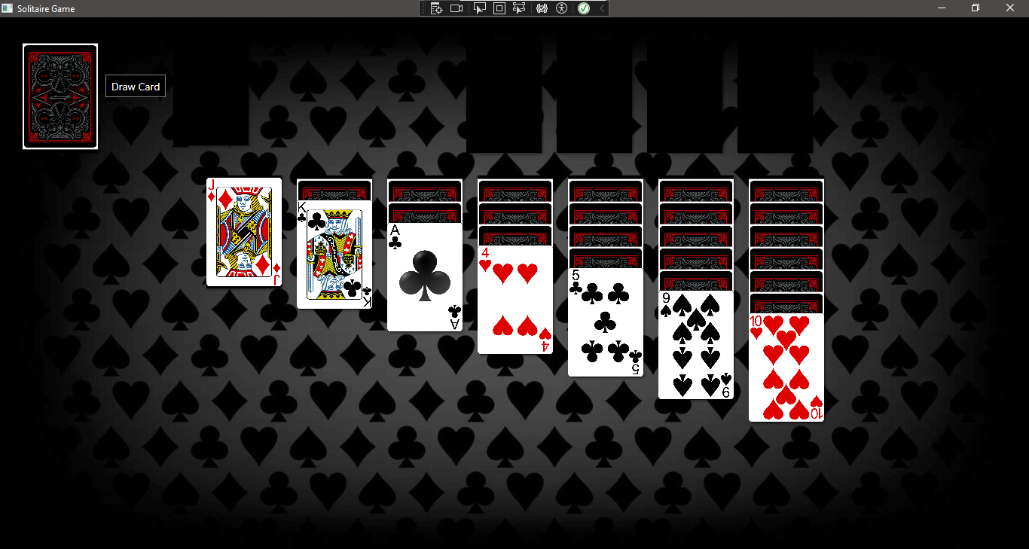
Main Game Window

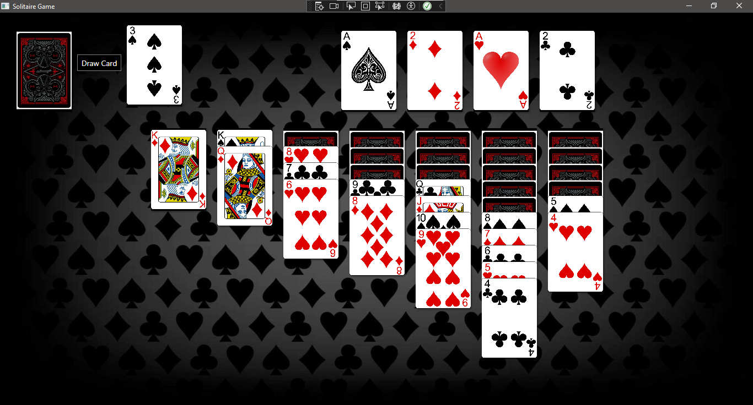
Playing Game – Card Movements

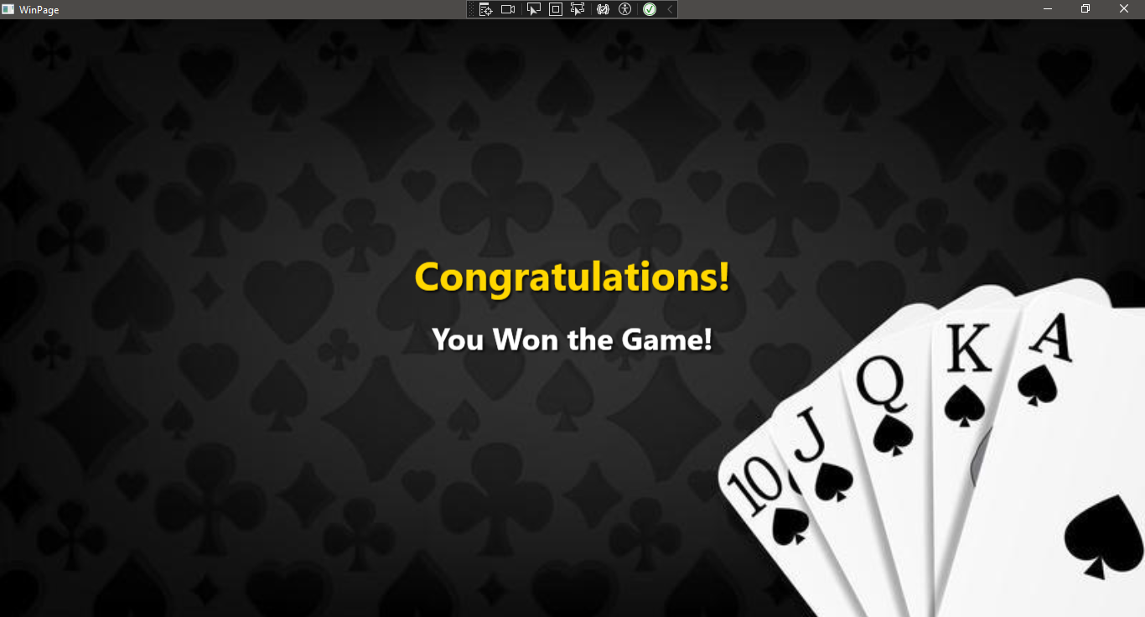
Win Condition Window

