**HTML**

Contents

**Chapter No 1 =>Structure/Introduction:** 9

What is HTML? 9

A Simple HTML Document 9

**Explained** 9

HTML History 10

**Chapter No 2 =>Text/Tages:** 12

**Chapter No 3 =>Lists:** 15

HTML List Tags 15

**Chapter No 4 =>Images:** 18

Image Size - Width and Height 18

You can use the style attribute to specify the width and height of an image. 18

Images on another Server/Website 18

Animated Images 19

Image as a Link 19

Image Floating 19

**HTML Image Maps:** 21

Background Image on a Page: 22

<style> body {   background-image: url('img_girl.jpg'); } </style> 22

Background Repeat: 22

<style> body {   background-image: url('example_img_girl.jpg'); } </style> 22

Background Non-Repeat: 22

<style> body {   background-image: url('example_img_girl.jpg');   background-repeat: no-repeat; } </style> 22

Background Cover: 22

<style> body {   background-image: url('img_girl.jpg');   background-repeat: no-repeat;   background-attachment: fixed;   background-size: cover; } </style> 22

**Chapter No 5 =>Tables:** 23

Define an HTML Table: 23

HTML Table - Add a Border: 23

To add a border to a table, use the CSS border property: 23

HTML Table - Collapsed Borders: 24

HTML Table - Add Cell Padding: 24

HTML Table - Left-align Headings: 25

HTML Table - Add Border Spacing: 26

HTML Table - Cell that Spans Many Columns: 27

HTML Table - Cell that Spans Many Rows: 28

HTML Table - Add a Caption: 29

<caption>Any Text</caption> 29

The text written in caption always in centre. 29

**Chapter No 6 =>Links:** 30

HTML Links – Hyperlinks: 30

HTML Links - The target Attribute: 30

HTML Links - Use an Image as a Link: 30

<a href="default.asp"> <img src="smiley.gif" alt="HTML tutorial" style="width:42px;height:42px;"> </a> 30

Link Titles: 30

<a href="https://www.w3schools.com/html/" title="Go to W3Schools HTML section">Visit our HTML Tutorial</a> 31

Link to an Email Address: 31

Button as a Link: 31

Absolute URLs vs. Relative URLs 31

**Chapter No 7 =>Blocks& span (div , span):** 32

**Block-level Elements:** 32

Inline Elements: 32

**Chapter No 8 =>class & Id:** 34

Using the class Attribute: 34

<!DOCTYPE html> 34

<html> 34

<head> 34

<style> 34

.city { 34

background-color: tomato; 34

color: white; 34

border: 2px solid black; 34

margin: 20px; 34

padding: 20px; 34

} 34

</style> 34

</head> 34

<body> 34

<div class="city"> 34

<h2>London</h2> 34

<p>London is the capital of England.</p> 34

</div> 34

Another Example By the Help of Span 35

<!DOCTYPE html> 35

<html> 35

<head> 35

<style> 35

.note { 35

font-size: 120%; 35

color: red; 35

} 35

</style> 35

</head> 35

<body> 35

<h1>My <span class="note">Important</span> Heading</h1> 35

<p>This is some <span class="note">important</span> text.</p> 35

</body> 35

</html> 35

</body> 35

</html> 35

Multiple Classes: 35

<h2 class="city main">London</h2> <h2 class="city">Paris</h2> <h2 class="city">Tokyo</h2> 35

Different Elements Can Share Same Class 36

<h2 class="city">Paris</h2> <p class="city">Paris is the capital of France</p> 36

**HTML id Attribute** 36

HTML Bookmarks with ID and Links: 36

<!DOCTYPE html> 36

<html> 36

<body> 36

<p><a href="#C4">Jump to Chapter 4</a></p> 37

<p><a href="#C6">Jump to Chapter 6</a></p> 37

<h2>Chapter 1</h2> 37

<p>This chapter explains ba bla bla</p> 37

<h2>Chapter 2</h2> 37

<p>This chapter explains ba bla bla</p> 37

<h2>Chapter 3</h2> 37

<p>This chapter explains ba bla bla</p> 37

<h2 id="C4">Chapter 4</h2> 37

<p>This chapter explains ba bla bla</p> 37

<h2>Chapter 5</h2> 37

<p>This chapter explains ba bla bla</p> 37

<h2 id="C6">Chapter 6</h2> 37

<p>This chapter explains ba bla bla</p> 37

<h2>Chapter 7</h2> 37

<p>This chapter explains ba bla bla</p> 37

</body> 37

</html> 37

Difference Between Class and ID: 37

<!DOCTYPE html> 37

<html> 37

<head> 37

<style> 38

/* Style the element with the id "myHeader" */ 38

#myHeader { 38

background-color: lightblue; 38

color: black; 38

padding: 40px; 38

text-align: center; 38

} 38

/* Style all elements with the class name "city" */ 38

.city { 38

background-color: tomato; 38

color: white; 38

padding: 10px; 38

} 38

</style> 38

</head> 38

<body> 38

<h2>Difference Between Class and ID</h2> 38

<p>A class name can be used by multiple HTML elements, while an id name must only be used by one HTML element within the page:</p> 38

<!-- An element with a unique id --> 38

<h1 id="myHeader">My Cities</h1> 38

<!-- Multiple elements with same class --> 38

<h2 class="city">London</h2> 38

<p>London is the capital of England.</p> 39

<h2 class="city">Paris</h2> 39

<p>Paris is the capital of France.</p> 39

<h2 class="city">Tokyo</h2> 39

<p>Tokyo is the capital of Japan.</p> 39

</body> 39

</html> 39

**Chapter No 9 =>Iframe:** 40

**HTML Iframes** 40

Iframe - Set Height and Width 40

<iframe src="demo_iframe.htm" height="200" width="300" title="Iframe Example"></iframe> 40

Another one is: 40

<iframe src="demo_iframe.htm" style="height:200px;width:300px;" title="Iframe Example"></iframe> 40

Iframe - Target for a Link 41

**Chapter No 10 =>Computer Code:** 43

HTML <kbd> For Keyboard Input 43

HTML <samp> For Program Output 43

HTML <var> For Variables 44

**Chapter No 11 =>HTML Entities:** 45

Some Useful HTML Character Entities 45

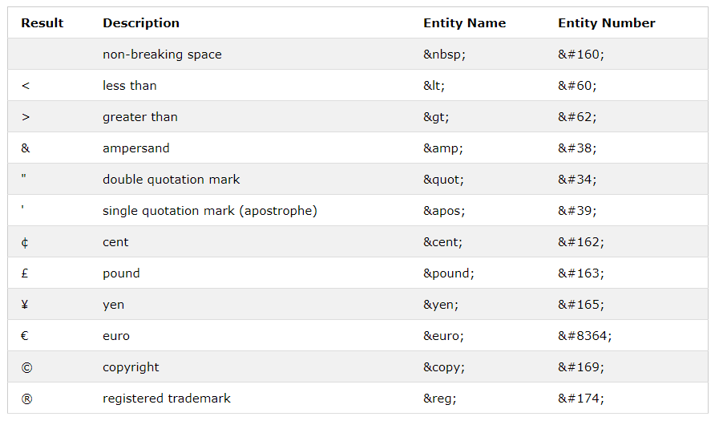 45

Combining Diacritical Marks 45

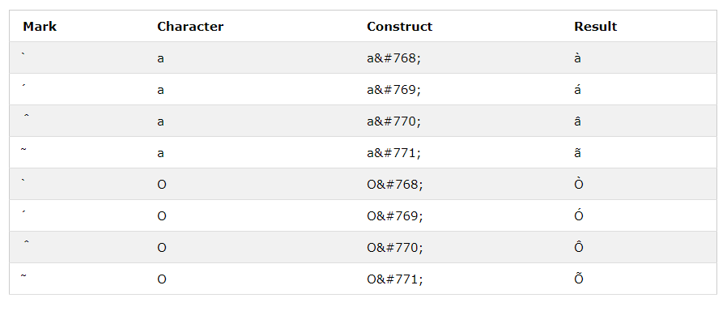 45

**Chapter No 12 =>HTML Symobls:** 46

Some Mathematical Symbols Supported by HTML 46

Some Greek Letters Supported by HTML 46

Some Other Entities Supported by HTML 47

**Chapter No 13 =>HTML Emojis:** 47

**Chapter No 14 =>HTML videos / audio / youtube / pdf** 48

The HTML <video> Element 48

<video width="320" height="240" controls>   <source src="movie.mp4" type="video/mp4">   <source src="movie.ogg" type="video/ogg"> Your browser does not support the video tag. </video> 48

HTML <video> Autoplay 48

<video width="320" height="240" autoplay>   <source src="movie.mp4" type="video/mp4">   <source src="movie.ogg" type="video/ogg"> Your browser does not support the video tag. </video> 48

HTML <video> Autoplay with mute 48

<video width="320" height="240" autoplay muted>   <source src="movie.mp4" type="video/mp4">   <source src="movie.ogg" type="video/ogg"> Your browser does not support the video tag. </video> 48

The HTML <audio> Element 48

<audio controls>   <source src="horse.ogg" type="audio/ogg">   <source src="horse.mp3" type="audio/mpeg"> Your browser does not support the audio element. </audio> 48

HTML <audio> Autoplay 48

<audio controls autoplay>   <source src="horse.ogg" type="audio/ogg">   <source src="horse.mp3" type="audio/mpeg"> Your browser does not support the audio element. </audio> 48

HTML <audio> Autoplay with mute 48

<audio controls autoplay muted>   <source src="horse.ogg" type="audio/ogg">   <source src="horse.mp3" type="audio/mpeg"> Your browser does not support the audio element. </audio> 48

Playing a YouTube Video in HTML 49

<iframe width="420" height="315" src="https://www.youtube.com/embed/tgbNymZ7vqY"> </iframe> 49

YouTube Autoplay + Mute 49

Add mute=1 after autoplay=1 to let your video start playing automatically (but muted). 49

<iframe width="420" height="315" src="https://www.youtube.com/embed/tgbNymZ7vqY?autoplay=1&mute=1"> </iframe> 49

YouTube Loop 49

YouTube Controls 49

# **Chapter No 1 =>Structure/Introduction:**

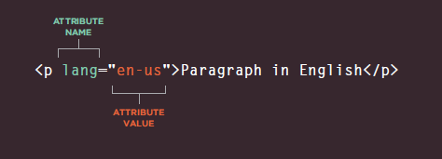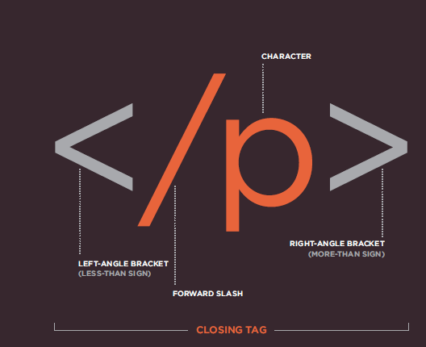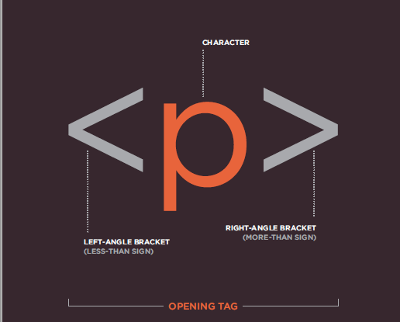

What is HTML?

* HTML stands for Hyper Text Markup Language
* HTML is the standard markup language for creating Web pages
* HTML describes the structure of a Web page
* HTML consists of a series of elements
* HTML elements tell the browser how to display the content
* HTML elements label pieces of content such as "this is a heading", "this is a paragraph", "this is a link", etc.

## A Simple HTML Document

<!DOCTYPE html>  
<html>  
<head>  
<title>Page Title</title>  
</head>  
<body>  
  
<h1>My First Heading</h1>  
<p>My first paragraph.</p>  
  
</body>  
</html>

### **Explained**

* The <!DOCTYPE html> declaration defines that this document is an HTML5 document
* The <html> element is the root element of an HTML page
* The <head> element contains meta information about the HTML page
* The <title> element specifies a title for the HTML page (which is shown in the browser's title bar or in the page's tab)
* The <body> element defines the document's body, and is a container for all the visible contents, such as headings, paragraphs, images, hyperlinks, tables, lists, etc.
* The <h1> element defines a large heading
* The <p> element defines a paragraph

## HTML History

Since the early days of the World Wide Web, there have been many versions of HTML:

|  |  |
| --- | --- |
| **Year** | **Version** |
| 1989 | Tim Berners-Lee invented www |
| 1991 | Tim Berners-Lee invented HTML |
| 1993 | Dave Raggett drafted HTML+ |
| 1995 | HTML Working Group defined HTML 2.0 |
| 1997 | W3C Recommendation: HTML 3.2 |
| 1999 | W3C Recommendation: HTML 4.01 |
| 2000 | W3C Recommendation: XHTML 1.0 |
| 2008 | WHATWG HTML5 First Public Draft |
| 2012 | [WHATWG HTML5 Living Standard](http://whatwg.org/html/) |
| 2014 | [W3C Recommendation: HTML5](http://www.w3.org/TR/html5/) |
| 2016 | W3C Candidate Recommendation: HTML 5.1 |
| 2017 | [W3C Recommendation: HTML5.1 2nd Edition](http://www.w3.org/TR/html51/) |
| 2017 | [W3C Recommendation: HTML5.2](http://www.w3.org/TR/html52/) |

* HTML pages are text documents.
* HTML uses tags (characters that sit inside angled brackets) to give the information they surround special meaning.
* Tags are often referred to as elements.
* Tags usually come in pairs. The opening tag denotes the start of a piece of content; the closing tag denotes the end.
* Opening tags can carry attributes, which tell us more about the content of that element.
* Attributes require a name and a value.
* To learn HTML you need to know what tags are available for you to use, what they do, and where they can go.

# **Chapter No 2 =>Text/Tages:**

**Headings:**

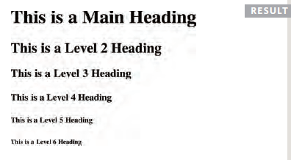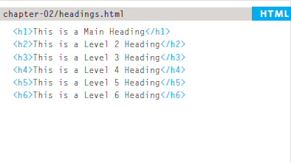HTML has six "levels" of headings:

**<p>**

To create a paragraph, surround the words that make up the paragraph with an opening **<p>** tag and closing **</p>** tag. By default, a browser will show each paragraph on a new line with some space between it an any subsequent paragraphs.

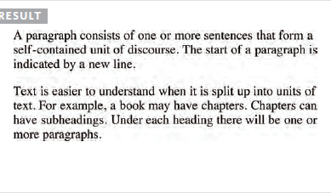

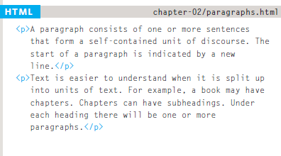

**Tages in HTML:**

**<b>(Bold)** This tag is used to bold . we can also use (**<strong>**) for bold.

**<i>(italic)** This tag is used to italic. we can also use (**<em>**) for ilatic.

**<pre>** Defines pre-formatted text

**<sup>(superscript)** is used for power for example: e<sup>2</sup> {e2}

**<sub>(subscript)** is used for bace for example: H<sup>2</sup>o {H2o}

**<br>(break)** This tag is used for break the line.

**<hr>(Horizantal)** This tag is used for horizontal line with line break.

**<q>(Quotation)** This tag is used for quote the given statement.

**<blockquote>(Quote)** This tag is used for quote

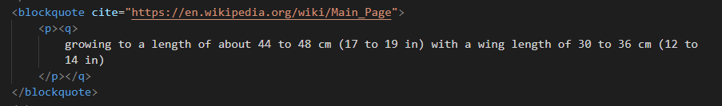

**<ins>(inserted)** The **<ins>** element can be used to show content that has been inserted into a document. We can also use <s> for inserted. **For example 2000**

**<del>** the **<del>** element can show text that has been deleted from it. **For example ~~3500.~~**

**<address>** The **<address>** element has quite a specific use: to contain contact details for the author of the page.

**<cite>** When you are referencing a piece of work such as a book, film or research paper, the **<cite>** element can be used to indicate where the citation is from.

**Abbreviations and Acronyms:**

<p>

<abbr title=” World Health Organization”>WHO</abbr>

</p>

<p>

<acronym title=” World Health Organization”>WHO</acronym>

</p>

**<small>** This tag is used for small the text.

**<!-- -->** Comment the text with in the tag.

**<Mark>** Defines marked/highlighted text

**<bdo>(Bi-Directional Override)**

<bdo dir="rtl">This line will be written from right to left</bdo>

**Output:** tfel ot thgir morf nettirw eb lliw enil sihT.

# **Chapter No 3 =>Lists:**

HTML List Tags

|  |  |
| --- | --- |
| **Tag** | **Description** |
| [<ul>](https://www.w3schools.com/tags/tag_ul.asp) | Defines an unordered list |
| [<ol>](https://www.w3schools.com/tags/tag_ol.asp) | Defines an ordered list |
| [<li>](https://www.w3schools.com/tags/tag_li.asp) | Defines a list item |
| [<dl>](https://www.w3schools.com/tags/tag_dl.asp) | Defines a description list |
| [<dt>](https://www.w3schools.com/tags/tag_dt.asp) | Defines a term in a description list |
| [<dd>](https://www.w3schools.com/tags/tag_dd.asp) | Describes the term in a description list |

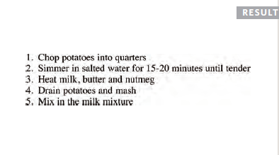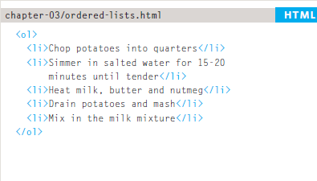**Ordered list:**

**Un-Ordered list:**

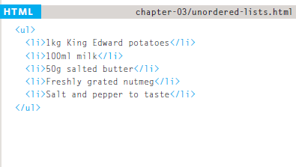

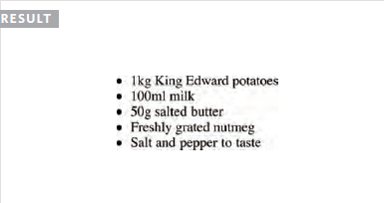

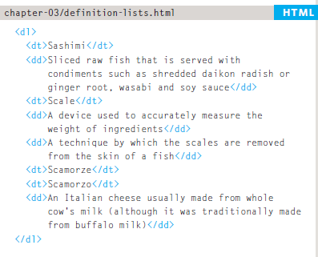**Description list:**

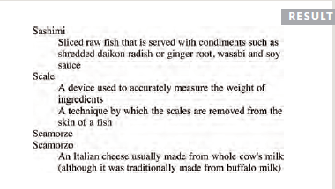

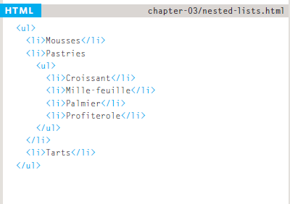**Nested list:**

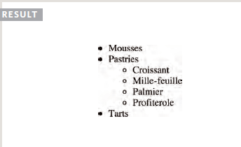

# **Chapter No 4 =>Images:**

<img src="image.jpg" alt="car Image" title="Toyota car>

**<img>**

To add an image into the page you need to use an **<img>** element. This is an empty element (which means there is no closing tag). It must carry the following two attributes:

**Src:**

This tells the browser where it can find the image file.

**alt**

This provides a text description of the image which describes the image if you cannot see it.

**title**

You can also use the **title** attribute with the **<img>** elementto provide additional informationabout the image.

## Image Size - Width and Height

## You can use the style attribute to specify the width and height of an image.

<img src="img_girl.jpg" alt="Girl in a jacket" style="width: 500px; height: 600px ;">

Alternatively, you can use the width and height attributes:

<img src="img_girl.jpg" alt="Girl in a jacket" width="500" height="600">

## Images on another Server/Website

Some web sites point to an image on another server.

To point to an image on another server, you must specify an absolute (full) URL in the src attribute:

<img src="https://www.w3schools.com/images/w3schools_green.jpg" alt="W3Schools.com">

## Animated Images

HTML allows animated GIFs:

<img src="programming.gif" alt="Computer Man" style="width:48px;height:48px;">

## Image as a Link

To use an image as a link, put the <img> tag inside the <a> tag:

<a href="https://ch-talha.web.app">

<img src="smiley.gif" alt="HTML tutorial" style="width:42px;height:42px;">

</a>

## Image Floating

Use the CSS float property to let the image float to the right or to the left of a text:

<p><img src="smiley.gif" alt="Smiley face" style="float:right;width:42px;height:42px;">  
The image will float to the right of the text.</p>

**Where to Place Images in Your Code:**

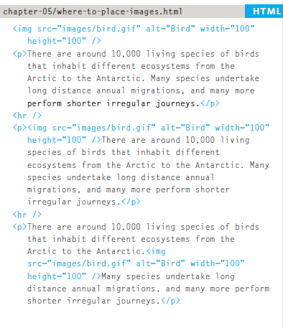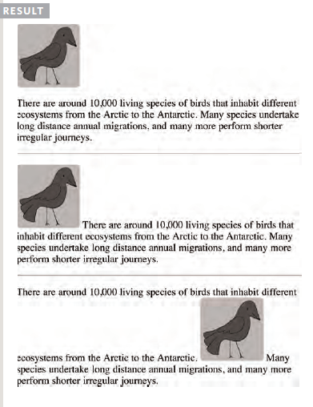

**Figure and Figure Caption**

<h1>Image caption</h1>

<figure>

<img src="[talha.jpeg](view-source:file:///E:/Web%20&%20Mobile%20Hybrid%20App%20Development/image/talha.jpeg)">

<br>

<figcaption>

This is a wonderful car and one of the best car which i recommended if i want to show my curicity

</figcaption>

</figure>

**Map:**

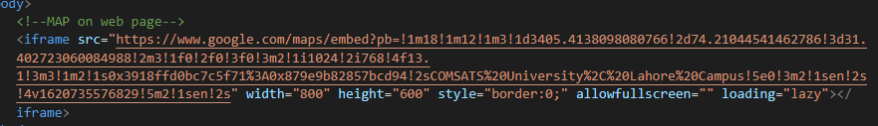

# **HTML Image Maps:**

<img src="workplace.jpg" alt="Workplace" usemap="#workmap">  
  
<map name="workmap">  
  <area shape="rect" coords="34,44,270,350" alt="Computer" href="computer.htm">  
  <area shape="rect" coords="290,172,333,250" alt="Phone" href="phone.htm">  
  <area shape="circle" coords="337,300,44" alt="Coffee" href="coffee.htm">  
</map>

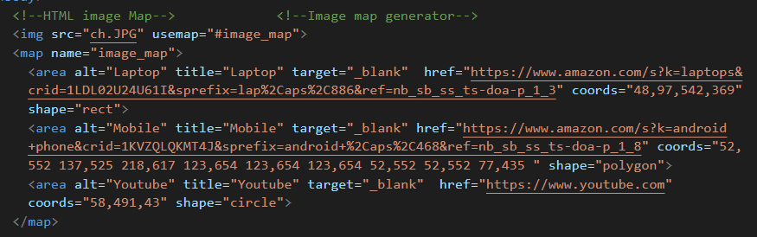

**Background Image:**

Add a background image on a HTML element:

<div style="background-image: url('img_girl.jpg');">

You can also specify the background image in the <style> element, in the <head> section

<style>  
div {  
  background-image: url('img_girl.jpg');  
}  
</style>

## Background Image on a Page:

## <style> body {   background-image: url('img_girl.jpg'); } </style>

## Background Repeat:

## <style> body {   background-image: url('example_img_girl.jpg'); } </style>

## Background Non-Repeat:

## <style> body {   background-image: url('example_img_girl.jpg');   background-repeat: no-repeat; } </style>

## Background Cover:

## <style> body {   background-image: url('img_girl.jpg');   background-repeat: no-repeat;   background-attachment: fixed;   background-size: cover; } </style>

# **Chapter No 5 =>Tables:**

## Define an HTML Table:

The <table> tag defines an HTML table.

Each table row is defined with a <tr> tag. Each table header is defined with a <th> tag. Each table data/cell is defined with a <td> tag.

By default, the text in <th> elements are bold and centered.

By default, the text in <td> elements are regular and left-aligned.

**A Simple Table:**

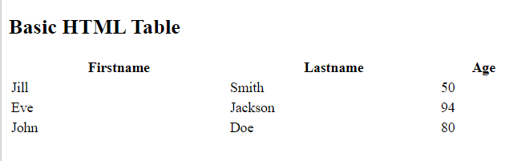<table style="width:100%">  
  <tr>  
    <th>Firstname</th>  
    <th>Lastname</th>  
    <th>Age</th>  
  </tr>  
  <tr>  
    <td>Jill</td>  
    <td>Smith</td>  
    <td>50</td>  
  </tr>  
  <tr>  
    <td>Eve</td>  
    <td>Jackson</td>  
    <td>94</td>  
  </tr>  
</table>

## HTML Table - Add a Border:

## To add a border to a table, use the CSS border property:

<head>

<style>

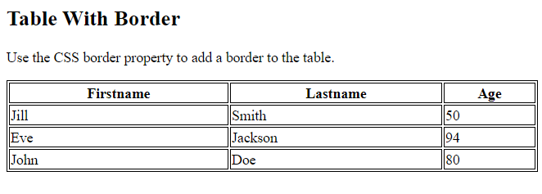table, th, td {

border: 1px solid black;

}

</style>

</head>

## HTML Table - Collapsed Borders:

To let the borders collapse into one border, add the CSS border-collapse property:

<head>

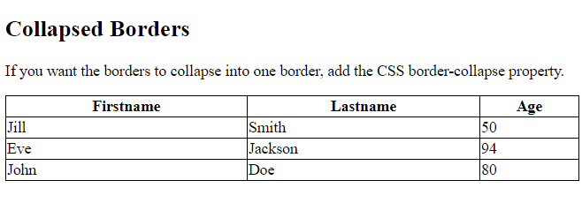<style>

table, th, td {

border: 1px solid black;

border-collapse: collapse;

}

</style>

</head>

## HTML Table - Add Cell Padding:

Cell padding specifies the space between the cell content and its borders.

If you do not specify a padding, the table cells will be displayed without padding.

To set the padding, use the CSS padding property:

<head>

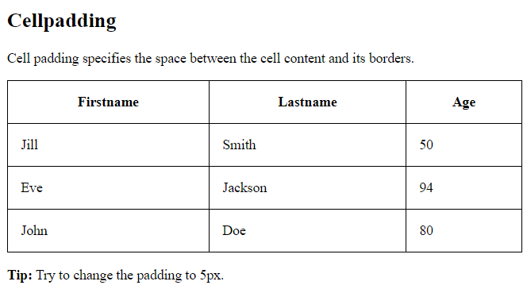<style>

table, th, td {

border: 1px solid black;

border-collapse: collapse;

}

th, td {

padding: 15px;

}

</style>

</head>

## HTML Table - Left-align Headings:

By default, table headings are bold and centered.

To left-align the table headings, use the CSS text-align property:

<head>

<style>

table, th, td {

border: 1px solid black;

border-collapse: collapse;

}

th, td {

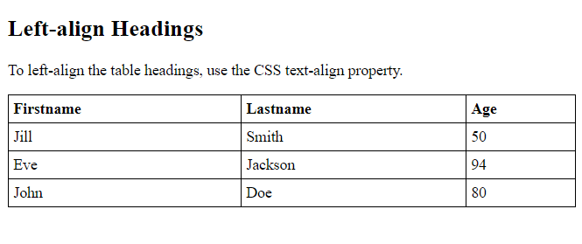 padding: 5px;

}

th {

text-align: left;

}

</style>

</head>

## HTML Table - Add Border Spacing:

Border spacing specifies the space between the cells.

To set the border spacing for a table, use the CSS border-spacing property:

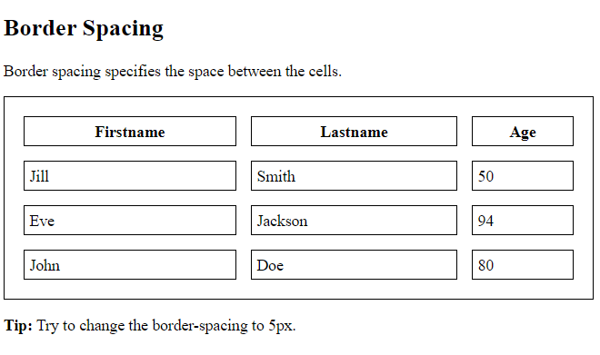<head>

<style>

table, th, td {

border: 1px solid black;

padding: 5px;

}

table {

border-spacing: 15px;

}

</style>

</head>

## HTML Table - Cell that Spans Many Columns:

To make a cell span more than one column, use the colspan attribute:

<!DOCTYPE html>

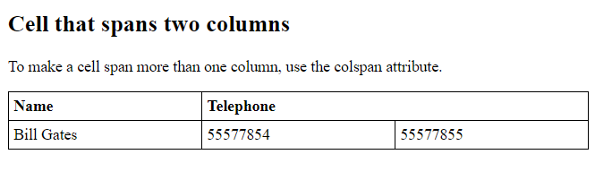<html>

<head>

<style>

table, th, td {

border: 1px solid black;

border-collapse: collapse;

}

th, td {

padding: 5px;

text-align: left;

}

</style>

</head>

<body>

<h2>Cell that spans two columns</h2>

<p>To make a cell span more than one column, use the colspan attribute.</p>

<table style="width:100%">

<tr>

<th>Name</th>

<th colspan="2">Telephone</th>

</tr>

<tr>

<td>Bill Gates</td>

<td>55577854</td>

<td>55577855</td>

</tr>

</table>

</body>

</html>

## HTML Table - Cell that Spans Many Rows:

To make a cell span more than one row, use the rowspan attribute:

<table style="width:100%">

<tr>

<th>Name:</th>

<td>Bill Gates</td>

</tr>

<tr>

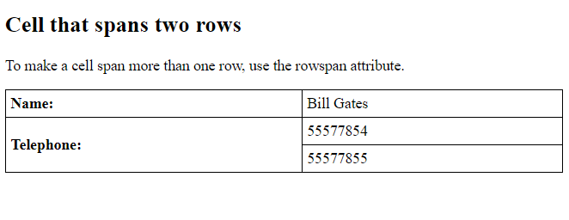 <th rowspan="2">Telephone:</th>

<td>55577854</td>

</tr>

<tr>

<td>55577855</td>

</tr>

</table>

## HTML Table - Add a Caption:

## <caption>Any Text</caption>

## The text written in caption always in centre.

**Important Points:**

* Use the HTML <table> element to define a table
* Use the HTML <tr> element to define a table row
* Use the HTML <td> element to define a table data
* Use the HTML <th> element to define a table heading
* Use the HTML <caption> element to define a table caption
* Use the CSS border property to define a border
* Use the CSS border-collapse property to collapse cell borders
* Use the CSS padding property to add padding to cells
* Use the CSS text-align property to align cell text
* Use the CSS border-spacing property to set the spacing between cells
* Use the colspan attribute to make a cell span many columns
* Use the rowspan attribute to make a cell span many rows
* Use the id attribute to uniquely define one table

**<thead> Group the header content in the body.**

**<tbody> Group the body content in the body.**

**<tfoot> Group the footer content in the body.**

# **Chapter No 6 =>Links:**

## HTML Links – Hyperlinks:

HTML links are hyperlinks.

You can click on a link and jump to another document.

When you move the mouse over a link, the mouse arrow will turn into a little hand.

The HTML <a> tag defines a hyperlink.

<a href="https://www.w3schools.com/">Visit W3Schools.com!</a>

## HTML Links - The target Attribute:

By default, the linked page will be displayed in the current browser window. To change this, you must specify another target for the link.

The target attribute specifies where to open the linked document.

The target attribute can have one of the following values:

* _self - Default. Opens the document in the same window/tab as it was clicked
* _blank - Opens the document in a new window or tab
* _parent - Opens the document in the parent frame
* _top - Opens the document in the full body of the window

<a href="https://www.w3schools.com/" target="_blank">Visit W3Schools!</a>

## HTML Links - Use an Image as a Link:

## <a href="default.asp"> <img src="smiley.gif" alt="HTML tutorial" style="width:42px;height:42px;"> </a>

## Link Titles:

The title attribute specifies extra information about an element. The information is most often shown as a tooltip text when the mouse moves over the element.

## <a href="https://www.w3schools.com/html/" title="Go to W3Schools HTML section">Visit our HTML Tutorial</a>

## Link to an Email Address:

Use mailto: inside the href attribute to create a link that opens the user's email program (to let them send a new email):

<a href="mailto:someone@example.com">Send email</a>

## Button as a Link:

To use an HTML button as a link, you have to add some JavaScript code.

JavaScript allows you to specify what happens at certain events, such as a click of a button:

<button onclick="document.location='default.asp'">HTML Tutorial</button>

## Absolute URLs vs. Relative URLs

**See the web pages**

# **Chapter No 7 =>Blocks& span (div , span):**

**Block-level Elements:**

A block-level element always starts on a new line.

A block-level element always takes up the full width available (stretches out to the left and right as far as it can).

A block level element has a top and a bottom margin, whereas an inline element does not.

The <div> element is a block-level element.

<div>Hello World</div>

|  |
| --- |
| Hello World |

**Here are the block-level elements in HTML:**

[<address>](https://www.w3schools.com/tags/tag_address.asp) [<article>](https://www.w3schools.com/tags/tag_article.asp) [<aside>](https://www.w3schools.com/tags/tag_aside.asp) [<blockquote>](https://www.w3schools.com/tags/tag_blockquote.asp) [<canvas>](https://www.w3schools.com/tags/tag_canvas.asp) [<dd>](https://www.w3schools.com/tags/tag_dd.asp) [<div>](https://www.w3schools.com/tags/tag_div.asp)

[<dl>](https://www.w3schools.com/tags/tag_dl.asp) [<dt>](https://www.w3schools.com/tags/tag_dt.asp) [<fieldset>](https://www.w3schools.com/tags/tag_fieldset.asp) [<figcaption>](https://www.w3schools.com/tags/tag_figcaption.asp) [<figure>](https://www.w3schools.com/tags/tag_figure.asp) [<footer>](https://www.w3schools.com/tags/tag_footer.asp)

[<form>](https://www.w3schools.com/tags/tag_form.asp) [<h1>-<h6>](https://www.w3schools.com/tags/tag_hn.asp) [<header>](https://www.w3schools.com/tags/tag_header.asp) [<hr>](https://www.w3schools.com/tags/tag_hr.asp) [<li>](https://www.w3schools.com/tags/tag_li.asp) [<main>](https://www.w3schools.com/tags/tag_main.asp)

[<nav>](https://www.w3schools.com/tags/tag_nav.asp) [<noscript>](https://www.w3schools.com/tags/tag_noscript.asp) [<ol>](https://www.w3schools.com/tags/tag_ol.asp) [<p>](https://www.w3schools.com/tags/tag_p.asp) [<pre>](https://www.w3schools.com/tags/tag_pre.asp) [<section>](https://www.w3schools.com/tags/tag_section.asp)

[<table>](https://www.w3schools.com/tags/tag_table.asp) [<tfoot>](https://www.w3schools.com/tags/tag_tfoot.asp) [<ul>](https://www.w3schools.com/tags/tag_ul.asp) [<video>](https://www.w3schools.com/tags/tag_video.asp)

## Inline Elements:

An inline element does not start on a new line.

An inline element only takes up as much width as necessary.

<span>Hello World</span>

Hello World

**Here are the inline elements in HTML:**

[<a>](https://www.w3schools.com/tags/tag_a.asp) [<abbr>](https://www.w3schools.com/tags/tag_abbr.asp) [<acronym>](https://www.w3schools.com/tags/tag_acronym.asp) [<b>](https://www.w3schools.com/tags/tag_b.asp) [<bdo>](https://www.w3schools.com/tags/tag_bdo.asp) [<big>](https://www.w3schools.com/tags/tag_big.asp) [<br>](https://www.w3schools.com/tags/tag_br.asp)

[<button>](https://www.w3schools.com/tags/tag_button.asp) [<cite>](https://www.w3schools.com/tags/tag_cite.asp) [<code>](https://www.w3schools.com/tags/tag_code.asp) [<dfn>](https://www.w3schools.com/tags/tag_dfn.asp) [<em>](https://www.w3schools.com/tags/tag_em.asp)

[<i>](https://www.w3schools.com/tags/tag_i.asp) [<img>](https://www.w3schools.com/tags/tag_img.asp) [<input>](https://www.w3schools.com/tags/tag_input.asp) [<kbd>](https://www.w3schools.com/tags/tag_kbd.asp) [<label>](https://www.w3schools.com/tags/tag_label.asp)

[<map>](https://www.w3schools.com/tags/tag_map.asp) [<object>](https://www.w3schools.com/tags/tag_object.asp) [<output>](https://www.w3schools.com/tags/tag_output.asp) [<q>](https://www.w3schools.com/tags/tag_q.asp) [<samp>](https://www.w3schools.com/tags/tag_samp.asp)

[<script>](https://www.w3schools.com/tags/tag_script.asp) [<select>](https://www.w3schools.com/tags/tag_select.asp) [<small>](https://www.w3schools.com/tags/tag_small.asp) [<span>](https://www.w3schools.com/tags/tag_span.asp) [<strong>](https://www.w3schools.com/tags/tag_strong.asp)

[<sub>](https://www.w3schools.com/tags/tag_sub.asp) [<sup>](https://www.w3schools.com/tags/tag_sup.asp) [<textarea>](https://www.w3schools.com/tags/tag_textarea.asp) [<time>](https://www.w3schools.com/tags/tag_time.asp) [<tt>](https://www.w3schools.com/tags/tag_tt.asp)

[<var>](https://www.w3schools.com/tags/tag_var.asp)

# **Chapter No 8 =>class & Id:**

## Using the class Attribute:

## <!DOCTYPE html>

## <html>

## <head>

## <style>

## .city {

## background-color: tomato;

## color: white;

## border: 2px solid black;

## margin: 20px;

## padding: 20px;

## }

## </style>

## </head>

## <body>

## <div class="city">

## <h2>London</h2>

## <p>London is the capital of England.</p>

## </div>

## Another Example By the Help of Span

## <!DOCTYPE html>

## <html>

## <head>

## <style>

## .note {

## font-size: 120%;

## color: red;

## }

## </style>

## </head>

## <body>

## <h1>My <span class="note">Important</span> Heading</h1>

## <p>This is some <span class="note">important</span> text.</p>

## </body>

## </html>

## </body>

## </html>

## Multiple Classes:

## <h2 class="city main">London</h2> <h2 class="city">Paris</h2> <h2 class="city">Tokyo</h2>

## Different Elements Can Share Same Class

## <h2 class="city">Paris</h2> <p class="city">Paris is the capital of France</p>

# **HTML id Attribute**

<!DOCTYPE html>

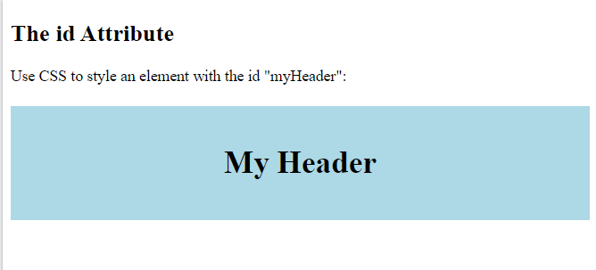<html>

<head>

<style>

#myHeader {

background-color: lightblue;

color: black;

padding: 40px;

text-align: center;

}

</style>

</head>

<body>

<h2>The id Attribute</h2>

<p>Use CSS to style an element with the id "myHeader":</p>

<h1 id="myHeader">My Header</h1>

</body>

</html>

## HTML Bookmarks with ID and Links:

## <!DOCTYPE html>

## <html>

## <body>

## <p><a href="#C4">Jump to Chapter 4</a></p>

## <p><a href="#C6">Jump to Chapter 6</a></p>

## <h2>Chapter 1</h2>

## <p>This chapter explains ba bla bla</p>

## <h2>Chapter 2</h2>

## <p>This chapter explains ba bla bla</p>

## <h2>Chapter 3</h2>

## <p>This chapter explains ba bla bla</p>

## <h2 id="C4">Chapter 4</h2>

## <p>This chapter explains ba bla bla</p>

## <h2>Chapter 5</h2>

## <p>This chapter explains ba bla bla</p>

## <h2 id="C6">Chapter 6</h2>

## <p>This chapter explains ba bla bla</p>

## <h2>Chapter 7</h2>

## <p>This chapter explains ba bla bla</p>

## </body>

## </html>

## Difference Between Class and ID:

## <!DOCTYPE html>

## <html>

## <head>

## <style>

## /* Style the element with the id "myHeader" */

## #myHeader {

## background-color: lightblue;

## color: black;

## padding: 40px;

## text-align: center;

## }

## /* Style all elements with the class name "city" */

## .city {

## background-color: tomato;

## color: white;

## padding: 10px;

## }

## </style>

## </head>

## <body>

## <h2>Difference Between Class and ID</h2>

## <p>A class name can be used by multiple HTML elements, while an id name must only be used by one HTML element within the page:</p>

## <!-- An element with a unique id -->

## <h1 id="myHeader">My Cities</h1>

## <!-- Multiple elements with same class -->

## <h2 class="city">London</h2>

## <p>London is the capital of England.</p>

## <h2 class="city">Paris</h2>

## <p>Paris is the capital of France.</p>

## <h2 class="city">Tokyo</h2>

## <p>Tokyo is the capital of Japan.</p>

## </body>

## </html>

# **Chapter No 9 =>Iframe:**

# **HTML Iframes**

<!DOCTYPE html>

<html>

<body>

<h2>HTML Iframes</h2>

<p>You can also use the CSS height and width properties to specify the size of the iframe:</p>

<iframe src="https://ch-talha.web.app" style="height:500px;width:700px" title="Iframe Example"></iframe>

</body>

</html>

## Iframe - Set Height and Width

## <iframe src="demo_iframe.htm" height="200" width="300" title="Iframe Example"></iframe>

## Another one is:

## <iframe src="demo_iframe.htm" style="height:200px;width:300px;" title="Iframe Example"></iframe>

**Iframe Borders:**

By default, an iframe has a border around it.

To remove the border, add the style attribute and use the CSS border property:

<iframe src="demo_iframe.htm" style="border:none;" title="Iframe Example"></iframe>

With CSS, you can also change the size, style and color of the iframe's border:

<iframe src="demo_iframe.htm" style="border:2px solid red;" title="Iframe Example"></iframe>

**Multiple Web page on Single Web page**

<!DOCTYPE html>

<html>

<head>

<title>

Ch Talha

</title>

</head>

<body>

<iframe src="https://ch-talha.web.app" style="border:2px solid red"> </iframe>

<iframe src="https://www.w3schools.com/html/" style="border:2px solid red" height="200" width="300" > </iframe>

</body>

</html>

## Iframe - Target for a Link

An iframe can be used as the target frame for a link.

The target attribute of the link must refer to the name attribute of the iframe:

<!DOCTYPE html>

<html>

<body>

<h2>Iframe - Target for a Link</h2>

<iframe src="demo_iframe.htm" name="iframe_a" height="300px" width="100%" title="Iframe Example"></iframe>

<p><a href="https://www.w3schools.com" target="iframe_a">W3Schools.com</a></p>

<p>When the target attribute of a link matches the name of an iframe, the link will open in the iframe.</p>

</body>

</html>

# **Chapter No 10 =>Computer Code:**

<!DOCTYPE html>

<html>

<body>

<h2>Computer Code</h2>

<p>Some programming code:</p>

<code>

x = 5;

y = 6;

z = x + y;

</code>

</body>

</html>

## HTML <kbd> For Keyboard Input

The HTML <kbd> element is used to define keyboard input. The content inside is displayed in the browser's default monospace font.

<!DOCTYPE html>

<html>

<body>

<h2>The kbd Element</h2>

<p>The kbd element is used to define keyboard input:</p>

<p>Save the document by pressing <kbd>Ctrl + S</kbd></p>

</body>

</html>

## HTML <samp> For Program Output

The HTML <samp> element is used to define sample output from a computer program. The content inside is displayed in the browser's default monospace font.

<!DOCTYPE html>

<html>

<body>

<h2>The samp Element</h2>

<p>The samp element is used to define sample output from a computer program.</p>

<p>Message from my computer:</p>

<p><samp>File not found.<br>Press F1 to continue</samp></p>

</body>

</html>

## HTML <var> For Variables

<!DOCTYPE html>

<html>

<body>

<h2>The var Element</h2>

<p>The area of a triangle is: 1/2 x <var>b</var> x <var>h</var>, where <var>b</var> is the base, and <var>h</var> is the vertical height.</p>

</body>

</html>

# **Chapter No 11 =>HTML Entities:**

## Some Useful HTML Character Entities

## 

## Combining Diacritical Marks

## 

# **Chapter No 12 =>HTML Symobls:**

## Some Mathematical Symbols Supported by HTML

## Some Greek Letters Supported by HTML

## Some Other Entities Supported by HTML

# **Chapter No 13 =>HTML Emojis:**

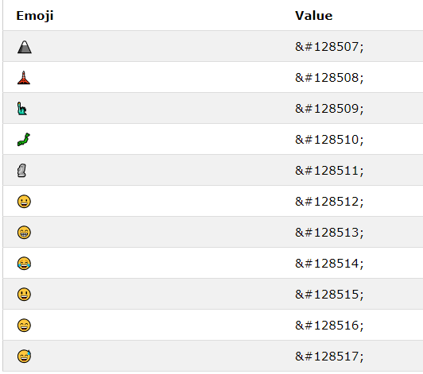

# **Chapter No 14 =>HTML videos / audio / youtube / pdf**

## The HTML <video> Element

## <video width="320" height="240" controls>   <source src="movie.mp4" type="video/mp4">   <source src="movie.ogg" type="video/ogg"> Your browser does not support the video tag. </video>

## HTML <video> Autoplay

## <video width="320" height="240" autoplay>   <source src="movie.mp4" type="video/mp4">   <source src="movie.ogg" type="video/ogg"> Your browser does not support the video tag. </video>

## HTML <video> Autoplay with mute

## <video width="320" height="240" autoplay muted>   <source src="movie.mp4" type="video/mp4">   <source src="movie.ogg" type="video/ogg"> Your browser does not support the video tag. </video>

## The HTML <audio> Element

## <audio controls>   <source src="horse.ogg" type="audio/ogg">   <source src="horse.mp3" type="audio/mpeg"> Your browser does not support the audio element. </audio>

## HTML <audio> Autoplay

## <audio controls autoplay>   <source src="horse.ogg" type="audio/ogg">   <source src="horse.mp3" type="audio/mpeg"> Your browser does not support the audio element. </audio>

## HTML <audio> Autoplay with mute

## <audio controls autoplay muted>   <source src="horse.ogg" type="audio/ogg">   <source src="horse.mp3" type="audio/mpeg"> Your browser does not support the audio element. </audio>

## Playing a YouTube Video in HTML

## <iframe width="420" height="315" src="https://www.youtube.com/embed/tgbNymZ7vqY"> </iframe>

## YouTube Autoplay + Mute

## Add mute=1 after autoplay=1 to let your video start playing automatically (but muted).

## <iframe width="420" height="315" src="https://www.youtube.com/embed/tgbNymZ7vqY?autoplay=1&mute=1"> </iframe>

## YouTube Loop

Add loop=1 to let your video loop forever.

Value 0 (default): The video will play only once.

Value 1: The video will loop (forever).

<iframe width="420" height="315"  
src="https://www.youtube.com/embed/tgbNymZ7vqY?playlist=tgbNymZ7vqY&loop=1">  
</iframe>

## YouTube Controls

Add controls=0 to not display controls in the video player.

Value 0: Player controls does not display.

Value 1 (default): Player controls display.

<iframe width="420" height="315"  
src="https://www.youtube.com/embed/tgbNymZ7vqY?controls=0">  
</iframe>

**HTML pdf:**

<iframe src="file.pdf"> <object data=file.pdf" type="application/pdf">

<embed src="file.pdf" type="application/pdf">