RFP-09
“Flyer Direct” — Digital Banking Portal Application Support, Maintenance & New Feature Development
Client: FlyerBank PLC (fictional) · Category: Application Support

Key Dates & Communication Protocol
Activity | Date & Time (BST) | Details
Written Q&A / Grooming Window | 31 July – 1 August 2026 (Closes 10:00 BST on 1 August) | Submit all questions in writing to islam.shaiful@bjitgroup.com.
Proposal Submission Deadline | 1 August 2026, 13:00 BST | Submit the proposal to the designated procurement folder. Late submissions will be accepted but recorded as late.
Vendor Presentation | 1 August 2026, 14:00 BST | Each vendor will have 10 minutes. The time limit will be strictly enforced. Presentations must be delivered in English.
Q&A Communication | Throughout the procurement process | All questions must be submitted in writing only to islam.shaiful@bjitgroup.com. Responses will be shared in writing with all proponents. Any verbal discussions are non-binding.

Table of Contents
1. About FlyerBank PLC 5
2. Background — A Mature Portal Needing Steady-State Support 5
2.1 Existing System Architecture (As-Built) 5
2.2 Existing Member User Flow 6
2.3 Current Infrastructure & Disaster Recovery Posture 7
2.4 Business & Volume Assumptions 8
3. Objectives 9
4. Scope of Work 9
4.1 Current Technology Stack (As-Built, Legacy) 10
4.2 Support Model 10
4.3 Change Request (CR) Process 11
4.4 AWS Environment & Monitoring 11
4.5 Initial New Feature Development 11
5. Items Retained by FlyerBank (Out of Vendor Scope) 11
6. Existing Features, New Feature Development & Support Requirements 12
6.1 Existing Feature List (As-Is) 12
6.2 New Feature Development (Initial Roadmap) 12
6.3 Support Categories 12
7. Non-Functional Requirements 12
8. Timeline Expectation 13
8.1 Roadmap at a Glance 13
9. Project Structure and Communication 14
10. Proposal Requirements 14
11. Selection Criteria and Commercial Terms 15
12. Appendix A — Volume & Environment Assumptions 15
13. Appendix B — Existing Feature List (As-Is) 16
14. Appendix C — New Feature Development (Initial Roadmap) 16
15. Appendix D — Support & Change Scope Detail 18
16. Appendix E — Glossary of Terms & Abbreviations 19

Request for Proposal
“Flyer Direct” — Digital Banking Portal Application Support, Maintenance & New Feature Development
This document is confidential and provided solely for preparing a proposal. Budget information will not be disclosed.

1. About FlyerBank PLC
FlyerBank PLC (“FlyerBank”) is a retail and small-business bank based in Dhaka, Bangladesh. It serves about 650,000 customers through 60 branches nationwide, plus a digital banking channel called “Flyer Direct.” FlyerBank follows Bangladesh Bank's rules on ICT security, including the Guideline on ICT Security for Banks and NBFIs (v4.0). A new Cyber Security Framework (v1.0) is also coming, and every scheduled bank must have it in place by 31 December 2026. Compliance, security and customer trust matter more to FlyerBank than almost anything else.
FlyerBank sources development partners, both offshore and nearshore, through its Technology Sourcing office. This engagement will run remotely, in English.

2. Background — A Mature Portal Needing Steady-State Support
“Flyer Direct” launched a little over three years ago and is now FlyerBank's main digital channel. About 400,000 registered members use it to check balances, move money, pay bills and pull e-statements. The original vendor built the portal and has supported it ever since, but that contract ends 30 September 2026 and won't be renewed.
FlyerBank needs a new partner to take over full application support — user support, infrastructure monitoring, front-end and back-end bug fixes, and change requests (CRs). Flyer Direct is a regulated banking channel, so it can't go dark even for a day; the handover from the outgoing vendor has to be smooth. Knowledge-transfer time is tight too, since the outgoing vendor's senior engineers are only required to stay available until the contract ends.

2.1 Existing System Architecture (As-Built)
The diagram below shows what's actually running in production today — it matches the stack described in Section 4.1. Use it for due diligence and knowledge transfer, not as a target architecture.
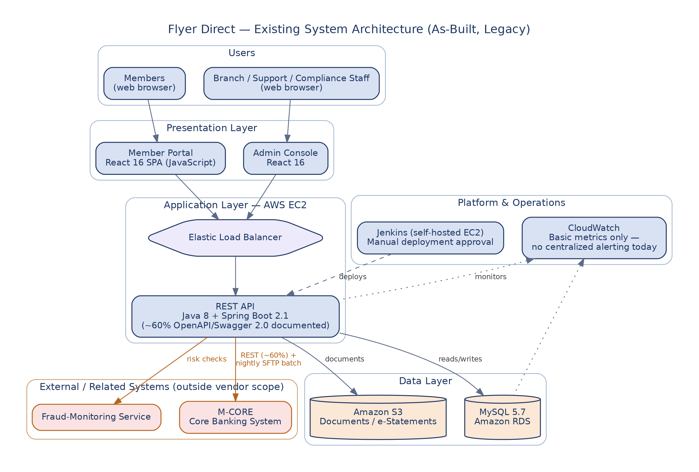

2.2 Existing Member User Flow
The flow below shows how a member uses the portal today. It references the existing features listed in Appendix B (EF-xx).
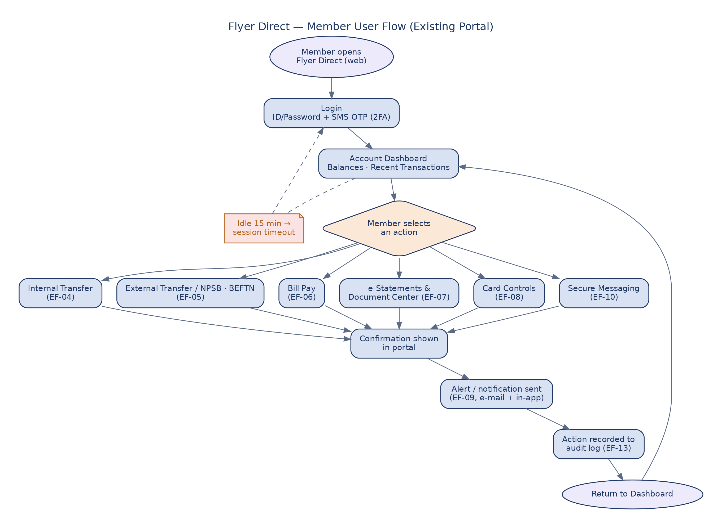

2.3 Current Infrastructure & Disaster Recovery Posture
The diagram below shows the current AWS infrastructure and what it can actually do for backup and recovery. FlyerBank is calling this gap out on purpose: today's environment doesn't meet the RTO/RPO targets in Section 7. Closing that gap is expected to be part of the vendor's early work, under Section 4.4.
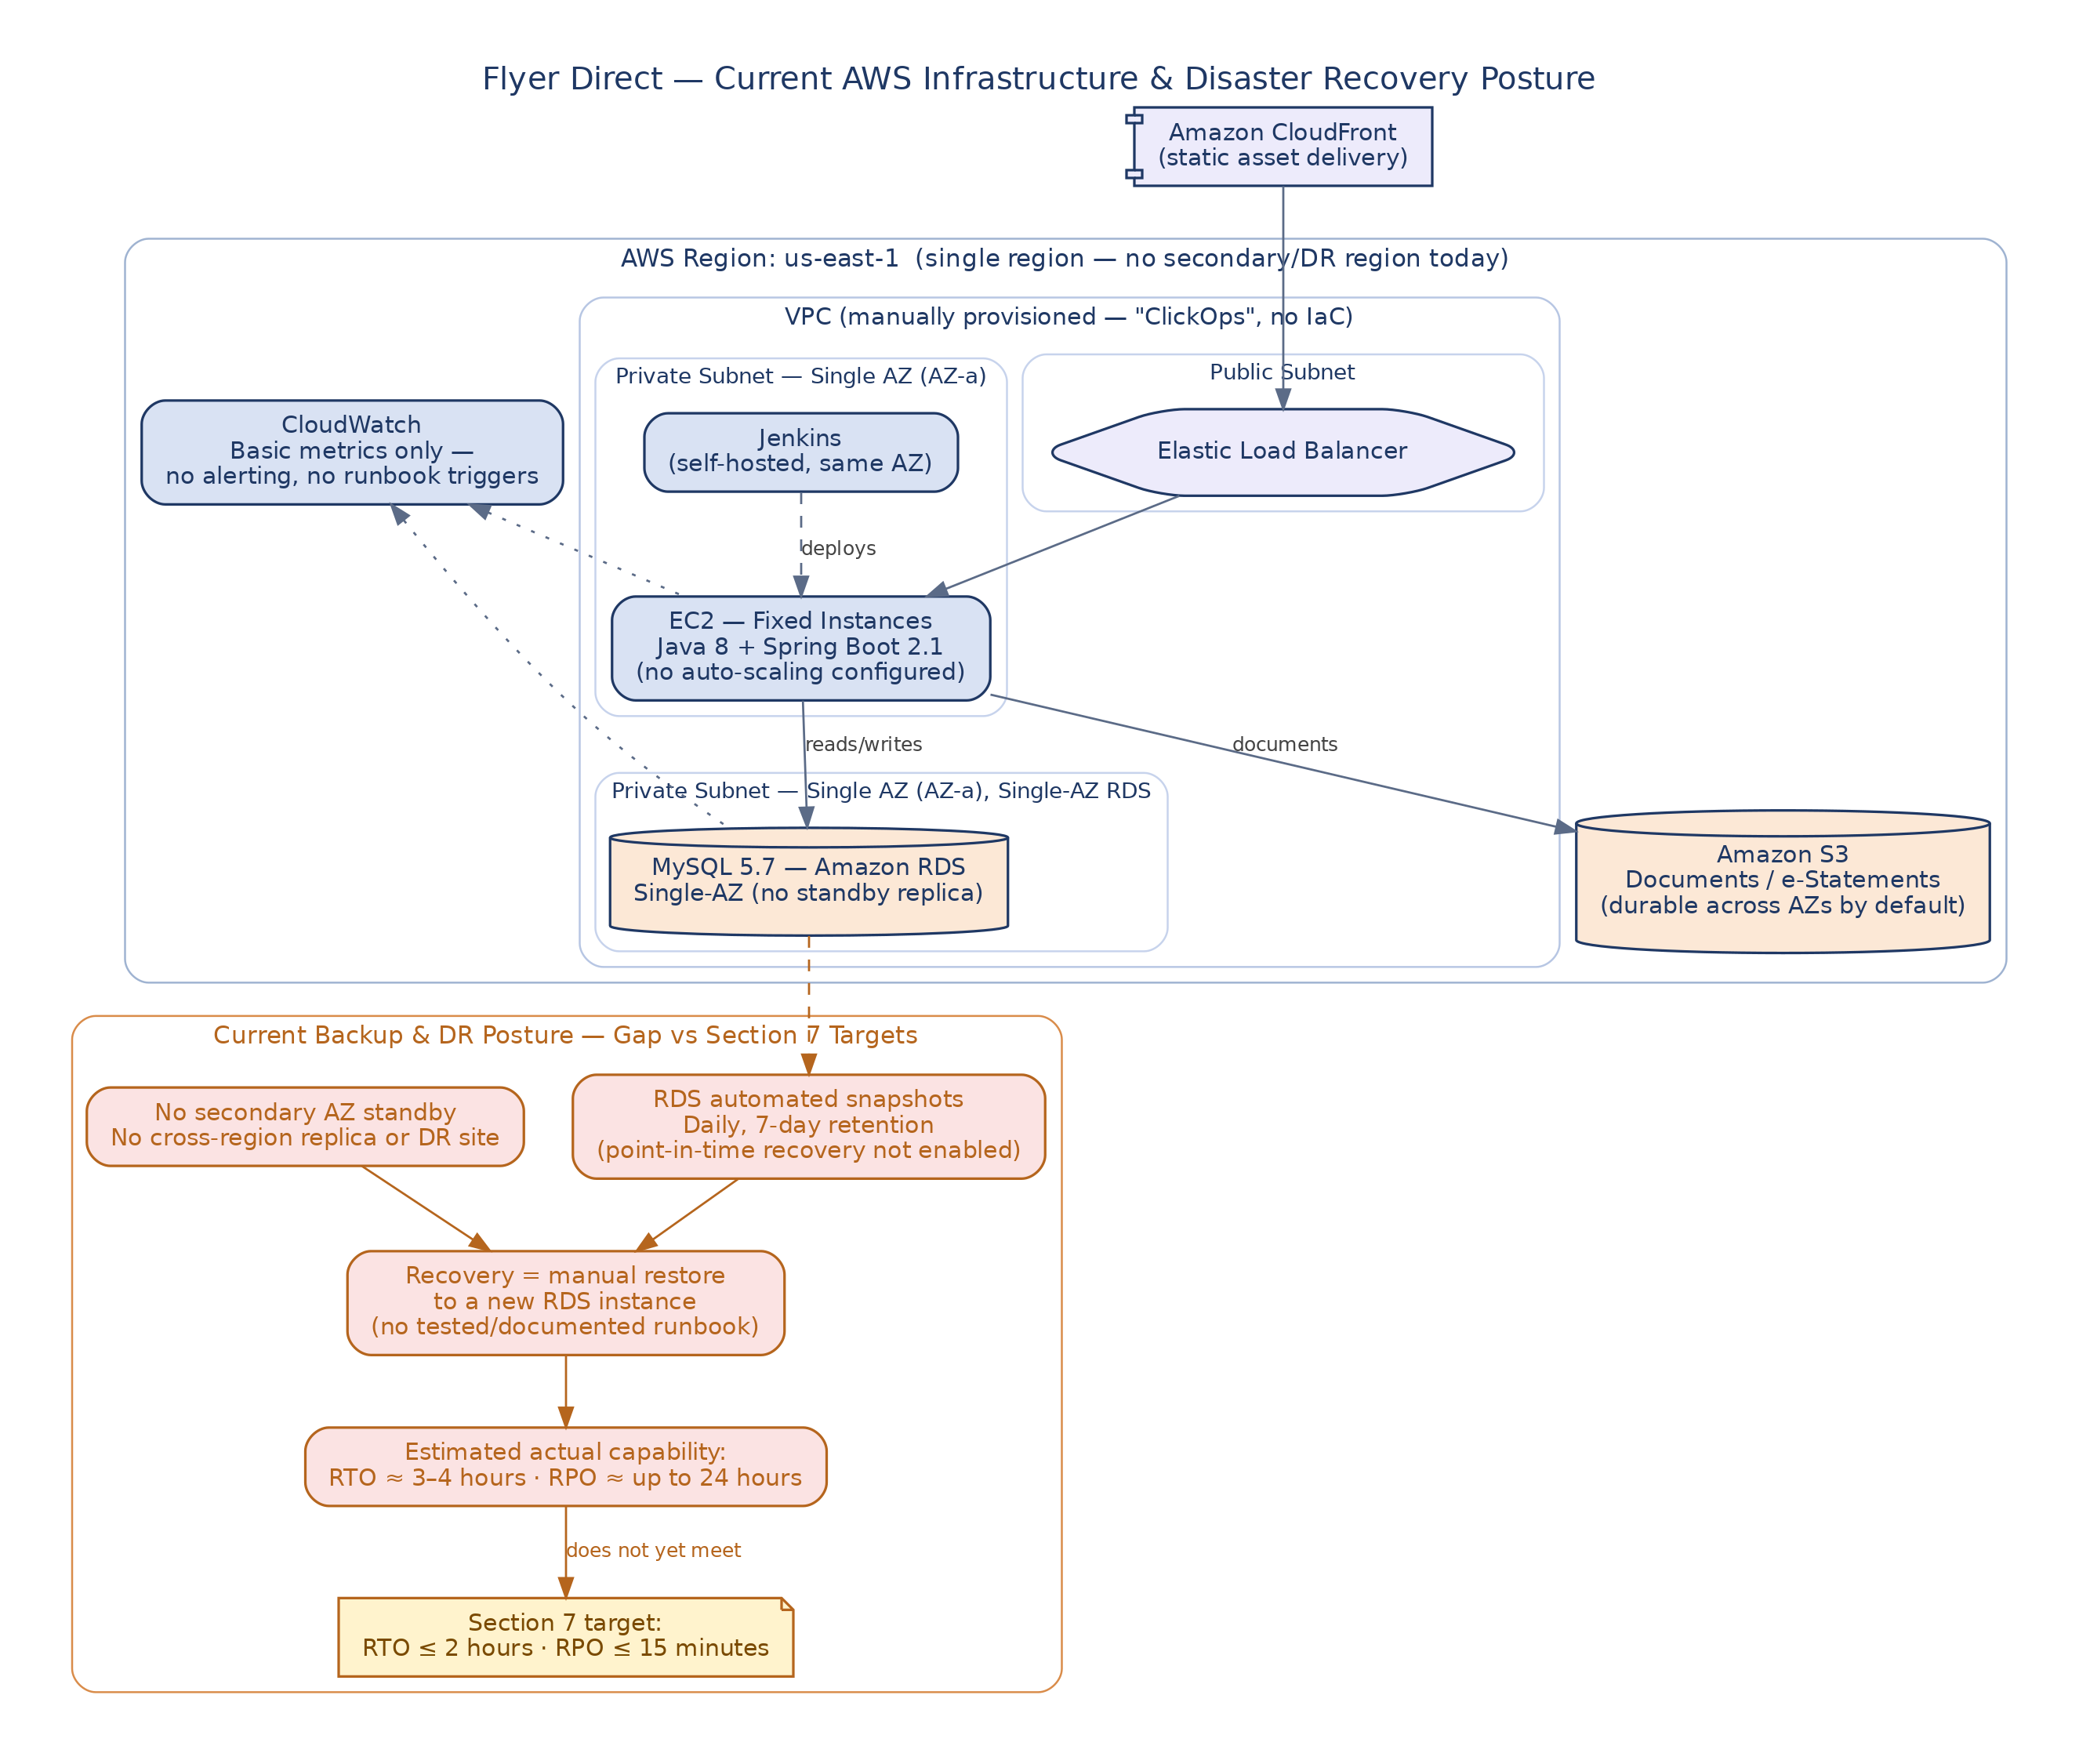

2.4 Business & Volume Assumptions
The business context below should help the vendor size staffing, capacity and support realistically before proposing. For the technical volume and environment figures — codebase size, environments, historical CR volume and so on — see Appendix A.
Item | Assumption
Digital adoption | About 250,000 monthly active users out of roughly 400,000 registered members — around 62% activation. Growth should stay steady, about 8–10% a year, over the 24-month initial term. This isn't a fast-scaling startup.
Daily transaction volume | Internal and external (NPSB/BEFTN) transfers combined average around 45,000–60,000 transactions a day. Peak days can run 2–3x that. Size infrastructure and support for the peak, not the average.
Seasonality | Two Eid periods — Eid-ul-Fitr and Eid-ul-Adha — bring predictable surges in remittances and withdrawals, and month-end salary disbursements bring another spike every month. None of this is a surprise, so build it into the capacity and staffing plan (see also S-09).
Customer segments | Retail and small-business members only — Flyer Direct doesn't serve corporate or wholesale banking clients. Large-value and bulk corporate payments go through a different channel, outside this RfP.
Branch network & geography | 60 branches across the country, concentrated in Dhaka, Chattogram and other divisional cities. The portal needs to work equally well for every member, no matter which branch or region they're in.
Currency & language | Everything runs in BDT only, and English is the working language for the UI and support. No multi-currency or Bangla localization is part of this contract right now.
Business criticality of downtime | Flyer Direct is FlyerBank's main digital channel, so any unplanned outage counts as a P1 business event no matter what caused it (see the Section 7 SLA). Outages hit member trust and draw regulatory attention fast.
Growth outlook for sizing | FlyerBank expects steady growth in users and ticket volume, not a startup-style spike. Treat the Appendix A numbers as a stable baseline with modest year-over-year growth — don't over-provision against them.

3. Objectives
- Take over support from the outgoing vendor with zero disruption — no gap in coverage.
- Give members and staff fast, SLA-bound support and bug fixes across the front end and back end.
- Get full visibility into the AWS infrastructure and monitor it proactively, so incidents go down instead of piling up.
- Run every change through a disciplined, costed CR process — nothing gets absorbed into scope quietly.
- Keep the compliance, audit and security posture that a regulated banking application needs.
- Deliver the first batch of new member-facing features already identified in Section 6.2 / Appendix C, alongside steady-state support, during the initial contract term.

4. Scope of Work
FlyerBank wants a proposal that covers two phases: knowledge transfer and transition from the outgoing vendor, then steady-state Application Managed Services (AMS). AMS means tiered user support, front-end and back-end bug fixes, AWS monitoring and operations, change request intake and delivery, release support, and security patching. FlyerBank has also already picked a first set of new member-facing features (Section 4.5 / Appendix C) to deliver during the initial term, through the standard CR process. Anything beyond CR-approved scope, along with product strategy and roadmap decisions, stays with FlyerBank (see Section 5).
Core requirements at a glance:
- Knowledge transfer and transition from the outgoing vendor, with no gap in support coverage through cutover (Section 8).
- Tiered user support — L1, L2 and L3 — for the ~400,000 registered members and ~60 admin-console users (Section 4.2).
- Front-end and back-end bug fixes across the existing Java/Spring Boot and React codebase (Section 4.1).
- Day-to-day AWS infrastructure operations: monitoring, alerting, patching, scaling and backup verification (Section 4.4).
- Change request (CR) intake, estimation and delivery through the standard governance process (Section 4.3).
- Release and deployment support through the existing Jenkins pipeline (S-07).
- Security patching and vulnerability remediation, including annual penetration-test findings (S-12).
- Delivery of the first set of new member-facing features — Appendix C, ND-01 through ND-06 — through the standard CR process (Section 4.5).
- Weekly progress and SLA reporting to FlyerBank stakeholders throughout the engagement (Section 9).

4.1 Current Technology Stack (As-Built, Legacy)
The stack below is what's actually deployed today — this isn't a mandate to modernize it. If the vendor sees risk anywhere (end-of-life components, for example), say so in the proposal and suggest an approach.
Layer | As Deployed
Backend | Java 8 + Spring Boot 2.1 (legacy; no framework upgrade mandated at contract start)
Frontend | React 16 (mixed class and hooks components), plain JavaScript — no TypeScript
Database | MySQL 5.7 on Amazon RDS
API style | REST; OpenAPI/Swagger 2.0 definitions exist for roughly 60% of endpoints
Cloud | AWS — EC2, RDS, S3, CloudFront, ELB; production account owned by FlyerBank
CI/CD | Jenkins, self-hosted on EC2; manual deployment approval
Monitoring | Basic CloudWatch metrics; no centralized alerting or log aggregation today

4.2 Support Model
- Support runs in tiers: L1 handles the help desk (password resets, how-to questions, first-line triage), L2 handles functional and configuration issues and coordinates with bank operations, and L3 fixes code-level bugs on the front end and back end.
- The vendor proposes the ticketing tool — ServiceNow or Jira Service Management is preferred — and integrates it with FlyerBank's ITSM process where that's feasible.
- Response and resolution targets are tied to severity (P1–P4) — see Section 7.
- Business-hours support is the baseline. If the vendor wants to offer extended or on-call coverage for P1 incidents, propose it and price it separately.

4.3 Change Request (CR) Process
- FlyerBank's Digital Product team owns the roadmap and sets priorities. The vendor executes whatever CRs that team approves.
- Every new feature, enhancement or scope change follows the same steps: impact analysis, then a costed CR, then written approval, then execution. No CR, no execution.
- Minor defect fixes — restoring behavior that was already documented or expected — are covered under the standard support SLA, not treated as CRs. The vendor needs to propose a clear line between “bug fix” and “enhancement,” because this has caused repeated friction with the outgoing vendor.

4.4 AWS Environment & Monitoring
- The vendor should assess the current AWS environment and propose improvements to monitoring and alerting — centralized dashboards, automated alerts, log aggregation.
- Day-to-day infrastructure operations are the vendor's job: patching, scaling, backup verification and incident response.
- FlyerBank keeps ownership of the production AWS account, and FlyerBank's infrastructure team has to approve any architecture changes.
- Today's environment was mostly built by hand, through manual console changes (“ClickOps”). Moving to Infrastructure as Code would be good, but it isn't required on day one — just state the approach and roadmap for getting there.

4.5 Initial New Feature Development
Beyond steady-state support, FlyerBank already has a short list of new member-facing features to deliver in the first phase of the contract — see Appendix C. Treat these as pre-scoped roadmap items: size and sequence them in the proposal. But each one still goes through the standard CR process in Section 4.3 — impact analysis, costed estimate, written approval — before work starts, because the Digital Product team keeps final say on priority and sign-off.
- Propose a phased delivery plan for the Appendix C items within the 24-month initial term, running alongside the steady-state support work.
- If an Appendix C feature needs a third party — a payment network, a document-imaging vendor — call it out explicitly in the proposal, with the expected lead time.

5. Items Retained by FlyerBank (Out of Vendor Scope)
- Product roadmap and feature priorities stay with FlyerBank's Digital Product team. The vendor can weigh in with input, estimates and feasibility checks, but doesn't set direction.
- UX and visual design for new or changed member-facing screens come from FlyerBank's in-house design team, delivered against each approved CR.
- The core banking system, M-CORE, is maintained by FlyerBank. Any change that touches M-CORE integration points needs FlyerBank's M-CORE team involved.
- Ownership of the production AWS account, final security and compliance sign-off, and regulatory audit ownership.
- Marketing content and legal/regulatory disclosure text.
- Tell us in the proposal how you'll manage dependencies on the items above.

6. Existing Features, New Feature Development & Support Requirements

6.1 Existing Feature List (As-Is)
“Flyer Direct” already provides the member-facing and admin features listed in Appendix B (EF-01 through EF-13). They're live in production today and form the baseline the vendor supports from day one — none of this is new development.

6.2 New Feature Development (Initial Roadmap)
FlyerBank has already picked the features in Appendix C (ND-01 through ND-06) as its next priorities. They're described here at a level good enough for proposal-stage sizing. Each one still gets confirmed in writing and formally approved through the CR process in Section 4.3 before build starts.

6.3 Support Categories
Appendix D spells out the support and change-handling categories. Three of them are mandatory from day one and can't be descoped: S-11 (roles, RBAC and audit support), S-12 (security patching and vulnerability remediation) and S-13 (incident management and on-call). The lists in Appendices B, C and D reflect FlyerBank's current understanding — confirm and refine any open points in writing during the RfP period.

7. Non-Functional Requirements
Aspect | Requirement
Availability | 99.9% monthly uptime for the member portal, measured outside a pre-announced maintenance window (up to 4 hours, once per month). Recovery objectives: RTO ≤ 2 hours, RPO ≤ 15 minutes.
Ticket SLAs | P1 (portal down / data integrity risk): response 15 minutes, target resolution 4 hours. P2 (major function impaired): response 1 hour, resolution 1 business day. P3 (minor defect, workaround exists): response 4 business hours, resolution 5 business days. P4 (cosmetic / low impact): scheduled into next release.
Performance | No degradation from current baseline: 95th-percentile server response ≤ 1.5 seconds; screen display ≤ 3 seconds under normal load. Vendor to establish a monitored baseline within the first 30 days of steady state.
Security | Full mitigation of OWASP Top 10 (2021); PCI DSS controls for payment-adjacent features; alignment with Bangladesh Bank's Guideline on ICT Security for Banks and NBFIs (v4.0) and the incoming Cyber Security Framework v1.0 (2026). SAST/DAST and dependency (SCA) scanning on all code touched by the vendor. Vulnerability remediation SLA by severity, proposed by vendor and agreed with FlyerBank InfoSec.
Client environment | OS: Windows 10/11, macOS 13+, iOS 16+, Android 12+. Browsers: latest two major versions of Chrome, Edge, Safari and Firefox. Responsive design already in place; no native app in this request.
Accessibility | WCAG 2.1 Level AA for all new or modified member-facing screens going forward.
Language | English is the operating language for support and documentation.
Auditability | Full activity logging for member actions and all admin-console operations; tamper-evident storage; 7-year retention per FlyerBank's regulatory record-keeping policy; clocks synchronized (NTP).

8. Timeline Expectation
Milestone | Expectation
Vendor finalized & contract awarded | Last week of August 2026
Knowledge transfer & shadow support | Starts 1 September 2026, parallel with the outgoing vendor
Full cutover — vendor sole support | 1 October 2026 — fixed; the outgoing vendor's contract and access end 30 September 2026
Steady-state AMS | October 2026 onward; initial term 24 months with an option to renew
Initial new-feature roadmap (Appendix C) | Vendor-proposed phased delivery within the first two quarters of steady state (target: by Q2 2027), run in parallel with steady-state support
Vendors should lay out their own transition plan and staffing ramp with key milestones, and be clear about any conditions attached to it.

8.1 Roadmap at a Glance
The calendar view below maps those milestones onto actual months — from this proposal presentation through cutover, steady-state support and the initial new-feature roadmap — so the vendor can see how knowledge transfer, handover and Appendix C delivery line up over time.
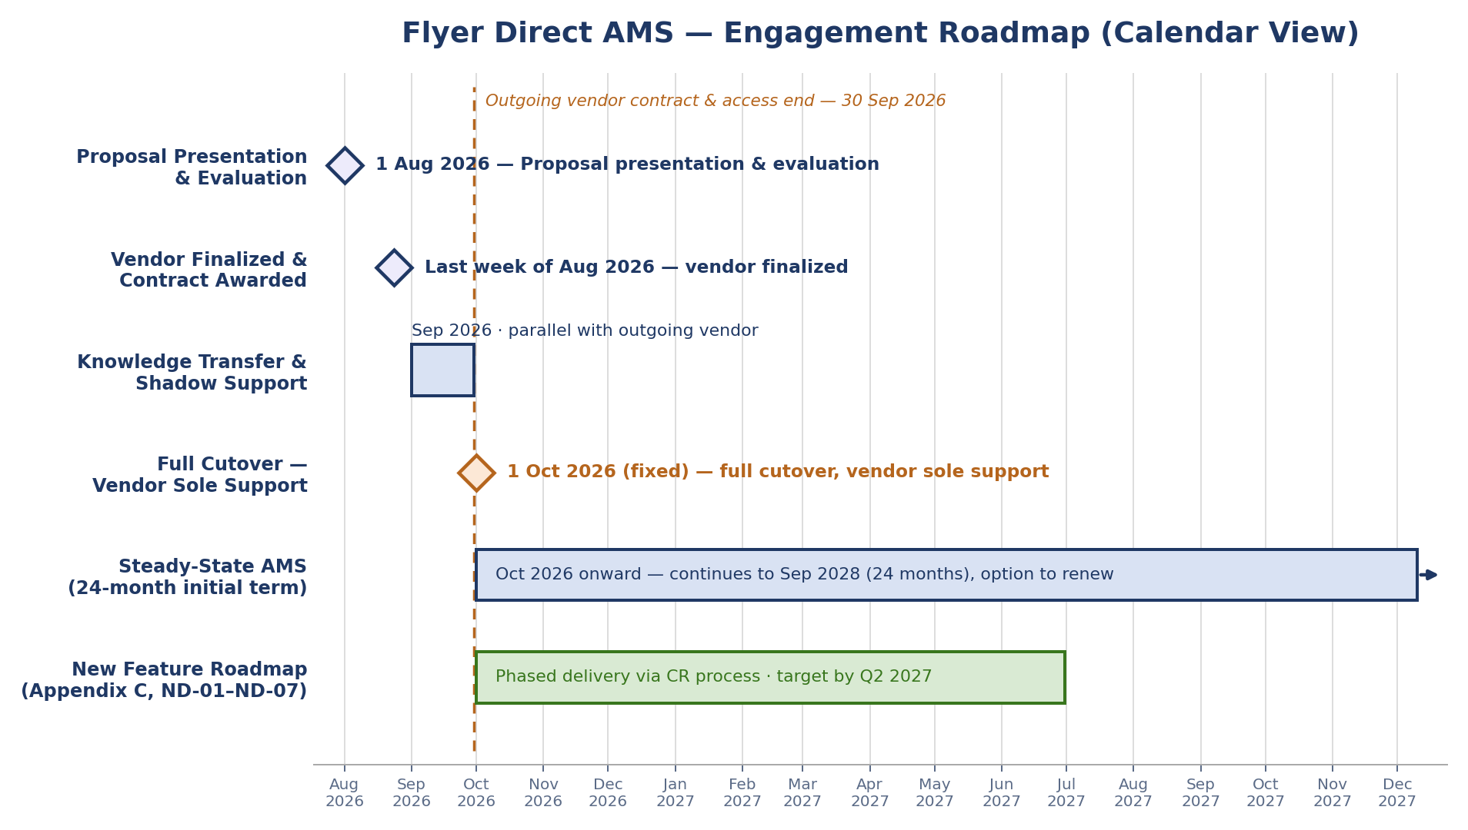

9. Project Structure and Communication
- All communication with FlyerBank goes through its Technology Sourcing office — remote, by chat and online meetings, in English.
- FlyerBank answers written questions submitted through the designated channel. Only written agreements count.
- Weekly progress and SLA reports are required, and every report needs to show ticket volumes, SLA attainment, open risks and dependencies.
- FlyerBank stakeholders include the Digital Product team (roadmap owner), IT Infrastructure, Information Security & Compliance, and the outgoing vendor, who's available only during knowledge transfer.

10. Proposal Requirements
The proposal should be in English and cover at least the following:
- Executive summary
- Scope of work and an explicit out-of-scope statement
- Knowledge-transfer and transition plan, including how you'll guarantee continuity of coverage through cutover
- Support model: tiers, staffing plan, on-call approach, and SLA commitments by severity
- A proposed solution for AWS monitoring/alerting improvements and patching cadence, including how you'd use AI tools to speed up triage and improve code-fix quality — with concrete, checkable claims, not just buzzwords
- Your estimate and how you got there — steady-state run rate, CR/enhancement pricing model, and a separate estimate for the Appendix C new-feature roadmap
- How you'll govern change requests, and how you'll decide “bug fix” vs. “enhancement”
- Your approach to managing risks, issues and dependencies, including assumptions
- Team structure and resourcing, including staffing for transition versus steady state
- Approval and version history of the proposal document

11. Selection Criteria and Commercial Terms
- We'll evaluate proposals on: how well you understand the legacy environment and the quality of your written clarifying questions; how sound and transparent your support/CR pricing model is; how well your technical solution fits our monitoring, security and AI needs; and how clear your proposal and presentation are.
- We won't disclose a budget. Present your pricing with a clear structure — fixed monthly retainer, time-and-materials, or a hybrid — and state your assumptions. Price the steady-state retainer separately from the Appendix C roadmap.
- If a defect is the vendor's responsibility, it gets fixed promptly under the support SLA at no extra cost — that's separate from CR-based enhancement work.
- All work products, code and documentation produced under this engagement become the property of FlyerBank.
- Any change to agreed scope follows the change-control procedure the vendor proposes (Section 4.3).
- FlyerBank may ask for a handful of extra admin or reporting functions based on internal feedback during the engagement — tell us how you'd handle requests like that.

12. Appendix A — Volume & Environment Assumptions
Item | Assumption
Registered users | Approximately 400,000; roughly 250,000 monthly active users (MAU)
Current ticket volume | Approximately 900–1,100 support tickets/month across all severities (outgoing vendor's last 6-month average)
Admin console users | About 60 (branch operations, compliance, customer service supervisors)
Codebase size | Backend ~180k lines of Java across 4 services; frontend ~90k lines of JavaScript/JSX
Environments | Dev, QA, staging, production — all on AWS, provisioned largely by hand over time
CR volume (historical) | Roughly 15–20 approved change requests per year under the outgoing vendor's contract
Outgoing vendor team | Currently 6 people (2 backend, 2 frontend, 1 infra, 1 support lead); availability during transition is limited to contracted hours only
Related systems | M-CORE (core banking), a fraud-monitoring service, and an internal document/e-statement archive
Payment network enrollment | FlyerBank is not currently enrolled in any real-time person-to-person payment network
Document-imaging vendor | FlyerBank has no existing contract with a check-imaging / remote-deposit-capture vendor

13. Appendix B — Existing Feature List (As-Is)
These features are already live in “Flyer Direct” and form the support baseline from day one.
ID | Feature | Current Functionality
EF-01 | Member enrollment | Existing customers self-enroll using account number and identity verification; no new-customer onboarding (FlyerBank has no digital-only accounts).
EF-02 | Login & authentication | ID/password login with SMS one-time-password (2FA); session timeout after 15 minutes idle.
EF-03 | Account dashboard | Balances and recent transaction history across checking, savings and loan accounts.
EF-04 | Internal transfers | Transfers between a member's own FlyerBank accounts.
EF-05 | External transfers (NPSB / BEFTN) | Transfers to and from accounts at other banks via NPSB (real-time, for smaller-value transfers) and BEFTN (batch settlement, for bulk/scheduled transfers), with standard hold periods.
EF-06 | Bill pay | Scheduled and one-time payments to registered payees.
EF-07 | e-Statements & document center | Statements and notices as PDF, with a filterable history.
EF-08 | Card controls | Lock/unlock debit card, report lost or stolen, request replacement.
EF-09 | Alerts & notifications | Balance, payment-due and login alerts via e-mail and in-portal message.
EF-10 | Secure messaging | Members submit inquiries to the bank and view response history in the portal.
EF-11 | Admin console — member operations | Member search, detail view, ticket handling, and basic account-status actions for branch and support staff.
EF-12 | Roles & RBAC | Role-based access across the admin console (see also S-11 in Appendix D).
EF-13 | Audit logging | Activity logging for member and admin actions (see also S-11 in Appendix D).

14. Appendix C — New Feature Development (Initial Roadmap)
FlyerBank's Digital Product team has prioritized these features for early delivery. Each one still gets confirmed and formally approved through the CR process (Section 4.3) before build starts — the detail below is just for proposal-stage sizing. Every feature comes with a worked example so the vendor can check its understanding before estimating.
ID | Feature | Description & Known Considerations | Illustrative Example
ND-01 | Remote check deposit (browser-based capture) | Capture and deposit a cheque using a member's phone or tablet camera through the existing responsive web portal — via the browser's standard camera/file-capture control, no native app required. Requires a third-party check-imaging/remote-deposit-capture (RDC) vendor integration; funds-availability rules must be reflected in the deposit-posting logic. | A member opens Flyer Direct in their phone's browser and photographs a BDT 20,000 client cheque using the page's camera-capture control; once the imaging vendor validates the scan, the deposit posts subject to the standard hold period.
ND-02 | Personal financial management (PFM) / spending insights | Categorized spending views and budgeting tools built from existing transaction data; no new external data source expected. | A member opens the Insights tab and sees that 35% of last month's spend went to utility bills and 20% to mobile recharge, with an alert that utility spend is trending above average.
ND-03 | Biometric / passkey login (web) | Face/fingerprint unlock for the existing responsive web portal via the browser's WebAuthn/passkey support — no native app required, works on modern mobile and desktop browsers — as a convenience layer on top of the current 2FA policy. | A returning member on a supported phone or laptop unlocks Flyer Direct with a fingerprint or face scan through the browser's built-in passkey prompt, instead of retyping password + SMS OTP; a brand-new device still requires full 2FA the first time.
ND-04 | Self-service dispute filing | Members initiate a card-transaction dispute directly in the portal; routes into the admin console's ticket queue for operations follow-up. | A member flags a BDT 1,200 charge they don't recognize directly from their transaction list; the case gets a tracking ID and appears in the branch operations queue the same day.
ND-05 | In-portal live chat | Real-time chat with a support agent within the existing web portal, integrated with the existing secure-messaging/ticketing flow in the admin console. | A member starts a live chat about a failed BEFTN transfer without leaving the portal; the conversation is saved alongside their existing support ticket history.
ND-06 | VAT & tax reporting on statements | Add Value Added Tax (VAT) and Advance Income Tax (AIT) breakdowns to e-statements, transaction receipts and service-charge invoices, in line with National Board of Revenue (NBR) requirements, plus a downloadable annual VAT/tax certificate. Vendor should confirm current VAT/AIT rates and NBR reporting format with FlyerBank Finance before build. | A member downloads their annual e-statement and sees total service charges paid, the 15% VAT charged on those fees, and AIT deducted on savings-account interest — matching the figures they need for their personal tax return.

15. Appendix D — Support & Change Scope Detail
S-11, S-12 and S-13 are mandatory from day one of steady-state support. This reflects FlyerBank's current understanding — confirm and refine any open points in writing during the RfP period.
ID | Category | Key Functions & Expected Handling
S-01 | L1 user support (help desk) | Password/lockout assistance, how-to guidance, first-line triage and ticket categorization for the ~400,000 registered members; escalation to L2/L3 per defined criteria.
S-02 | L2 functional support | Configuration and functional issues not requiring code changes (e.g., notification template edits, account-status corrections in the admin console) in coordination with bank operations.
S-03 | Front-end bug fixes (L3) | Diagnosis and resolution of member-portal and admin-console UI defects; regression coverage added for each fix; deployed under the standard release process.
S-04 | Back-end bug fixes (L3) | Diagnosis and resolution of API/service-layer defects, including issues surfaced through M-CORE integration; root-cause analysis recorded for recurring issues.
S-05 | CR intake & estimation | Impact analysis and costed estimate for each FlyerBank-initiated change request within an agreed turnaround time; options presented where schedule/scope trade-offs exist.
S-06 | CR delivery (approved enhancements) | Implementation, testing and release of approved CRs, including the Appendix C roadmap items once each is approved; design assets provided by FlyerBank's design team per Section 5.
S-07 | Release & deployment support | Coordination and execution of releases through the existing Jenkins pipeline; deployment runbooks maintained and kept current.
S-08 | Infra monitoring & alerting | Implementation and ongoing tuning of centralized monitoring/alerting (building on CloudWatch); on-call rotation for P1 infrastructure alerts.
S-09 | Backup, DR & capacity | Verification of backup jobs, periodic recovery testing against the stated RTO/RPO, and capacity/scaling recommendations ahead of known peak periods (e.g., Eid remittance season, month-end salary disbursement).
S-10 | Reporting & SLA dashboards | Weekly and monthly reporting on ticket volume, SLA attainment, CR status and infrastructure health, visible to FlyerBank stakeholders.
S-11 | Roles, RBAC & audit support (mandatory) | Maintenance of role-based access control across the admin console; support for periodic access-review exports required by Compliance.
S-12 | Security patching & vulnerability remediation (mandatory) | Regular dependency/OS/framework patching within agreed cadences; remediation of findings from scans or the annual penetration test within SLA by severity.
S-13 | Incident management & on-call (mandatory) | Formal incident-response process for P1/P2 events, including post-incident review and corrective-action tracking, with on-call coverage as proposed under Section 4.2.

16. Appendix E — Glossary of Terms & Abbreviations
These definitions should help the vendor read this RfP without ambiguity. Reference codes (EF-xx, ND-xx, S-xx, P1–P4) point back to wherever the full detail lives.
Term | Definition
2FA | Two-Factor Authentication — a login control requiring two independent proofs of identity (e.g., password plus a one-time SMS code).
AMS | Application Managed Services — the ongoing support, maintenance and enhancement services being procured under this RfP.
API | Application Programming Interface — a defined interface that lets one software system exchange data with another.
AWS | Amazon Web Services — the cloud provider hosting Flyer Direct's infrastructure.
AIT | Advance Income Tax — tax deducted at source by the bank on items such as savings-account interest, remitted to the National Board of Revenue (see ND-07).
Bangladesh Bank | The central bank of Bangladesh; the primary regulator referenced throughout this RfP (ICT security guidelines, inspections).
BEFTN | Bangladesh Electronic Funds Transfer Network — Bangladesh Bank's batch-settlement system for bulk/scheduled interbank fund transfers (see EF-05).
CI/CD | Continuous Integration / Continuous Deployment — automated pipelines for building, testing and releasing software.
CloudWatch | Amazon's monitoring and logging service, used today for basic infrastructure metrics (see Section 4.1, S-08).
CR | Change Request — FlyerBank's formal process for approving any new feature, enhancement or scope change (see Section 4.3).
CVE | Common Vulnerabilities and Exposures — a public identifier assigned to a known security vulnerability.
DR | Disaster Recovery — the plans and systems used to restore service after a major outage (see Section 2.3, S-09).
EC2 | Amazon Elastic Compute Cloud — AWS's virtual server (compute) service.
EF-xx | Existing Feature — reference code for the feature inventory in Appendix B (e.g., EF-05 = external transfers).
ELB | Elastic Load Balancer — the AWS component that distributes incoming traffic across application servers.
ICT | Information and Communication Technology.
IaC | Infrastructure as Code — managing infrastructure through versioned configuration files rather than manual console changes (“ClickOps”).
ITSM | IT Service Management — FlyerBank's processes for managing IT services, incidents and requests.
KT | Knowledge Transfer — the process by which the outgoing vendor hands over system knowledge to the incoming vendor.
L1 / L2 / L3 | Support tiers: Level 1 (help desk), Level 2 (functional/configuration support), Level 3 (code-level bug fixes). See Section 4.2.
Level AA | The middle of WCAG's three conformance tiers — A (minimum), AA (mid-level, the target for this RfP), and AAA (highest, not required here). Example: a low-contrast gray-on-white balance label that fails the 4.5:1 contrast ratio, or a transfer-confirmation dialog that can't be dismissed without a mouse, would each fail Level AA and need to be fixed on any new or modified screen (see Section 7, Accessibility).
M-CORE | FlyerBank's core banking system, maintained internally and outside vendor scope except for integration points (see Section 5, S-04).
MAU | Monthly Active Users.
NBFI | Non-Bank Financial Institution — a Bangladesh Bank-regulated financial institution that does not hold a full banking license.
NBR | National Board of Revenue — Bangladesh's tax authority, responsible for VAT and income-tax administration (see ND-07).
ND-xx | New Development — reference code for the new-feature roadmap in Appendix C (e.g., ND-01 = Remote check deposit).
NPSB | National Payment Switch Bangladesh — Bangladesh Bank's real-time interbank switch for card, ATM and fund-transfer transactions (see EF-05).
NTP | Network Time Protocol — used to synchronize system clocks for audit-log accuracy (see Section 7, Auditability).
OWASP Top 10 | The Open Web Application Security Project's list of the ten most critical web application security risks (see Section 7, Security).
P1–P4 | Ticket priority/severity levels, from P1 (critical, portal down) to P4 (cosmetic). See Section 7 for SLA targets by priority.
PCI DSS | Payment Card Industry Data Security Standard — a security standard for organizations handling card payment data.
PFM | Personal Financial Management — categorized spending and budgeting features (see ND-03).
RBAC | Role-Based Access Control — restricting system access based on a user's assigned role (see EF-12, S-11).
RDC | Remote Deposit Capture — depositing a cheque by photographing it via a phone/tablet browser, with no native app required (see ND-02).
RDS | Amazon Relational Database Service — AWS's managed database hosting service, running MySQL 5.7 today (see Section 4.1).
RPO | Recovery Point Objective — the maximum acceptable amount of data loss, measured in time, following an outage (see Section 7).
RTO | Recovery Time Objective — the maximum acceptable time to restore service after an outage (see Section 7).
S-xx | Support category code — reference used in Appendix D (e.g., S-11 = Roles, RBAC & audit support).
SAST / DAST | Static / Dynamic Application Security Testing — automated code-scanning and running-application security-testing techniques (see Section 7, Security).
SCA | Software Composition Analysis — scanning of third-party/open-source dependencies for known vulnerabilities.
SFTP | Secure File Transfer Protocol — used for the nightly batch file exchange between the REST API and M-CORE (see Section 2.1).
SLA | Service Level Agreement — a committed response/resolution target by ticket severity (see Section 7, Ticket SLAs).
SPA | Single-Page Application — the web application architecture used for the React member portal (see Section 4.1).
VAT | Value Added Tax — a consumption tax applied to service charges in Bangladesh, currently required on statements/receipts per NBR rules (see ND-07).
WCAG | Web Content Accessibility Guidelines — the international standard for making web content usable by people with disabilities. Example checks: text has a contrast ratio of at least 4.5:1 against its background, every image has meaningful alt text for screen readers, and every action reachable by mouse is also reachable by keyboard alone.

