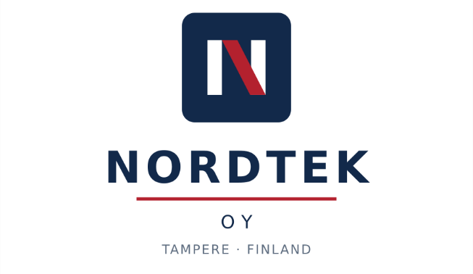

Request for Proposal
Project KOSKI-2
Built-in Oven Range - Mechanical Design Services in SolidWorks
RfP reference | NT-2026-KOSKI2-BD
Issue date | 31 July 2026
Q&A window closes | 1 August 2026, 10:00 BST
Proposal deadline | 1 August 2026, 13:00 BST
Presentation | 1 August 2026, 14:00 BST · 10 minutes
Intended for | Group 14 — The Tolerance Negotiators

COMMERCIAL IN CONFIDENCE

Document control
Document | Request for Proposal — Mechanical Design Services
Reference | NT-2026-KOSKI2-BD
Version | 1.0
Issued by | Product Engineering Procurement, NordTek Oy, Tampere, Finland
Classification | Commercial in Confidence. Named recipient only; onward distribution prohibited.
Design tool | SolidWorks 2024 SP5, in the NordTek PDM environment
Language | English, for all artifacts, communication and presentation
Workshop reference | RFP-14 · BJIT Delivery Excellence Workshop, 1 August 2026
Contents
1 Introduction and Invitation 3
2 Instructions to Proponents 3
3 Objective and Background 3
4 Product Architecture and Design Environment 3
5 Scope of Work 4
6 Out of Scope — Retained by NordTek 5
7 Design and Functional Requirements 5
8 Design Quality Requirements 6
9 Security, Confidentiality and Compliance Requirements 6
10 Estimation and Governance Requirements 7
11 Deliverables and Acceptance 8
12 Timeline Expectation 9
13 Project Structure, Communication and Collaboration 9
14 Commercial and Contractual Requirements 10
15 Proposal Requirements 10
16 Evaluation Criteria 11
17 Appendix A — Compliance Matrix 12
18 Appendix B — Commercial Response Schedule and Submission Checklist 12

1 Introduction and Invitation
NordTek Oy ("NordTek") invites proposals for mechanical design services in support of Project KOSKI-2, a new built-in electric oven range for the European market. NordTek designs and manufactures built-in cooking, hob and extraction appliances from its head office and design centre in Tampere, Finland.
This document is issued to obtain proposals and does not constitute an offer. Throughout, shall indicates a mandatory requirement, should a preference, and may an option. Respondents are referred to as Proponents. This RfP is confidential and shall not be shared outside the recipient organisation.

2 Instructions to Proponents
Questions and grooming | Written Q&A window and grooming session, 31 July – 1 August 2026, closing 1 August 2026 at 10:00 BST.
Form of questions | In writing only, azizul.islam@bjitgroup.com from the Proponent’s own registered email address. Answers are shared in writing with all Proponents. Verbal exchanges are not binding.
Proposal deadline | 1 August 2026, 13:00 BST, to the NordTek procurement folder. Late proposals are accepted but are recorded as late.
Presentation | 1 August 2026, 14:00 BST. Ten minutes per Proponent, strictly enforced, in English.
Form of response | A single PDF package, in the order of Section 15, with Appendix A and Appendix B completed.
Bid costs | Each Proponent bears its own costs of responding. NordTek does not reimburse bid costs.
Validity | Proposals shall remain valid for 90 days from the proposal deadline.
No obligation | NordTek is not obliged to award any contract, or to award to the lowest-priced proposal, and may amend or withdraw this RfP at any time.

3 Objective and Background
NordTek seeks a design partner able to take defined mechanical design work packages from concept direction through to drawing release, working to NordTek standards inside the NordTek PDM environment, with the governance maturity to manage change, risk and escalation across an offshore engagement and to deliver against a fixed design freeze date.
Project KOSKI-2 replaces the current built-in oven range. It covers the cavity and body structure, the door assembly, the fascia and control housing, and the parts interfacing with surrounding cabinetry.

4 Product Architecture and Design Environment
Attribute | Position
Product category | Built-in electric oven
Installation | Standard built-in niche, column and under-worktop
Cavity construction | Enamelled steel cavity, insulated, with sheet-metal outer structure
Nominal niche width | 600 mm. Additional widths are under evaluation.
Exterior materials | Stainless steel outer panels. Toughened glass fascia and door outer on selected models.
Moulded parts | Flame-retardant thermoplastics, with higher-specification grades in high-temperature locations.
Joining | Self-piercing rivets and screw fixings, with adhesive bonding at glass interfaces.
3D design tool | SolidWorks 2024 SP5. An evaluation of 3DEXPERIENCE SOLIDWORKS is underway within the engineering organisation.
Data environment | NordTek PDM, accessed through a NordTek-provided virtual desktop environment.

The control system and heating elements are supplied to the programme. Cavity, door, fascia and mounting parts shall accommodate their installation.

5 Scope of Work

5.1 Work packages
Ref | Work package
WP-01 | Cavity and structural sheet-metal parts
WP-02 | Door assembly — outer, inner, pane retention, seal interface and handle
WP-03 | Fascia, control housing and moulded parts
WP-04 | Interface, trim and cabinetry-fit parts
WP-05 | Drawings and GD&T
WP-06 | Tolerance stack-up
WP-07 | Design change implementation
WP-08 | Simulation preparation and design quality verification

5.2 Indicative volume
Parameter | Indicative position
Parts in scope | Approximately 115 to 135
Door assemblies | Approximately 2 to 3
Drawings | For the majority of released parts
Carryover content | A proportion of parts are carryover, in scope for review and update as necessary
Change activity | Consistent with previous programmes of similar scope
Peak resourcing | In the second and third quarters of the engagement

These figures reflect the current position of the product engineering working group and are indicative only. The Proponent shall state the volume assumptions on which its response is based and shall record them in its Assumptions Register.

6 Out of Scope — Retained by NordTek
- Manufacturing engineering, including tooling, press planning, the enamelling line and assembly line planning
- Physical validation, including prototype build, safety and EMC testing, durability testing, certification and CE conformity assessment
- Simulation execution and validation sign-off, thermal and structural
- Industrial design, visible-surface creation and styling authority
- Final design release authority in the NordTek PDM system
- Direct communication with channel partners and certification bodies
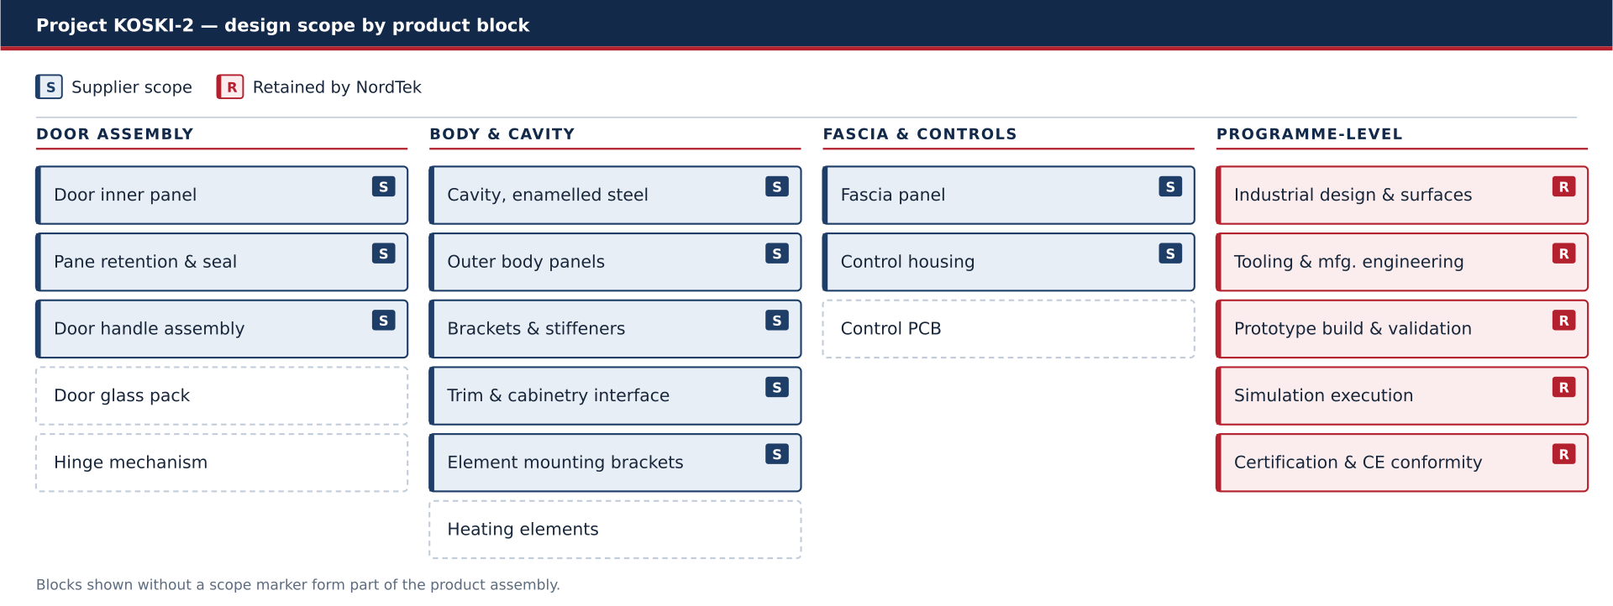
Figure 1 — Project KOSKI-2 design scope by product block.

7 Design and Functional Requirements
ID | Requirement
FR-01 | The Supplier shall create parametric 3D part models in SolidWorks for all parts within the agreed work packages.
FR-02 | The Supplier shall create assembly models and maintain the product structure in the NordTek PDM system.
FR-03 | The 3D model is the master. Deliverables shall comply with ISO 16792.
FR-04 | The Supplier shall produce drawings for the majority of released parts, to the applicable ISO standards and to NordTek internal standard NT-CAD-011.
FR-05 | Geometric dimensioning and tolerancing (GD&T) shall be applied to ISO 1101 on all released drawings. General tolerances shall be to ISO 2768-mK.
FR-06 | The Supplier shall perform tolerance stack-up analysis for gap and flush at the door and fascia interfaces, and shall report results per assembly.
FR-07 | The Supplier shall track part and assembly mass against the targets issued by the programme team.
FR-08 | The Supplier shall verify interference and clearance before each design review, including thermal clearance to adjacent cabinetry.
FR-09 | The Supplier shall implement design changes with full traceability to the originating change record.
FR-10 | The Supplier shall support thermal and structural simulation by preparing and handing over simulation-ready models.
FR-11 | The Supplier shall prepare for and participate in design reviews, and shall revise deliverables as required until design approval is achieved.
FR-12 | The Supplier shall document design intent and shall deliver a knowledge transfer package at the close of each work package.
FR-13 | The Supplier shall design the cavity, door, fascia and mounting parts to accommodate the control system and heating elements, to the interface conditions issued by the programme team.
FR-14 | The Supplier shall apply forming, draft and enamel-process allowances appropriate to the material and process of each part.

8 Design Quality Requirements
ID | Requirement
DQ-01 | Models shall comply with the NordTek CAD standard, including feature-tree discipline, naming convention and parametric robustness.
DQ-02 | All models shall pass the client’s standard model check before submission.
DQ-03 | Deliverables shall contain no broken references or unresolved external links, and configuration integrity shall be maintained.
DQ-04 | Drawings shall be complete in dimensioning coverage, with a consistent datum scheme across mating parts.
DQ-05 | The Supplier shall state its tolerance stack-up methodology and reporting format, and shall apply it consistently.
DQ-06 | Revision and version consistency shall be maintained between models, drawings and the PDM record.
DQ-07 | Every design change shall be traceable from the change record to the affected models and drawings.
DQ-08 | The Supplier shall report first-time-right rate, shall handle rework, and shall perform root cause analysis on repeated findings.
DQ-09 | The Supplier shall meet the defined design review readiness criteria and shall submit an evidence pack before each review.
DQ-10 | The Supplier shall maintain a metrics dashboard, shall report exceptions, and shall reconcile the final release package against the agreed deliverable list.

9 Security, Confidentiality and Compliance Requirements
ID | Requirement
SEC-01 | A non-disclosure agreement shall be executed, with undertakings from all named personnel.
SEC-02 | The Supplier shall hold ISO/IEC 27001 certification or shall demonstrate an equivalent information security management system.
SEC-03 | Access to the NordTek PDM system shall be through a secure VPN and the NordTek-provided virtual desktop environment.
SEC-04 | Local storage, download or extraction of CAD data outside that environment is prohibited.
SEC-05 | Access control shall follow least privilege, with documented onboarding and offboarding of personnel.
SEC-06 | The delivery area shall be physically segregated, with a clean desk policy, no camera devices and controlled access.
SEC-07 | The programme is pre-launch. The Supplier shall make no reference to it in marketing material, portfolios or public case studies.
SEC-08 | The Supplier shall provide personnel details for background screening.
SEC-09 | A data residency requirement applies to programme data.
SEC-10 | The Supplier shall comply with the GDPR and shall execute a data processing agreement.
SEC-11 | Channel-partner confidentiality obligations shall be flowed down to all personnel and to any approved subcontractor.
SEC-12 | Re-subcontracting of any part of the scope is prohibited without prior written consent.

Designs shall comply with EN 60335-1 and EN 60335-2-6, EN 60529, RoHS, REACH, WEEE, and the applicable Ecodesign and energy labelling regulations.

10 Estimation and Governance Requirements
These requirements apply in full to every engagement type design services, maintenance, quality assurance or resident engineering. No step may be omitted on the grounds that the engagement is small, ongoing, or resourced on a time basis. Evidence for each is a required annex to the proposal.

ID | Requirement | Gate or control
EST-01 | The Supplier shall consolidate a Requirement Package from this RfP. | Requirement clarification
EST-02 | The Supplier shall maintain an Open Questions Register. All clarification shall be in writing. | Requirement clarification
EST-03 | The Supplier shall record requirement maturity level (RML) per requirement. Estimation shall not begin until RML is at least 2 for every requirement. | Estimation Entry Gate
EST-04 | The Supplier shall classify every requirement under uncertainty and complexity management (UCM) as Stable, Partially Defined, High Uncertainty or R&D. | Estimation
EST-05 | The Supplier shall hold a Reverse Validation Workshop and shall record it before the proposal is issued. | Critical control
EST-06 | The Supplier shall maintain a client-visible Risk and Assumption Register. | Bid and contract
EST-07 | The Supplier shall obtain solution approval and shall submit a Technology Risk Assessment. | Solution Validation Gate
EST-08 | The Supplier shall produce a deliverable-based work breakdown structure, one hundred per cent traceable to the work packages in Section 5.1. | Estimation
EST-09 | The Supplier shall calculate its risk buffer against the UCM classification and shall maintain an Estimation Assumptions Log. | Estimation Validation Gate
EST-10 | The Supplier shall establish a Scope Baseline and a Margin Baseline using the issued Rate Card. | Scope Baseline Confirmation
EST-11 | The Supplier shall record a Bid Review Committee decision, Go or No-Go. | Bid approval
EST-12 | Any scope change shall be handled through a Change Impact Analysis and a costed change request before execution. No change request, no execution. | Change control
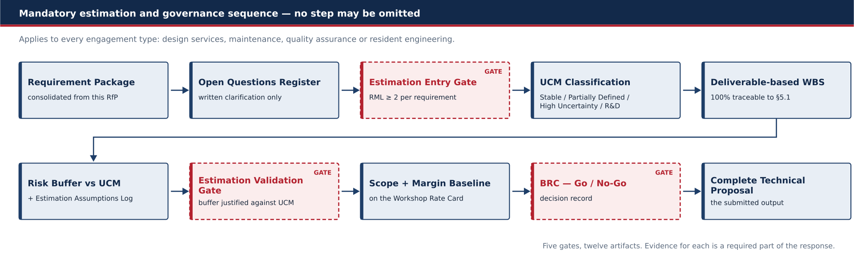
Figure 2 — Mandatory estimation and governance sequence, with its five gates.

11 Deliverables and Acceptance
ID | Deliverable | Format | Frequency
D-01 | 3D part models | Native SolidWorks and neutral format | Per work package batch
D-02 | Assembly models and product structure | Native, released to PDM | Per work package batch
D-03 | Detail and assembly drawings | PDF and native | Per released part
D-04 | Tolerance stack-up reports | PDF, with source data | Per assembly, before each review
D-05 | Weight tracking report | Spreadsheet | Monthly
D-06 | Interference and clearance reports | PDF | Before each design review
D-07 | Model quality check evidence | Check-tool output | With each submitted batch
D-08 | Design change records | Register and affected-item list | Per change
D-09 | Design intent documentation | PDF | At close of each work package
D-10 | Knowledge transfer package | PDF and models | At close of each work package
D-11 | Design Verification Plan | PDF | Per work package, before detail design
D-12 | Drawing check and release report | PDF | Per drawing batch
D-13 | Design Verification Report | PDF | Per design review

Deliverables are submitted in batches and are subject to a Design Acceptance Review. On successful completion an acceptance certificate is issued, and invoicing follows its issue. Discipline-specific deliverables additional to this list may be agreed per Call-off Order.

12 Timeline Expectation
Milestone | Date | Gate content
Engagement start | November 2026 | Kick-off, ramp-up and data handover
DR1 — concept direction | December 2026 | Concept direction agreed
DR2 — concept complete | March 2027 | Concept complete across all work packages
DR3 — design freeze | August 2027 | Release to tooling. This date is fixed.
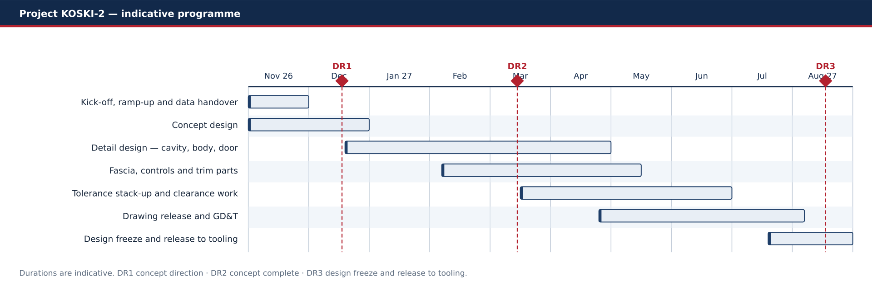
Figure 3 — Indicative programme and design review milestones.

13 Project Structure, Communication and Collaboration
The Supplier shall nominate a Design Coordination Lead as single point of contact, attending all progress meetings and issuing minutes. A weekly progress meeting shall be held. All decisions shall be recorded in the minutes. Matters not recorded in the minutes are not agreed.
NordTek function | Involvement
Product Engineering | Owns the product definition and participates in design approval
Manufacturing Engineering | Reviews manufacturability and participates in design approval
Simulation | Executes thermal and structural analysis and owns validation sign-off
Industrial Design | Owns visible surfaces and styling authority
Quality | Reviews tolerancing and quality evidence and participates in design approval
Programme Management | Owns the milestone plan and participates in design approval

The Proponent shall set out, in its proposal, a collaboration strategy for each NordTek-side team it must work through — manufacturing engineering, simulation and industrial design — stating the working interface, the cadence, and the escalation route where a dependency is not met.

14 Commercial and Contractual Requirements
Topic | Position
Contract structure | Framework Agreement, with work placed through Call-off Orders
Commercial basis | As set out in the applicable Call-off Order
Invoicing trigger | Issue of the acceptance certificate
Payment | Per the payment cycle stated in the Framework Agreement
Design defect remedy | The Supplier shall remedy design non-conformities identified after release
Intellectual property | IP in all deliverables and derivative geometry vests in NordTek
Key personnel | Replacement requires prior written approval
Change control | No work outside the agreed scope baseline shall proceed without an approved change request
Insurance and liability | Per the Framework Agreement

15 Proposal Requirements
Proposals shall address items 1 to 12 in this order, followed by items 13 to 16.
# | Content | Note
1 | Executive summary
2 | Scope
3 | Out of scope
4 | Solution with tools (Workstation & CAD license provider plan) and methods
5 | Estimation | As per the requirements of Section 10
6 | Schedule with key milestones
7 | Meeting cadence
8 | Reporting
9 | Risk, issue and dependency management
10 | Approval and version history
11 | Team structure
12 | Resource allocation plan
13 | AI Leverage Plan | Tools named, activities stated, and the cost and quality effect claimed. Claims will be challenged.
14 | Collaboration strategy with NordTek-side teams | State the working interface, cadence and escalation route for each retained team: manufacturing engineering, simulation, and industrial design.
15 | Estimation and governance evidence pack | The artifacts required by Section 10, submitted as annexes.
16 | Assumptions Register | Each assumption, its basis, the impact if it proves incorrect, and the clarification question raised against it, if any.

16 Evaluation Criteria
Proposals are scored out of 100 on the following criteria.
# | Criterion | Weight | Judged on | What we look for
1 | Governance compliance | 40 | Submitted artifact pack | Gates passed in order, artifacts complete, Reverse Validation Workshop held, change-request discipline
2 | Estimation and margin logic | 30 | Proposal and artifacts | WBS traceability, risk buffer against UCM, assumptions stated, margin baseline on the Rate Card
3 | AI leverage | 15 | Proposal section and Q&A | Credible plan, tools named, claimed savings challengeable
4 | Presentation quality | 15 | The ten-minute pitch | Clarity, structure, timekeeping
 | Total | 100

NordTek may shortlist, request clarification, and hold discussions with any Proponent before making a selection.

17 Appendix A — Compliance Matrix
Enter C for comply, CC for comply with comment, or D for deviate. Every CC and D entry shall carry a comment.
ID | C/CC/D | Comment | ID | C/CC/D | Comment
FR-01 |  |  | SEC-01
FR-02 |  |  | SEC-02
FR-03 |  |  | SEC-03
FR-04 |  |  | SEC-04
FR-05 |  |  | SEC-05
FR-06 |  |  | SEC-06
FR-07 |  |  | SEC-07
FR-08 |  |  | SEC-08
FR-09 |  |  | SEC-09
FR-10 |  |  | SEC-10
FR-11 |  |  | SEC-11
FR-12 |  |  | SEC-12
FR-13 |  |  | EST-01
FR-14 |  |  | EST-02
DQ-01 |  |  | EST-03
DQ-02 |  |  | EST-04
DQ-03 |  |  | EST-05
DQ-04 |  |  | EST-06
DQ-05 |  |  | EST-07
DQ-06 |  |  | EST-08
DQ-07 |  |  | EST-09
DQ-08 |  |  | EST-10
DQ-09 |  |  | EST-11
DQ-10 |  |  | EST-12

18 Appendix B — Commercial Response Schedule and Submission Checklist

18.1 Commercial response schedule
One line per work package. NordTek does not disclose a budget and no target price is available on request.
WP | Work package | Quantity / unit | Price | Basis of figure
WP-01 | Cavity and structural sheet-metal parts
WP-02 | Door assembly — outer, inner, pane retention, seal interface and handle
WP-03 | Fascia, control housing and moulded parts
WP-04 | Interface, trim and cabinetry-fit parts
WP-05 | Drawings and GD&T
WP-06 | Tolerance stack-up
WP-07 | Design change implementation
WP-08 | Simulation preparation and design quality verification
 | Total

18.2 Basis of price — to be completed by the Proponent
Item | Proponent statement
Pricing model applied
Currency of the figures above
Period for which the price is held
Payment terms proposed
Assumptions on which the price depends
Exclusions from the price

18.3 Submission checklist
Reference | Item | Included
Section 15, items 1–12 | Core proposal content, in the stated order | ☐
Section 15, item 13 | AI Leverage Plan | ☐
Section 15, item 14 | Collaboration strategy for each retained NordTek team | ☐
Section 15, item 15 | Estimation and governance evidence pack — all Section 10 artifacts | ☐
Section 15, item 16 | Assumptions Register, cross-referenced to questions raised | ☐
Appendix A | Compliance matrix completed, with comments on CC and D entries | ☐
Appendix B | Commercial response schedule and basis of price completed | ☐
Format | Single PDF package, in English | ☐
Deadline | Submitted by 1 August 2026, 13:00 BST | ☐

