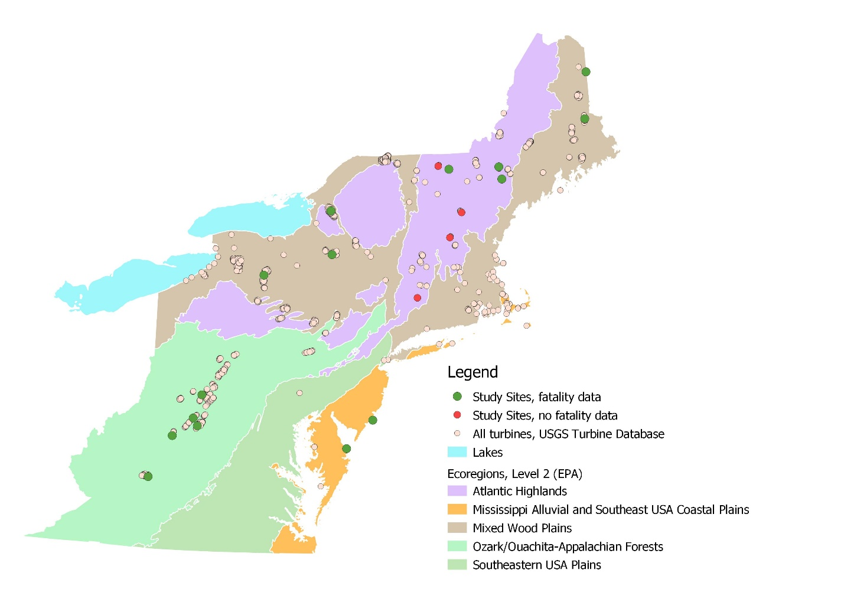

Figure 1. Map of Region 5 with level 2 ecoregions, Lake Erie, Lake Ontario, turbines from the USGS Turbine Database, and the sites with studies (calculated using Mean Coordinates tool in QGIS 3.6.2 to create one point for each project site when multiple turbines).

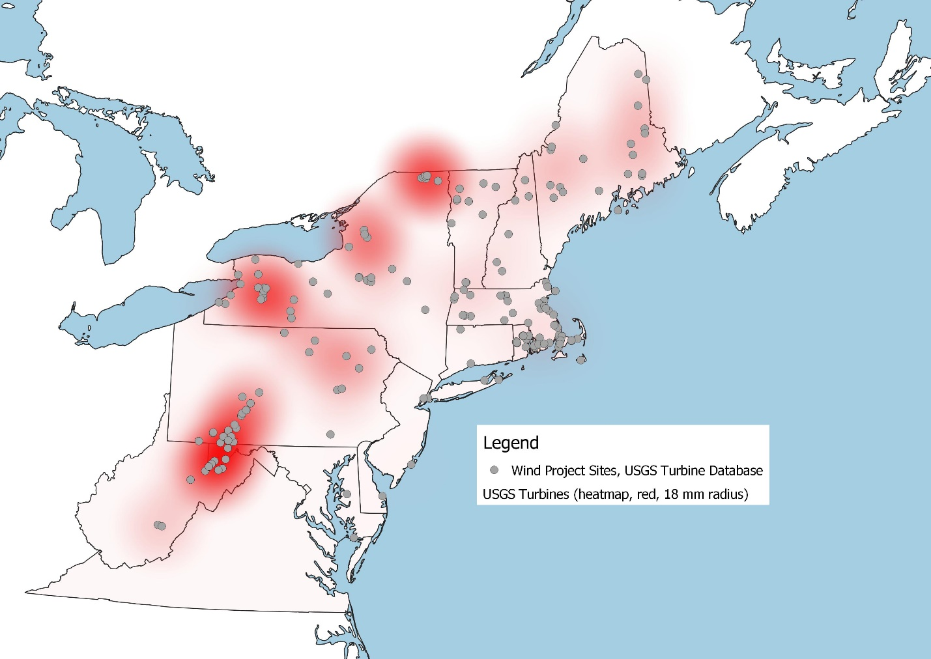

Figure 2. Map of Region 5 with heatmap based on individual turbines in USGS Turbine database. Blue dots representing wind projects calculated using Mean Coordinates tool in QGIS 3.6.2.

[Used 18 mm for heatmap radius— doing it in map units wouldn’t work. Heatmap applied to individual turbines (shown in Figure 1)].