**Report analyzing landscape metrics at 25 km buffer for Beech Ridge (WV-2) site**

**Maddie Tango**

**3/19/21**

This region is mostly forest (76.5%) with some open cover (9.88%) and cropland (8.47%). Therefore, it makes sense that the edge density, mean patch size, and largest patch index are highest for the forest class. All positive clumpiness indices show that patches tend to be aggregated, with cropland and wetland having the highest aggregation and urban areas with the lowest aggregation (this is likely because roads are classified as urban areas). This is also supported by the aggregation index for the region as a whole being 90.4 out of 100, showing close to maximum aggregation. According to the Simpson’s evenness index, the landscape is neither homogenous nor heterogeneous given on a scale from 0 to 1 the measure was 0.476. The forest core area was relatively at 65.5% supporting the relative clumpiness of the forest cover. Ridges and valleys are fairly evenly split, with ridges being 7.7% of the landscape and valleys being 8.34% of the landscape.

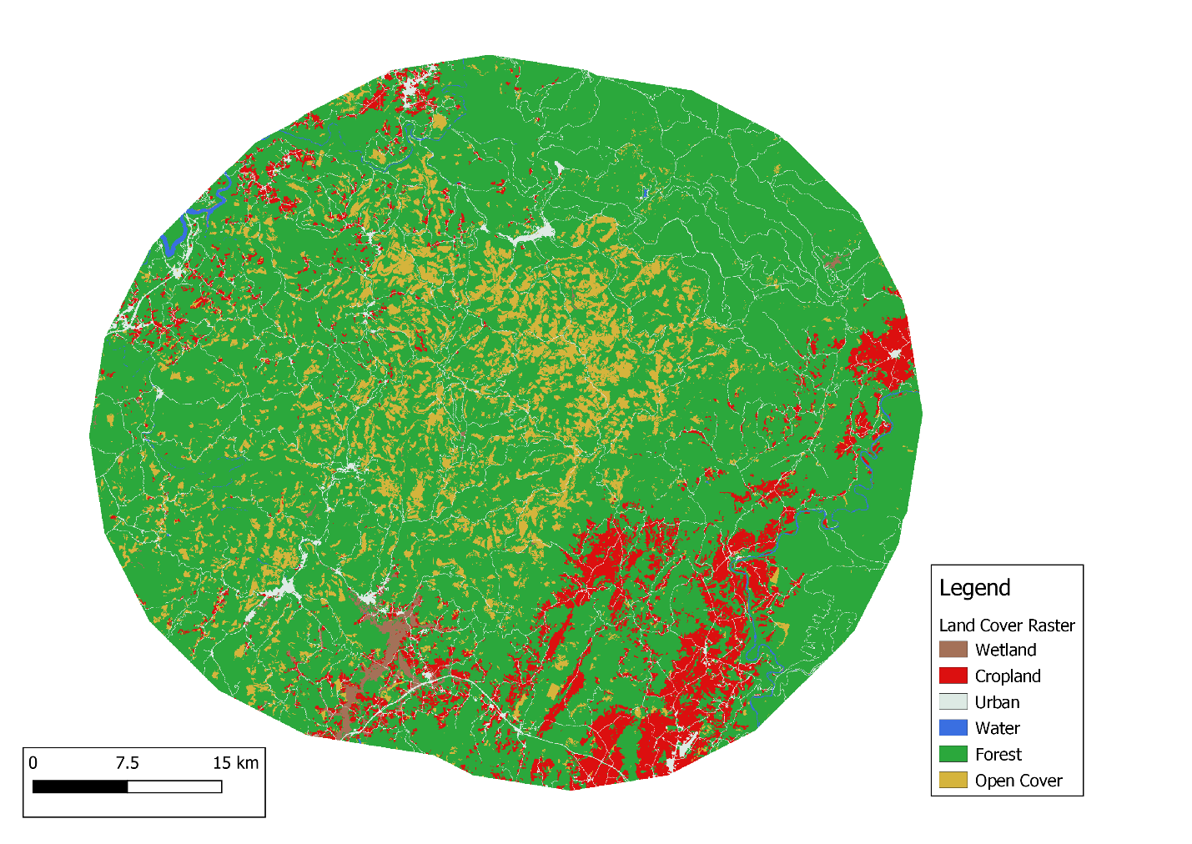

|  |  |  |  |  |  |
| --- | --- | --- | --- | --- | --- |
| **R calculations for 25 km metrics for WV-2 site** | | |  |  |  |
|  |  |  |  |  |  |
|  | **14- wetland** | **15- cropland** | **17- urban** | **20- forest (1,5,6)** | **21- open cover (8,10,16)** |
| **% area** (proportional abundance of land cover classes): lsm_c_pland | 0.806 | 8.47 | 3.98 | 76.5 | 9.88 |
| **Edge density** (sum of all edge segments in patch type & divide by landscape area): lsm_c_ed | 2.07 | 18 | 23.5 | 55.3 | 25.6 |
| **Mean patch size** (average total area in particular class): lsm_c_area_mn | 5.17 | 11.7 | 6.71 | 151 | 6.58 |
| **Largest patch index** (% landscape occupied by largest patch of a given class): lsm_c_lpi | 0.418 | 1.69 | 0.301 | 74.8 | 0.388 |
| **Clumpiness index** (adjacency of patches. -1 = disaggregated, 0 = random, 1 = aggregated): lsm_c_clumpy | 0.807 | 0.825 | 0.533 | 0.768 | 0.782 |
|  |  |  |  |  |  |
|  |  | **Landscape area** |  |  |  |
| **Aggregation index** (describes adjacency of habitat cells: 0 = maximally disaggregated, 100 = maximally aggregated classes): lsm_l_ai | | 90.4 |  |  |  |
|  | |  |  |  |  |
| **Simpson's evenness index** (evenness of proportions of land cover; homogeneity measure:"Equals SIEI = 0 when only one patch is present and approaches SIEI = 1 when the number of class types increases while the proportions are equally distributed" [source: R help documentation]): lsm_l_siei | | 0.476 |  |  |  |
|  | |  |  |  |  |
| **Forest core area %** (core area percentage of landscape; edge depth was 1.3114):  lsm_c_cpland | *0 (not forested)* | *13.9* |  |  |  |
|  | 1 (forested) | 65.5 |  |  |  |
|  |  |  |  |  |  |
| **TPI % area** (percentage of landscape of class): lsm_c_pland | Valleys (<-1) | 8.34 |  |  |  |
|  | *Neither (-1:1)* | *84* |  |  |  |
|  | Ridges (>1) | 7.7 |  |  |  |