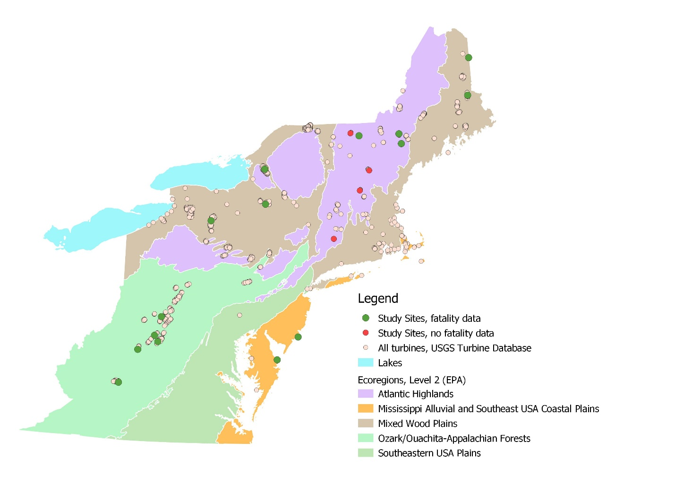

Figure 1. Map of Region 5 with level 2 ecoregions, Lake Erie, Lake Ontario, turbines from the USGS Turbine Database, and the sites with studies (calculated using Mean Coordinates tool in QGIS 3.6.2 to create one point for each project site when multiple turbines).

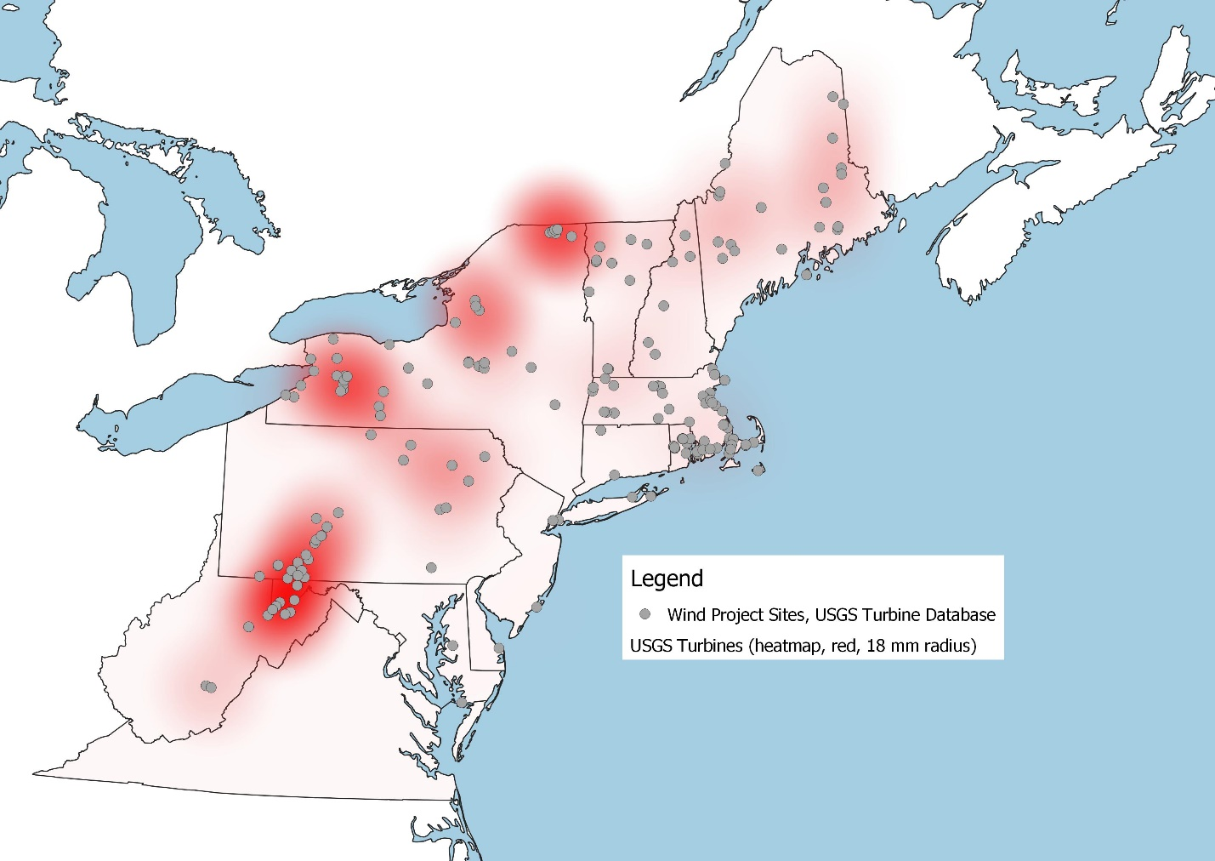

Figure 2. Map of Region 5 with heatmap based on individual turbines in USGS Turbine database. Blue dots representing wind projects calculated using Mean Coordinates tool in QGIS 3.6.2.

[Used 18 mm for heatmap radius— doing it in map units wouldn’t work. Heatmap applied to individual turbines (shown in Figure 1)].

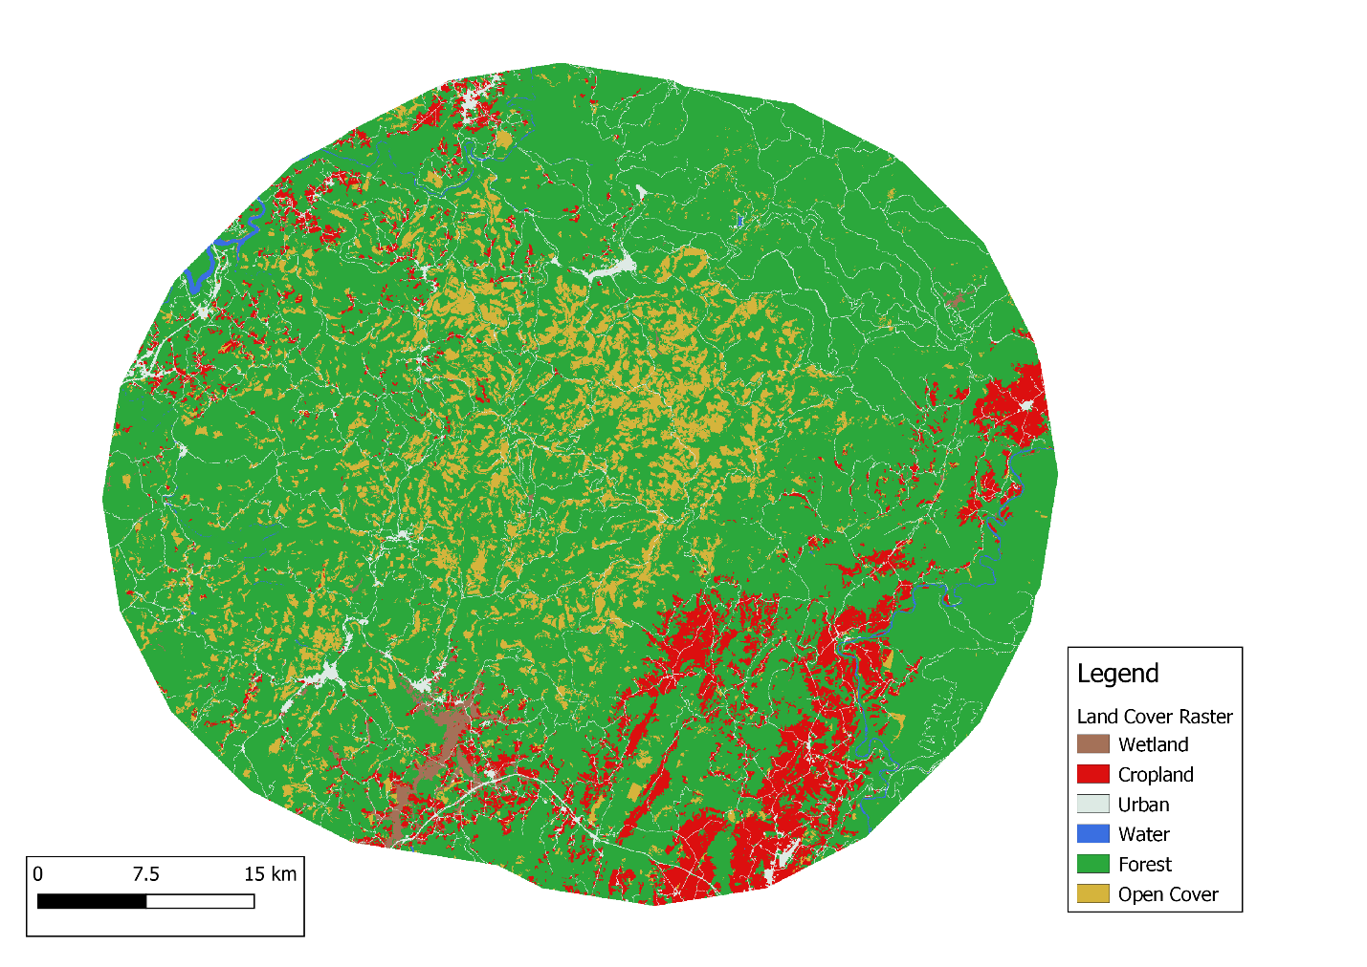

Land cover classes (aggregated from original NALCMS layer)

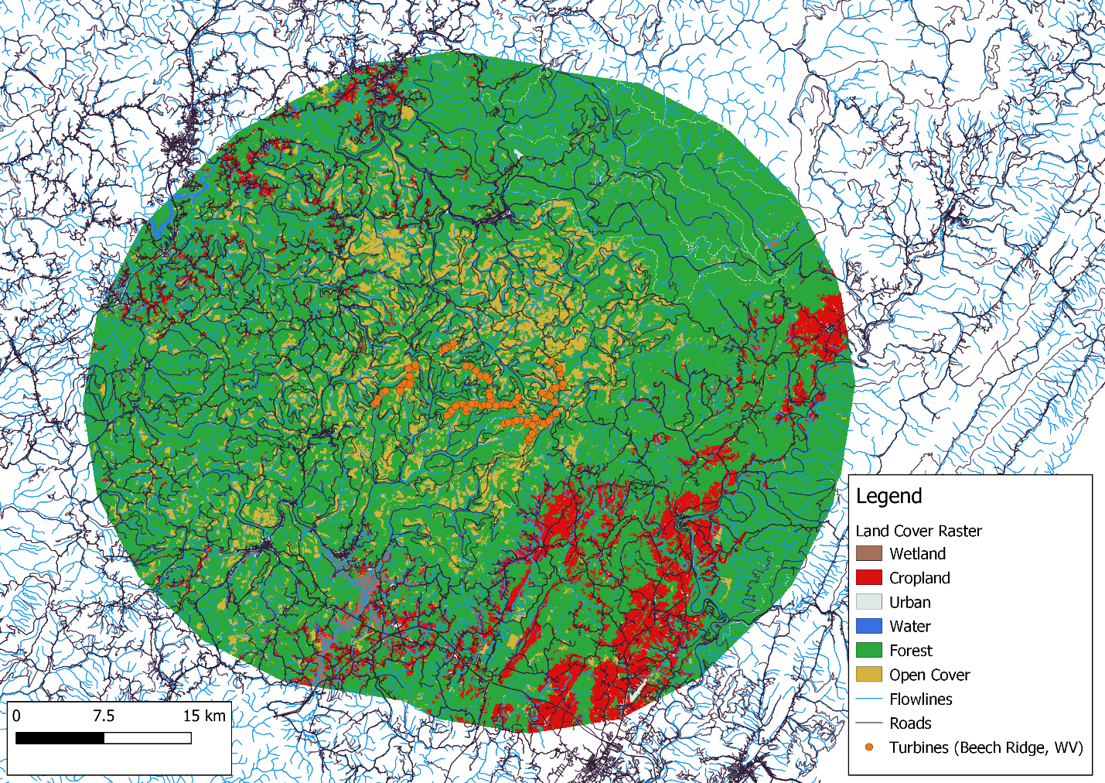

Land cover raster within a 25 km buffer of turbines at Beech Ridge wind site (WV), flowlines, and roads.

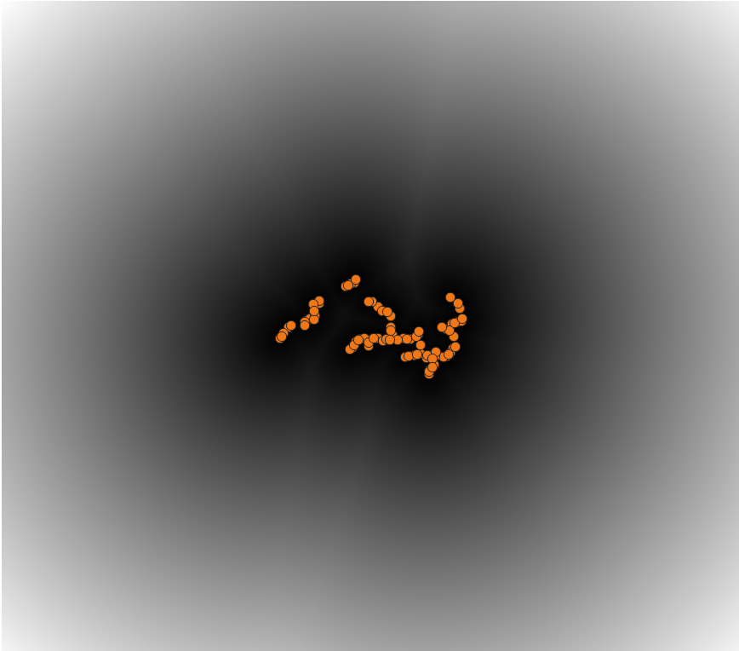

Proximity map from turbines

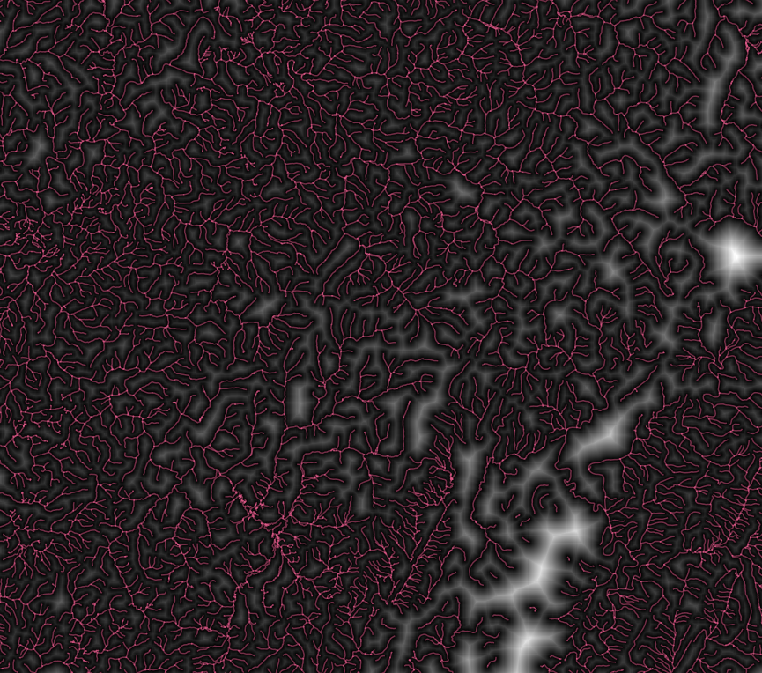

Proximity map from flowlines

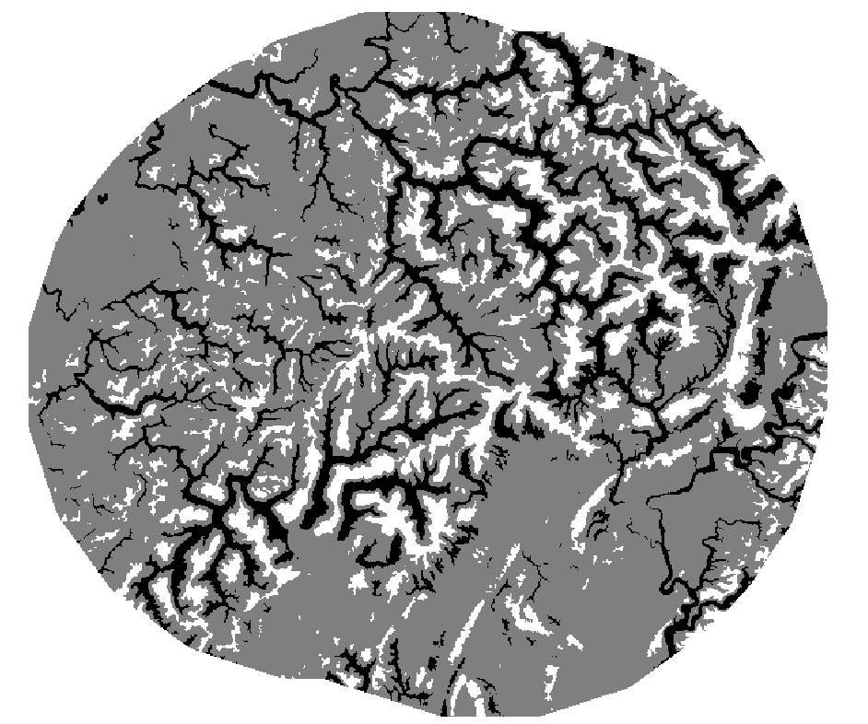

TPI reclass: ridges (white) and valleys (black); ridges >1SD from mean, valleys >-1SD from mean.

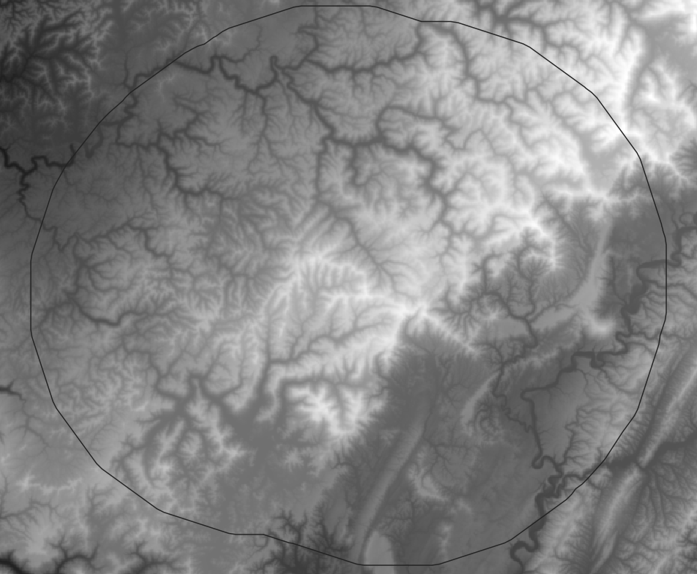

3DEP layer with 25 km buffer from Beech Ridge, WV turbines