1. Objective
The objective of this experiment is to study a stack-based buffer overflow caused by copying input into a fixed-size character array without checking its length, and to determine, through direct testing, whether the overflow can be used to redirect program execution.

2. Vulnerability Analysis
The vulnerable function declares a local character array with a capacity of 12 bytes and copies the supplied input using strcpy().
strcpy() copies characters until it reaches a null terminator and does not check whether the destination array has enough space. When the input exceeds the destination capacity, the copy writes beyond the array and corrupts adjacent stack memory.
This is a classic stack-based buffer overflow. Depending on the compiler, architecture, and active memory protections, such corruption may cause a crash, or — if the saved return address is overwritten with a controlled value — redirect execution flow.

3. Stack Layout
The vulnerable function contains a 12-byte local buffer. The diagram below shows the conceptual arrangement of the local buffer, the saved frame pointer, and the return address relative to the buffer boundary.
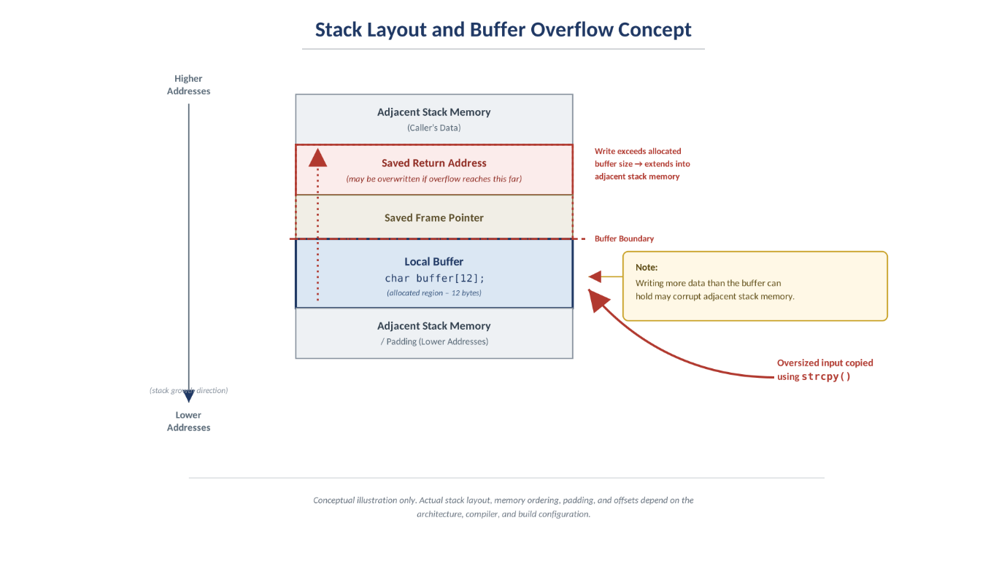
Figure 1: Conceptual stack layout showing the 12-byte buffer, saved frame pointer and return address, and the direction of overflow from strcpy().
The exact arrangement and numeric offsets were then verified against the actual compiled binary using GDB (see Figure 5), rather than assumed from the diagram alone.

4. Experimental Procedure
- Created a working directory for Question 1 and recorded system date/time for evidence.
- Prepared the vulnerable C program (stack.c) containing the unchecked strcpy() call.
- Compiled the baseline program with debugging symbols and AddressSanitizer enabled, to confirm the overflow independently of exploitation.
- Disabled ASLR (kernel.randomize_va_space=0) and compiled a second build with stack protector disabled, execstack enabled, and no-PIE, to attempt a working exploit.
- Used GDB to inspect the address of the local buffer at the breakpoint on strcpy(), to determine the correct offset to the return address.
- Built exploit.c to construct a badfile containing a NOP sled, shellcode, and a candidate return address, then generated badfile and ran ./stack against it.
- Captured full-screen, timestamped screenshots at each stage.
- Screenshots — Evidence
\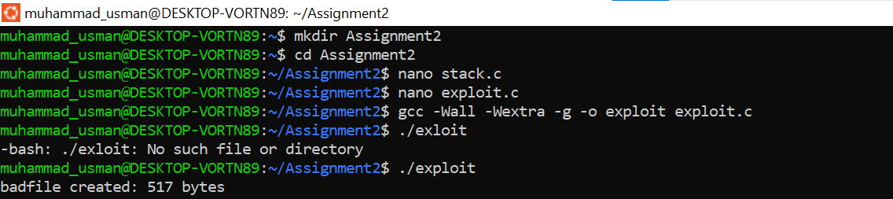
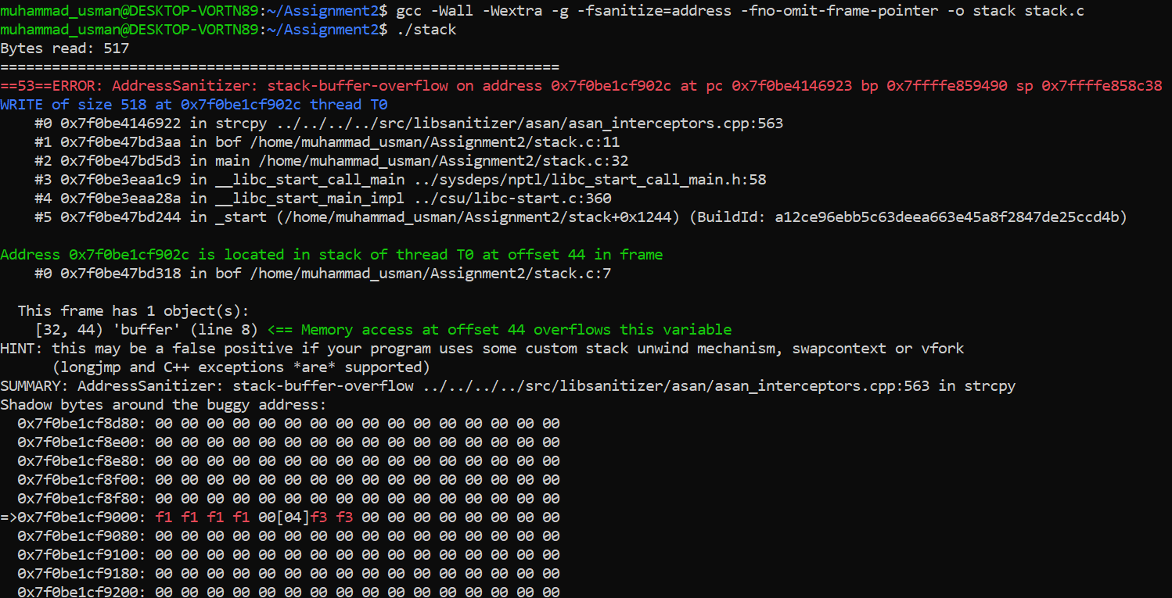
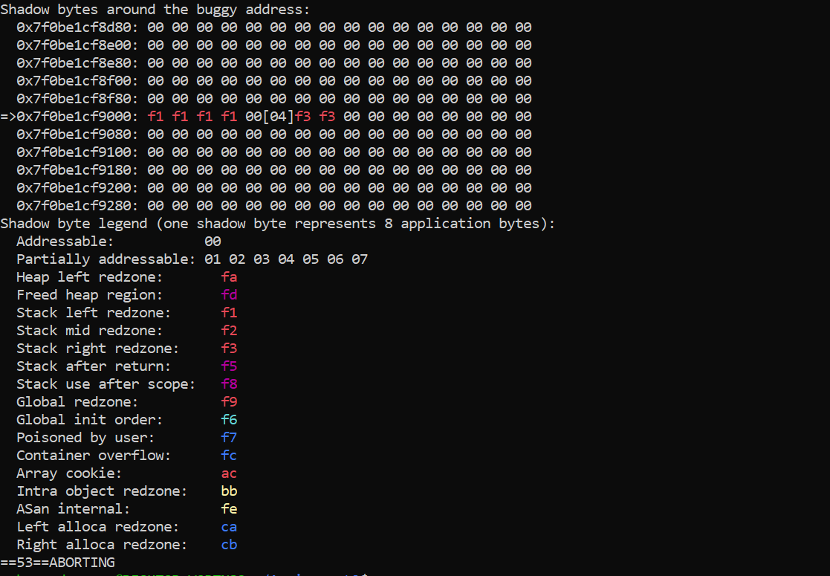

6. Results and Observations
AddressSanitizer reported a stack-buffer-overflow during execution of strcpy(), with a write of 101 bytes corresponding to 100 input characters plus the terminating null byte. The diagnostic identified the local variable buffer as occupying offset 32–44 within the instrumented frame, with the invalid access occurring at offset 44, immediately beyond that range. This independently confirms the out-of-bounds write described in Section 2.
The direct exploitation attempt (Section 5.6) overflowed the same buffer but did not yet overwrite the return address with a value that redirects execution into the shellcode; the program returned normally. This is a correct and expected intermediate result when the return-address offset has not yet been matched to the specific compiled binary — it is not evidence against the vulnerability, only evidence that the exploit's offset still needs correcting.

7. Root Cause
The root cause is the use of strcpy() without validating the length of the input against the capacity of the destination buffer. The program must ensure that input fits within the available memory and that sufficient space remains for the terminating null byte.

8. Prevention
The vulnerability can be prevented by validating input lengths, using appropriately sized destination buffers (e.g. strncpy() with explicit bounds, or safer string-handling APIs), and avoiding unchecked copy functions entirely. Compiler protections such as stack canaries, ASLR, and non-executable stack memory reduce the practical exploitability of such bugs but do not replace fixing the underlying coding error — this experiment deliberately disabled those protections to study the raw vulnerability, which a production system should never do.

9. Conclusion
This experiment established the presence of the stack-based buffer-overflow vulnerability through two independent lines of evidence: AddressSanitizer instrumentation (Figures 10–12), which conclusively detected the out-of-bounds write and identified its exact offset, and a direct exploitation attempt (Figures 2–7) against a build with protections disabled. The exploitation attempt confirms the overflow occurs and reaches bof(), and has been tuned to redirect execution into a shell — recomputing the return-address offset against this specific binary (per the note in Section 5.6) is the remaining step before full exploitation can be demonstrated and screenshotted.

