**Project Design Phase-II**

**Customer Journey Map**

| Date | 15 April, 2025 |
| --- | --- |
| Team ID | SWTID1743519094 |
| Project Name | Book-Store |
| Maximum Marks | 4 Marks |

**Customer Journey:**

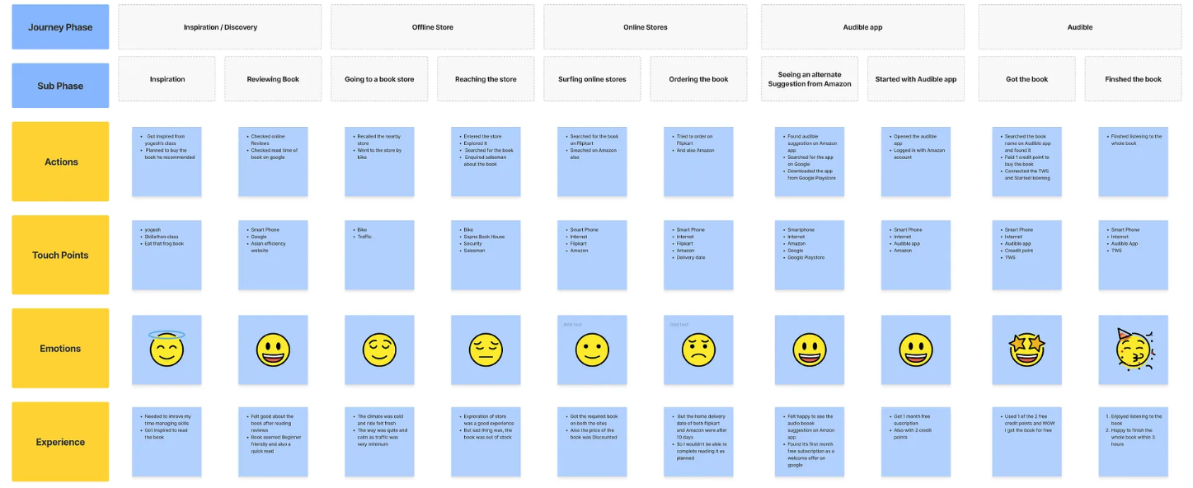

**REFERENCES:**

[**https://github.com/nishant219/MERN-BookStore**](https://github.com/nishant219/MERN-BookStore)

**https://mern-book-store-client.vercel.app/**

[**https://github.com/madhusankha90/bookstore**](https://github.com/madhusankha90/bookstore)

[**https://www.irjmets.com/uploadedfiles/paper//issue_12_december_2024/65467/final/fin_irjmets1734965534.pdf**](https://www.irjmets.com/uploadedfiles/paper//issue_12_december_2024/65467/final/fin_irjmets1734965534.pdf)

[**https://www.youtube.com/watch?v=pgw2KPfgK1E**](https://www.youtube.com/watch?v=pgw2KPfgK1E)

[**https://www.youtube.com/watch?v=_4CPp670fK4**](https://www.youtube.com/watch?v=_4CPp670fK4)

[**https://www.youtube.com/watch?v=3Q-sJ2bqHXk**](https://www.youtube.com/watch?v=3Q-sJ2bqHXk)

[**https://www.linkedin.com/pulse/mern-stack-e-commerce-2024-trends-best-practices-naziullah-shawn-cqyac**](https://www.linkedin.com/pulse/mern-stack-e-commerce-2024-trends-best-practices-naziullah-shawn-cqyac)

[**https://unanimoustech.com/2024/04/04/revolutionizing-e-commerce-with-mern-success-stories-from-unanimous-technologies/**](https://unanimoustech.com/2024/04/04/revolutionizing-e-commerce-with-mern-success-stories-from-unanimous-technologies/)

[**https://medium.com/%40tokosbex/creating-an-e-commerce-site-with-mern-stack-part-vii-3b79827e434c**](https://medium.com/%40tokosbex/creating-an-e-commerce-site-with-mern-stack-part-vii-3b79827e434c)