**Project Design Phase-II**

**Technology Stack (Architecture & Stack)**

| Date | 15 April 2025 |
| --- | --- |
| Team ID | SWTID1743519094 |
| Project Name | Book-Store |
| Maximum Marks | 4 Marks |

**Technical Architecture:**

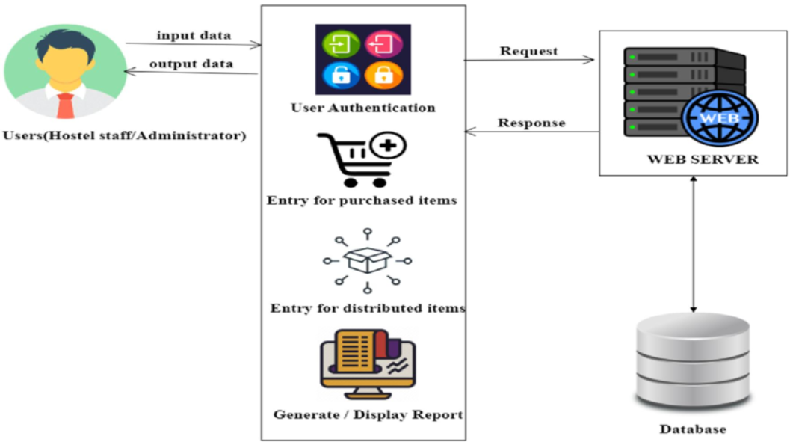

**Table-1 : Components & Technologies:**

| **S.No** | **Component** | **Description** | **Technology** |
| --- | --- | --- | --- |
|  | User Interaction Layer | Mode through which end-users engage with the system, such as web platforms, mobile applications, or conversational agents | HTML, CSS, JavaScript / Angular Js / React Js etc. |
|  | Logic Layer-1 | Code responsible for handling specific functions of the application | Java / Python |
|  | Logic Layer-2 | Module managing speech input conversion | IBM Watson STT service |
|  | Logic Layer-3 | Handles chatbot and interaction-based tasks | IBM Watson Virtual Agent |
|  | Database | Database schema and data structuring approaches | MySQL, NoSQL, etc. |
|  | Cloud Database | Managed database platforms on cloud | IBM DB2, IBM Cloudant etc. |
|  | File Handling | Managing and maintaining user files and documents | IBM Block Storage or Other Storage Service or Local Filesystem |
|  | External API-1 | External service integration required in the solution | IBM Climate API or equivalent |
|  | External API-2 | Another external system linked for validation or identity servicesn | Aadhar API, etc. |
|  | Machine Learning Model | AI component purpose within the system | Object Recognition Model, etc. |
|  | Infrastructure (Server / Cloud) | Application hosting, deployment environments | Local, Cloud Foundry, Kubernetes, etc. |

**Table-2: Application Characteristics:**

| **S.No** | **Characteristics** | **Description** | **Technology** |
| --- | --- | --- | --- |
|  | Community-Driven Tools | Open-source tools or ecosystems leveraged during development | Technologies from open-source ecosystems |
|  | Security Implementations | List all the security / access controls implemented, use of firewalls etc. | Techniques such as SHA-256, IAM Policies, Data Encryption, OWASP Compliance |
|  | Expandable Design | Explain the mechanisms ensuring system uptime (e.g., load balancers, redundancy setup) | Technology adopted for modular scaling |
|  | Availability | Justify the availability of applications (e.g. use of load balancers, distributed servers etc.) | Tools and infrastructure ensuring high availability |
|  | Efficiency & Speed | Design measures taken to improve response rate (e.g., caching, CDN, request handling) | Performance optimization technologies |