**Day 15 Task: Readme File:**

**Step1: In this task I have created Java app:**

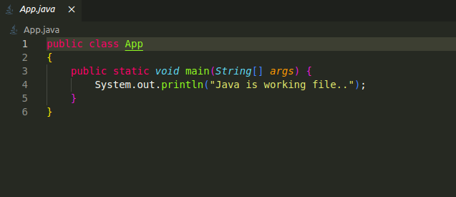

**Step 2: Made a docker image with the help of dockerfile.**

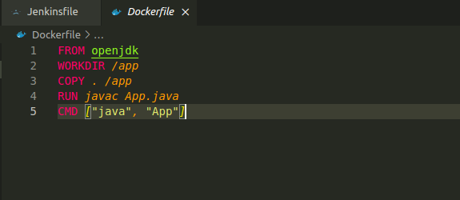

**Step3: Created the jenkins pipeline**

**pipeline {**

**agent any**

**environment {**

**DOCKER_CREDENTIALS_ID = 'docker'**

**DOCKERHUB_REPOSITORY = 'mtaori/javaimage:v14'**

**}**

**stages {**

**stage('Checkout') {**

**steps {**

**git 'https://github.com/mtaori/day14_task.git'**

**}**

**}**

**stage('Build Docker Image') {**

**steps {**

**script {**

***def* customImage = docker.build("${env.DOCKERHUB_REPOSITORY}")**

**docker.withRegistry('https://index.docker.io/v1/', "${env.DOCKER_CREDENTIALS_ID}") {**

**customImage.push()**

**}**

**}**

**}**

**}**

**stage('Run Docker Image') {**

**steps {**

**script {**

***def* container = docker.image("${env.DOCKERHUB_REPOSITORY}").run('-d')**

**sleep(time: 10, unit: 'SECONDS')**

**sh "docker logs ${container.id}"**

**}**

**}**

**}**

**}**

**}**

**Step 5: Push the code in github repo named as day17_task**

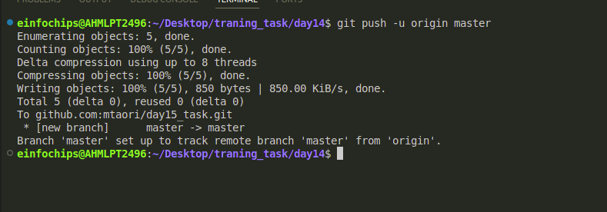

**Step 6: add Git credential in jenkins like this:**Dashboard -> Manage Jenkins -> Credential

and add it git credential like this

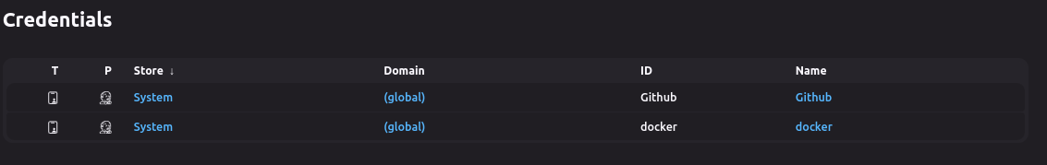

**Step:7 Now make a ansible playbook which install docker in worker node and**

**Basic Playbook Creation**:

Develop an Ansible playbook to automate the deployment of the Docker container.

**Playbook Tasks**:

Install Docker on the target server (if Docker is not already installed).

Pull the Docker image from the container registry.

Run the Docker container with the required configurations.

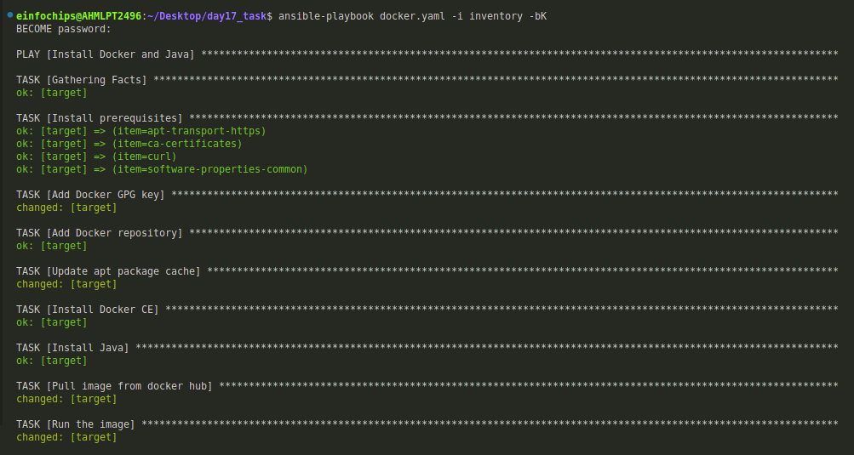

**Step7: Choose the pipeline script from SCM**

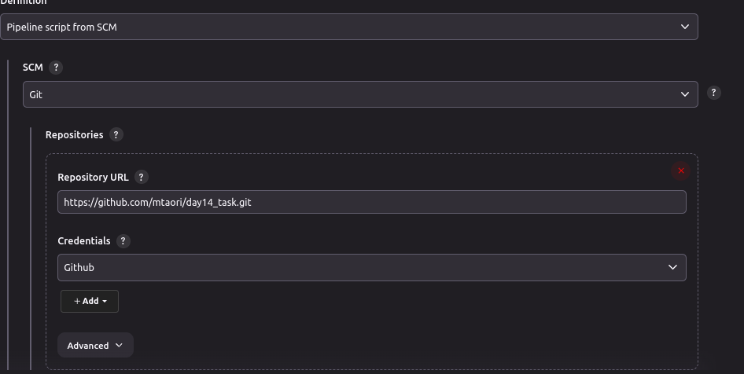

**And choose the branch:  
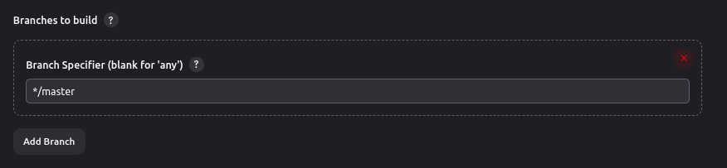**

**Step7 : Run the pipeline**

