Day4_task documentation

#### **1. Create Docker Volumes**

Docker volumes are used to persist data generated by and used by Docker containers.

docker volume create wordpress_data

docker volume create mysql_data

#### **2. Create a Docker Network**

Create a custom network for the containers to communicate.

docker network create wordpress_network

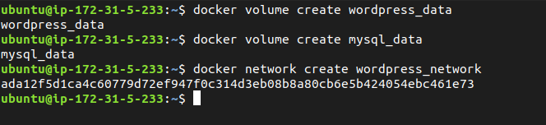

#### **4. Deploy the Application with Docker Compose**

Run the following command to start the services defined in the docker-compose.yml file.

docker-compose up -d

* Verify that the containers are running.

docker-compose ps

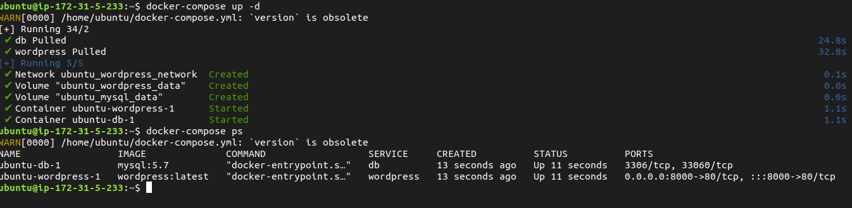

* Access the WordPress setup by navigating to <http://localhost:8000>.

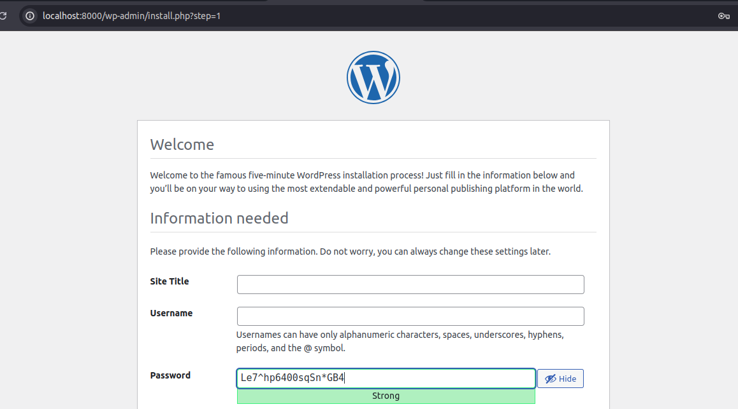

#### **5. Manage Docker Logs**

* View logs for a specific service.

docker-compose logs wordpress

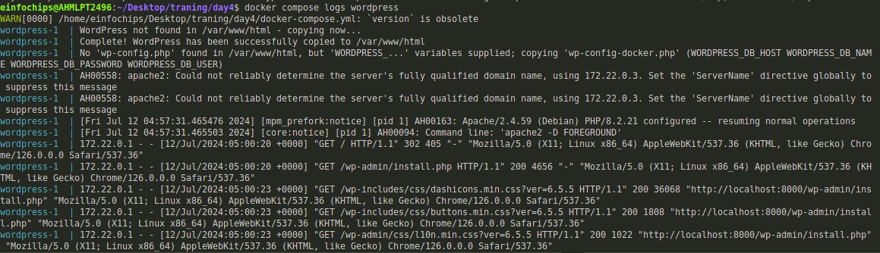

* Follow logs for real-time updates.

docker-compose logs -f wordpress

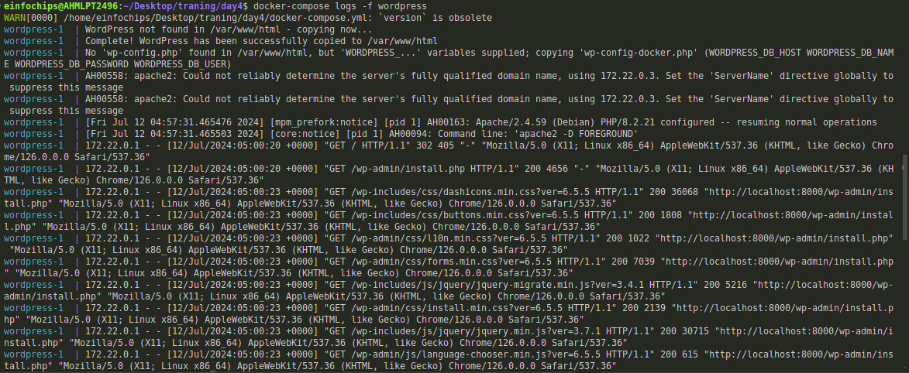

#### **6. Deploy the Application Using Docker Swarm**

Docker Swarm is a native clustering and orchestration tool for Docker.

* Initialize Docker Swarm.

docker swarm init

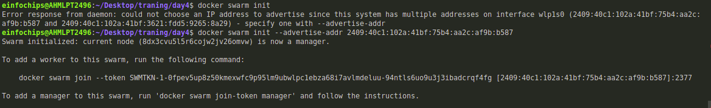

* Deploy the stack using Docker Swarm.

docker stack deploy -c docker-stack.yml wordpress_stack

Verify the stack is running.

docker stack services wordpress_stack

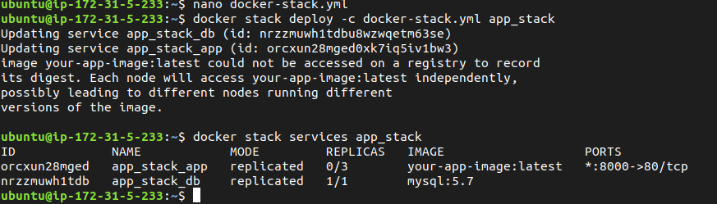

By typing un browser localhost:8000 it will give this page.

