## Phase II Report – Restaurant Reservation System
### 1. Introduction and Goals
The Restaurant Reservation System was developed to streamline the process of managing restaurant reservations, customer data, and table allocations. The motivation behind this project is to reduce manual scheduling errors, prevent double-booking, and improve restaurant efficiency through data-driven insights.
The main objectives of the system are:
* To provide a centralized database for restaurant, customer, and reservation management.
* To ensure referential integrity across all relational entities.
* To support analytical queries and visual reporting using SQL views.
* To enable future integration with web and mobile applications for real-time updates.
---
### 2. Relational Schema and SQL Code
This section defines the relational schema, constraints, and data relationships used in the database. The design ensures data normalization and consistency across multiple interconnected entities.
**Key Design Features:**
* **Foreign Keys** maintain relationships between entities such as `Reservation`, `Customer`, and `Restaurant`.
* **Primary Keys** uniquely identify records across all tables.
* **Constraints** (e.g., `CHECK`, `UNIQUE`, `ENUM`) guarantee data validity.
**SQL Schema:**
```sql

DROP DATABASE IF EXISTS RestaurantDB;
CREATE DATABASE RestaurantDB;
USE RestaurantDB;

SET FOREIGN_KEY_CHECKS = 0;

DROP TABLE IF EXISTS Reservation;
DROP TABLE IF EXISTS Restaurant_Cuisine;
DROP TABLE IF EXISTS Table_Info;
DROP TABLE IF EXISTS Cuisine;
DROP TABLE IF EXISTS Customer;
DROP TABLE IF EXISTS Restaurant;

SET FOREIGN_KEY_CHECKS = 1;

CREATE TABLE Restaurant (
restaurant_id INT AUTO_INCREMENT PRIMARY KEY,
name VARCHAR(100) NOT NULL,
location VARCHAR(100),
email VARCHAR(100),
opening_time TIME,
closing_time TIME
);

CREATE TABLE Table_Info (
table_id INT AUTO_INCREMENT PRIMARY KEY,
restaurant_id INT NOT NULL,
capacity INT NOT NULL CHECK (capacity > 0),
table_number INT NOT NULL,
FOREIGN KEY (restaurant_id) REFERENCES Restaurant(restaurant_id)
ON DELETE CASCADE
ON UPDATE CASCADE
);

CREATE TABLE Customer (
customer_id INT AUTO_INCREMENT PRIMARY KEY,
full_name VARCHAR(100) NOT NULL,
email VARCHAR(100) UNIQUE,
phone VARCHAR(20)
);

CREATE TABLE Cuisine (
cuisine_id INT AUTO_INCREMENT PRIMARY KEY,
cuisine_name VARCHAR(50) UNIQUE NOT NULL
);

CREATE TABLE Restaurant_Cuisine (
restaurant_id INT NOT NULL,
cuisine_id INT NOT NULL,
PRIMARY KEY (restaurant_id, cuisine_id),
FOREIGN KEY (restaurant_id) REFERENCES Restaurant(restaurant_id)
ON DELETE CASCADE
ON UPDATE CASCADE,
FOREIGN KEY (cuisine_id) REFERENCES Cuisine(cuisine_id)
ON DELETE CASCADE
ON UPDATE CASCADE
);

CREATE TABLE Reservation (
reservation_id INT AUTO_INCREMENT PRIMARY KEY,
customer_id INT NOT NULL,
restaurant_id INT NOT NULL,
table_id INT NOT NULL,
reservation_date DATE NOT NULL,
start_time TIME NOT NULL,
end_time TIME NOT NULL,
num_people INT NOT NULL CHECK (num_people > 0),
status ENUM('Booked', 'Completed', 'Cancelled') DEFAULT 'Booked',
FOREIGN KEY (customer_id) REFERENCES Customer(customer_id)
ON DELETE CASCADE
ON UPDATE CASCADE,
FOREIGN KEY (restaurant_id) REFERENCES Restaurant(restaurant_id)
ON DELETE CASCADE
ON UPDATE CASCADE,
FOREIGN KEY (table_id) REFERENCES Table_Info(table_id)
ON DELETE CASCADE
ON UPDATE CASCADE
);

SHOW TABLES;
```
**Screenshot Reference:**
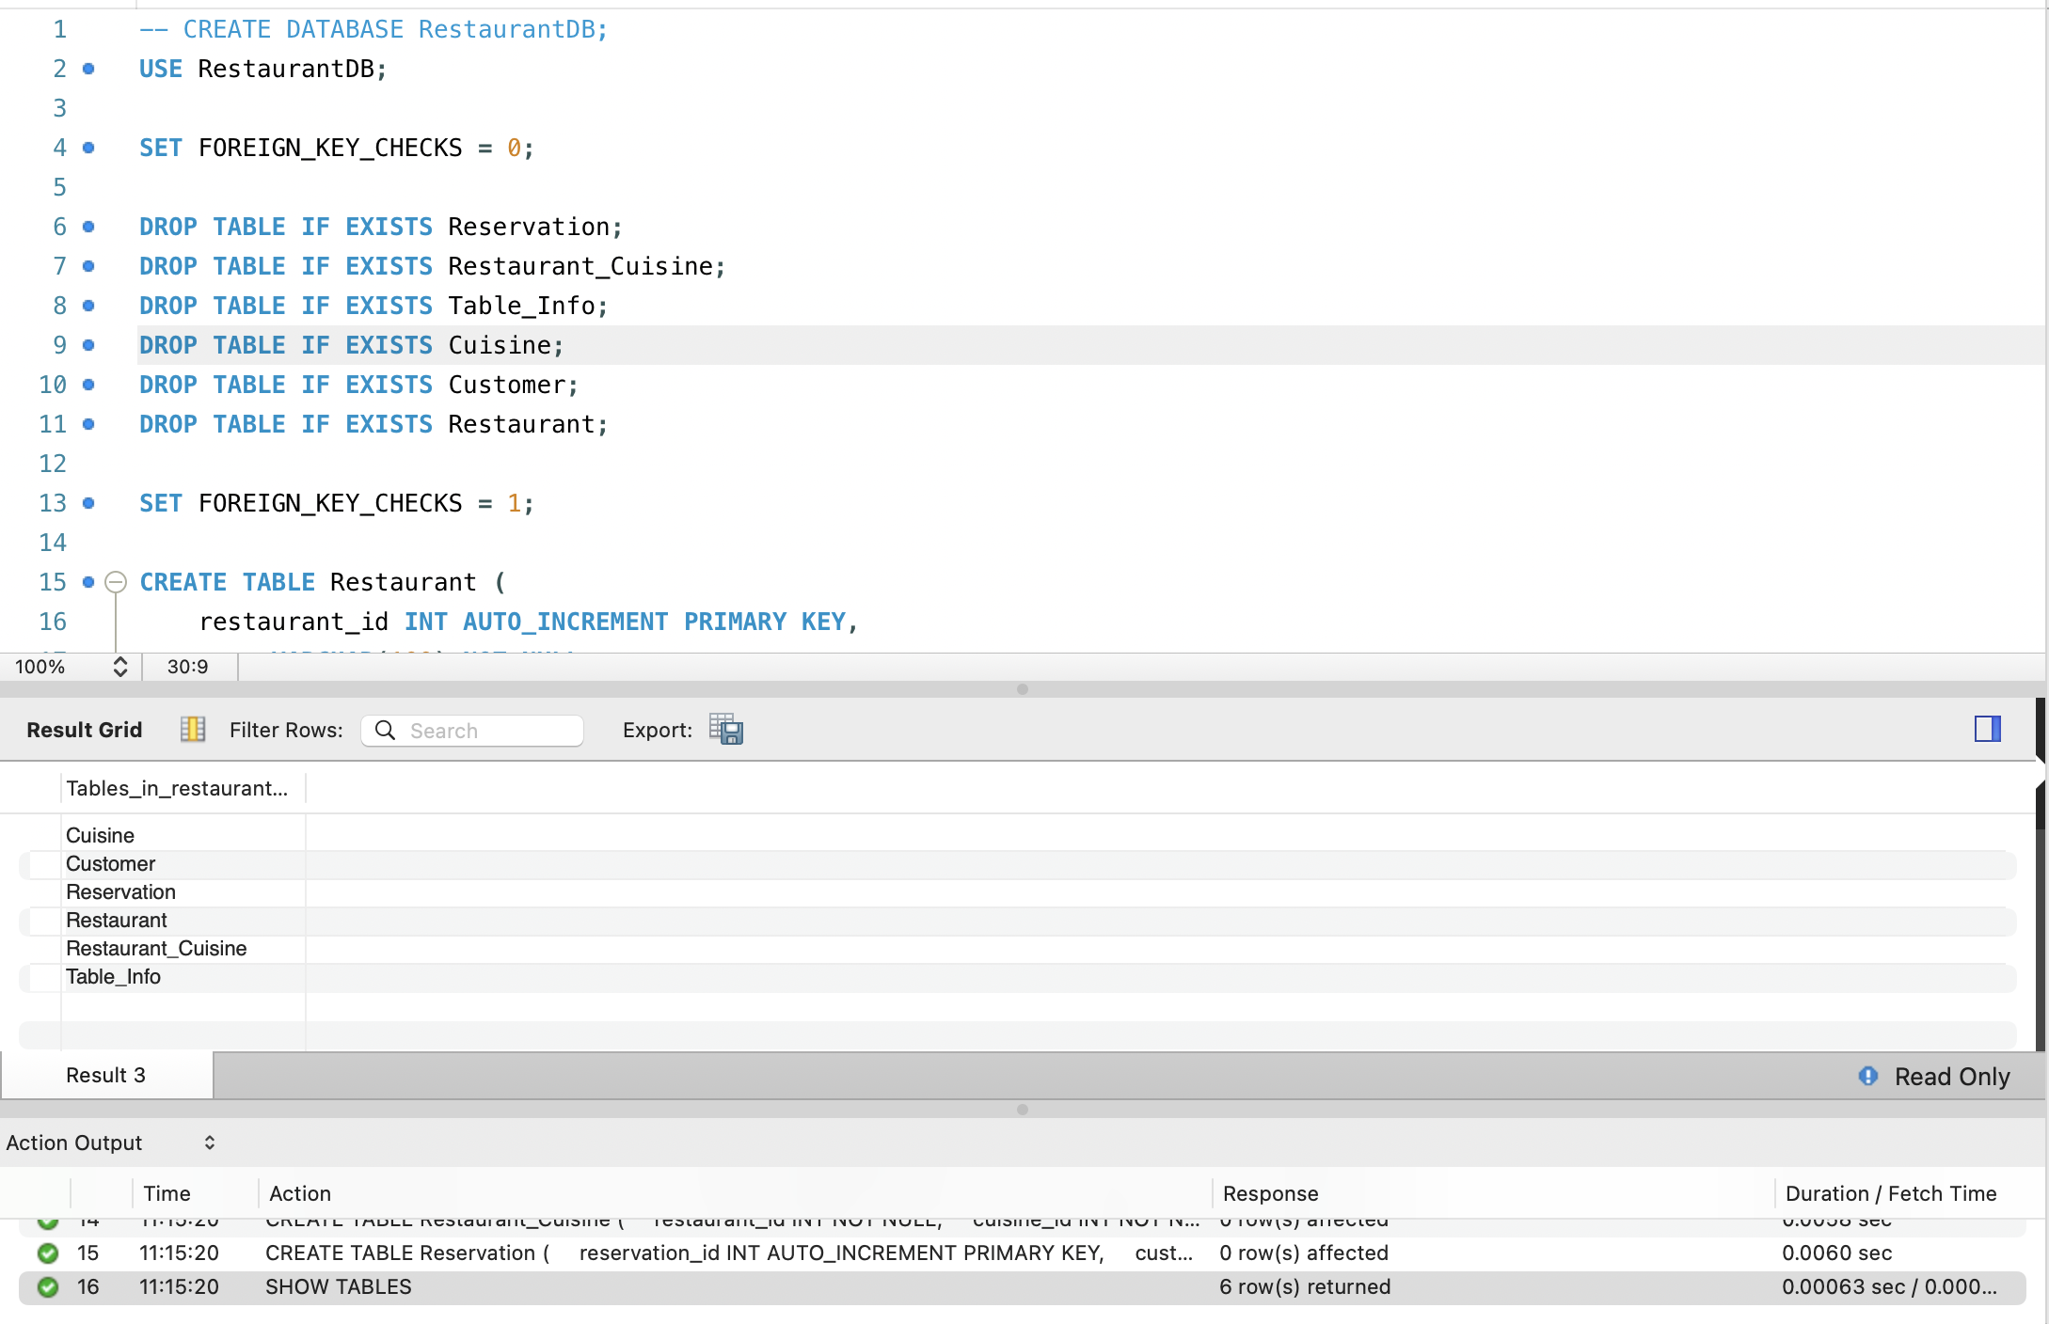
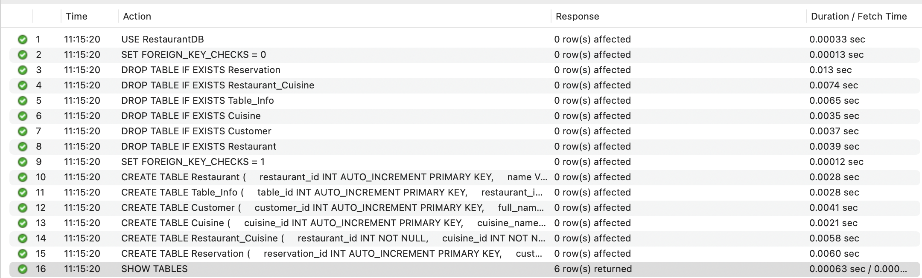
---
### 3. ER Diagram
The Entity-Relationship (ER) diagram provides a visual overview of all entities and their relationships. It ensures database normalization and depicts how tables interconnect.
**Entity Summaries:**
* **Restaurant:** Stores details about each restaurant, including operating hours.
* **Customer:** Contains personal and contact details for reservation tracking.
* **Reservation:** Manages booking details, connecting customers and restaurants.
* **Table_Info:** Represents tables with capacity and numbering.
* **Cuisine & Restaurant_Cuisine:** Define restaurant categories and their associations.
**ER Diagram:**
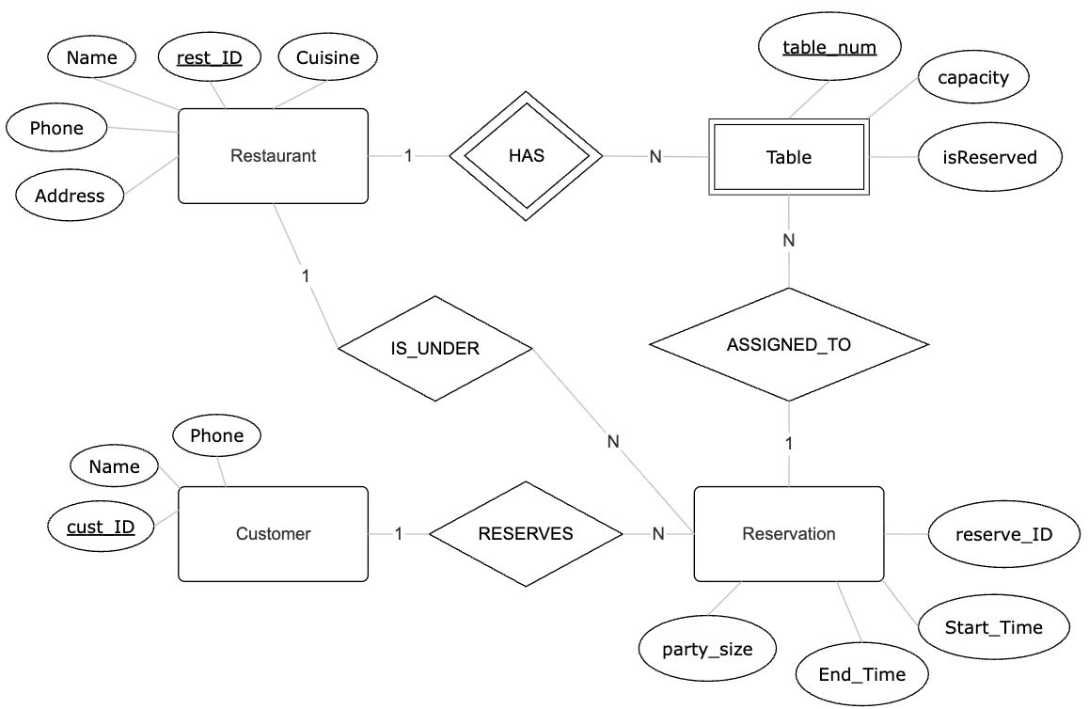
---
### 4. Views and Data Retrieval
This section presents ten SQL views created for the Restaurant Reservation System database. Each view is designed to simplify querying, improve maintainability, and provide quick access to key operational and analytical information. For each view, a description, SQL definition, and sample result are included.
---
### **View 1: view_full_reservation_info**
**Purpose:**
Displays a complete overview of reservations, including restaurant, customer, and table details.
**SQL Definition:**
```sql
CREATE VIEW view_full_reservation_info AS
SELECT rsv.reservation_id, c.full_name AS customer_name, rest.name AS restaurant_name,
rsv.reservation_date, rsv.start_time, rsv.end_time, t.capacity, rsv.num_people, rsv.status
FROM Reservation rsv
JOIN Customer c ON rsv.customer_id = c.customer_id
JOIN Restaurant rest ON rsv.restaurant_id = rest.restaurant_id
JOIN Table_Info t ON rsv.table_id = t.table_id;
```
**Description:**
Provides unified reservation details for reports and dashboards.
**Sample Output:**
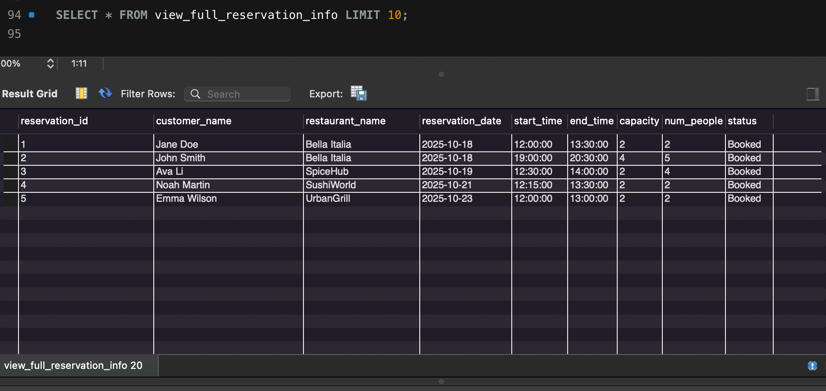
---
### **View 2: view_popular_restaurants**
**Purpose:**
Shows restaurants ranked by total number of reservations.
**SQL Definition:**
```sql
CREATE VIEW view_popular_restaurants AS
SELECT r.restaurant_id, r.name AS restaurant_name, COUNT(rs.reservation_id) AS total_reservations
FROM Reservation rs
JOIN Restaurant r ON rs.restaurant_id = r.restaurant_id
GROUP BY r.restaurant_id, r.name
ORDER BY total_reservations DESC;
```
**Sample Output:**
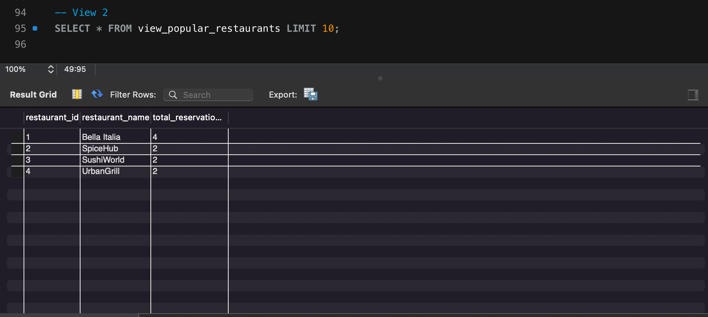
---
### **View 3: view_available_tables**
**Purpose:**
Lists tables that are not reserved for a given date.
**SQL Definition:**
```sql
CREATE VIEW view_available_tables AS
SELECT t.table_id, t.restaurant_id, r.name AS restaurant_name, t.table_number, t.capacity
FROM Table_Info t
JOIN Restaurant r ON r.restaurant_id = t.restaurant_id
WHERE t.table_id NOT IN (
SELECT table_id FROM Reservation WHERE reservation_date = CURDATE()
);
```
**Sample Output:**
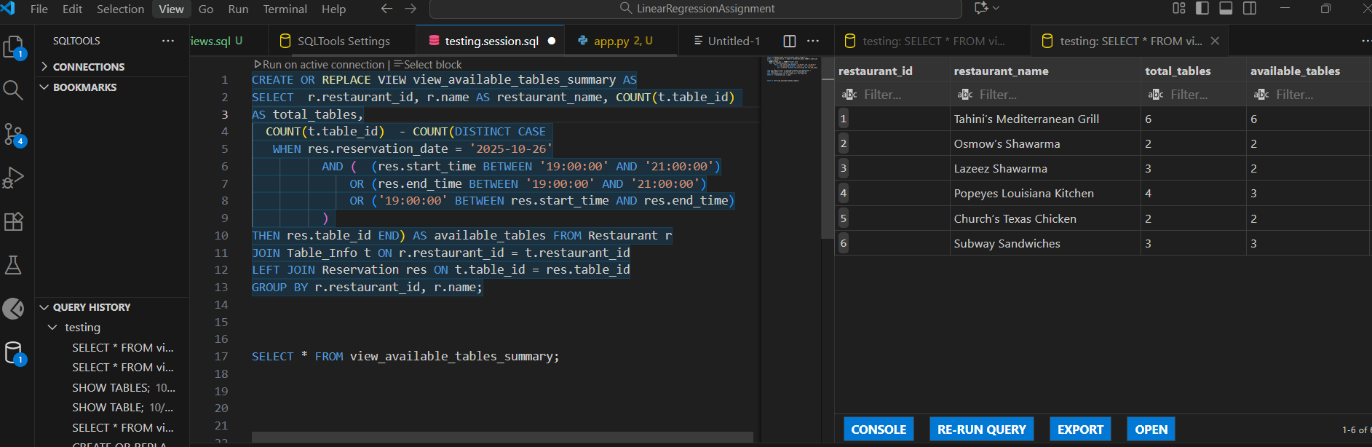
---
### **View 4: view_customer_history**
**Purpose:**
Displays a list of all past reservations made by each customer.
**SQL Definition:**
```sql
CREATE VIEW view_customer_history AS
SELECT c.full_name, r.name AS restaurant_name, rs.reservation_date, rs.num_people, rs.status
FROM Reservation rs
JOIN Customer c ON rs.customer_id = c.customer_id
JOIN Restaurant r ON rs.restaurant_id = r.restaurant_id
WHERE rs.reservation_date < CURDATE();
```
**Sample Output:**
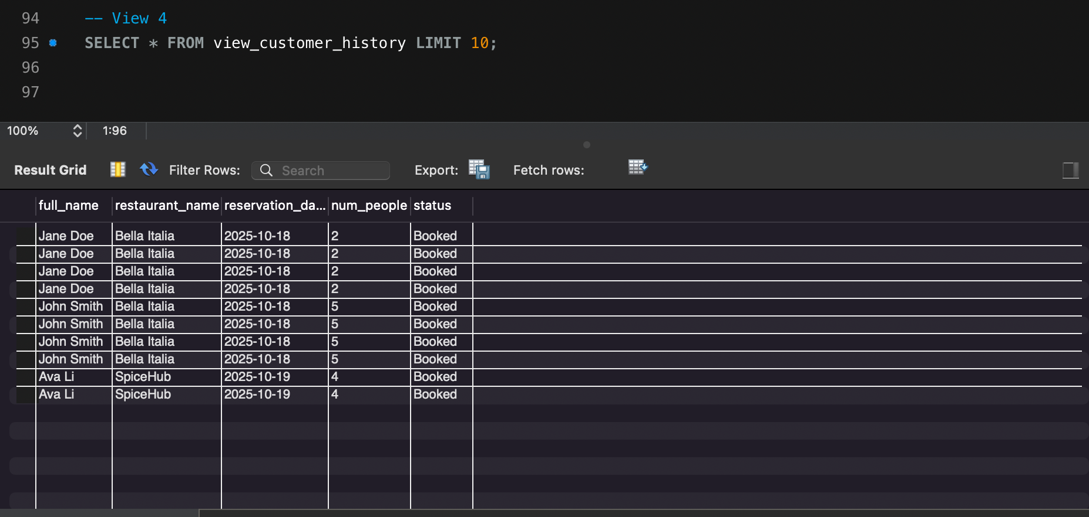
---
### **View 5: view_cuisine_summary**
**Purpose:**
Summarizes how many restaurants offer each cuisine type.
**SQL Definition:**
```sql
CREATE VIEW view_cuisine_summary AS
SELECT c.cuisine_name, COUNT(rc.restaurant_id) AS total_restaurants
FROM Cuisine c
JOIN Restaurant_Cuisine rc ON c.cuisine_id = rc.cuisine_id
GROUP BY c.cuisine_name;
```
**Sample Output:**
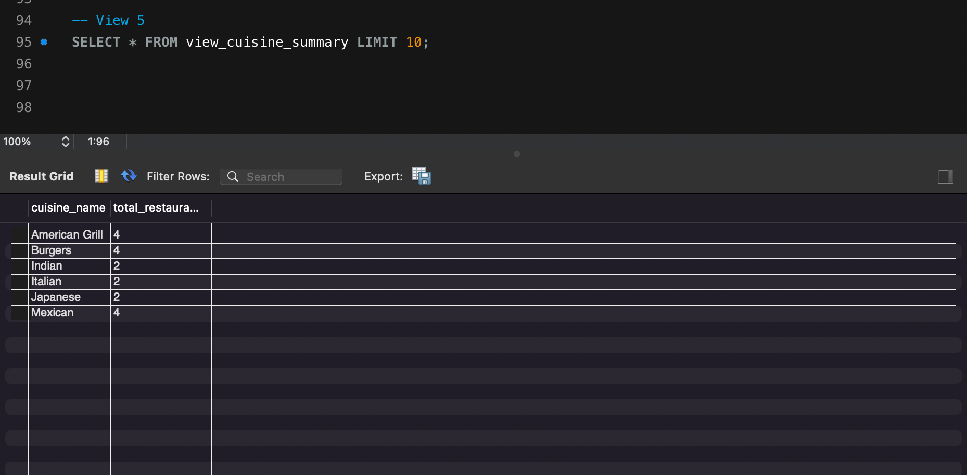
---
### **View 6: view_reservations_by_day**
**Purpose:**
Aggregates reservation counts by day of week.
**SQL Definition:**
```sql
CREATE VIEW view_reservations_by_day AS
SELECT DAYNAME(reservation_date) AS day_of_week, COUNT(*) AS total_reservations
FROM Reservation
GROUP BY DAYNAME(reservation_date)
ORDER BY total_reservations DESC;
```
**Sample Output:**
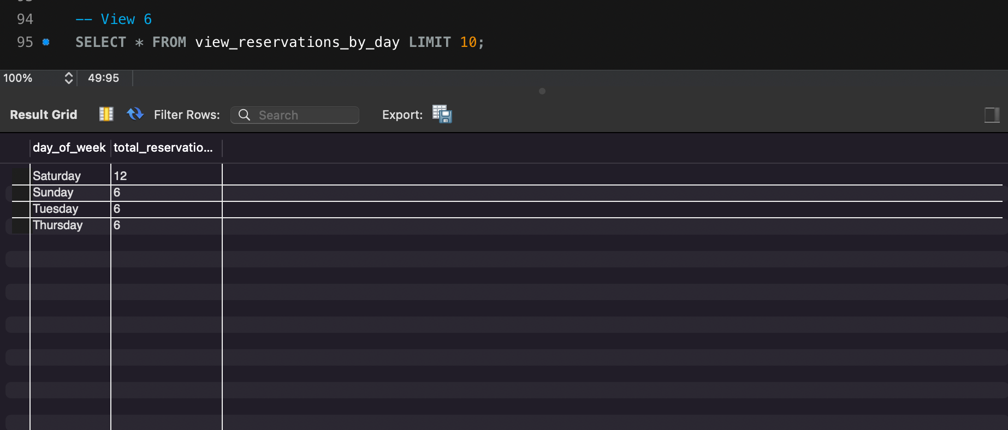
---
### **View 7: view_active_bookings**
**Purpose:**
Displays all upcoming reservations.
**SQL Definition:**
```sql
CREATE VIEW view_active_bookings AS
SELECT rsv.reservation_id, c.full_name, rest.name AS restaurant_name,
rsv.reservation_date, rsv.start_time, rsv.status
FROM Reservation rsv
JOIN Customer c ON rsv.customer_id = c.customer_id
JOIN Restaurant rest ON rsv.restaurant_id = rest.restaurant_id
WHERE rsv.reservation_date >= CURDATE() AND rsv.status = 'Booked';
```
**Sample Output:**
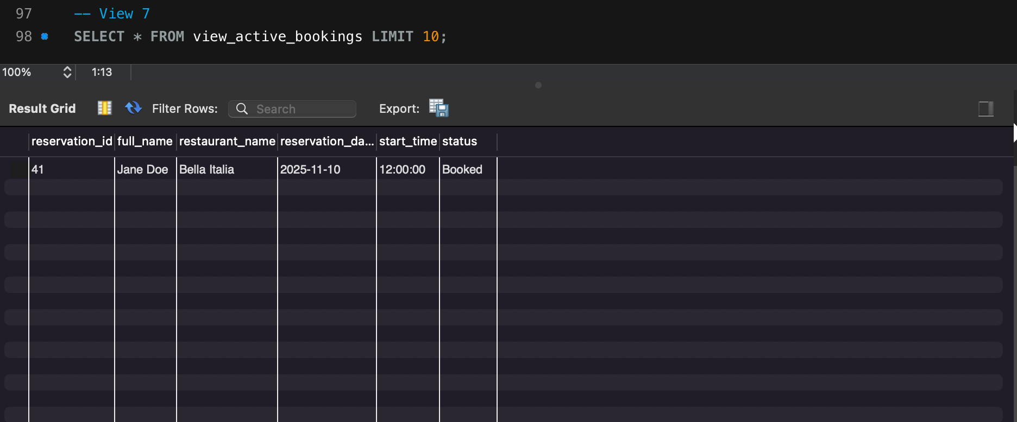
---
### **View 8: view_table_utilization**
**Purpose:**
Shows number of reservations per table, useful for load analysis.
**SQL Definition:**
```sql
CREATE VIEW view_table_utilization AS
SELECT t.table_id, r.name AS restaurant_name, COUNT(rs.reservation_id) AS total_reservations
FROM Table_Info t
LEFT JOIN Reservation rs ON rs.table_id = t.table_id
JOIN Restaurant r ON r.restaurant_id = t.restaurant_id
GROUP BY t.table_id, r.name;
```
**Sample Output:**
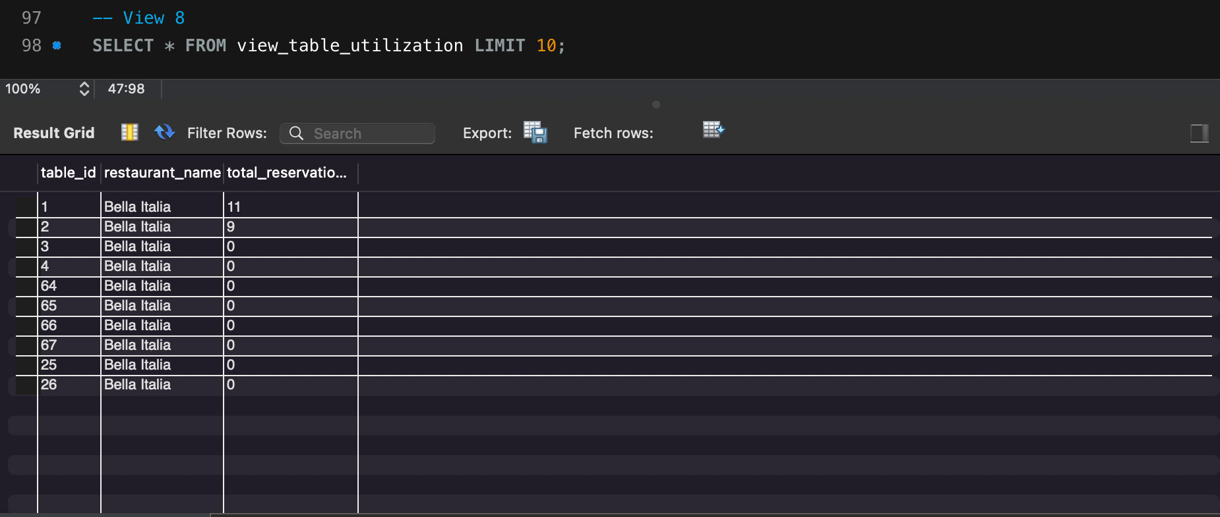
---
### **View 9: view_top_customers**
**Purpose:**
Identifies customers with the highest number of reservations.
**SQL Definition:**
```sql
CREATE VIEW view_top_customers AS
SELECT c.full_name, COUNT(rs.reservation_id) AS total_reservations
FROM Reservation rs
JOIN Customer c ON rs.customer_id = c.customer_id
GROUP BY c.full_name
ORDER BY total_reservations DESC;
```
**Sample Output:**
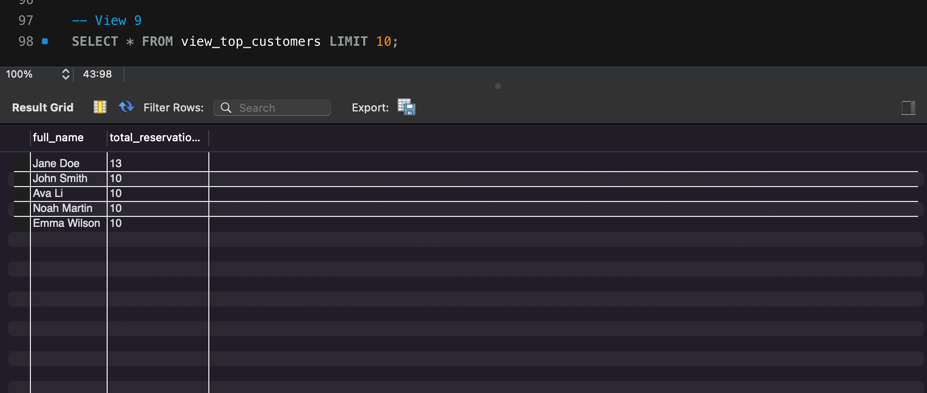
---
### **View 10: view_cancelled_reservations**
**Purpose:**
Lists all reservations that were cancelled.
**SQL Definition:**
```sql
CREATE VIEW view_cancelled_reservations AS
SELECT rs.reservation_id, c.full_name, r.name AS restaurant_name, rs.reservation_date, rs.status
FROM Reservation rs
JOIN Customer c ON rs.customer_id = c.customer_id
JOIN Restaurant r ON rs.restaurant_id = r.restaurant_id
WHERE rs.status = 'Cancelled';
```
**Sample Output:**
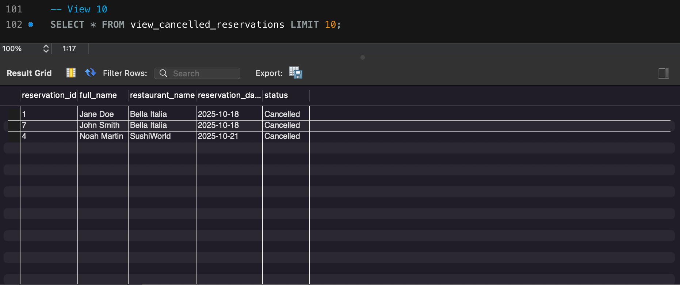
---
### 5. Contribution Matrix
| Assignee | Issue Key | Summary | Issue Type | Status |
|:--------------------|:------------|:--------------------------------------------------------------|:-------------|:------------|
| Ali Hakkani | CRRSSFP-36 | Task 5.3 — Prepare PowerPoint Slides | Task | To Do |
| Ayaan Ahmed | CRRSSFP-35 | Task 5.2 — Insert Screenshots & Visual Evidence | Task | To Do |
| Mohammad Taqi | CRRSSFP-34 | Task 5.1 — Write Final Report (10–12 Pages) | Task | To Do |
| — | CRRSSFP-33 | Final Report & Presentation | Epic | To Do |
| Mohamed Tawfik Omar | CRRSSFP-32 | Task 4.3 — CRUD & API Test Pass (E2E) | Task | To Do |
| Mohammad Taqi | CRRSSFP-31 | Task 4.2 — Error Handling (Frontend & API) | Task | To Do |
| Ali Hakkani | CRRSSFP-30 | Task 4.1 — Client-Side Validation | Task | To Do |
| Ayaan Ahmed | CRRSSFP-29 | Task 3.5 — AJAX/Fetch Integration & UX Polish | Task | To Do |
| Mohammad Taqi | CRRSSFP-28 | Task 3.4 — Chart.js Visualizations | Task | To Do |
| Ali Hakkani | CRRSSFP-27 | Task 3.3 — Search & Filter Page | Task | To Do |
| Ayaan Ahmed | CRRSSFP-26 | Task 3.2 — Reservations Dashboard (Show 10 Views) | Task | To Do |
| Mohammad Taqi | CRRSSFP-25 | Task 3.1 — Frontend Project Setup | Task | To Do |
| — | CRRSSFP-24 | Phase III — Frontend Development | Epic | To Do |
| Mohammad Taqi | CRRSSFP-23 | Task 2.2 — Integrate External API with Reservations Logic | Task | To Do |
| Mohamed Tawfik Omar | CRRSSFP-22 | Task 2.1 — External API Integration (OpenWeather Example) | Task | To Do |
| Mohammad Taqi | CRRSSFP-21 | Task 1.3 — Implement User Authentication and Role Management | Task | To Do |
| Ayaan Ahmed | CRRSSFP-20 | Task 1.2 — Implement CRUD Operations | Task | To Do |
| Ali Hakkani | CRRSSFP-19 | Task 1.1 — Select Backend Stack and Set Up Server Environment | Task | To Do |
| — | CRRSSFP-18 | Phase III — Backend Development | Epic | To Do |
| Mohammad Taqi | CRRSSFP-17 | Task 5.4 — Export and Submit | Task | In Progress |
| Ayaan Ahmed | CRRSSFP-16 | Task 5.3 — Final Validation | Task | To Do |
| Mohammad Taqi | CRRSSFP-15 | Task 5.2 — Grammar, Formatting, and Clarity Review | Task | Done |
| Ayaan Ahmed | CRRSSFP-14 | Task 5.1 — Add Contribution Matrix | Task | In Progress |
| Mohammad Taqi | CRRSSFP-13 | Phase II Report Finalization | Epic | To Do |
| Mohammad Taqi | CRRSSFP-12 | Task 3.6 — Draft Phase II Report | Task | Done |
| Mohammad Taqi | CRRSSFP-11 | Task 3.5 — Phase II Report: Views Section | Task | Done |
| Mohammad Taqi | CRRSSFP-10 | Task 3.4 — Performance & Integrity Checks | Task | Done |
| Ali Hakkani | CRRSSFP-9 | Task 3.3 — Test & Validate All Views | Task | Done |
| Ali Hakkani | CRRSSFP-8 | Task 3.2 — Implement 5 Custom Views (Domain-Specific) | Task | Done |
| Mohamed Tawfik Omar | CRRSSFP-7 | Task 3.1 — Implement 5 Common Views (Required) | Task | Done |
| Mohamed Tawfik Omar | CRRSSFP-6 | Task 5: Validate Schema and Data Integrity | Task | Done |
| Mohammad Taqi | CRRSSFP-5 | Task 4: Populate Tables with Sample Data | Task | Done |
| Ali Hakkani | CRRSSFP-4 | Task 3: Write SQL CREATE TABLE Commands | Task | Done |
| Ayaan Ahmed | CRRSSFP-3 | Task 2: Create ER Diagram | Task | Done |
| Ayaan Ahmed | CRRSSFP-2 | Task 1: Finalize Entities and Relationships | Task | Done |
| — | CRRSSFP-1 | Database Foundation | Epic | To Do |
---
### 6. Conclusion
The Phase II implementation successfully integrates schema design, referential integrity, and analytical data views for the Restaurant Reservation System. Each module of the project aligns with database management principles, enabling efficient querying, strong data consistency, and readiness for future application development.
**Next Steps:**
* Implement stored procedures for automated booking conflict checks.
* Connect to a web front-end for user-based reservation management.
* Extend analytics to track daily performance trends and cancellation ratios.
**End of Report**

