Article
HBOCpred: an ensemble framework for prioritisation of germline missense variants in hereditary breast and ovarian cancer
Mustafa Tarık Alay ^{1,}* and Haktan Bağış Erdem ¹
¹ Department of Medical Genetics, Ankara Etlik City Hospital, 06170 Ankara, Türkiye; mtarikalay@gmail.com (M.T.A.)
¹ Department of Medical Genetics, Ankara Etlik City Hospital, 06170 Ankara, Türkiye; haktanbagis@gmail.com (H.B.E.)
* Correspondence: Mustafa Tarık Alay, Department of Medical Genetics, Ankara Etlik City Hospital, 06170 Ankara, Türkiye; mtarikalay@gmail.com
Abstract
HBOCpred prioritises unresolved germline missense variants in 17 hereditary breast and ovarian cancer genes. Four calibrated learners provide a vote vector, V0–V4 agreement states and the S_MAC ranking score. Identical descriptors apply to source-labelled and unresolved records: V0 denotes unanimous B/LB-directed votes, V1–V3 mixed votes and V4 unanimous LP/P-directed votes; none assigns ACMG/AMP status. Development used 2,160 anchors with five repeats of nested five-fold cross-validation and preprocessing fitted within training partitions. The annotation-completeness rule allowed outputs for 2,046 anchors per repeat and suppressed 114. Among evaluable anchors, the secondary ≥3-of-4 endpoint yielded balanced accuracy 0.9604 ± 0.0023; S_MAC yielded AUROC 0.9909 ± 0.0013 and Brier score 0.0294 ± 0.0010. Values after ± describe split stability. First-repeat unanimous outputs agreed with source labels in 1,920/1,968 cases, but 32 LP/P anchors received V0. Leave-one-gene-out AUROC was 0.9812 among 2,045 evaluable anchors, with substantial gene-specific variation. Among 43,679 unresolved records, V0, V1–V3 and V4 contained 33,414, 4,491 and 5,774 variants. These internal consistency estimates remain subject to predictor–label dependence and distribution shift; independent clinical performance and utility are unestablished.
Keywords: hereditary breast and ovarian cancer; variant of uncertain significance; missense variant; machine learning; ensemble learning; variant prioritisation

1. Introduction
Hereditary breast and ovarian cancer (HBOC) is an autosomal dominant cancer-predisposition syndrome primarily associated with an increased risk of breast cancer and tubo-ovarian cancer. Inherited predisposition due to pathogenic germline variants in HBOC genes is estimated to account for 5–10% of breast cancers and 10–15% of ovarian cancers [1,2]. HBOC is a genetically heterogeneous disorder and the implicated gene influences penetrance, age at onset, tumour spectrum and clinical presentation.
Among the principal high-penetrance breast cancer susceptibility genes, BRCA1 and BRCA2 are the best characterised and remain the most common genetic causes of classical HBOC. Both genes encode central components of the homologous-recombination pathway involved in repairing DNA double-strand breaks. Germline pathogenic variants in both genes confer substantially increased risks of breast and tubo-ovarian cancer. By 80 years of age, the cumulative breast cancer risk is estimated at approximately 72% for BRCA1 and 69% for BRCA2 carriers, whereas the corresponding ovarian cancer risks are approximately 44% and 17%, respectively [3].
Accordingly, hereditary breast and ovarian cancer testing historically focused on BRCA1 and BRCA2, although contemporary diagnostic practice increasingly uses multigene panels. PALB2 is also established as a high-penetrance breast cancer susceptibility gene, with the cumulative breast cancer risk reaching approximately 50% by 80 years of age [4,5]. TP53, PTEN, STK11 and CDH1 are associated with rarer high-penetrance cancer-predisposition syndromes [6], including Li–Fraumeni syndrome [7], PTEN hamartoma tumour syndrome [8], Peutz–Jeghers syndrome [9] and diffuse gastric and lobular breast cancer syndrome [10], respectively. In contrast, pathogenic variants in ATM and CHEK2 generally confer moderate breast cancer risk, although the magnitude of risk may vary according to the specific variant and family history. RAD51C and RAD51D are moderate-penetrance susceptibility genes for tubo-ovarian cancer and also confer a more modest, subtype-dependent increase in breast cancer risk, particularly for oestrogen receptor-negative and triple-negative disease [11,12]. In contrast, BARD1 is primarily a moderate-penetrance breast cancer susceptibility gene, with no established association with ovarian cancer, whereas BRIP1 is an established tubo-ovarian cancer susceptibility gene and is not currently considered a breast cancer predisposition gene.
Next-generation sequencing-based multigene panels have broadened the diagnostic scope of hereditary cancer testing but have also increased the detection of variants of uncertain significance (VUS), most of which are missense substitutions. Expert groups such as the Evidence-based Network for the Interpretation of Germline Mutant Alleles (ENIGMA) and the Clinical Genome Resource (ClinGen) improve interpretive consistency through gene-specific integration of population, segregation, case–control, functional, and clinical evidence; however, expert curation remains resource-intensive and uneven across genes [13–16]. Under the American College of Medical Genetics and Genomics/Association for Molecular Pathology (ACMG/AMP) framework, appropriately calibrated computational predictions may contribute PP3 or BP4 evidence; however, correlated predictors should not be counted as independent lines of evidence [17–19]. Consequently, a substantial proportion of missense variants, particularly in non-BRCA1/2 HBOC-associated genes, remains unresolved.
The principal challenge is therefore not VUS detection but systematic prioritisation for expert review and functional follow-up, particularly because comprehensive gene-specific curation frameworks remain unavailable for many hereditary cancer genes [20]. Scalable computational approaches may help bridge this gap by directing limited resources towards variants with the strongest benign- or pathogenic-leaning evidence. As a proof of principle, an integrative filter using ten in silico predictors narrowed 153 eligible BRCA1/2 VUS to 10 priority candidates [21]. However, most established predictors were developed for genome-wide application and may not capture disease-, gene- or domain-specific mechanisms [22,23]; disease-focused models may therefore offer greater contextual relevance for HBOC-associated missense variants [24].
We therefore developed and internally evaluated HBOCpred to support expert research review of unresolved variants in a defined 17-gene study panel. The model combines two conventional non-tree learners, a bagging learner and a boosting learner, retaining their calibrated probabilities, complete four-bit vote vector, V0–V4 agreement state and continuous S_MAC ranking score. An identical reporting rule is used for source-labelled anchors and unresolved application records: V0 denotes unanimous B/LB-directed votes, V1–V3 mixed votes and V4 unanimous LP/P-directed votes. These descriptors concern model direction and disagreement, not clinical certainty. We evaluated source-label consistency, annotation completeness, gene-specific generalisability and development-to-application shift; the outputs do not establish ACMG/AMP classifications, PP3/BP4 evidence strengths or clinical posterior probabilities.

2. Results

2.1 Analytic separation and feature stability
The source spreadsheets yielded 90 numeric fields after SpliceAI aggregation and removal of its positional fields. A label-independent semantic reduction produced 48 candidate representatives; Reliability_index was excluded from the primary analysis, leaving 47 candidates. Missingness filtering, imputation, scaling, supervised consensus ranking and correlation pruning were refitted separately in every inner-training and outer-training partition. No application-archive missingness filter was used. The deployment refit retained 25 predictors, of which 22 appeared in at least 20 of 25 outer-training panels (Table 1). This is a new reanalysis of the source inputs; its fitted objects and estimates supersede those in the previous revision.
Table 1. Deployment panel and selection frequency across 25 outer-training fits.
Rank | Predictor | Category | Outer folds | Frequency
1 | MetaRNN_rankscore | Variant-effect score | 24 | 96%
2 | am_pathogenicity | Variant-effect score | 25 | 100%
3 | CADD_PHRED | Variant-effect score | 25 | 100%
4 | PHACTboost_rankscore | Variant-effect score | 25 | 100%
5 | gMVP_rankscore | Variant-effect score | 22 | 88%
6 | MutationTaster_rankscore | Variant-effect score | 25 | 100%
7 | REVEL_rankscore | Variant-effect score | 20 | 80%
8 | Eigen-raw_coding_rankscore | Variant-effect score | 25 | 100%
9 | VARITY_R_LOO_rankscore | Variant-effect score | 18 | 72%
10 | ESM1b_converted_rankscore | Variant-effect score | 25 | 100%
11 | PrimateAI_rankscore | Variant-effect score | 25 | 100%
12 | fathmm-XF_coding_rankscore | Variant-effect score | 25 | 100%
13 | MVP_rankscore | Variant-effect score | 25 | 100%
14 | MutationAssessor_rankscore | Variant-effect score | 25 | 100%
15 | GERP++_RS_rankscore | Conservation/context | 25 | 100%
16 | phyloP100way_vertebrate_rankscore | Conservation/context | 25 | 100%
17 | phyloP470way_mammalian_rankscore | Conservation/context | 25 | 100%
18 | phastCons100way_vertebrate_rankscore | Conservation/context | 25 | 100%
19 | SpliceAI_DS_max | Splicing | 25 | 100%
20 | EVE_SCORE | Variant-effect score | 25 | 100%
21 | MetaSVM_rankscore | Variant-effect score | 25 | 100%
22 | DEOGEN2_rankscore | Variant-effect score | 24 | 96%
23 | MetaLR_rankscore | Variant-effect score | 9 | 36%
24 | bStatistic_converted_rankscore | Conservation/context | 10 | 40%
25 | MutFormer_rankscore | Variant-effect score | 22 | 88%

2.2 Fixed learner families and repeated nested internal evaluation
The revision evaluated four fixed learner families: SVM–RBF, L2 logistic regression, Extra Trees and histogram gradient boosting. Their hyperparameters, calibrators and vote thresholds were fitted within each training partition; there was no new nine-learner selection competition. Deployment vote thresholds were 0.5000, 0.6897, 0.5905 and 0.5000, respectively (Table 2). The learner set and reporting terminology were revision-stage choices informed by earlier development, so this analysis does not constitute an independent validation of those choices.
Table 2. Fitted deployment hyperparameters, calibration coefficients and vote thresholds.

Component | Role | Hyperparameters | Intercept | Slope | Threshold | Interpretation
SVM–RBF | Base learner | C = 6; gamma = scale | 0.04250 | 2.71178 | 0.5000 | One vote
L2 logistic | Base learner | C = 1; L2 penalty | -0.01277 | 0.93765 | 0.6897 | One vote
Extra Trees | Base learner | 220 trees; depth 18; max features 0.7; min leaf 1 | 0.01758 | 1.22101 | 0.5905 | One vote
HistGB | Base learner | 31 leaves; min leaf 20; 100 iterations; rate 0.1; L2 = 0 | -0.02603 | 0.53038 | 0.5000 | One vote
Mean4 | Mean score | Four calibrated probabilities | — | — | — | No vote
S_MAC | Meta-calibration | Logit(Mean4) | 0.03388 | 1.13536 | — | Ranking only
Across five complete outer-test repeats, 2,046/2,160 anchors (94.72%) satisfied the annotation-completeness rule in each repeat. Among evaluable anchors, the secondary ≥3-of-4 endpoint achieved balanced accuracy 0.9604 ± 0.0023, sensitivity 0.9457 ± 0.0021 and specificity 0.9751 ± 0.0037. Mean PPV, NPV, F1 and MCC were 0.9699, 0.9549, 0.9576 and 0.9228. S_MAC yielded AUROC 0.9909 ± 0.0013, AUPRC 0.9912 ± 0.0013 and Brier score 0.0294 ± 0.0010 (Figure 1). The ± values are sample standard deviations across repeat-level estimates, not confidence intervals. All metrics measure agreement with the processed source labels in the evaluable subset.
The 114 nonevaluable anchors comprised 80 B/LB and 34 LP/P records; their learner probabilities, votes, V-states and S_MAC were suppressed and they remained in source-cohort accounting. Thus, discrimination and binary metrics do not describe every source record. Outer-test calibration slopes ranged from 0.968 to 1.036 and intercepts from −0.148 to −0.023. These calibration results concern the ascertained source-label distribution and cannot establish clinical probability calibration.
In the fixed first-repeat out-of-fold audit, V0 contained 1,078 anchors (1,046 B/LB and 32 LP/P), V1–V3 contained 78 (45 B/LB and 33 LP/P), and V4 contained 890 (16 B/LB and 874 LP/P); 114 were incomplete (Table 3). Unanimous-vote coverage was 1,968/2,160 (91.11%), with source-direction agreement in 1,920/1,968 unanimous outputs (97.56%). Opposite unanimous direction occurred for 32/973 LP/P anchors at V0 (3.29%; Wilson 95% interval, 2.34–4.61%) and 16/1,187 B/LB anchors at V4 (1.35%; 0.83–2.18%). These proportions use all source records of the respective label; their rate ratio was 2.44.
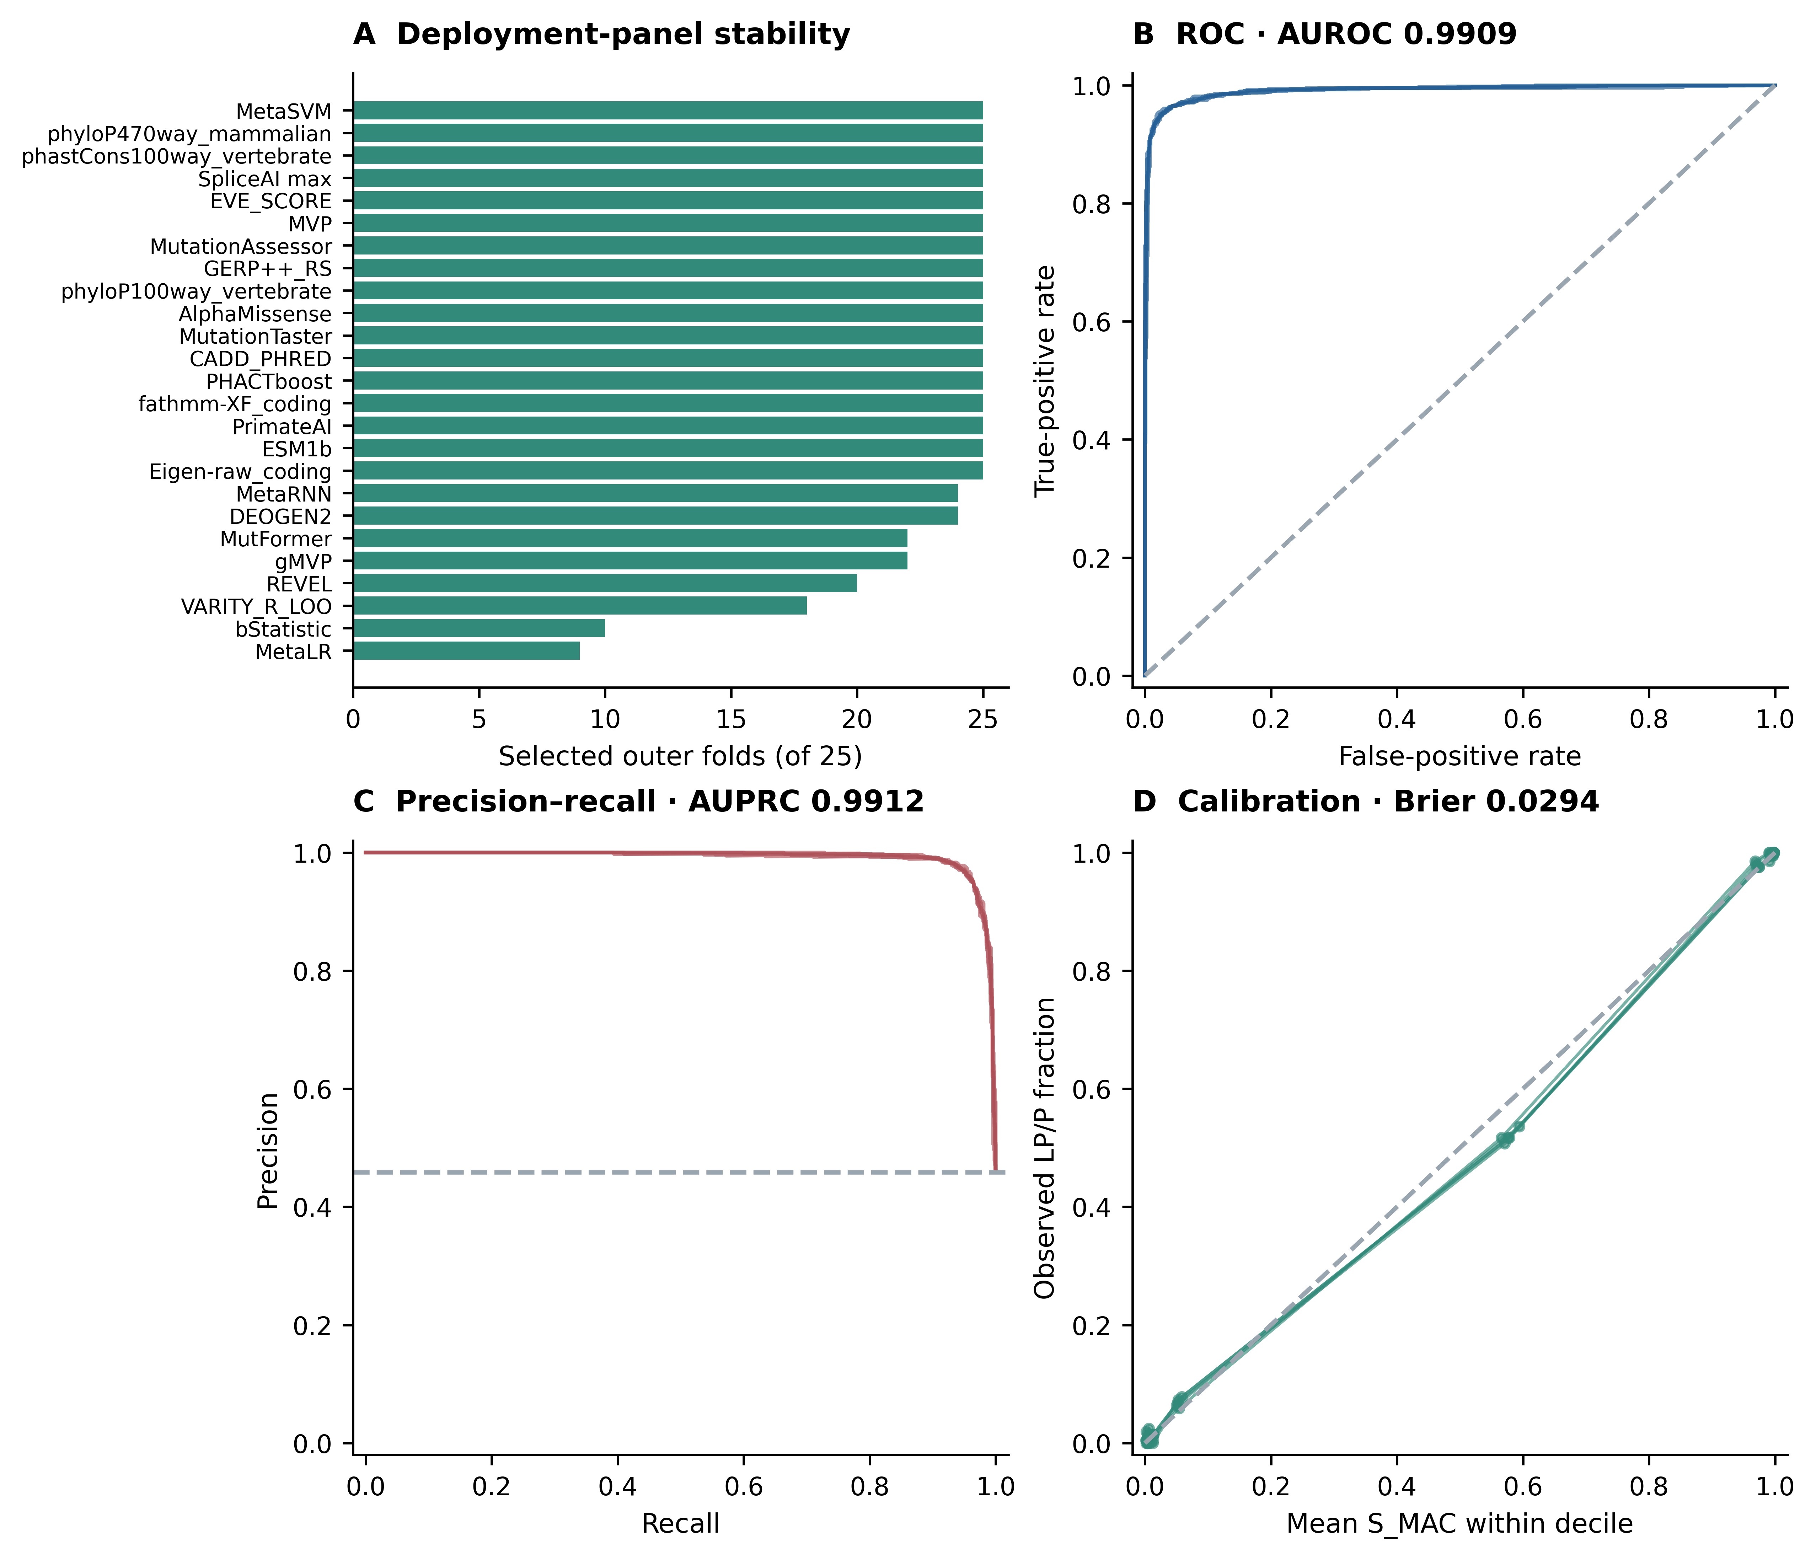
Figure 1. Internal evaluation of the refitted ensemble. (A) Selection frequency of the deployment predictors across 25 outer-training panels. (B) S_MAC ROC curves for five outer-test repeats. (C) Precision–recall curves; the baseline is the LP/P proportion among the evaluable anchors. (D) Decile calibration curves. Each repeat includes 2,046 evaluable anchors and excludes 114 records failing the same output-completeness rule used in application. Repeated curves describe split stability on this source cohort and do not represent external validation.
Table 3. First-repeat out-of-fold vote groups and incomplete-record accounting.
Source label | V0 | V1–V3 | V4 | Incomplete | Total
B/LB | 1,046 | 45 | 16 | 80 | 1,187
LP/P | 32 | 33 | 874 | 34 | 973
Total | 1,078 | 78 | 890 | 114 | 2,160
Note. V0 and V4 denote unanimous direction of four correlated model votes; V1–V3 denotes disagreement. The terminology is identical for anchors and application records. Incomplete is an annotation-quality flag, not a clinical class. Unanimity coverage uses all 2,160 source anchors; conditional agreement uses the 1,968 unanimous outputs. Neither is an accuracy estimate for unresolved variants.

2.3 Shared output descriptors and vote-pattern audit
The deployment model assigned the 43,679 unresolved records to V0 (33,414), V1 (1,943), V2 (1,189), V3 (1,359) and V4 (5,774). All satisfied the completeness requirement. The shared descriptors therefore comprised 33,414 unanimous B/LB-directed, 4,491 mixed-vote and 5,774 unanimous LP/P-directed records (Figure 2). V0 is not a benign classification or an instruction to discontinue review, and V4 is not a pathogenic classification. The exact state, learner identities and probabilities remain available with S_MAC.
Among evaluable first-repeat anchors, mixed votes occurred in 78/2,046 (3.81%), compared with 4,491/43,679 (10.28%) application records, a 2.70-fold difference. This comparison conditions on evaluability in both datasets; the 114 incomplete anchors are reported separately. It is a difference in model-output distributions, not evidence that the unresolved variants have a particular true-label error rate.
The first-repeat mixed-vote states contained 27 V1 anchors (9 LP/P), 25 V2 anchors (11 LP/P) and 26 V3 anchors (13 LP/P). The LP/P fractions were 44.0% at V2 (Wilson 95% interval, 26.7–62.9%) and 50.0% at V3 (32.1–67.9%). These overlapping intervals do not support ordered clinical tiers. The earlier V2/V3 point-ordering reversal belonged to the previous fit and is not reproduced as a result of this reanalysis.
At exact 2:2 disagreement, the two tree learners supplied the LP/P-directed votes in 16/25 anchors (10 LP/P and 6 B/LB). One tree and one conventional learner formed the pair in 9/25 (1 LP/P and 8 B/LB); the two conventional learners never formed the pair. Pair identity describes structured algorithmic disagreement and is not a biological class.
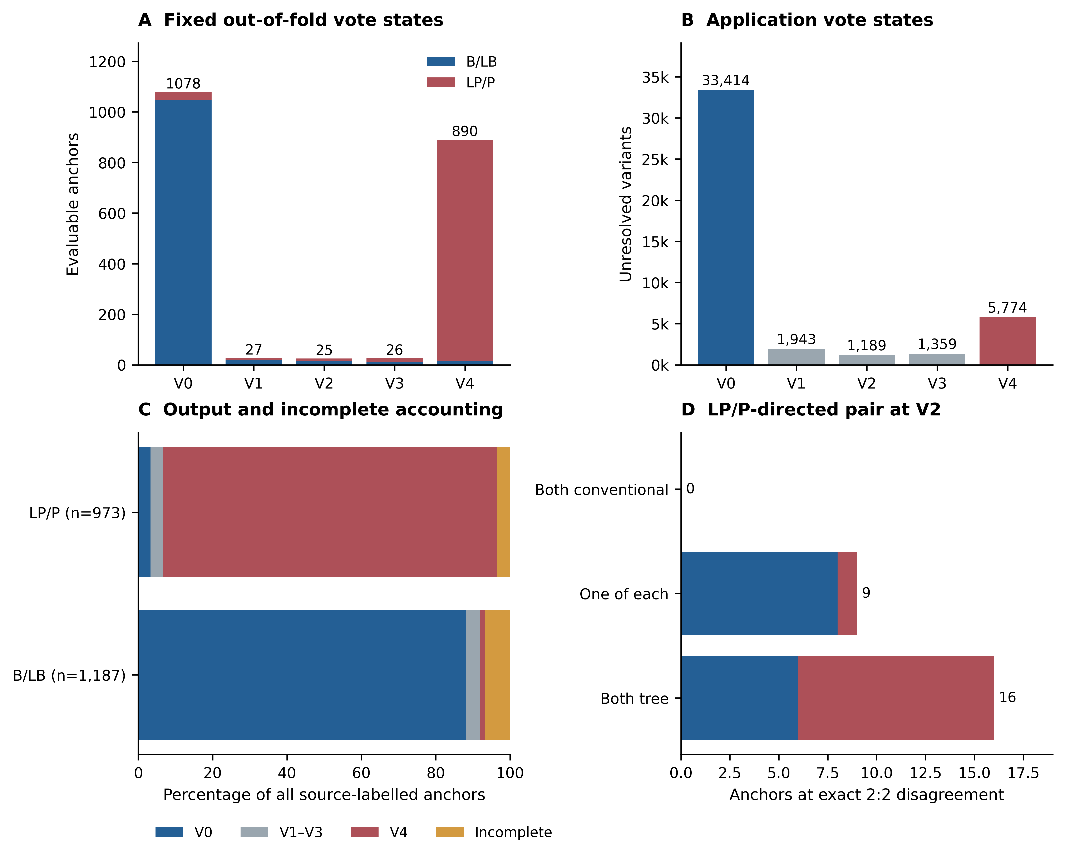
Figure 2. Shared vote states and completeness accounting. (A) First-repeat evaluable anchor counts by V-state and source label. (B) Deployment counts among 43,679 unresolved records. (C) Vote groups and incomplete records as percentages of all anchors within each source label. (D) Identities of the two LP/P-directed learners at V2; colours indicate source labels. The same directional descriptors are used throughout, without uncertainty-low/mid/high labels or clinical reclassification.

2.4 Sensitivity analyses
Five-fold sensitivity analyses used the first-repeat fold assignments. Including Reliability_index yielded balanced accuracy 0.9614 and AUROC 0.9891, versus 0.9592 and 0.9886 in the primary first repeat. Excluding both BayesDel addAF and AlphaMissense, while retaining the other eligible candidates, yielded 0.9607 and 0.9896. These small within-cohort differences do not establish equivalence or remove predictor–label dependence. Refitting on the 2,120 variants with a current same-gene transcript missense annotation yielded balanced accuracy 0.9615 and AUROC 0.9902 among 2,019 evaluable records; restricting the primary predictions to the same records yielded 0.9584 and 0.9884 (Table 4). In a separate descriptive subset of 1,998 anchors whose embedded ClinVar significance agreed with the processed source label, mean balanced accuracy was 0.9598 ± 0.0022 and AUROC 0.9907 ± 0.0013; this was a prediction-subset analysis, not a new external sample.
Table 4. Internal sensitivity analyses with explicit total and evaluable denominators.
Analysis | Total n | Scored n | BA | AUROC | AUPRC | Evaluation
Primary, five repeats | 2,160 | 2,046 | 0.9604 ± 0.0023 | 0.9909 ± 0.0013 | 0.9912 ± 0.0013 | Mean ± split SD
Primary, repeat 1 | 2,160 | 2,046 | 0.9592 | 0.9886 | 0.9890 | First-repeat folds
With Reliability_index | 2,160 | 2,046 | 0.9614 | 0.9891 | 0.9895 | First-repeat folds
Without addAF + AlphaMissense | 2,160 | 2,046 | 0.9607 | 0.9896 | 0.9904 | First-repeat folds
Current-missense refit | 2,120 | 2,019 | 0.9615 | 0.9902 | 0.9906 | First-repeat folds
Primary, same missense subset | 2,120 | 2,019 | 0.9584 | 0.9884 | 0.9887 | First-repeat folds
Leave one gene out | 2160 | 2045 | 0.9453 | 0.9812 | 0.9810 | 17 complete gene holdouts

2.5 Gene-held-out evaluation and reference-source audits
Seventeen leave-one-gene-out fits each excluded one complete gene from preprocessing, selection, tuning, calibration and threshold estimation. Pooled across 2,045 evaluable anchors, the ≥3-of-4 endpoint had balanced accuracy 0.9453, sensitivity 0.9276 and specificity 0.9629; S_MAC AUROC was 0.9812, AUPRC 0.9810 and Brier score 0.0443. There were 115 incomplete records. Figure 3 and Supplementary Table S1 and the accompanying per-gene CSV report the denominators in Shinny application, confusion counts, vote states and Wilson intervals for every gene.
Aggregate performance concealed important variation. For FANCA, sensitivity was 50/75 (66.7%) among evaluable LP/P anchors; for NBN it was 0/2, with a correspondingly wide interval. BRCA1 sensitivity was 193/207 (93.2%) and specificity 306/321 (95.3%); BRCA2 sensitivity was 77/81 (95.1%) and specificity 289/302 (95.7%). PTEN specificity of 5/5 must be read with its small evaluable benign denominator and 17 incomplete benign anchors. These are gene-specific internal source-label results, not evidence of uniformly transferable clinical performance.
The complete hospital source list contained 122 rows, of which 47 fell within the 17-gene scope. These 47 rows resolved to 31 distinct missense variants after transcript aliases and repeated records were collapsed (Table 5). Twenty-two variants overlapped the anchor set, eight were in the frozen application catalogue, and one was present only in the wider source training archive. All 31 met the ≥20/25 completeness rule and were scored with the frozen deployment model. Anchor-overlapping outputs are in-sample illustrations, not independent validation. CHEK2 Ile157Thr received V0 (S_MAC = 0.0093), illustrating why model direction cannot replace clinical interpretation. No hospital reference labels were adjudicated or external performance estimates calculated.
Table 5. Complete hospital-list audit of 31 distinct missense variants within the 17-gene scope.
Gene | MANE description | Source rows | Observed / 25 | Record origin | Votes | V | S_MAC
BRCA1 | c.53T>C; p.Met18Thr | 1 | 25 | Anchor | 1111 | V4 | 0.9922
BRCA1 | c.181T>G; p.Cys61Gly | 1 | 25 | Anchor | 1111 | V4 | 0.9977
BRCA1 | c.5072C>G; p.Thr1691Arg | 1 | 24 | Anchor | 1111 | V4 | 0.9808
BRCA1 | c.5074G>C; p.Asp1692His | 1 | 24 | Anchor | 1111 | V4 | 0.9982
BRCA1 | c.5096G>A; p.Arg1699Gln | 1 | 25 | Anchor | 1111 | V4 | 0.9906
BRCA1 | c.5123C>A; p.Ala1708Glu | 2 | 25 | Anchor | 1111 | V4 | 0.9976
BRCA1 | c.5497G>A; p.Val1833Met | 1 | 25 | Anchor | 1111 | V4 | 0.9861
BRCA2 | c.8177A>G; p.Tyr2726Cys | 1 | 22 | Anchor | 1111 | V4 | 0.9789
BRCA2 | c.8351G>A; p.Arg2784Gln | 1 | 22 | Catalogue | 1101 | V3 | 0.7156
BRCA2 | c.8524C>T; p.Arg2842Cys | 1 | 22 | Catalogue | 1111 | V4 | 0.9345
BRCA2 | c.9371A>T; p.Asn3124Ile | 2 | 22 | Anchor | 1111 | V4 | 0.9815
PALB2 | c.3113G>C; p.Trp1038Ser | 1 | 23 | Archive | 1111 | V4 | 0.9695
ATM | c.875C>T; p.Pro292Leu | 1 | 25 | Anchor | 1111 | V4 | 0.9780
ATM | c.967A>G; p.Ile323Val | 1 | 25 | Anchor | 1111 | V4 | 0.9947
ATM | c.6047A>G; p.Asp2016Gly | 3 | 25 | Anchor | 1111 | V4 | 0.9978
ATM | c.6154G>A; p.Glu2052Lys | 2 | 25 | Catalogue | 0001 | V1 | 0.2646
ATM | c.6188G>A; p.Gly2063Glu | 2 | 25 | Catalogue | 1111 | V4 | 0.9867
ATM | c.6679C>T; p.Arg2227Cys | 1 | 25 | Anchor | 1111 | V4 | 0.9937
ATM | c.8122G>A; p.Asp2708Asn | 1 | 25 | Anchor | 1111 | V4 | 0.9632
CHEK2 | c.190G>A; p.Glu64Lys | 2 | 24 | Catalogue | 0000 | V0 | 0.0947
CHEK2 | c.427C>T; p.His143Tyr | 1 | 24 | Catalogue | 1111 | V4 | 0.9858
CHEK2 | c.433C>T; p.Arg145Trp | 3 | 24 | Anchor | 1111 | V4 | 0.9883
CHEK2 | c.470T>C; p.Ile157Thr | 5 | 24 | Catalogue | 0000 | V0 | 0.0093
CHEK2 | c.499G>A; p.Gly167Arg | 3 | 24 | Anchor | 1111 | V4 | 0.9909
CHEK2 | c.557A>G; p.Asn186Ser | 1 | 24 | Catalogue | 0000 | V0 | 0.0040
TP53 | c.473G>A; p.Arg158His | 1 | 25 | Anchor | 1111 | V4 | 0.9930
TP53 | c.742C>T; p.Arg248Trp | 1 | 25 | Anchor | 1111 | V4 | 0.9988
TP53 | c.818G>A; p.Arg273His | 1 | 25 | Anchor | 1111 | V4 | 0.9901
TP53 | c.856G>A; p.Glu286Lys | 1 | 25 | Anchor | 1111 | V4 | 0.9948
RAD51C | c.414G>C; p.Leu138Phe | 2 | 25 | Anchor | 1011 | V3 | 0.8903
FANCA | c.4009A>G; p.Ser1337Gly | 1 | 24 | Anchor | 1111 | V4 | 0.9597
All 47 in-scope source rows are represented; 75 rows from other genes remain in the full source audit. Votes are ordered SVM–RBF, logistic regression, Extra Trees and HistGB. Anchor: variant used to fit the deployment model (22 variants; displayed scores are in-sample). Catalogue: existing application record (8). Archive: wider source training archive, outside the anchor and application sets (1). All 31 pass ≥20/25 completeness. CHEK2 Ile200Thr/Ile157Thr and Gly210Arg/Gly167Arg are transcript aliases and were collapsed. Other CHEK2 descriptions are also shown on MANE Select. The ATM Asp2016Gly source rows contain discrepant rsIDs, retained in the row-level audit; matching used concordant coding/protein descriptions. RefSeq versions, genomic identities and unchanged source strings accompany the table. Source-row counts do not establish patient counts. S_MAC is a ranking score, not a clinical probability; these outputs provide no independent external performance estimate.
The gnomAD eligibility audit identified 50 missense candidates: 47 overlapped the full training archive and one additional candidate overlapped the unresolved archive. The two remaining candidates, in CHEK2 and PTEN, were missense on alternative transcripts but not on MANE Select and lacked complete aligned model inputs. Neither was scored. This screen therefore supplied no independent benign test set (Supplementary Figure S1).
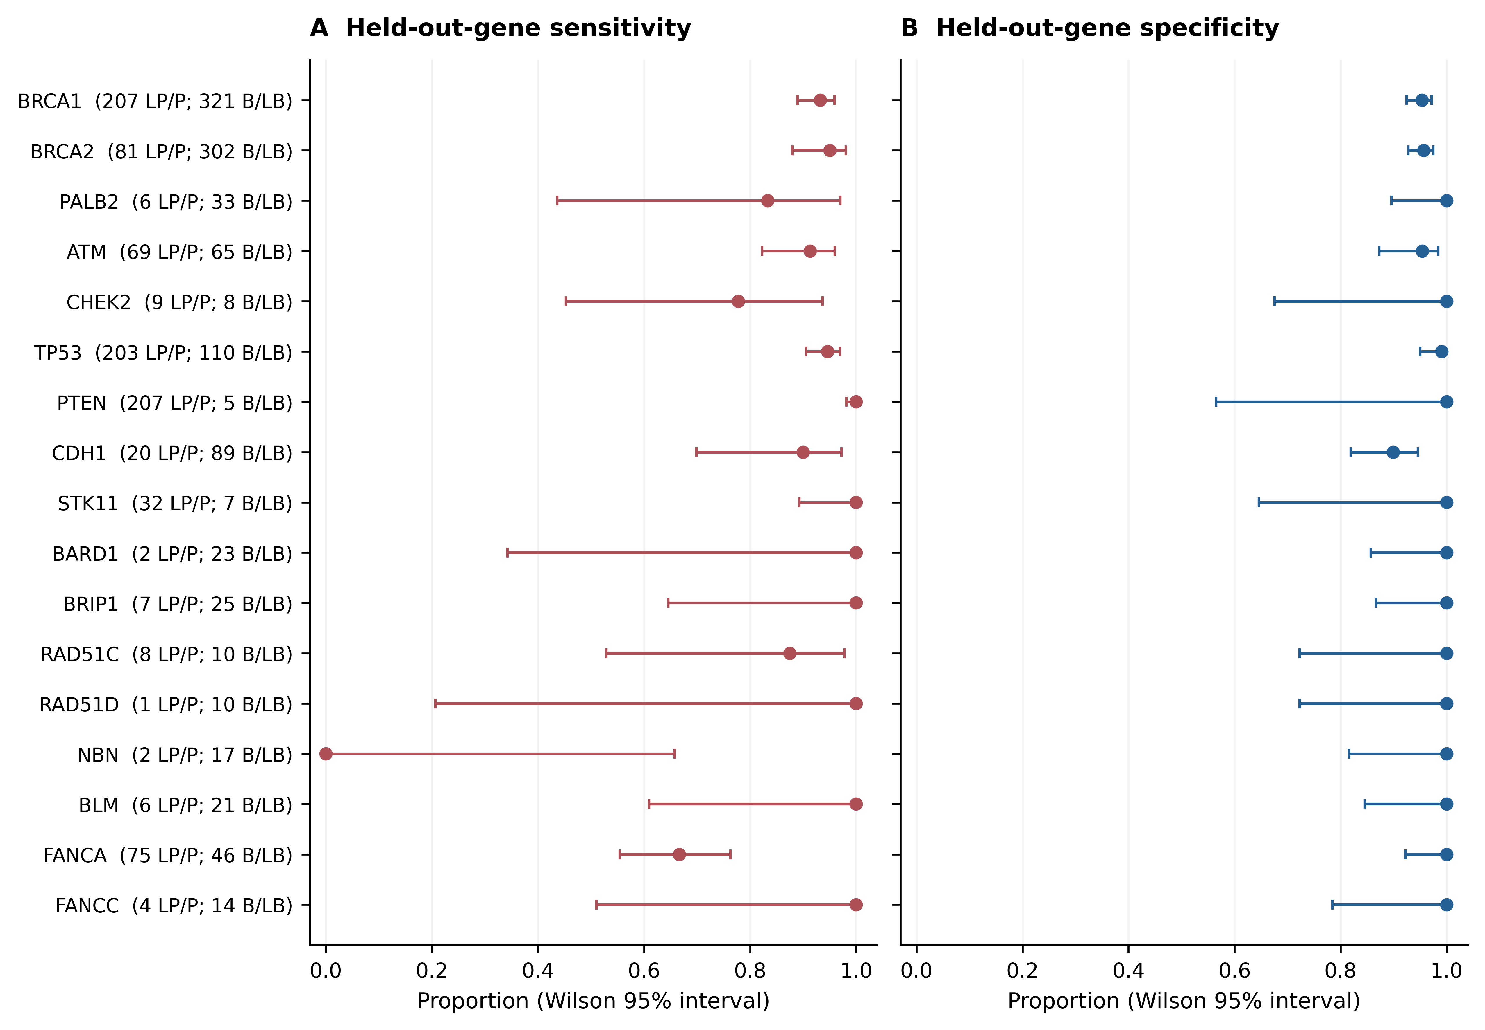
Figure 3. Per-gene leave-one-gene-out evaluation. Points show sensitivity and specificity of the secondary ≥3-of-4 endpoint; lines show Wilson 95% intervals. Row labels give the evaluable LP/P and B/LB denominators. Each gene was absent from every fitting stage of its corresponding model. Incomplete records are excluded from these fractions and retained in the supplementary per-gene accounting. Perfect point estimates with small denominators should not be interpreted as established perfect performance.

2.6 Secondary binary complementarity relative to individual comparators
Matched-record comparisons with REVEL, MetaLR, VARITY_R, BayesDel addAF and AlphaMissense were descriptive because these scores were eligible or retained model inputs. Across repeats, S_MAC AUROC was approximately 0.9906–0.9909 on the respective matched subsets, compared with 0.8773–0.9630 for the native scores (Figure 4). This comparison cannot establish superiority against independent tools. For the secondary ≥3-of-4 endpoint, stable rescue required a correct ensemble direction and an incorrect comparator direction in all five outer-test appearances. Each comparator threshold was estimated using only its outer-training records.
The review-status audit explicitly separates source counts from evaluable counts (Figure 5). The NR category contains 101 records, comprising 78 B/LB and 23 LP/P, all of which failed the completeness rule. No learner-concordance fraction is therefore estimable for NR under the revised output policy. The former 22/23 versus 5/23 NR comparison is withdrawn. NR means that a review-status annotation was not recorded; it is not an ordered ClinVar evidence category. Results for recorded review strata are descriptive and remain subject to source-label dependence.
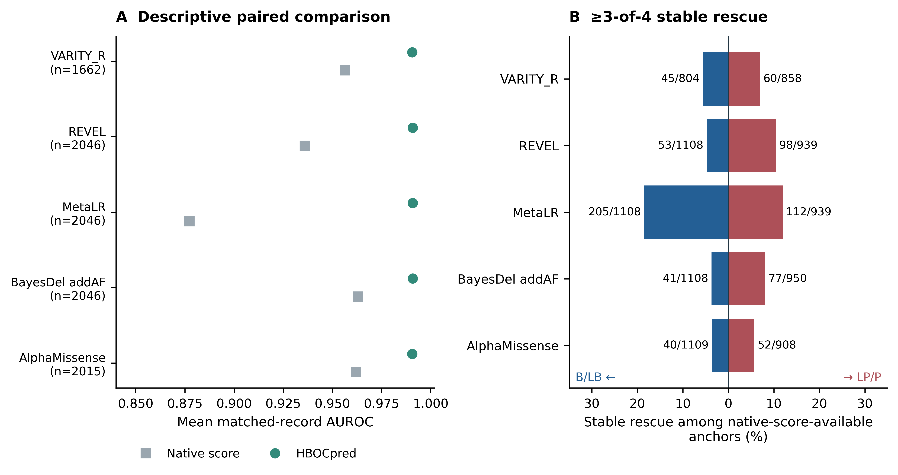
Figure 4. Descriptive constituent-score comparisons. (A) Mean AUROC on records with an observed comparator score and an evaluable HBOCpred output; matched sample sizes are shown. (B) Stable rescue at the secondary ≥3-of-4 endpoint. Numerators count variants rescued in all five outer-test appearances. Denominators include all source anchors with the native comparator score, including records that could not qualify as a complete five-repeat rescue; they can therefore exceed the evaluable matched denominators in panel A. Comparator cut-points use outer-training labels only. These are internal complementarity summaries, not independent superiority tests.
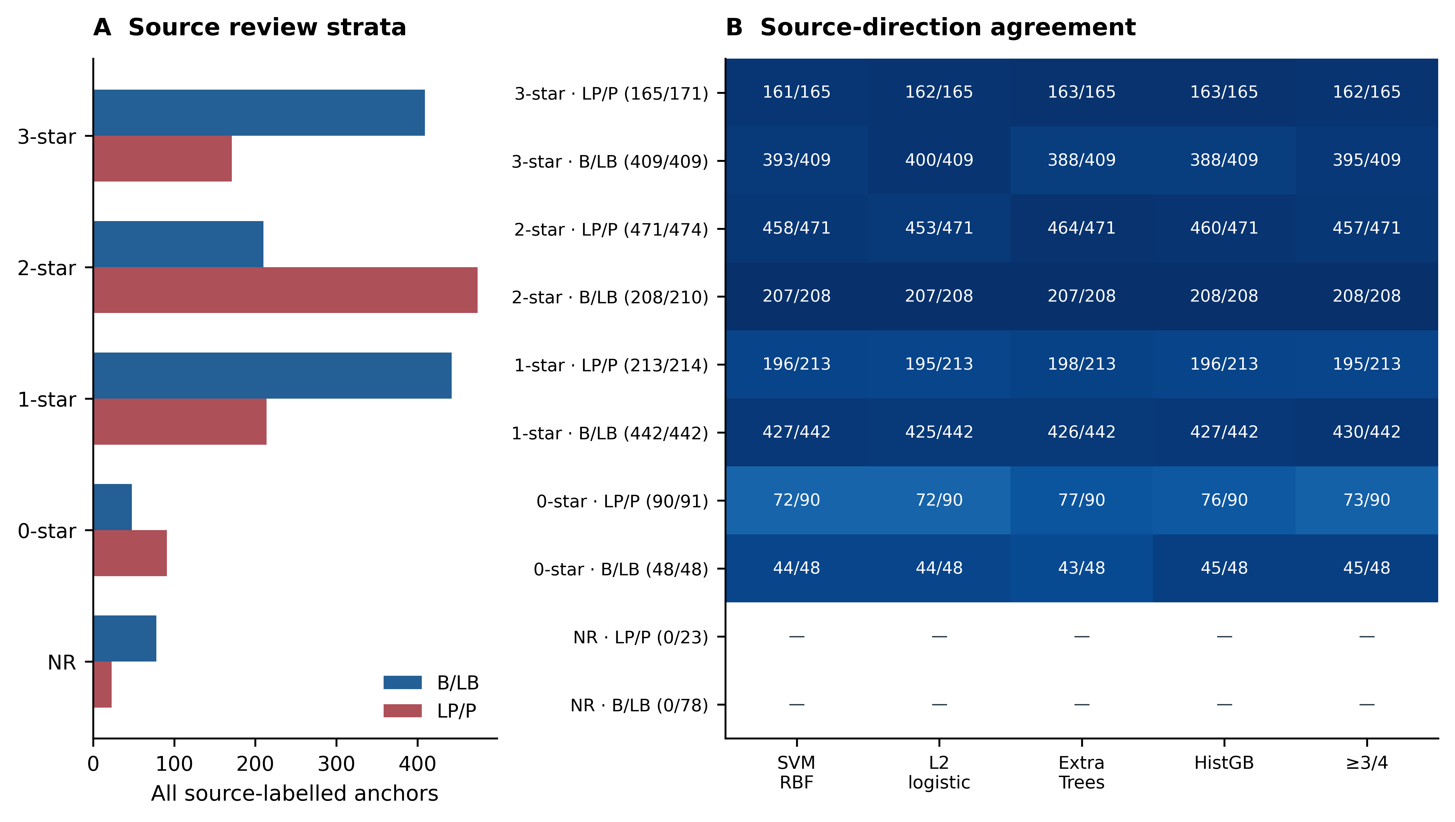
Figure 5. Review-status accounting and source-label agreement. (A) Source counts by recorded review status. (B) Correct/evaluable counts for each learner and the secondary ensemble endpoint in the first repeat. A dash denotes no evaluable denominator. All 101 NR records are incomplete; no NR performance claim is made. Review-status groups are descriptive and are not ordinal model-output categories.

2.7 Distribution shift, gene signal and application catalogue
Nineteen of the 25 deployment predictors had absolute standardised mean differences of at least 0.20 between anchors and the application catalogue; 24 shifted in the negative direction (Figure 6A). This feature shift accompanies the increase in mixed-vote frequency from 3.81% to 10.28% among evaluable records. An auxiliary classifier recovered gene identity from outer-training-selected predictors with 89.40% out-of-fold accuracy, compared with 26.11% for the majority-gene baseline (Figure 6B). A separate gene-prevalence-only classifier yielded source-label AUROC 0.7553. These diagnostics demonstrate substantial gene information in the predictors and label distribution; they do not assign a causal fraction of ensemble performance to confounding.
All 43,679 application records satisfied the deployment requirement of at least 20 observed predictors out of 25; the minimum was 20 and the median 24. Their gene labels, variant identifiers, four learner probabilities, vote vector, V-state, directional descriptor, S_MAC and completeness accounting are distributed as a frozen catalogue. Source classification is retained separately from the model descriptor. No clinical accuracy, predictive value or error rate is assigned to the unresolved catalogue because reference outcomes are unavailable.
The companion Shiny catalogue viewer uses the same descriptors, counts and completeness rules as the analysis. It supports gene and variant searches, displays individual learner scores and vote patterns, and exports filtered records. Figure 7 shows the running viewer with the complete 43,679-record catalogue. The viewer is available at https://alaymd.shinyapps.io/hbocpred/. The corresponding author confirmed testing the live viewer on 7 September 2026.
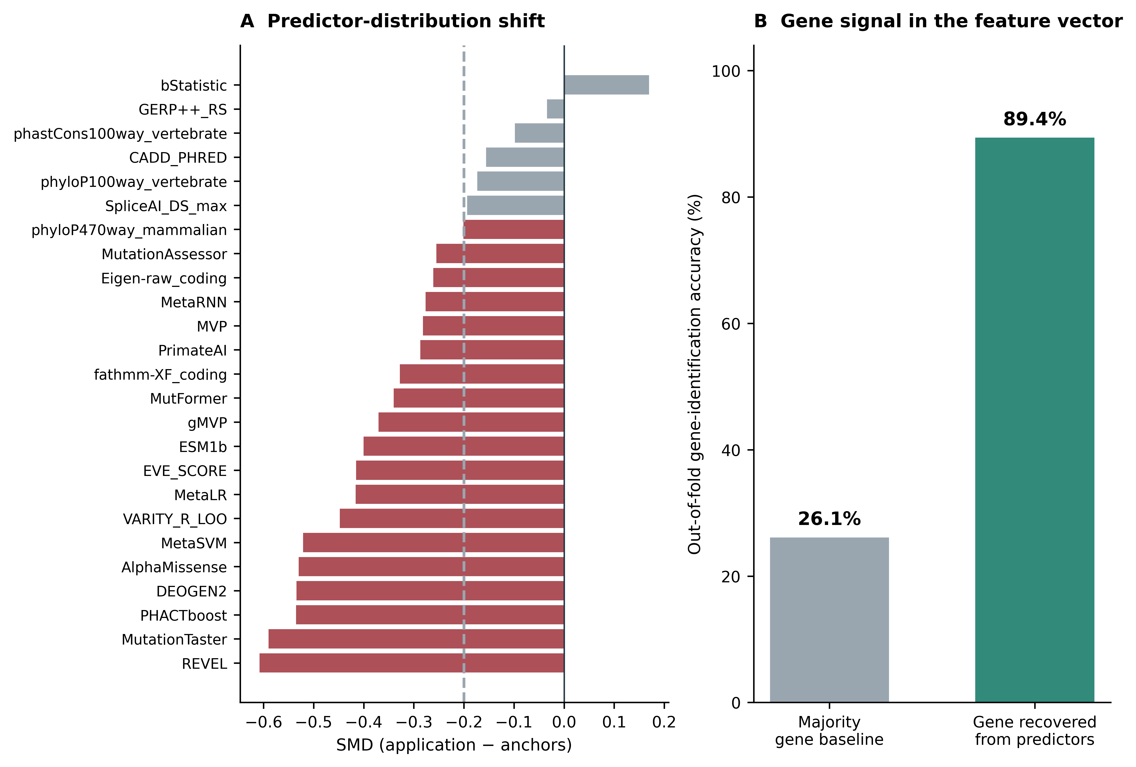
Figure 6. Development-to-application shift and gene information. (A) Standardised mean differences for the 25 deployment predictors, calculated from observed values as application minus anchor mean divided by the square root of the average of their variances. Negative values indicate lower application values; the dashed line marks −0.20. (B) First-repeat out-of-fold gene-identification accuracy from training-selected predictors versus a majority-gene baseline. Gene identity was the auxiliary outcome, not a primary-model input. These diagnostics motivate qualified interpretation of the aggregate source-label estimates.
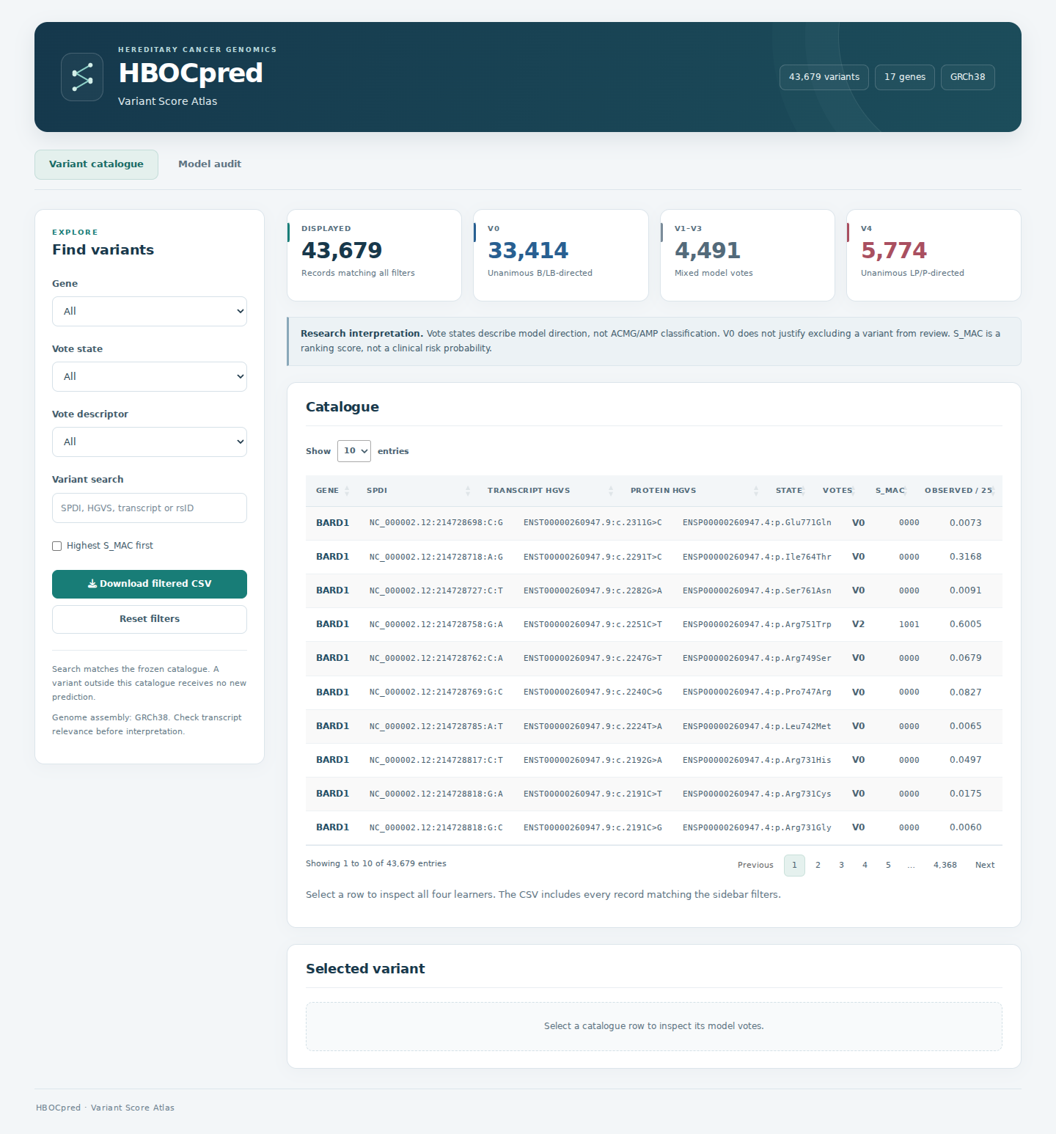
Figure 7. Companion Shiny variant catalogue. The unfiltered view displays all 43,679 application records and the shared vote-group counts. Filters support gene, vote-state, descriptor and variant searches; users can inspect individual learner outputs and export matching records. This screenshot was captured from the locally running R4.4 viewer on 6 September 2026. Model direction is displayed separately from source classification; the interface does not assign ACMG/AMP classifications.

3. Discussion
HBOCpred provides a research framework for examining agreement and disagreement among four heterogeneous learners while retaining a continuous score for prioritisation. The revision uses the same vote descriptors in development and application and explicitly distinguishes model direction from clinical uncertainty. Repeated nested internal evaluation gave S_MAC AUROC 0.9909 and secondary-endpoint balanced accuracy 0.9604 among the 2,046 evaluable anchors per repeat. These results demonstrate consistency with source labels on a selected, well-annotated subset; they do not estimate accuracy for unresolved variants. The 114 incomplete anchors and the gene-specific limitations are part of the principal result rather than exclusions from its interpretation.
The four-learner architecture makes disagreement inspectable. At V2, the two tree learners formed the LP/P-directed pair in 16/25 first-repeat anchors, whereas the two conventional learners never did so. Retaining pair identity exposes configurations hidden by a single averaged score. However, model agreement is not equivalent to biological certainty: the learners share inputs, the inputs themselves can share training data, and unanimous output does not provide four independent lines of ACMG/AMP evidence. The incomplete NR stratum also prevents the previous claim of preferential recovery in that group.
This architecture distinguishes HBOCpred from disease- or gene-focused studies that compared alternative learning algorithms but ultimately issued predictions from one selected fitted model for each gene or prediction task. BRCA-ML selected a gradient-boosting machine for BRCA1 and XGBoost for BRCA2 [25]. Subsequent BRCA1/2 studies identified gene-specific random forests as their best-performing models [26,27]. Ahmad et al. selected Extra Trees after evaluating nine algorithms [28]. Two broader hereditary-cancer-specific tools were subsequently reported: HCSpred, an integrative ensemble framework first presented in 2025 with an accuracy and F1 score of approximately 0.99 on known variants [29], and HerCanPred, published in 2026 and led by a random-forest classifier [24]. Taken together, these studies support disease- and gene-focused training. A closer methodological comparator is Lee et al. [30], who coupled disease- and gene-specific autoencoder pretraining with a 50-member deep ensemble for BRCA1, BRCA2, MLH1, and MSH2. However, their ensemble comprised independently fine-tuned instances of a shared deep neural network (DNN) architecture whose outputs were averaged. HBOCpred instead retains four algorithmically distinct learners and reports their thresholded vote pattern at the variant level. Meta-EA provides a second contrast: it derives gene-specific weighted combinations of existing variant-effect predictors using Evolutionary Action as the reference but returns a single composite score rather than component-level decisions [31]. Phenotype-based evaluation in UK Biobank likewise found marked variation among hereditary breast-cancer genes and limited utility for VUS-only analyses, underscoring that strong aggregate performance need not be uniform across genes [32].
Relative to hard voting alone[22,33], S_MAC distinguishes variants with the same vote count for expert review and functional follow-up. The four learner decisions define V0–V4; S_MAC ranks variants without adding a vote or changing their descriptor. Its calibration against source labels does not provide a clinical probability or a PP3/BP4 evidence threshold[19,34–36].
Agreement with ClinVar reflects two sources of shared information. Some constituent predictors were trained on clinical variant classifications, and ClinVar submitters may use computational evidence through PP3/BP4. A variant held out of HBOCpred can therefore remain linked to predictor training or to labels informed by similar tools. Removing BayesDel addAF and AlphaMissense left internal discrimination largely unchanged, while other clinically trained or frequency-informed predictors remained. The external lists face related limits: common gnomAD variants were selected by frequency, and long-documented hospital alleles may overlap upstream training. These records support an audit of selected variants; they do not provide an independent test of clinical accuracy.
Nineteen predictors shifted between anchors and unresolved variants, and mixed votes were 2.70 times as frequent in the application catalogue. This pattern is consistent with definite classifications being more common when the available evidence is decisive. Reference outcomes are needed to measure performance in the unresolved population. Gene identity was also recoverable from the predictors with 89.40% accuracy. The lower held-out sensitivity in FANCA and the small NBN stratum show why the pooled AUROC should be read alongside the per-gene results.
V0 included 32 of 973 LP/P anchors, whereas V4 included 16 of 1,187 B/LB anchors. This asymmetry matters because low scores could delay review of pathogenic variants. V0 must therefore remain a model-direction descriptor, never a reason to exclude a variant from expert review or reassure a patient. Our balanced-accuracy threshold objective weighted the two classes equally; clinical decision costs require separate evaluation.
Missing annotations were concentrated in the least documented records: 101 of the 114 incomplete anchors belonged to the NR group. Reliability_index was excluded because it describes annotation quality; the completeness audit documents the imbalance that remains across records. Forty anchors also lacked a current same-gene missense annotation, and historical transcript assignments remain incomplete despite the transcript-restricted sensitivity analysis. The next evaluation should use a frozen pipeline, matched transcripts and independently assessed functional, segregation or case–control evidence across genes and both classes. HBOCpred’s present role is to organise variants for research review and functional follow-up.

4. Materials and Methods

4.1 Study design
This retrospective variant-level study develops and internally evaluates a research prioritisation model using a processed source-labelled archive, then applies the frozen deployment fit to a disjoint unresolved archive. The 17-gene scope includes established HBOC susceptibility genes, syndromic genes and exploratory limited-evidence genes; inclusion in the study is not a claim of equal clinical validity or penetrance. The source archive was originally ascertained as missense, but the current transcript audit identified discrepancies that are retained transparently in the primary cohort and examined by a restricted refit. No prospectively collected, independently adjudicated clinical validation cohort was analysed. The reanalysis used all available eligible source records without a formal sample-size calculation; sparse gene/label strata limit precision. This revision-stage analysis was not prospectively registered. Its executed protocol and deviations from the previous revision are documented in the reproducibility package. No resampling or class-weight correction was applied to alter class prevalence.
For every evaluable record, HBOCpred reports the four calibrated learner probabilities and thresholded votes, their four-bit pattern, vote count V0–V4, S_MAC and an annotation-completeness flag. The descriptive mapping is identical in all datasets: V0, unanimous B/LB-directed; V1–V3, mixed votes; V4, unanimous LP/P-directed. These are research descriptors of correlated algorithmic outputs. An incomplete record receives no probabilities, votes, V-state, descriptor or S_MAC. Figure 8 summarises model development and the shared reporting workflow.
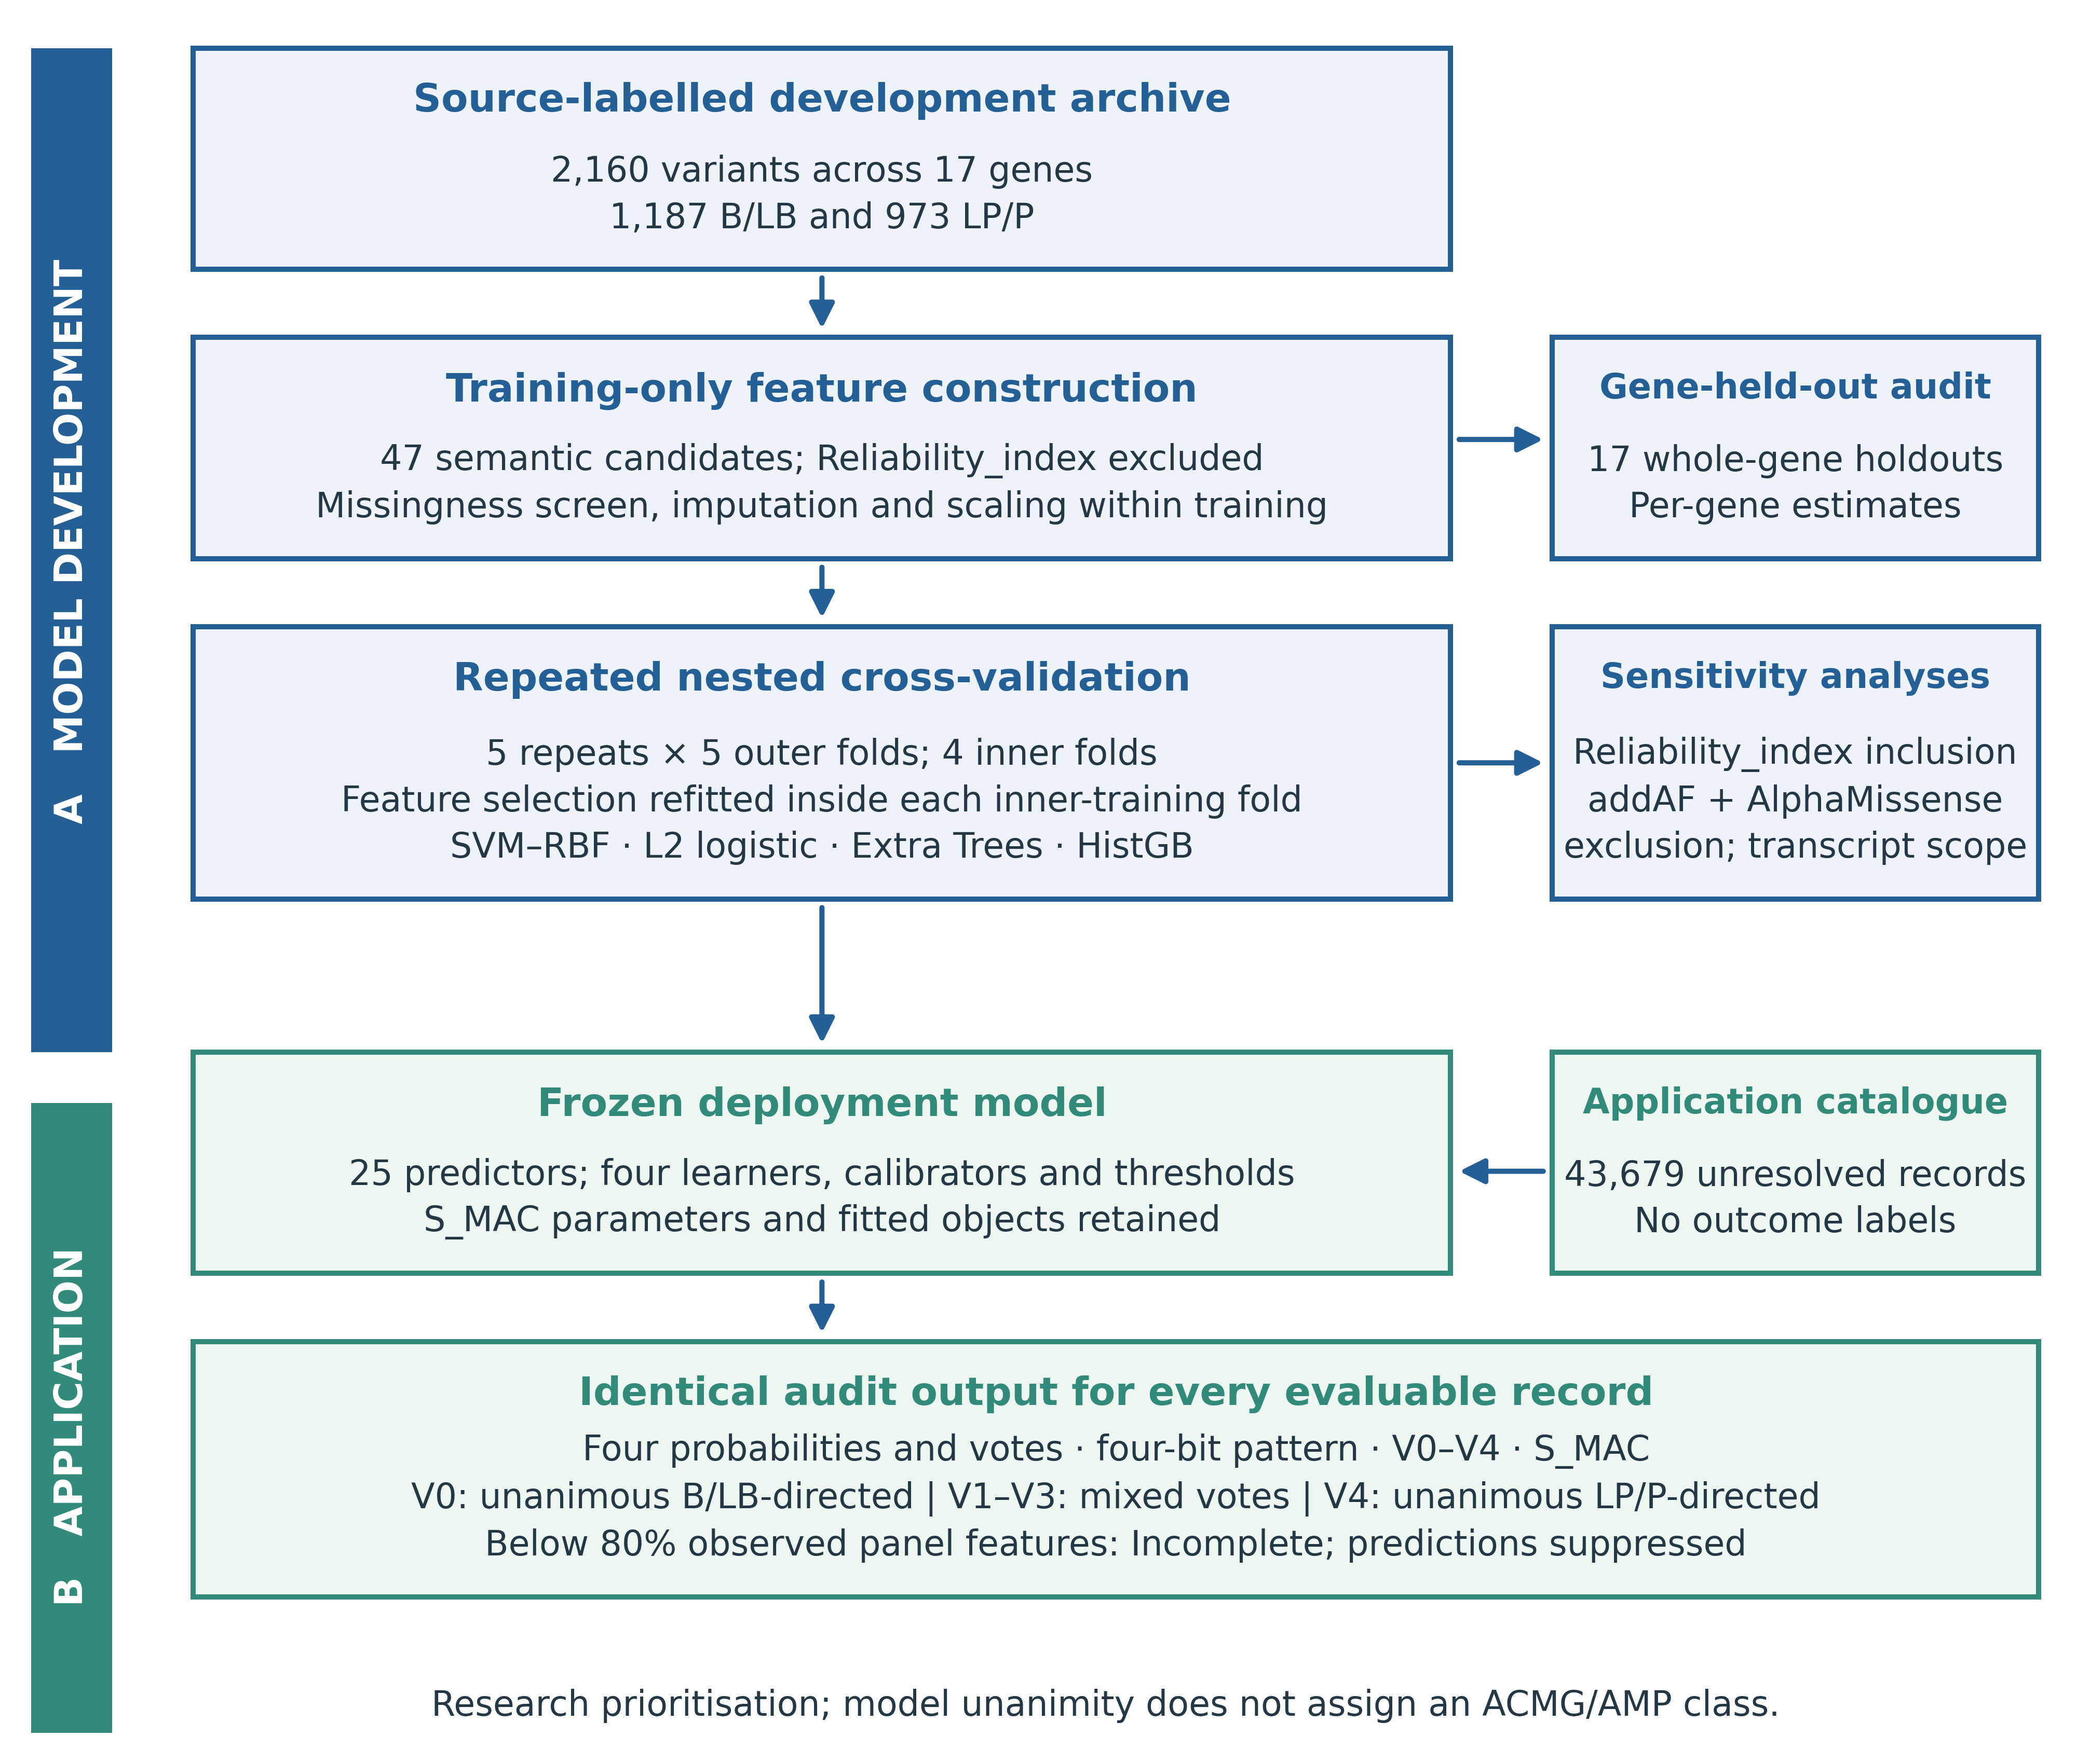
Figure 8. Development and shared reporting workflow. The source-labelled archive contains 2,160 anchors across 17 genes. Label-independent numeric processing produces 47 primary candidates after excluding Reliability_index. Missingness filtering, imputation, scaling, feature selection and tuning are refitted within each training partition. Evaluation comprises repeated nested cross-validation, complete gene holdouts and paired sensitivity analyses. A separate deployment fit uses all anchors and scores the 43,679 unresolved records without refitting. Both evaluation and application use the same directional descriptors and completeness guard.

4.2 HBOCpred algorithm
Fixed learner families
Throughout, LP/P is coded as 1 and B/LB as 0.
The ensemble contains SVM–RBF and L2 logistic regression as conventional non-tree learners, Extra Trees as a bagging learner and histogram gradient boosting as a boosting learner. This set was fixed for the revision-stage reanalysis, informed by earlier development. Hyperparameter tuning was repeated within training data, but learner-family membership was not reselected.
Calibrated adaptive voting
For variant i and learner m, let z_im denote the raw SVM decision score or the clipped logit probability from a probability-output learner. A Platt transformation gives p_im = logistic(a_m + b_m z_im). The learner-specific coefficients are fitted using inner out-of-fold scores from the selected configuration.
$$p_{im} = σ(a_{m} + b_{m} z_{im}), σ(z) = \frac{1}{1 + exp(-z)} (1)$$
For each selected configuration, Platt calibration is cross-fitted across the four inner folds. The vote threshold maximises balanced accuracy on these cross-calibrated inner out-of-fold probabilities. A tie is resolved by the threshold closest to 0.5 and then by the lower threshold. The final calibrator is refitted on all inner out-of-fold scores, and the base learner is refitted on the complete corresponding training partition.
$$τ_{m} = {arg max}_{t} \frac{{TPR}_{m}(t) + {TNR}_{m}(t)}{2} (2)$$
A learner casts an LP/P-directed vote when its calibrated probability is at least its fitted threshold. In the equations, M denotes the fixed set of four learners and c_i is their total vote count.
$$v_{im} = I(p_{im} ≥ τ_{m}), c_{i} = ∑_{m∈M}v_{im}, |M| = 4. (3)$$
The audit state is Vc, where c is the sum of the four LP/P-directed votes and c ∈ {0,1,2,3,4}. V2 denotes exact 2:2 disagreement. V0 and V4 receive unanimous directional descriptors, while V1–V3 receive the mixed-vote descriptor in every dataset. This mapping is a retrospective reporting convention and was not independently selected or validated. The secondary binary endpoint c ≥ 3 is used only to calculate conventional source-label metrics; it does not replace the reported vote states.
The complete four-bit vote vector is retained because equal vote counts can arise from different learner-family configurations. Learner-pair identity is therefore an audit variable rather than a latent biological label.
Continuous HBOCpred score
Mean4 is the arithmetic mean of the four calibrated learner probabilities. The continuous score is S_MAC = logistic(α + β × logit(Mean4)); α = 0.03387595 and β = 1.13536398 in the deployment fit. Meta-calibration is fitted to the mean of the inner cross-calibrated probabilities using training labels. S_MAC supplies no additional vote and is not a clinical posterior probability or ACMG/AMP category.

Primary output and completeness flag
The output tuple includes probabilities, votes, V-state, vote vector, directional descriptor, Mean4, S_MAC, observed-panel count and completeness. At prediction, the record must have at least ceil(0.8 × panel size) observed selected predictors before imputation; the deployment panel therefore requires 20 of 25. Otherwise all model outputs are suppressed. The same guard applies to outer-test predictions, gene-held-out predictions and the application catalogue. Incomplete records remain in cohort counts but are excluded from evaluable-performance denominators.
Variant curation and label definition
The study scope comprises ATM, BARD1, BLM, BRCA1, BRCA2, BRIP1, CDH1, CHEK2, FANCA, FANCC, NBN, PALB2, PTEN, RAD51C, RAD51D, STK11 and TP53. The original 7,137-record training spreadsheet supplied 2,160 unique source-labelled anchors (1,187 B/LB and 973 LP/P; Table 6), represented by normalised genomic identities. Its historical transcript-specific inclusion decisions cannot be fully reconstructed because the retained sheet does not preserve the original consequence/transcript pairing. A current Ensembl audit found a same-gene missense annotation for 2,120 anchors: 2,039 on MANE Select and 81 only on other transcripts; 40 lacked a current same-gene missense annotation. Multi-nucleotide substitutions were retained where present, so the cohort is not exclusively SNVs. The original binary source labels were preserved, with embedded ClinVar significance and review status retained separately; 1,998 matched the embedded significance. The application archive contains 43,679 unresolved records with no anchor-identity overlap. Current annotation is an audit, not retrospective proof of the original transcript assignment.
Table 6. Prespecified 17-gene source counts.
Gene | B/LB | LP/P
ATM | 67 | 75
BARD1 | 24 | 3
BLM | 21 | 6
BRCA1 | 347 | 217
BRCA2 | 306 | 84
BRIP1 | 25 | 7
CDH1 | 89 | 20
CHEK2 | 8 | 9
FANCA | 63 | 77
FANCC | 15 | 4
NBN | 18 | 2
PALB2 | 34 | 6
PTEN | 22 | 211
RAD51C | 10 | 9
RAD51D | 10 | 1
STK11 | 7 | 33
TP53 | 121 | 209
Total | 1,187 | 973

4.3 Feature matrix construction and preprocessing
Numeric processing excluded identities, labels, categorical predictions and annotation-position fields. The four SpliceAI delta scores [37] were collapsed to their row-wise maximum. Ninety numeric fields were retained in the distributed matrix; deterministic preference among semantically paired score/rank fields gave 48 candidate representatives, or 47 after primary exclusion of Reliability_index. No missingness screen used the unresolved application archive. Within each inner-training and outer-training partition, candidates with more than 40% missingness or no observed variation were removed, remaining missing entries were median-imputed and values standardised using that partition only. Four criteria were averaged by rank: orientation-independent univariate AUROC, mutual information, median absolute L1-logistic coefficient over 12 bootstrap fits with selection frequency as a tie-break, and Extra Trees importance relative to permuted shadow features over six fits. Predictors were taken greedily in consensus order, skipping candidates with absolute Pearson correlation above 0.90 with an already retained predictor, up to 25. Parameters and panels were applied unchanged to the relevant assessment records. The first finite numeric token was retained from multi-valued fields; this deterministic parsing rule does not guarantee transcript alignment. The original application-based feature screen was transductive and is superseded by this inductive reanalysis.

4.4 Learner specifications and tuning
Four learner families were fixed before running the revised evaluation. Within each training partition, six unique configurations per learner were sampled without replacement from the listed grids (Table 7); the L2 logistic grid has exactly six configurations. Configurations were ranked by mean inner-fold raw-score AUROC, then lower sample SD and finally the sorted parameter string. The retained algorithm key ENET_LR denotes L2 logistic regression throughout this release (l1_ratio = 0), not a selected elastic-net mixture. Full settings, sampled configurations and fitted objects are distributed with the code.
Table 7. Hyperparameter grids for the four fixed learner families.
Learner | Search space
L2 logistic regression | C: 0.03, 0.1, 0.3, 1, 3, 10; l1_ratio = 0
SVM–RBF | C: 0.25, 0.75, 2, 6, 16; gamma: scale, 0.01, 0.03, 0.1
Extra Trees | 220 trees; max depth: none, 10, 18; max features: sqrt, 0.4, 0.7; min leaf: 1, 3, 7
HistGB | Max leaves: 15, 31; min leaf: 10, 20; iterations: 100, 200; learning rate: 0.03, 0.1; L2: 0, 1
Note. Six unique configurations per learner and training partition were sampled without replacement. Extra Trees used 220 trees. Hyperparameters were ranked by mean inner AUROC, its sample SD and a deterministic parameter-string tie-break.

4.5 Repeated nested cross-validation
Primary evaluation used five repeats of five-fold outer cross-validation, with four-fold inner cross-validation for tuning. Gene/outcome strata with sufficient counts were retained; sparse strata were pooled by outcome. Each outer fold contained 432 source anchors. Every inner-training partition independently fitted its missingness screen, imputer, scaler, feature ranking and correlation pruning before application to its inner assessment fold. Outer-training preprocessing was then refitted for the selected configurations. The outer-test data were excluded from every fitting step. Tuning, threshold development and calibration still reuse labels within outer training, and the revision-stage design was informed by previous work; the outer estimates therefore assess the specified algorithm on the available source cohort, not the full historical model-search process.

4.6 Calibration, adaptive voting and deployment refit
Raw SVM decision values were used directly for Platt fitting. Other learner probabilities were clipped to [10⁻⁶, 1 − 10⁻⁶] and logit-transformed. Cross-calibrated inner probabilities were used for threshold development and S_MAC fitting, followed by complete training-partition refits. The deployment model was fitted separately using all 2,160 anchors and frozen before scoring the unresolved catalogue. All fitted preprocessors, base learners, calibrators, thresholds, training identities and inner fold memberships are retained. Deployment predictions on the anchors are explicitly marked in-sample and are not used for reported performance.
The primary descriptive audit retains exact V-states and the three shared vote groups, with incomplete accounting alongside them. Unanimity coverage is (nV0 + nV4)/n_source; conditional source-direction agreement is (nB/LB,V0 + nLP/P,V4)/(nV0 + nV4). Mixed-vote proportions used to compare populations condition on evaluability in each population. The first outer-test repeat supplies one prediction per anchor for fixed-state tables. Conventional binary metrics use c ≥ 3 among evaluable records, while AUROC, AUPRC and Brier score use S_MAC. No threshold on S_MAC defines a clinical class.

4.7 Gene-held-out and sensitivity analyses
Leave-one-gene-out evaluation comprised 17 fits, each excluding one whole gene from all training operations. Performance and evaluability were reported both pooled and separately for each held-out gene, with confusion counts and Wilson intervals. First-repeat five-fold sensitivity refits (i) included Reliability_index, (ii) excluded BayesDel_addAF_rankscore and am_pathogenicity in addition to Reliability_index, and (iii) restricted training and assessment to the 2,120 current same-gene-transcript missense anchors. For the last analysis, the primary predictions were also restricted to those same records to separate a population restriction from refitting. The restricted models reused the original fold assignments after filtering.
To quantify gene information, an auxiliary 300-tree Extra Trees classifier predicted gene identity using the primary first-repeat training-selected predictor panels and training-fitted preprocessing; assessment gene labels were held out. A majority-gene classifier provided its baseline. A separate source-label baseline used only the gene-specific LP/P prevalence in the corresponding outer-training fold. These are diagnostics of gene information and label imbalance, not a decomposition of causal confounding. They supplement, rather than replace, complete gene holdouts.

4.8 Reference-source and application audits
The gnomAD v4 GRCh38 query covered all 17 genes and screened PASS gene-level missense SNPs for alternate-allele frequency above 0.05 in a continental population with at least 2,000 observed alleles in the same callset. Candidate identities, allele counts and denominators were retained and checked against the full 7,137-record training archive and the unresolved archive. Same-gene and MANE Select consequences were recorded. This was an eligibility screen, not automatic BA1 adjudication. All hospital source rows were audited. In-scope variants were resolved using concordant gene, coding-allele and protein descriptions, with the supplied RefSeq transcript used where needed to distinguish matches. Current Ensembl transcript snapshots and frozen catalogue annotations documented aliases; original source strings and discrepant rsIDs were retained. Matching never relied on rsID alone. Each resolved genomic allele was scored once with the frozen deployment model using its existing numeric features and the same ≥20/25 completeness rule. Anchor, application-catalogue and non-anchor source-archive overlaps were reported separately. Repeated rows were not treated as independent patients. No new fitting or external outcome adjudication was performed.
Application-versus-anchor standardised mean differences were calculated on observed values using the square root of the mean of the two sample variances as denominator. Missingness fractions are supplied separately. Application scoring used the frozen deployment fit and the same output-completeness rule as internal evaluation. No application outcome was available for estimating clinical performance. The previous unreproducible UniProt localisation summary remains excluded; the analytical figures are regenerated from distributed row-level data and saved model outputs, while Figure 7 is a browser capture of the running companion viewer.

4.9 Statistical analysis
AUROC and AUPRC quantify source-label discrimination, and Brier score quantifies squared error against the binary source label; none is interpreted as clinical accuracy. Five-repeat mean ± sample SD describes split stability. The repeated predictions are not pooled as independent observations to form confidence intervals. Supplementary Table S2 gives conditional first-repeat intervals from 2,000 class-stratified bootstrap resamples of one fixed out-of-fold prediction per evaluable variant (seed 20260905); these do not refit models or resample gene clusters and therefore omit training and clustering uncertainty. Wilson 95% intervals describe binomial proportions conditional on the sampled source records and do not account for ascertainment, upstream predictor dependence or transport to unresolved variants.
The ≥3-of-4 endpoint supplies conventional sensitivity, specificity, PPV, NPV, F1, MCC and balanced accuracy only among evaluable records. Denominators and incomplete counts are retained by source label and gene. V0/V4 agreement is reported jointly with unanimity coverage. Opposite-direction rates use all source anchors within each label and do not quantify clinical harm probabilities. Comparator AUROCs are calculated on matched evaluable records; stable rescue requires correct ensemble direction and incorrect comparator direction in all five outer-test appearances, with comparator cut-points fitted separately in each outer-training partition.
Analyses used Python 3.12.13, NumPy 2.3.5, pandas 2.2.3 and scikit-learn 1.8.0; scientific figures were generated with Matplotlib. No result in this reanalysis was computed using the previously stated “Rstudio 4.13”. Split seeds start at 20260723 and modelling seeds at 20260714 with deterministic offsets recorded in the scripts. The package includes exact environment versions, fold maps, input hashes, feature-selection audits and 58 fitted model objects. Replaying all saved assessment outputs and the complete application catalogue reproduced probabilities to numerical precision. Generative AI tools, ChatGPT (OpenAI) and Claude (Anthropic), assisted English-language editing and manuscript revision, analysis-code development and debugging, and figure and interface layout. Numerical results were computed from the supplied data using the archived executable code; analytical plots and the interface screenshot were not generated as synthetic images.

Supplementary Materials: Figure S1: gnomAD candidate eligibility and archive overlap; Table S1: gene-held-out source and evaluable counts with class-specific results; Table S2: conditional first-repeat performance intervals; Table S3: candidates outside both archives without model predictions; Table S4: study-specific TRIPOD+AI reporting map.
Author Contributions: Conceptualization, M.T.A.; methodology, M.T.A.; software, M.T.A.; validation, M.T.A.; formal analysis, M.T.A.; investigation, M.T.A.; resources, M.T.A.; data curation, M.T.A.; writing—original draft preparation, M.T.A.; writing—review and editing, M.T.A. and H.B.E.; visualization, M.T.A.; supervision, M.T.A. and H.B.E.; project administration, M.T.A. All authors have read and agreed to the published version of the manuscript.
Funding: This research received no external funding.
Institutional Review Board Statement: Model development used public variant resources. The supplied hospital source list originated from the Ankara Etlik City Hospital hereditary-cancer testing workflow under institutional ethics approval AEŞH-BADEK-2024-219. No new patient-level outcome analysis or external clinical validation was performed in this reanalysis; only de-identified variant records were considered for source curation.
Informed Consent Statement: Written informed consent was obtained from all individuals included in the source clinical testing workflow. No patient identifier was supplied to the HBOCpred model.
Data Availability Statement: The accompanying reproducibility archive provides the 2,160-anchor numeric matrix, the 25-predictor deployment matrix, gene and processed source labels, embedded ClinVar metadata, repeated fold assignments, out-of-fold and gene-held-out predictions, completeness flags, transcript and gnomAD eligibility audits, and the frozen 43,679-record application catalogue. Patient-level clinical data are not distributed. Persistent repository deposition and its final accession/DOI must be completed before resubmission.
Code Availability: The accompanying archive contains the executable preprocessing, fitting, scoring, table and figure scripts, 58 frozen fitted objects, software-version information and a companion Shiny viewer. The release reproduces the revised numerical analyses and includes a completed model-replay audit. Public repository and persistent-archive identifiers are pending; no post-publication-only availability promise or completed DOI deposition is asserted.
Acknowledgments: We thank the Alay family for supporting novel ideas. Generative-AI assistance is described in Section 4.9. The authors take responsibility for the content of this publication.
Conflicts of Interest: None.

Abbreviations
Abbreviations: ACMG/AMP, American College of Medical Genetics and Genomics/Association for Molecular Pathology; AUPRC, area under the precision–recall curve; AUROC, area under the receiver-operating-characteristic curve; B/LB, benign/likely benign; HistGB, histogram-based gradient boosting; LOGO, leave-one-gene-out; LP/P, likely pathogenic/pathogenic; MAC, modified adaptive classifier; MANE, Matched Annotation from NCBI and EMBL-EBI; OOF, out-of-fold; S_MAC, continuous HBOCpred ranking score; SMD, standardised mean difference; SVM–RBF, support vector machine with radial basis function kernel; V0–V4, audit states defined by 0–4 LP/P-directed votes; VUS, variant of uncertain significance. Incomplete denotes insufficient observed selected predictors and is not a clinical class.

References
1. Doğan, C.; Akosman, C.; Sönmez, M. Analysis of the Results of the BRCA1 and BRCA2 Genes in Early-Onset Breast Cancer Patients from the Ordu Province. Atl. J. Med. Sci. Res. 2026, 6, 93–99.
2. Elias, K.; Smyczynska, U.; Stawiski, K.; Nowicka, Z.; Webber, J.; Kaplan, J.; Landen, C.; Lubinski, J.; Mukhopadhyay, A.; Chakraborty, D.; et al. Identification of BRCA1/2 Mutation Female Carriers Using Circulating MicroRNA Profiles. Nat. Commun. 2023, 14, 3350, doi:10.1038/s41467-023-38925-4.
3. Kuchenbaecker, K.B.; Hopper, J.L.; Barnes, D.R.; Phillips, K.-A.; Mooij, T.M.; Roos-Blom, M.-J.; Jervis, S.; van Leeuwen, F.E.; Milne, R.L.; Andrieu, N.; et al. Risks of Breast, Ovarian, and Contralateral Breast Cancer for BRCA1 and BRCA2 Mutation Carriers. JAMA 2017, 317, 2402–2416, doi:10.1001/jama.2017.7112.
4. Yang, X.; Leslie, G.; Doroszuk, A.; Schneider, S.; Allen, J.; Decker, B.; Dunning, A.M.; Redman, J.; Scarth, J.; Plaskocinska, I.; et al. Cancer Risks Associated With Germline PALB2 Pathogenic Variants: An International Study of 524 Families. J. Clin. Oncol. 2019, 38, 674–685, doi:10.1200/JCO.19.01907.
5. Antoniou, A.C.; Casadei, S.; Heikkinen, T.; Barrowdale, D.; Pylkäs, K.; Roberts, J.; Lee, A.; Subramanian, D.; De Leeneer, K.; Fostira, F.; et al. Breast-Cancer Risk in Families with Mutations in PALB2. N. Engl. J. Med. 2014, 371, 497–506, doi:10.1056/NEJMoa1400382.
6. Breast Cancer Risk Genes — Association Analysis in More than 113,000 Women. N. Engl. J. Med. 2021, 384, 428–439, doi:10.1056/NEJMoa1913948.
7. Qian, M.; Cao, X.; Devidas, M.; Yang, W.; Cheng, C.; Dai, Y.; Carroll, A.; Heerema, N.A.; Zhang, H.; Moriyama, T.; et al. TP53 Germline Variations Influence the Predisposition and Prognosis of B-Cell Acute Lymphoblastic Leukemia in Children. J. Clin. Oncol. Off. J. Am. Soc. Clin. Oncol. 2018, 36, 591–599, doi:10.1200/JCO.2017.75.5215.
8. Tischkowitz, M.; Colas, C.; Pouwels, S.; Hoogerbrugge, N.; Bisseling, T.; Bubien, V.; Caux, F.; Chabbert-Buffet, N.; Colas, C.; Da Mota Gomes, S.; et al. Cancer Surveillance Guideline for Individuals with PTEN Hamartoma Tumour Syndrome. Eur. J. Hum. Genet. 2020, 28, 1387–1393, doi:10.1038/s41431-020-0651-7.
9. Duarte, M.; Milikowski, C. Gastrointestinal Polyposis with Associated Cutaneous Manifestations. Pathology 2022, 54, 157–166, doi:10.1016/j.pathol.2021.08.009.
10. Blair, V.R.; McLeod, M.; Carneiro, F.; Coit, D.G.; D’Addario, J.L.; van Dieren, J.M.; Harris, K.L.; Hoogerbrugge, N.; Oliveira, C.; van der Post, R.S.; et al. Hereditary Diffuse Gastric Cancer: Updated Clinical Practice Guidelines. Lancet Oncol. 2020, 21, e386–e397, doi:10.1016/S1470-2045(20)30219-9.
11. Alenezi, W.M.; Milano, L.; Fierheller, C.T.; Serruya, C.; Revil, T.; Oros, K.K.; Behl, S.; Arcand, S.L.; Nayar, P.; Spiegelman, D.; et al. The Genetic and Molecular Analyses of RAD51C and RAD51D Identifies Rare Variants Implicated in Hereditary Ovarian Cancer from a Genetically Unique Population. Cancers (Basel). 2022, 14, doi:10.3390/cancers14092251.
12. Yang, X.; Song, H.; Leslie, G.; Engel, C.; Hahnen, E.; Auber, B.; Horváth, J.; Kast, K.; Niederacher, D.; Turnbull, C.; et al. Ovarian and Breast Cancer Risks Associated With Pathogenic Variants in RAD51C and RAD51D. J. Natl. Cancer Inst. 2020, 112, 1242–1250, doi:10.1093/jnci/djaa030.
13. Santamariña, M.; Fuentes-Ríos, O.; Blanco-Pérez, A.; Rodríguez-Lage, B.; Crujeiras-González, A.; Sánchez de Abajo, A.M.; Galego-Carro, J.; Coedo-Costa, C.; Aguado-Barrera, M.E.; Sampayo, V.; et al. Splicing Predictions, Splicing Assays, and Variant Classification Using ACMG/AMP Guidelines: Challenges Observed with BRCA1 and BRCA2 Variants . Clin. Chem. 2026, 72, 266–280, doi:10.1093/clinchem/hvaf177.
14. Zanti, M.; O’Mahony, D.G.; Parsons, M.T.; Dorling, L.; Dennis, J.; Boddicker, N.J.; Chen, W.; Hu, C.; Naven, M.; Yiangou, K.; et al. Analysis of More than 400,000 Women Provides Case-Control Evidence for BRCA1 and BRCA2 Variant Classification. Nat. Commun. 2025, 16, 1–18, doi:10.1038/s41467-025-59979-6.
15. Favalli, V.; Tini, G.; Bonetti, E.; Vozza, G.; Guida, A.; Gandini, S.; Pelicci, P.G.; Mazzarella, L. Machine Learning-Based Reclassification of Germline Variants of Unknown Significance: The RENOVO Algorithm. Am. J. Hum. Genet. 2021, 108, 682–695, doi:10.1016/j.ajhg.2021.03.010.
16. Düzenli, T.; Babazade, A.; Vural, O.; Bahap, Y.; Ergün, M.A. HECTOR : A Web-Based Tool for Automated BRCA1 / BRCA2 Variant Classification Under the ClinGen ENIGMA Specifications. 2026.
17. Richards, S.; Aziz, N.; Bale, S.; Bick, D.; Das, S.; Gastier-Foster, J.; Grody, W.W.; Hegde, M.; Lyon, E.; Spector, E.; et al. Standards and Guidelines for the Interpretation of Sequence Variants: A Joint Consensus Recommendation of the American College of Medical Genetics and Genomics and the Association for Molecular Pathology. Genet. Med. Off. J. Am. Coll. Med. Genet. 2015, 17, 405–424, doi:10.1038/gim.2015.30.
18. Wilcox, E.H.; Sarmady, M.; Wulf, B.; Wright, M.W.; Rehm, H.L.; Biesecker, L.G.; Abou Tayoun, A.N. Evaluating the Impact of in Silico Predictors on Clinical Variant Classification. Genet. Med. Off. J. Am. Coll. Med. Genet. 2022, 24, 924–930, doi:10.1016/j.gim.2021.11.018.
19. Zhuo, X.; Bi, X.; Aggarwal, V.; Liao, J. Calibration and Evaluation of Machine-Learning Algorithms for Missense Variant Classification under ACMG/ClinGen Recommendations. Genet. Med. 2026, 102606, doi:https://doi.org/10.1016/j.gim.2026.102606.
20. Lucas, M.C.; Keßler, T.; Benet-Pagès, A.; Holinski-Feder, E.; Laner, A.; Klink, B. Validation Structures for Sequence Variants of Uncertain Significance in Hereditary Cancer. Eur. J. Hum. Genet. 2026, 1–7, doi:10.1038/s41431-026-02073-2.
21. Nakahara, H.; Niitsu, H.; Toshida, A.; Goto, K.; Yamauchi, M.; Saipova, K.M.; Hayes, C.N.; Hinata, N.; Oka, S.; Hinoi, T. A Prioritization Framework for BRCA1/2 Variants of Uncertain Significance Identified by Comprehensive Genomic Profiling. Eur. J. Hum. Genet. 2026, 1–8, doi:10.1038/s41431-026-02058-1.
22. Alay, M.T. A Novel Seven-Tier Framework for the Classification of MEFV Missense Variants Using Adaptive and Rigid Classifiers. Sci. Rep. 2025, 15, 9054, doi:10.1038/s41598-025-94142-7.
23. Alay, M.T. Integrative Classifiers for Variant Interpretation: Supervised Votes Meet Unsupervised Cluster Dominance. Digit. Heal. Technol. -Innovative Technol. Chang. ProcesessChanging Procesess 2025, 147–160, doi:10.59537/saupress.2415.
24. Akyerli, C.B.; Gerdan, G.; Bülbül, A.; Keskin-Karakoyun, H.; Yüksel, Ş.K.; Timucin, E. Pathogenicity Prediction of Missense Variations in Hereditary Cancer Genes. Int. J. Mol. Sci. 2026, 27, 1–17, doi:10.3390/ijms27052453.
25. Hart, S.N.; Polley, E.C.; Shimelis, H.; Yadav, S.; Couch, F.J. Prediction of the Functional Impact of Missense Variants in BRCA1 and BRCA2 with BRCA-ML. npj Breast Cancer 2020, 6, 13, doi:10.1038/s41523-020-0159-x.
26. Aljarf, R.; Shen, M.; Pires, D.E. V; Ascher, D.B. Understanding and Predicting the Functional Consequences of Missense Mutations in BRCA1 and BRCA2. Sci. Rep. 2022, 12, 10458, doi:10.1038/s41598-022-13508-3.
27. Kang, M.; Kim, S.; Lee, D.-B.; Hong, C.; Hwang, K.-B. Gene-Specific Machine Learning for Pathogenicity Prediction of Rare BRCA1 and BRCA2 Missense Variants. Sci. Rep. 2023, 13, 10478, doi:10.1038/s41598-023-37698-6.
28. Ahmad, R.M.; AlDhaheri, N.; Mohamad, M.S.; Ali, B.R. Precision in Prediction: Tailoring Machine Learning Models for Breast Cancer Missense Variants Pathogenicity Prediction. Brief. Bioinform. 2025, 26, bbaf611, doi:10.1093/bib/bbaf611.
29. Alay, M.; Erdem, H.; Bahsi, T.; Onat, A.; Saat, H. A Novel Ensemble Tool for Hereditary Cancer Genes Variant Detection HCSPred. In Proceedings of the EUROPEAN JOURNAL OF HUMAN GENETICS; SPRINGERNATURE CAMPUS, 4 CRINAN ST, LONDON, N1 9XW, ENGLAND, 2025; Vol. 33, p. 436.
30. Lee, D. Bin; Kang, H.U.; Hwang, K.B. Disease- and Gene-Specific Deep Learning for Pathogenicity Prediction of Rare Missense Variants in Cancer Predisposition Genes. BioData Min. 2026, 19, doi:10.1186/s13040-026-00533-5.
31. Katsonis, P.; Lichtarge, O. Meta-EA: A Gene-Specific Combination of Available Computational Tools for Predicting Missense Variant Effects. Nat. Commun. 2025, 16, 159, doi:10.1038/s41467-024-55066-4.
32. Chow, R.D.; Nathanson, K.L.; Parikh, R.B. Phenotypic Evaluation of Deep Learning Models for Classifying Germline Variant Pathogenicity. npj Precis. Oncol. 2024, 8, 235, doi:10.1038/s41698-024-00710-x.
33. Alay, T.; Demir, İ.; Kirisci, M. Modified Hard Voting Classifier Implementation on MEFV Gene Variants Increases in Silico Tool Performance: A Novel Approach for Small Sample Size TT - MEFY Gen Varyantlarında Modifiye Edilmiş Sert Oylama Sınıflandırıcısı Uygulaması, In-Silico Araç Perfor. J. Intell. Syst. Theory Appl. 2025, 8, 35–46, doi:10.38016/jista.1501164.
34. Pejaver, V.; Byrne, A.B.; Feng, B.-J.; Pagel, K.A.; Mooney, S.D.; Karchin, R.; O’Donnell-Luria, A.; Harrison, S.M.; Tavtigian, S. V; Greenblatt, M.S.; et al. Calibration of Computational Tools for Missense Variant Pathogenicity Classification and ClinGen Recommendations for PP3/BP4 Criteria. Am. J. Hum. Genet. 2022, 109, 2163–2177, doi:10.1016/j.ajhg.2022.10.013.
35. Savige, J.; Storey, H.; Watson, E.; Hertz, J.M.; Deltas, C.; Renieri, A.; Mari, F.; Hilbert, P.; Plevova, P.; Byers, P.; et al. Consensus Statement on Standards and Guidelines for the Molecular Diagnostics of Alport Syndrome: Refining the ACMG Criteria. Eur. J. Hum. Genet. 2021, 29, 1186–1197, doi:10.1038/s41431-021-00858-1.
36. Waring, A.; Harper, A.; Salatino, S.; Kramer, C.; Neubauer, S.; Thomson, K.; Watkins, H.; Farrall, M. Data-Driven Modelling of Mutational Hotspots and in Silico Predictors in Hypertrophic Cardiomyopathy. J. Med. Genet. 2021, 58, 556–564, doi:10.1136/jmedgenet-2020-106922.
37. Jaganathan, K.; Kyriazopoulou Panagiotopoulou, S.; McRae, J.F.; Darbandi, S.F.; Knowles, D.; Li, Y.I.; Kosmicki, J.A.; Arbelaez, J.; Cui, W.; Schwartz, G.B.; et al. Predicting Splicing from Primary Sequence with Deep Learning. Cell 2019, 176, 535-548.e24, doi:https://doi.org/10.1016/j.cell.2018.12.015.

Disclaimer/Publisher’s Note: The statements, opinions and data contained in all publications are solely those of the individual author(s) and contributor(s) and not of MDPI and/or the editor(s). MDPI and/or the editor(s) disclaim responsibility for any injury to people or property resulting from any ideas, methods, instructions or products referred to in the content.

