Article
HBOCpred: an ensemble framework for prioritisation of germline missense variants in hereditary breast and ovarian cancer
Mustafa Tarık Alay ^{1,}* and Haktan Bağış Erdem ¹
¹ Department of Medical Genetics, Ankara Etlik City Hospital, 06170 Ankara, Türkiye; mtarikalay@gmail.com (M.T.A.)
¹ Department of Medical Genetics, Ankara Etlik City Hospital, 06170 Ankara, Türkiye; haktanbagis@gmail.com (H.B.E.)
* Correspondence: Mustafa Tarık Alay, Department of Medical Genetics, Ankara Etlik City Hospital, 06170 Ankara, Türkiye; mtarikalay@gmail.com
Abstract
Hereditary breast and ovarian cancer (HBOC) multigene testing yields many unresolved germline missense variants, while expert curation and functional validation remain limited. We developed HBOCpred as a research-use heterogeneous ensemble model that reports four calibrated learner outputs, the complete thresholded vote vector, a V0–V4 audit state and the continuous S_MAC ranking score without assigning ACMG/AMP status. Model development used 2,160 B/LB and LP/P anchors from a prespecified 17-gene panel. Fold-local preprocessing and consensus selection reduced 93 eligible predictors to 25, and family-constrained ranking selected SVM–RBF, L2 logistic regression, Extra Trees and histogram gradient boosting. Across five repeats of five-fold nested cross-validation, the secondary ≥3-of-4 binary endpoint achieved balanced accuracy 0.9527, sensitivity 0.9287 and specificity 0.9767; S_MAC yielded AUROC 0.9900, AUPRC 0.9903 and Brier score 0.0317. In the out-of-fold three-output audit, 2,049/2,160 anchors (94.86%) received a definite B/LB or LP/P output, 111/2,160 (5.14%) were retained as Uncertain and 1,998/2,049 (97.51%) definite outputs agreed with the source direction. Application to 43,679 unresolved records assigned 31,627 (72.41%) to Uncertain-low, 5,279 (12.09%) to Uncertain-mid and 6,773 (15.51%) to Uncertain-high. In the independent resource, 15/16 hospital LP/P variants received an LP/P output and one was Uncertain; none received B/LB. None of the 49 evaluable selected gnomAD benign proxies received an LP/P output. HBOCpred therefore separates three-output reporting for labelled records from prioritisation zones for unresolved variants while retaining the complete learner-level audit; prospective clinical validation remains necessary.
Keywords: hereditary breast and ovarian cancer; variant of uncertain significance; missense variant; machine learning; ensemble learning; variant prioritisation

1. Introduction
Hereditary breast and ovarian cancer (HBOC) is an autosomal dominant cancer-predisposition syndrome primarily associated with an increased risk of breast cancer and tubo-ovarian cancer. Inherited predisposition due to pathogenic germline variants in HBOC genes is estimated to account for 5–10% of breast cancers and 10–15% of ovarian cancers [1,2]. HBOC is a genetically heterogeneous disorder and the implicated gene influences penetrance, age at onset, tumour spectrum and clinical presentation.
Among the principal high-penetrance breast cancer susceptibility genes, BRCA1 and BRCA2 are the best characterised and remain the most common genetic causes of classical HBOC. Both genes encode central components of the homologous-recombination pathway involved in repairing DNA double-strand breaks. Germline pathogenic variants in both genes confer substantially increased risks of breast and tubo-ovarian cancer. By 80 years of age, the cumulative breast cancer risk is estimated at approximately 72% for BRCA1 and 69% for BRCA2 carriers, whereas the corresponding ovarian cancer risks are approximately 44% and 17%, respectively [3].
Accordingly, hereditary breast and ovarian cancer testing historically focused on BRCA1 and BRCA2, although contemporary diagnostic practice increasingly uses multigene panels. PALB2 is also established as a high-penetrance breast cancer susceptibility gene, with the cumulative breast cancer risk reaching approximately 50% by 80 years of age [4,5]. TP53, PTEN, STK11 and CDH1 are associated with rarer high-penetrance cancer-predisposition syndromes [6], including Li–Fraumeni syndrome [7], PTEN hamartoma tumour syndrome [8], Peutz–Jeghers syndrome [9] and diffuse gastric and lobular breast cancer syndrome [10], respectively. In contrast, pathogenic variants in ATM and CHEK2 generally confer moderate breast cancer risk, although the magnitude of risk may vary according to the specific variant and family history. RAD51C and RAD51D are moderate-penetrance susceptibility genes for tubo-ovarian cancer and also confer a more modest, subtype-dependent increase in breast cancer risk, particularly for oestrogen receptor-negative and triple-negative disease [11,12]. In contrast, BARD1 is primarily a moderate-penetrance breast cancer susceptibility gene, with no established association with ovarian cancer, whereas BRIP1 is an established tubo-ovarian cancer susceptibility gene and is not currently considered a breast cancer predisposition gene.
Next-generation sequencing-based multigene panels have broadened the diagnostic scope of hereditary cancer testing but have also increased the detection of variants of uncertain significance (VUS), most of which are missense substitutions. Expert groups such as the Evidence-based Network for the Interpretation of Germline Mutant Alleles (ENIGMA) and the Clinical Genome Resource (ClinGen) improve interpretive consistency through gene-specific integration of population, segregation, case–control, functional, and clinical evidence; however, expert curation remains resource-intensive and uneven across genes [13–16]. Under the American College of Medical Genetics and Genomics/Association for Molecular Pathology (ACMG/AMP) framework, appropriately calibrated computational predictions may contribute PP3 or BP4 evidence; however, correlated predictors should not be counted as independent lines of evidence [17–19]. Consequently, a substantial proportion of missense variants, particularly in non-BRCA1/2 HBOC-associated genes, remains unresolved.
The principal challenge is therefore not VUS detection but systematic prioritisation for expert review and functional follow-up, particularly because comprehensive gene-specific curation frameworks remain unavailable for many hereditary cancer genes [20]. Scalable computational approaches may help bridge this gap by directing limited resources towards variants with the strongest benign- or pathogenic-leaning evidence. As a proof of principle, an integrative filter using ten in silico predictors narrowed 153 eligible BRCA1/2 VUS to 10 priority candidates [21]. However, most established predictors were developed for genome-wide application and may not capture disease-, gene- or domain-specific mechanisms [22,23]; disease-focused models may therefore offer greater contextual relevance for HBOC-associated missense variants [24].
HBOCpred uses two conventional non-tree learners, one bagging learner and one boosting learner within a family-balanced modified adaptive voting classifier. Its audit output comprises the four learner-specific calibrated probabilities and votes, the com-plete four-bit vote vector, the corresponding V0–V4 state and the continuous S_MAC ranking score. The categorical output is interpreted according to record context. For labelled internal and external records, V0 denotes a predicted B/LB output, V1–V3 de-note an Uncertain output and V4 denotes a predicted LP/P output. For unresolved application records only, the same states are displayed as Uncertain-low, Uncertain-mid and Uncertain-high variant-prioritisation zones. These outputs are intended for research prioritisation and do not constitute ACMG/AMP classifications, PP3/BP4 evidence strengths or clinical posterior probabilities.

2. Results

2.1 Analytic separation and feature stability
Robust consensus feature selection was performed only within each partition of the outer-training data. Candidate predictors were ranked according to five complementary criteria: orientation-independent univariate AUROCs, mutual information, selection frequency in 12 bootstrap fits of L1-penalised logistic regression, importance over permuted shadow features in six fits of Extra Trees, and minimum-redundancy-maximum-relevance (mRMR) ranking. The consensus order was set by the average rank on these criteria, and the best-ranked predictors (up to 25) were submitted for learner tuning. Following missingness filtering to establish the anchor dataset, the feature space was reduced from 93 to 85, then to 82 using SpliceAI aggregation, to 43 semantic representatives, to 33 correlation-cluster representatives and ultimately to 25 consensus predictors when the pipeline was refitted on the whole anchor dataset for deployment. Twenty-three of the 25 final predictors were retained in at least 20 outer folds. All 43,679 unresolved records passed the 80% annotation-completeness flag; the median observed fraction was 96% and the minimum was 84% (Table 3).
Table 3. Final 25-predictor panel and outer-fold selection stability.
Consensus rank | Predictor | Predictor category | Selected outer folds | Selection frequency
1 | BayesDel_addAF_rankscore | Pathogenicity | 25 | 100.0%
2 | ClinPred_rankscore | Pathogenicity | 25 | 100.0%
3 | am_pathogenicity | Pathogenicity | 25 | 100.0%
4 | MutationTaster_rankscore | Pathogenicity | 25 | 100.0%
5 | gMVP_rankscore | Pathogenicity | 24 | 96.0%
6 | CADD_PHRED | Pathogenicity | 25 | 100.0%
7 | MutPred2_rankscore | Pathogenicity | 25 | 100.0%
8 | ESM1b_converted_rankscore | Pathogenicity | 25 | 100.0%
9 | VARITY_R_rankscore | Pathogenicity | 25 | 100.0%
10 | MVP_rankscore | Pathogenicity | 25 | 100.0%
11 | phyloP470way_mammalian_rankscore | Conservation | 24 | 96.0%
12 | fathmm-XF_coding_rankscore | Pathogenicity | 25 | 100.0%
13 | bStatistic_converted_rankscore | Context / constraint | 25 | 100.0%
14 | phyloP100way_vertebrate_rankscore | Conservation | 25 | 100.0%
15 | GERP++_RS_rankscore | Conservation | 25 | 100.0%
16 | SpliceAI_DS_max | Splicing | 25 | 100.0%
17 | DEOGEN2_rankscore | Pathogenicity | 25 | 100.0%
18 | PrimateAI_rankscore | Pathogenicity | 25 | 100.0%
19 | MutationAssessor_rankscore | Pathogenicity | 25 | 100.0%
20 | MetaLR_rankscore | Pathogenicity | 22 | 88.0%
21 | phastCons100way_vertebrate_rankscore | Conservation | 24 | 96.0%
22 | MutFormer_rankscore | Pathogenicity | 24 | 96.0%
23 | GERP_91_mammals_rankscore | Conservation | 11 | 44.0%
24 | PROVEAN_converted_rankscore | Pathogenicity | 17 | 68.0%
25 | Reliability_index | Context / quality | 24 | 96.0%

2.2 Family-constrained selection and repeated nested validation
Nine candidate learners were evaluated. Aggregate family-wise ranking selected a support vector machine with a radial basis function kernel (SVM-RBF) and elastic-net logistic regression from the classical family, Extra Trees from the bagging family and histogram gradient boosting from the boosting family. Their descriptive outer-fold selection frequencies were SVM-RBF (25/25), elastic-net logistic regression (20/25), Extra Trees (19/25) and histogram gradient boosting (17/25) (Fig. 2A). The final thresholds were SVM-RBF 0.5460, elastic-net logistic regression 0.6722, Extra Trees 0.4821 and histogram gradient boosting 0.5134; complete deployment parameters are reported in Table 4.
Table 4. Best hyperparameters, selected deployment, calibration and continuous-score parameters.

Component | Role | Best hyperparameters | Calibration intercept | Calibration slope / coefficients | Threshold | Interpretation
SVM–RBF | Base learner | C=16; gamma=0.03 | 0.080 | 2.480 | 0.5460 | Selected classical learner
L2 logistic regression | Base learner | C=0.3; L1 ratio=0 | −0.204 | 1.036 | 0.6722 | Selected classical learner
Extra Trees | Base learner | max depth=None; max features=0.7; min leaf=1 | 0.008 | 1.096 | 0.4821 | Selected bagging learner
Histogram gradient boosting | Base learner | learning rate=0.1; iterations=200; max leaves=15; min leaf=20; L2=0 | −0.013 | 0.410 | 0.5134 | Selected boosting learner
S_MAC meta-calibration | Continuous ranking score | Logistic calibration of logit(Mean4) | 0.074 | 1.206 | — | No additional vote or clinical probability claim
Note. Base-learner Platt parameters, locked thresholds and S_MAC meta-calibration parameters are reported for the deployment fit.
The continuous HBOCpred score (S_MAC) was calculated by logistic meta-calibration of Mean4, the arithmetic mean of the four calibrated learner probabilities, and did not contribute an additional vote. No global S_MAC threshold was applied; all five V0–V4 audit states remained vote-defined. Across five complete repeat-level outer-test evaluations, the prespecified ≥3-of-4 endpoint achieved balanced accuracy 0.9527 ± 0.0022, sensitivity 0.9287 ± 0.0049 and specificity 0.9767 ± 0.0027. Mean PPV, NPV, F1 and MCC were 0.9704, 0.9435, 0.9491 and 0.9097, respectively. Continuous S_MAC discrimination yielded AUROC 0.9900 ± 0.0008, AUPRC 0.9903 ± 0.0006 and a Brier score of 0.0317 ± 0.0006 (Fig. 2B). These ± values are sample standard deviations across repeat-level estimates and describe split stability rather than sampling-based uncertainty.
At the more stringent four-of-four binary endpoint, specificity and PPV climbed to 0.9875 and 0.9836, while sensitivity and NPV were 0.9094 and 0.9300; balanced accuracy was 0.9484 ± 0.0022. These binary metrics consider V0-V3 together as the negative class, and hence measure V4 capture, but do not assess the complete three-output B/LB-Uncertain-LP/P rule. Calibration slopes among repeats were from 0.979 to 1.020 and intercepts were from −0.037 to 0.040 (Fig. 2C). These are internal nested-validation estimates, not external clinical validation.
In the out-of-fold evaluation, HBOCpred assigned 1,151 anchors to predicted B/LB (1,117 B/LB and 34 LP/P), 111 to Uncertain (53 B/LB and 58 LP/P), and 898 to predicted LP/P (17 B/LB and 881 LP/P) (Table 5). Overall, 2,049 of 2,160 anchors received a B/LB or LP/P output (94.86%; Wilson 95% CI, 93.85–95.72%), whereas 111 received an Uncertain output (5.14%; 4.28–6.15%). Among the 2,049 non-Uncertain outputs, 1,998 agreed with the source label (97.51%; 96.74–98.10%). Among B/LB anchors, 94.10% received a B/LB output, 4.47% an Uncertain output, and 1.43% an LP/P output. Among LP/P anchors, 90.54% received an LP/P output, 5.96% an Uncertain output, and 3.49% a B/LB output.
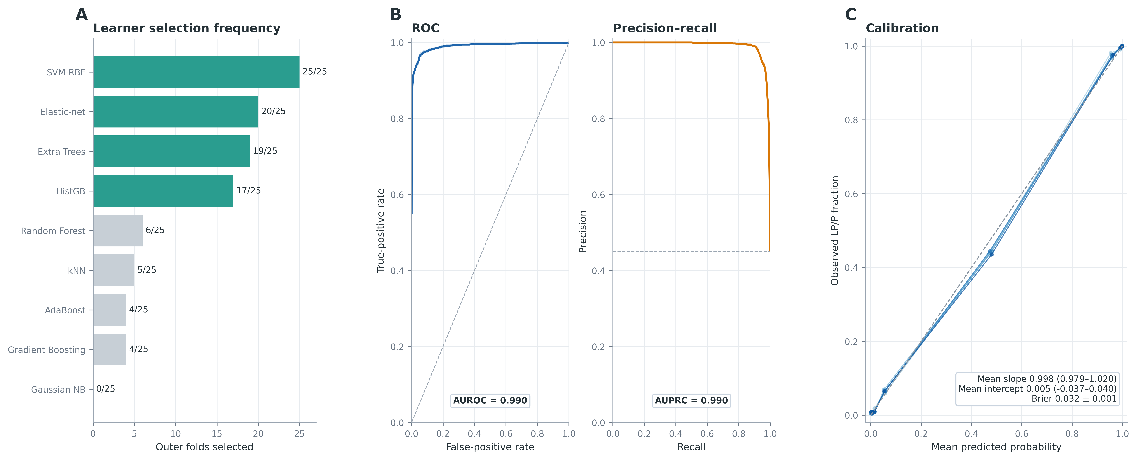
Figure 2. Family-constrained learner selection and repeated nested-validation performance. (A) Learner-selection frequencies across 25 outer folds; teal bars identify the four deployment learners. Frequencies are descriptive, whereas deployment membership was determined by aggregate within-family ranking. (B) ROC and precision–recall curves from the continuous S_MAC score in five complete outer-test repeats. Thin curves show individual repeats, solid curves show the mean and ribbons show ±1 sample SD. Dashed lines denote chance discrimination and the 45.05% LP/P anchor prevalence, respectively. The lower annotations show AUROC = 0.990 and AUPRC = 0.990; full estimates are 0.9900 ± 0.0008 and 0.9903 ± 0.0006. (C) Decile-based calibration curves for each outer-test repeat; the dashed line denotes perfect calibration. Calibration slopes ranged from 0.979 to 1.020, intercepts from −0.037 to 0.040 and the mean Brier score was 0.0317 ± 0.0006.
Table 5. Fixed out-of-fold three-output audit of labelled anchors.
Source label | Predicted B/LB (V0) | Uncertain (V1–V3) | Predicted LP/P (V4) | Total
B/LB | 1,117 | 53 | 17 | 1,187
LP/P | 34 | 58 | 881 | 973
Total | 1,151 | 111 | 898 | 2,160
Note. B/LB and LP/P are model outputs for labelled internal or external records and do not constitute ACMG/AMP reclassification. Definite-output coverage was 2,049/2,160 (94.86%), the Uncertain rate was 111/2,160 (5.14%), and source-direction concordance among definite outputs was 1,998/2,049 (97.51%).

2.3 Context-specific categorical outputs and vote-pattern audit
Application of the four selected learners to 43,679 unresolved records assigned 31,627 to V0, 2,228 to V1, 1,429 to V2, 1,622 to V3 and 6,773 to V4. Because these records were already unresolved, they were not labelled B/LB or LP/P. Instead, V0 was displayed as Uncertain-low (31,627; 72.41%), V1–V3 as Uncertain-mid (5,279; 12.09%) and V4 as Uncertain-high (6,773; 15.51%) (Fig. 3A). Learner LP/P-directed call fractions remained 22.50% for SVM–RBF, 19.87% for L2 logistic regression, 20.86% for Extra Trees and 21.58% for histogram gradient boosting. The exact V-state and four-bit vote vector are retained for every evaluable record; the application-zone labels do not replace the audit layer.
The distinction between evaluation and application contexts is shown in Fig. 3B–C. Labelled anchors were evaluated as predicted B/LB, Uncertain or predicted LP/P: the predicted B/LB output had 1,117/1,151 B/LB source-label concordance (97.05%; Wilson 95% CI, 95.90–97.88%), the predicted LP/P output had 881/898 LP/P concordance (98.11%; 96.99–98.81%), and the Uncertain output contained 58/111 LP/P anchors (52.25%; 43.04–61.31%). Uncertain-low/mid/high terminology is therefore restricted to the unresolved application catalogue and is not used to describe known anchors.
The mixed-vote output comprised V1 (36 anchors; 10 LP/P), V2 (41 anchors; 29 LP/P) and V3 (34 anchors; 19 LP/P) (Fig. 3C). For labelled records, all three states are reported as Uncertain; for unresolved application records, they form the Uncertain-mid zone. Their component states remain visible because learner configurations differ, but they are not interpreted as ordered pathogenicity levels. In the fixed out-of-fold atlas, the LP/P fractions were 29/41 for V2 (70.7%; Wilson 95% CI, 55.5–82.4%) and 19/34 for V3 (55.9%; 39.5–71.1%). The overlapping intervals and reversal of the repeated-cross-validation point ordering preclude an ordinal interpretation.
The exact V2 state remained strongly structured by learner-family identity. Both tree learners supplied the two LP/P-directed votes in 32/41 V2 anchors, one tree plus one classical learner did so in 9/41 and both classical learners did so in 0/41 (Fig. 3D). Of the 32 tree-pair cases, 23 were LP/P-labelled and nine were B/LB-labelled. V2 is therefore retained as an audit of structured model-family disagreement within the Uncertain output, not as a biological class.
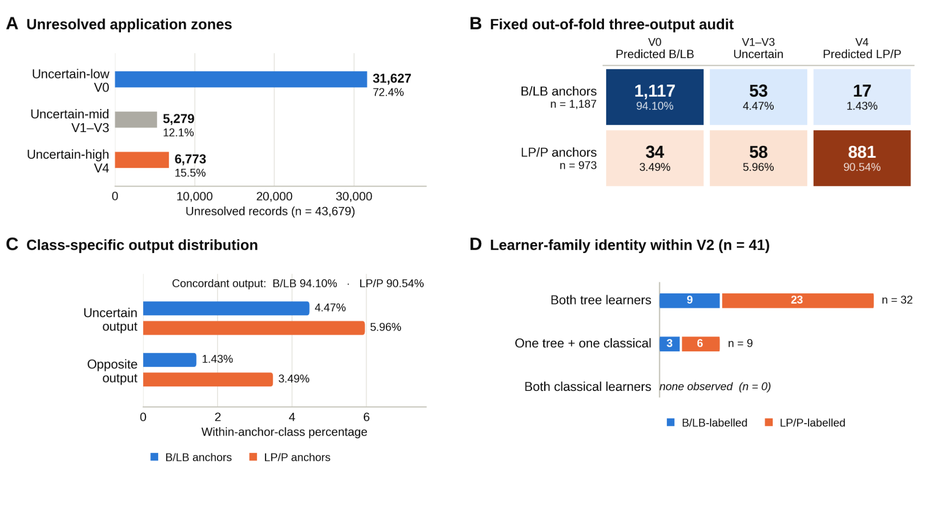
Figure 3. Context-specific categorical outputs and fixed-atlas vote-pattern audit. (A) Locked-model application counts for Uncertain-low (V0), Uncertain-mid (V1–V3) and Uncertain-high (V4) among 43,679 unresolved records. These zone labels are used only for the unresolved application catalogue. (B) Fixed out-of-fold matrix for the 2,160 labelled anchors under the three-output rule: predicted B/LB at V0, Uncertain at V1–V3 and predicted LP/P at V4. (C) Within-source-label proportions receiving the correct directional output, an Uncertain output or the opposite directional output. (D) Learner-pair composition among the 41 anchors at exact 2:2 disagreement. “Both tree learners” denotes Extra Trees plus HistGB as the LP/P-directed pair; “both classical learners” denotes SVM–RBF plus L2 logistic regression.

2.4 Sensitivity analyses and paired constituent-score comparisons
Restriction to the embedded-ClinVar-concordant anchors yielded a balanced accuracy of 0.9589 ± 0.0021 and an AUROC of 0.9906 ± 0.0007. In the strict five-fold held-out-gene (gene-grouped) internal sensitivity analysis, with complete genes held outside fold-local feature selection, tuning, calibration and threshold estimation, the pooled balanced accuracy was 0.9368, the AUROC was 0.9787 and the AUPRC was 0.9790; fold AUROC ranged from 0.9657 to 0.9951 (Table 6).
Table 6. Internal sensitivity and paired constituent-score benchmarks.
Analysis | Subset or comparator (n) | Metric | HBOCpred mean | HBOCpred SD | Reference | Difference / note
Label-concordant sensitivity | Embedded-ClinVar-concordant anchors (n=1,998) | Balanced accuracy | 0.9589 | 0.0021 | 0.9527 | 0.0062
Label-concordant sensitivity | Embedded-ClinVar-concordant anchors (n=1,998) | AUROC | 0.9906 | 0.0007 | 0.9900 | 0.0007
Strict held-out-gene sensitivity | Five gene-grouped folds (n=2,160) | Balanced accuracy | 0.9368 | — | — | Internal sensitivity; not external validation
Strict held-out-gene sensitivity | Five gene-grouped folds (n=2,160) | Sensitivity | 0.9209 | — | — | Internal sensitivity; not external validation
Strict held-out-gene sensitivity | Five gene-grouped folds (n=2,160) | Specificity | 0.9528 | — | — | Internal sensitivity; not external validation
Strict held-out-gene sensitivity | Five gene-grouped folds (n=2,160) | AUROC | 0.9787 | — | — | Internal sensitivity; not external validation
Strict held-out-gene sensitivity | Five gene-grouped folds (n=2,160) | AUPRC | 0.9790 | — | — | Internal sensitivity; not external validation
Paired constituent-score benchmark | BayesDel addAF (n=2,058) | AUROC | 0.9908 | 0.0007 | 0.9632 | 0.0277
Paired constituent-score benchmark | BayesDel addAF (n=2,058) | AUPRC | 0.9916 | 0.0005 | 0.9623 | 0.0293
Paired constituent-score benchmark | CADD PHRED (n=2,137) | AUROC | 0.9907 | 0.0008 | 0.9417 | 0.049
Paired constituent-score benchmark | CADD PHRED (n=2,137) | AUPRC | 0.9912 | 0.0005 | 0.9255 | 0.0657
Paired constituent-score benchmark | ClinPred (n=2,055) | AUROC | 0.9908 | 0.0007 | 0.9624 | 0.0284
Paired constituent-score benchmark | ClinPred (n=2,055) | AUPRC | 0.9916 | 0.0005 | 0.9522 | 0.0394
Paired constituent-score benchmark | MutPred2 (n=2,048) | AUROC | 0.9908 | 0.0007 | 0.9540 | 0.0367
Paired constituent-score benchmark | MutPred2 (n=2,048) | AUPRC | 0.9915 | 0.0005 | 0.9471 | 0.0444
Paired constituent-score benchmark | AlphaMissense (n=2,017) | AUROC | 0.9905 | 0.0007 | 0.9621 | 0.0284
Paired constituent-score benchmark | AlphaMissense (n=2,017) | AUPRC | 0.9910 | 0.0005 | 0.9643 | 0.0268
The label-concordant reference is the full-anchor nested analysis. Held-out-gene results are strict internal grouped sensitivity estimates. Constituent-score rows compare HBOCpred and each native score on the same non-missing records; matched-record denominators are shown in the second column. All five scores are members of the 25-predictor panel, so these are descriptive paired comparisons rather than independent or external validation.

2.5 Independent external-resource three-output audit
An external resource inherited from the HCSpred study was kept fully outside HBOCpred development. The broader hospital source comprised 122 HCS-tested patients and 62 unique LP/P variants across the hereditary-cancer panel. Restriction to HBOC-enriched records yielded 33 patients with 24 unique hospital variants; after the locked 17-gene missense/transcript, deduplication, overlap-screening and score-availability requirements, 16 hospital LP/P variants remained for HBOCpred scoring. Within the HBOCpred scope, 63 common benign variant candidates yielded 50 selected non-anchor variants, of which 49 were evaluable (Fig. 4A). None of these external records contributed to feature selection, model fitting, calibration or threshold selection.
Among the 16 hospital LP/P variants, 15 received a predicted LP/P output (V4) and one, ATM c.8122G>A p.(Asp2708Asn), received an Uncertain output (V2; S_MAC = 0.631); no hospital LP/P variant received a predicted B/LB output (Fig. 4B,C). The LP/P-output rate was 15/16 (93.8%; Wilson 95% CI, 71.7–98.9%), the Uncertain rate was 1/16 (6.2%; 1.1–28.3%) and the opposite B/LB-output rate was 0/16 (0%; 0–19.4%). The hospital arm comprised BRCA1 (n = 5), BRCA2 (n = 2), ATM (n = 2), CHEK2 (n = 2), TP53 (n = 4) and RAD51C (n = 1).
All 49 evaluable gnomAD proxies remained below three LP/P-directed votes and therefore lay in V0–V2; none received the final predicted LP/P output (V4). One additional selected TP53 record was non-evaluable (Fig. 4D). The supplied external audit export did not retain the exact V0–V2 decomposition, so the predicted B/LB rate and the Uncertain rate could not be separated. The 50 selected proxies spanned 12 genes: FANCA (n = 15), BRCA1 (n = 9), BARD1 (n = 6), ATM (n = 6), PALB2 (n = 4), BLM (n = 3), BRIP1 (n = 2), and one each in TP53, RAD51D, NBN, FANCC and BRCA2.
The hospital and gnomAD arms address different directional questions and were not combined into one balanced-accuracy estimate. The hospital arm estimates LP/P-output capture, Uncertain abstention and opposite B/LB-output errors in known LP/P variants. The gnomAD arm establishes that no evaluable benign proxy received an LP/P output, but the unavailable V0-versus-V1–V2 decomposition prevents estimation of predicted B/LB capture or unanimity-based specificity. Small and gene-imbalanced denominators preclude stable per-gene or prospective clinical-validation claims.
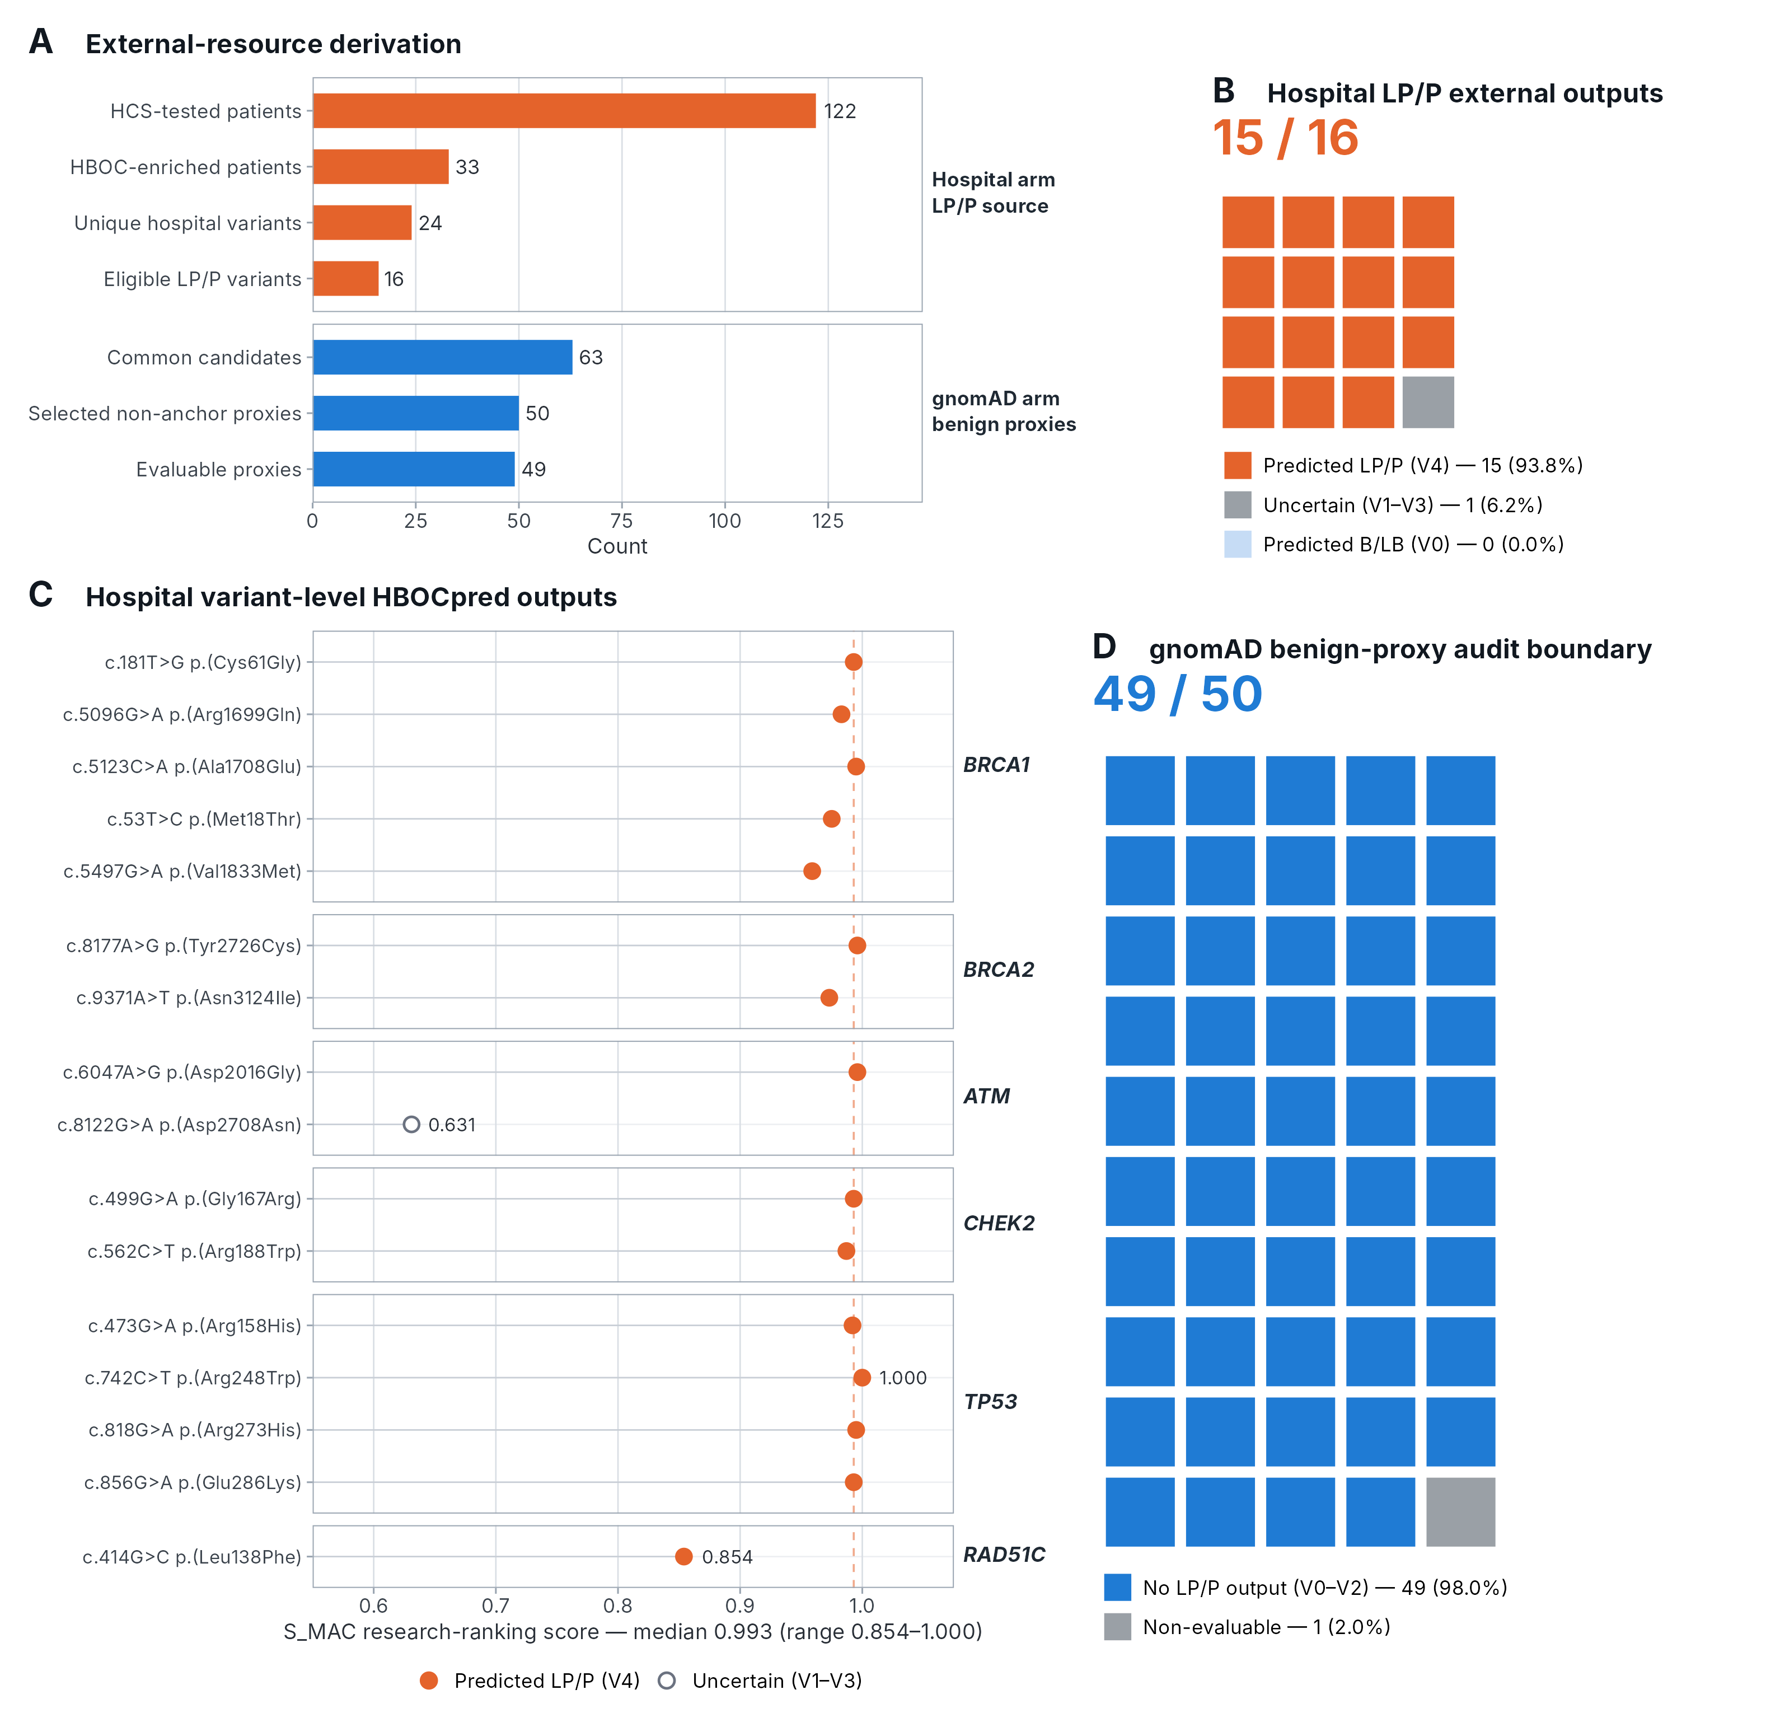
Figure 4. Independent external-resource audit under the context-specific three-output framework. (A) Resource derivation for the hospital LP/P and gnomAD benign-proxy arms. (B) Categorical outputs for the 16 hospital LP/P variants: 15 predicted LP/P, one Uncertain and none predicted B/LB. (C) Variant-level hospital outputs and S_MAC research-ranking scores; ATM c.8122G>A p.(Asp2708Asn) was the only Uncertain output. (D) gnomAD audit boundary: all 49 evaluable proxies avoided the predicted LP/P output, but the supplied export did not retain exact V0–V2 states and therefore cannot distinguish predicted B/LB from Uncertain; one proxy was non-evaluable. These analyses assess limited directional transportability and do not reclassify variants or establish prospective clinical utility.

2.6 Secondary binary complementarity relative to individual comparators
As a secondary diagnostic benchmark, variant-level complementarity was assessed for REVEL [27], MetaLR [28], VARITY [29], BayesDel addAF [30] and AlphaMissense [31] using repeat-specific nested outer-test predictions and the prespecified ≥3-of-4 binary endpoint (Fig 5.). This analysis is separate from the primary three-output rule: labelled records at V1–V3 remain Uncertain, while unresolved application records at V1–V3 remain in Uncertain-mid, even though the secondary binary benchmark treats V3 as LP/P-directed and V0–V2 as B/LB-directed. For each comparator, its cut-point was estimated separately within each repeat and outer fold from available scores among the 1,728 outer-training anchors and then applied to the untouched 432-anchor outer-test fold. Stable rescue was defined only for this secondary binary benchmark.
Review-status-stratified OOF analysis showed marked learner-family divergence within the NR stratum. NR denoted a review-status value not recorded in the source dataset and was not treated as an ordinal ClinVar category. Of the 101 NR anchors, 78 (77.2%) were B/LB and 23 (22.8%) were LP/P. Among LP/P–NR anchors, Extra Trees and HistGB were concordant with the source anchor direction for 22/23 variants (95.7%) each, whereas SVM–RBF and L2 logistic regression were concordant for 5/23 (21.7%) each; consequently, only 5/23 variants (21.7%) met the prespecified ≥3-of-4 LP/P-directed endpoint. Among B/LB–NR anchors, SVM–RBF and L2 logistic regression were concordant for 78/78 variants (100%), compared with 70/78 (89.7%) for Extra Trees and 71/78 (91.0%) for HistGB; no B/LB–NR anchor crossed the ≥3-of-4 LP/P-directed endpoint. These source-stratified OOF findings are descriptive and remain an internal assessment. The full review-status audit is shown in Fig. 6.
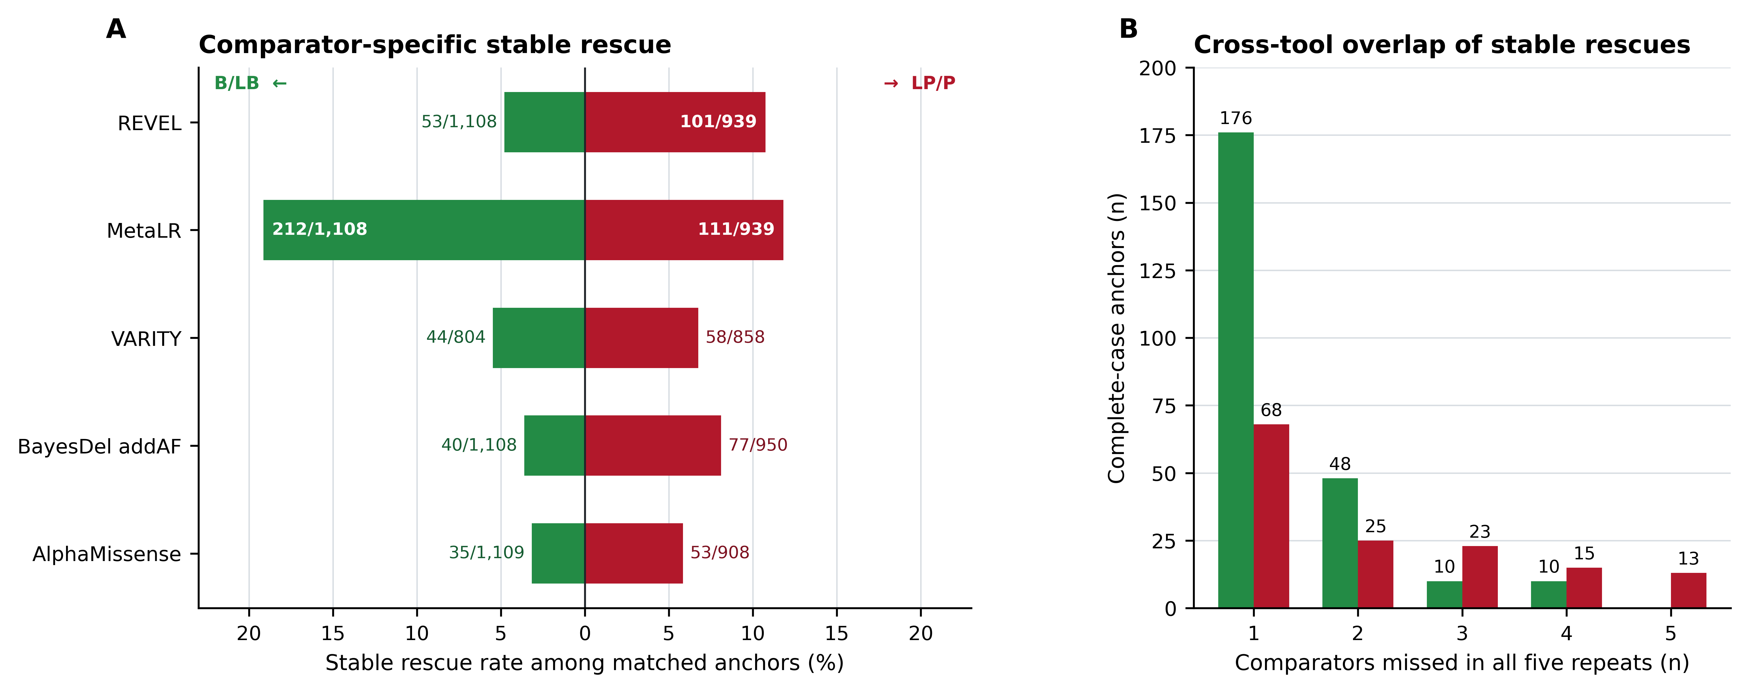
Figure 5. Secondary ≥3-of-4 binary rescue of anchor variants misclassified by individual in silico comparators. (A) Diverging bars show the proportions of matched B/LB and LP/P anchors for which HBOCpred was correct at the prespecified secondary binary endpoint and the indicated comparator was incorrect in all five repeated nested outer tests; labels give rescued variants/non-missing matched anchors. Comparator cut-points were estimated within each outer-training partition and applied to its untouched outer-test fold. (B) Among all-five complete cases, bars show the numbers of B/LB and LP/P anchors stably rescued against one to five comparators. These results assess internal binary complementarity and do not define either the primary B/LB–Uncertain–LP/P output or the Uncertain-low/mid/high application zones.
Figure 6. Review-status-stratified distribution and secondary binary performance of HBOCpred. (A) Distribution of the 2,160 source anchors across the recorded ClinVar review-status strata, shown separately for LP/P and B/LB anchors. (B) Correct source-direction calls for the two conventional learners, two tree-based learners and the prespecified ≥3-of-4 secondary binary endpoint. This audit does not alter the primary B/LB–Uncertain–LP/P output or the Uncertain-low/mid/high labels used only for unresolved application records. OOF, out-of-fold; B/LB, benign/likely benign; LP/P, likely pathogenic/pathogenic; NR, not recorded; HistGB, histogram-based gradient boosting.

2.7 Feature-distribution diagnostics and deployment catalogue
Application-versus-anchor distribution diagnostics showed absolute standardised mean differences (|SMD|) >=0.20 for 17/25 final predictors and >=0.10 for 22/25. Most shifts were negative, indicating lower application-set values on the standardised predictor scale; missingness also varied by feature. These diagnostics did not change any model output and do not establish clinical transportability.
All 43,679 unresolved application records satisfied the prespecified requirement that at least 20 of the 25 final predictors be observed. The deployment catalogue retains the exact V0–V4 audit state, the unresolved-only Uncertain-low/mid/high research-prioritisation zone, the four calibrated learner probabilities and votes, S_MAC, observed-feature count and completeness flag.
A companion R Shiny interface, the HBOCpred Variant Score Atlas (https://alaymd.shinyapps.io/hbocpred/), provides exploratory search and inspection of variant-level audit outputs. The interface is intended for research use only and was not used for model fitting, feature selection, threshold optimisation or performance evaluation (Fig. 7).
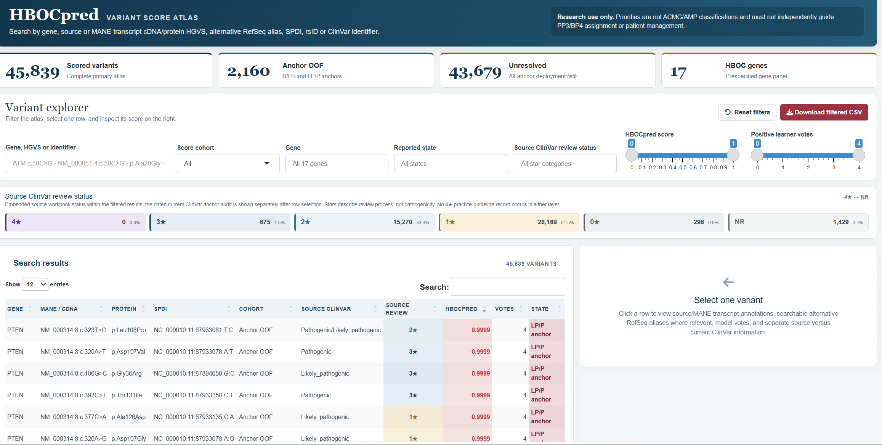
Figure 7. HBOCpred application.

3. Discussion
Here, we present HBOCpred as an HBOC-specific heterogeneous ensemble for research prioritisation of unresolved germline missense variants. For labelled internal and external records, V0 is reported as predicted B/LB, V1–V3 as Uncertain and V4 as predicted LP/P; for already unresolved application records, the same states are displayed as Uncertain-low, Uncertain-mid and Uncertain-high prioritisation zones. In repeated nested outer-test evaluation of 2,160 anchors from 17 genes, the secondary ≥3-of-4 endpoint achieved a balanced accuracy of 0.9527, while S_MAC yielded an AUROC of 0.9900, an AUPRC of 0.9903 and a Brier score of 0.0317. Re-tabulation of the frozen out-of-fold predictions yielded 1,151 predicted B/LB, 111 Uncertain and 898 predicted LP/P outputs, corresponding to 94.86% definite-output coverage, a 5.14% Uncertain rate and 97.51% source-direction concordance among definite outputs. These are internal estimates, and repeat-level standard deviations describe split stability.
HBOCpred is designed to expose agreement and disagreement among distinct modelling families. The ensemble combines SVM–RBF, L2 logistic regression, Extra Trees and HistGB while retaining the calibrated probabilities and complete four-bit vote vector. In the exact 2:2 audit, both tree learners formed the LP/P-directed pair in 32/41 anchors, whereas the two classical learners never formed that pair. Similarly, each tree learner recovered 22/23 LP/P–NR anchors, compared with 5/23 for each conventional learner and the secondary ≥3-of-4 endpoint. Mixed-vote states therefore represent structured model-family disagreement rather than an ordinal pathogenicity midpoint or latent biological class.
This architecture distinguishes HBOCpred from disease- or gene-focused studies that compared alternative learning algorithms but ultimately issued predictions from one selected fitted model for each gene or prediction task. BRCA-ML selected a gradient-boosting machine for BRCA1 and XGBoost for BRCA2 [25]. Subsequent BRCA1/2 studies identified gene-specific random forests as their best-performing models [26,27]. Ahmad et al. selected Extra Trees after evaluating nine algorithms [28]. Two broader hereditary-cancer-specific tools were subsequently reported: HCSpred, an integrative ensemble framework first presented in 2025 with an accuracy and F1 score of approximately 0.99 on known variants [29], and HerCanPred, published in 2026 and led by a random-forest classifier [24]. Taken together, these studies support disease- and gene-focused training. A closer methodological comparator is Lee et al. [30], who coupled disease- and gene-specific autoencoder pretraining with a 50-member deep ensemble for BRCA1, BRCA2, MLH1, and MSH2. However, their ensemble comprised independently fine-tuned instances of a shared deep neural network (DNN) architecture whose outputs were averaged. HBOCpred instead retains four algorithmically distinct learners and reports their thresholded vote pattern at the variant level. Meta-EA provides a second contrast: it derives gene-specific weighted combinations of existing variant-effect predictors using Evolutionary Action as the reference but returns a single composite score rather than component-level decisions [31]. Phenotype-based evaluation in UK Biobank likewise found marked variation among hereditary breast-cancer genes and limited utility for VUS-only analyses, underscoring that strong aggregate performance need not be uniform across genes [32].
Relative to hard voting alone [33], S_MAC provides a continuous ranking score, allowing variants with the same vote count or categorical output to be prioritised for expert review and functional follow-up. The four thresholded learner decisions define the V0–V4 audit states, whereas S_MAC, obtained through logistic meta-calibration of Mean4, is reported alongside the vote pattern and neither contributes an additional vote nor alters the context-specific mapping. This dual-output design keeps learner-level disagreement visible while adding ranking resolution beyond vote count alone. Because S_MAC was calibrated within the HBOCpred anchor framework, it is not a clinical posterior probability or a direct PP3/BP4 evidence threshold [18,19,34].
A number of limitations should be taken into consideration when interpreting these results. While residual circularity cannot be ruled out because multiple retained predictors were developed or calibrated using overlapping clinical variant datasets, the use of curated public resources may introduce ascertainment bias and gene-specific imbalances in the available evidence. As a result, the strong overall performance might not apply consistently to all genes, especially those with few labeled or external variants. Furthermore, even though all application records satisfied the predetermined completeness requirement, 17 of the 25 final predictors displayed absolute standardized mean differences between the anchor and unresolved application datasets of at least 0.20, indicating a distribution shift. Instead of being independently fitted or prospectively specified, the three-output rule and unresolved-zone display were determined deterministically from the current V-states, necessitating external validation. Additionally, rather than being independent biological evidence, the four votes should be viewed as correlated algorithmic outputs; even unanimous agreement does not increase the strength of ACMG/AMP evidence. Lastly, HBOCpred does not include phenotype, segregation, tumor characteristics, ancestry, or functional information; it is restricted to missense variants.
In conclusion, HBOCpred provides an auditable, disagreement-aware framework that separates three-output reporting from prioritisation of already unresolved variants. Labelled internal and external records are reported as predicted B/LB at V0, Uncertain at V1–V3 or predicted LP/P at V4; the same states are displayed as Uncertain-low, Uncertain-mid and Uncertain-high only for unresolved application records. Exact V-state, learner identities and calibrated probabilities remain available for audit, while S_MAC provides continuous ranking without overriding disagreement. HBOCpred is intended for research prioritisation and should not be used as a stand-alone clinical classifier or to guide patient management.

4. Materials and Methods

4.1 Study design
HBOCpred was developed as a variant-level in silico framework for prioritising germline missense variants in hereditary breast and ovarian cancer susceptibility genes for research follow-up. The workflow comprised four stages. In stage 1, fixed benign/likely benign and likely pathogenic/pathogenic anchors were curated and kept separate from the unresolved application pool. In stage 2, the numerical feature matrix was assembled, with preprocessing and consensus feature selection performed within each training partition. In stage 3, a family-balanced four-learner ensemble was selected, calibrated and internally evaluated. In stage 4, the fitted preprocessing objects, learners, calibrators and thresholds were applied without refitting to unresolved records and to an external resource held apart from every step of model development.
HBOCpred reports four calibrated learner probabilities and votes, the complete four-bit vote pattern, the corresponding V0–V4 state, S_MAC, and a completeness flag. For labelled internal and external records, V0 is reported as predicted B/LB, V1–V3 as Uncertain, and V4 as predicted LP/P. For unresolved application records, the same V-states are presented as Uncertain-low, Uncertain-mid, and Uncertain-high research-prioritisation zones.
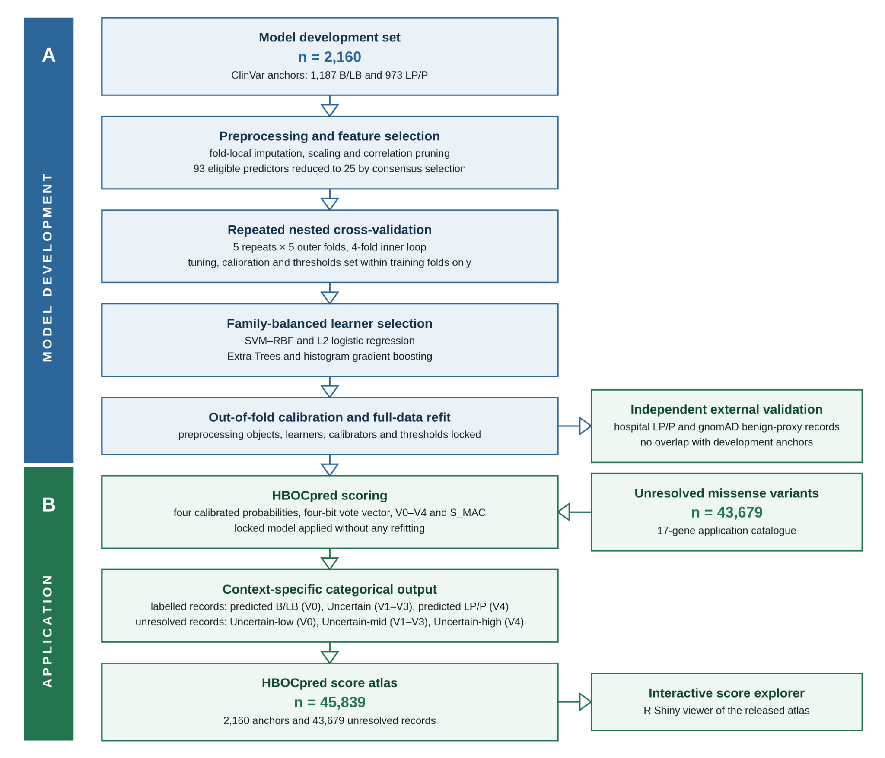
Figure 1. Model-development and context-specific output workflow. (A) Model development. A total of 2,160 ClinVar anchors entered fold-local preprocessing and consensus feature selection, which reduced 93 eligible predictors to 25, followed by repeated nested cross-validation and family-balanced learner selection. Tuning, calibration and learner thresholds were estimated within training partitions only. (B) Locked scoring and reporting. Every evaluable record retains four calibrated probabilities, the four-bit vote vector, V0–V4 and S_MAC. Labelled internal and external records are reported as predicted B/LB at V0, Uncertain at V1–V3 and predicted LP/P at V4. The 43,679 unresolved application records instead use Uncertain-low, Uncertain-mid and Uncertain-high zones. The latter labels are not applied to known or external records and do not constitute ACMG/AMP classes or clinical posterior probabilities.

4.2 HBOCpred algorithm
Family-wise learner selection
Throughout, LP/P is coded as 1 and B/LB as 0.
Let $C$, $B$ and $G$ denote the classical, bagging and boosting candidate families. For learner $m$, define the cross-validated ranking tuple
$$R_{m}=\left({\overline{BA}}_{m},{\overline{AUROC}}_{m},{\overline{AUPRC}}_{m}\right), {BA}_{m}=\frac{{TPR}_{m}+{TNR}_{m}}{2}. \left(1\right)$$
Learners are ranked lexicographically in decreasing order of $R_{m}$. The family-balanced modified adaptive classifier (MAC) is
$$M^{*}={Top}_{2}\left(C;R\right)∪{Top}_{1}\left(B;R\right)∪{Top}_{1}\left(G;R\right), \left|M^{*}\right|=4. \left(2\right)$$
Calibrated adaptive voting
For variant $i$ and selected learner $m$, let $r_{im}$ be the raw LP/P-directed probability. Development out-of-fold predictions are Platt-calibrated as
$$l_{ε}\left(r\right)=log​\left[\frac{clip\left(r,ε,1-ε\right)}{1-clip\left(r,ε,1-ε\right)}\right], p_{im}=σ​\left({\hat{α}}_{m}+{\hat{β}}_{m}l_{ε}\left(r_{im}\right)\right), σ\left(a\right)=\frac{1}{1+e^{-a}}. \left(3\right)$$
The locked learner-specific threshold is
$$τ_{m}=\underset{t∈T_{m}}{arg max} \frac{{TPR}_{m}\left(t\right)+{TNR}_{m}\left(t\right)}{2}, \left(4\right)$$
with an exact tie resolved by retaining the maximising threshold closest to $0.5$. The LP/P-directed vote and total vote count are
vim=Ipim≥τm, Si=m∈M*​vim. 5
The audit state is Vc, where c is the sum of the four LP/P-directed votes and c ∈ {0,1,2,3,4}; V2 denotes exact 2:2 disagreement. For labelled internal and external records, the three-output reporting rule is predicted B/LB when c = 0, Uncertain when 1 ≤ c ≤ 3 and predicted LP/P when c = 4. For unresolved application records only, the same audit states are displayed as Uncertain-low, Uncertain-mid and Uncertain-high, respectively. Both mappings are deterministic, introduce no fitted parameter and do not modify learner probabilities, thresholds, votes or S_MAC. For secondary binary evaluation only, the prespecified LP/P-directed endpoint remains c ≥ 3; it does not define the three-output reporting rule.
The complete four-bit vote vector is retained because equal vote counts can arise from different learner-family configurations. Learner-pair identity is therefore an audit variable rather than a latent biological label.
Continuous HBOCpred score
The arithmetic mean of the four calibrated learner probabilities is Mean4. The reported continuous score is S_MAC = logistic(α + β × logit(Mean4)), with α = 0.0735 and β = 1.2056 in the frozen deployment fit. S_MAC is retained as a ranking score and is not a fifth vote, a clinical posterior probability or an ACMG/AMP evidence category.

Primary output and completeness flag
For each record, the locked output tuple contains the four calibrated learner probabilities, four thresholded votes, vote count and complete pattern, V0–V4 audit state, S_MAC, observed final-feature count and a completeness flag. A context field determines the displayed categorical output: predicted B/LB / Uncertain / predicted LP/P for labelled internal or external records, and Uncertain-low / Uncertain-mid / Uncertain-high for unresolved application records. S_MAC is used only for ranking and is not a clinical posterior probability. The deployment completeness rule requires at least 20 of 25 final predictors. Records below this threshold are labelled incomplete and their audit state, categorical display and S_MAC are suppressed.
Variant curation and label definition
ClinVar-derived missense variants were restricted to the prespecified 17-gene HBOC study scope: ATM, BARD1, BLM, BRCA1, BRCA2, BRIP1, CDH1, CHEK2, FANCA, FANCC, NBN, PALB2, PTEN, RAD51C, RAD51D, STK11 and TP53. The set spans established high-penetrance or syndromic genes, moderate-penetrance breast/ovarian cancer genes and a limited-evidence study stratum retained for exploratory generalisability; the evidence stratum is reported and is not a clinical risk classification. MANE Select transcripts were used when available; otherwise a prespecified canonical transcript was frozen before modelling. Inclusion required germline missense SNVs with one gene/transcript assignment, harmonised genomic/SPDI and HGVS representation, and one of the retained clinical-significance groups. B/LB and LP/P records formed the 2,160 labelled anchors pool (Table 1).
Table 1. Prespecified 17-gene source counts.
Gene | B/LB | LP/P
ATM | 67 | 75
BARD1 | 24 | 3
BLM | 21 | 6
BRCA1 | 347 | 217
BRCA2 | 306 | 84
BRIP1 | 25 | 7
CDH1 | 89 | 20
CHEK2 | 8 | 9
FANCA | 63 | 77
FANCC | 15 | 4
NBN | 18 | 2
PALB2 | 34 | 6
PTEN | 22 | 211
RAD51C | 10 | 9
RAD51D | 10 | 1
STK11 | 7 | 33
TP53 | 121 | 209
Total | 1,187 | 973

4.3 Feature matrix construction and preprocessing
Each variant was represented by a numerical feature vector containing in silico pathogenicity scores, rank scores, conservation metrics, splicing-related predictors and protein/context annotations. After exclusion of identity, label, categorical prediction and annotation fields, 93 of the 122 in silico scores were eligible numerical predictors. Eight predictors with more than 40% missingness in the unlabelled application archive were removed before resampling, leaving 85 deployment-compatible predictors. Missing values were imputed within the training workflow. Continuous predictors were scaled after imputation. Within each analysis-training partition, the four SpliceAI delta scores [35] were collapsed to their row-wise maximum; predictors with more than 40% missingness, zero variance or near-zero variance were removed; semantically duplicated score/rank representations were reduced deterministically; and complete-linkage clusters based on pairwise-complete absolute Spearman correlation were cut at |ρ| ≥ 0.90. Training-partition medians and z-standardisation parameters were then applied unchanged to the corresponding assessment partition. Gene-aware splitting, imputation, scaling and feature selection were performed within the training partition, and the locked preprocessing objects were applied to the corresponding outer assessment partition and the final application catalogue without refitting.

4.4 Candidate learners and family-wise selection
The labelled anchor set was used exclusively for supervised model development and internal evaluation. Nine candidate learners were assessed: elastic-net logistic regression, radial-basis-function support vector machine (SVM-RBF), k-nearest neighbours, Gaussian naive Bayes, random forest, Extra Trees, AdaBoost, gradient boosting and histogram gradient boosting. Four learners were selected by a prespecified family-wise rule comprising the two highest-ranked classical models, the highest-ranked bagging model and the highest-ranked boosting model, thereby preserving algorithmic diversity. Within each analysis split, up to eight unique configurations per learner were sampled without replacement from the prespecified search spaces (Table 2). Hyperparameters were selected by mean inner-CV AUROC, with lower AUROC SD and then a deterministic parameter-string rule used to resolve ties.
Table 2. Prespecified hyperparameter search spaces.
Learner | Evaluated search space
Elastic-net logistic | C: 0.03, 0.10, 0.30, 1, 3, 10; L1 ratio: 0, 0.5, 1
SVM-RBF | C: 0.25, 0.75, 2, 6, 16; gamma: scale, 0.01, 0.03, 0.10
k-nearest neighbours | k: 5, 9, 15, 25, 41; weights: uniform/distance; Minkowski p: 1/2
Gaussian naive Bayes | Variance smoothing: 12 log-spaced values from 10^-11 to 10^-6
Random forest / Extra Trees | 220 trees; depth: none, 10, 18; max features: sqrt(p), 0.4p, 0.7p; minimum leaf: 1, 3, 7
AdaBoost | Tree depth: 1, 2, 3; minimum leaf: 2, 8, 16; estimators: 100, 250, 400; learning rate: 0.05, 0.20, 0.80
Gradient boosting | Tree depth: 1, 2, 3; minimum leaf: 5, 15; estimators: 100, 250; learning rate: 0.03, 0.10
Histogram gradient boosting | Maximum leaves: 15, 31; minimum leaf: 10, 20; iterations: 100, 200; learning rate: 0.03, 0.10; L2: 0, 1
Note. For each learner and analysis split, up to eight configurations were sampled without replacement. Configurations were ranked by mean inner-CV AUROC, then by lower AUROC SD and finally by a deterministic parameter-string tie-break.

4.5 Repeated nested cross-validation
Primary internal evaluation used five repeats of five-fold outer cross-validation with four-fold inner cross-validation. Splits were jointly stratified by gene and processed outcome when feasible; sparse gene-outcome strata were pooled by outcome. Each outer-test fold comprised 432 records. Within each outer-training partition, learners were ranked lexicographically by calibrated inner out-of-fold balanced accuracy, AUROC and AUPRC. Learner-specific thresholds maximised balanced accuracy. If several thresholds produced the same maximum, the value closest to 0.5 was selected; if an equal-distance tie remained, the lower threshold was retained. Within each repeat, predictions from its five outer-test folds were pooled, and performance was summarised as the mean, sample SD and range across the five repeat-level estimates.

4.6 Calibration, adaptive voting and deployment refit
Each learner produced an LP/P-directed score. Decision-function outputs were calibrated by Platt scaling; probability-only outputs were clipped to [10^-6, 1 - 10^-6] and logit-transformed before calibration. Learner-specific thresholds, estimated solely within training partitions, converted calibrated probabilities to four binary votes. The primary state V0–V4 equals the total number of LP/P-directed votes, while the complete vote vector preserves learner-family identity. S_MAC is a logistic meta-calibration of Mean4 and contributes no additional vote. All final preprocessing objects, learner specifications, calibrators and thresholds were frozen before application to the unresolved catalogue; the external resource remained isolated from HBOCpred development.
The ≥3-of-4 threshold was retained as the prespecified secondary binary endpoint for conventional sensitivity, specificity and balanced-accuracy benchmarking. The three-output reporting rule was evaluated separately using definite-output coverage, Uncertain rate, output-specific source-label composition and conditional source-direction concordance among V0 and V4 records. Definite-output coverage was (nV0 + nV4)/n, the Uncertain rate was (nV1 + nV2 + nV3)/n, and conditional source-direction concordance was (B/LB records in V0 + LP/P records in V4)/(nV0 + nV4). Coverage and conditional concordance were always reported together.

4.7 Independent external-resource three-output audit
The external resource was inherited from the HCSpred study and remained fully isolated from HBOCpred feature selection, fitting, calibration and threshold estimation. The hospital source began with 122 HCS-tested records. From these, an HBOC-enriched subset was selected based on a personal history of breast or ovarian cancer in the tested individual together with breast or ovarian cancer in at least four additional relatives. This yielded 33 patients with 24 unique hospital variants. Following unique-variant collapsing, restriction to the prespecified 17-gene missense/transcript scope, SPDI normalisation, anchor-overlap screening and score-availability requirements, 16 unique hospital LP/P variants remained and constituted the hospital external-validation arm. The gnomAD v4.1 arm began with 63 common missense candidates; 50 non-anchor proxies were selected and 49 satisfied the score-availability requirement.
The HBOCpred pipeline was applied without refitting or threshold modification. For hospital LP/P variants, V4 was a concordant predicted LP/P output, V1–V3 were Uncertain and V0 was an opposite predicted B/LB output. For gnomAD benign proxies, V0 was a concordant predicted B/LB output, V1–V3 were Uncertain and V4 was an opposite predicted LP/P output. The hospital audit retained exact V-states. The selected gnomAD export retained only whether each evaluable record remained below the ≥3-of-4 LP/P-directed endpoint; therefore all evaluable proxies were known to lie in V0–V2 and to avoid the predicted LP/P output, but predicted B/LB versus Uncertain could not be reconstructed.

4.8 Context-specific output and audit summaries
Labelled-anchor and hospital records were summarised under the predicted B/LB / Uncertain / predicted LP/P output rule. Application counts were summarised separately by exact V0–V4 audit state and by the unresolved-only Uncertain-low/mid/high zones. The V1, V2 and V3 components were retained separately for descriptive audit, and exact V2 records were additionally summarised by the identity of the two LP/P-directed learners. External-resource records were summarised by gene and evaluability.
The earlier UniProt localisation analysis used the incompatible grouping V0–V1, V2 and V3–V4. Because the row-level localisation table required to recompute the analysis under the revised V0, V1–V3 and V4 mapping was not available in the supplied revision package, the analysis was removed rather than relabelled.

4.9 Statistical analysis
Continuous discrimination was assessed by AUROC and AUPRC, and probabilistic accuracy by the Brier score. The mean ± sample SD across five complete repeated outer-test evaluations is reported only as resampling-stability information and is not interpreted as a confidence interval for model performance. Conventional sensitivity, specificity, PPV, NPV, F1, MCC and balanced accuracy refer to the prespecified secondary ≥3-of-4 binary endpoint unless explicitly stated otherwise.
For the three-output reporting rule, exact counts and proportions were reported for predicted B/LB (V0), Uncertain (V1–V3) and predicted LP/P (V4), together with definite-output coverage, Uncertain rate and conditional source-direction concordance. For unresolved application records, the same V-state counts were additionally displayed as Uncertain-low, Uncertain-mid and Uncertain-high zones. Wilson 95% confidence intervals were calculated for binomial proportions. Uncertain records were not counted as correct or incorrect in conditional concordance; they remained in the denominator for coverage and abstention. External records failing the completeness requirement were retained in resource accounting but excluded from evaluable proportions.
Internal constituent-score comparisons are descriptive because the comparators were candidate or retained model inputs; no inferential superiority claim is made. The stable-rescue and review-status analyses use the secondary ≥3-of-4 binary endpoint and are explicitly separated from both the three-output reporting rule and the unresolved application zones. Per-gene external results are interpreted descriptively where counts permit. Analyses used Rstudio 4.13 (ggplot2 package), Python 3.12.13 (NumPy 2.3.5, pandas 2.3.3 and scikit-learn 1.8.0). Data preparation used seed 20260723; modelling used seed 20260714 with deterministic offsets.

Institutional Review Board Statement: Model development used public variant resources. The external-validation resource was derived from the Ankara Etlik City Hospital hereditary-cancer testing workflow under institutional ethics approval AEŞH-BADEK-2024-219. Only de-identified variant-level data were used in the HBOCpred analysis.
Informed Consent Statement: Written informed consent was obtained from all individuals included in the source clinical testing workflow. No patient identifier was supplied to the HBOCpred model.
Data Availability Statement: The interactive HBOCpred Variant Score Atlas and integrated variant-level outputs are available at https://alaymd.shinyapps.io/hbocpred/. Public inputs were obtained from ClinVar, gnomAD and Ensembl. De-identified external-validation summaries, including per-gene denominators and the hospital variant-level audit, are reported in Results 2.5 and Figure 4. Additional de-identified processed research outputs are available from the corresponding author upon reasonable request, subject to institutional and privacy restrictions; patient-level clinical data are not publicly available.
Code Availability: The source code, frozen model objects and scripts required to reproduce the reported analyses will be made publicly available on GitHub after publication.
Acknowledgments: We thank the Alay family for supporting novel ideas.
Conflicts of Interest: None.

Abbreviations
Abbreviations: ACMG/AMP, American College of Medical Genetics and Genomics/Association for Molecular Pathology; AUPRC, area under the precision–recall curve; AUROC, area under the receiver-operating-characteristic curve; B/LB, benign/likely benign; HistGB, histogram-based gradient boosting; LP/P, likely pathogenic/pathogenic; MAC, modified adaptive classifier; OOF, out-of-fold; S_MAC, continuous HBOCpred ranking score; SMD, standardised mean difference; SVM–RBF, support vector machine with radial basis function kernel; V0–V4, audit states defined by 0–4 LP/P-directed learner votes; Uncertain, non-unanimous categorical output for labelled internal or external records; Uncertain-low, unresolved application zone defined by V0; Uncertain-mid, unresolved application zone defined by V1–V3; Uncertain-high, unresolved application zone defined by V4; VUS, variant of uncertain significance.

References
1. Doğan, C.; Akosman, C.; Sönmez, M. Analysis of the Results of the BRCA1 and BRCA2 Genes in Early-Onset Breast Cancer Patients from the Ordu Province. Atl. J. Med. Sci. Res. 2026, 6, 93–99.
2. Elias, K.; Smyczynska, U.; Stawiski, K.; Nowicka, Z.; Webber, J.; Kaplan, J.; Landen, C.; Lubinski, J.; Mukhopadhyay, A.; Chakraborty, D.; et al. Identification of BRCA1/2 Mutation Female Carriers Using Circulating MicroRNA Profiles. Nat. Commun. 2023, 14, 3350, doi:10.1038/s41467-023-38925-4.
3. Kuchenbaecker, K.B.; Hopper, J.L.; Barnes, D.R.; Phillips, K.-A.; Mooij, T.M.; Roos-Blom, M.-J.; Jervis, S.; van Leeuwen, F.E.; Milne, R.L.; Andrieu, N.; et al. Risks of Breast, Ovarian, and Contralateral Breast Cancer for BRCA1 and BRCA2 Mutation Carriers. JAMA 2017, 317, 2402–2416, doi:10.1001/jama.2017.7112.
4. Yang, X.; Leslie, G.; Doroszuk, A.; Schneider, S.; Allen, J.; Decker, B.; Dunning, A.M.; Redman, J.; Scarth, J.; Plaskocinska, I.; et al. Cancer Risks Associated With Germline PALB2 Pathogenic Variants: An International Study of 524 Families. J. Clin. Oncol. 2019, 38, 674–685, doi:10.1200/JCO.19.01907.
5. Antoniou, A.C.; Casadei, S.; Heikkinen, T.; Barrowdale, D.; Pylkäs, K.; Roberts, J.; Lee, A.; Subramanian, D.; De Leeneer, K.; Fostira, F.; et al. Breast-Cancer Risk in Families with Mutations in PALB2. N. Engl. J. Med. 2014, 371, 497–506, doi:10.1056/NEJMoa1400382.
6. Breast Cancer Risk Genes — Association Analysis in More than 113,000 Women. N. Engl. J. Med. 2021, 384, 428–439, doi:10.1056/NEJMoa1913948.
7. Qian, M.; Cao, X.; Devidas, M.; Yang, W.; Cheng, C.; Dai, Y.; Carroll, A.; Heerema, N.A.; Zhang, H.; Moriyama, T.; et al. TP53 Germline Variations Influence the Predisposition and Prognosis of B-Cell Acute Lymphoblastic Leukemia in Children. J. Clin. Oncol. Off. J. Am. Soc. Clin. Oncol. 2018, 36, 591–599, doi:10.1200/JCO.2017.75.5215.
8. Tischkowitz, M.; Colas, C.; Pouwels, S.; Hoogerbrugge, N.; Bisseling, T.; Bubien, V.; Caux, F.; Chabbert-Buffet, N.; Colas, C.; Da Mota Gomes, S.; et al. Cancer Surveillance Guideline for Individuals with PTEN Hamartoma Tumour Syndrome. Eur. J. Hum. Genet. 2020, 28, 1387–1393, doi:10.1038/s41431-020-0651-7.
9. Duarte, M.; Milikowski, C. Gastrointestinal Polyposis with Associated Cutaneous Manifestations. Pathology 2022, 54, 157–166, doi:10.1016/j.pathol.2021.08.009.
10. Blair, V.R.; McLeod, M.; Carneiro, F.; Coit, D.G.; D’Addario, J.L.; van Dieren, J.M.; Harris, K.L.; Hoogerbrugge, N.; Oliveira, C.; van der Post, R.S.; et al. Hereditary Diffuse Gastric Cancer: Updated Clinical Practice Guidelines. Lancet Oncol. 2020, 21, e386–e397, doi:10.1016/S1470-2045(20)30219-9.
11. Alenezi, W.M.; Milano, L.; Fierheller, C.T.; Serruya, C.; Revil, T.; Oros, K.K.; Behl, S.; Arcand, S.L.; Nayar, P.; Spiegelman, D.; et al. The Genetic and Molecular Analyses of RAD51C and RAD51D Identifies Rare Variants Implicated in Hereditary Ovarian Cancer from a Genetically Unique Population. Cancers (Basel). 2022, 14, doi:10.3390/cancers14092251.
12. Yang, X.; Song, H.; Leslie, G.; Engel, C.; Hahnen, E.; Auber, B.; Horváth, J.; Kast, K.; Niederacher, D.; Turnbull, C.; et al. Ovarian and Breast Cancer Risks Associated With Pathogenic Variants in RAD51C and RAD51D. J. Natl. Cancer Inst. 2020, 112, 1242–1250, doi:10.1093/jnci/djaa030.
13. Santamariña, M.; Fuentes-Ríos, O.; Blanco-Pérez, A.; Rodríguez-Lage, B.; Crujeiras-González, A.; Sánchez de Abajo, A.M.; Galego-Carro, J.; Coedo-Costa, C.; Aguado-Barrera, M.E.; Sampayo, V.; et al. Splicing Predictions, Splicing Assays, and Variant Classification Using ACMG/AMP Guidelines: Challenges Observed with BRCA1 and BRCA2 Variants . Clin. Chem. 2026, 72, 266–280, doi:10.1093/clinchem/hvaf177.
14. Zanti, M.; O’Mahony, D.G.; Parsons, M.T.; Dorling, L.; Dennis, J.; Boddicker, N.J.; Chen, W.; Hu, C.; Naven, M.; Yiangou, K.; et al. Analysis of More than 400,000 Women Provides Case-Control Evidence for BRCA1 and BRCA2 Variant Classification. Nat. Commun. 2025, 16, 1–18, doi:10.1038/s41467-025-59979-6.
15. Favalli, V.; Tini, G.; Bonetti, E.; Vozza, G.; Guida, A.; Gandini, S.; Pelicci, P.G.; Mazzarella, L. Machine Learning-Based Reclassification of Germline Variants of Unknown Significance: The RENOVO Algorithm. Am. J. Hum. Genet. 2021, 108, 682–695, doi:10.1016/j.ajhg.2021.03.010.
16. Düzenli, T.; Babazade, A.; Vural, O.; Bahap, Y.; Ergün, M.A. HECTOR : A Web-Based Tool for Automated BRCA1 / BRCA2 Variant Classification Under the ClinGen ENIGMA Specifications. 2026.
17. Savige, J.; Storey, H.; Watson, E.; Hertz, J.M.; Deltas, C.; Renieri, A.; Mari, F.; Hilbert, P.; Plevova, P.; Byers, P.; et al. Consensus Statement on Standards and Guidelines for the Molecular Diagnostics of Alport Syndrome: Refining the ACMG Criteria. Eur. J. Hum. Genet. 2021, 29, 1186–1197, doi:10.1038/s41431-021-00858-1.
18. Wilcox, E.H.; Sarmady, M.; Wulf, B.; Wright, M.W.; Rehm, H.L.; Biesecker, L.G.; Abou Tayoun, A.N. Evaluating the Impact of in Silico Predictors on Clinical Variant Classification. Genet. Med. Off. J. Am. Coll. Med. Genet. 2022, 24, 924–930, doi:10.1016/j.gim.2021.11.018.
19. Zhuo, X.; Bi, X.; Aggarwal, V.; Liao, J. Calibration and Evaluation of Machine-Learning Algorithms for Missense Variant Classification under ACMG/ClinGen Recommendations. Genet. Med. 2026, 102606, doi:https://doi.org/10.1016/j.gim.2026.102606.
20. Lucas, M.C.; Keßler, T.; Benet-Pagès, A.; Holinski-Feder, E.; Laner, A.; Klink, B. Validation Structures for Sequence Variants of Uncertain Significance in Hereditary Cancer. Eur. J. Hum. Genet. 2026, 1–7, doi:10.1038/s41431-026-02073-2.
21. Nakahara, H.; Niitsu, H.; Toshida, A.; Goto, K.; Yamauchi, M.; Saipova, K.M.; Hayes, C.N.; Hinata, N.; Oka, S.; Hinoi, T. A Prioritization Framework for BRCA1/2 Variants of Uncertain Significance Identified by Comprehensive Genomic Profiling. Eur. J. Hum. Genet. 2026, 1–8, doi:10.1038/s41431-026-02058-1.
22. Alay, M.T. A Novel Seven-Tier Framework for the Classification of MEFV Missense Variants Using Adaptive and Rigid Classifiers. Sci. Rep. 2025, 15, 9054, doi:10.1038/s41598-025-94142-7.
23. Alay, M.T. Integrative Classifiers for Variant Interpretation: Supervised Votes Meet Unsupervised Cluster Dominance. Digit. Heal. Technol. -Innovative Technol. Chang. ProcesessChanging Procesess 2025, 147–160, doi:10.59537/saupress.2415.
24. Akyerli, C.B.; Gerdan, G.; Bülbül, A.; Keskin-Karakoyun, H.; Yüksel, Ş.K.; Timucin, E. Pathogenicity Prediction of Missense Variations in Hereditary Cancer Genes. Int. J. Mol. Sci. 2026, 27, 1–17, doi:10.3390/ijms27052453.
25. Hart, S.N.; Polley, E.C.; Shimelis, H.; Yadav, S.; Couch, F.J. Prediction of the Functional Impact of Missense Variants in BRCA1 and BRCA2 with BRCA-ML. npj Breast Cancer 2020, 6, 13, doi:10.1038/s41523-020-0159-x.
26. Aljarf, R.; Shen, M.; Pires, D.E. V; Ascher, D.B. Understanding and Predicting the Functional Consequences of Missense Mutations in BRCA1 and BRCA2. Sci. Rep. 2022, 12, 10458, doi:10.1038/s41598-022-13508-3.
27. Kang, M.; Kim, S.; Lee, D.-B.; Hong, C.; Hwang, K.-B. Gene-Specific Machine Learning for Pathogenicity Prediction of Rare BRCA1 and BRCA2 Missense Variants. Sci. Rep. 2023, 13, 10478, doi:10.1038/s41598-023-37698-6.
28. Ahmad, R.M.; AlDhaheri, N.; Mohamad, M.S.; Ali, B.R. Precision in Prediction: Tailoring Machine Learning Models for Breast Cancer Missense Variants Pathogenicity Prediction. Brief. Bioinform. 2025, 26, bbaf611, doi:10.1093/bib/bbaf611.
29. Alay, M.; Erdem, H.; Bahsi, T.; Onat, A.; Saat, H. A Novel Ensemble Tool for Hereditary Cancer Genes Variant Detection HCSPred. In Proceedings of the EUROPEAN JOURNAL OF HUMAN GENETICS; SPRINGERNATURE CAMPUS, 4 CRINAN ST, LONDON, N1 9XW, ENGLAND, 2025; Vol. 33, p. 436.
30. Lee, D. Bin; Kang, H.U.; Hwang, K.B. Disease- and Gene-Specific Deep Learning for Pathogenicity Prediction of Rare Missense Variants in Cancer Predisposition Genes. BioData Min. 2026, 19, doi:10.1186/s13040-026-00533-5.
31. Katsonis, P.; Lichtarge, O. Meta-EA: A Gene-Specific Combination of Available Computational Tools for Predicting Missense Variant Effects. Nat. Commun. 2025, 16, 159, doi:10.1038/s41467-024-55066-4.
32. Chow, R.D.; Nathanson, K.L.; Parikh, R.B. Phenotypic Evaluation of Deep Learning Models for Classifying Germline Variant Pathogenicity. npj Precis. Oncol. 2024, 8, 235, doi:10.1038/s41698-024-00710-x.
33. Alay, T.; Demir, İ.; Kirisci, M. Modified Hard Voting Classifier Implementation on MEFV Gene Variants Increases in Silico Tool Performance: A Novel Approach for Small Sample Size TT - MEFY Gen Varyantlarında Modifiye Edilmiş Sert Oylama Sınıflandırıcısı Uygulaması, In-Silico Araç Perfor. J. Intell. Syst. Theory Appl. 2025, 8, 35–46, doi:10.38016/jista.1501164.
34. Pejaver, V.; Byrne, A.B.; Feng, B.-J.; Pagel, K.A.; Mooney, S.D.; Karchin, R.; O’Donnell-Luria, A.; Harrison, S.M.; Tavtigian, S. V; Greenblatt, M.S.; et al. Calibration of Computational Tools for Missense Variant Pathogenicity Classification and ClinGen Recommendations for PP3/BP4 Criteria. Am. J. Hum. Genet. 2022, 109, 2163–2177, doi:10.1016/j.ajhg.2022.10.013.
35. Jaganathan, K.; Kyriazopoulou Panagiotopoulou, S.; McRae, J.F.; Darbandi, S.F.; Knowles, D.; Li, Y.I.; Kosmicki, J.A.; Arbelaez, J.; Cui, W.; Schwartz, G.B.; et al. Predicting Splicing from Primary Sequence with Deep Learning. Cell 2019, 176, 535-548.e24, doi:https://doi.org/10.1016/j.cell.2018.12.015.

Disclaimer/Publisher’s Note: The statements, opinions and data contained in all publications are solely those of the individual author(s) and contributor(s) and not of MDPI and/or the editor(s). MDPI and/or the editor(s) disclaim responsibility for any injury to people or property resulting from any ideas, methods, instructions or products referred to in the content.

