Progress Report 2
WLS (GPR177/Wntless) Expression in Human Dental Pulp Stem Cells: Cell Annotation and Donor-Level Analysis
Dataset: GSE164157 (human dental pulp, 5 donors, 10x Genomics)
Prepared for: Professor Wei Hsu, Ph.D., The ADA Forsyth Institute
Prepared by: Md Tariqul Islam
Date: October 2, 2026
Repository: github.com/mtariqi/dpsc-wls-human-scRNAseq

1. Summary
Answer to date
WLS is expressed in candidate dental pulp stem/progenitor cells in all five donors, with a median of 11.1% of cells per donor showing detectable transcript (range 1.3–16.8%). However, it is not enriched in these cells. Using donors as the unit of replication, WLS is about 1.9-fold lower in candidate DPSCs than in pulp fibroblasts (FDR 0.0014), similar to the pulp average, and about 2.4-fold higher than in endothelial cells. Pulp fibroblasts and myeloid cells are the main WLS-expressing populations.

Since the first progress report, the analysis has moved from clustering to a donor-level answer. The main steps completed are:
- Doublet removal. scDblFinder removed 1,703 likely doublets (6.3–7.5% per donor), leaving 23,327 cells.
- Batch correction. Harmony integration mixed the five donors well in all mesenchymal, endothelial and glial clusters.
- Cell type annotation. Sixteen clusters were assigned to nine cell types using marker module scores and manual review.
- Candidate DPSC definition. Sub-clustering of 12,474 mesenchymal cells identified three perivascular sub-clusters (2,847 cells) with stem/progenitor marker enrichment.
- WLS analysis. WLS was quantified per donor and tested with pseudobulk edgeR models and a mixed-effects model.
A sensitivity analysis testing whether the result depends on the DPSC definition is running now and will be reported separately.

2. Question and approach
The project asks whether WLS (GPR177/Wntless), the cargo receptor required for secretion of Wnt ligands, is expressed in human dental pulp stem cells (DPSCs). Because published single-cell datasets profile cells taken directly from tissue, where no single marker defines DPSCs, the analysis identifies candidate stem/progenitor populations from combinations of markers and then asks two questions: is WLS expressed in these cells, and is it enriched relative to other pulp cell types?
All statistical inference treats the donor, not the individual cell, as the unit of replication, because thousands of cells from five individuals are not independent observations.

2.1 Workflow status
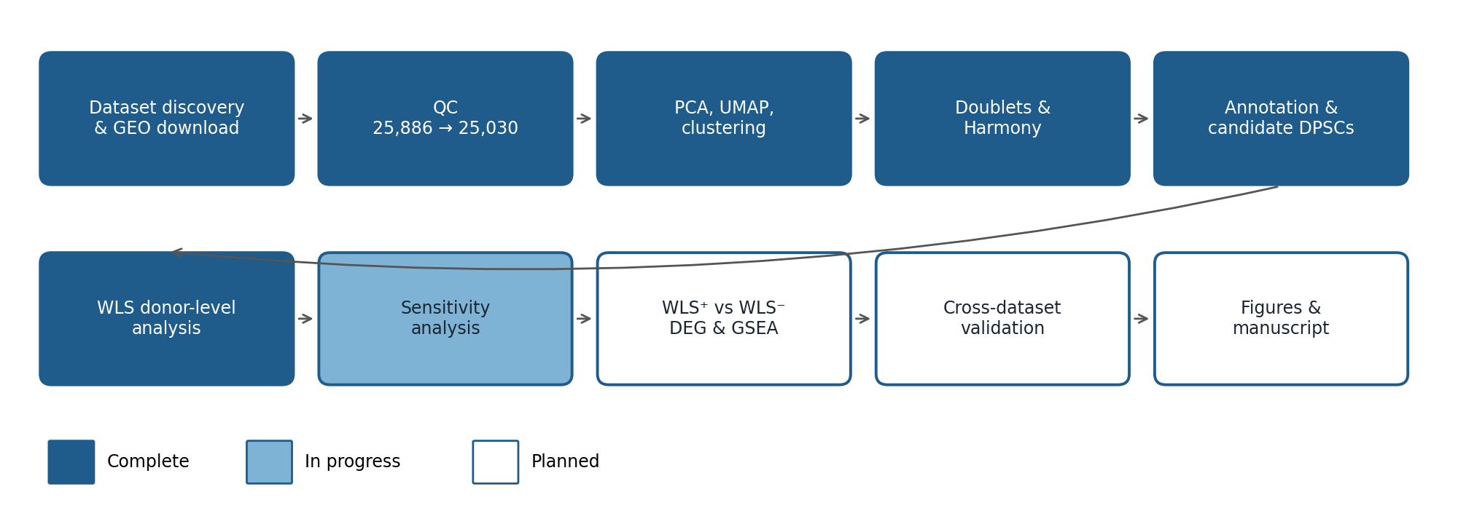
Figure 1. Analysis workflow. Stages 1–6 are complete; the sensitivity analysis is running; differential expression, validation and figures are planned.

3. Methods for this stage

3.1 Doublet detection
Doublets (two cells captured in one droplet) express markers of two cell types and can form artificial clusters. They were identified with scDblFinder, run separately for each donor because doublets can only form within one 10x capture. Cells called as doublets were removed before re-clustering.

3.2 Batch correction
After doublet removal, the data were re-normalised and PCA was recomputed. Harmony was applied to the first 20 principal components with donor as the batch variable, and the neighbour graph, UMAP and Louvain clusters (resolution 0.5) were recomputed on the Harmony embedding. For each cluster, the fraction of cells from its most common donor was calculated before and after integration; clusters above 80% were flagged for review.

3.3 Cell type annotation
Each cell was scored for 14 marker panels covering the cell types expected in human dental pulp (fibroblasts, mesenchymal progenitors, perivascular cells, odontoblasts, endothelial and lymphatic cells, Schwann cells, immune subsets, epithelial cells, erythrocytes and proliferating cells) using Seurat module scores. Each cluster was assigned the panel with the highest mean score; the suggested labels were then reviewed against a marker dot plot and confirmed manually.

3.4 Candidate DPSC definition
Mesenchymal cells (fibroblasts and perivascular cells) were extracted, re-integrated with Harmony and sub-clustered (resolution 0.4). Two separate module scores were calculated: a stem/progenitor score (THY1, NT5E, ENG, NGFR, FRZB, LEPR, PRRX1, CXCL12) and a perivascular score (MCAM, PDGFRB, RGS5, KCNJ8, NOTCH3, ACTA2). Sub-clusters with a positive mean stem score, meaning expression above matched background genes, were defined as candidate DPSCs. The perivascular score was reported alongside but not used for the call, to avoid defining stem cells by perivascular markers.

3.5 WLS quantification and testing
- Per-donor summaries. The percentage of WLS-positive cells and mean normalised expression were computed for each cell group in each donor (groups with at least 20 cells).
- Pseudobulk tests. Counts were summed per donor and cell group. Candidate DPSCs were compared with each other group using edgeR quasi-likelihood models with donor as a blocking factor (design: ~ donor + group), so each comparison is paired within donors.
- Mixed-effects model. Within the mesenchyme, WLS detection in each cell was modelled with logistic regression including a random intercept for donor (lme4).
- Wnt ligand co-expression. For each group, the observed percentage of cells co-expressing WLS and at least one WNT ligand was compared with the percentage expected by chance.

4. Results

4.1 Doublets
Donor | Singlets | Doublets | Doublet %
Pulp1 (GSM4998457) | 4,775 | 346 | 6.8
Pulp2 (GSM4998458) | 5,406 | 395 | 6.8
Pulp3 (GSM4998459) | 5,395 | 440 | 7.5
Pulp4 (GSM4998460) | 3,717 | 253 | 6.4
Pulp5 (GSM4998461) | 4,034 | 269 | 6.3
Total | 23,327 | 1,703 | 6.8
Table 1. Doublets detected by scDblFinder. Rates are even across donors and typical for captures of this size.

4.2 Batch correction
After Harmony integration, the mesenchymal, endothelial and glial clusters drew 27–48% of their cells from their largest donor, indicating good mixing of all five donors. Four small clusters remained donor-biased:
- T/NK cells (cluster 6, 1,435 cells) came entirely from Pulp4 and Pulp5 (61% Pulp5). These two samples also had the highest mitochondrial content during QC. This pattern is more consistent with an immune infiltrate in two of the teeth, for example from inflammation, than with a technical batch effect, and it was therefore not removed.
- Epithelial cells (cluster 14, 87 cells) were 82% from Pulp3, suggesting contamination of one sample.
- Myeloid cluster 13 and plasma cluster 12 were small and leaned towards single donors.
None of these clusters belongs to the mesenchymal compartment, so they do not affect the DPSC comparison.

4.3 Cell types
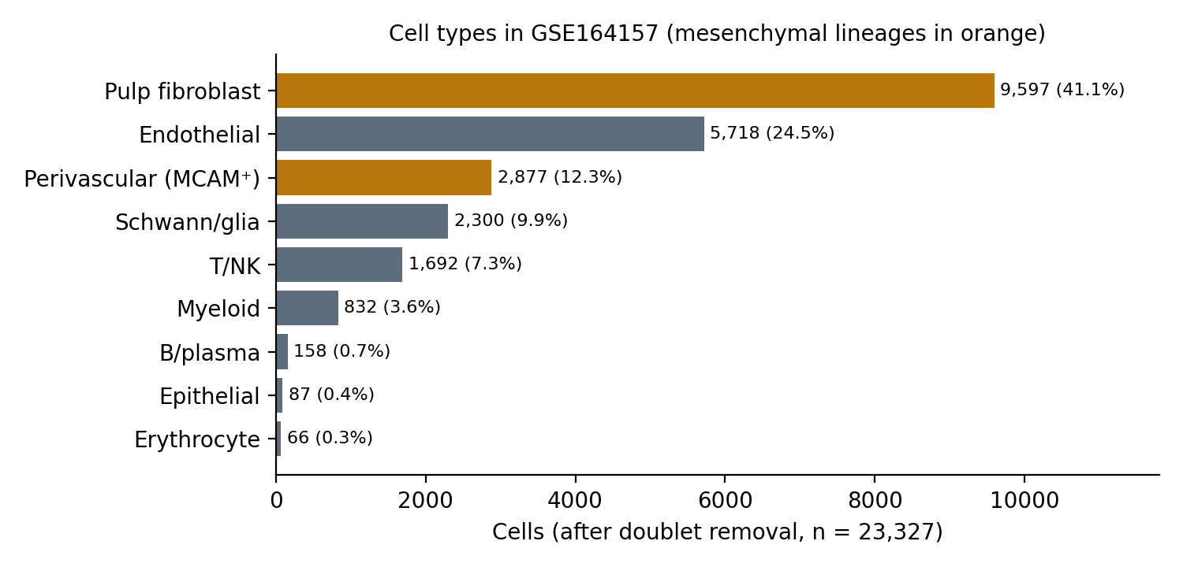
Figure 2. Cell type composition after annotation (23,327 cells).
Cell type | Cells | Clusters and notes
Pulp fibroblast | 9,597 | 0, 1
Endothelial | 5,718 | 2, 3, 10; likely different vessel types
Perivascular (MCAM⁺) | 2,877 | 4, 7; contains the candidate DPSCs
Schwann/glia | 2,300 | 5, 8; likely myelinating and non-myelinating
T/NK | 1,692 | 6, 11; cluster 6 only in Pulp4/Pulp5
Myeloid | 832 | 9, 13
B/plasma | 158 | 12
Epithelial | 87 | 14; mostly one donor, excluded from WLS analysis
Erythrocyte | 66 | 15; excluded from WLS analysis
Table 2. Annotated cell types. All 16 cluster labels had a clear winning marker panel and were confirmed manually. No cluster was assigned to odontoblasts, which are often lost when pulp is extracted, or to lymphatic or mast cells, which are probably too rare to cluster separately.

4.4 Candidate DPSCs
Sub-cluster | Cells | Stem score | Perivascular score | Main type / call
4 | 1,171 | 0.197 | 1.127 | Perivascular, candidate DPSC
2 | 1,489 | 0.099 | 1.065 | Perivascular, candidate DPSC
8 | 187 | 0.035 | 0.619 | Perivascular, candidate DPSC
1 | 2,719 | −0.102 | −0.148 | Fibroblast
5 | 1,108 | −0.109 | −0.270 | Fibroblast
7 | 611 | −0.110 | −0.341 | Fibroblast
0 | 2,823 | −0.141 | −0.381 | Fibroblast
6 | 1,076 | −0.174 | −0.306 | Fibroblast
3 | 1,237 | −0.200 | −0.149 | Fibroblast
9 | 53 | −0.275 | −0.379 | Fibroblast
Table 3. Mesenchymal sub-clusters ranked by stem/progenitor score. Positive scores indicate expression above matched background genes.
Only the three perivascular sub-clusters had stem/progenitor marker expression above background; all seven fibroblast sub-clusters scored below it. The stem scores of the candidates were modest (0.04–0.20) compared with their perivascular scores (0.62–1.13). The candidate DPSCs are therefore best described as perivascular cells with progenitor features. This is consistent with the established view that DPSCs reside in a CD146⁺ perivascular niche, but the population should be reported as candidate perivascular progenitors rather than confirmed stem cells.

4.5 WLS expression by cell type
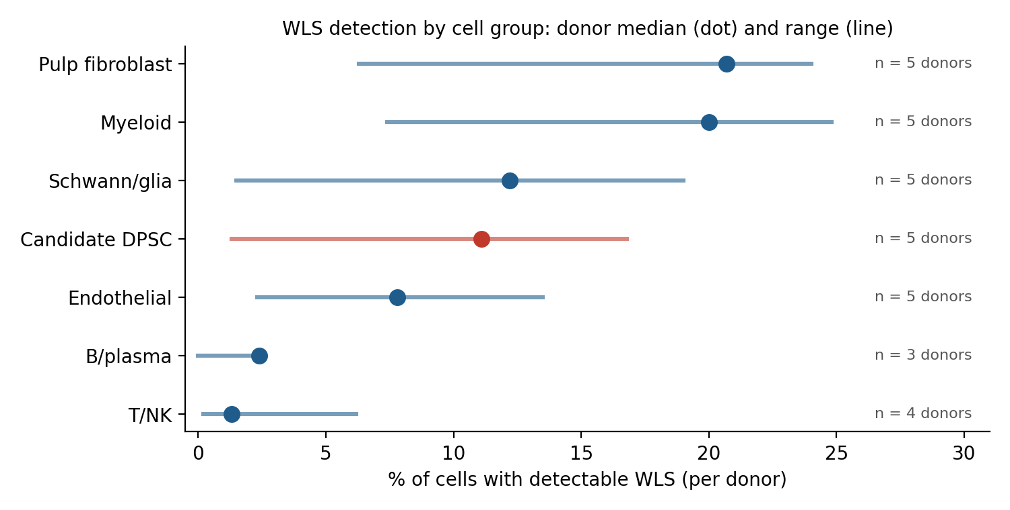
Figure 3. Percentage of WLS-positive cells per donor. Dots show the median across donors and lines the range.
Cell group | Donors | % WLS⁺ (median) | Range across donors | Mean expression
Pulp fibroblast | 5 | 20.7 | 6.3–24.0 | 0.289
Myeloid | 5 | 20.0 | 7.4–24.8 | 0.314
Schwann/glia | 5 | 12.2 | 1.5–19.0 | 0.186
Candidate DPSC | 5 | 11.1 | 1.3–16.8 | 0.151
Endothelial | 5 | 7.8 | 2.3–13.5 | 0.078
B/plasma | 3 | 2.4 | 0–2.5 | 0.034
T/NK | 4 | 1.3 | 0.2–6.2 | 0.043
Table 4. WLS detection by cell group, using donors with at least 20 cells in the group. Mean expression is log-normalised.
WLS was detected in candidate DPSCs in every donor. Detection rates in 10x data understate true expression for moderately expressed genes, because many transcripts are not captured in each cell; the percentages should therefore be read as relative, not as the fraction of cells that truly express WLS.

4.6 Donor-level statistical tests
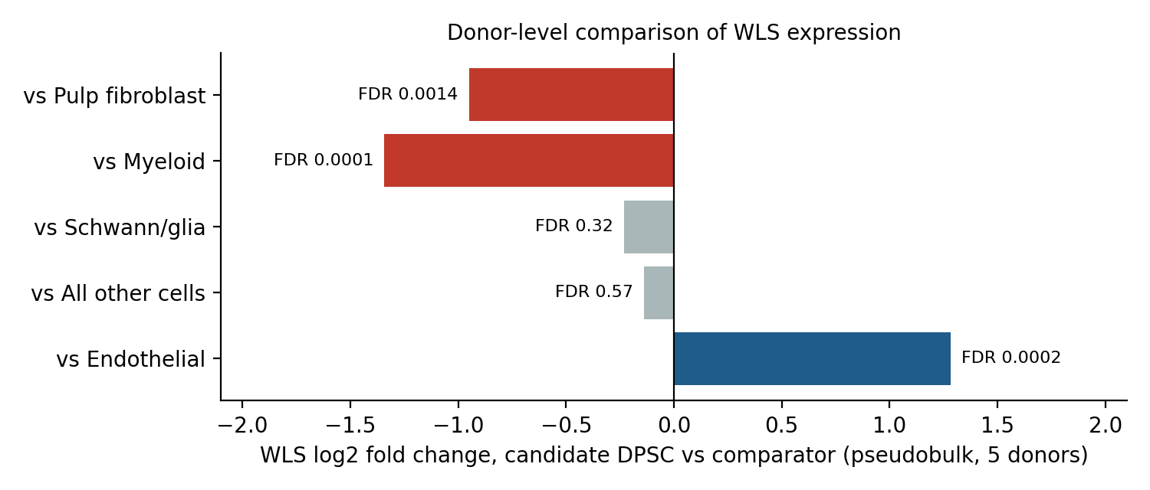
Figure 4. WLS fold change in candidate DPSCs relative to each comparator group, from pseudobulk edgeR models paired within donors.
Comparison | Donors | WLS log2FC | Fold | FDR
Candidate DPSC vs pulp fibroblast | 5 | −0.95 | 1.9× lower | 0.0014
Candidate DPSC vs myeloid | 5 | −1.34 | 2.5× lower | 0.0001
Candidate DPSC vs Schwann/glia | 5 | −0.23 | no difference | 0.32
Candidate DPSC vs all other cells | 5 | −0.14 | no difference | 0.57
Candidate DPSC vs endothelial | 5 | +1.28 | 2.4× higher | 0.0002
Table 5. Pseudobulk edgeR quasi-likelihood tests with donor as a blocking factor. FDR is the genome-wide Benjamini–Hochberg value for WLS within each comparison.
The mixed-effects model gave the same picture within the mesenchyme: candidate DPSCs were less than half as likely as other mesenchymal cells to have detectable WLS (odds ratio 0.43, 95% CI 0.37–0.50). Because this model treats cells as observations, its p-value (4 × 10⁻²⁷) overstates the evidence; the pseudobulk tests are the primary inference and the odds ratio is reported as an effect size.

4.7 Co-expression with WNT ligands
Cell group | % WLS⁺ | % any WNT⁺ | % both | % expected | Ratio
Myeloid | 19.7 | 4.8 | 1.44 | 0.95 | 1.52
Pulp fibroblast | 16.5 | 14.9 | 2.93 | 2.46 | 1.19
Schwann/glia | 13.1 | 6.7 | 1.48 | 0.88 | 1.68
Candidate DPSC | 7.1 | 6.6 | 0.84 | 0.47 | 1.79
Endothelial | 7.1 | 8.1 | 0.98 | 0.57 | 1.72
T/NK | 1.1 | 1.3 | 0 | 0.01 | 0
Table 6. Co-expression of WLS with at least one WNT ligand, compared with the product of the individual frequencies (expected by chance).
In most groups, WLS and WNT ligands were found together 1.2–1.8 times more often than expected by chance, which would fit WLS being active in Wnt-producing cells. Only 0.8% of candidate DPSCs co-expressed both. Because cells with more sequencing depth detect more genes of every kind, part of this enrichment may be technical; a depth-adjusted analysis is included in the sensitivity analysis now running.

5. Interpretation
Three conclusions are supported by the data so far.
- WLS is expressed in candidate human DPSCs. It is detected in the candidate population in all five donors, so the result is reproducible across individuals and not driven by one sample.
- WLS is not specifically enriched in candidate DPSCs. Their WLS level is about the pulp average: lower than pulp fibroblasts and myeloid cells, similar to Schwann cells, and higher than endothelial and lymphoid cells.
- Pulp fibroblasts are the main WLS-expressing mesenchymal population. Given their abundance (41% of all cells) and their high WLS detection, fibroblasts are the most likely source of WLS-dependent Wnt secretion in the pulp mesenchyme, alongside myeloid cells.
If the biological interest is in DPSCs as Wnt-secreting cells, these results suggest that DPSCs contribute but are not the dominant WLS-expressing population in uninjured adult pulp. Whether WLS is induced in DPSCs during culture, injury or differentiation is a separate question that this dataset cannot answer.

6. Limitations
- DPSC definition. The candidate population is defined computationally as perivascular cells with stem-marker enrichment. A different definition could change the comparison; this is being tested now.
- Detection sensitivity. 10x data capture a fraction of transcripts per cell, so WLS-negative cells may still express it at low levels. Pseudobulk tests reduce but do not remove this limitation.
- Donor variability. One donor had WLS in only 1.3% of candidate DPSCs. Two donors also showed immune infiltration and higher mitochondrial content, which may reflect differences in tooth condition. Clinical details of the donors are not yet known.
- Single dataset. All results come from GSE164157 and need confirmation in an independent dataset.
- Tissue, not culture. These are freshly isolated pulp cells. WLS expression in cultured DPSCs, which are often what is meant by DPSCs experimentally, may differ.

7. Next steps
Priority | Action
Running now | Sensitivity analysis: repeat the WLS comparison with three alternative DPSC definitions (top 20% stem score, cells expressing ≥3 stem markers, and MCAM⁺ cells), add depth-adjusted WLS–WNT co-expression, and identify the low-WLS donor.
Short term | Compare WLS⁺ and WLS⁻ cells within the candidate DPSCs and fibroblasts (pseudobulk DEG, GSEA, Wnt pathway module scores).
Short term | Identify which WNT ligands are co-expressed with WLS in each population, and map predicted Wnt senders and receivers (CellChat or NicheNet).
Medium term | Validate in an independent human pulp dataset (GSE161267, Pagella et al. 2021; or GSE202476, Ren et al. 2022) using the same pipeline.
Medium term | Check WLS in cultured hDPSC data (Lee et al. 2022, if the authors share it, or bulk RNA-seq of cultured DPSCs).
Final | Publication-quality figures, methods text and a summary of conclusions.
Table 7. Planned next steps.

8. Questions for Professor Hsu
- Which DPSC definition is most relevant to the lab: the perivascular (CD146⁺) population used here, or a broader progenitor definition? The sensitivity analysis will show how much this matters.
- Is the main interest WLS in DPSCs in uninjured tissue, or WLS in cultured DPSCs? If the latter, the cultured-cell datasets should be prioritised.
- Would a figure focused on pulp fibroblasts as the main WLS-expressing population be useful, given the results above?

Appendix: Reproducibility
Script | Purpose
scripts/04_QC.R | Load, merge and filter the five samples
scripts/05_clustering.R | PCA, UMAP and Louvain clustering
scripts/06a_batch_doublets.R | Batch inspection, scDblFinder, Harmony integration
scripts/06_annotation.R | Module-score annotation, mesenchymal sub-clustering, candidate DPSC call
scripts/07_WLS_expression.R | Per-donor WLS summaries, pseudobulk edgeR, mixed model, co-expression
scripts/07b_WLS_sensitivity.R | Alternative DPSC definitions and depth-adjusted co-expression (running)
data/annotation/cluster_labels.csv | Manually confirmed cluster labels
Table 8. Scripts for the analyses in this report. Package versions are recorded in renv.lock and in each stage's sessionInfo.txt.
Software: R 4.6 with Seurat v5, harmony, scDblFinder, edgeR, lme4 and ggplot2, managed with renv.

