WLS (Gpr177/Wntless) in human dental pulp stem cells
Cross-dataset validation · Md Tariqul Islam, Laboratory of Professor Wei Hsu, ADA Forsyth Institute · October 2026
Question: is Gpr177/Wntless (WLS) expressed in, and enriched in, the DPSC population?
Answer: WLS is expressed in candidate DPSCs in all four datasets (11–70% of cells), but it is enriched in none of them. DPSCs sit at or below the level of surrounding cells, and in pulp tissue the main WLS⁺ mesenchymal cells are fibroblasts.

Results across four datasets
Dataset | Sample | DPSCs | % WLS⁺ DPSC | % WLS⁺ comparison | log2FC | Statistics
GSE164157 | Fresh pulp, 5 donors (discovery) | 2,847 | 11.1 | pulp average | −0.14 | Pseudobulk edgeR, FDR 0.57
GSE202476 | Fresh pulp, 13-year-old, immature third molar | 1,011 | 33.8 | 36.7 | −0.16 | Descriptive, 1 donor (p 0.14)
GSE185222 | Fresh pulp, sound tooth (DTP_01) | 122 | 14.8 | 16.9 | +0.21 | Descriptive, 1 donor (p 0.71)
GSE227731 | Stem cells: DPSCs vs PDLSCs | 2,150 | 69.5 | 83.7 (PDLSC) | −0.72 | Descriptive, 1 library each
log2FC compares candidate DPSCs with all other cells in the same sample (with PDLSCs for GSE227731); positive means higher in DPSCs. Compare DPSCs with other cells within a row only: the share of WLS⁺ cells differs between datasets because of sequencing depth, chemistry and culture.

What the validation shows
- Expressed: WLS is detected in candidate DPSCs in every dataset.
- Not enriched: no dataset shows higher WLS in DPSCs; fold changes range from −0.72 to +0.21, all near zero or negative.
- Fibroblasts lead: in all three pulp tissues, pulp fibroblasts are the top WLS⁺ mesenchymal population (Figure 1).
- Carious teeth agree: in the three carious teeth of GSE185222, DPSCs are never above other cells (6.4–15.4% vs 15.8–24.1%).
- Stem cells: DPSCs have less WLS than PDLSCs, and no DPSC sub-cluster is WLS-high (main sub-clusters 64–80%; one 187-cell sub-cluster is WLS-low at 14%).
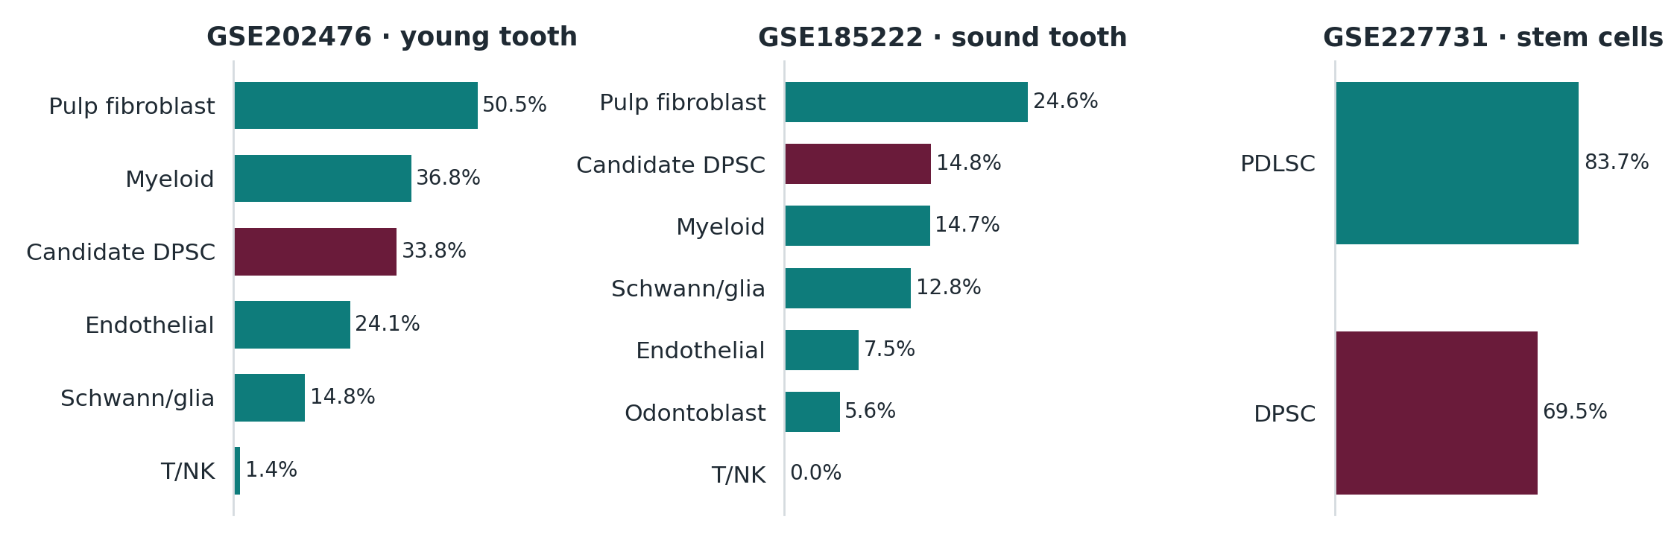
Figure 1. Percentage of WLS⁺ cells by cell type in each validation dataset; candidate DPSCs in burgundy. GSE185222 shows the sound tooth only.
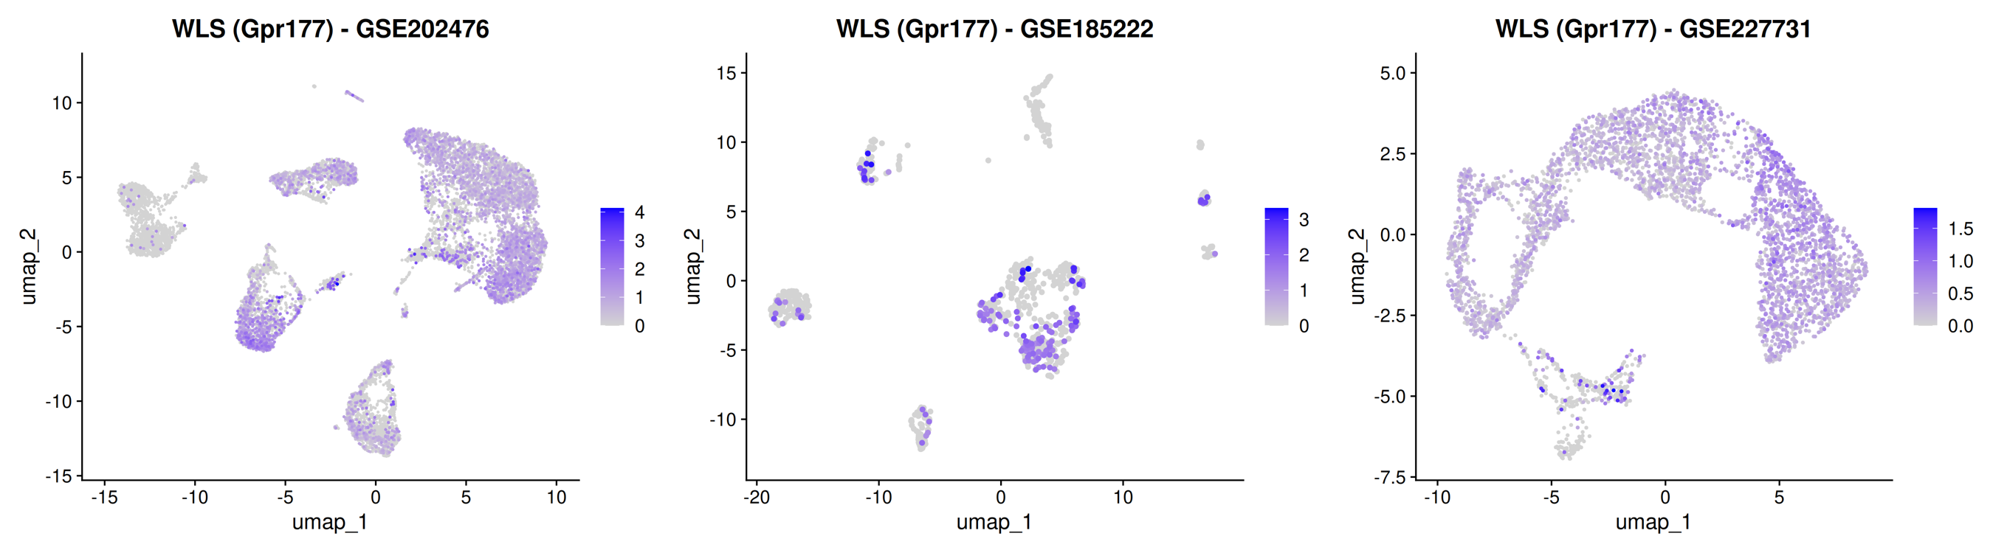
Figure 2. WLS expression on each validation dataset's UMAP (grey = not detected). Left: the dense signal on the right is the fibroblast population.

Methods in brief
Each dataset was processed with the same pipeline as the GSE164157 discovery analysis: QC (more than 200 genes, more than 500 UMIs, less than 20% mitochondrial reads), scDblFinder doublet removal, Harmony integration by sample, and score-based annotation with the same marker panels. Candidate DPSCs (definition A) are mesenchymal sub-clusters, re-clustered with Harmony dims 1–15 at resolution 0.4, whose mean stem/progenitor score (THY1, NT5E, ENG, NGFR, FRZB, LEPR, PRRX1, CXCL12) is above background. Three alternative definitions (top 20% stem score, three or more stem markers, MCAM⁺) gave the same conclusion. Datasets with three or more donors were tested by donor-paired pseudobulk edgeR; datasets with fewer donors are reported descriptively.

Caveats
- The three validation datasets have one donor or library per group, so their p-values are descriptive; only GSE164157 has donor-level statistics.
- DPSCs are defined computationally, by the same rule in every dataset, not by function.
- GSE227731 culture conditions and donor numbers should be confirmed with the authors (Kantarci lab, ADA Forsyth).
- RNA only: no WLS protein or secretion data.
Code and full tables: github.com/mtariqi/dpsc-wls-validation (validation) and github.com/mtariqi/dpsc-wls-human-scRNAseq (discovery).

