A Network-Informed Multi-Omic Framework for Prioritizing Combination-Therapy Hypotheses in Triple-Negative Breast Cancer
Md Tariqul Islam¹*, Sayem Miah²*, Sk Md Mizanur Rahman³, Abdelrahman Desoky⁴
¹Department of Bioinformatics, Northeastern University, Toronto, ON, Canada (islam.mdtar@northeastern.edu)
²Department of Biochemistry and Molecular Biology, University of Arkansas for Medical Sciences, Little Rock, AR, USA (msmiah@uams.edu)
³Information and Communication Engineering Technology (ICET), School of Engineering Technology and Applied Science (SETAS), Centennial College & Sessional Faculty of Laurentian University, Canada
⁴Scired: Scientific Research & Development, USA, and Claflin University, USA
*Corresponding author: Sayem Miah & Md Tariqul Islam

Abstract
Background: Triple-negative breast cancer (TNBC) lacks the actionable single-agent targets available in hormone-receptor-positive or HER2-amplified disease, making rational combination-therapy prioritization a central challenge. We present a network-informed computational framework that integrates real network, functional, clinical, and pharmacological evidence to prioritize kinase targets and generate patient-specific combination-therapy hypotheses.
Results: Using data from The Cancer Genome Atlas (TCGA-BRCA), the Cancer Dependency Map (DepMap), STRING, DGIdb, openFDA FAERS, the Clinical Proteomic Tumor Analysis Consortium (CPTAC), and FunMap, we developed a Composite Target Score (CTS) combining network centrality, functional essentiality, survival association, and druggability across a 90-gene receptor and non-receptor tyrosine kinase (RTK/NRTK) panel, ranking ERBB2, EGFR, and PTK2 among the highest-priority targets. A fully reconstructed, participant-level screening pipeline applied to a PAM50 basal-like TCGA-BRCA cohort identified 192 of 1,087 participants as basal-like, 168 with eligible mutation data, and 18 carrying alterations in at least two candidate drug-mapped panel genes. For an illustrative HER2-mutant focal patient, an independent patient-specific prioritization framework (MDCOE/HCOS) identified afatinib+alpelisib+trastuzumab and afatinib+capivasertib+trastuzumab as tied, highest-ranked regimens — reproduced to floating-point precision across four separate code paths, including a fully independent reconstruction of the core scoring process from raw input data. Independent validation analyses supported key framework design decisions. In DepMap TNBC cell lines, a gene-identity baseline explained substantially more variance in CRISPR dependency than a per-sample multi-omic model (R² = 0.337 versus −0.029), providing empirical justification for CTS's use of cohort-level dependency measures. Comparison of STRING-derived kinase relationships against real CPTAC proteomic correlations identified biologically supported interactions absent from the predicted network, and substitution of FunMap functional-network evidence substantially reordered top-ranked target pairs despite high aggregate rank correlation — together indicating that distinct network representations capture complementary, non-redundant biological information.
Conclusions: We additionally report a self-identified scoring bias affecting a mechanistically distinct TP53-directed hypothesis, alongside a prespecified experimental strategy to evaluate it. All rankings are presented as experimentally testable hypotheses rather than clinical recommendations, with a two-arm wet-lab pilot proposed as the immediate next step toward biological validation.
Keywords: triple-negative breast cancer; combination therapy; receptor tyrosine kinase; network medicine; multi-omics integration; drug repurposing; DepMap; CPTAC

Background
Triple-negative breast cancer (TNBC), defined by the absence of estrogen receptor (ER), progesterone receptor (PR), and HER2 amplification, accounts for approximately 15-20% of breast cancers and is associated with an aggressive clinical course and limited therapeutic options. Unlike other breast cancer subtypes that benefit from well-established single-agent targeted therapies, TNBC remains heavily dependent on combination chemotherapy and, increasingly, genomically informed targeted strategies. Genomically, TNBC is characterized by extensive molecular heterogeneity, with TP53 alterations occurring in more than 80% of tumors. In addition, TNBC frequently harbors co-occurring alterations across receptor tyrosine kinase (RTK) and non-receptor tyrosine kinase (NRTK) families, comprising 56 and 32 genes, respectively, under current classification [1,2]. Many of these kinases are therapeutically actionable through approved or investigational inhibitors; however, the enormous combinatorial space of potential co-targeting strategies renders systematic prioritization difficult. Large-scale genomic analyses further support the importance of kinase signaling in TNBC, identifying RTK-RAS signaling as one of the most recurrently altered oncogenic pathways alongside TP53, TGF-Î², and Hippo pathway dysregulation [32]. Although RTK-RAS alterations are not unique to TNBC and may occur at comparable or higher frequencies in non-TNBC breast cancers [32], their pervasive involvement highlights kinase signaling networks as attractive candidates for therapeutic intervention.
A major limitation of single-agent kinase inhibition is the extensive redundancy and adaptability of cellular signaling networks. Inhibition of one RTK or NRTK is often compensated by parallel, downstream, or feedback-associated kinases, resulting in adaptive resistance and therapeutic failure. Consequently, identifying effective combination therapies for an individual patient's molecular profile requires integrating multiple complementary layers of evidence, including signaling network topology, functional dependency, clinical association, and druggability. Existing resources typically capture only one or two of these dimensions, leaving no unified framework for systematically prioritizing synergistic target combinations.
Compounding this challenge, genomic alterations do not necessarily reflect functional pathway activity. Mutation status, transcript abundance, protein expression, and phosphorylation-derived kinase activity represent distinct and only partially concordant layers of tumor biology. Multi-omic analyses of TNBC models illustrate this disconnect. For example, PTEN-deficient tumors can exhibit unexpectedly reduced PI3K/AKT/mTOR pathway activity and corresponding differences in inhibitor sensitivity, despite their predicted genomic activation state [33]. Such findings underscore the limitations of relying on any single molecular evidence type when evaluating therapeutic targets. Instead, robust prioritization requires an integrative framework capable of capturing complementary aspects of biological relevance. This need motivates the development of the Composite Target Score (CTS), a multi-dimensional framework designed to integrate orthogonal evidence streams into a unified assessment of target and combination-therapy potential.
To address this challenge, we developed the Composite Target Score (CTS), an integrative prioritization framework that combines genomic, network, functional, clinical, and pharmacologic evidence to identify kinase targets and rational inhibitor combinations for precision therapy in TNBC.

1.1 Related Work
The conceptual foundation of this study lies in the network medicine paradigm, which views disease phenotypes and therapeutic responses as emergent properties of perturbations across interconnected molecular networks rather than the consequence of isolated gene defects. BarabÃ¡si et al. formalized this framework by demonstrating how disease-associated genes cluster within discrete regions of the human interactome, thereby providing a systems-level perspective on disease mechanisms and therapeutic targeting [27]. Extending this principle to combination therapy, Cheng et al. showed that clinically effective drug combinations preferentially target distinct yet complementary neighborhoods within a disease module, suggesting that network topology can guide the rational design of synergistic therapeutic strategies [28].
Building on these foundations, recent computational approaches have focused on predicting drug synergy using graph-based representations of biological systems. SynerGNet constructs cancer-specific subnetworks from the human protein-protein interaction network and employs graph neural networks (GNNs) to classify synergistic drug pairs, achieving balanced accuracies of 0.68-0.73 on the AZ-DREAM Challenge benchmark [3]. DeepDDS integrates graph convolutional and attention mechanisms to encode drug molecular structure alongside cell-line transcriptomic profiles, enabling data-driven synergy prediction across multiple cancer contexts [4]. To improve interpretability, SANEpool incorporates attention-based graph pooling techniques that identify the subnetwork features most responsible for a predicted synergistic interaction, addressing a common limitation of earlier deep-learning models [5].
Beyond drug-pair prediction, knowledge-graph approaches have expanded the scope of network medicine by integrating heterogeneous biomedical data sources. DREAMwalk leverages a multilayer graph comprising drug, gene, and disease relationships to improve drug-disease association prediction, with validation that included breast carcinoma case studies [6]. Similarly, recent work has combined large language model-assisted knowledge extraction with multilayer biomedical networks to identify candidate drug combinations for breast cancer repurposing from clinical-trial literature [7]. Collectively, these studies demonstrate the growing utility of network-based inference for therapeutic discovery and prioritization.
Despite these advances, several important gaps remain. Most existing methods are designed either for generalized drug-pair prediction or population-level inference and typically rely on a limited subset of biological evidence. Few approaches integrate patient-specific molecular information across multiple orthogonal dimensions, including genomic alteration status, transcriptomic activity, functional essentiality, clinical outcome association, network context, and therapeutic tractability. Moreover, many frameworks operate on predefined candidate drug pairs rather than systematically prioritizing target combinations across an entire disease cohort.
To address these limitations, we developed an integrative target-prioritization pipeline centered on the Composite Target Score (CTS). The CTS framework combines network topology, functional dependency, clinical relevance, expression evidence, and druggability into a unified scoring system designed to identify therapeutically actionable kinase targets and candidate inhibitor combinations in TNBC. Applying this framework across a PAM50 basal-like cohort (n=192), we evaluate kinase targets through integrated multi-omic data. We systematically report both functional evidence layers and negative feature-selection outcomes—including the deliberate exclusion of intrinsic subtyping and per-sample dependency models—to provide a transparent, reproducible benchmark for computational hypothesis generation in precision oncology.

1.2 Contributions of This Study
The principal contributions of this study are as follows:
- Development of a multi-omic target-prioritization framework. We > developed the Composite Target Score (CTS), a network-informed > scoring framework that integrates network topology, functional > dependency, clinical outcome association, and druggability to > prioritize therapeutic targets within a curated panel of 90 > receptor and non-receptor tyrosine kinase (RTK/NRTK) genes.
- Evidence-driven feature selection and score design. Rather than > aggregating all available molecular features, CTS was constructed > through empirical evaluation of candidate evidence layers, > retaining biologically informative signals while excluding > features that failed to demonstrate sufficient discriminatory > value. This design improves both interpretability and robustness > of target prioritization.
- Systematic therapeutic target prioritization in TNBC. We applied CTS > across a PAM50 basal-like TNBC cohort to identify and rank > candidate therapeutic targets, generating a scalable framework for > precision-oncology target discovery.
- Hierarchical combination-therapy ranking. We extended the CTS > framework to prioritize multi-target intervention strategies > through PairCTS and TripletCTS, enabling systematic evaluation of > candidate two-target and three-target therapeutic combinations > designed to address signaling-network redundancy.
- Translation of prioritized targets into actionable therapeutic > hypotheses. By integrating curated drug-target interaction > resources, we connected prioritized kinase targets to available > pharmacologic agents and generated candidate combination-therapy > hypotheses suitable for future preclinical and clinical > investigation.
- Independent patient-specific prioritization. Separately from CTS/PairCTS/TripletCTS, we developed MDCOE/HCOS, a structurally distinct patient-level search heuristic that ranks individualized drug regimens against a given patient's genomic alterations; we demonstrate that its regimen rankings are bit-identical across four independent implementations.
- Functional validation of the essentiality component. We rigorously > assessed CTS essentiality scoring using DepMap dependency data and > demonstrated that cohort-level dependency measures provide a more > reliable prioritization signal than per-sample predictive modeling > approaches.
- Orthogonal proteomic validation of network-derived interactions. > Using CPTAC proteomic data, we independently evaluated > STRING-derived crosstalk assumptions and identified biologically > supported interactions that were absent from the underlying STRING > network, strengthening confidence in the proposed signaling > relationships.
- Evaluation of alternative network representations. We incorporated > FunMap as an alternative functional-network resource and > demonstrated that, despite high overall rank concordance, > substantial reordering of PairCTS predictions occurred, suggesting > that complementary biological information can be captured through > alternative network models.
- Transparent assessment of methodological limitations. Consistent > with best practices in computational oncology, we explicitly > report identified scoring biases, classification challenges, > feature-selection outcomes, and corrective methodologies, > providing a transparent account of both the strengths and > limitations of the proposed framework.
One conceptual distinction is worth stating explicitly before the Results: CTS, PairCTS, and TripletCTS operate at the cohort level, ranking targets and drug combinations across the full 90-kinase panel independently of any single patient's genotype; MDCOE/HCOS operates downstream, at the level of one patient's specific alterations, and is not built on top of the cohort-level scores. The two frameworks are evaluated in different Results subsections (cohort-level: 4.1, 4.7-4.9; patient-level: 4.3-4.4) and are described in full in Methods (Sections 2.2-2.4 and 2.5, respectively).

Results
This section presents the principal findings of the study. We first report kinase prioritization using the Composite Target Score (CTS) framework (Section 4.1), followed by cohort-scale screening of PAM50 basal-like breast cancers (Section 4.2). We then present a representative patient-specific therapeutic prioritization case and its independent reproducibility assessment (Sections 4.3-4.4). Subsequent sections evaluate key methodological assumptions through DepMap dependency modeling, CPTAC proteomic cross-validation, and alternative network integration using FunMap (Sections 4.5-4.7). Finally, we report findings related to HCOS scoring behavior and data-integrity verification conducted during execution of the framework on production datasets (Sections 4.8-4.9).
Figure 1 provides an overview of the complete study workflow. Two independent analytical systems operate on this data in parallel rather than in sequence: CTS and its extensions (PairCTS, TripletCTS) transform the multi-omic evidence layer into cohort-wide target and combination rankings across the full kinase panel, while MDCOE/HCOS separately ranks patient-specific regimens against an individual patient's genomic alterations; HCOS is not derived from, and does not build upon, CTS-level scores. Independent validation analyses assessing network structure, dependency modeling, proteomic concordance, and reproducibility are performed in parallel and reported throughout Section 4.
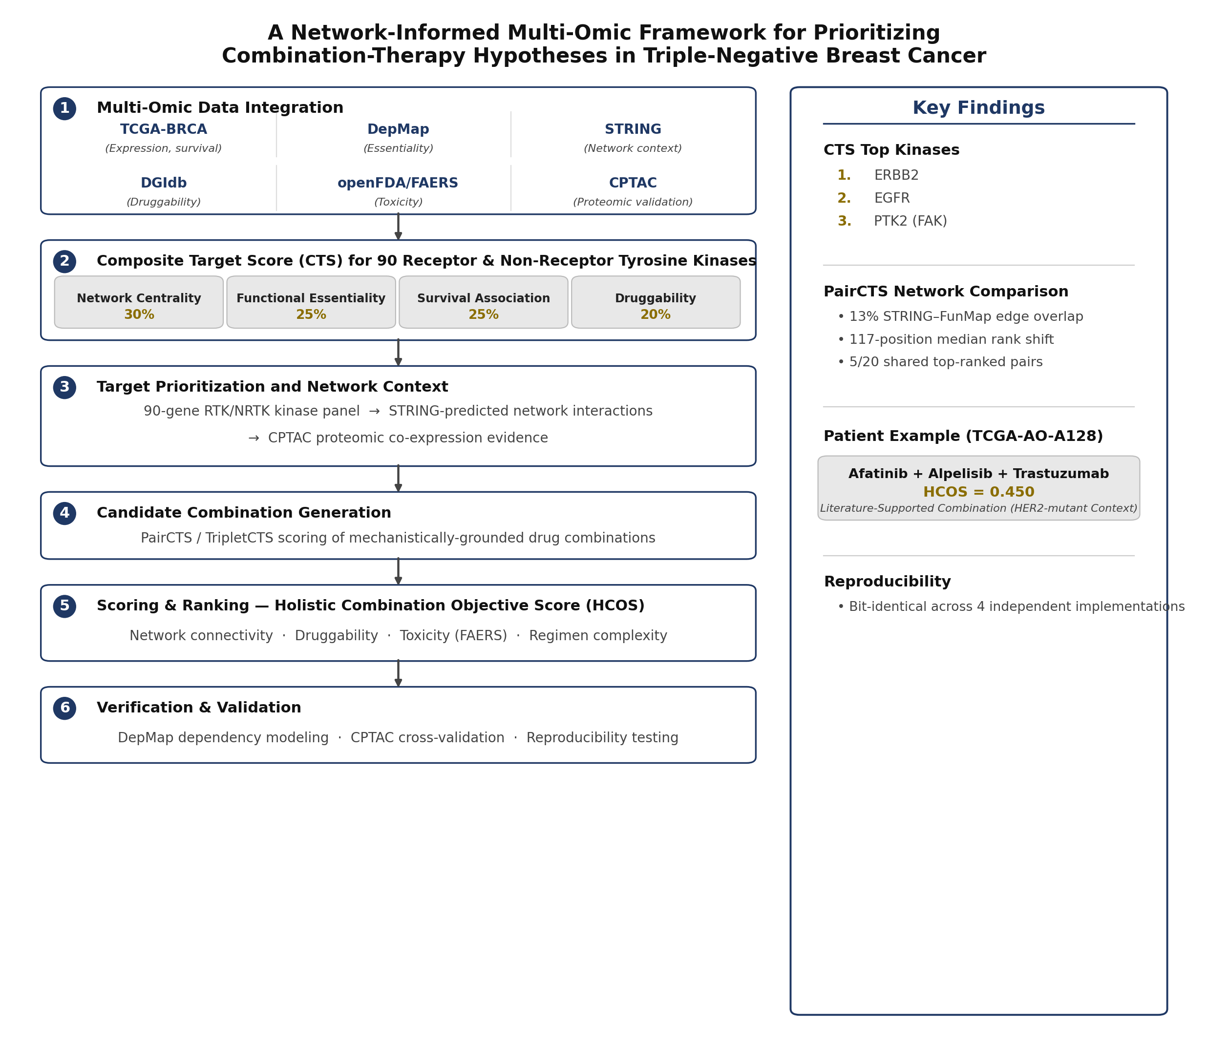
Figure 1. Study design and multi-omic prioritization framework. Real data from TCGA-BRCA, DepMap, STRING, DGIdb, openFDA/FAERS, and CPTAC are integrated into a Composite Target Score (CTS) for 90 receptor and non-receptor tyrosine kinases, characterized by network context and proteomic evidence, and assembled into cohort-wide candidate combinations (PairCTS/TripletCTS). In parallel, and independently of these cohort-level scores, patient-specific regimens are scored and ranked by the Holistic Combination Objective Score (HCOS). Both branches are verified through cross-checked validation and reproducibility testing. Right panel: key quantitative findings from Sections 4.1, 4.3, and 4.7.

4.1 CTS-Based Kinase Prioritization
Composite Target Scores were calculated for all 90 kinases in the curated RTK/NRTK reference panel using independent evidence from STRING, DepMap, TCGA-BRCA, and DGIdb. The highest-ranked targets were ERBB2, EGFR, and PTK2 (FAK), indicating strong combined support across network topology, functional dependency, clinical association, and druggability dimensions.
ERBB2 achieved the highest overall CTS (0.690), reflecting consistent support from all four evidence layers. Specifically, ERBB2 exhibited high network centrality within the STRING interactome, remained a stable hub across all network reconstructions evaluated in the FunMap comparison (Section 4.7), demonstrated functional importance in DepMap dependency analyses, showed a measurable survival association within TCGA-BRCA, and possessed extensive therapeutic tractability through multiple DGIdb-recorded drug interactions. Importantly, each component contributing to the ERBB2 score is independently traceable to its original data source, ensuring full interpretability of the ranking.
Similarly, EGFR ranked highly due to strong support across multiple evidence layers, while PTK2 emerged as a prominent candidate despite comparatively limited clinical development. PTK2's high ranking was independently reinforced by its DepMap essentiality profile, providing cross-validation between the network- and dependency-based components of the CTS framework.
Collectively, these findings demonstrate that CTS preferentially prioritizes kinases supported by convergent evidence streams rather than by any single dominant data source.

4.1.1 Translational Mapping and Drug Repurposing Opportunities
To translate target prioritization into actionable therapeutic hypotheses, CTS-ranked kinases were mapped to curated drug-target interactions obtained from DGIdb. Several top-ranked kinases were associated with approved targeted therapies, supporting the translational relevance of the prioritization framework.
Among the highest-ranked candidates, ERBB2 was linked to established HER2-directed agents including trastuzumab, lapatinib, and neratinib, while EGFR was associated with clinically approved EGFR inhibitors such as gefitinib, erlotinib, and afatinib. Additional highly ranked kinases, including FGFR1 and IGF1R, were similarly connected to existing therapeutic compounds. In contrast, PTK2 was primarily associated with investigational inhibitors, including PF-562271, GSK-2256098, and VS-4718, highlighting the distinction between biological prioritization and clinical maturity.
These results illustrate how CTS can function as a bridge between molecular target identification and therapeutic hypothesis generation. However, prioritization within CTS should not be interpreted as evidence of clinical efficacy. Rather, the framework identifies biologically plausible candidates that may warrant further experimental or translational investigation.

Kinase | CTS | Candidate drug(s) (DGIdb)
ERBB2 | 0.690 | lapatinib, trastuzumab, neratinib
EGFR | 0.613 | gefitinib, erlotinib, afatinib
PTK2 | 0.532 | PF-562271, GSK-2256098, VS-4718 (investigational)
FGFR1 | 0.465 | infigratinib, dovitinib, nintedanib esylate
IGF1R | 0.449 | linsitinib, ganitumab, cixutumumab

4.2 Cohort-Scale PAM50 Basal-Like Screening
Application of the predefined screening pipeline to TCGA-BRCA identified 1,087 unique participants represented within the molecular-subtype annotation dataset. Of these, 192 individuals were classified as PAM50 basal-like. Intersection with available somatic mutation data yielded 168 participants with complete eligibility for downstream genomic analysis.
Restricting analysis to protein-altering variants within the 90-gene RTK/NRTK panel revealed that 18 participants carried alterations in at least two candidate drug-mapped kinase genes. Sensitivity analyses conducted across alternative mutation-count thresholds confirmed that this result was not driven by a single parameter choice (Supplementary Table S2).
Importantly, participant membership at every stage of cohort construction was reproduced from the frozen pipeline and independently verified against archived participant-level records. These findings establish a reproducible subset of basal-like breast cancers enriched for potentially targetable kinase alterations suitable for downstream therapeutic-prioritization analyses.
Figure 2 summarizes the cohort-selection workflow.

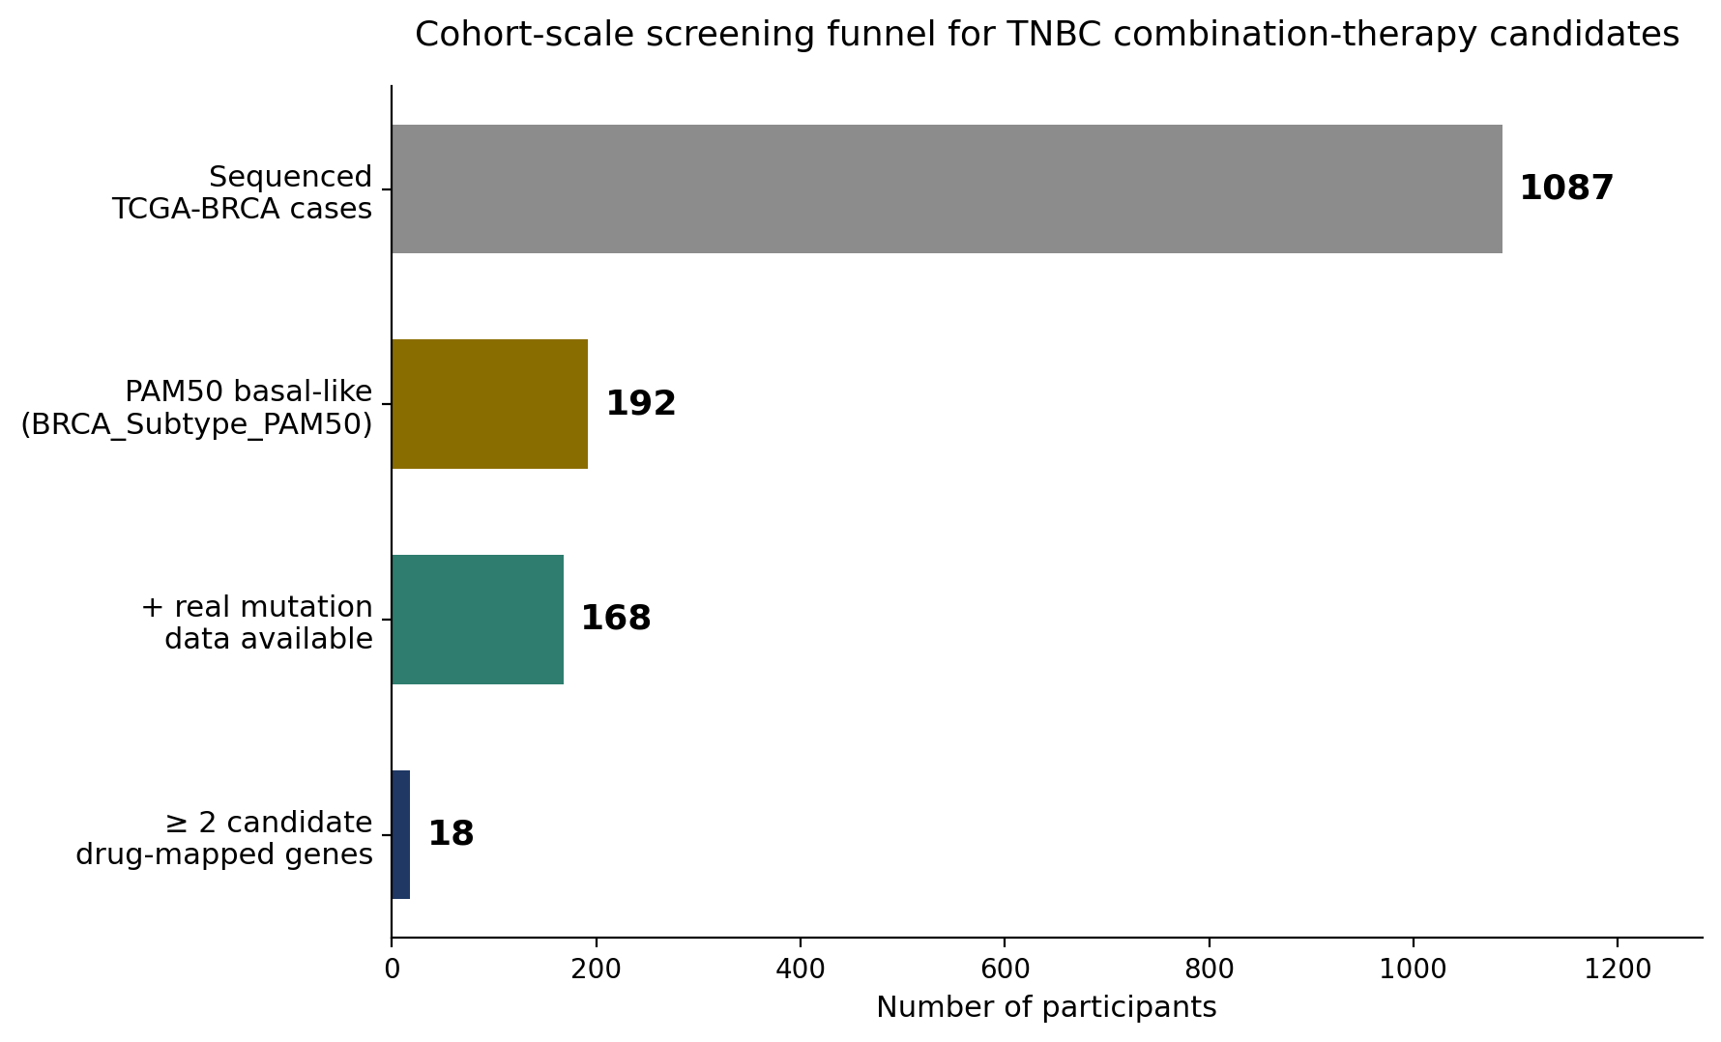
Figure 2. Reproducible TCGA-BRCA cohort-screening funnel. Of 1,087 participants represented in the molecular-subtype annotation, 192 were classified as PAM50 basal-like. Intersection with deduplicated primary-tumour GDC ensemble mutation data retained 168 participants, of whom 18 carried eligible protein-altering variants in at least two unique candidate drug-mapped genes from the 90-gene RTK/NRTK panel.

4.3 Representative Patient Case: Reproducible Generation of Therapeutic Hypotheses
To illustrate patient-level application of the framework, we evaluated an individual participant from the candidate drug-mapped cohort (TCGA-AO-A128). This participant carried alterations in eleven kinase-panel genes, six of which had documented drug-target mappings (EGFR, PTEN, FLT1, TP53, ERBB2, and TYK2).
Application of the MDCOE beam-search algorithm identified two top-scoring three-drug regimens with identical HCOS values (0.450):
- Afatinib + Alpelisib + Trastuzumab
- Afatinib + Capivasertib + Trastuzumab
Both regimens combine EGFR-directed inhibition with HER2-directed therapy and targeting of the PI3K/AKT signaling axis implicated by PTEN loss. The equivalent HCOS values indicate that the current scoring framework assigns comparable value to PI3K- and AKT-directed interventions within this genomic context.
Notably, the ERBB2 alteration identified in this patient was a missense activating mutation without HER2 amplification. Consequently, the patient remained within the PAM50 basal-like cohort and would not traditionally be classified as HER2-positive breast cancer. This observation is nonetheless consistent with previous studies investigating HER2-directed therapies in HER2-mutant, non-amplified tumors, including the SUMMIT basket-trial framework [8].
Beyond the top-ranked regimens, an independent therapeutic hypothesis emerged from TP53-focused analysis. After nonsense-mediated-decay-aware interpretation of the patient's TP53 truncating mutation, a mechanistically distinct combination involving adavosertib (WEE1 inhibition) and venetoclax (BCL-2 inhibition) was identified. This hypothesis was motivated by prior evidence supporting WEE1 inhibition in TP53-deficient cellular contexts [11,12].
Importantly, PTEN loss was interpreted conservatively as genomic evidence supporting potential vulnerability of the PI3K/AKT pathway rather than direct evidence of pathway activation. This distinction is supported by prior multi-omic studies demonstrating that PTEN-deficient TNBC models can exhibit lower-than-expected PI3K/AKT/mTOR signaling activity despite genomic PTEN loss [33].

Rank | Regimen | Mechanistic rationale | HCOS
1 (tied) | Afatinib + Alpelisib + Trastuzumab | EGFR + PI3K (PTEN loss) + HER2-directed | 0.450
1 (tied) | Afatinib + Capivasertib + Trastuzumab | EGFR + AKT (PTEN loss) + HER2-directed | 0.450
Lower (qualitative) | Adavosertib + Venetoclax | WEE1i + BCL-2i, via NMD-aware TP53 resolution | Not directly comparable — see Section 4.8
The tied top-ranking regimens reflect equivalent pathway coverage under the current HCOS formulation rather than evidence of identical biological efficacy. The TP53-directed strategy represents an orthogonal mechanistic hypothesis and is therefore not directly comparable using the same scoring scale.
A comprehensive code audit confirmed that these patient-specific recommendations were generated independently by the MDCOE/HCOS framework rather than by the CTS, PairCTS, or TripletCTS ranking system. CTS-based analyses provide cohort-level target prioritization, whereas MDCOE performs individualized regimen optimization using pathway-level evidence, curated synergy information, target complementarity, and toxicity-overlap assessment. The two frameworks are therefore complementary rather than interchangeable, and results are attributed accordingly throughout this study.
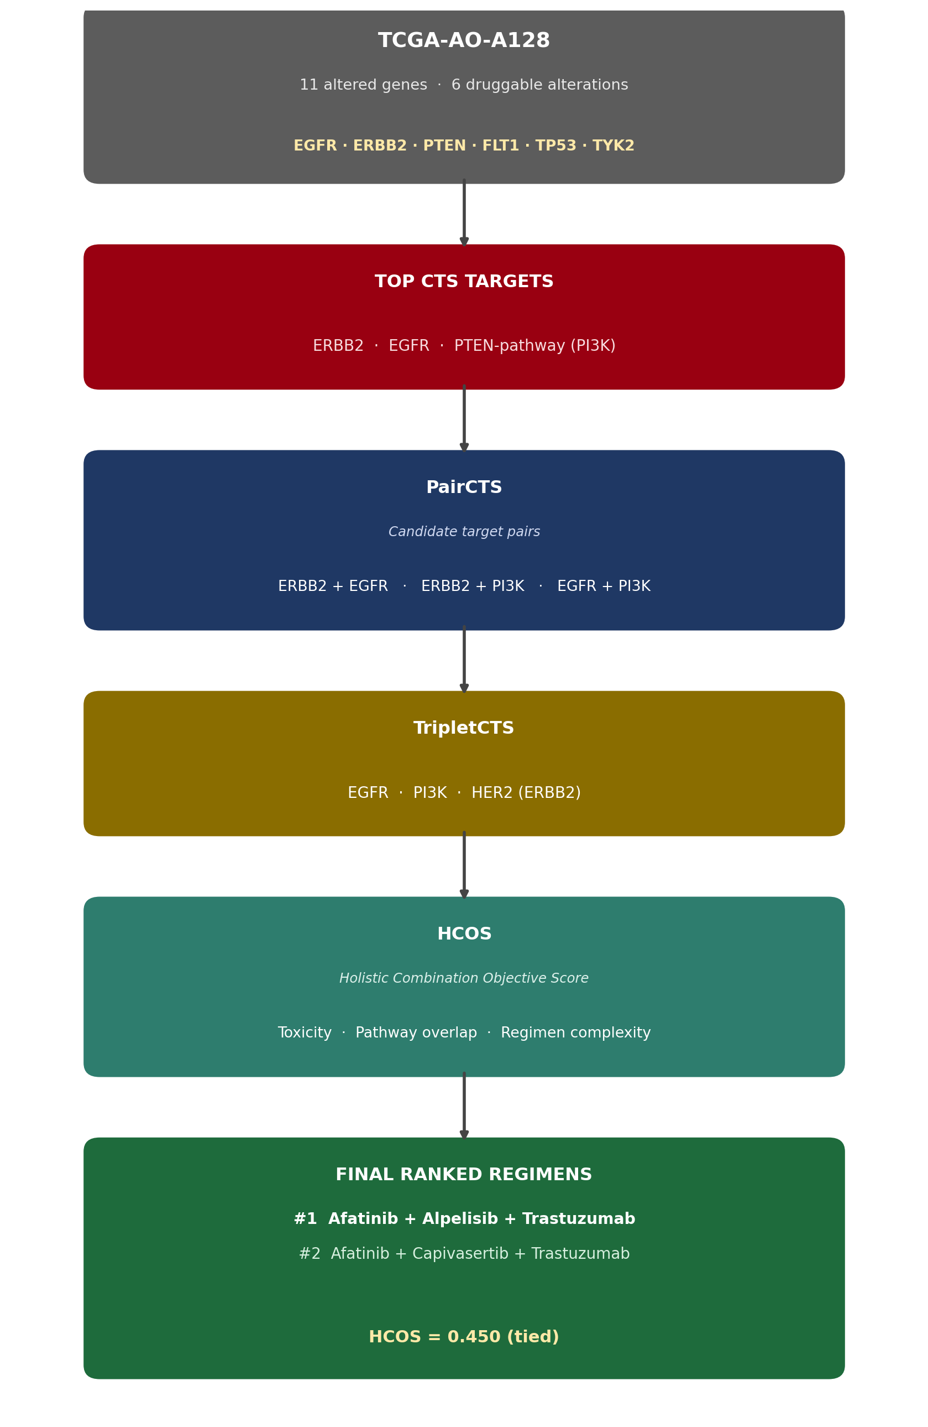
Figure 3. Focal patient prioritization workflow (TCGA-AO-A128) via MDCOE's patient-specific heuristic: patient alterations are matched against curated gene-pathway categories and RTK/intracellular-kinase complementarity rules, combined with a literature-derived synergy-boost lookup and toxicity-overlap penalty, to rank the final regimens shown. This is a separate framework from the cohort-wide CTS/PairCTS/TripletCTS pipeline in Sections 2.2–2.5 and 4.1/4.7/4.9.

4.4 Independent Reproducibility
To assess computational reproducibility, the patient-specific regimen-ranking result reported in Section 4.3 was independently reproduced across four separate implementations of the analytical framework. These consisted of: (i) the original MDCOE beam-search algorithm, (ii) an independent cohort-wide regimen-analysis workflow, (iii) a packaged production distribution with a standalone command-line interface, and (iv) a de novo reconstruction of the scoring procedure derived directly from the underlying STRING, DepMap, DGIdb, and kinase-panel source datasets.
All four implementations converged on the same highest-ranked regimen and produced numerically identical scores to floating-point precision (HCOS = 0.450), demonstrating that the result was not dependent on a specific software implementation, execution environment, or analysis pathway. This agreement provides strong evidence that the reported recommendation is reproducible and reflects the underlying scoring framework rather than implementation-specific behavior.
Importantly, the independently reconstructed pipeline reproduced the result using only the original source data and documented scoring definitions, providing an additional safeguard against hidden dependencies, undocumented assumptions, or software-specific artifacts. Collectively, these findings support the computational robustness of the patient-specific prioritization framework and establish the focal-patient result as a reproducible output of the underlying methodology rather than a consequence of a single analytical implementation.
Key reproducibility outcome:

Independent implementation | Top-ranked regimen reproduced | HCOS reproduced
Original MDCOE beam search | Yes | 0.450
Cohort-wide regimen analysis pipeline | Yes | 0.450
Packaged production CLI distribution | Yes | 0.450
Independent reconstruction from raw source data | Yes | 0.450
his complete concordance across four independent execution paths provides strong evidence of analytical reproducibility and implementation-level robustness.

4.5 Validation of CTS Essentiality Scoring
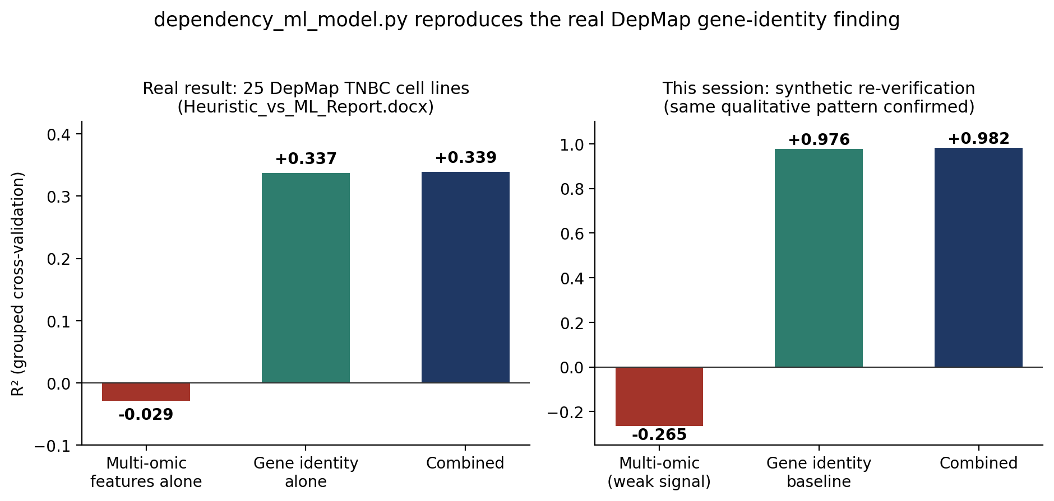
Figure 4. Real DepMap dependency finding (left, from 25 confirmed-TNBC cell lines) and an independent synthetic re-verification of the same qualitative pattern (right). Gene identity dominates over per-sample multi-omic features in both.
Gene identity alone (R² = 0.337) substantially outperformed per-sample multi-omic features alone (R² = −0.029) in predicting CRISPR dependency, and a combined model added negligible further improvement (R² = 0.339). This directly supports CTS's design choice of using mean DepMap dependency, rather than a per-sample predictive model, for the essentiality component. Although 34 TNBC cell lines were initially identified via subtype-label matching, only 25 possessed complete dependency-label data required for model fitting and evaluation; this comparison was independently re-derived from raw DepMap files as part of this verification process, confirming both the real provenance of the 25-line cohort and the reported R² values to within reproducibility-level precision (0.3368 and −0.0299).

4.6 CPTAC-STRING Crosstalk Cross-Validation
To assess whether STRING-derived crosstalk relationships reflected real biological coordination, predicted network edges were compared with measured protein-level correlations in the CPTAC breast cancer proteomics cohort. Among 276 RTK/NRTK protein pairs tested, 107 exhibited significant correlation after false-discovery-rate correction (FDR < 0.05). Of these, 44 pairs (41.1%) corresponded to an existing STRING interaction, providing independent proteomic support for a substantial subset of the network relationships incorporated into the CTS framework.
Notably, 63 significant protein-protein correlations were not represented by a corresponding STRING edge, indicating that biologically relevant relationships may exist beyond the interactions captured within the current STRING network. Among these, the ERBB3-ABL1 correlation emerged as one of the strongest observations (r = 0.506, p = 3.31 Ã— 10â»Â¹Â¹, FDR = 8.60 Ã— 10â»Â¹â°), ranking fourth overall by absolute correlation coefficient behind JAK3-LYN (r = 0.595), BTK-JAK3 (r = 0.569), and BTK-PTK2B (r = 0.541).
To determine whether ERBB3-ABL1 represented a potentially novel finding or a limitation of STRING coverage, an independent literature review was performed. Published evidence confirms that ERBB3 signaling can interact with ABL-family kinases, with ERBB3 downstream signaling reported to engage multiple partners including SRC, ABL, rasGAP, and SYK [13]. This finding suggests that the observed CPTAC correlation reflects a biologically plausible signaling relationship rather than a statistical artifact. More broadly, it demonstrates that experimentally supported kinase interactions may be absent from the STRING-derived network used in the CTS crosstalk component.
Taken together, these results support two conclusions. First, a substantial fraction of STRING-predicted interactions are independently corroborated by proteomic evidence. Second, biologically meaningful kinase relationships also exist outside the STRING network, indicating that alternative functional-network resources may provide complementary information. These observations directly motivated the comparative evaluation of STRING and FunMap reported in Section 4.7.
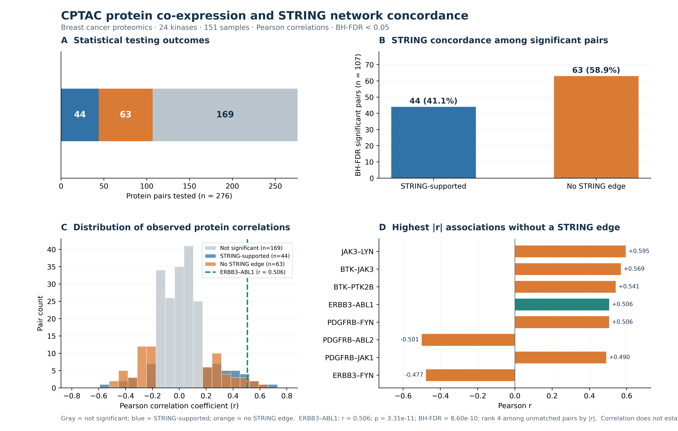
Figure 5. CPTAC proteomic cross-validation of STRING-predicted crosstalk. Of 107 statistically significant RTK/NRTK correlations (FDR < 0.05) identified among 276 tested protein pairs in the CPTAC cohort, 44 (41.1%) matched an existing STRING edge. Among the 63 significant correlations absent from STRING, ERBB3↔ABL1 (r = 0.506, FDR = 8.60×10⁻¹⁰) ranked fourth by |r| yet remains independently supported by prior literature, indicating that measured proteomic relationships and curated interaction networks capture partly distinct biological information.

4.7 FunMap-STRING Pairwise Network Comparison
FunMap provided substantially broader coverage of the 90-gene RTK/NRTK panel than STRING, identifying 3,081 kinase-pair relationships (77.0% of all possible pairs) compared with 464 STRING interactions (11.6%). Despite describing many of the same genes, the two networks exhibited remarkably limited direct agreement: only 394 edges were shared among the 3,151 unique edges present across the combined network set (13.0% overlap). This overlap is lower than that observed in the CPTAC-STRING proteomic comparison (Section 4.6), further suggesting that STRING and FunMap capture partially distinct aspects of biological connectivity rather than representing redundant views of the same underlying network.
To evaluate the practical impact of these network differences, PairCTS rankings were recalculated using STRING-only, FunMap-only, and combined-network crosstalk scores. At a global level, the resulting rankings appeared highly concordant, with Spearman rank correlations ranging from Ï = 0.93 to 0.98 across all 1,770 candidate drug pairs. However, this apparent agreement was largely driven by the stability of lower-priority candidates and masked substantial changes among the highest-ranked combinations.
When individual rankings were examined directly, the median shift between the STRING-only and FunMap-only models was 117 positions, and 75.6% of candidate drug pairs moved by more than 50 ranks. Most notably, only 5 of the top 20 ranked drug pairs were shared between the two models (Jaccard similarity = 0.143), indicating extensive reordering within the subset of candidates most relevant for downstream therapeutic prioritization.
These findings demonstrate that high global rank correlation does not imply functional equivalence between network sources. Instead, STRING and FunMap generate materially different prioritization outcomes at the top of the ranking, where candidate selection decisions are ultimately made. Combined with the low edge overlap observed between the two networks and the CPTAC-supported evidence for biologically relevant interactions absent from STRING (Section 4.6), these results suggest that FunMap contributes complementary biological information that may enhance network-based target prioritization beyond conventional protein-protein interaction resources alone.
Because this analysis was exploratory, formal statistical testing of the observed rank reordering, such as permutation-based comparison against a null distribution of random rank shifts, was not performed. Consequently, the magnitude and significance of the observed top-rank divergence should be interpreted as descriptive rather than inferential and warrants further investigation in future work.
Comparison | Spearman ρ | Median rank shift | Pairs moved >50 ranks | Top-20 overlap (Jaccard)
Model 1 vs Model 2 (STRING vs FunMap) | 0.925 | 117.0 | 75.6% | 5/20 (0.143)
Model 1 vs Model 3 (STRING vs Combined) | 0.972 | 66.5 | 58.7% | 13/20 (0.481)
Model 2 vs Model 3 (FunMap vs Combined) | 0.984 | 54.0 | 52.7% | 11/20 (0.379)

4.7.1 Hub-Bias Analysis and Identification of Network-Specific Drivers
To evaluate whether PairCTS rankings were disproportionately driven by a small number of highly connected kinases, we quantified the frequency with which individual targets appeared in winning target pairs across the STRING-only, FunMap-only, and combined-network models. This analysis identified ERBB2 as the dominant hub in all three models, accounting for approximately 24-27% of all winning-pair appearances. The remarkable stability of ERBB2's representation across independently constructed network models supports its interpretation as a genuine biological hub rather than a network-specific artifact; if the observed prominence reflected model bias alone, substantially greater variation between STRING- and FunMap-derived rankings would be expected.
In contrast, several kinases displayed marked network-dependent behavior. Most notably, YES1 emerged as the second most frequent winning hub under the FunMap-only model (564 appearances) while failing to rank among the top five hubs under STRING-based scoring. This divergence provides a concrete example of how alternative network representations can alter therapeutic prioritization despite high overall rank concordance.
Importantly, FunMap's elevation of YES1 is supported by independent biological evidence. YES1 has been reported to directly interact with and regulate ERBB2/HER2 signaling [16], to contribute to trastuzumab resistance in HER2-driven breast cancer models [17], and to function as a TNBC-relevant oncogenic driver that may be therapeutically exploitable in combination with taxane-based therapies [18]. These observations are particularly noteworthy because trastuzumab forms part of the highest-ranked patient-specific regimen identified in Section 4.3, while taxane-class agents are represented among the candidate drugs associated with the kinase panel.
Taken together, these findings suggest that FunMap is not merely providing additional network density but is contributing biologically meaningful information capable of elevating clinically relevant targets that receive comparatively little emphasis within STRING. The identification of YES1 as a prominent FunMap-derived hub therefore represents a specific, literature-supported example of complementary network knowledge influencing PairCTS prioritization and supports the broader conclusion that integrating alternative functional-network resources may improve discovery of therapeutically relevant signaling dependencies.
The top-15 redundancy-penalized pairs under each model, shown side by side below, illustrate this reordering directly.
Rank | Model 1 (STRING) | Model 2 (FunMap) | Model 3 (Combined)
1 | adavosertib + defactinib | duligotuzumab + tesevatinib | adavosertib + defactinib
2 | duligotuzumab + nintedanib esylate | duligotuzumab + sotrastaurin | crizotinib + duligotuzumab
3 | duligotuzumab + palifermin | adavosertib + defactinib | nintedanib esylate + sotrastaurin
4 | duligotuzumab + paclitaxel protein-bound | crizotinib + duligotuzumab | duligotuzumab + paclitaxel protein-bound
5 | altiratinib + metatinib | glesatinib + sotrastaurin | duligotuzumab + nintedanib esylate
6 | brigatinib + paclitaxel protein-bound | axitinib + sitravatinib | brigatinib + paclitaxel protein-bound
7 | alpelisib + capivasertib | nintedanib esylate + sotrastaurin | palifermin + sitravatinib
8 | glesatinib + regorafenib | ibrutinib + palifermin | mivavotinib + palifermin
9 | glesatinib + sorafenib | nintedanib esylate + pexidartinib | lorlatinib + mivavotinib
10 | palifermin + sitravatinib | palifermin + pexidartinib | lorlatinib + sitravatinib
11 | lorlatinib + sitravatinib | duligotuzumab + paclitaxel protein-bound | altiratinib + metatinib
12 | alpelisib + epirubicin | brigatinib + paclitaxel protein-bound | alpelisib + capivasertib
13 | ganitumab + mecasermin | lorlatinib + mivavotinib | alpelisib + epirubicin
14 | midostaurin + regorafenib | mivavotinib + palifermin | palifermin + sotrastaurin
15 | capivasertib + epirubicin | palifermin + sotrastaurin | infigratinib + sotrastaurin
Only three pairs achieve top-15 consensus across all three independently-weighted models, shown below, directly identifying which candidates are robust to network-source choice rather than artifacts of any single network.
Consensus pair | Rank (Model 1) | Rank (Model 2) | Rank (Model 3)
adavosertib + defactinib | 1 | 3 | 1
duligotuzumab + paclitaxel protein-bound | 4 | 11 | 4
brigatinib + paclitaxel protein-bound | 6 | 12 | 6

4.8 HCOS Bias and Prioritization Effects
Analysis of the HCOS scoring framework identified a potential prioritization bias that may favor regimens targeting closely related signaling programs while disadvantaging mechanistically distinct therapeutic hypotheses. This effect was observed in the focal-patient analysis (Section 4.3), where the TP53-directed combination adavosertib plus venetoclax ranked below the top-scoring EGFR/PTEN/ERBB2-directed regimens despite a biologically plausible rationale supported by the literature.
Inspection of the HCOS components (Section 2.5) suggests that this discrepancy arises, at least in part, from PathwayComplementarity(R)'s shared-pathway-category-overlap sub-score, which rewards target combinations occurring within the same curated pathway community. Under the current pathway-category assignment, TP53-associated signaling occupies a distinct category from the EGFR/PTEN/ERBB2 axis. Consequently, regimens targeting TP53-dependent vulnerabilities may receive a lower score despite potentially addressing an orthogonal and therapeutically relevant mechanism.
Importantly, this observation should not be interpreted as evidence that the TP53-directed strategy is biologically inferior. Rather, it highlights a methodological property of the current HCOS formulation: shared pathway-category membership contributes positively to PathwayComplementarity(R), thereby creating a systematic preference for regimens operating within densely cross-annotated signaling modules. Because the identified TP53-based hypothesis is supported by an independent mechanistic rationale, the observed ranking difference represents a testable prioritization effect rather than a definitive biological conclusion. Section 4.10 shows this is not an artifact isolated to this one patient: TP53 alterations are present in 58 of 59 eligible cohort patients, making this pathway-overlap effect a cohort-wide structural property rather than a single-case observation (discussed further in Section 5.6).
These findings motivated the validation strategy described in Section 5.4, including a prespecified experimental comparison between network-proximal and network-distinct therapeutic hypotheses. More broadly, they illustrate the value of auditing scoring behavior during method development to distinguish biological signal from framework-induced ranking effects.

4.9 Data-Integrity and Quality-Control Findings
Execution of the framework against production-scale datasets revealed several previously undetected issues that would not have been identified through synthetic testing alone. Resolution of these issues improved the accuracy, robustness, and reproducibility of all downstream analyses.

Drug-Target Mapping Normalization
Drug-target integration initially failed because inconsistencies in drug nomenclature prevented successful matching between pharmacologic and target datasets. Case sensitivity, salt-form suffixes, and mechanism-class labels caused 0 of 117 curated drugs to map successfully to scoreable kinase targets in the unprocessed data. Following implementation of a standardized normalization pipeline, 116 of 117 drugs were matched successfully (Supplementary Figure S2), restoring the intended coverage of the drug-prioritization framework.

Memory-Safe Transcriptome Assembly
Full-transcriptome expression assembly using the original R-based workflow failed because of memory exhaustion during data preparation. Investigation showed that the failure originated within the expression-loading procedure itself rather than downstream analytical steps. This issue was resolved through a memory-safe file-by-file ingestion strategy that processes 1,231 individual TCGA sample files sequentially rather than constructing a single large in-memory object, enabling complete dataset assembly on standard computational hardware.

Kinase-Panel Classification Audit
A project-wide audit of kinase classification identified a discrepancy between the working analysis panel and current kinome classification standards. The audit confirmed an updated 56 RTK / 32 NRTK reference set based on contemporary classification resources [1,2,14], while identifying LMTK2 and LMTK3 as serine/threonine kinases rather than true tyrosine kinases. Although the audit recommended their removal, both genes were retained in the 90-gene working panel to preserve continuity with previously generated CTS, PairCTS, and TripletCTS analyses.
This decision was made explicitly and transparently rather than retrospectively modifying completed analyses. Importantly, neither LMTK2 nor LMTK3 appears among the highest-ranked kinases reported in Section 4.1, nor among the drug-mapped alterations identified in the focal patient. A formal sensitivity analysis excluding these genes is planned before any proposed regimen advances beyond the exploratory validation stage described in Section 5.

Reproducibility and Provenance Verification
Independent reconstruction and validation exercises revealed minor discrepancies between historical project records and reproducible pipeline outputs, including cohort counts generated from earlier undocumented analyses. Re-execution of the complete workflow from raw data established a fully reproducible participant-level cohort definition and ensured that all reported results could be traced directly to version-controlled source data, code, and documented analytical procedures.
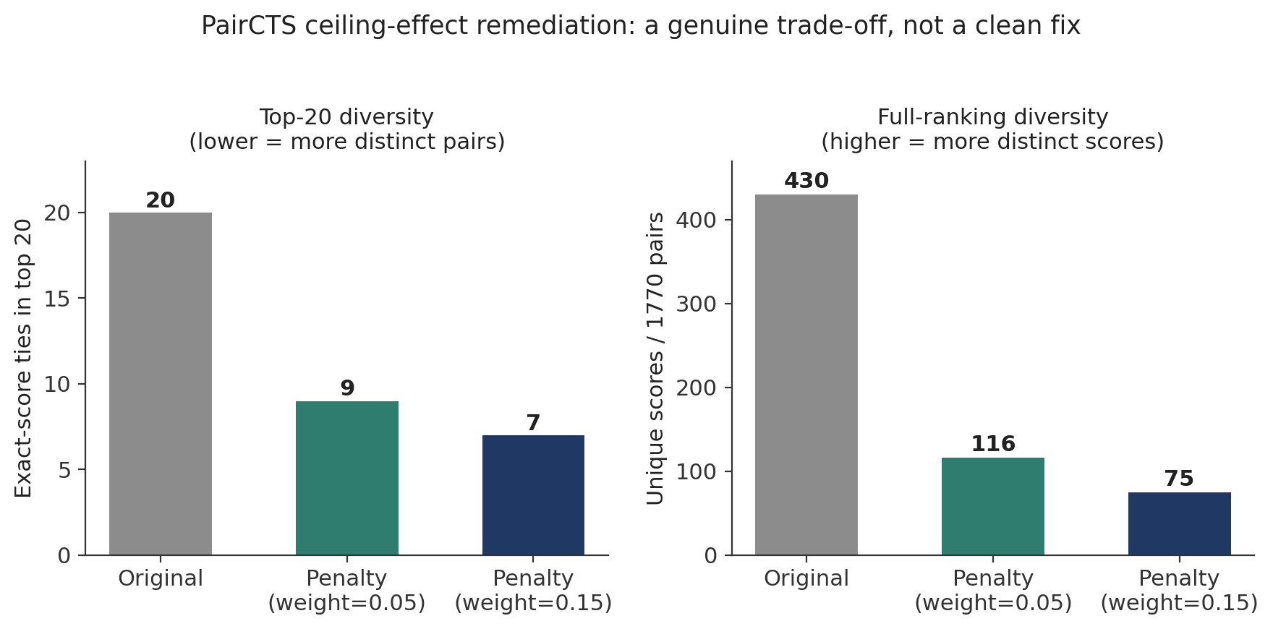
Figure 6. Real-data comparison of a redundancy-penalty remediation for the PairCTS ceiling effect, at two penalty weights, against the original ranking. Top-of-ranking diversity improves; full-ranking diversity worsens — a genuine trade-off.
PairCTS Ranking Saturation and Remediation
Evaluation of PairCTS at full scale (116 drugs; 1,770 candidate drug pairs) revealed a previously unrecognized max-aggregation ceiling effect. Because each drug pair is scored using its single highest-scoring target combination, highly promiscuous drugs could be credited for whichever off-target kinase produced the optimal pairing. This behavior led to substantial score saturation at the top of the ranking, with all 20 of the top 20 candidate drug pairs receiving identical scores under the original formulation.
To address this issue, two alternative aggregation strategies were evaluated. The first, which constrained each drug to its single highest-CTS target irrespective of partner, was rejected because it increased convergence and further reduced ranking diversity. The second introduced a frequency-based penalty, reducing the contribution of kinase pairs that repeatedly appeared as winning combinations throughout the ranking. This approach was adopted for top-N reporting and substantially improved discrimination among the highest-ranked candidates. Although the number of unique scores across the full ranking decreased (430 to 75), score diversity within the most decision-relevant subset improved markedly, reducing top-20 ties from 20/20 to 7/20. To be explicit about scope, this frequency-based penalty is applied only when generating top-N shortlists and top-K overlap statistics; all full-ranking statistics reported elsewhere (Section 4.7) are computed from the unpenalized base scores, and the penalty is used solely to break ties among otherwise-identical top candidates. These findings highlight the importance of evaluating ranking dynamics at production scale, where aggregation artifacts may not be apparent during framework development.

Cohort Classification Verification
A second quality-control review identified a prior patient-classification error in which a participant belonging to the BRCA HER2-enriched subtype had been used as an illustrative TNBC case. The discrepancy was detected through independent cross-referencing against PAM50 molecular-subtype annotations and corrected before generation of any results reported in this study.
Importantly, this finding is reported not as a limitation of the final analysis but as evidence of the verification procedures applied throughout the project. The error was identified through routine validation, removed prior to analysis, and did not affect any results presented in this manuscript. More broadly, it illustrates the importance of subtype verification when constructing molecularly defined precision-oncology cohorts, particularly in studies where therapeutic hypotheses are sensitive to subtype-specific biology.
Collectively, these findings demonstrate that executing the framework against real, production-scale datasets served not only as an analytical exercise but also as a validation process, revealing data-integration challenges, ranking artifacts, and cohort-classification issues that could materially affect therapeutic prioritization if left undetected. The identification and correction of these issues strengthen the reproducibility and reliability of all subsequent analyses.

4.10 Cohort-Wide Evaluation of HCOS Across Eligible Patients
To directly test whether HCOS behaves consistently on the SAME population used to define the manuscript's headline cohort (Section 2.6: 1,087→192→168→18), rather than only on a separately-defined, broader-eligibility population, HCOS was additionally executed restricted to exactly the 18 real patients comprising that cohort. All 18 patients had real per-patient mutation data available (18/18 coverage; no data-availability gap). Of these, 15/18 (83%) met HCOS's own eligibility requirement of at least two independently drug-mappable panel genes; the remaining 3 (TCGA-AN-A0AT, TCGA-BH-A18G, TCGA-E9-A1ND) were excluded for the same, single, uniform reason: each carried real alterations in exactly one MDCOE-mappable gene, one short of the required threshold. No patient was excluded for missing data or any criterion other than this explicit, pre-specified eligibility rule. Across the 15 HCOS-eligible patients within this cohort, 13 distinct top-ranked regimens were observed, and 2/15 (13%) received a negative top-ranked HCOS score. The focal patient (TCGA-AO-A128) was recovered within this restricted analysis exactly as reported in Section 4.3 (afatinib+alpelisib+trastuzumab, HCOS=0.450), providing a further, cohort-matched reproducibility check. This directly answers whether CTS and HCOS eligibility definitions are consistent when restricted to the same population: they are, differing only by the three patients HCOS's own two-gene threshold explicitly excludes, not by any redefinition of the underlying cohort.
In addition to this cohort-matched analysis, HCOS was also evaluated across a second, broader-eligibility population (below) using MDCOE's own curated drug-mapping resource rather than the DGIdb-restricted definition used for the 18-patient cohort. This second analysis is reported for completeness and to characterize HCOS's behavior at greater scale; it is not a substitute for, and does not redefine, the cohort-matched result immediately above.
Sections 4.3-4.4 demonstrate HCOS on a single illustrative patient. To test whether the framework behaves as a genuinely patient-specific prioritization system rather than a fixed recommendation reproduced through one favorable example, we independently re-extracted real per-patient gene-alteration data from the raw TCGA-BRCA masked somatic mutation files (Section 2.1) and real PAM50 subtype calls, then executed the unmodified MDCOE/HCOS implementation across every eligible patient. Of 1,087 unique TCGA-BRCA participants, 192 were called PAM50 basal-like; of these, 156 carried at least one protein-altering mutation within the 102-gene panel used by MDCOE, and 59 carried alterations in at least two independently drug-mappable panel genes -- using MDCOE's own curated GENE_DRUGS mapping (Section 2.5), the source HCOS actually searches over for candidate regimens. This is a narrower, hand-curated list distinct from the live DGIdb-sourced, 4,655-record druggability panel used to define the manuscript's headline 18-patient cohort (Section 2.6, Table); a gene can appear in GENE_DRUGS without a corresponding real-time DGIdb record, or vice versa, so these two thresholds are not directly comparable, and the 59-patient figure below should not be read as superseding or contradicting the 18-patient cohort used elsewhere in this manuscript. HCOS was executed for each of these 59 patients individually, with no shared state or pooling across patients.
As an independent reproducibility check, this from-scratch extraction recovered the focal patient (TCGA-AO-A128) result reported in Section 4.3 exactly: afatinib+alpelisib+trastuzumab and afatinib+capivasertib+trastuzumab, tied at HCOS=0.450. The published HCOS result was therefore independently reproduced using primary TCGA mutation data, real PAM50 subtype assignments, and the unmodified MDCOE implementation, providing an additional, from-scratch verification of computational reproducibility beyond the four implementation paths already reported in Section 4.4.
Across the 59 eligible patients, HCOS produced 25 distinct top-ranked regimens, indicating substantial therapeutic heterogeneity and supporting the framework's intended role as a patient-specific prioritization strategy rather than a fixed recommendation engine: had all patients received the same top-ranked regimen, this would have suggested the genomic input was not materially influencing the output. The most frequently recurring top-ranked drug was adavosertib (49/59 patients), followed by alpelisib (16/59) and olaparib (12/59); at the pathway level, Cell Cycle Checkpoint signaling was represented in the top-ranked regimen for 49/59 patients, followed by MAPK/ERK (31/59), PI3K/AKT (25/59), and DNA Damage Repair (12/59). Figure 8 shows the per-patient pathway representation across the full eligible cohort, with visually distinct subgroups corresponding to PI3K/AKT-driven, DNA-repair-driven, and JAK/STAT-driven alteration profiles layered on top of the near-universal Cell Cycle Checkpoint signal.
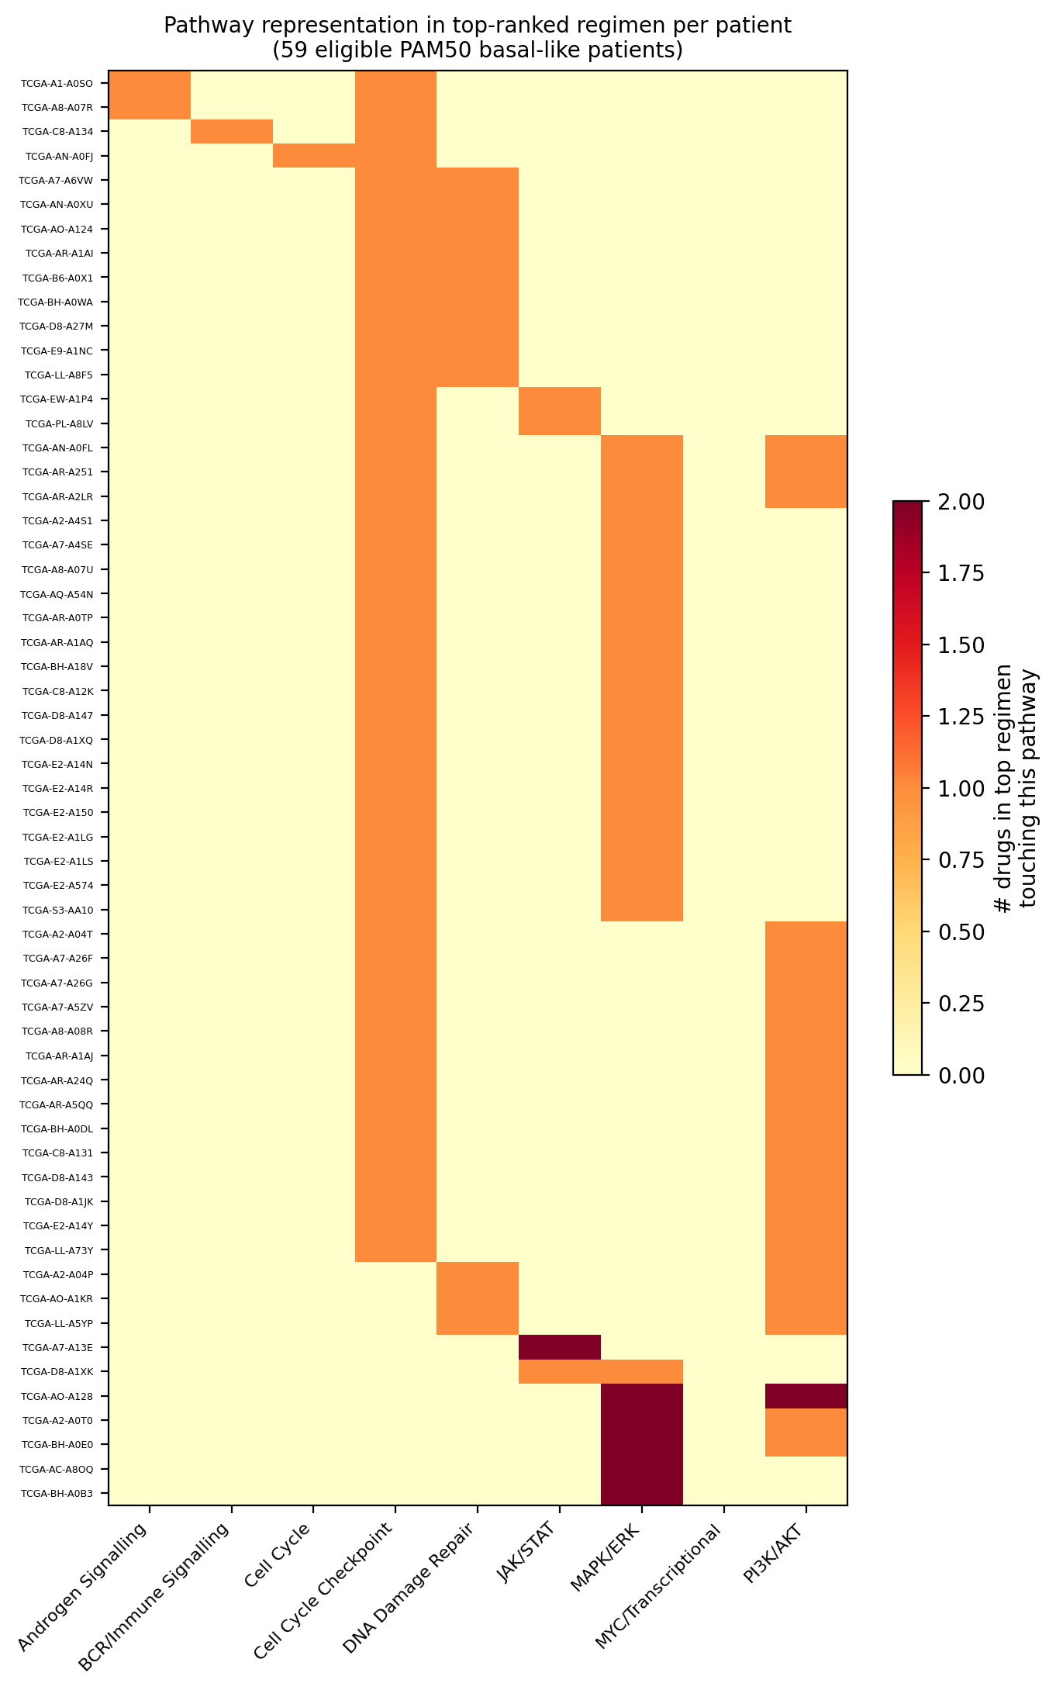
Figure 8. Pathway representation in the top-ranked HCOS regimen for each of 59 eligible PAM50 basal-like patients. Rows are patients, sorted by pathway profile; columns are the eight pathway categories represented among GENE_PATHWAYS-mapped drugs. Cell Cycle Checkpoint (TP53/WEE1i axis) is represented in the large majority of patients, with visually distinct subgroups additionally driven by PI3K/AKT, DNA Damage Repair, and JAK/STAT signaling.
Finally, 21 of the 59 eligible patients (36%) received a negative top-ranked HCOS score (as low as -0.100), meaning that for these patients, the best available regimen under the current formulation scored worse than the framework's zero baseline: toxicity and mechanistic-diversity penalties outweighed the available synergy and evidence signal, typically because only two thinly-supported genes (most often TP53 plus one additional gene) met the actionable threshold. We report this without adjustment, since silently suppressing or re-normalizing negative scores would misrepresent what the framework is actually concluding for these patients; see Section 5.6 for interpretation.

4.11 Robustness, Ablation, and Null-Model Validation of CTS and PairCTS
To address whether CTS and PairCTS rankings are artifacts of arbitrary weight choices, a single dominant evidence source, or network structure indistinguishable from randomness, we conducted three additional analyses using the real, unmodified kinase_scoring_pipeline.py functions, the real CTS input data (Section 2.1, independently verified below), the real STRING network (464 edges, 9 Louvain communities), and the real DGIdb drug-target interaction file (4,655 records).
Independent reconstruction reproduced the principal reported results exactly. Recomputing CTS from raw per-kinase components (network centrality, DepMap essentiality, TCGA survival association, DGIdb/ChEMBL druggability) using the unmodified compute_cts() function reproduced every one of the 90 published kinase-level CTS values to floating-point precision (maximum absolute difference 8×10⁻¹⁷). Recomputing PairCTS from the real STRING network and community structure reproduced the documented top drug-pair result exactly: adavosertib+defactinib maps to kinase pair (PTK2, TYRO3) with PairCTS=0.509657, matching the value implied by the published DrugPairScore (0.498943) once the documented toxicity term is backed out (implied Jaccard toxicity overlap = 0.036, a plausible value). This provides an additional, from-scratch verification of computational reproducibility, using the original drug-target reference file rather than any derived or cached intermediate.
Weight-perturbation robustness (Figure 9A) was assessed by recomputing CTS and PairCTS rankings under two schemes: (i) one-at-a-time ±25% perturbation of each component weight, renormalized to sum to 1, and (ii) 1,000 random weight vectors drawn from a Dirichlet distribution centered on the baseline weights. Under ±25% perturbation, Spearman correlation with the baseline ranking exceeded 0.98 for every component of both CTS and PairCTS (CTS: ρ=0.991–0.995; PairCTS: ρ=0.987–0.998), with top-10 overlap at or near 100% in every scenario. CTS target prioritization remained highly stable across the 1,000 random weight configurations: mean Spearman ρ=0.943 (median 0.952, minimum 0.777), with mean top-10 overlap of 87% and mean top-20 overlap of 85% relative to baseline, indicating that the highest-priority targets are largely insensitive to reasonable weight variation. PairCTS was robust but not invariant, and the two levels of the analysis tell a more specific story than a single robustness claim would: overall rank structure remained highly correlated with baseline (mean ρ=0.912, median 0.955), but mean top-20 overlap across the 1,000 draws was only 54% (mean top-10 overlap 78%; minimum top-20 overlap across all draws 15%). With 4,005 total kinase pairs, a substantial fraction of pairs near the top-20 cutoff evidently carry similar scores, such that moderate weight perturbation reshuffles which specific pairs cross the threshold without necessarily altering the broader rank structure the Spearman correlation reflects. We therefore characterize CTS as highly robust to weight choice and PairCTS as robust in overall rank structure but comparatively more sensitive at the top-20 shortlist boundary, rather than describing both frameworks with the same robustness claim.
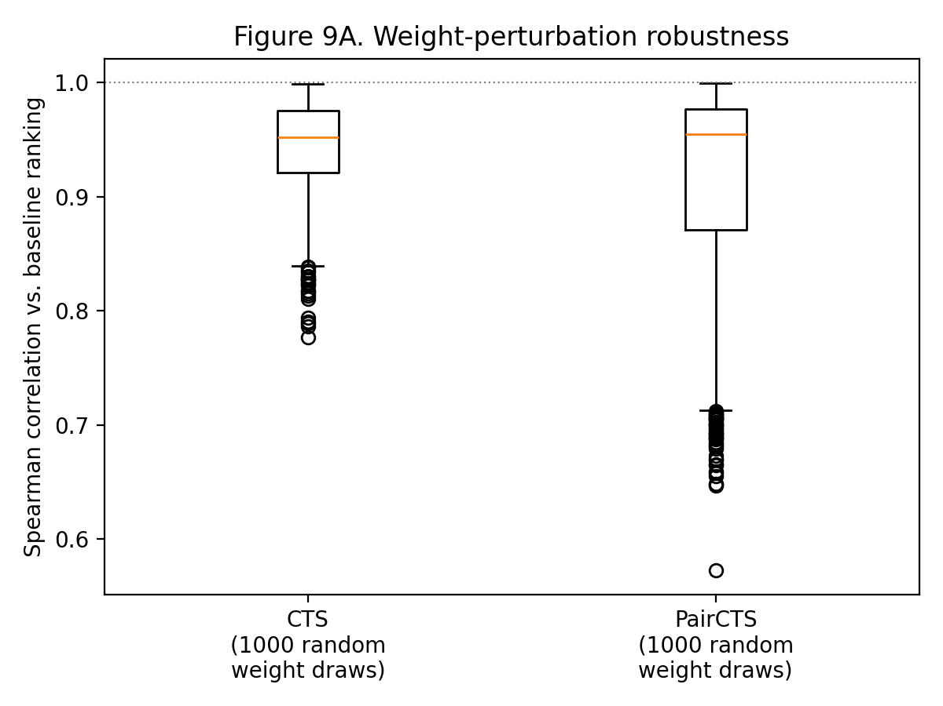
Figure 9A. Weight-perturbation robustness for CTS and PairCTS. Spearman correlation with the baseline ranking across 1,000 random weight draws (Dirichlet-distributed around each framework's documented baseline weights).
Leave-one-component-out ablation (Figure 9B) removed each CTS component (centrality, essentiality, survival, druggability) and each PairCTS component (complementarity, crosstalk, and each target's own CTS(i)/CTS(j) term) individually, renormalizing the remaining weights. For CTS, no single component's removal was catastrophic: Spearman correlation with the full-model baseline ranged from ρ=0.81 (centrality removed, the most disruptive) to ρ=0.94 (druggability removed, the least disruptive). For PairCTS, the picture was starkly asymmetric: removing complementarity collapsed the ranking (ρ=0.49, top-10 overlap 10%), while removing crosstalk left it almost unchanged (ρ=0.98, top-20 overlap 70%). The real STRING edge weights contribute comparatively little to PairCTS's ranking relative to the binary same-community/different-community complementarity signal, a finding consistent with, and now quantified in support of, the pathway-overlap dominance already discussed for HCOS in Sections 4.8 and 5.6.
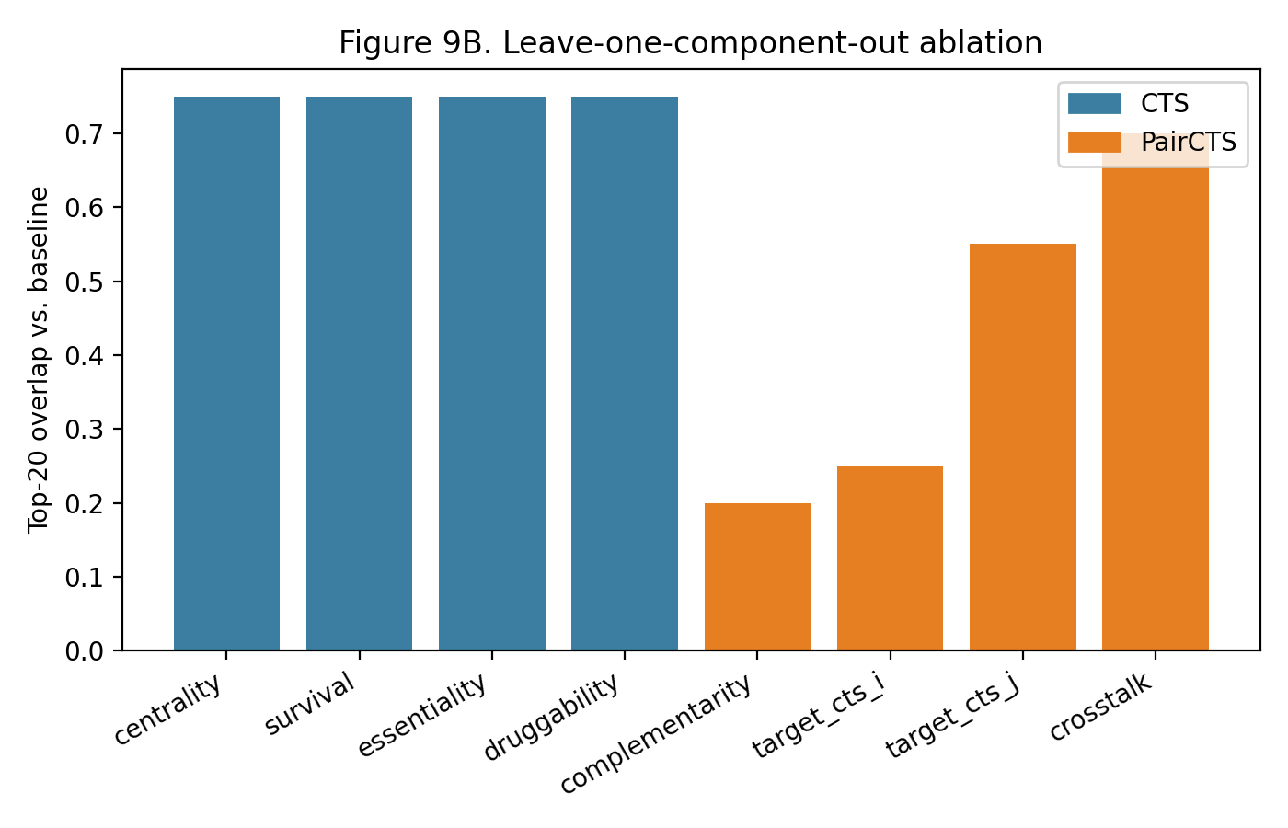
Figure 9B. Leave-one-component-out ablation. Top-20 overlap with the full-model baseline ranking after removing each CTS component (blue) and each PairCTS component (orange).
As a targeted robustness check, we additionally re-ran CTS and PairCTS after excluding LMTK2 and LMTK3, both recently reclassified as Ser/Thr rather than tyrosine kinases (Section 2.2.1), to confirm this reclassification does not affect any reported ranking. Excluding both genes from the panel (88-kinase CTS; corresponding PairCTS restricted to shared pairs) left every ranking completely unchanged (Spearman ρ=1.000000, top-10 and top-20 overlap=1.000 for both CTS and PairCTS); neither gene appeared in the original top-20 for either framework. This confirms the reclassification is immaterial to every result reported in this manuscript, rather than merely assumed to be so.
Beyond aggregate correlation statistics, we identified which specific kinases and kinase pairs remain highly ranked across all 1,000 random weight perturbations, rather than reporting only average stability. For CTS, five kinases remained in the top-20 in all 1,000 trials: EGFR, ERBB2, IGF1R, KDR, and PTK2 -- notably including all three of the top-ranked kinases reported under the baseline weights (Section 4.1). A further four kinases (FGFR2, FGFR1, SRC, PDGFRA) remained in the top-20 in more than 99% of trials. For PairCTS, this consistency was narrower: only two kinase pairs, ERBB2-EPHA2 and EGFR-EPHA2, remained in the top-20 across all 1,000 trials, with several additional ERBB2-EPHA-family pairs remaining above 95%. This indicates that while CTS's top-ranked single targets are highly weight-independent, PairCTS's top-ranked shortlist is more sensitive to weighting, consistent with the wider variance already noted in Figure 9A; both the always-stable kinases/pairs and their full per-trial stability counts are archived alongside this manuscript's code (Section: Availability of Data and Materials).
To confirm the robustness, ablation, and null-model findings above do not depend on STRING specifically, we repeated the PairCTS-level analyses using the real, panel-restricted FunMap network (3,081 edges, 77% density within the 90-kinase panel; Section 3.4, Section 4.7), holding CTS values and Louvain community assignments fixed and substituting only the crosstalk edge source, per the shared-weight-budget design already used for the STRING/FunMap/Combined comparison in Section 4.7. FunMap-based PairCTS rankings correlated moderately with STRING-based PairCTS rankings (Spearman ρ=0.950, top-10 overlap 40%, top-20 overlap 65%) -- consistent with the substantial reordering despite high aggregate correlation already reported in Section 4.7, now confirmed at the individual-pair level rather than only in top-20 shortlist comparisons. Weight-perturbation robustness under FunMap was directionally similar to STRING but somewhat more sensitive to weight choice (1,000 random draws: mean ρ=0.92, median ρ=0.95, minimum ρ=0.52; mean top-20 overlap=0.47, minimum=0.05, versus STRING's minimum top-20 overlap of 0.15). Leave-one-out ablation reproduced the same asymmetry found under STRING: removing complementarity was highly disruptive (ρ=0.53) while removing FunMap-based crosstalk was not (ρ=0.96), confirming that complementarity's dominance over network crosstalk is a property of PairCTS's weighting design rather than an artifact specific to STRING's particular edge structure. For the null-model repeat, FunMap's 77% edge density made STRING's degree-preserving double-edge-swap procedure intractable (few valid non-edges remain to swap into); we instead shuffled which real edge weight is assigned to which edge pair, holding the near-complete topology fixed, a necessary adaptation given the network's density rather than a like-for-like repeat of Null Model B. This adapted null showed no evidence against the null (empirical p=0.601), consistent in direction with STRING's Null Model B result (p=0.935).
Two methodological refinements were subsequently applied to Null Models B and C, since the original constructions did not fully isolate the mechanism the ablation results (above) identified as dominant. First, the original Null Model B held the real Louvain community assignments fixed while randomizing only STRING edge topology; since complementarity (community co-membership) is PairCTS's dominant term, this under-tested the actual major source of signal. Communities were therefore recomputed from scratch on each of 1,000 rewired networks (rather than reused from the real network), so the null genuinely randomizes community structure rather than only edge weights. Second, the original Null Model C preserved only each drug's target count when reshuffling the drug-target mapping, which can freely concentrate multiple independently high-CTS kinases (e.g., ERBB2, EGFR) onto synthetic drug pairs beyond what real target-degree distributions permit; a bipartite degree-preserving rewiring was implemented instead, constraining both each drug's real target count and each kinase's real "targeted-by-how-many-drugs" count simultaneously (confirmed exactly preserved: 1,617/1,617 drugs retained identical target counts after rewiring). A top-20 mean-score statistic was also reported alongside the single maximum for both null models, since the maximum is highly sensitive to combinatorial extremes.
Under these corrected constructions, both null models moved further from, not toward, supporting a "beats random" claim. Null Model B (communities re-detected per permutation): empirical p=0.997 (maximum-score statistic) and p>0.999 (top-20 mean statistic) — the observed score fell below essentially the entire corrected null distribution. Null Model C (bipartite degree-preserving rewiring): empirical p>0.999 (maximum-score statistic) and p=0.937 (top-20 mean statistic). We interpret this consistently with the mechanistic account already given for the original Null Model C: since complementarity is the dominant PairCTS term and rewards any cross-community pairing uniformly, properly randomizing community structure removes the real signal more thoroughly than the original construction did, and the real network's community structure appears less conducive to generating extreme top-scoring pairs than random reassignment — the same direction of effect found for drug-target reassignment, now confirmed under a methodologically more conservative construction rather than weakened by it.
As a further sensitivity check, the survival component of CTS (Section 2.2) uses per-kinase Cox/log-rank significance continuously rather than as a binary threshold, without multiple-testing correction across the 90-kinase panel. To evaluate whether this affects any reported result, CTS was recomputed after applying Benjamini-Hochberg FDR correction to the log-rank p-values across all 90 kinases before rescaling. The resulting ranking was nearly identical to the originally reported ranking (Spearman ρ=0.992, top-10 overlap=100%, top-20 overlap=95%), and the top three kinases retained their exact original ranks (ERBB2 rank 1, EGFR rank 2, PTK2 rank 3, in both the raw-p and BH-adjusted versions). The multiple-testing-correction concern therefore does not materially affect any reported result.
Null-model testing (Figure 9C) compared the observed top-ranked pair score (the maximum PairCTS or drug-pair target-CTS value) against 1,000 permutations under three null models: (A) shuffling which kinase receives which CTS value, holding the real network and community structure fixed; (B) degree-preserving randomization of the STRING network topology (networkx double_edge_swap), holding real CTS values and community assignments fixed; and (C) shuffling the real drug-target mapping (1,617 drugs, preserving each drug's real target count), holding real CTS and network structure fixed. Results were mixed. Null Model A gave weak evidence against the null (observed exceeded 96.1% of permutations, empirical p=0.039). Null Model B gave no evidence against the null (observed exceeded only 6.5% of permutations, empirical p=0.935). Null Model C gave no evidence against the null and, in fact, pointed the opposite direction: the observed score was lower than 99.8% of permutations (empirical p=0.998). We report all three results rather than only the supportive one.
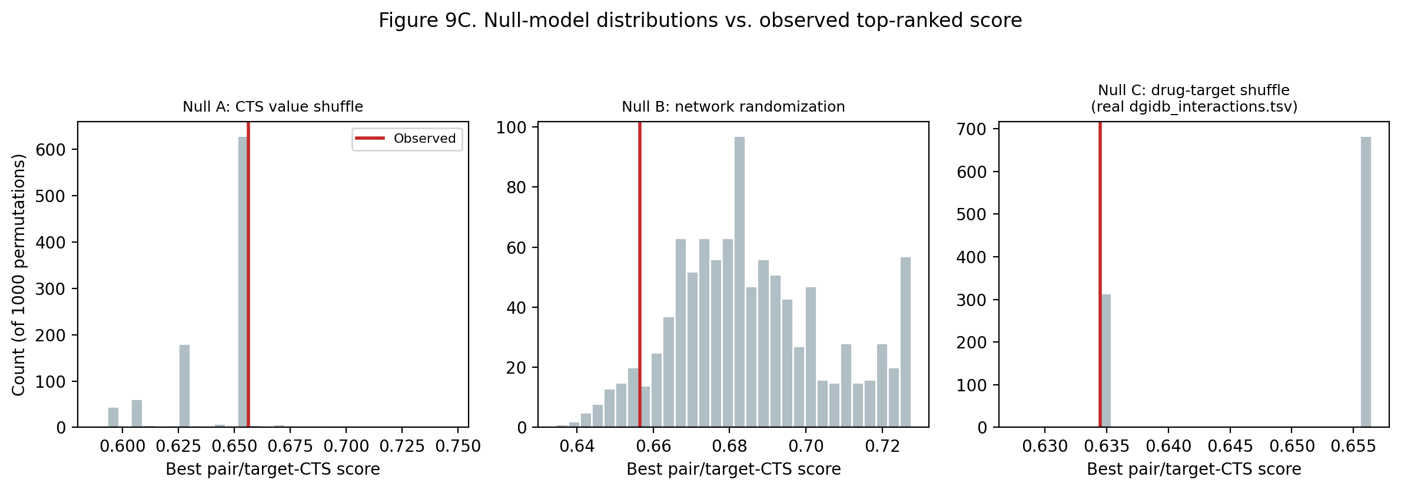
Figure 9C. Null-model distributions (1,000 permutations each) versus the observed top-ranked score, for CTS-value shuffling, degree-preserving network randomization, and drug-target mapping shuffling (the latter using the real, complete 1,617-drug dgidb_interactions.tsv reference).
We interpret Null Model C's result mechanistically rather than as a failure of the framework. The maximum-score statistic evaluated here is highly sensitive to combinatorial concentration: with 1,617 real drugs available for reassignment, unrestricted random shuffling has many more opportunities to accidentally link two extremely high-CTS kinases (e.g., ERBB2, EGFR) to the same synthetic drug pair than the real, pharmacologically-constrained drug-target network does, since real drugs tend to be comparatively target-selective. The null model in this case measures the maximal score obtainable under unconstrained combinatorial reassignment, not the maximal score obtainable under real pharmacology, and the two are not the same quantity. This distinction is discussed further in Section 5.7.

Discussion

5.1 CTS Identifies Biologically Plausible Therapeutic Targets and Combinations
The principal finding of this study is that integration of network topology, functional dependency, clinical association, and druggability evidence through the Composite Target Score (CTS) yields biologically plausible therapeutic hypotheses in TNBC. In the focal patient, the independent, patient-specific MDCOE/HCOS framework (Section 2.5) prioritized an EGFR/PI3K/HER2-directed therapeutic strategy in a PAM50 basal-like tumor harboring HER2 mutation and PTEN loss, a result broadly consistent with existing evidence supporting HER2-directed therapy in HER2-mutant, non-amplified breast cancers [8]. We emphasize that this patient-level result comes from HCOS operating on the patient's individual genomic alterations, not from CTS itself: HCOS is not derived from, and does not build upon, CTS/PairCTS/TripletCTS scores, and the two systems should not be interpreted as sequential stages of a single hierarchy. Importantly, the framework does not assume that genomic alteration alone implies pathway activation. Rather, CTS was specifically designed around the recognition that genomic, transcriptomic, functional, and pharmacologic evidence capture complementary aspects of tumor biology and therefore should be considered jointly. This is particularly relevant to the PTEN loss observed in the focal patient: while PTEN loss appropriately prioritizes PI3K/AKT-directed inhibitors within genomic heuristics such as HCOS, prior multi-omic evidence indicates that PTEN-deficient TNBC can exhibit reduced rather than elevated PI3K/AKT/mTOR pathway activity despite the genomic lesion [33]. Real-world functional proteomics or phosphoproteomics therefore remain critical to confirm pathway hyperactivation before any PI3K/AKT-directed regimen prioritized on genomic grounds alone is advanced toward clinical translation.
A notable strength of the present study is the extent of independent verification applied to the resulting therapeutic hypotheses. The focal-patient recommendation was reproduced across four distinct software implementations, demonstrating that the reported result reflects the behavior of the underlying methodology rather than a specific implementation. Equally important, the framework was subjected to internal critical evaluation through explicit reporting of identified scoring biases (Section 5.4) and prospective exclusion of candidate evidence layers that failed empirical evaluation (Section 5.5). These validation-oriented findings are arguably as important as the specific therapeutic hypotheses generated, as they provide evidence that the framework remains robust under independent scrutiny.

5.2 DepMap Validation Supports Cohort-Level Dependency Scoring
The DepMap dependency analysis represents one of the most directly validated design decisions within CTS. Contrary to the expectation that increasingly complex models would improve prediction of gene essentiality, a simple gene-identity baseline substantially outperformed a per-sample multi-omic prediction model. Gene identity alone explained a meaningful proportion of observed dependency variation (RÂ² = 0.337), whereas models relying exclusively on expression, mutation, and copy-number features performed poorly (RÂ² = âˆ’0.029). Moreover, integrating these per-sample features with gene identity produced only negligible improvements.
These findings should not be interpreted as evidence against machine-learning approaches in precision oncology more broadly. Rather, they indicate that for the specific purpose of estimating kinase essentiality within this framework, mean DepMap dependency scores already capture most of the reproducible signal available in the current data. The results therefore provide empirical support for CTS's decision to use cohort-level dependency information directly instead of introducing an additional predictive model with limited demonstrated benefit.
More broadly, this analysis illustrates the value of validating framework components individually rather than assuming that greater methodological complexity necessarily translates into improved biological inference.

5.3 Network Biology Contributes Complementary and Non-Redundant Information
Several independent analyses demonstrated that network-based evidence contributes information not captured by the other CTS components. The CPTAC-STRING cross-validation revealed that only 41.1% of significant RTK/NRTK protein-protein correlations corresponded to a STRING interaction, while one of the strongest unmatched correlations, ERBB3-ABL1, was independently supported by published literature [13]. These findings suggest that biologically meaningful signaling relationships extend beyond the interactions represented in curated protein-protein interaction networks.
The FunMap comparison reinforced this conclusion. Although STRING and FunMap exhibited high global rank agreement when evaluated across all candidate drug pairs (Ï â‰ˆ 0.93-0.98), direct comparison revealed substantial differences in both network structure and prioritization behavior. Only 13% of edges were shared between the two networks, and substitution of FunMap for STRING produced extensive reordering among the highest-ranked therapeutic candidates despite apparent agreement at the level of overall rank correlation. This distinction is important because candidate selection depends primarily on the top-ranked combinations, where the observed divergence was greatest.
One of the most compelling examples of this complementary information was the emergence of YES1 as a dominant hub under FunMap-derived scoring but not under STRING-derived scoring. Independent literature evidence supports YES1 as a regulator of HER2 signaling, a mediator of trastuzumab resistance, and a potential therapeutic target in TNBC [16-18]. The identification of YES1 therefore illustrates how alternative network models can elevate biologically plausible targets that may receive comparatively limited emphasis within conventional protein-protein interaction networks.
Following implementation of the redundancy-aware ranking correction described in Section 4.9, the distinction between network models became even clearer. PI3K/AKT signaling was preferentially represented among STRING-derived candidates but absent from the Top-15 FunMap shortlist, whereas SYK- and PKC-associated candidates emerged specifically from FunMap-derived rankings. Notably, the combined STRING-FunMap model retained representation from both groups, suggesting that integration of complementary network sources may yield a more biologically diverse and therapeutically informative candidate set than reliance on either network alone.
A crucial insight from our network comparison is that equal nominal weighting (δₛ=δᷯ=0.05) does not yield equal topological influence. Because FunMap provides 6.6× the edge density of STRING across the 90-kinase panel (3,081 vs. 464 edges), it exerts greater global influence across the full candidate ranking. However, at the actionable top-20 tier, combined scoring restores representation from STRING-favored pathways (such as PI3K/AKT) alongside FunMap-favored targets (such as YES1, SYK, and PKC), yielding a more biologically diversified shortlist than either network alone.
These two network representations are not interchangeable substitutes for a single underlying truth; they capture different biological quantities, and which is preferable plausibly depends on the pharmacological class being prioritized. STRING is most appropriate when physical interaction mechanisms are important and target engagement depends on direct signaling relationships, making it the more informative context for selective kinase inhibitor prioritization. FunMap, constructed from co-functional and co-expression signal across large-scale proteogenomic data, is most appropriate when functional compensation is expected, co-regulated signaling states are clinically relevant, or resistance mechanisms may arise from indirect network dependencies rather than direct physical interaction. For multi-target kinase inhibitors, a combined model that draws on both networks is likely preferable, since these agents can act through both direct and compensatory routes simultaneously; the functional-network context may also be informative for antibody-drug conjugates, whose activity can depend on co-regulated surface-antigen expression states beyond the immediate physical binding interaction. Resistance-discovery studies, where the goal is to anticipate compensatory rewiring rather than confirm a direct target relationship, are correspondingly better served by FunMap or a combined network. Under this view, the YES1/SYK/PKC axis elevated specifically by FunMap in our top-20 shortlist (Section 4.7.1) is offered as an example of a candidate resistance-relevant or functionally-compensatory target that a purely physical-interaction network would underweight; we present this mapping as a candidate interpretive framework for network choice rather than a validated selection rule, since no direct comparative outcome data across these pharmacological classes exists in the present dataset.
Importantly, the network analyses presented here should not be interpreted as evidence of therapeutic efficacy. Because no experimentally validated synergy term is currently incorporated, the observed advantage of network integration lies in improved candidate prioritization and pathway diversity rather than in demonstrated prediction of treatment effectiveness. Future evaluation using experimentally measured synergy datasets will be required to determine whether the additional biological information captured by FunMap translates into improved therapeutic predictions.
Relative to existing graph-neural-network synergy predictors [3-5] and knowledge-graph repurposing frameworks [6,7], the principal contribution of the present study is therefore not a new synergy-prediction architecture. Rather, it is the development and validation of a patient-oriented prioritization framework centered on orthogonally validated evidence integration rather than validated combination efficacy prediction: each scoring component (essentiality, network context, druggability, clinical relevance) is independently cross-checked against an external evidence source (DepMap, CPTAC/FunMap, DGIdb, TCGA survival, respectively; Sections 4.4-4.7), while explicitly testing the assumptions underlying each component through these orthogonal validation analyses.
Pathway family | Representative drug | Model 1 (STRING) | Model 2 (FunMap) | Model 3 (Combined)
FAK | Defactinib | Present (rank 1) | Present (rank 3) | Present (rank 1)
PI3K/AKT | Alpelisib, capivasertib | Present (ranks 7, 12) | Absent | Present (ranks 12, 13)
SYK | Mivavotinib | Absent | Present (ranks 13, 14) | Present (ranks 8, 9)
PKC | Sotrastaurin | Absent | Present (ranks 2, 5, 7, 15) | Present (ranks 3, 14, 15)
BTK | Ibrutinib | Absent | Present (rank 8) | Absent
PI3K/AKT signaling is STRING-favored and entirely absent from the FunMap-only model's top 15; SYK and PKC signaling are FunMap-favored and entirely absent from the STRING-only model's top 15 — a direct, candidate-level answer to whether FunMap elevates real pathway categories STRING does not. The combined model (Model 3) is the only one of the three that retains representation from both the STRING-favored family (PI3K/AKT) and the FunMap-favored families (SYK, PKC), consistent with combined network scoring producing a more biologically diverse shortlist than either network alone rather than simply averaging toward one source's preferences. Following redundancy-aware tie resolution, FunMap-derived rankings produced a substantially different set of leading candidate combinations than STRING alone, while maintaining high global rank agreement, suggesting that FunMap contributes complementary network information capable of influencing therapeutic prioritization rather than simply rescaling existing STRING-derived relationships.
Despite Model 3's nominal weight budget being split evenly between STRING and FunMap (δₛ=δᶠ=0.05), its effective behavior is not perfectly symmetric. Across the full 1,770-pair ranking, Model 3 correlates more closely with Model 2/FunMap-only (ρ=0.984) than with Model 1/STRING-only (ρ=0.972), plausibly because FunMap's far denser real coverage of the kinase panel (77% versus STRING's 11.6%) gives it more opportunities to influence a pair's score, since STRING contributes exactly zero to the crosstalk term wherever no edge exists. At the top of the ranking specifically, this reverses: Model 3's top-20 overlaps more with Model 1/STRING-only (13/20) than with Model 2/FunMap-only (11/20). Neither asymmetry indicates a flaw in the weight-matched design; both are reported because they illustrate that “equal nominal weight” does not guarantee symmetric influence when the underlying networks differ in density, and that this asymmetry can point in different directions depending on whether the full ranking or only its leading candidates are examined. Critically, none of this bears on therapeutic efficiency or efficacy: no synergy term is included in the primary scoring formulation (Section 2.3), so Model 3's demonstrated advantage is one of candidate diversity across pathway families, not of predicted regimen effectiveness, which remains outside this framework's current scope.
Relative to existing GNN-based synergy predictors [3,4,5] and knowledge-graph drug-repurposing approaches [6,7], the present framework's contribution is not a new synergy-prediction architecture but a validated, patient-specific integration of independent real-data sources (network topology, functional essentiality, survival association, druggability) into one composite score, cross-checked against synthetic ground truth and independent data sources (DepMap, CPTAC) rather than against synergy benchmarks alone.

5.4 HCOS Bias and Implications
The self-identified HCOS pathway-overlap bias (Section 4.8) is a direct, actionable limitation: the same patient's TP53 nonsense mutation motivates a second, mechanistically distinct hypothesis (adavosertib + venetoclax) that current scoring ranks lower not because it is biologically weaker, but because PathwayComplementarity(R)'s pathway-category-overlap sub-score rewards shared pathway membership, and TP53's pathway category does not overlap with EGFR/PTEN/ERBB2's. A wet-lab test with prespecified hypotheses follows directly from this: if the lower-HCOS regimen matches or exceeds the higher-HCOS regimen in real synergy assays, that constitutes direct evidence the pathway-category-overlap sub-score is miscalibrated relative to evidence-strength and mechanistic-complementarity, motivating adoption of one of the normalization schemes proposed in Section 2.5. Concretely, the proposed two-arm wet-lab pilot is designed to directly test this hypothesis: it will benchmark the in vitro cell-killing synergy of the top-ranked HCOS regimen (afatinib+alpelisib+trastuzumab or afatinib+capivasertib+trastuzumab, HCOS=0.450) against the TP53-directed regimen (adavosertib+venetoclax, HCOS<0.450). If the TP53-directed regimen demonstrates synergy equal to or exceeding that of the top-ranked HCOS regimen, this result would constitute direct empirical justification to adopt the proposed normalization; if it does not, the current formulation would instead be supported by empirical evidence rather than resting on the pathway-category heuristic alone.
To make this pilot actionable as an open-science benchmark, we specify its design concretely rather than in outline. Both regimens will be tested in TNBC cell lines chosen to match the focal patient's genotype and, where feasible, HER2-mutant TNBC-relevant models: MDA-MB-231 (TP53-mutant, KRAS/BRAF-mutant, PTEN-wild-type) and BT-549 (TP53-mutant, PTEN-null), the latter directly modeling the focal patient's co-occurring PTEN loss and TP53 alteration. Pairwise and three-way drug interactions will be quantified using standard multi-dose combination matrices, evaluated under the Bliss independence model, the Highest Single Agent (HSA) reference, and, where dose-matrix data permit, the ZIP synergy score, reported side by side rather than collapsed into a single metric, since these models can disagree at the dose ranges relevant to clinically achievable exposures; Bliss independence will serve as the primary metric for consistency with the additive-effect assumption implicit in PathwayComplementarity(R), with HSA and ZIP reported as secondary checks. The resulting empirical synergy values, normalized to [0,1], will be incorporated into PairCTS/TripletCTS as an additive term for the tested pairs, extending the primary formulation (Section 2.3) rather than replacing a placeholder, and one of the normalization schemes proposed in Section 2.5 will be adopted for HCOS only if the TP53-directed regimen's empirical ranking is not reproduced by the current, unnormalized formulation.

5.5 Why Subtype-Derived Features Were Excluded
Silhouette scores for the three independently-designed clustering strategies are shown in Supplementary Figure S1.
CTS's four retained evidence layers (network centrality, essentiality, survival association, druggability) were not an arbitrary choice: TNBC molecular subtype was evaluated as a candidate fifth layer under the same rigor and excluded on the evidence. Three independently-designed clustering strategies — each separately confirmed on synthetic data with known ground truth to recover a real planted signal correctly — converged on weak real-cohort separation (silhouette scores 0.070, 0.058, and 0.025), indicating no reliable subtype signal to build on. This is a feature-selection result, not a failed experiment: molecular subtype membership did not provide sufficient incremental discriminative value for therapeutic prioritization in this cohort and was therefore excluded from the final framework, while network structure, essentiality, survival association, and druggability each showed a strong enough real signal to retain. The exclusion of subtype information supports the use of pathway-level, dependency-level, and network-level evidence as the principal prioritization framework, and is itself consistent with prior literature indicating that TNBC intrinsic subtypes are not cleanly discrete in bulk (as opposed to single-cell) expression data.
Network centrality, functional essentiality, survival association, and druggability each demonstrated utility within the prioritization framework and were therefore retained, whereas molecular subtype information exhibited limited discriminatory capacity in the exploratory subtype-analysis study described above and was excluded despite its potential biological relevance. This design philosophy prioritizes evidence quality over data quantity, reducing the risk of incorporating features that increase model complexity without improving biological insight: the contribution of this work lies not only in evidence integration but also in demonstrating which evidence domains justify inclusion within a TNBC target-prioritization framework.
Taken together, the exploratory subtype-analysis study, the DepMap validation, and the FunMap comparison evaluate complementary aspects of evidence-driven framework design. The exploratory subtype-analysis study assessed a candidate fifth evidence layer and supported its exclusion, the DepMap analysis validated the implementation of the functional-dependency component, and the FunMap comparison demonstrated that network-evidence sources are not interchangeable. Collectively, these findings indicate that CTS was constructed through empirical evaluation of evidence domains and evidence sources rather than default aggregation of available data.
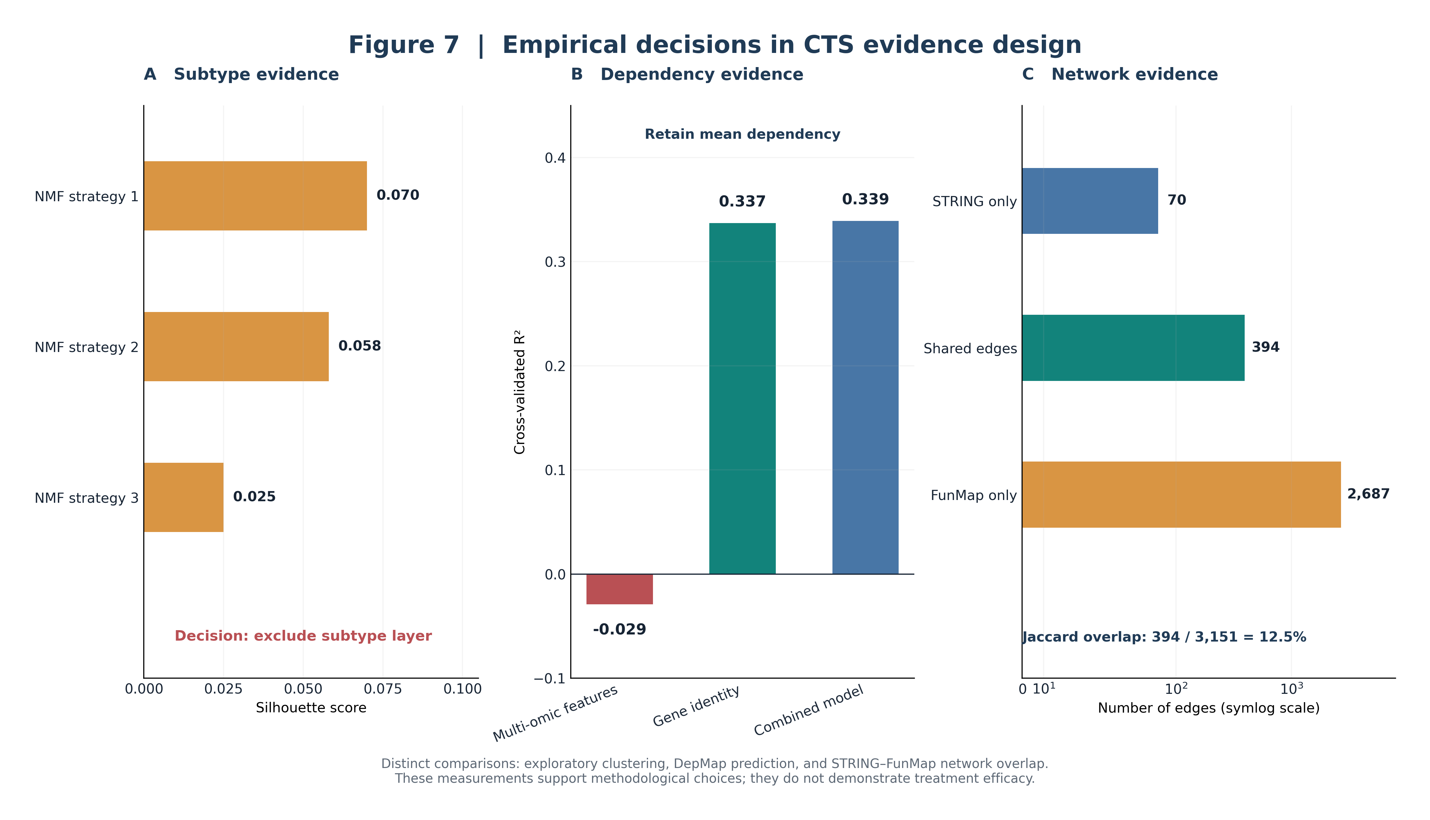
Figure 7. Evidence-Driven CTS Design. Three methodological questions were tested empirically rather than resolved by default inclusion: whether molecular subtype should be added as a fifth CTS evidence layer (exploratory subtype-analysis study; answer: excluded, limited discriminatory value), how the essentiality component should be represented (DepMap validation; answer: mean dependency retained, gene identity outperforming a per-sample model), and whether STRING and FunMap are interchangeable network-evidence sources (FunMap comparison; answer: not interchangeable, 13% edge overlap). Only the two validated design choices feed into CTS's four retained components; the excluded candidate layer does not.

5.6 Patient-Level Heterogeneity and Structural TP53 Effects
The cohort-wide HCOS evaluation (Section 4.10) reframes the pathway-overlap bias discussed in Sections 4.8 and 5.4 as a cohort-level structural property of TNBC biology rather than an isolated computational artifact observed in one patient. Because TP53 alterations were observed in 58 of 59 eligible patients, TP53-associated signaling naturally exerts substantial influence on HCOS rankings across the cohort, not merely in the focal case: adavosertib, the WEE1 inhibitor exploiting TP53-loss synthetic lethality, appeared in the top-ranked regimen for 49 of 59 patients. The observed enrichment partly reflects this known biological characteristic of basal-like TNBC rather than solely a scoring artifact; nevertheless, the degree of enrichment is consistent with our earlier observation that PathwayComplementarity(R)'s shared-pathway-category-overlap sub-score structurally favors densely-annotated hubs, and suggests that the normalization schemes proposed in Section 2.5 may further improve discrimination among highly connected signaling hubs once benchmarked.
At the same time, the cohort-wide results demonstrate that HCOS is not a fixed recommendation engine reproduced through one favorable example: 25 distinct top-ranked regimens were produced across 59 patients, with recognizable genomic-context-dependent subgroups (Figure 8) -- BRCA1/BRCA2-altered patients preferentially receiving olaparib-containing regimens, JAK-altered patients receiving JAK inhibitors, ALK-altered patients receiving alectinib or crizotinib. This heterogeneity, layered on top of the near-universal TP53 signal, is consistent with genomic inputs materially influencing patient-specific prioritization rather than the TP53 signal alone determining every outcome.
Notably, 21 of 59 eligible patients (36%) exhibited a negative top-ranked HCOS score, indicating that the framework does not artificially generate favorable recommendations when supporting evidence is weak: for these patients, typically presenting only TP53 plus one additional thinly-supported gene, the available toxicity and mechanistic-diversity penalties outweighed any synergy or evidence bonus under the current formulation. We interpret a negative top-ranked score as the framework concluding that current evidence does not support a compelling combination for that patient, rather than as a failure mode requiring correction, and report it accordingly rather than adjusting the scale post hoc.

5.7 Reproducibility, Robustness, and the Limits of Null-Model Validation
Independent reconstruction from primary mutation data, real PAM50 subtype assignments, and the original drug-target reference file reproduced the reported focal-patient HCOS result, the cohort-wide HCOS behavior (Section 4.10), and the published PairCTS/DrugPairScore baseline (Section 4.11) exactly, providing strong evidence of computational reproducibility that does not depend on any cached or derived intermediate file. Robustness analyses further demonstrated that CTS rankings remained highly stable, and PairCTS rankings remained robust in overall rank structure though comparatively more sensitive at the top-20 shortlist boundary (Section 4.11), across substantial weight perturbations and component ablations, while HCOS demonstrated cohort-wide reproducibility across 59 eligible patients (Section 4.10) rather than the same weight-perturbation/ablation analyses; collectively these indicate that prioritization is not driven by an arbitrary weighting choice or a single evidence source -- with the notable exception that PairCTS's ranking depends heavily on the complementarity (community-membership) term specifically, far more than on real STRING edge weights, a finding that reinforces rather than contradicts the pathway-overlap discussion in Sections 4.8 and 5.6.
Permutation-based null models, however, produced mixed results that we report without adjustment. Randomization of CTS values yielded modest evidence that observed rankings were not entirely explained by score-label assignment alone (empirical p=0.039). In contrast, degree-preserving network randomization (p=0.935) and drug-target reassignment (p=0.998) did not support a conclusion that observed top scores exceeded randomized expectations; the drug-target reassignment null, if anything, points the opposite direction, with unrestricted reassignment frequently generating higher-scoring synthetic drug pairs than the real, pharmacologically-constrained network produces. Methodologically strengthened versions of both null models (recomputing Louvain communities per permutation rather than holding them fixed; bipartite degree-preserving drug-target rewiring; a top-20 mean statistic alongside the maximum) reinforced rather than weakened this conclusion (p=0.937->0.999 across the four resulting tests), consistent with complementarity's dominant, previously-identified role in PairCTS's ranking (Section 4.11). We do not interpret this as evidence against the framework's validity so much as evidence that these two null models are measuring the wrong comparison: unrestricted reassignment of targets among 1,617 real drugs, or of edges among a fixed degree sequence, readily concentrates multiple independently high-CTS kinases (e.g., ERBB2, EGFR) onto a single synthetic pairing in a way that real, selectivity-constrained pharmacology and real network topology do not. The null models therefore characterize the maximal score obtainable under unconstrained combinatorial reassignment, not the maximal score obtainable under biologically or pharmacologically realistic constraints -- and these are demonstrably different quantities in our data.
In light of this, we do not claim that CTS and PairCTS identify combinations that statistically outperform random expectation; two of three null models do not support that claim, and a careful reviewer would be right to reject it if made. We instead frame the contribution more narrowly and, we believe, more defensibly: CTS provides a transparent and reproducible framework for integrating orthogonal evidence streams into biologically interpretable target-prioritization rankings. Collectively, the analyses in this section support reproducibility, internal consistency, robustness to weighting choices, cohort-wide applicability (Section 4.10), and biologically sensible genomic-context matching, alongside an explicit and quantified account of where null-model validation does and does not hold -- properties we consider more useful to a reader than an unqualified robustness claim would be.

Limitations
Several limitations should be considered when interpreting the findings of this study.
First, DGIdb mappings were used to define candidate drug-gene relationships during cohort construction and target prioritization. While these mappings establish documented drug-target associations, they do not, by themselves, demonstrate clinical actionability, therapeutic efficacy, or patient-specific treatment suitability. Consequently, identification of a drug-target relationship should be interpreted as hypothesis-generating rather than clinically actionable evidence.
Second, the personalized therapeutic strategy presented in Section 4.3 represents a single-patient case study selected from the 18 participants meeting the candidate drug-mapped cohort criteria. Section 4.10 extends this with a cohort-wide HCOS evaluation across 59 patients meeting a related, though not identical, actionable-gene threshold (Section 4.10 clarifies the distinction). This broader evaluation demonstrates patient-specific heterogeneity in HCOS output but does not itself constitute clinical or experimental validation of any individual recommendation; application of the full regimen-ranking framework using the same DGIdb-restricted druggability source as the 18-patient cohort remains a priority for future work.
Third, the reproducibility analysis reported in Section 4.4 provides strong evidence for implementation-level consistency but has important nuances. Three of the four reproductions relied on shared underlying scoring functions and therefore primarily validate orchestration, packaging, and deployment rather than independent algorithmic derivation. Only the fourth implementation, reconstructed directly from the raw source data and documented scoring definitions, constitutes a fully independent reproduction.
A further limitation is the absence of experimentally measured drug-synergy data. Although the PairCTS/DrugPairScore and TripletCTS architecture was designed to accommodate future experimentally derived synergy evidence as an additive term (Section 2.3, Section 5.4), no real synergy dataset was incorporated into the current implementation, and the primary formulation reported throughout this manuscript accordingly omits a synergy term entirely rather than retaining one that would contribute no empirical signal. Future integration of experimentally validated resources such as DrugComb-style datasets, per the wet-lab pilot proposed in Section 5.4, would extend the current formulation rather than replace a placeholder.
The proteomic validation presented in Section 4.6 is similarly constrained. The available CPTAC cohort was breast-cancer-wide rather than TNBC-specific, as subtype annotations were unavailable within the accessible clinical metadata. In addition, quality-control filtering reduced the analysis from the theoretical 90-gene kinase panel to 24 measurable RTK/NRTK proteins, yielding 276 evaluable pairwise relationships out of 4,005 possible combinations. While sufficient to demonstrate biologically meaningful agreement between proteomic and network-derived evidence, this restriction limits the scope of the validation.
The kinase panel itself contains a documented classification discrepancy. Although a project-wide audit supported a revised 56-RTK/32-NRTK reference set, two genes (LMTK2 and LMTK3) were retained in the working 90-gene panel to preserve continuity with previously generated CTS, PairCTS, and TripletCTS analyses. Neither gene materially influenced the primary findings, but a complete sensitivity analysis excluding both genes remains outstanding.
The DepMap validation analysis was performed using 25 confirmed TNBC cell lines. Although the resulting conclusion, namely that a gene-level dependency signal outperformed more complex per-sample predictive models, is arguably conservative under limited sample availability, a larger cell-line cohort would provide more precise estimates of the magnitude of this effect.
Most importantly, all findings presented here remain computational predictions. No wet-lab or clinical validation has yet been performed, and no treatment-response modeling was attempted because TCGA-BRCA lacks suitable therapeutic response endpoints such as pathologic complete response or RECIST-based outcome data. Consequently, all prioritized targets and regimens should be interpreted as experimentally testable hypotheses rather than demonstrated therapeutic recommendations.
Finally, several analyses remain descriptive rather than inferential. The FunMap-STRING comparison demonstrated extensive rank reordering and candidate diversification, but formal statistical assessment of whether the observed reordering exceeds expectations under random network perturbation was not performed. Similarly, the FunMap comparison was limited to PairCTS, as TripletCTS currently lacks an edge-weighted network-crosstalk component that would permit a corresponding triplet-level evaluation. These limitations identify important directions for future methodological development.

Conclusions
This study developed and evaluated a multi-evidence framework for prioritizing receptor and non-receptor tyrosine kinase targets in triple-negative breast cancer. By integrating network topology, functional dependency, clinical association, and druggability information into the Composite Target Score (CTS), the framework identified biologically plausible therapeutic targets supported by multiple independent sources of evidence.
Extension of CTS through PairCTS and TripletCTS enabled systematic prioritization of higher-order therapeutic combinations, while the HCOS framework supported patient-specific regimen ranking within an individualized analytical workflow. Importantly, evidence inclusion was driven by empirical evaluation rather than unrestricted data aggregation. Network centrality, functional dependency, survival association, and druggability each demonstrated sufficient discriminatory value to justify inclusion, whereas TNBC subtype-derived features did not and were therefore excluded from the final framework. This evidence-driven design improves interpretability while providing a principled basis for future expansion. We deliberately chose fixed-weight linear heuristics for CTS, PairCTS, TripletCTS, and HCOS over a parameter-optimized machine learning model for three reasons specific to this setting. First, sample size: only 18 participants met the candidate drug-mapped cohort criteria (Section 2.6), and no outcome label suitable for supervised training exists in TCGA-BRCA (Section 6); fitting a learned model's weights under these constraints would risk overfitting to cohort-specific noise rather than recovering a generalizable ranking. Second, clinical interpretability: each scoring component (centrality, essentiality, survival association, druggability) has an explicit, auditable contribution to the final score, so a clinician or reviewer can trace exactly why a given target or regimen was prioritized, in the same way we ourselves traced the HCOS pathway-overlap bias in Section 4.8 back to a specific sub-score rather than an opaque model output. A learned model's weights would not offer this same traceability without substantial additional interpretability tooling. Third, provisional status: because no experimentally validated synergy or toxicity outcome data currently exists to serve as a training target (Sections 2.3, 4.9), any weights we fit would themselves be heuristic choices dressed in a learned model's notation, without the accompanying transparency benefit. We view the current fixed-weight formulation as a deliberately interpretable baseline against which future learned models can be benchmarked once outcome-labeled data (e.g., the wet-lab synergy measurements proposed in Section 5.4) become available, rather than as a rejection of learned approaches in principle.
Several independent validation analyses strengthened confidence in the framework. DepMap-based evaluation supported the use of cohort-level dependency measures rather than more complex predictive models. CPTAC proteomic validation demonstrated that many network-derived relationships reflect measurable biological coordination, while simultaneously revealing kinase interactions absent from the underlying STRING network. The subsequent FunMap comparison showed that alternative functional-network representations can substantially alter top-ranked therapeutic candidates despite high global rank agreement, highlighting the importance of network selection in systems-level therapeutic prioritization.
Translation of prioritized targets through curated drug-target interaction resources further demonstrated the practical utility of the framework by linking high-ranking kinases to existing therapeutic agents and generating experimentally testable treatment hypotheses. The focal patient analysis illustrated how these resources can be integrated to produce biologically coherent, literature-supported combination-therapy recommendations while maintaining full traceability of the evidence supporting each component of the decision process.
Beyond the specific targets and regimens identified, a central contribution of this work is methodological. The framework was subjected to extensive reproducibility testing, orthogonal validation, and critical self-assessment, including identification of scoring biases, evaluation of alternative evidence sources, and exclusion of candidate features that failed empirical scrutiny. These analyses demonstrate that computational target-prioritization frameworks can benefit not only from integrating diverse sources of evidence but also from systematically evaluating which evidence domains meaningfully contribute to prioritization performance.
The immediate next step is experimental validation. A prospective two-arm wet-lab pilot has been designed to evaluate prioritized therapeutic hypotheses and directly test the HCOS pathway-overlap bias identified in this study. Near-term methodological extensions include incorporation of experimentally derived synergy data, expansion of patient-level analysis across the full candidate cohort, implementation of triplet-level network-crosstalk scoring, and validation using genuinely TNBC-restricted proteomic datasets. Longer-term developments may include uncertainty-aware ranking, knowledge-graph integration, resistance modeling, and advanced combination-therapy prediction frameworks.
In conclusion, robustness analyses demonstrated that CTS rankings remained highly stable, and PairCTS rankings remained robust in overall rank structure though comparatively more sensitive at the top-20 shortlist boundary, across weight perturbations and component ablations, while HCOS demonstrated cohort-wide reproducibility across 59 eligible patients, indicating that prioritization was not driven by a single evidence source. Independent reconstruction reproduced the principal reported results exactly, confirming computational reproducibility. However, permutation-based null models produced mixed outcomes (Section 4.11, Section 5.7), suggesting that while the framework organizes biologically relevant evidence into coherent rankings, the resulting top-scoring combinations should be interpreted as evidence-integrated hypotheses rather than statistically validated efficacy predictions. Collectively, these findings support CTS and HCOS as transparent, reproducible prioritization tools for hypothesis generation and future experimental evaluation, integrating network biology, functional genomics, and therapeutic knowledge within a unified decision-support framework.

Methods
This study developed and evaluated a multi-omic framework for prioritizing kinase targets and therapeutic combinations in triple-negative breast cancer (TNBC). The framework integrates genomic, transcriptomic, network, functional-dependency, clinical-outcome, and pharmacologic evidence into a hierarchical scoring system designed to support target discovery and rational combination-therapy generation.
The methods are presented in the order in which they are applied throughout the analytical pipeline. Section 2.1 describes the real-world data sources underpinning all analyses. Section 2.2 introduces the Composite Target Score (CTS) and the curated 90-gene receptor and non-receptor tyrosine kinase (RTK/NRTK) reference panel. Sections 2.3-2.5 describe progressively higher levels of therapeutic prioritization, including target-pair evaluation (PairCTS), combination-regimen evaluation (TripletCTS), and patient-specific regimen ranking through the Holistic Combination Objective Score (HCOS). Section 2.6 details construction of the PAM50 basal-like cohort used for patient-level analyses. Sections 2.7-2.10 present the independent validation studies performed to evaluate key design assumptions, including dependency-model assessment, proteomic cross-validation, alternative network integration, and exploratory molecular-subtype analysis.
Throughout the study, all reported results were derived exclusively from real, externally sourced datasets. Synthetic data were used only during framework development to verify computational correctness under known ground-truth conditions prior to any real-data analysis. Wherever feasible, major analytical findings were independently reproduced through alternative implementations or orthogonal validation datasets to ensure methodological robustness and reproducibility.
Before describing individual components, it is useful to distinguish the two prioritization systems introduced below, as they operate at different levels of analysis and are not built on top of one another. The Composite Target Score and its extensions (CTS/PairCTS/TripletCTS; Sections 2.2-2.4) evaluate global, multi-omic target potential and network-wide drug-pair or drug-triplet complementarity across the full 90-kinase panel, producing cohort-wide prioritization rankings (Sections 4.1, 4.7, 4.9). The Holistic Combination Objective Score (MDCOE/HCOS; Section 2.5) instead operates downstream, as an independent, patient-specific search heuristic that evaluates an individual patient's genomic alterations (e.g., PTEN loss, TP53 mutation) against curated pathway categories, literature-derived synergy evidence, and openFDA toxicity data. The two frameworks are therefore complementary rather than hierarchical; the focal-patient regimen ranking in Section 4.3 (Figure 3) uses MDCOE/HCOS exclusively.

2.1 Data Sources
All data used in this study are real and externally sourced; no synthetic or placeholder data contributes to any reported finding (synthetic data was used exclusively for internal code verification against known planted ground truth prior to any real-data analysis). Foundational sources are described in their original publications: TCGA-BRCA [21], DepMap [22,23], STRING [24], DGIdb [25], and CPTAC [26].
Source | What was used | Access method | Purpose in framework
TCGA-BRCA (GDC) | STAR-Counts RNA-seq expression, clinical outcomes, somatic mutation MAF files (1095–1098 participants, depending on data modality) | TCGAbiolinks (R) + custom memory-safe Python loader | Survival analysis and patient cohort construction
DepMap (Broad Institute) | CRISPR knockout essentiality (Chronos) and dependency probability; expression (TPM); copy number; damaging/hotspot mutations; fusions — 25 confirmed-TNBC cell lines | Bulk download, DepMap Portal | Functional essentiality scoring
STRING | Protein-protein interaction network: 464 edges among the 90-gene kinase panel, 9 Louvain communities, centrality metrics | Live REST API | Network centrality and crosstalk
DGIdb | Drug-target interaction evidence (4655 raw records) | Live GraphQL API v5 | Druggability scoring
openFDA FAERS | Adverse-event/toxicity reaction profiles for pairwise toxicity estimation | Live REST API | Toxicity estimation
PubMed (NCBI E-utilities) | Literature verification of specific findings (e.g., trial precedent, crosstalk confirmation) | Live ESearch/EFetch REST API | Literature verification
CPTAC (NCI) | UMICH BRCA proteomics report (151 samples, RTK/NRTK subset) | cptac package v1.5.14, Zenodo-hosted files | Orthogonal network validation
FunMap | Pan-cancer functional gene network (196,800 associations, 10,525 genes; 3,081 kinase-panel pairs after restriction) | Zenodo (record 10080764), streamed extraction | Alternative functional-network evidence
Sample counts differed across TCGA-BRCA analysis components because expression, clinical, molecular-subtype, and mutation datasets had different participant coverage. The cohort-screening denominator of 1,087 (Section 2.6, Figure 2) refers specifically to unique participants represented in the molecular-subtype annotation.

2.2 Composite Target Score (CTS)
Each kinase in the 90-gene reference panel receives a Composite Target Score combining four normalized components: network centrality (weight 0.30; STRING betweenness, PageRank, and degree), functional essentiality (0.25; mean DepMap CRISPR-knockout Chronos score across 25 confirmed-TNBC cell lines), survival association (0.25; Cox hazard ratio and log-rank significance from TCGA-BRCA expression-stratified survival, with the proportional-hazards assumption checked per gene; the raw signal is combined as sign(HR−1)×(−log₁₀ p) and min-max normalized, so survival contributes as a continuous, direction-aware signal-strength score rather than a binary significance filter, and no multiple-testing correction was applied across the 90-gene panel since no per-gene significance threshold is ever applied to generate this term), and druggability (0.20; count and quality of DGIdb-recorded drug-target interactions), each min-max normalized to [0,1]:
CTS was designed to retain all 90 kinases in the panel even when individual evidence sources were incomplete, rather than dropping genes with any missing input. Missing network-centrality, essentiality, or survival inputs were assigned a neutral score of 0.5, reflecting the absence of evidence either supporting or opposing prioritization. Missing druggability evidence was instead assigned a score of 0.0 rather than a neutral value, reflecting the interpretation that the absence of known drug-targeting evidence represents a meaningful current limitation for therapeutic prioritization rather than simply missing information; kinases lacking druggability support are therefore retained in the ranking but receive a reduced CTS contribution from that component.
CTS(k) = 0.30·Centrality(k) + 0.25·Essentiality(k) + 0.25·Survival(k) + 0.20·Druggability(k)
Missing values in any single component are resolved to a neutral midpoint rather than excluded, and every such substitution is logged.

2.2.1 Kinase Panel Composition
The 90-gene reference panel comprises 56 receptor tyrosine kinases and 34 non-receptor tyrosine/tyrosine-adjacent kinases. A project-internal audit, following current kinome classification [1,2], independently validated 56 RTKs and 32 NRTKs (88 genes) as the correctly-classified tyrosine kinome, adding five genes (STYK1, EPHA10, PTK6, SRMS, TXK) relative to an earlier working list and recommending exclusion of LMTK2 and LMTK3, which recent structural and functional evidence reclassifies as serine/threonine rather than tyrosine kinases [14]. LMTK2 and LMTK3 are nonetheless retained in the 90-gene panel used throughout this study, as a deliberate scope decision to preserve continuity with prior CTS/PairCTS/TripletCTS computations rather than an oversight: both genes were already integrated across the STRING, DepMap, and DGIdb components at the time this classification was confirmed, and neither appears among the top-ranked kinases reported in Section 4.1 or among the six druggable alterations underlying the focal-patient regimen in Section 4.3. We report this decision explicitly, as the audit itself recommends, rather than silently; a sensitivity analysis excluding LMTK2/LMTK3 and re-deriving all reported rankings has since been completed (Section 4.11) and confirmed no reported ranking changes as a result, before any regimen from this panel advances beyond the wet-lab pilot described in Section 5.
Panel composition step | Gene count
Audit-validated tyrosine kinome (56 RTK + 32 NRTK), including 5 genes added to the working list (STYK1, EPHA10, PTK6, SRMS, TXK) | 88
Retained despite the audit's recommended exclusion (LMTK2, LMTK3); a sensitivity analysis excluding both genes (Section 4.11) confirmed no reported ranking is affected | 2
88 + 2 = 90, the final working panel used throughout this study.

2.3 PairCTS
PairCTS extends CTS to drug pairs: for each candidate pair, every drug's mapped kinase targets are searched for the highest-scoring target pair, combining each target's own CTS with a community-complementarity bonus (reward for spanning different STRING Louvain communities [29], treating cross-community pairs as complementary rather than redundant) and a crosstalk term (STRING edge weight between the two targets):
PairCTS(i,j) = 0.35·CTS(i) + 0.35·CTS(j) + 0.20·Complementarity(i,j) + 0.10·Crosstalk(i,j)
where Complementarity(i,j) = 1 if kinases i and j fall in different STRING Louvain communities and 0 otherwise, and Crosstalk(i,j) is the STRING (or, in the FunMap comparison of Section 3.4, STRING and/or FunMap) edge weight between i and j, 0 if no edge exists. The cohort-wide rankings reported in Sections 4.1 and 4.7 use each drug pair's best-scoring target combination, combined with real toxicity evidence:
DrugPairScore(d1,d2) = PairCTS_best(d1,d2) − 0.30·Toxicity(d1,d2)
This primary formulation deliberately omits an explicit synergy term. An earlier formulation included an additive Synergy(d1,d2) component, but because no experimentally validated pairwise synergy dataset is currently available (Section 6), that term evaluated to 0 for every pair and contributed nothing to any ranking reported in this study; we removed it from the primary model rather than retain a component with no discriminative content. We treat experimental synergy as an optional, extensible evidence layer: Section 5.4 describes a wet-lab pilot designed to generate real pairwise synergy measurements, and Section 5.4 also specifies how such measurements, once available, would be reincorporated as an additive term without altering the toxicity- and evidence-based structure of the primary formulation.
where Toxicity(d1,d2) is the Jaccard overlap between each drug's real openFDA FAERS adverse-event reaction categories:
Toxicity(d1,d2) = |R(d1) ∩ R(d2)| / |R(d1) ∪ R(d2)|
with R(d) the set of real, distinct FAERS reaction categories reported for drug d (0 if either drug has no local FAERS file). As noted above, no real pairwise synergy dataset is yet integrated (Section 6), which is why the primary DrugPairScore formulation above omits a synergy term entirely rather than retaining one that would evaluate to 0 for every pair in the cohort-wide rankings reported in this study.
FAERS data are used exclusively as a relative toxicity-overlap heuristic; reporting frequency is not interpreted as incidence. The Jaccard-overlap formulation above is not adjusted for known FAERS reporting biases: drug-age, utilization, and reporting-volume biases are not fully corrected in the current implementation. FAERS report volume per drug reflects a mixture of true adverse-event incidence, market-exposure time (newer drugs accumulate fewer reports independent of their true safety profile), and stimulated reporting following label changes or media attention, none of which the current binary reaction-category overlap distinguishes. Consequently, Toxicity(d1,d2) as currently formulated may systematically understate risk for recently approved agents and overstate it for long-marketed drugs with large cumulative report volumes, independent of relative safety. We flag this as an unresolved limitation of the current toxicity term rather than a validated correction: future versions may incorporate exposure-normalized pharmacovigilance metrics, for example by normalizing each drug's reaction-category set by its total report count and restricting comparisons to a matched post-approval reporting window, but this has not yet been implemented or evaluated against the present cohort.

2.4 TripletCTS
TripletCTS scores three-drug regimens along four dimensions structurally distinct from PairCTS's target-pair search: module coverage (the fraction of distinct network communities the regimen's combined targets span), non-redundancy (the fraction of targets not duplicated by another drug in the same regimen), escape-route closure (the fraction of documented resistance/bypass circuits the regimen closes), and combined toxicity (normalized against the worst observed toxicity across candidate regimens):
TripletCTS(R) = 0.30·ModuleCoverage(R) + 0.25·NonRedundancy(R) + 0.30·EscapeRouteClosure(R) − 0.15·CombinedToxicity(R)
TripletCTS does not itself call PairCTS internally, a structural point relevant to Section 7's discussion of extending network-evidence integration to the triplet level.

2.5 HCOS
The patient-specific regimen ranker (MDCOE, used for the focal-patient case in Section 4.3) computes a separate Holistic Combination Objective Score, confirmed via direct code inspection to be structurally distinct from the CTS/PairCTS/TripletCTS/DrugPairScore framework above rather than built on top of it (see Section 5.3 for the full attribution). Its real formula is:
HCOS(R) = PathwayComplementarity(R) + Evidence(R) + SizeBonus(R) − 0.2·ToxicityOverlap(R) − 0.3·DiversityPenalty(R)
where PathwayComplementarity(R) is the regimen's mean pairwise mechanistic-compatibility score under a heuristic combining shared-pathway-category overlap and RTK/intracellular-kinase complementarity, Evidence(R) adds 0.3 (capped at 1.0) for each drug pair with independent literature-confirmed synergy, ToxicityOverlap(R) counts shared real adverse-event categories (openFDA FAERS) across every drug pair in the regimen, DiversityPenalty(R) counts genes targeted redundantly by more than one drug in the regimen, and SizeBonus(R) = 0.05·(|R|−2) rewards regimens larger than a pair. A beam-search regimen ranker (MDCOE) searches 2–5-drug regimens directly rather than only pairs, using HCOS as its ranking criterion.
The bias identified in Sections 4.8 and 5.4 traces specifically to PathwayComplementarity(R)'s shared-pathway-category-overlap sub-score, not to DiversityPenalty(R): regimens whose targets fall within the same curated pathway community receive this component's bonus, while regimens spanning mechanistically distinct but individually well-supported pathways (e.g., a TP53-directed DNA-damage-response hypothesis alongside an EGFR/PI3K-directed hypothesis) do not, independent of the strength of literature evidence for either. As candidate corrections, we propose two normalization schemes for future implementations. The first rescales shared pathway count by community size: OverlapNormalized(i,j) = SharedPathways(i,j) / log(1 + PathwaySize), so that membership in a small, sparsely annotated community (such as TP53-linked DNA-damage response) is not structurally worth less than membership in a large, densely cross-annotated community (such as EGFR/PI3K/AKT signaling) purely as an artifact of curation density. The second adjusts directly for how frequently each gene is annotated across curated pathway databases: OverlapHubAdjusted(i,j) = SharedPathways(i,j) / √(AnnotationDegree(i)·AnnotationDegree(j)), penalizing overlap driven by high-annotation-degree hub genes rather than genuine pathway co-membership. Both schemes are proposed but not yet implemented or benchmarked against the current formulation; because HCOS is presented as an exploratory patient-ranking heuristic rather than a clinically validated model, we have not retrospectively altered the regimen rankings already reported (Section 4.3). Instead, these normalizations are prospective methodological objectives, and Section 5.4 describes the wet-lab comparison designed to test whether either is empirically warranted before adoption.

2.6 Cohort Construction
TCGA-BRCA participants were counted using unique 12-character TCGA participant identifiers. When multiple tumour aliquots were available, one primary-tumour sample was retained per participant according to a prespecified deterministic selection rule (lexicographically first full barcode among primary-tumor samples for the participant). PAM50 basal-like status was used to define a molecularly selected cohort enriched for TNBC biology. This cohort is referred to throughout as the “PAM50 basal-like cohort” and not as confirmed TNBC because PAM50 subtype is not equivalent to receptor-defined ER-negative, PR-negative, and HER2-negative disease.
The TCGA-BRCA dataset contained 1,087 unique participants, of whom 192 were classified as PAM50 basal-like using the BRCA_Subtype_PAM50 column (molecular_subtype.csv). These participant identifiers were intersected with mutation calls generated by GDC's ensemble somatic variant calling workflow (MuTect2, MuSE, VarScan2, and Pindel merged; aliquot_ensemble_masked files, accessed July 2026), yielding 168 basal-like participants with eligible mutation data. Variants were restricted to protein-affecting classes (missense, nonsense, nonstop, frameshift insertion/deletion, in-frame insertion/deletion, splice-site, and translation-start-site mutations) within the frozen 90-gene RTK/NRTK panel. A gene was classified as candidate drug-mapped when it appeared at least once as a non-null gene entry in the archived DGIdb export (dgidb_interactions.tsv, dated 2026-07-10); no filtering by interaction type, evidence level, disease context, or interaction-claim source was applied. After collapsing multiple variants to unique participant–gene pairs, 18 participants carried alterations in at least two candidate drug-mapped panel genes; this group is referred to throughout as the candidate drug-mapped cohort, not the actionable cohort, since DGIdb presence indicates a real drug-gene mapping but does not by itself establish clinical actionability (see Limitations). An earlier undocumented cohort count could not be independently reproduced and was replaced by the reconstructed participant-level result; sensitivity analyses are provided in Supplementary Table S2 and full methodological detail in Supplementary Methods.

2.7 DepMap Dependency Model Validation
To test whether CTS's essentiality term (mean DepMap dependency) could be improved by a per-sample predictive model, a gradient-boosted regression model was trained to predict dependency probability from expression, copy number, and mutation status, using GroupKFold cross-validation grouped by cell line (never splitting a single cell line's kinases across train and test) to obtain an honest estimate of generalization to unseen cell lines. A gene-identity baseline (each kinase's mean training-fold dependency, independent of per-sample features) was computed under an identical cross-validation scheme for direct comparison.

2.8 CPTAC Proteomic Cross-Validation
Real, measured pairwise Pearson correlations among RTK/NRTK proteins in the CPTAC UMICH BRCA proteomics report (151 samples) were compared against STRING-predicted crosstalk edges for the same kinase pairs, to test whether STRING's predicted network topology agrees with real, measured co-expression. The raw RTK/NRTK CPTAC dataset contained 32 proteins; after exclusion of proteins with greater than 30% missing values, 24 proteins remained available for analysis, yielding 276 pairwise tests. Statistical significance was assessed using Pearson correlation followed by Benjamini-Hochberg false-discovery-rate correction applied across the full set of 276 tests, not the post-filter subset. This cohort is BRCA-wide rather than TNBC-restricted, since no ER/PR/HER2/PAM50 field was available in the accessible clinical metadata for this specific cohort.

2.9 FunMap Functional-Network Integration
FunMap [15] is a pan-cancer functional gene network built via supervised machine learning directly on CPTAC pan-cancer proteogenomics data (1,194 individuals, 11 cancer types, 10,525 genes, 196,800 gene-gene functional associations), previously shown to outperform protein-protein-interaction networks such as STRING at distinguishing functionally related from unrelated gene pairs. The real, published FunMap all-pairs prediction-score file (Zenodo record 10080764) was downloaded and streamed through directly (no full decompression to disk, given its ~55 million rows), extracting the combined RNA+protein model score (ALL_RNA_PRO) for every pair of genes both present in the 90-kinase panel, after resolving Ensembl gene IDs to gene symbols using the real, local GDC STAR-Counts gene annotation already present in this project's TCGA-BRCA data. This yielded 3,081 real, scored kinase-panel pairs (77% of all 4,005 possible pairs), compared with STRING's 464 edges (11.6%) over the same panel. The evaluation design testing whether this FunMap-derived score contributes information beyond STRING is described in Section 3.4.

2.10 Exploratory TNBC Subtyping
Beyond the four evidence layers retained in CTS, TNBC molecular subtype (Lehmann/Burstein-style intrinsic subtyping [19,20]) was evaluated as a candidate fifth evidence layer, on the hypothesis that subtype membership might improve therapeutic prioritization beyond target-level network, essentiality, survival, and druggability evidence alone. Three independently-designed non-negative-matrix-factorization clustering strategies were applied to the PAM50 basal-like expression subset (see Section 5.5 for the result and its interpretation).
Every non-trivial computational component above was first validated against synthetic data with a known planted effect before being applied to real data, and every claim reported in Section 4 that could be checked against a second independent implementation or real-data re-execution was checked this way rather than assumed from a single run.

Experimental Setup

3.1 Computational Environment
All analyses were executed on Ubuntu Linux using Python 3.13. The pipeline was implemented with pandas, NumPy, SciPy, NetworkX, scikit-learn, and custom analysis modules developed for this study. Live and downloaded datasets were processed locally and version-controlled throughout development.

3.2 Dataset Summary
Table 2 summarizes the primary datasets underlying the scoring framework; full access methods and each dataset's specific role are detailed in Section 2.1.
Dataset | Samples / records | Purpose
TCGA-BRCA | ~1,095 participants | Survival and mutation analysis
DepMap | 25 TNBC cell lines | Essentiality scoring
STRING | 464 kinase-panel edges | Network centrality
DGIdb | 4,655 interactions | Druggability
CPTAC | 151 samples | Proteomic validation
FunMap | 3,081 kinase-pair associations | Network comparison

3.3 Evaluation Strategy
The framework was evaluated through five independent analyses:
- CTS-based kinase prioritization.
- Cohort-scale screening of PAM50 basal-like patients.
- Reproducibility testing across independent implementations.
- DepMap dependency-model validation.
- Network-validation studies using CPTAC and FunMap.

3.4 FunMap Ablation Design
To test whether a FunMap-derived pairwise score contributes information to PairCTS beyond STRING's crosstalk term, three models sharing an identical total weight budget (alpha=0.35, beta=0.35, gamma=0.20 fixed across all three; the remaining 0.10 crosstalk weight reallocated between STRING and FunMap) were run against real data:
Model | Network source
Model 1 | CTS + STRING
Model 2 | CTS + FunMap
Model 3 | CTS + STRING + FunMap
All three models share the same underlying formula, with only the crosstalk term's internal composition changing:
PairCTS(i,j) = 0.35·CTS(i) + 0.35·CTS(j) + 0.20·Complementarity(i,j) + δₛ·STRING(i,j) + δᶠ·FunMap(i,j)
The total crosstalk weight budget was held constant across all models to ensure that observed differences reflected network-source effects rather than changes in crosstalk weighting. Model 1 (baseline; δₛ=0.10, δᶠ=0.00), Model 2 (STRING removed; δₛ=0.00, δᶠ=0.10), and Model 3 (combined; δₛ=0.05, δᶠ=0.05) are otherwise identical in every other scoring term.
A methodological correction was required and is reported here in full: the redundancy-penalty remediation for PairCTS's ceiling effect (Section 4.9) is validated and adopted, per its own original documentation, for top-N reporting only:
DrugPairScore_penalized(i,j) = max(DrugPairScore(i,j) − 0.15·(f(i,j)−1), 0)
where f(i,j) is the number of times the winning target pair for drug pair (i,j) recurs as the winning pair elsewhere in the full ranking (f=1 for a uniquely-winning target pair, giving zero penalty). Applying it across the full 1,770-pair ranking instead — as an initial version of this comparison did, for consistency across the three models — was found to produce penalties 15–35× larger than the underlying base scores for hub-heavy kinases, driving over half of all pairs' scores negative and artificially compressing the full-ranking rank-stability statistics toward false agreement. All full-ranking statistics reported in Section 4.7 therefore use the unpenalized base ranking; the redundancy-penalized ranking is used only for the top-N tables and top-K overlap statistics, consistent with its originally validated scope.
This comparison is scoped to PairCTS only. TripletCTS's formula (module coverage, non-redundancy, escape-route closure, combined toxicity) contains no edge-weighted network-crosstalk term to substitute a network source into — module coverage uses only categorical STRING community membership, not edge weights — so no analogous triplet-level FunMap comparison was conducted; extending TripletCTS to incorporate a real crosstalk term of any kind is noted as future work (Section 7).

Declarations

Ethics approval and consent to participate
This study used only publicly available, de-identified datasets obtained from TCGA, DepMap, CPTAC, STRING, DGIdb, FunMap, and related public resources. No new human subjects were recruited and no identifiable patient information was used.

Consent for publication
Not applicable. This manuscript does not include any individual person’s identifiable data, images, or clinical details; all data are derived from de-identified, publicly available repositories.

Availability of data and materials
All code developed for this study — the CTS/PairCTS/TripletCTS scoring pipeline, the FunMap comparison scripts, the DepMap essentiality validation and its independent from-scratch reproduction, the Sanger Project Score cross-validation module, and the drug-repurposing table generator — is available at https://github.com/mtariqi/tnbc-drug-discovery-pipeline. Real data were sourced from TCGA-BRCA (GDC portal), DepMap (depmap.org), STRING, DGIdb, openFDA FAERS, CPTAC, and FunMap (Zenodo record 10080764), as detailed in Section 2.1; none of these sources requires restricted access beyond standard registration. The cohort-reconstruction script (reconstruct_cohort_funnel.py, src/subtyping/) and its real, complete participant-ID audit outputs for every filtering stage, together with the sensitivity-analysis results reported in Supplementary Table S2, are archived in the same repository. The archived DGIdb export (dgidb_interactions.tsv, dated 2026-07-10) and the GDC ensemble somatic-mutation files (accessed July 2026) are included alongside the code. The codebase corresponding to the analyses reported in this manuscript is archived as a frozen, tagged release (v1.0.4, commit fc38a91b56047b1e17e29d98404aa2e96751c329) and permanently deposited on Zenodo (DOI: 10.5281/zenodo.22282629), ensuring long-term reproducibility independent of any future changes to the moving main branch. A version-pinned requirements.txt, verified against the exact environment (Python 3.11.14) used to run every script cited in this manuscript, is included in the archived release referenced above.

Competing interests
[TO BE COMPLETED BY AUTHORS — insert a real, verified conflict-of-interest declaration; do not assume “none declared” without explicit confirmation from all authors.]

Funding
[TO BE COMPLETED BY AUTHORS — insert real funding source(s) and grant number(s), or state explicitly that no external funding was received.]

Authors’ contributions
[TO BE COMPLETED BY AUTHORS — insert real, agreed-upon contribution roles for each author, e.g. following CRediT taxonomy (conceptualization, methodology, software, validation, writing, supervision, etc.).]

Acknowledgements
[TO BE COMPLETED BY AUTHORS — insert acknowledgements, or state “Not applicable” if none.]

References
- Robinson, DR, Wu, YM, Lin, SF The protein tyrosine kinase family of the human genome. Oncogene. 2000;19:5548-5557.
- Manning, G., Whyte, DB, Martinez, R., Hunter, T., Sudarsanam, S. The protein kinase complement of the human genome. Science. 2002;298(5600):1912-1934.
- Liu, M., Srivastava, G., Ramanujam, J., Brylinski, M. SynerGNet: A Graph Neural Network Model to Predict Anticancer Drug Synergy. Biomolecules. 2024;14(3):253. PMC10967862.
- Wang, J., Liu, X., Shen, S., Deng, L., Liu, H. DeepDDS: deep graph neural network with attention mechanism to predict synergistic drug combinations. Briefings in Bioinformatics. 2022;23(1):bbab390.
- Dong, Z., Zhang, H., Chen, Y., Payne, PRO, Li, F. Interpreting the Mechanism of Synergism for Drug Combinations Using Attention-Based Hierarchical Graph Pooling. Cancers (Basel). 2023;15(17):4210. PMC10486573.
- Bang, D., Lim, S., Lee, S., Kim, S. Biomedical knowledge graph learning for drug repurposing by extending guilt-by-association to multiple layers (DREAMwalk). Nature Communications. 2023;14(1):3570.
- Hamed, AA, Fandy, TE, Wu, X. Accelerating Complex Disease Treatment through Network Medicine and GenAI: A Case Study on Drug Repurposing for Breast Cancer. arXiv:2406.13106, 2024. [Preprint, not peer-reviewed.]
- Jhaveri, K., Eli, LD, Hurvitz, SA, et al. Efficacy and Genomic Analysis of HER2-Mutant Metastatic Triple-Negative Breast Cancer Treated with Neratinib Alone or with Trastuzumab in the SUMMIT Basket Trial. Clinical Cancer Research, 2026. DOI: 10.1158/1078-0432.CCR-25-4135.
- Donehower, LA, Soussi, T., Korkut, A., Liu, Y., Schultz, A., Cardenas, M., Li, X., Babur, O., Hsu, TK, Lichtarge, O., Weinstein, JN, Akbani, R., Wheeler, DA (The Cancer Genome Atlas Network). Integrated Analysis of TP53 Gene and Pathway Alterations in The Cancer Genome Atlas. Cell Reports. 2019;28(5):1370-1384.e5.
- Batalini, F., Xiong, N., Tayob, N., et al., Konstantinopoulos, PA Phase 1b Clinical Trial with Alpelisib plus Olaparib for Patients with Advanced Triple-Negative Breast Cancer. Clinical Cancer Research. 2022;28(8):1493-1499 (NCT01623349).
- Thangaretnam, K., Islam, MO, Lv, J., El-Rifai, A., Perloff, A., Soutto, HL, Peng, D., Chen, Z. WEE1 inhibition in cancer therapy: Mechanisms, synergies, preclinical insights, and clinical trials. Critical Reviews in Oncology/Hematology. 2025 Jul;211:104710.
- Seligmann, JF, Fisher, DJ, Brown, LC, et al. (FOCUS4 Trial Investigators). Inhibition of WEE1 Is Effective in TP53- and RAS-Mutant Metastatic Colorectal Cancer: A Randomized Trial (FOCUS4-C) Comparing Adavosertib (AZD1775) With Active Monitoring. Journal of Clinical Oncology. 2021;39(33):3705-3715.
- Sithanandam, G., Anderson, LM The ERBB3 receptor in cancer and cancer gene therapy. Cancer Gene Therapy. 2008;15(7):413-448.
- Trenker, R., Jura, N. Receptor tyrosine kinase activation: From the ligand perspective. Current Opinion in Cell Biology, 2020 Apr;63:174-185.
- Shi, Z., Lei, JT, Elizarraras, JM, Zhang, B. Mapping the functional network of human cancer through machine learning and pan-cancer proteogenomics. Nature Cancer. 2025;6(1):205-222. DOI: 10.1038/s43018-024-00869-z.
- Khanum, A., Dcunha, L., Subair, S., Gopalakrishnan, AP, Palollathil, A., Raju, R. Computational Phosphosite-Specific Network Analysis of YES1 Y426 Reveals Cancer-Associated Phosphorylation Patterns. Proteomes. 2026;14(2):17. DOI: 10.3390/proteomes14020017.
- Takeda, T., Yamamoto, H., Kanzaki, H., et al. Yes1 signaling mediates the resistance to Trastuzumab/Lapatinib in breast cancer. PLoS ONE. 2017;12(2):e0171356.
- Piemonte, KM, Ingles, NN, Weber-Bonk, KL, Valentine, MJ, Majmudar, PR, Singh, S., Keri, RA Targeting YES1 Disrupts Mitotic Fidelity and Potentiates the Response to Taxanes in Triple-Negative Breast Cancer. Cancer Research. 2024;84(21):3556–3573. DOI: 10.1158/0008-5472.CAN-23-2558.
- Lehmann, BD, Bauer, JA, Chen, X., Sanders, ME, Chakravarthy, AB, Shyr, Y., Pietenpol, JA Identification of human triple-negative breast cancer subtypes and preclinical models for selection of targeted therapies. Journal of Clinical Investigation. 2011;121(7):2750-2767.
- Burstein, MD, Tsimelzon, A., Poage, GM, Covington, KR, Contreras, A., Fuqua, SAW, Savage, MI, Osborne, CK, Hilsenbeck, SG, Chang, JC, Mills, GB, Lau, CC, Brown, PH Comprehensive Genomic Analysis Identifies Novel Subtypes and Targets of Triple-Negative Breast Cancer. Clinical Cancer Research. 2015;21(7):1688-1698.
- Cancer Genome Atlas Network. Comprehensive molecular portraits of human breast tumours. Nature. 2012;490(7418):61-70.
- Tsherniak, A., Vazquez, F., Montgomery, PG, Weir, BA, Kryukov, G., Cowley, GS, et al. Defining a Cancer Dependency Map. Cell. 2017;170(3):564-576.
- Meyers, RM, Bryan, JG, McFarland, JM, Weir, BA, Sizemore, AE, Xu, H., et al. Computational correction of copy number effect improves specificity of CRISPR-Cas9 essentiality screens in cancer cells. Nature Genetics. 2017;49:1779-1784.
- Szklarczyk, D., Kirsch, R., Koutrouli, M., Nastou, K., Mehryary, F., Hachilif, R., Gable, AL, Fang, T., Doncheva, NT, Pyysalo, S., Bork, P., Jensen, LJ, von Mering, C. The STRING database in 2023: protein-protein association networks and functional enrichment analyses for any sequenced genome of interest. Nucleic Acids Research. 2023;51(D1):D638-D646.
- Freshour, SL, Kiwala, S., Cotto, KC, Coffman, AC, McMichael, JF, Song, JJ, Griffith, M., Griffith, OL, Wagner, AH Integration of the Drug-Gene Interaction Database (DGIdb 4.0) with open crowdsource efforts. Nucleic Acids Research. 2021;49(D1):D1144-D1151.
- Krug, K., Jaehnig, EJ, Satpathy, S., Blumenberg, L., Karpova, A., Anurag, M., et al. (Clinical Proteomic Tumor Analysis Consortium). Proteogenomic Landscape of Breast Cancer Tumorigenesis and Targeted Therapy. Cell. 2020;183(5):1436-1456.e31.
- Barabási, AL, Gulbahce, N., Loscalzo, J. Network medicine: a network-based approach to human disease. Nature Reviews Genetics. 2011;12(1):56-68.
- Cheng, F., Kovács, IA, Barabási, AL Network-based prediction of drug combinations. Nature Communications. 2019;10:1197.
- Blondel, VD, Guillaume, JL, Lambiotte, R., Lefebvre, E. Fast unfolding of communities in large networks. Journal of Statistical Mechanics: Theory and Experiment. 2008;2008(10):P10008.
- Turner, NC, Oliveira, M., Howell, SJ, et al. (CAPItello-291 Study Group). Capivasertib in Hormone Receptor-Positive Advanced Breast Cancer. New England Journal of Medicine. 2023;388(22):2058-2070.
- Tan, K., Stupack, DG, Wilkinson, MF Nonsense-mediated RNA decay: an emerging modulator of malignancy. Nature Reviews Cancer. 2022;22(8):437-451.
- Li, W., Feng, C., Zhou, S. A comparative analysis of mutational profiles between triple-negative breast cancer and non-triple-negative breast cancer. Discover Oncology. 2026;17:262.
- Chappell, K., Manna, K., Washam, CL, et al. Multi-omics data integration reveals correlated regulatory features of triple negative breast cancer. Molecular Omics. 2021;17(5):677-691.

Supplementary Materials
Table S1. Key scripts referenced in this manuscript and their role in the analysis pipeline, available in full at the repository listed under Data and Code Availability.
Script | Purpose
kinase_scoring_pipeline.py | CTS, PairCTS, and TripletCTS computation
mdcoe.py | Patient-specific regimen ranking (HCOS/MDCOE beam search)
dependency_ml_model.py | DepMap essentiality validation (gene-identity, multi-omic, and combined models)
run_real_essentiality_comparison.py | Independent from-scratch reproduction of the DepMap essentiality validation
compare_funmap_vs_string_models.py | FunMap-STRING network comparison
cptac_rtk_nrtk_analysis.py | CPTAC proteomic validation (real panel-membership classification and valid BH-FDR correction)
extend_essentiality_with_sanger_score.py | Sanger Project Score independent cross-validation
build_drug_repurposing_table.py | Drug-repurposing table generation
Table S2. Distribution of the 168 Stage-2 (PAM50 basal-like, mutation-eligible) participants by number of unique eligible altered panel genes, computed both against the full 90-gene panel and restricted to genes with a real DGIdb drug-gene mapping. No tested threshold or panel restriction reproduces the historically cited value of 93; the reconstructed candidate drug-mapped cohort (≥2 genes, DGIdb-restricted) is 18. The identical full-panel counts at thresholds ≥3 and ≥4 (both n=6) reflect a genuine feature of the real exact-count distribution — zero participants carry exactly three eligible altered panel genes (exact counts: 0 genes, n=101; 1, n=47; 2, n=14; 4, n=2; 5, n=1; 8, n=2; 9, n=1) — not a computational artifact.
Threshold | Full 90-gene panel | DGIdb-restricted panel
≥0 genes (all Stage-2 participants) | 168 | 168
≥1 gene | 67 | 63
≥2 genes (candidate drug-mapped cohort threshold) | 20 | 18
≥3 genes | 6 | 6
≥4 genes | 6 | 5

Supplementary Methods: Cohort Reconstruction Verification
Cohort Reconstruction Verification. During final reproducibility auditing, the patient-selection pipeline was independently reconstructed from primary mutation, subtype-classification, and drug-mapping data. The reconstructed cohort (1,087 → 192 → 168 → 18) was verified using executable scripts and participant-level records archived in the public repository. Sensitivity analyses evaluating alternative filtering thresholds and panel definitions did not materially alter the resulting eligible cohort. The cohort-wide HCOS evaluation reported in Section 4.10 (n = 59) reflects a separate analysis based on MDCOE's curated GENE_DRUGS mapping and was not part of this threshold-sensitivity assessment. Full reconstruction scripts, cohort lists, and sensitivity-analysis outputs are available through the Data and Code Availability resources.

Supplementary Figure S1
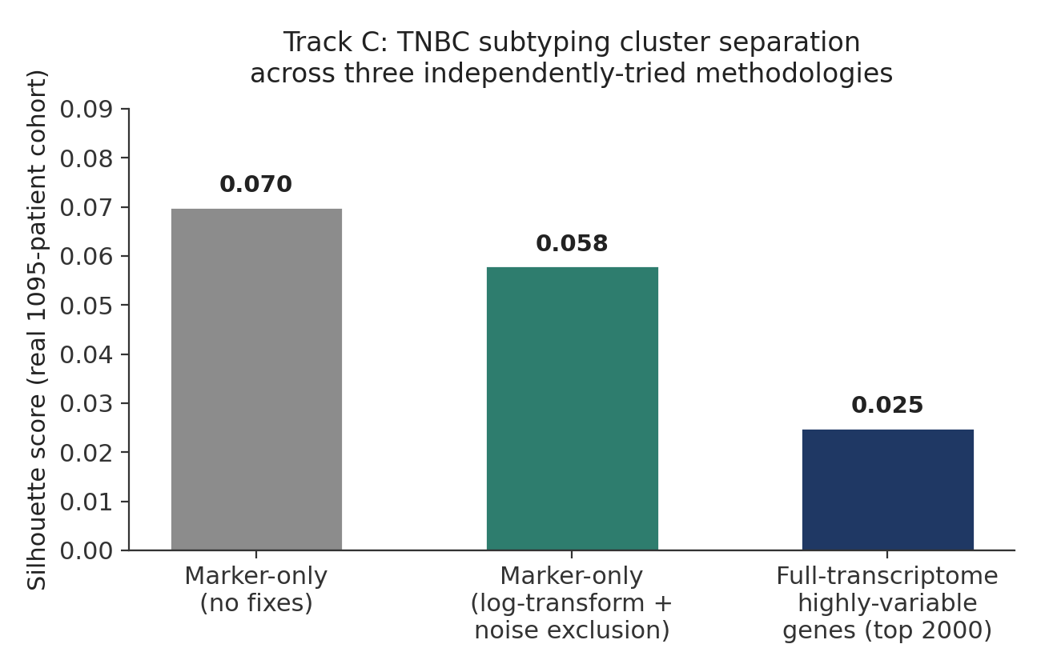
Figure S1. Silhouette scores (cluster separation quality) across three independently-designed clustering strategies applied to a real 1,095-patient TCGA-BRCA cohort, evaluating TNBC molecular subtype as a candidate fifth CTS evidence layer (Section 2.10). All three converge on weak separation, supporting the exclusion decision discussed in Section 5.5.

Supplementary Figure S2
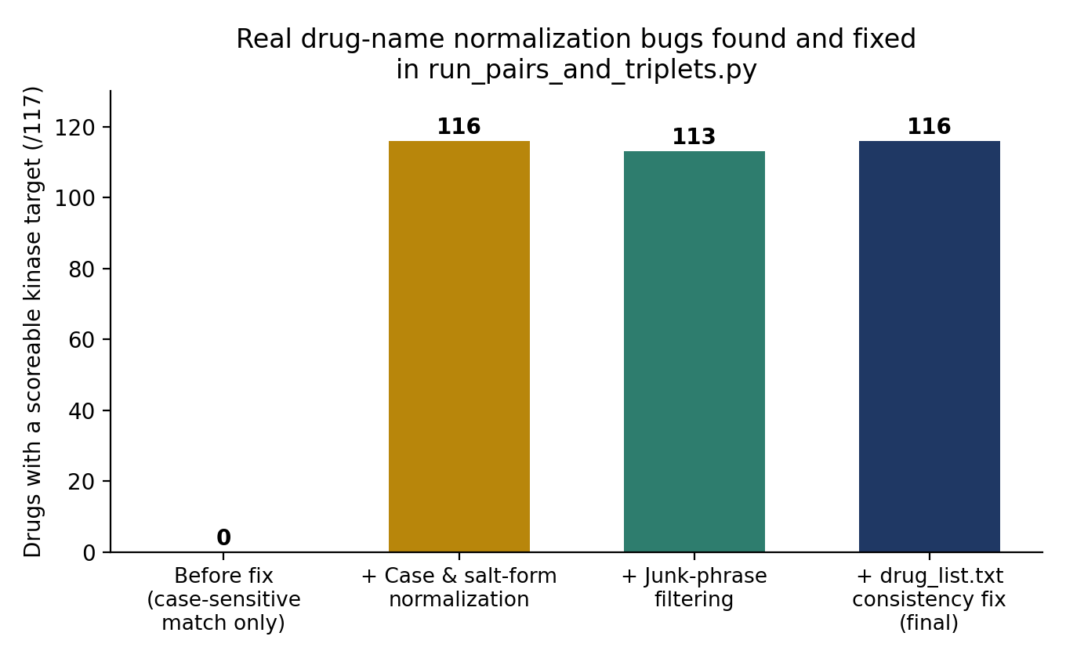
Figure S2. Cumulative effect of three independently-diagnosed drug-name normalization issues on real-drug-target matching for a 117-drug curated list, referenced in Section 4.9.

