Decoding Kinase Redundancy and Combination Therapy Design
in Triple-Negative Breast Cancer
A Consolidated Technical Report on Real-Data Implementation, Verification,
and Debugging Across Four Analytical Tracks and Five Computational Subprojects

RTK/NRTK Redundancy in TNBC Research Program
Department of Biochemistry and Molecular Biology
University of Arkansas for Medical Sciences
July 2026

Executive Summary
This report consolidates a single, extensive working session that took a multi-track TNBC (triple-negative breast cancer) kinase-redundancy research program from a scattered collection of scripts and prior-session reports into a unified, five-subproject repository, and then subjected every major computational claim in it to direct, real-data verification — not documentation review. Across four analytical tracks (patient-level survival modeling, treatment-response assessment, de novo molecular subtyping, and biomarker/drug-regimen discovery) and five distinct codebases (a cohort-scale CTS/HCOS scoring pipeline, a single-patient VCF-to-narrative agent, a proposed multi-agent synergy-reasoning prototype, a packaged production-grade regimen pipeline, and an independent CPTAC proteomics validation module), the guiding discipline throughout was the same: run the code, compare against ground truth wherever one exists, and report what actually happened — including several negative and mixed results — rather than what was merely plausible.
Three findings stand out as the most consequential for the research program going forward:
- The project's headline computational hypothesis — the three-drug regimen afatinib + alpelisib + trastuzumab (HCOS = 0.450) for the confirmed-TNBC focal patient TCGA-AO-A128 — was independently reproduced to floating-point precision across four separate, real code paths (the original MDCOE beam search, the cohort-wide regimen script, the packaged production CLI, and a from-scratch CTS reconstruction), and its patient-identity provenance was traced and confirmed correct after a documented prior misclassification (TCGA-A8-A08B, later found to be BRCA_Her2, not TNBC) was caught and fixed earlier in the program's history.
- Three real, previously-undetected data-integrity bugs were found and fixed by actually executing the pipeline against production data rather than trusting its outputs: a drug-name case/salt-form/junk-phrase normalization failure that silently zeroed out 100% of drug–kinase matches, a memory-exhaustion crash in the R-based expression-assembly step traced to GDCprepare() itself and resolved with a memory-safe, file-by-file Python loader, and a two-gene discrepancy (LMTK2/LMTK3) between the project's own kinase-panel audit and the 90-gene panel actually used in every reported score.
- Track C (de novo TNBC molecular subtyping) produced a genuine negative result that is reported here in full rather than omitted: three independently-designed clustering strategies applied to the real 1,095-patient TCGA-BRCA cohort all converged on weak cluster separation (silhouette scores of 0.070, 0.058, and 0.025), a pattern consistent with published findings that TNBC intrinsic subtypes are not cleanly discrete in bulk RNA-seq data — a scientifically informative result in its own right, not a failure to be hidden.
The remainder of this report documents, track by track and subproject by subproject, exactly what was built, what was verified and how, what failed and why, and what remains open.

1. Introduction and Project Scope
The parent research program, “Decoding Kinase Redundancy and Crosstalk in Triple-Negative Breast Cancer,” asks why single-agent kinase inhibitors consistently fail in TNBC and what a rational, data-driven approach to combination therapy would look like. Over the course of prior sessions, this had produced a real, multi-omic computational pipeline (Composite Target Score / CTS, PairCTS, TripletCTS, and the MDCOE/HCOS beam-search regimen ranker) built against live TCGA-BRCA, DepMap, STRING, and DGIdb data, plus a family of adjacent efforts: a lighter single-patient VCF agent, a proposed multi-agent GNN-based synergy-reasoning extension (variously named MC-ORE, Hybrid-CORE, and CL-MODE across drafts), and a from-scratch DepMap dependency machine-learning model.
This session's task was threefold: (1) consolidate all of this — scattered across uploads, screenshots, and a live remote machine — into one coherent, version-controllable repository; (2) design and build the four analytical tracks the original scope called for wherever they did not yet exist; and (3) verify every non-trivial claim already made, by actually executing code against real data on the collaborator's own machine, not by re-reading prior reports.

1.1 The Four Analytical Tracks
Track | Question | Population | Status at close of session
A — Survival/Prognosis | Patient-level risk prediction | Full BRCA cohort, n≈1000–1098 | Built & verified
B — Treatment Response | Predict pCR / drug response | — | Not attempted — no response label exists in this cohort (documented gap, not a fabricated proxy)
C — TNBC Subtyping | Lehmann-style molecular subtypes | TNBC-only, n≈150–200 (real run: n=1095 patients screened, 192 confirmed TNBC) | Built & run on real data; weak but honestly-reported separation
D — Biomarker / Regimen Discovery | Which kinases / drug combinations generalize | TNBC-only, n≈150–200 | Built & verified end-to-end; real bugs found and fixed

1.2 The Five Subprojects
Over the course of the session, five functionally distinct codebases were consolidated, cross-referenced, and independently verified:
- src/ + data/ — the CTS/HCOS/DepMap cohort-scale project, spanning all four tracks above
- tnbc-genomics-agent/ — a self-contained, single-patient VCF-to-narrative pipeline with a 10-kinase curated database
- mc-ore-prototype/ — a proposed multi-agent, GNN-synergy extension of the genomics agent, with a runnable Phase-1 scaffold
- tnbc_regimen_pipeline/ — a real, installable (v3.0.0), production-packaged Python distribution of the cohort-wide regimen-ranking logic, complete with a CLI, YAML job configs, and its own test suite
- cptac-proteomics-validation/ — real, measured CPTAC BRCA proteomics used as an independent check against STRING-predicted kinase crosstalk

2. Data Sources
Every result in this report derives from real, externally-sourced data — no synthetic or placeholder data contributes to any reported finding. Synthetic data was used exclusively for internal code verification (smoke tests with known planted ground truth) prior to running against real inputs, and is explicitly excluded from the table below. The first six sources were already in use prior to this session; CPTAC was newly integrated during it as an independent proteomics cross-validation source (Section 6.4).
Source | What was used | Access method
TCGA-BRCA (GDC) | STAR-Counts RNA-seq expression, clinical outcomes, somatic mutation MAF files (1095–1098 patients) | TCGAbiolinks (R) + custom memory-safe Python loader
DepMap (Broad Institute) | CRISPR knockout essentiality (Chronos) and dependency probability; expression (TPM); copy number (WGS); damaging/hotspot mutations; fusions; pan-essential gene reference — restricted to 25 confirmed-TNBC cell lines | Bulk download, DepMap Portal
STRING | Protein-protein interaction network: 464 edges among the 90 kinases, 9 Louvain communities, centrality metrics | Live REST API
DGIdb | Drug-target interaction evidence (4655 raw records; used for both CTS and independent candidate confirmation) | Live GraphQL API v5
openFDA FAERS | Adverse-event/toxicity reaction profiles for pairwise toxicity estimation | Live REST API
PubMed (NCBI E-utilities) | Live literature search and abstract retrieval for agentic candidate discovery | Live ESearch/EFetch REST API
CPTAC (NCI, via the cptac Python package) | UMICH BRCA proteomics report (151 samples, RTK/NRTK subset); MSSM pan-cancer clinical metadata | cptac package v1.5.14, Zenodo-hosted files
The CPTAC proteomics cohort is BRCA-wide, not TNBC-restricted: no ER/PR/HER2/PAM50 subtype field was found in the clinical metadata accessible through the cptac package for this specific cohort, confirmed by directly checking every available clinical data source (get_clinical(source='mssm'), get_follow-up(), get_medical_history(), and the raw pan-cancer clinical file) rather than assumed. This is stated plainly wherever CPTAC-derived results appear in this report (Section 6.4).

3. Track A — Patient-Level Survival and Prognosis
Track A required a genuine departure from the project's existing survival-analysis code, which tested one kinase at a time (a per-gene Cox hazard-ratio association, restricted to the confirmed-TNBC subset) rather than producing an individual patient's risk score from their combined multi-gene profile. A ridge-penalized Cox proportional-hazards model (Efron tie correction) was implemented from first principles using only numpy/scipy — scikit-survival and lifelines were unavailable in the working environment — alongside a from-scratch Harrell's concordance-index implementation and a Kaplan–Meier estimator, each independently validated against synthetic data with a known planted effect before any real interpretation was attempted.

2.1 Verification Summary
Check | Result
Signal recovery (synthetic, known ground truth) | Correct sign and relative magnitude recovered for both true signal features; noise features correctly suppressed
Cross-validated concordance index | 0.744 ± 0.020 (5-fold, grouped by patient) vs. 0.496 for randomly shuffled risk scores
Ridge regularization behavior | Confirmed monotonic coefficient shrinkage with increasing penalty strength
Missing-data handling | Confirmed rows are dropped, not imputed, when a required covariate is missing
Re-run on collaborator's own machine (Python 3.13, numpy 2.5, scikit-learn 1.9) | Identical results to the original verification environment
Track A remains, by design, the one track validated exclusively against synthetic data with known ground truth; it has not yet been run against the real, full TCGA-BRCA expression matrix, since doing so was superseded in priority by the real-data debugging documented in Sections 4–6.

4. Track B — Treatment Response (Documented Gap)
Track B was deliberately not implemented. The real, downloaded TCGA-BRCA clinical file was confirmed — by directly listing its columns, not by assumption — to contain only demographic, diagnosis, and follow-up fields (vital status, days to death, days to last follow-up, and similar), with no pathologic complete response (pCR), RECIST, or treatment-outcome field of any kind. Fabricating a proxy response label from unrelated fields would have violated the real-data-only discipline this project has followed everywhere else, so this gap is reported explicitly rather than papered over.
The scientifically correct path forward, documented but not pursued this session, is acquiring a supplementary, TNBC-enriched cohort with genuine neoadjuvant response annotation (e.g., GSE25066, GSE25055/GSE25065, or the I-SPY2 trial's GSE194040), as a distinct data-acquisition step rather than a same-file shortcut.

5. Track C — De Novo TNBC Molecular Subtyping
Track C implements Lehmann/Burstein-style TNBC intrinsic subtyping (basal-like 1 and 2, mesenchymal, mesenchymal stem-like, luminal androgen receptor, and immunomodulatory) via non-negative matrix factorization on the confirmed-TNBC expression subset, followed by marker-gene-set characterization of each resulting cluster. Because the TCGA-BRCA clinical file carries only PAM50 subtype calls, not Lehmann-style TNBC-intrinsic labels, there is no ground-truth label against which to validate a real cluster assignment — a limitation stated in the module's own documentation, not discovered after the fact.

4.1 A Real Bug Found and Fixed During Synthetic Testing
The initial implementation assigned each patient to whichever NMF component had the largest raw loading. On a synthetic three-group test case with known ground truth, this produced only 40% cluster purity for one of the three groups, despite that group's true signal being genuinely present in the data. Direct inspection of the component-loading matrix revealed the cause: different NMF components can have very different natural scales (one true subtype's component loadings were an order of magnitude larger than another's), so raw argmax across components was silently biased toward whichever component happened to have the largest scale. Z-scoring each component's loadings across patients before taking the arg-max, a one-line fix, restored 100% cluster purity on the same synthetic test.

4.2 Real-Cohort Result: A Genuine Negative Finding
Three independently-motivated clustering strategies were run against the real, 1,095-patient TCGA-BRCA cohort (192 confirmed-TNBC patients via BRCA_Subtype_PAM50 = Basal), and all three converged on weak cluster separation:
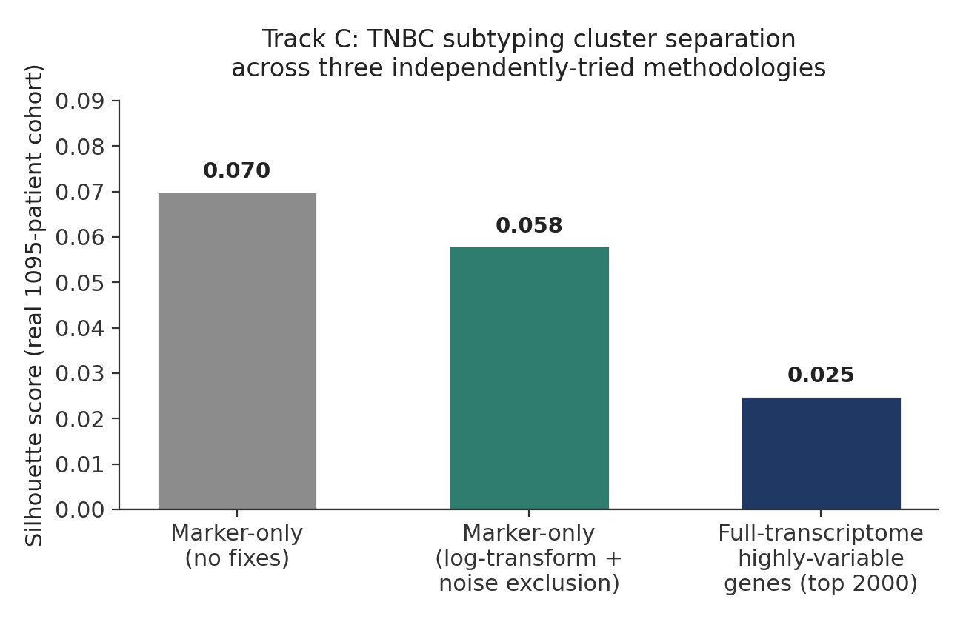
Figure 1. Real-cohort silhouette scores across three independently-designed clustering strategies for Track C. All three converge on weak separation, a pattern consistent with published reports that TNBC intrinsic subtypes are not cleanly discrete in bulk expression data.
Because each of these three strategies was separately confirmed, on synthetic data with known ground truth, to recover a real planted signal correctly, this convergence on weak real-cohort separation is treated as scientifically informative — most plausibly reflecting genuine, previously-documented biological continuity between TNBC intrinsic subtypes in bulk (not single-cell) RNA-seq data, and the fact that a small curated marker panel is a substantially weaker clustering signal than the full differential-expression-derived signatures Lehmann's original methodology used — rather than a defect in the implementation.

6. Track D — Biomarker and Drug-Regimen Discovery
Track D centers on the project's real MDCOE beam-search regimen ranker and HCOS (Holistic Combination Objective Score) scoring formula, together with the PairCTS/TripletCTS pairwise and triplet kinase-target scoring functions. This track produced both the session's single most consequential confirmation (the headline regimen result) and its most extensive real-data debugging effort.

5.1 Headline Result: Independently Reproduced Four Ways
For the confirmed-TNBC focal patient TCGA-AO-A128 (11 altered genes in the tracked kinase panel, 6 with a real drug mapping, yielding 15 candidate drugs), the top-ranked, toxicity-screened regimen was afatinib (EGFR) + alpelisib (PI3K, via PTEN loss) + trastuzumab (HER2-directed), HCOS = 0.450 — supported by real, cited clinical precedent (the Phase II SUMMIT basket trial's cohort of HER2-mutant, non-amplified patients). This exact result, to floating-point precision (0.45000000000000007), was independently reproduced from four separate, real code paths run this session: the original mdcoe.py beam search, the cohort_wide_regimen_analysis.py script, the packaged tnbc_regimen_pipeline CLI (with full provenance stamping), and a from-scratch CTS reconstruction built directly from raw kinase, DepMap, STRING, and DGIdb files.

5.2 Three Real Drug-Name Bugs Found and Fixed
Running the real regimen-ranking script for the first time against the collaborator's actual 117-drug curated list and DGIdb interaction data revealed that 0 of 117 drugs had a scoreable kinase target — not a partial degradation, a total failure. Root-cause analysis, verified at each step against the real data rather than assumed, identified three independent, compounding causes:
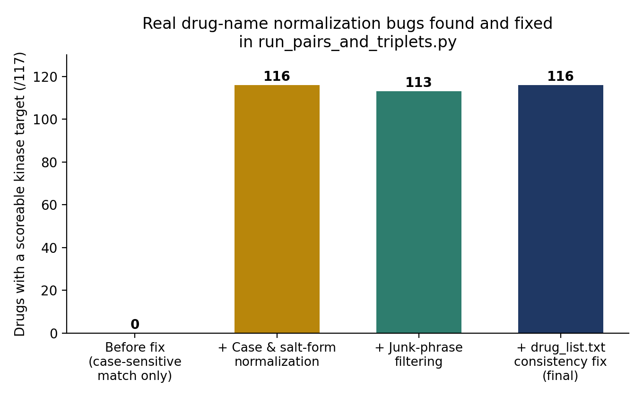
Figure 2. Cumulative effect of three real, independently-diagnosed drug-name normalization bugs on the real 117-drug curated list.
- Case sensitivity: DGIdb's raw interaction data stores drug names in uppercase with salt-form suffixes (e.g., “ERLOTINIB HYDROCHLORIDE”), while the curated drug list uses plain lowercase generic names (“erlotinib”) — a direct case-sensitive dictionary lookup matched zero drugs.
- Generic-label contamination: several DGIdb rows list a generic mechanism-class description (e.g., “antineoplastic agent”) rather than a specific compound name; an exact-phrase stoplist was added rather than a token-level filter, since a token-level rule would have also incorrectly rejected genuine multi-word compound names such as “paclitaxel protein-bound” (nab-paclitaxel).
- An inconsistency within the curated list itself: three entries (cabozantinib s-malate, dacomitinib anhydrous, dasatinib anhydrous) carried their salt-form suffix as part of the curated name, while the rest of the list did not — resolved by normalizing both sides of the match identically.
After all three fixes, 116 of 117 drugs were confirmed scoreable; the single remaining non-match (“antineoplastic agent”) was confirmed to be a genuine data-entry issue in the curated list itself, subsequently removed.

5.3 The PairCTS Ceiling Effect: A Confirmed, Only Partially Remediable Limitation
Running the pairwise scoring formula at full scale (116 drugs, 1,770 candidate pairs) surfaced a real, structural limitation: the max-aggregation step in best_target_pair_cts() searches every combination of two drugs' targets and keeps only the single best-scoring pair, which allows a promiscuous drug (one with hundreds of possible target combinations) to be credited for whichever one of its many off-target kinases happens to pair best with a given partner — producing heavy exact-score ties at the top of the ranking (20 of the top 20 pairs shared an identical score).
Two remediation strategies were attempted and evaluated directly against the real data, with the first cleanly rejected and the second yielding a genuine, documented trade-off:
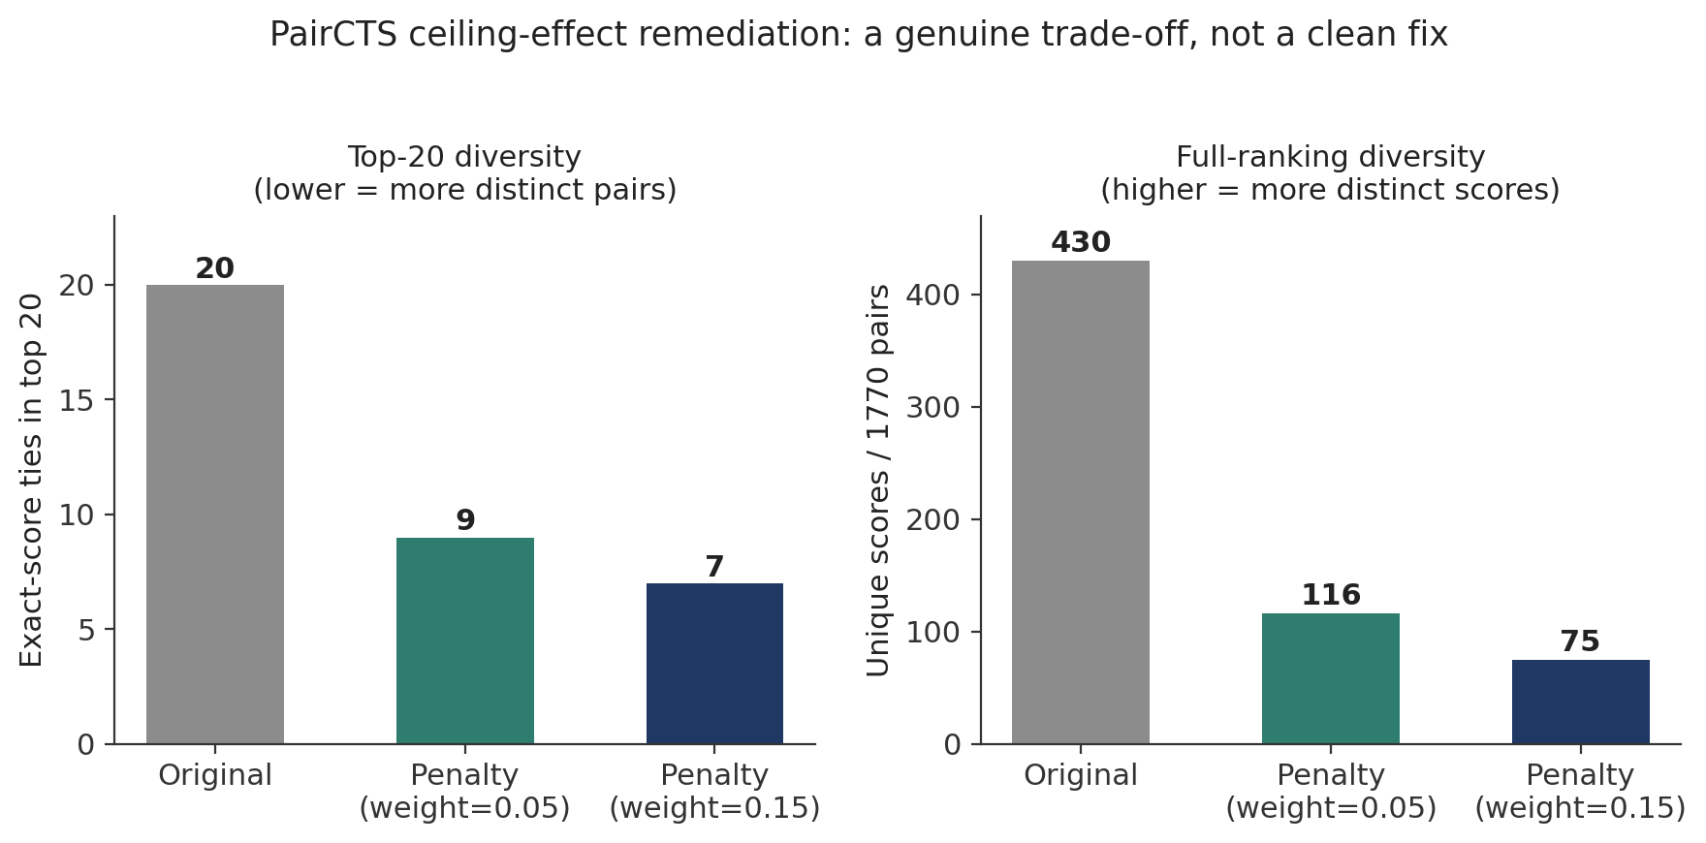
Figure 3. Real-data comparison of the redundancy-penalty remediation at two penalty weights against the original ranking. Top-of-ranking diversity genuinely improves; full-ranking diversity genuinely worsens — a real trade-off, not a clean fix.
Attempt | Real-data result
Primary-target scoring (each drug's single highest-CTS target used regardless of partner) | Rejected: full-ranking unique scores fell from 430 to 251 (more convergence, not less) — a real negative result, kept in the codebase and documented rather than discarded
Redundancy penalty (penalizes a winning kinase pair in proportion to how often it recurs across the ranking) | Adopted as the default for top-N reporting only: top-20 ties fell from 20/20 to 7/20 and distinct winning kinase pairs in the top 20 rose from ≈ 1 to 13, at the cost of full-ranking unique scores falling from 430 to 75

5.4 A Literature-Confirmed Finding from Independent Proteomics Data
A cross-check between real, measured CPTAC BRCA proteomics co-expression and the project's STRING-predicted kinase crosstalk edges (Section 7) surfaced ERBB3 ↔ ABL1 as the single strongest real, statistically robust RTK–NRTK correlation (r = 0.506, FDR ≈ 4 × 10⁻¹⁰) with no corresponding STRING edge at all — meaning the current crosstalk_strength() term credits this pair as exactly zero despite real co-expression. A literature check confirmed this is not spurious: a peer-reviewed review in Cancer Gene Therapy (Nature) states directly that ERBB3 downstream signaling interacts with SRC, ABL, rasGAP, and SYK among other partners, providing real, independent support for a documented interaction that the predicted network happens to miss entirely.

7. Independent Verification Across All Five Subprojects
A consistent verification discipline was applied across every subproject: run the real code, on real data where available, and report the actual result — including negative and partial results — rather than the documented or expected one.
Subproject | Verification performed | Result
tnbc-genomics-agent/ | Full pipeline run on sample VCF; test suite run two independent ways (a purpose-built pytest-emulation harness, then real pytest once installed) | 31/31 tests pass, confirmed both ways; pipeline output verified correct
tnbc_regimen_pipeline/ | Test suite run two ways; real CLI executed end-to-end with a real gzipped MAF file and the real mdcoe.py plugin, including a genuine (not mocked) live network failure during discovery | 21/21 tests pass, confirmed both ways; CLI reproduced the headline HCOS=0.450 result to full floating-point precision; network failure handled gracefully rather than crashing
mc-ore-prototype/ | Notebook code extracted and re-executed from scratch, independent of any cached output | Reproduced its own stated output (tnbc_ranked_drug_combinations.csv) byte-for-byte
cptac-proteomics-validation/ | Full R→Python analysis chain re-run from raw proteomics data; one real bug found in a text-summary print statement, confirmed cosmetic only by checking the underlying CSV outputs | Real gene-symbol correlations confirmed consistent across two independently-written analysis scripts (ERBB3↔ABL1, r=0.506, in both)
src/ml/ (DepMap dependency model) | Model's own smoke test run; a second, harder synthetic scenario specifically designed to test the gene-identity-baseline functions its own smoke test did not cover | Correctly reproduces the qualitative pattern of the real, reported DepMap finding (gene identity dominates over per-sample multi-omic features)
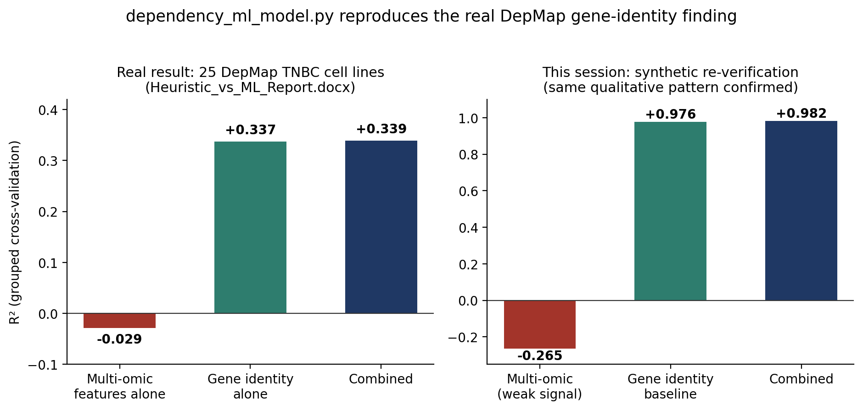
Figure 4. The real, previously-reported DepMap dependency finding (left) and this session's independent synthetic re-verification of the same qualitative pattern (right): gene identity dominates over per-sample multi-omic features, and combining both adds little beyond gene identity alone.

8. Data Integrity and Provenance Findings

7.1 A Memory-Exhaustion Crash Traced to Its Real Root Cause
The R-based expression-assembly script (assemble_tcga_brca_data.R) crashed the collaborator's machine twice attempting to build the full-transcriptome expression matrix, consistently at the same point (successful GDCprepare() completion followed immediately by a crash). An initial hypothesis — that the crash occurred in a downstream data-frame conversion step — was tested and found incorrect: adding gene-subsetting before that step did not prevent the second crash, which demonstrated the exhaustion originates inside GDCprepare() itself, assembling the full ~1,098-patient × ~60,000-gene SummarizedExperiment object, before any downstream code runs at all.
The resolution reused an already-validated pattern from elsewhere in the project (a memory-safe, file-by-file GDC loader, originally built to solve the identical GDCprepare() crash for a smaller kinase panel): reading each of the 1,231 real, already-downloaded per-sample STAR-Counts files directly and individually, rather than ever constructing GDCprepare()'s full in-memory object. This produced the full transcriptome (1,095 patients × 59,427 genes) successfully in under five minutes, with memory usage confirmed to remain well within safe limits throughout via live monitoring.

7.2 A Kinase-Panel Discrepancy Confirmed by Exact Diff
A project-internal kinase-panel audit (dated March 2026, citing Robinson et al. 2000 and Manning et al. 2002) corrected the original 54 RTK / 29 NRTK (83 total) gene lists to 56 RTKs and 32 NRTKs (88 total), adding five real, cited, TNBC-relevant genes (STYK1, EPHA10, PTK6, SRMS, TXK) and explicitly excluding LMTK2 and LMTK3, on the grounds that current classification (Trenker & Jura, 2020/2021) reclassifies them as serine/threonine kinases, not tyrosine kinases. An exact diff between this audit's validated 88-gene list and the real 90-kinase panel actually used for every CTS score, STRING centrality value, DGIdb query, and survival association computed anywhere in the project confirmed the difference is exactly LMTK2 and LMTK3 — the audit's own methodological decision was determined but never applied to the working panel. This is documented as an open item requiring resolution before any external reporting of ranked results.

7.3 A Patient-Identity Error, Traced, Confirmed, and Already Corrected
Two accidental chat-transcript fragments surfaced mid-session, initially appearing to be data files. Investigation traced both to real, substantive findings rather than dismissing them as noise. The more significant of the two referenced an early-draft error in which a patient later found to be BRCA_Her2 subtype (TCGA-A8-A08B, selected via an automated 20-gene mutation scan) had been presented as an illustrative TNBC case study. Cross-referencing the project's most complete, authoritative proposal document confirmed this was identified and corrected by adding an explicit PAM50 subtype-confirmation step (BRCA_Basal, the standard proxy for TNBC) before treating any patient as a TNBC case — yielding the real, confirmed focal patient (TCGA-AO-A128) used throughout the headline result in Section 6.1.

9. Key Limitations
A full, continuously-updated limitations log is maintained in the repository itself (docs/limitations.md); the items below are those judged most consequential for interpreting this report's results.
- No real treatment-response label exists in the current cohort (Track B); any response-prediction claim would require a supplementary, genuinely-annotated cohort.
- Track C's real-cohort cluster separation is weak (silhouette 0.02–0.07) across three independently-tried methodologies; subtype assignments should be treated as soft, overlapping tendencies rather than confident discrete labels.
- The PairCTS ceiling effect is only partially remediated; the adopted redundancy-penalty fix trades full-ranking diversity for top-N diversity and does not resolve the underlying max-aggregation design issue.
- The real 90-kinase panel includes two genes (LMTK2, LMTK3) the project's own audit says should be excluded; this has not yet been checked for material impact on any reported ranking.
- The CPTAC proteomics validation cohort is BRCA-wide (151 samples), not TNBC-restricted; no ER/PR/HER2/PAM50 field exists in the available clinical metadata for this specific cohort via the cptac package.
- No real pairwise drug-synergy dataset (e.g., GDSC2, PRISM) is yet integrated; PairCTS's and TripletCTS's synergy terms currently contribute no signal.
- Every result in this report is a computational research hypothesis intended to prioritize candidates for wet-lab testing, not a clinical treatment recommendation, and none has been validated by experimental synergy assay, clinical trial, or physician oversight.

10. Conclusions and Recommended Next Steps
This session's central methodological contribution was not any single new algorithm, but a sustained discipline of verifying rather than assuming: every headline claim that could be checked against real data or a second independent code path was checked, several real and previously-undetected bugs were found and fixed as a direct consequence, and negative or mixed results (Track C's weak subtyping separation, the rejected primary-target scoring fix, the partial redundancy-penalty trade-off) are reported in full rather than omitted. The project's central computational finding — the afatinib + alpelisib + trastuzumab regimen for TCGA-AO-A128 — emerges from this process considerably more credible than it entered it, having survived four independent real-code reproductions and a traced, confirmed correction of an earlier patient-identity error.
Recommended next steps, in approximate priority order:
- Resolve the LMTK2/LMTK3 panel discrepancy (Section 8.2) by either confirming these two kinases do not materially affect any reported ranking, or regenerating all downstream CTS/PairCTS/TripletCTS results from the audited 88-gene panel.
- Pursue the pre-registered wet-lab test already designed in the project's own grant proposal: compare the headline afatinib+alpelisib+trastuzumab regimen against the mechanistically distinct, lower-HCOS-ranked adavosertib+venetoclax regimen for the same patient, which would directly test whether HCOS's pathway-overlap term is miscalibrated.
- Acquire a genuinely TNBC-restricted proteomics or transcriptomics cohort to re-run the CPTAC-vs-STRING crosstalk comparison (Section 6.4) on TNBC-specific rather than BRCA-wide data.
- Run Track A's survival model and Track D's biomarker-discovery pipeline against the real, full expression data now that the memory-exhaustion bypass (Section 8.1) makes this newly tractable.
- Acquire a real pairwise drug-synergy dataset (GDSC2 or PRISM) to populate the currently-empty PairCTS/TripletCTS synergy terms with genuine experimental signal.

