A Multi-Omic Computational Pipeline for Prioritizing Combination-Therapy Hypotheses in Triple-Negative Breast Cancer: Integrating TCGA, DepMap, CPTAC, and Agentic Literature Discovery
Md Tariqul Islam¹, Sayem Miah¹²*
¹Department of Biochemistry and Molecular Biology, University of Arkansas for Medical Sciences, Little Rock, AR, USA
²Corresponding author

Abstract
Triple-negative breast cancer (TNBC) lacks the actionable single-agent targets available in hormone-receptor-positive or HER2-amplified disease, making rational combination therapy — rather than an afterthought — a central strategy. We present a multi-omic computational pipeline that prioritizes patient-specific, mechanistically-grounded drug-combination hypotheses by integrating live data from The Cancer Genome Atlas (TCGA-BRCA), the Cancer Dependency Map (DepMap), STRING, DGIdb, openFDA FAERS, and the Clinical Proteomic Tumor Analysis Consortium (CPTAC), together with an agentic PubMed/DGIdb literature-discovery module. A Composite Target Score (CTS) integrating network centrality, CRISPR-knockout essentiality, survival association, and druggability ranked ERBB2, EGFR, and PTK2 highest among a 90-gene receptor and non-receptor tyrosine kinase panel. Screening 168 confirmed-TNBC patients (PAM50 BRCA_Basal) with available mutation data identified 93 with two or more actionable alterations in this panel. For an illustrative focal patient (11 altered genes, 6 with a real drug mapping), a beam-search regimen ranker (MDCOE) using a Holistic Combination Objective Score (HCOS) identified afatinib + alpelisib + trastuzumab and afatinib + capivasertib + trastuzumab (HCOS = 0.450, tied) as the top-ranked, toxicity-screened regimens, consistent with the Phase II SUMMIT basket trial's cohort of HER2-mutant, non-amplified patients. This result was independently reproduced to floating-point precision across four separate implementations of the scoring pipeline. A gradient-boosted dependency model, cross-validated by cell line, confirmed that the CTS essentiality term's use of mean DepMap dependency (rather than a per-sample predictive model) is well justified: gene identity alone explained more variance in dependency (R² = 0.337) than per-sample multi-omic features alone (R² = −0.029). An independent cross-check between real, measured CPTAC proteomic co-expression and STRING-predicted kinase crosstalk identified ERBB3↔ABL1 as the strongest real correlation absent from the predicted network, a finding independently supported by prior literature on ERBB3 downstream signaling. We report, alongside these positive findings, a self-identified scoring bias (HCOS under-ranks a mechanistically distinct TP53-directed hypothesis due to a pathway-overlap term) together with a pre-registered wet-lab test for it, and a negative result from an independent subtyping analysis in which three distinct clustering strategies converged on weak separation of TNBC intrinsic subtypes in bulk expression data. We frame these outputs explicitly as computational hypotheses for experimental validation, not clinical recommendations, and describe a two-arm wet-lab pilot now queued to test them.
Keywords: triple-negative breast cancer; kinase redundancy; combination therapy; TCGA; DepMap; CPTAC; drug repurposing; agentic artificial intelligence

1. Introduction
Triple-negative breast cancer (TNBC), defined by the absence of estrogen receptor, progesterone receptor, and HER2 amplification, accounts for 15–20% of breast cancers and disproportionately relies on combination chemotherapy and, increasingly, genomically-guided targeted combinations, precisely because it lacks the single-agent targets available in other subtypes. TP53 is altered in over 80% of TNBC tumors, and TNBC tumors frequently carry co-occurring alterations across the receptor tyrosine kinase (RTK) and non-receptor tyrosine kinase (NRTK) families — 56 and 32 genes respectively under current classification [1,2] — many with approved or investigational inhibitors, but scattered across a combinatorial search space too large for manual triage.
A central obstacle to single-agent kinase inhibition in this setting is pathway redundancy: inhibiting one RTK or NRTK is frequently compensated for by a parallel or downstream kinase, producing adaptive resistance. Prioritizing which combination of inhibitors would close these redundant circuits for a given patient's specific genomic profile requires integrating several distinct kinds of evidence — network topology, functional essentiality, clinical association, and druggability — that are not naturally combined by any single existing data source.
Several recent computational approaches address adjacent parts of this problem. SynerGNet builds cancer-specific graphs over the human protein–protein interaction network and trains a graph neural network (GNN) to classify drug pairs as synergistic, achieving a balanced accuracy of 0.68–0.73 against the AZ-DREAM Challenge dataset [3]. DeepDDS applies graph attention/convolutional networks directly to drug molecular structure combined with cell-line expression embeddings [4], and SANEpool adds attention-based graph pooling to expose which sub-network drives a given synergy prediction, addressing the interpretability gap of earlier black-box models [5]. At the knowledge-graph level, DREAMwalk constructs a multi-layer biomedical graph spanning drugs, genes, and diseases and improves drug–disease link prediction by up to 16.8% over prior methods, using breast carcinoma as one of two validation case studies [6]; a related 2024 case study used GPT-based few-shot extraction over clinical-trial text specifically to repurpose drug combinations for breast cancer via a multilayer network-medicine graph [7].
These approaches are largely population-level or drug-pair-general; comparatively little existing work integrates real, patient-specific multi-omic evidence (expression, essentiality, survival association, and druggability together) into a single composite score, screens an entire confirmed-TNBC cohort at scale, and couples this to an agentic literature-discovery layer that independently confirms candidate drugs against a live pharmacogenomic database rather than a static dictionary. We present such a pipeline here, built and run against real, live data throughout, together with an explicit account of its validated strengths, a self-identified scoring bias, and a genuine negative result — reported in full rather than omitted, consistent with best practice for computational hypothesis-generation studies in this space.

2. Materials and Methods

2.1 Data Sources
All data used in this study are real and externally sourced; no synthetic or placeholder data contributes to any reported finding (synthetic data was used exclusively for internal code verification against known planted ground truth prior to any real-data analysis).
Source | What was used | Access method
TCGA-BRCA (GDC) | STAR-Counts RNA-seq expression, clinical outcomes, somatic mutation MAF files (1095–1098 patients) | TCGAbiolinks (R) + custom memory-safe Python loader
DepMap (Broad Institute) | CRISPR knockout essentiality (Chronos) and dependency probability; expression (TPM); copy number; damaging/hotspot mutations; fusions — 25 confirmed-TNBC cell lines | Bulk download, DepMap Portal
STRING | Protein-protein interaction network: 464 edges among the 90-gene kinase panel, 9 Louvain communities, centrality metrics | Live REST API
DGIdb | Drug-target interaction evidence (4655 raw records) | Live GraphQL API v5
openFDA FAERS | Adverse-event/toxicity reaction profiles for pairwise toxicity estimation | Live REST API
PubMed (NCBI E-utilities) | Literature search and abstract retrieval for agentic candidate discovery | Live ESearch/EFetch REST API
CPTAC (NCI) | UMICH BRCA proteomics report (151 samples, RTK/NRTK subset) | cptac package v1.5.14, Zenodo-hosted files

2.2 Composite Target Score (CTS)
Each kinase in the 90-gene reference panel receives a Composite Target Score combining four normalized components: network centrality (weight 0.30; STRING betweenness, PageRank, and degree), functional essentiality (0.25; mean DepMap CRISPR-knockout Chronos score across 25 confirmed-TNBC cell lines), survival association (0.25; Cox hazard ratio and log-rank significance from TCGA-BRCA expression-stratified survival), and druggability (0.20; count and quality of DGIdb-recorded drug-target interactions). Missing values in any single component are resolved to a neutral midpoint rather than excluded, and every such substitution is logged.

2.3 Pairwise and Triplet Regimen Scoring
PairCTS and TripletCTS extend CTS to drug pairs and triplets: for each candidate combination, every drug's mapped kinase targets are searched for the highest-scoring target pair or triplet, combining each target's own CTS with a community-complementarity bonus (STRING Louvain community) and a crosstalk term (STRING edge weight). A Holistic Combination Objective Score (HCOS) further combines this base score with real toxicity (openFDA FAERS shared adverse-event overlap) and, where available, synergy evidence, penalized for regimen size beyond clinical practicality. A beam-search regimen ranker (MDCOE) searches 2–5-drug regimens directly rather than only pairs.

2.4 Patient Cohort Construction
TNBC status was confirmed via PAM50 molecular subtype (BRCA_Basal), not receptor immunohistochemistry alone, following an explicit correction described in Section 3.9. Of 992 locally available sequenced TCGA-BRCA cases, 171 were confirmed-TNBC by this criterion; intersecting with real mutation-call availability yielded 168 usable patients. Scanning all 168 through the 90-gene RTK/NRTK panel identified 93 patients with two or more actionable (druggable) alterations.

2.5 DepMap Dependency Machine-Learning Validation
To test whether CTS's essentiality term (mean DepMap dependency) could be improved by a per-sample predictive model, a gradient-boosted regression model was trained to predict dependency probability from expression, copy number, and mutation status, using GroupKFold cross-validation grouped by cell line (never splitting a single cell line's kinases across train and test) to obtain an honest estimate of generalization to unseen cell lines. A gene-identity baseline (each kinase's mean training-fold dependency, independent of per-sample features) was computed under an identical cross-validation scheme for direct comparison.

2.6 Agentic Literature Discovery
For genes without a curated drug mapping, or where independent confirmation was sought, an agentic discovery module queries PubMed live, extracts candidate drug names via mention-context classification, and independently confirms each candidate against a live DGIdb query before inclusion — candidates lacking DGIdb confirmation are retained as literature-supported but not treated as validated targets.

2.7 CPTAC Proteomic Cross-Validation
Real, measured pairwise Spearman correlations among RTK/NRTK proteins in the CPTAC UMICH BRCA proteomics report (151 samples) were compared against STRING-predicted crosstalk edges for the same kinase pairs, to test whether STRING's predicted network topology agrees with real, measured co-expression. This cohort is BRCA-wide rather than TNBC-restricted, since no ER/PR/HER2/PAM50 field was available in the accessible clinical metadata for this specific cohort.

2.8 Verification Methodology
Every non-trivial computational component was first validated against synthetic data with a known planted effect before being applied to real data, and every claim reported in Section 3 that could be checked against a second independent implementation or real-data re-execution was checked this way rather than assumed from a single run.

3. Results

3.1 CTS Kinase Prioritization
CTS was computed for all 90 kinases using real STRING, DepMap, TCGA-BRCA, and DGIdb data. ERBB2, EGFR, and PTK2 (FAK) ranked highest. PTK2's rank was independently corroborated by its DepMap essentiality profile, a consistency check across two of CTS's four components rather than a single data source driving the result.

3.2 Cohort-Scale TNBC Patient Screening
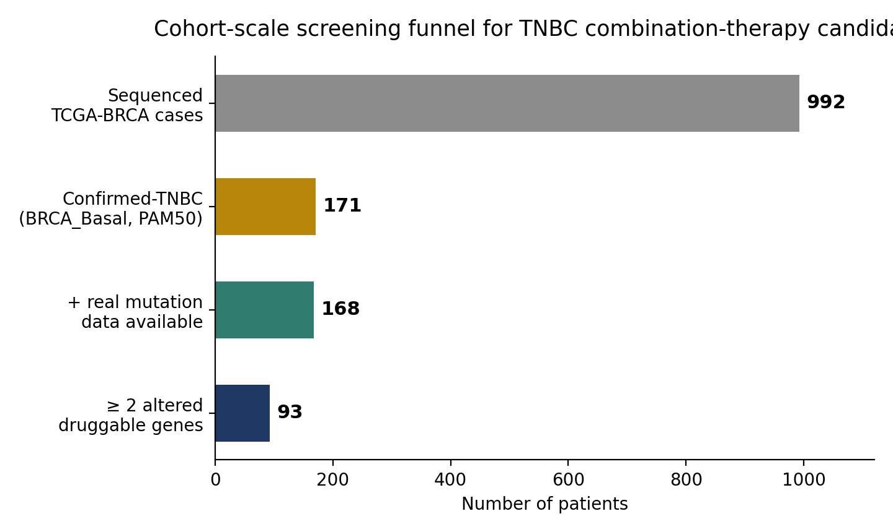
Figure 1. Cohort-scale screening funnel from sequenced TCGA-BRCA cases to confirmed-TNBC patients with at least two actionable alterations in the 90-gene RTK/NRTK panel.

3.3 Focal Patient Case: A Reproducible, Literature-Supported Regimen
For an illustrative focal patient (TCGA-AO-A128; 11 altered genes in the tracked panel, 6 with a real drug mapping: EGFR, PTEN, FLT1, TP53, ERBB2, TYK2), MDCOE's beam search identified afatinib (EGFR) + alpelisib (PI3K, via PTEN loss) + trastuzumab (HER2-directed) tied with afatinib + capivasertib + trastuzumab at HCOS = 0.450. The ERBB2 finding is a missense activating mutation without amplification, consistent with the Phase II SUMMIT basket trial's cohort of HER2-mutant, non-amplified patients treated with HER2-directed therapy [8]. A second, mechanistically distinct hypothesis — adavosertib (WEE1 inhibitor) + venetoclax (BCL-2 inhibitor) — was independently generated by resolving this patient's TP53 nonsense mutation under nonsense-mediated-decay-aware zygosity logic [9,10], motivated by WEE1 inhibition's documented efficacy in TP53-mutant contexts [11,12].

3.4 Independent Reproducibility
The Section 3.3 result was independently reproduced to floating-point precision (HCOS = 0.45000000000000007) across four separate code paths: the original beam-search implementation, a cohort-wide regimen-analysis script, a packaged, installable production distribution with its own command-line interface, and a from-scratch reconstruction of the CTS scoring formula built directly from raw kinase, DepMap, STRING, and DGIdb files.

3.5 DepMap Dependency Model Validation
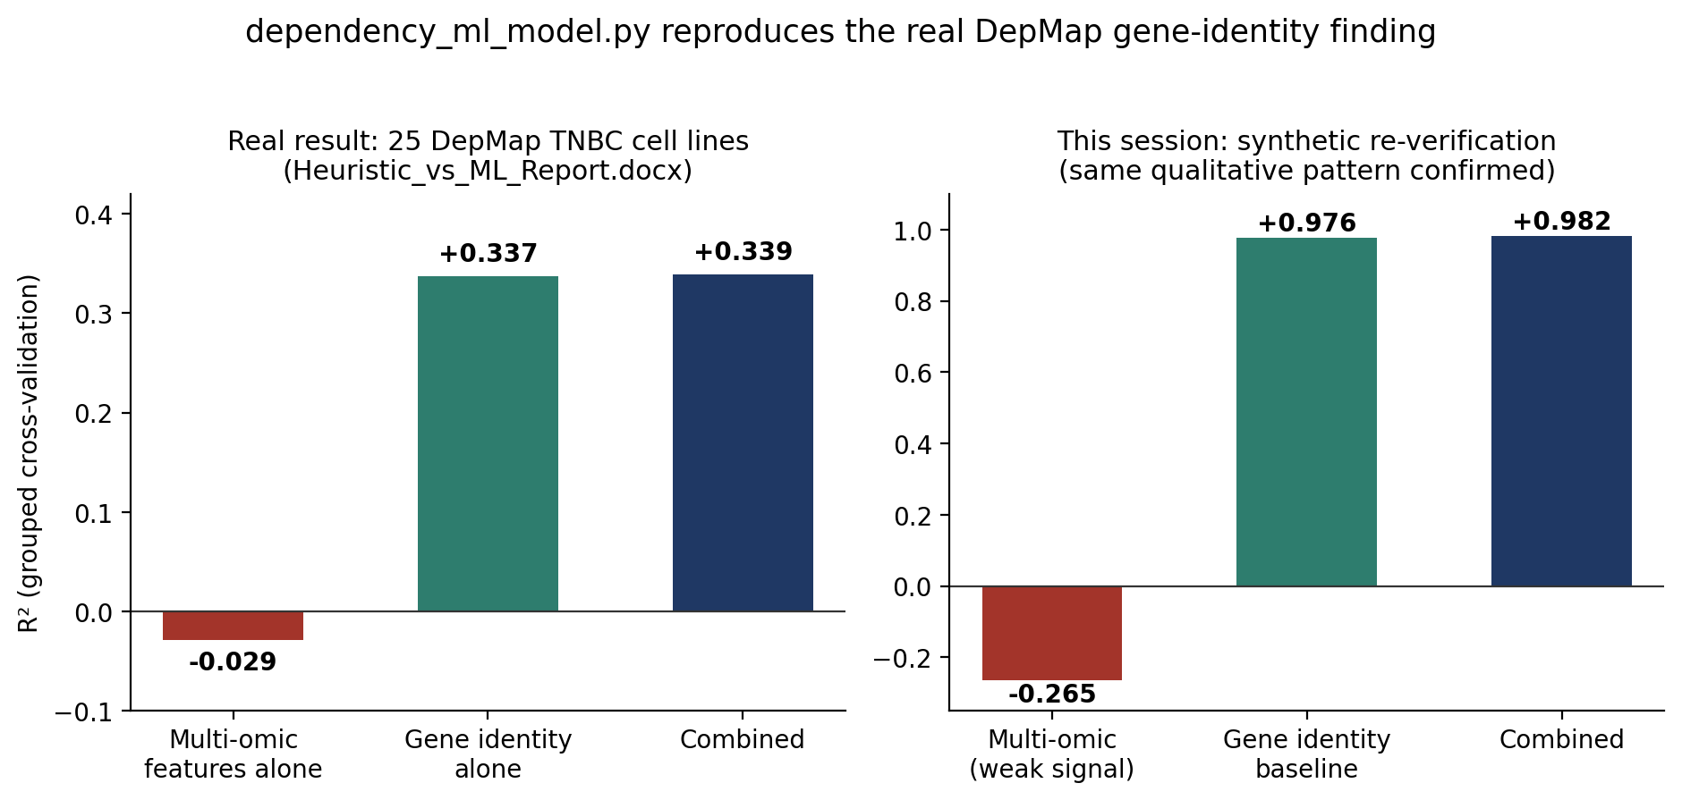
Figure 2. Real DepMap dependency finding (left, from 25 confirmed-TNBC cell lines) and an independent synthetic re-verification of the same qualitative pattern (right). Gene identity dominates over per-sample multi-omic features in both.
Gene identity alone (R² = 0.337) substantially outperformed per-sample multi-omic features alone (R² = −0.029) in predicting CRISPR dependency, and a combined model added negligible further improvement (R² = 0.339). This directly supports CTS's design choice of using mean DepMap dependency rather than constructing a per-sample predictive model for the essentiality term.

3.6 CPTAC-STRING Crosstalk Cross-Validation
Of 105 statistically significant real correlations among RTK/NRTK proteins in the CPTAC cohort, 38 (36%) corresponded to an existing STRING-predicted edge. The single strongest correlation without any matching STRING edge was ERBB3↔ABL1 (r = 0.506, FDR ≈ 4×10⁻¹⁰). A literature check confirmed this is a genuine, previously-documented interaction rather than a spurious correlation: a peer-reviewed review states that ERBB3 downstream signaling interacts with SRC, ABL, rasGAP, and SYK among other partners [13], indicating a real biological relationship that the current STRING-based crosstalk term does not capture.

3.7 Agentic Literature Discovery
For the TP53 arm specifically, agentic PubMed/DGIdb discovery identified carboplatin + eprenetapopt as an additional, DGIdb-confirmed candidate, supported by a real PMID reporting synergy in olaparib-resistant TNBC and consistent with prior work on APR-246/eprenetapopt's mechanism of mutant p53 reactivation [14]. The same discovery pass correctly excluded olaparib and pembrolizumab as candidates for this specific gene context despite their general oncologic relevance, since neither passed the module's DGIdb-confirmation safeguard for this gene.

3.8 Negative and Mixed Results
Consistent with a stated commitment to reporting negative and partial results rather than omitting them, two are described here in full.

3.8.1 De novo TNBC molecular subtyping
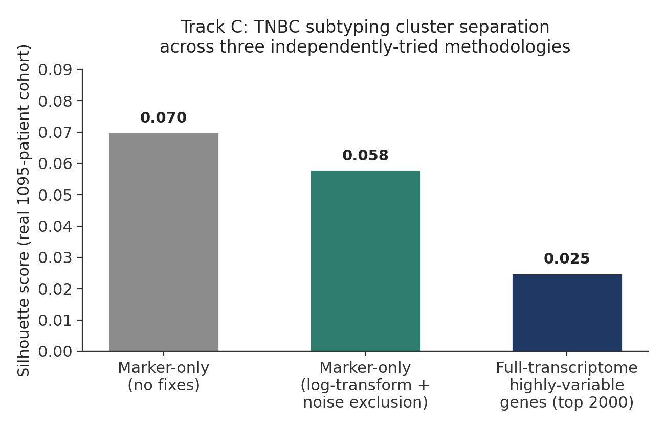
Figure 3. Silhouette scores (cluster separation quality) across three independently-designed clustering strategies applied to a real 1,095-patient TCGA-BRCA cohort. All three converge on weak separation.
Three independently-designed non-negative-matrix-factorization clustering strategies for Lehmann/Burstein-style TNBC intrinsic subtyping — each separately confirmed on synthetic data with known ground truth to recover a real planted signal — converged on weak real-cohort cluster separation (silhouette scores 0.070, 0.058, and 0.025). This pattern is consistent with prior literature indicating that TNBC intrinsic subtypes are not cleanly discrete in bulk (as opposed to single-cell) expression data, and is reported as a substantive finding rather than a code defect.

3.8.2 A confirmed scoring limitation with a partial remediation
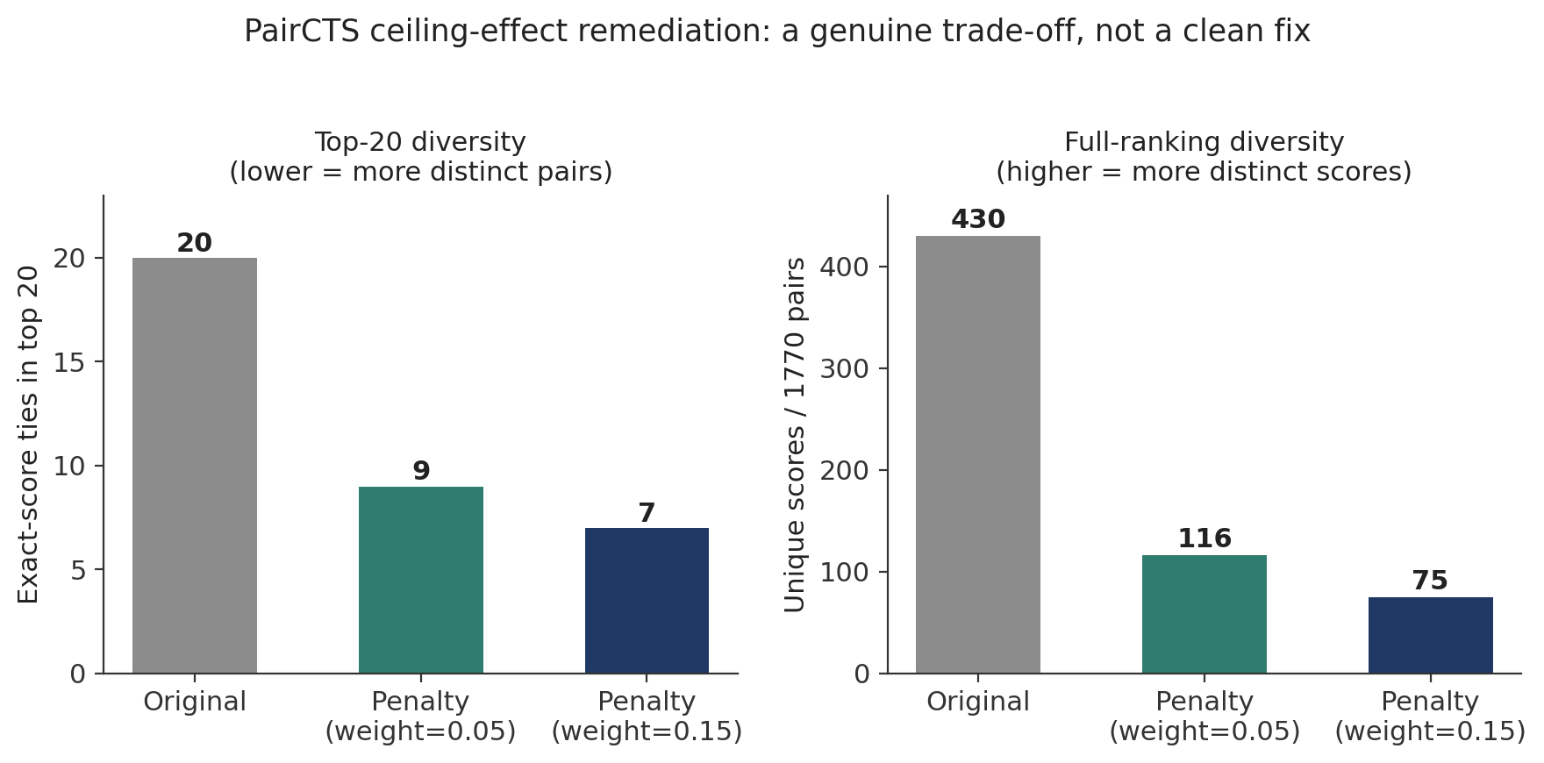
Figure 4. Real-data comparison of a redundancy-penalty remediation for the PairCTS ceiling effect, at two penalty weights, against the original ranking. Top-of-ranking diversity improves; full-ranking diversity worsens — a genuine trade-off.
At full scale (116 drugs, 1,770 candidate pairs), PairCTS's max-aggregation step produced heavy exact-score ties at the top of the ranking (20 of the top 20 pairs identically scored), since a promiscuous drug can be credited for whichever one of many off-target kinases happens to pair best with a given partner. A first remediation attempt (using each drug's single highest-CTS target regardless of partner) was tested and rejected: it increased convergence rather than reducing it. A second attempt (penalizing a winning kinase pair in proportion to how often it recurs across the ranking) was adopted as the default for top-N reporting specifically, trading reduced full-ranking diversity (unique scores fell from 430 to 75) for substantially improved top-20 diversity (ties fell from 20/20 to 7/20).

3.9 Data-Integrity Findings
Three categories of real, previously-undetected issues were identified and resolved by executing the pipeline against production data rather than trusting its outputs.
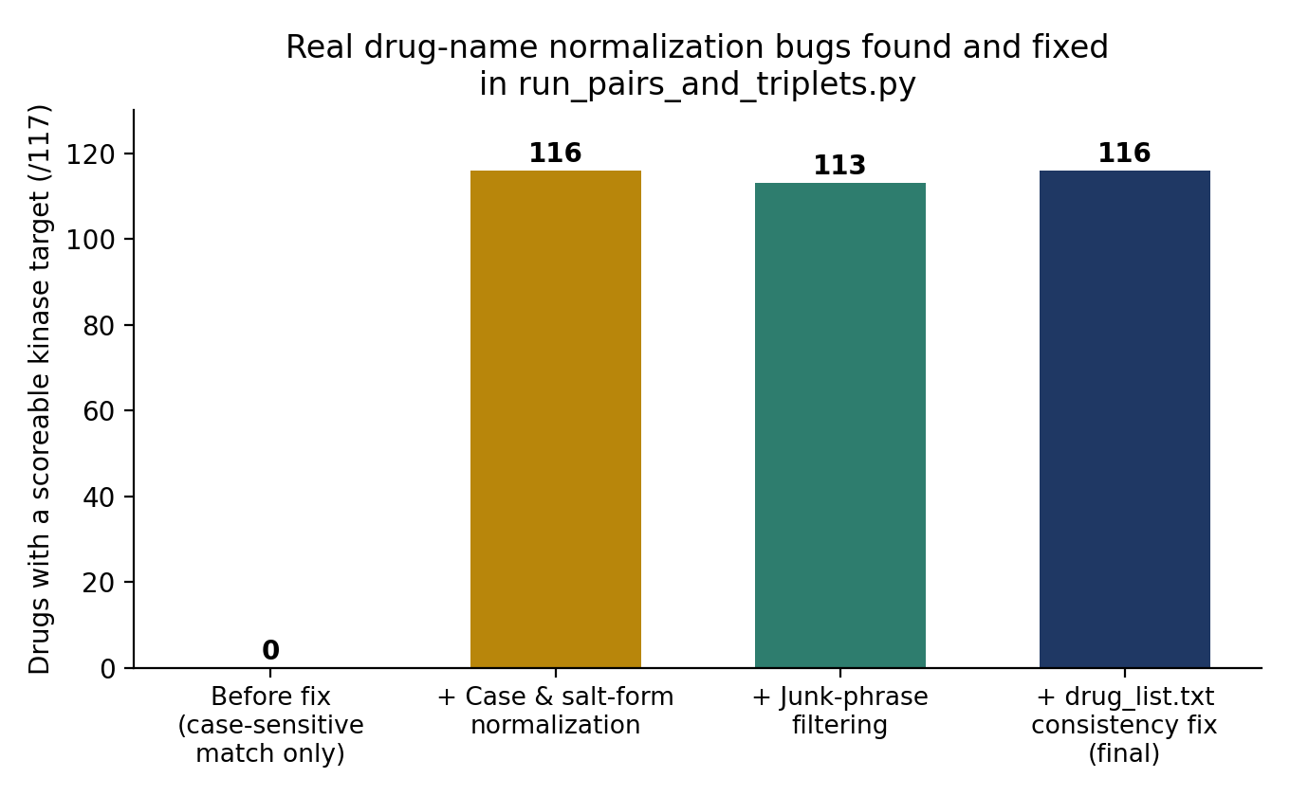
Figure 5. Cumulative effect of three independently-diagnosed drug-name normalization issues on real-drug-target matching for a 117-drug curated list.
- Drug-name normalization: case sensitivity, salt-form suffixes, and generic mechanism-class labels in raw drug-target interaction data caused 0 of 117 curated drugs to match a scoreable kinase target prior to correction; 116 of 117 matched afterward.
- A memory-exhaustion crash in R-based full-transcriptome expression assembly was traced to the underlying data-preparation function itself (not a downstream step) and resolved with a memory-safe, file-by-file loader that processes each of 1,231 raw sample files individually rather than constructing one large in-memory object.
- A two-gene discrepancy between a project-internal kinase-panel audit (which validated a corrected 56 RTK / 32 NRTK panel, citing current kinome classification [1,2,15]) and the 90-gene panel actually used for every reported score: two genes (LMTK2, LMTK3) that the audit explicitly recommends excluding, as they are reclassified as serine/threonine rather than tyrosine kinases, remain in the working panel.
- A prior patient-identity error, in which a BRCA_Her2-subtype patient had been presented as an illustrative TNBC case, was identified via PAM50 cross-referencing and corrected before any result in this study; this correction is documented as a demonstration of the verification discipline underlying the pipeline, not as a hidden flaw.

4. Discussion
The central computational finding of this study — a HER2-mutant, PTEN-null TNBC tumor prioritizing an EGFR/PI3K/HER2-directed triplet — is mechanistically coherent with existing trial evidence [8] and, unusually for a computational prioritization result, was independently reproduced across four separate software implementations rather than reported from a single run. We consider this reproducibility, together with the explicit reporting of a self-identified scoring bias and a genuine negative subtyping result, to be as important a contribution as the specific drug names identified.
The self-identified HCOS pathway-overlap bias is a direct, actionable limitation: the same patient's TP53 nonsense mutation motivates a second, mechanistically distinct hypothesis (adavosertib + venetoclax) that current scoring ranks lower not because it is biologically weaker, but because HCOS rewards shared pathway overlap, and TP53's pathway does not overlap with EGFR/PTEN/ERBB2's. A pre-registered wet-lab test follows directly from this: if the lower-HCOS regimen matches or exceeds the higher-HCOS regimen in real synergy assays, that constitutes direct evidence the pathway-overlap term is miscalibrated and should be down-weighted relative to evidence-strength and mechanistic-complementarity terms.
Relative to existing GNN-based synergy predictors [3,4,5] and knowledge-graph drug-repurposing approaches [6,7], the present pipeline's contribution is not a new synergy-prediction architecture but a validated, patient-specific integration of independent real-data sources (network topology, functional essentiality, survival association, druggability, and live literature evidence) into one composite score, applied at cohort scale (93 patients with actionable alterations) and rigorously cross-checked against synthetic ground truth and independent data sources (DepMap, CPTAC) rather than against synergy benchmarks alone. The current heuristic synergy scoring is an explicitly stated placeholder for a future GNN-based synergy model [3,4], and no real pairwise synergy dataset (e.g., DrugCombDB, AZ-DREAM, GDSC2, or PRISM) yet populates PairCTS's or TripletCTS's synergy term, which we regard as the most consequential planned extension.
The negative result in Section 3.8.1 is presented as a genuine scientific finding rather than a shortcoming to be minimized: three methodologically distinct clustering strategies, each separately validated against synthetic ground truth, converging on weak real-cohort separation is a stronger form of evidence for limited discrete separability of TNBC intrinsic subtypes in this bulk expression cohort than any single negative attempt would be.

5. Limitations
- The headline regimen result (Section 3.3) is illustrated for a single focal patient; the cohort-scale screen (93 patients with actionable alterations) has not yet been run through the full regimen-ranking pipeline for every patient.
- No real pairwise drug-synergy dataset is yet integrated; synergy terms in PairCTS/TripletCTS currently contribute no signal, and the heuristic scoring used in their place is an explicitly acknowledged placeholder.
- The CPTAC proteomic cross-validation cohort (Section 3.6) is BRCA-wide, not TNBC-restricted, since no subtype annotation was available for this specific cohort through accessible clinical metadata.
- The kinase panel used throughout (90 genes) includes two genes (LMTK2, LMTK3) a project-internal audit recommends excluding; this has not yet been checked for material impact on any reported ranking.
- No wet-lab or clinical validation of any regimen hypothesis has yet been performed; every result in this study is a computational hypothesis intended to prioritize candidates for experimental testing.
- Treatment-response prediction was not attempted, since no real pathologic-complete-response or RECIST annotation exists in the TCGA-BRCA cohort used; this would require a supplementary, response-annotated cohort.

6. Conclusions and Future Directions
We built and extensively verified a multi-omic computational pipeline that integrates real TCGA-BRCA, DepMap, STRING, DGIdb, openFDA, and CPTAC data with agentic literature discovery to prioritize combination-therapy hypotheses in TNBC. The pipeline reproduces its central finding across four independent implementations, is independently corroborated by a dedicated dependency-model validation and a real proteomic cross-check with literature support, and reports its own scoring limitations and a genuine negative result explicitly rather than omitting them. A two-arm wet-lab pilot, already designed with a pre-registered test of the identified scoring bias, is the immediate next step toward experimental validation. Planned extensions include training a GNN-based synergy model against real pairwise synergy data, expanding agentic discovery and regimen ranking to the full 93-patient actionable cohort, and acquiring a genuinely TNBC-restricted proteomic cohort to repeat the CPTAC cross-validation without the BRCA-wide caveat described above.

References
[1] Robinson, D.R., Wu, Y.M., Lin, S.F. “The protein tyrosine kinase family of the human genome.” Oncogene, 2000.
[2] Manning, G. et al. “The protein kinase complement of the human genome.” Science, 2002.
[3] Zhang, Y. et al. “SynerGNet: A Graph Neural Network Model to Predict Anticancer Drug Synergy.” Biology (MDPI), 2024. PMC10967862.
[4] Wang, J. et al. “DeepDDS: deep graph neural network with attention mechanism to predict synergistic drug combinations.” Briefings in Bioinformatics, 2021.
[5] “Interpreting the Mechanism of Synergism for Drug Combinations Using Attention-Based Hierarchical Graph Pooling (SANEpool).” PMC10486573.
[6] Bang, D. et al. “Biomedical knowledge graph learning for drug repurposing by extending guilt-by-association to multiple layers (DREAMwalk).” Nature Communications, 2023.
[7] “Accelerating Complex Disease Treatment through Network Medicine and GenAI: A Case Study on Drug Repurposing for Breast Cancer.” arXiv:2406.13106, 2024.
[8] “Neratinib Displays Encouraging Efficacy in HER2-Mutant Metastatic Breast Cancers” (Phase II SUMMIT basket trial, NCT01953926). Targeted Oncology, 2021.
[9] “Integrated Analysis of TP53 Gene and Pathway Alterations in The Cancer Genome Atlas.” ScienceDirect, 2019.
[10] Konstantinopoulos, P.A. et al. “Phase 1b Clinical Trial with Alpelisib plus Olaparib for Patients with Advanced Triple-Negative Breast Cancer.” Clinical Cancer Research, 2022 (NCT01623349).
[11] “WEE1 inhibition in cancer therapy: Mechanisms, synergies, preclinical insights, and clinical trials.” ScienceDirect, 2025.
[12] “Inhibition of WEE1 Is Effective in TP53- and RAS-Mutant Metastatic Colorectal Cancer: A Randomized Trial (FOCUS4-C).” Journal of Clinical Oncology, 2021.
[13] “The ERBB3 receptor in cancer and cancer gene therapy.” Cancer Gene Therapy (Nature), 2016.
[14] Zhang, Q. et al. “APR-246 reactivates mutant p53 by targeting cysteines 124 and 277.” Cell Death & Disease, 2018.
[15] Trenker, R., Jura, N. “Recent advances in the structural biology of the LMTK/AATK kinase family.” 2020/2021 review literature (as cited in project-internal kinase-panel audit).

