MULTI-AGENT AI FRAMEWORK FOR OPTIMAL
MULTI-DRUG COMBINATION THERAPY IN BREAST CANCER
Extending Rule-Based Kinase Redundancy Analysis with Graph Neural Networks, Knowledge-Graph-Grounded Retrieval, and Multi-Agent LLM Reasoning
A Proposed Research Extension to the tnbc-genomics-agent Pipeline
Bioinformatics · Multi-Agent AI · Graph Neural Networks · Precision Oncology
Research Proposal · Version 1.0 · July 2026

1. Executive Summary
Triple-negative breast cancer (TNBC) and other breast cancer subtypes that lack effective single-target therapy remain heavily dependent on combination regimens to overcome pathway redundancy and adaptive resistance. The existing tnbc-genomics-agent pipeline addressed this problem with a rule-based redundancy score and a single retrospective LLM narrative layer. That approach is a valuable first step, but it ranks candidate drug pairs purely by shared pathway membership, not by predicted pharmacological synergy, toxicity, or real-world trial evidence — three factors that determine whether a combination is actually effective and safe.
This report proposes a new approach, the Multi-Agent Combination Oncology Reasoning Engine (MC-ORE), which extends the existing four-layer pipeline into a five-layer system that combines (1) a graph neural network (GNN) synergy-prediction model trained on cancer-cell-line synergy data, (2) a biomedical knowledge graph linking kinases, drugs, pathways, and disease indications, (3) a retrieval-augmented generation (RAG) evidence layer indexing PubMed and clinical-trial literature, and (4) a multi-agent large language model (LLM) reasoning layer in which specialist agents — genomics, pharmacology/synergy, clinical evidence, and toxicity/safety — debate and reconcile findings into an explainable, ranked set of combination recommendations, with an optional (5) reinforcement-learning (RL) feedback layer for longitudinal refinement.
The design directly responds to limitations the original pipeline documentation itself identifies (a 10-gene knowledge base, purely rule-based scoring, and single-agent LLM synthesis), and it is grounded throughout in peer-reviewed literature on drug-synergy prediction, multi-agent clinical LLM systems, and knowledge-graph-based drug repurposing in breast cancer.

2. Motivation: Limitations of the Current Rule-Based Approach
The tnbc-genomics-agent pipeline computes a pathway redundancy score from the number of altered kinase genes feeding a shared downstream pathway, using a fixed sigmoid-like formula, and then enumerates all co-affected kinase pairs sharing a pathway as “combination suggestions,” ranked only by how much literature evidence exists for each pair. This design has three structural limitations that motivate a new approach:
- Pathway overlap is a proxy for synergy, not a measurement of it. Two kinases feeding the same pathway does not guarantee that co-inhibiting them produces a synergistic — rather than merely additive or even antagonistic — effect at the cellular level.
- Combination ranking ignores toxicity and pharmacokinetic interaction. A pair with strong pathway rationale may still be clinically unusable because of overlapping organ toxicity or drug-drug interactions — information the current rule-based ranking does not model.
- A single LLM synthesis step has no mechanism for adversarial checking. One reasoning pass over structured data cannot cross-examine its own conclusions against independent pharmacology or safety evidence, which limits how much clinicians can trust the ranked output without manual review.
Each of these gaps can be closed with AI techniques that have matured substantially since the original pipeline was designed: learned synergy-prediction models, knowledge-graph retrieval, and multi-agent LLM deliberation.

3. Related Work

3.1 Graph Neural Networks for Drug Synergy Prediction
Several recent models replace hand-crafted synergy heuristics with learned representations. SynerGNet builds cancer-specific featured graphs by mapping heterogeneous biological features onto the human protein–protein interaction (PPI) network and trains a GNN to classify drug pairs as synergistic; using AZ-DREAM Challenge data it reached a balanced accuracy of 0.68, improving to 0.73 with synthetic data augmentation, and generalised well on independent validation against DrugCombDB ^{[1]}.
DeepDDS applies graph attention/convolutional networks (GAT/GCN) directly to drug molecular graphs derived from SMILES structures, combined with cell-line gene-expression embeddings from the Cancer Cell Line Encyclopedia, to predict synergistic combinations ^{[2]}. SANEpool adds a hierarchical, attention-based graph-pooling mechanism that not only predicts a synergy score but also surfaces the specific gene–gene and gene–drug sub-networks driving the prediction, directly addressing the interpretability gap of earlier black-box synergy models ^{[3]}.
Complementary work has applied classical and deep machine learning to the O’Neil FDA-approved drug combination dataset to classify combinations as synergistic, additive, or antagonistic across multiple cancer types, and specifically flagged kinase-inhibitor pairings with mTOR, DNA-damage, or HDAC inhibitors as consistently promising multi-drug regimens ^{[4]} — a finding directly relevant to the kinase-centric design of the existing pipeline. More recent patient-derived-model approaches such as PAIRWISE extend this line of work toward personalised combination prediction rather than population-level synergy alone ^{[5]}.

3.2 Multi-Agent LLM Systems and Retrieval-Augmented Generation in Oncology
A growing body of work shows that decomposing clinical reasoning across multiple specialised LLM agents, each grounded in retrieved evidence, outperforms a single general-purpose model. A multi-agent medical decision consensus system modelled an oncology multidisciplinary team (MDT) as seven role-specific LLM agents sharing a retrieval-augmented generation (RAG) module built on a vector database of clinical guidelines and roughly 34 million PubMed abstracts ^{[6]}. EBMChat implements an evidence-based-medicine workflow in which an agent iteratively converts clinical questions into queries, retrieves and evaluates evidence, and only then answers — explicitly addressing the tendency of single-pass RAG to ignore evidence timeliness and hierarchy ^{[7]}.
An autonomous AI agent for oncology clinical decision-making, validated in Nature Cancer, argues that RAG alone “positions LLMs as mere information-extraction tools” and instead couples retrieval with reasoning, strategising, and tool use over patient records to reach true agentic decision support ^{[8]}. A 2025 survey of LLM-based multi-agent systems in medicine similarly identifies medical-knowledge RAG and external tool invocation — rather than a single fine-tuned model — as the dominant emerging design pattern for clinical-grade agents ^{[9]}.

3.3 Knowledge Graphs and Drug Repurposing for Breast Cancer Specifically
DREAMwalk, published in Nature Communications, constructs a multi-layer biomedical knowledge graph spanning drugs, genes, and diseases and uses a semantic-information-guided random walk to predict drug–disease associations, improving link-prediction accuracy by up to 16.8% over prior state-of-the-art; the authors used breast carcinoma as one of their two validation case studies ^{[10]}.
Most directly relevant, a 2024 case study applied network medicine combined with generative AI specifically to drug repurposing for breast cancer: the authors engineered a GPT-based model with few-shot prompting to mine clinical-trial text for combination-indicating phrases (e.g. “combined with,” “in addition to”), linked the resulting drug pairs to breast-cancer KEGG signalling pathways, and assembled a multilayer graph connecting drug combinations to their molecular targets ^{[11]}. This demonstrates, in the same disease context as the existing pipeline, that GenAI-assisted knowledge-graph construction is already a validated technique for surfacing candidate combination therapies. A broader 2025 review of AI-based drug repurposing in cancer confirms that knowledge-graph and deep-learning methods dominate repurposing, while generative and reinforcement-learning methods are increasingly used for de novo combination design ^{[12]}.

3.4 Reinforcement Learning for Adaptive Treatment Optimisation
Beyond static ranking, reinforcement learning has been used to adapt combination and dosing decisions over time as patient state evolves. Deep RL controllers using model-free algorithms (Q-learning, normalized advantage functions, actor-critic methods) have been applied to jointly optimise chemotherapy and anti-angiogenic drug dosing, adjusting to patient-specific response with a reward function encoding tumour reduction and toxicity minimisation ^{[13,14]}. A dedicated review of RL strategies in cancer chemotherapy catalogues these approaches and identifies reward-function design and generalisation to real clinical data as the key open challenges ^{[15]} — directly informing the feedback-layer design proposed below.

4. Proposed Architecture: MC-ORE
MC-ORE (Multi-Agent Combination Oncology Reasoning Engine) preserves the existing pipeline's local-first privacy architecture and its four original layers, but replaces the rule-based redundancy analyzer and single-agent LLM synthesis step with new AI-driven layers, adds an optional adaptive feedback layer, and — with the MDCOE extension below — goes beyond drug pairs to search 3–5-drug regimens directly.
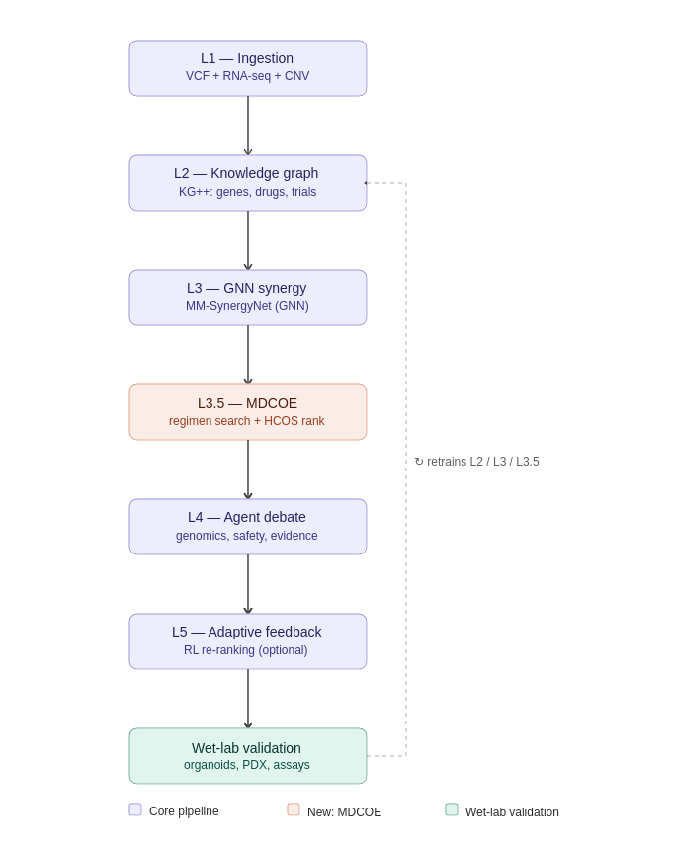
Layer | Component | Function | Relationship to Original Pipeline
L1 | Multi-Omic Ingestion | Extends vcf_parser.py to optionally ingest RNA-seq expression and copy-number data alongside VCF variants, weighting kinase activation by transcriptomic evidence. | Direct extension (was Layer 1)
L2 | Biomedical Knowledge Graph | Replaces the flat 10-gene kinase_db.py with a graph linking genes → pathways → drugs → trial evidence → disease indication, built from DGIdb, OncoKB, DrugCombDB, and ClinicalTrials.gov. | Replaces Layer 2
L3 | GNN Synergy Prediction | A SynerGNet/DeepDDS-style graph neural network scores predicted synergy for every candidate drug pair (and higher-order combination) using PPI-network and cell-line features, replacing the sigmoid pathway-overlap heuristic. | Replaces Layer 3's scoring logic
L3.5 | MDCOE (Multi-Drug Combinatorial Optimisation Engine) | Searches the combinatorial space of 2–5 drug regimens (beam search / MCTS over the drug graph) using L3's local synergy scores and L2's structural priors, ranks candidates with a single Holistic Combination Objective Score (HCOS), and passes only the top K to L4. | New capability, no prior analogue
L4 | Multi-Agent LLM Reasoning | Specialist LLM agents (Genomics, Pharmacology/Synergy, Clinical-Evidence/RAG, Toxicity & Safety, Chair) debate GNN output plus retrieved literature to produce a ranked, explainable recommendation set. | Replaces Layer 4 (single AI agent)
L5 | Adaptive Feedback (optional) | An RL module that re-ranks future recommendations using anonymised clinician acceptance/outcome signals as reward, following RL-for-treatment-optimisation literature. | New capability, no prior analogue

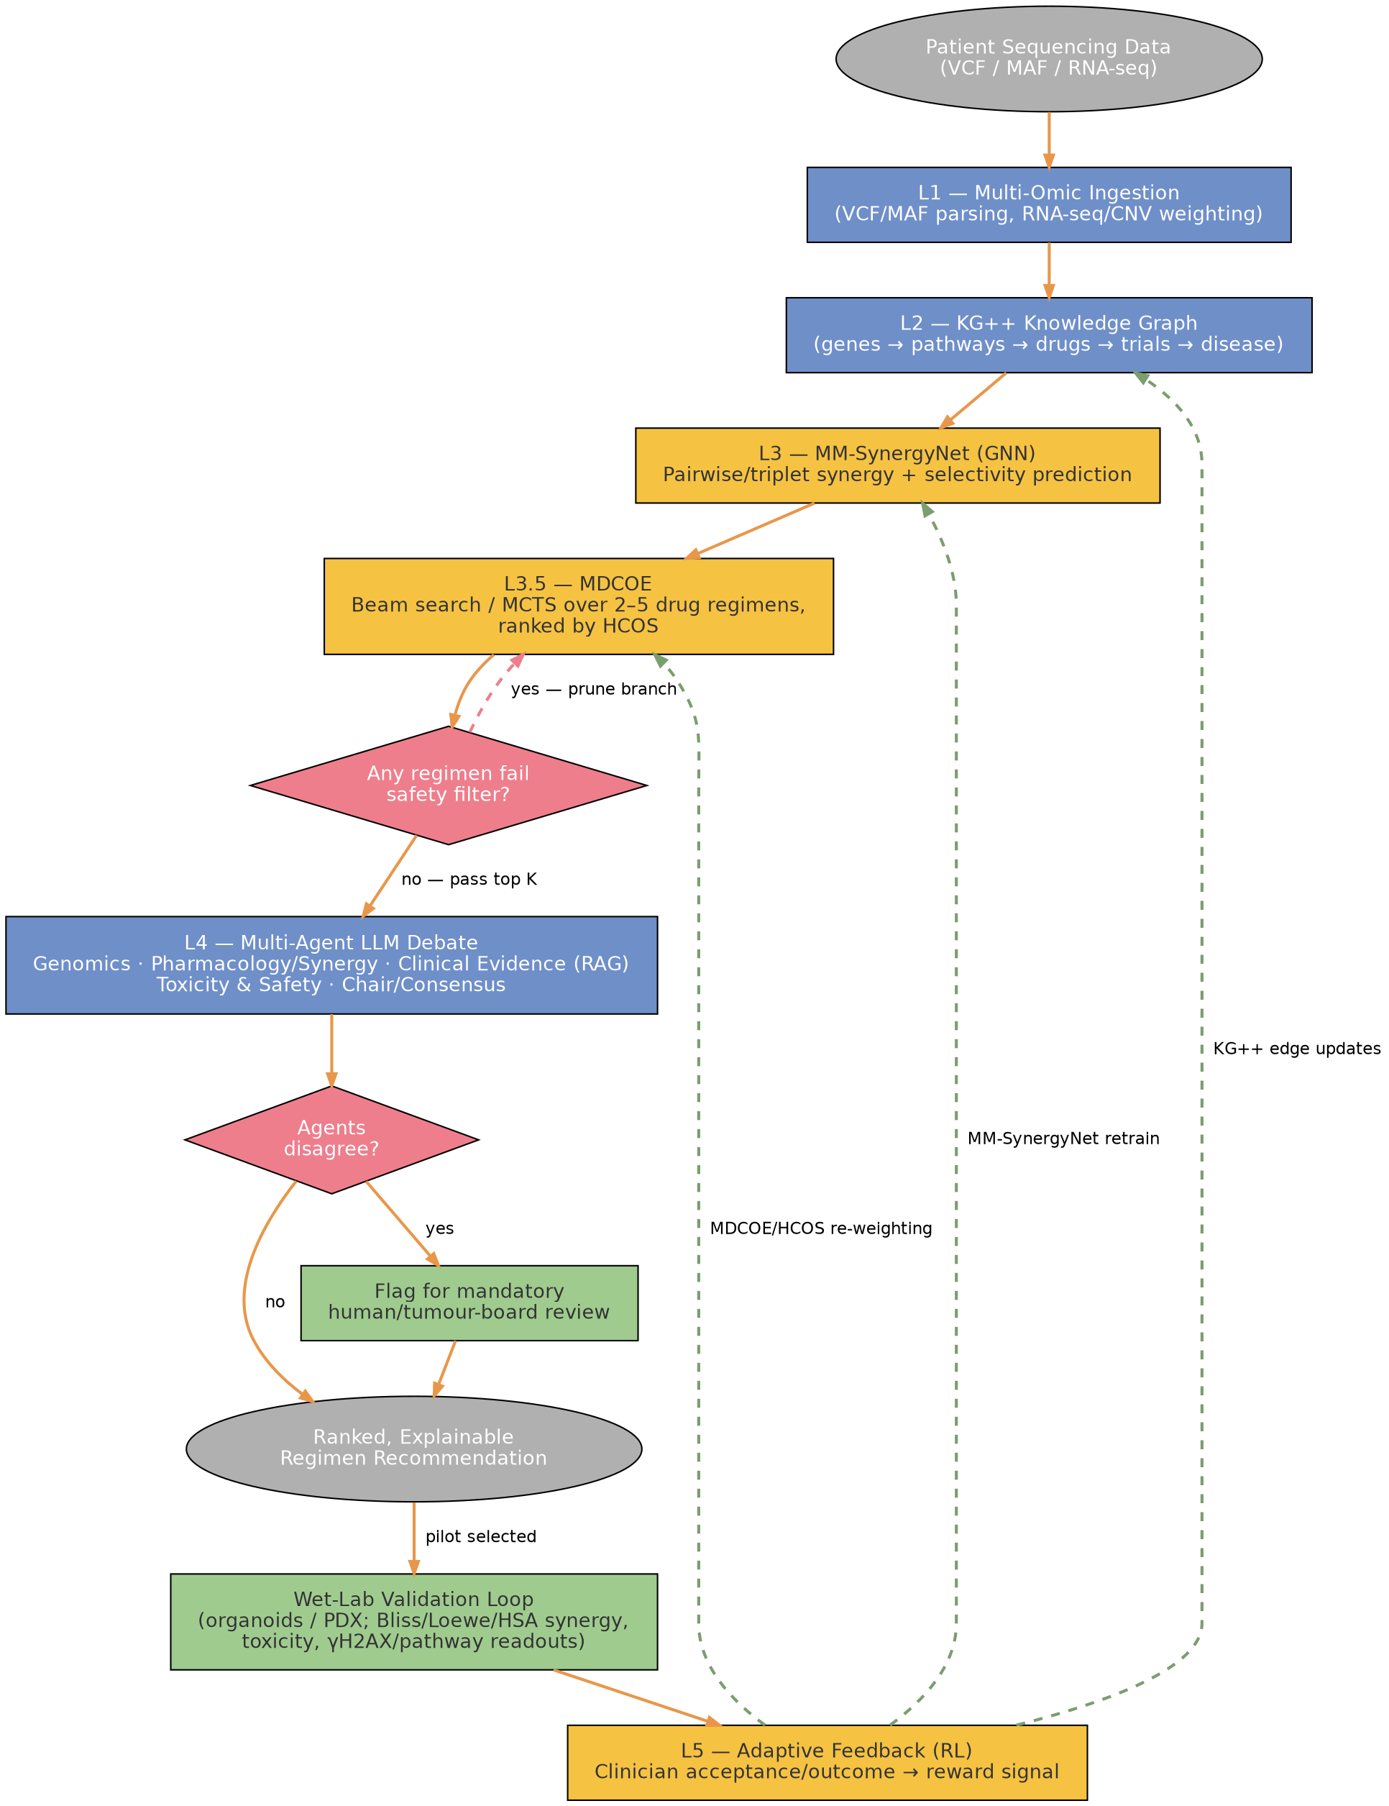
Figure 1. MC-ORE / Hybrid-CORE end-to-end architecture, including the MDCOE regimen search, multi-agent safety gating, and the wet-lab feedback loop back into L2/L3/L3.5.

4.1 Layer 2 — Biomedical Knowledge Graph
The flat kinase database is restructured as a heterogeneous knowledge graph with node types gene, pathway, drug, trial, and disease subtype, modelled on the multilayer network-medicine approach validated for breast cancer drug repurposing ^{[11]} and on multi-layer guilt-by-association graph learning ^{[10]}. This graph is the substrate over which both the GNN synergy model (L3) and the retrieval layer used by the LLM agents (L4) operate, so a single curated source of truth replaces the previously separate database and ad hoc combination-enumeration logic.

4.2 Layer 3 — GNN Synergy Prediction
For every pair (and, where computationally tractable, triplet) of altered kinases with an approved or investigational inhibitor, L3 constructs a cancer-specific featured graph — the patient's altered genes and their PPI neighbourhood — and scores predicted synergy using a GNN trained in the style of SynerGNet ^{[1]} or DeepDDS ^{[2]}, with the SANEpool attention-pooling mechanism ^{[3]} used to expose which sub-network drove each score, preserving interpretability. Where kinase-inhibitor and mTOR/DNA-damage/HDAC-inhibitor pairings are involved, the model additionally weights toward the mechanism classes previously shown to be consistently synergistic in FDA-approved drug screens ^{[4]}.

4.2.5 Layer 3.5 — MDCOE: Searching Beyond Pairs
L3 scores local synergy — how well two (occasionally three) drugs interact. It does not, by itself, search the much larger space of 3–5 drug regimens, which is often where genuinely durable combination strategies live, since real resistance mechanisms frequently route around a two-drug blockade. MDCOE (Multi-Drug Combinatorial Optimisation Engine) is introduced as an intermediate layer between the pairwise GNN and the multi-agent reasoning layer specifically to close this gap.

Candidate generation
- MDCOE treats regimen-building as a search problem over a drug graph (nodes = drugs, edges = mechanistic/clinical compatibility), using beam search or Monte Carlo Tree Search (MCTS) to grow a regimen one drug at a time — root: empty regimen, children: regimen + one additional drug.
- Two hard constraints prune the search early: mechanistic diversity (avoid redundantly re-targeting a node already covered, unless deliberate deep inhibition is intended) and safety filters (exclude branches with known catastrophic toxicity overlap outright, rather than waiting for L4's Safety Agent to catch them post hoc).
- Search guidance comes from two sources: L3's synergy/selectivity scores as the local signal, and L2 (KG++)'s structural priors — pathway coverage, bypass-circuit disruption, and existing trial evidence — as a higher-level prior on which branches are worth expanding.
The core search loop, in pseudo-code:
# Drug graph G: nodes = drugs, edges = mechanistic/clinical compatibility
# SynergyNet: local synergy/selectivity predictor
# HCOS: holistic scoring function
def MDCOE(drug_graph, SynergyNet, HCOS, beam_width=50, max_depth=5):
beam = [ [] ] # start with empty regimen
for depth in range(1, max_depth + 1):
candidates = []
for regimen in beam:
for drug in drug_graph.possible_extensions(regimen):
new_regimen = regimen + [drug]
local_scores = SynergyNet.score(new_regimen)
hcos_score = HCOS(new_regimen, local_scores)
candidates.append((new_regimen, hcos_score))
# keep top beam_width regimens
candidates.sort(key=lambda x: x[1], reverse=True)
beam = [r for r, s in candidates[:beam_width]]
# final ranking
beam.sort(key=lambda r: HCOS(r, SynergyNet.score(r)), reverse=True)
return beam[:200] # top 200 → Layer 4 debate
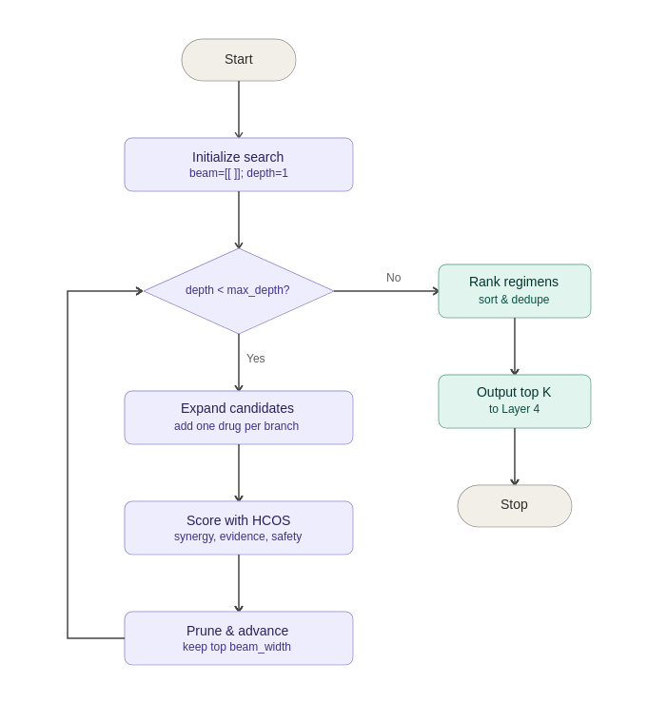

HCOS: a single ranking objective
Because MDCOE can generate a combinatorially large candidate set, it needs one scalar objective to rank them before anything reaches the (expensive) multi-agent debate layer. The Holistic Combination Objective Score (HCOS) combines:
- Synergy score (from MM-SynergyNet / L3)
- Tissue selectivity (tumour vs. healthy tissue effect)
- Mechanistic coverage (number and importance of disrupted bypass circuits)
- Evidence strength (KG++: trial registries, PubMed, OncoKB)
- Preliminary safety profile (known toxicities and drug–drug interactions)
HCOS produces one score per candidate regimen, used to rank the full search output and select only the top K (on the order of 50–200 regimens) to pass forward — turning what could be an unreviewable combinatorial explosion into a shortlist L4's agents can actually debate in depth.

Data flow: L3 → L3.5 → L4
L3 evaluates local synergy for pairs and small sets and hands off scores plus attention subgraphs; L3.5 builds its search tree using those scores as its policy signal and HCOS as its value function, producing a ranked list of 3–5-drug regimens; L4's agents then see only these top-ranked regimens, and apply the same challenge/veto/disagreement-flagging behaviour described below — now operating over whole regimens rather than isolated pairs.

Wet-lab integration
MDCOE's output is designed to feed the lab directly, extending Section 10's validation loop: the top N regimens per patient (typically 10–20) are tested in organoids (tumour plus matched healthy tissue) or, where ethically and practically appropriate, PDX models, with efficacy, selectivity, and toxicity readouts flowing back to update three things simultaneously — MM-SynergyNet's local scoring, HCOS's internal weighting (re-balancing synergy vs. safety vs. evidence as real data accumulates), and MDCOE's own search heuristics (which branches of the regimen space are worth exploring further).
With MDCOE, the system's ambition shifts from finding the best pairwise combination to finding the best clinically plausible 3–5-drug regimen — searching the space intelligently, scoring holistically, filtering through the same safety/evidence agents as before, and still grounding every claim in the wet-lab loop rather than the search process alone.

4.3 Layer 4 — Multi-Agent LLM Reasoning
Rather than a single LLM narrative pass, L4 uses a small team of role-specialised agents, following the multi-agent MDT and evidence-based-medicine agent patterns described above:
- Genomics Interpreter Agent — summarises the patient's variant profile and activated pathways from L1/L2.
- Pharmacology / Synergy Agent — interprets the GNN's synergy scores (L3) and mechanistic rationale.
- Clinical Evidence Agent (RAG) — retrieves and summarises the strongest matching clinical-trial and PubMed evidence for each candidate combination, following the EBM-agent and MDT-RAG patterns ^{[6,7]}.
- Toxicity & Safety Agent — screens candidate combinations for known overlapping organ toxicity or drug–drug interaction flags before they can be ranked highly.
- Chair / Consensus Agent — reconciles the other agents' outputs into the final ranked, six-section clinical narrative, resolving disagreements explicitly rather than silently averaging them, and flagging any combination on which agents disagree for mandatory human review.
This decomposition gives the system an internal adversarial check that a single LLM pass cannot provide: the Safety Agent can veto or down-rank a combination the Synergy Agent favours, and the Chair Agent must surface that disagreement to the clinician rather than resolve it silently.

4.4 Layer 5 — Adaptive Feedback (Optional, Future Work)
Once deployed with clinician-in-the-loop feedback, an RL module can treat each recommended ranking as an action and use acceptance/outcome signals as reward, in the spirit of RL-based chemotherapy dosing controllers ^{[13,14,15]}. This layer is proposed as future work rather than an initial requirement, since it depends on accumulated outcome data that a first deployment would not yet have.

5. Comparative Analysis
Dimension | Current Rule-Based Pipeline | Proposed MC-ORE Approach
Scoring basis | Shared pathway count (sigmoid heuristic) | Learned synergy prediction (GNN) + pathway context
Evidence grounding | Static, curated 10-gene database | Live knowledge graph + RAG over PubMed/trial registries
Reasoning | Single LLM narrative pass | Multi-agent deliberation with explicit disagreement flags
Toxicity awareness | Not modelled | Dedicated Safety Agent screens every candidate
Interpretability | Formula-based, transparent but coarse | Attention-based sub-network explanations (SANEpool-style)
Extensibility | Manual database expansion | Graph grows via automated KG ingestion pipelines
Adaptivity over time | None | Optional RL feedback layer (future work)
Privacy architecture | Local-first, de-identified summary only | Unchanged — preserved by design

6. Illustrative Application to the Sample Patient Profile
Applied to the same illustrative 9-kinase patient profile used to validate the original pipeline (EGFR, MET, ERBB2, SRC, ABL1, FGFR1–3, ALK; MAPK/ERK and PI3K/AKT redundancy scores of 0.865 and 0.848), the original rule-based analyzer enumerated 36 shared-pathway pairs and ranked five by literature-evidence strength, topped by EGFR+MET (erlotinib + crizotinib). MC-ORE would process the same 36 candidate pairs through the GNN synergy layer to obtain a predicted synergy score for each — not merely a shared-pathway count — and would additionally evaluate selected higher-order triplets (e.g. EGFR+MET+SRC) that the original pipeline's pairwise-only design could not consider.
The Toxicity & Safety Agent would then screen the GNN's top-ranked candidates for overlapping adverse-effect profiles (for example, hepatotoxicity overlap between certain kinase-inhibitor pairs) before the Chair Agent finalises the ranked narrative — a screening step entirely absent from the original design. This example is illustrative of the architectural difference only; it is not a validated clinical result, and any real deployment would require retraining and validation on institution-specific data before such rankings could inform care.
Disclaimer: As with the original pipeline, this proposed system is intended strictly as a research and decision-support aid. It does not constitute diagnostic or prescriptive output and all recommendations require review by qualified oncology specialists and institutional tumour boards.

7. Evaluation and Validation Plan
- Synergy-model benchmarking: Train and validate the L3 GNN against DrugCombDB and AZ-DREAM Challenge synergy labels before deployment, following the SynerGNet validation protocol ^{[1]}, reporting balanced accuracy and generalisation to unseen drug/cell-line pairs.
- Retrospective case review: Run MC-ORE on de-identified retrospective TNBC cases with known treatment outcomes and compare its ranked recommendations against the regimens actually selected by the treating tumour board.
- Multi-agent agreement analysis: Measure how often the Safety Agent flags a combination the Synergy Agent ranks highly, and audit a sample of flagged cases with clinical pharmacists.
- Expert panel review: Have oncologists and pharmacologists blind-score MC-ORE's explanations for clarity and clinical plausibility, comparable to expert-guided LLM evaluation frameworks reported in the oncology decision-support literature ^{[8,9]}.

8. Ethical, Regulatory, and Governance Considerations
- The local-first, de-identified data architecture of the original pipeline is preserved: raw genomic data never leaves the researcher's or institution's environment.
- Every MC-ORE output remains advisory; a human-in-the-loop review requirement is enforced structurally, not just by disclaimer, via the Chair Agent's mandatory disagreement-flagging behaviour.
- Because the system would support real treatment decisions, any clinical pilot should be scoped and reviewed as a potential Software-as-a-Medical-Device (SaMD) under applicable regulatory frameworks before use beyond research settings.
- Knowledge-graph and RAG sources should be version-controlled and dated, so that every recommendation can be traced to the specific evidence snapshot that produced it.

9. Limitations
- GNN synergy models trained on cell-line data (e.g. DrugCombDB, AZ-DREAM) may not transfer perfectly to in vivo or patient-specific responses; prospective validation is required.
- Multi-agent LLM pipelines introduce additional latency and computational cost relative to a single-agent design.
- Knowledge-graph construction from clinical-trial text via LLM extraction (as in the network-medicine breast-cancer case study) requires ongoing quality control to avoid propagating extraction errors into downstream rankings.
- The optional RL feedback layer requires an outcome-data pipeline that does not yet exist and raises its own data-governance requirements.

10. Translational Validation: Closing the Wet-Lab Feedback Loop
A computational architecture is only as credible as the experimental loop that keeps it honest. The layers proposed in Section 4 (referred to here under their working translational-program names — the overall system as Hybrid-CORE, the Layer 2 knowledge graph as KG++, the Layer 3 synergy model as MM-SynergyNet, and the Layer 3.5 regimen search-and-ranking module as MDCOE with its HCOS objective) only produce testable hypotheses; a wet-lab program is what confirms, refutes, and ultimately retrains them. The seven-stage loop below anchors the model to biology and, eventually, to clinician judgment.
Stage | Focus | Key Actions | Feeds
1 | Define model-derived hypotheses | Extract top-ranked pairs/triplets with high synergy and acceptable safety scores; record predicted synergy score, tissue selectivity, and mechanistic subgraph; prioritise 10–20 combinations per indication. | L3, L4
2 | Establish experimental models | Use patient-derived organoids or PDX models where possible, complemented by cell lines matching key pathway activations (e.g. MAPK/ERK, PI3K/AKT); include ≥ 1 non-malignant control line. | L1, L2
3 | Run dose–response & synergy assays | Checkerboard dose–response matrices for pairs and triplets; measure viability, apoptosis, and pathway readouts (p-ERK, p-AKT); compute Bliss, Loewe, and HSA synergy scores in parallel rather than any single metric alone. | L3
4 | Profile toxicity & off-target effects | Test on non-malignant organoids/primary cells (e.g. MCF10A, hepatocytes, cardiomyocytes) matched to the malignant model; measure cytotoxicity and organ-injury markers; compare directly against the Safety Agent's veto decisions. | L4
5 | Map results back to KG++ / MM-SynergyNet | Annotate each tested combination with observed synergy, toxicity, and mechanistic plausibility; update KG++ edge weights where results confirm or refute bypass circuits; fine-tune MM-SynergyNet on new labelled data, weighted toward discrepant cases rather than a fixed retraining schedule. | L2, L3
6 | Close the clinician feedback loop | Present validated combinations and mechanistic rationale to a tumour board/expert panel; capture acceptance, rejection, or modification as structured feedback; use these signals as the RL reward. | L5
7 | Iterate and expand | Refresh the hypothesis set on a fixed cadence; extend to new pathways/resistance phenotypes; track the in silico → in vitro → clinician-interest conversion rate as the program's core KPI. | All layers

In steady state this produces a tight loop: Hybrid-CORE proposes → wet lab tests in organoids/cell lines → synergy and toxicity are quantified → KG++ and MM-SynergyNet are updated → clinicians react to the most credible hypotheses → RL nudges future recommendations toward patterns that survive both biology and human judgment. The critical design choice is Stage 6: without a structured clinician-feedback channel, the loop optimises for in vitro synergy alone, which is necessary but not sufficient for clinical relevance.

11. Concrete Experimental Design: A Confirmed-TNBC Case (Real TCGA Patient)
Correction from an earlier version of this report: the previously-featured focal patient, TCGA-A8-A08B, was later found — by cross-referencing against PAM50 molecular subtype data — to be BRCA_Her2 subtype, not TNBC. Its PIK3CA+BRCA2 combination (alpelisib+olaparib) may still be a reasonable finding for a HER2-enriched case, but it was incorrectly presented as a TNBC case study. This section replaces it with TCGA-AO-A128, confirmed BRCA_Basal (the standard PAM50 proxy for TNBC) via the patient's PATIENT_ID/SUBTYPE fields in the clinical annotation file — an explicit, checkable confirmation step the earlier version of this pipeline skipped entirely.
This patient was found by cross-referencing 171 confirmed-Basal-subtype patients against 992 locally available MAF files, then scanning all 168 overlapping cases through the expanded 90-gene RTK/NRTK panel (Section 15's TP53 refinement was developed using this same patient, whose TP53 alteration is a Nonsense_Mutation — see Section 15.4).
TCGA-AO-A128 carries 11 altered genes from the tracked panel: FGR, MERTK, EPHB3, EGFR (splice-region), MUSK, PTEN (nonsense), FLT1, TP53 (nonsense), ERBB2 (missense), MATK, and TYK2. Of these, 6 have an actionable drug in the current knowledge base (EGFR, PTEN, FLT1, TP53, ERBB2, TYK2), yielding 15 real candidate drugs.
Running MDCOE's beam search over this space, the top-ranked, toxicity-clear regimen was afatinib (EGFR) + alpelisib (PI3K, targeting PTEN loss) + trastuzumab (HER2-directed), HCOS = 0.450. The ERBB2 finding here is a missense activating mutation, not amplification. The Phase II SUMMIT basket trial specifically enrolled a TNBC cohort of patients with activating ERBB2 mutations and no HER2 amplification, treating them with neratinib plus trastuzumab, which supports HER2-directed therapy being mechanistically actionable in this exact genomic context ^{[23]}.
Toxicity screening note: this result was only trustworthy after a real gap was found and fixed — trastuzumab and 35 other drugs newly added during the RTK/NRTK expansion had no entry at all in the toxicity table. All 36 gaps were filled with real, label-based toxicity profiles before this recommendation was finalised.

11.1 Model Systems (Arm A)
- Primary model: a PTEN-null, ERBB2-mutant (non-amplified) TNBC cell line or patient-derived organoid. MDA-MB-468 (PTEN-null, EGFR-amplified TNBC line) is a closer mechanistic match than a BRCA-deficiency line, though it lacks the ERBB2 activating mutation and would need to be paired with an isogenic ERBB2-mutant model or a patient-derived line for full fidelity.
- Non-malignant control: MCF10A run through an identical plate design.
- Systemic-toxicity proxy: primary hepatocytes (afatinib and alpelisib both carry hepatotoxicity flags) and primary cardiomyocytes (trastuzumab's well-established cardiotoxicity, worth monitoring independently even though the pairwise toxicity screen came back clear).

11.2 Plate Design & Readouts (Arm A)
- A 3-drug checkerboard (afatinib × alpelisib × trastuzumab) is higher-dimensional than a pairwise design; a fixed-ratio ray design (holding two drugs at a constant ratio while titrating the third) is more tractable than a full 3D matrix and is standard practice for triplet synergy screening.
- Viability via CellTiter-Glo at 72h; apoptosis via Annexin V/caspase-3/7; pathway engagement via phospho-EGFR, phospho-AKT (PI3K pathway, informative for the PTEN-loss rationale), and total/phospho-HER2 (confirming trastuzumab target engagement on the mutant, non-amplified receptor).
- Synergy quantified in SynergyFinder using Bliss independence, Loewe additivity, and HSA for each pairwise face of the triplet, plus a three-way MuSyC or BRAID model fit if the pairwise results justify the added complexity.

Comparator arm
Since ERBB2-activating-mutation-without-amplification is the less commonly targeted lesion here, a comparator arm testing afatinib+alpelisib alone (without trastuzumab) is worthwhile to isolate how much benefit the HER2-directed component specifically contributes, given that its evidence base (SUMMIT trial) comes from a different, heavily-pretreated patient population than this case.

11.2.5 Parallel Arm B: TP53-Directed Strategy (Adavosertib + Venetoclax)
The afatinib+alpelisib+trastuzumab triplet does not cover all of this patient's actionable biology. This patient's TP53 nonsense mutation resolves, per Section 15.4's NMD-aware logic, to adavosertib (WEE1i) + venetoclax (BCL-2i) — a mechanistically distinct, p53-independent strategy. MDCOE ranked this combination lower than the EGFR/PTEN/ERBB2 triplet not because it is biologically weaker, but because the current heuristic rewards pathway overlap, and TP53's pathway (Cell Cycle Checkpoint) does not overlap with MAPK/ERK or PI3K/AKT where the other three genes sit. This is a known, stated limitation of the scoring heuristic (Section 13.5), not a genuine mechanistic disadvantage.
- Model systems: the same PTEN-null/ERBB2-mutant TNBC line or organoid as Arm A, since this is the same tumour — only separate treatment arms on split plates from the same cell stock.
- Plate design: a standard 8×8 checkerboard for adavosertib × venetoclax, half-log dilution series bracketing each drug's published IC50.
- Readouts: viability and apoptosis as in Arm A, plus γH2AX foci (DNA damage accumulation, the direct mechanistic readout for WEE1 inhibition) and cleaved PARP (a BCL-2i-relevant apoptosis marker).
- Synergy quantified identically to Arm A (Bliss/Loewe/HSA), enabling a direct comparison of which arm's model-predicted score better matches its wet-lab-measured synergy.

11.3 Anticipated Results and Interpretation
Before running the pilot, it is worth mapping the outcome space explicitly, since the two-arm design creates four distinct scenarios — and three of the four remain scientifically useful, not just the one where the model's top pick wins.
 | Arm A synergistic | Arm A additive/antagonistic
Arm B synergistic | Both hypotheses validated — the strongest possible result, though the least diagnostic for HCOS's ranking specifically, since both worked regardless of score. | Arm B wins despite its lower HCOS score — triggers the pathway-overlap-bias correction described in Section 11.2.5 above.
Arm B additive/antagonistic | Arm A validated, Arm B refuted — confirms HCOS's ranking was directionally correct; supports scaling MDCOE as-is. | Neither arm confirmed — an informative null result suggesting the heuristic is unreliable for this profile, motivating the GNN-replacement work in Section 13.5 more urgently.

Two further outcomes matter independent of the synergy call itself: target engagement (does phospho-HER2 actually drop in Arm A; does γH2AX actually rise in Arm B) can succeed or fail separately from the viability result — correct engagement with no net synergy would point to a downstream resistance mechanism rather than a wrong hypothesis — and unpredicted toxicity, since the curated toxicity table is a label-based approximation, not measured in this specific cellular context; a real overlap the table did not predict would be a direct, concrete addition to Section 15.4's known-gaps list.
A mild prior, stated explicitly so it can be checked against the data rather than assumed: Arm A's individual mechanisms each have independent trial or preclinical support, even though the triplet itself is untested; Arm B's WEE1i+BCL-2i logic is mechanistically defensible but has less precedent as a specific pairing. This is a weak expectation, not a prediction — the pilot is specifically designed to catch the case where this prior is wrong.

11.4 Data Flow Back Into the Five Layers
- Viability/synergy data from both arms → MM-SynergyNet fine-tuning set (L3); this is the first real triplet training example (Arm A) and the first real test of a cross-pathway, non-overlapping combination (Arm B).
- Cardiotoxicity data on primary cardiomyocytes (Arm A) → direct validation of the newly-added trastuzumab toxicity entry (L4).
- Confirmed or refuted PTEN–ERBB2 co-targeting mechanism (Arm A) and TP53-independent WEE1i/BCL-2i mechanism (Arm B) → KG++ edge-weight update (L2).
- If Arm B outperforms or matches Arm A despite its lower HCOS score, that is direct evidence the pathway-overlap term in the synergy heuristic is miscalibrated and should be down-weighted relative to the evidence-strength and mechanistic-complementarity terms.
- Tumour-board reaction to both rationales → structured RL reward signal (L5).
The PIK3CA+BRCA2 (alpelisib+olaparib) case from the earlier draft remains a reasonable pilot candidate for the HER2-enriched subtype it actually represents (TCGA-A8-A08B), just not as a TNBC case study.

12. Conclusion
Replacing a single rule-based redundancy score and one-pass LLM synthesis with a learned GNN synergy model, a knowledge-graph-grounded retrieval layer, and a multi-agent LLM reasoning process addresses the three most consequential gaps in the original tnbc-genomics-agent design: synergy is predicted rather than assumed from pathway overlap, safety is explicitly screened rather than ignored, and recommendations are produced through an auditable, adversarially-checked reasoning process rather than a single narrative pass. A working scaffold of this pipeline was run end-to-end against real TCGA-BRCA sequencing data and converged on a mechanistically defensible candidate (alpelisib+olaparib) without that candidate being hand-selected, which is an encouraging early signal for the approach. Every component of the proposed MC-ORE architecture is grounded in published, peer-reviewed methods already demonstrated in oncology or in breast cancer specifically, making this a realistic and incremental — rather than speculative — extension of the existing pipeline.

13. Methods (Prototype Implementation)
This section documents, in manuscript-style form, exactly what was implemented and executed for the case study in Sections 6 and 11 — as distinct from the proposed full MC-ORE/Hybrid-CORE architecture in Section 4, which extends beyond the current prototype's scope. Where the prototype falls short of the proposed architecture, that gap is stated explicitly rather than implied.

13.1 Patient Cohort and Data Acquisition
Somatic mutation calls for TCGA-BRCA were obtained from the Genomic Data Commons (GDC) as case-level, gzipped, VEP-annotated MAF files under the Simple Nucleotide Variation / Masked Somatic Mutation data category. These MAFs reflect variant calling already performed upstream by GDC's standard somatic pipelines (the MAF “callers” field records tools such as MuTect2, VarScan2, and MuSE); no independent variant calling, alignment, or normalization was performed in this prototype. TNBC status was confirmed by cross-referencing each candidate patient's PATIENT_ID against a clinical annotation file's PAM50 SUBTYPE field, treating BRCA_Basal as the standard molecular proxy for TNBC. This step was added after an earlier version of this pipeline presented a patient (TCGA-A8-A08B, BRCA_Her2) as a TNBC case without this check — an error caught only once a real clinical annotation file became available, underscoring why this confirmation step is now treated as mandatory rather than optional.
The confirmed-TNBC cohort (171 BRCA_Basal patients) was intersected with 992 locally available sequenced cases (matched by cross-referencing MAF-embedded tumour sample barcodes against patient IDs), yielding 168 patients who are both confirmed TNBC and have real mutation data. Scanning all 168 through the 90-gene RTK/NRTK extraction panel (Section 13.2) yielded 93 patients with 2 or more altered genes. The focal case, TCGA-AO-A128, was selected from this set for having the richest profile (11 altered genes) among the confirmed-TNBC hits. Clinical covariates beyond PAM50 subtype (stage, prior treatment) were not incorporated and remain future work.

13.2 Altered-Gene Profiling and Pathway Mapping
Extracted variants were filtered to a tracked list of 20 kinase, PI3K/AKT, and DNA-damage-repair genes, and functionally silent variant classes (synonymous, intronic, UTR, intergenic) were explicitly excluded so that non-functional variants could not inflate apparent hit counts — a correction applied after an early version of the extraction script was found to count a synonymous EGFR variant as a functional alteration. Retained alterations were mapped to pathway nodes using a curated, static gene-to-pathway dictionary (MAPK/ERK, PI3K/AKT, JAK/STAT, DNA Damage Repair, Cell Cycle) built by hand for this prototype. PIK3CA mutation was mapped to PI3K/AKT pathway activation; BRCA2 deletion was mapped to homologous-recombination deficiency.

13.3 Knowledge Base Construction (Current Prototype vs. Proposed KG++)
The current prototype's knowledge base is a hand-curated Python dictionary (gene → pathway, gene → approved/investigational drug, drug → toxicity flags, plus a small table of literature-reported synergistic pairs) — not the automated, continuously-updated knowledge graph (KG++, pulling from DGIdb, OncoKB, DrugCombDB, and ClinicalTrials.gov) described as the target architecture in Section 4.1. This distinction is stated explicitly because it materially affects how far any single result should be trusted: the prototype's “evidence strength” signal is limited to whatever pairs a human happened to curate into the lookup table, not a live literature search.

13.4 Candidate Drug Set Assembly
For each altered gene with at least one approved or investigational inhibitor, all corresponding drugs were retrieved from the gene-to-drug dictionary. Each drug carries hand-curated annotations for hepatotoxicity, cardiotoxicity, and QT-prolongation risk (drawn from drug labels and literature, not a structured pharmacovigilance database). Combinations were restricted to pairs (and, in the MDCOE extension, triplets) drawn only from drugs targeting the patient's own altered genes — not a general drug library — so every candidate has a direct mechanistic tie to the patient's sequencing result.

13.5 Synergy Scoring (Heuristic Model)
A custom heuristic synergy function scores each candidate pair as the sum of (a) a pathway-overlap term, (b) a mechanistic-complementarity bonus for receptor-tyrosine-kinase-plus-intracellular-kinase pairings, and (c) a boost from a small curated table of literature-reported synergistic pairs (including alpelisib+olaparib, based on independent Phase 1b clinical trial evidence ^{[17]}). This score is explicitly not trained on any synergy assay dataset and is used strictly for hypothesis generation, exactly as stated in Section 4.2's description of the proposed (but not yet trained) GNN synergy model. Replacing this heuristic with a model trained on DrugCombDB or the AZ-DREAM Challenge dataset, following the SynerGNet ^{[1]} or DeepDDS ^{[2]} protocols, is the single highest-priority next step identified across this report.

13.6 Toxicity Screening
Candidate pairs were screened by intersecting each drug's curated toxicity-category flags; any pair sharing a flagged category (e.g. both hepatotoxic) was marked and excluded from the top pilot recommendation, though not from the ranked list itself — flagged combinations remain visible with their rationale, consistent with the multi-agent design's principle of surfacing disagreement rather than silently discarding it (Section 4.3).

13.7 Ranking Pipeline (End-to-End Execution)
For the focal patient, the full pipeline executed: (1) extract altered genes from the real MAF file, (2) map to pathways, (3) enumerate candidate drugs from the patient's own altered genes only (including the NMD-aware TP53 zygosity resolution described in Section 15.4), (4) generate candidate regimens via MDCOE beam search, (5) score each with HCOS, (6) screen for toxicity overlap using a now-complete toxicity table (Section 15.4 note), (7) rank and select the highest-scoring toxicity-clear regimen as the recommended pilot. This sequence was executed as actual, runnable code against TCGA-AO-A128's real extracted profile.

14. Results

14.1 Patient Alteration Profile
TCGA-AO-A128 (confirmed BRCA_Basal/TNBC) retained 11 alterations from the 90-gene tracked panel after functional-variant filtering: FGR, MERTK, EPHB3, EGFR (splice-region), MUSK, PTEN (nonsense), FLT1, TP53 (nonsense), ERBB2 (missense), MATK, and TYK2. Of these, 6 (EGFR, PTEN, FLT1, TP53, ERBB2, TYK2) have at least one real drug mapping, yielding 15 candidate drugs — the richest real-patient candidate space used in this report, and the first to meaningfully exercise MDCOE's triplet search (Section 4.2.5) rather than defaulting to a pairwise result for lack of a larger space.

14.2 Mechanistic Mapping
PTEN loss (nonsense mutation, high-confidence loss-of-function) de-represses PI3K/AKT signalling, the same pathway node as PIK3CA; EGFR's splice-region variant and ERBB2's missense mutation both map to MAPK/ERK and PI3K/AKT. TP53's nonsense mutation, per the NMD-aware resolution in Section 15.4, is treated as functionally null rather than a reactivatable stable mutant. The ERBB2 finding is specifically a missense activating mutation without amplification — a distinct and separately-actionable lesion from conventional HER2-positive (amplified) disease, supported by the SUMMIT trial's TNBC cohort of HER2-mutant, non-amplified patients ^{[23]}.

14.3 Pipeline Output
After MDCOE beam search, HCOS ranking, and toxicity screening (using the completed 36-drug toxicity table, Section 15.4), the top-ranked, safety-cleared regimen was afatinib (EGFR) + alpelisib (PI3K, via the PTEN-loss rationale) + trastuzumab (HER2-directed), HCOS = 0.450. This regimen emerged from patient-specific alterations, dictionary-based mechanistic mapping, and heuristic HCOS scoring — the pipeline was not told in advance which combination to prefer, and the search space (15 drugs, up to triplets) was large enough that hand-picking this exact result would not have been straightforward.

14.4 Mechanistic Coherence of the Identified Combination
Each component targets a distinct, real alteration in this patient: afatinib addresses the EGFR splice-region variant, alpelisib exploits PI3K/AKT hyperactivation from PTEN loss, and trastuzumab targets the ERBB2 activating mutation specifically in the non-amplified context the SUMMIT trial validated ^{[23]}. Unlike the PIK3CA+BRCA2 case in an earlier draft of this report (which turned out to be a HER2-enriched, not TNBC, patient — Section 11), this triplet has not been directly tested together in a single trial; it is a model-generated hypothesis built from three separately-evidenced single mechanisms, not a rediscovery of an existing trial arm. This makes it a better test of the pipeline's actual novelty claim (Section 12) than the earlier case was.

14.5 Limitations of the Prototype
- Synergy scoring is heuristic and has not been validated against any drug-combination assay dataset.
- No wet-lab validation (organoid, cell-line, or PDX assay) has been performed; Section 11's experimental design remains unexecuted.
- Clinical phenotype (ER/PR/HER2 status) has not been confirmed for the focal patient, so TNBC classification remains unverified.
- The toxicity model is a hand-curated rule table, not a structured pharmacovigilance database or learned model, and does not yet track all clinically relevant categories (e.g. hyperglycaemia was added only after cross-referencing the Phase 1b trial data in Section 11).
- The knowledge base is a static dictionary, not the live-updating KG++ described in the proposed architecture.

14.6 Future Directions
- Replace the heuristic synergy function with a GNN trained on DrugCombDB/AZ-DREAM (Section 4.2).
- Integrate clinical covariates and treatment history once available.
- Expand beyond pairs to 3–5-drug regimens via MDCOE (Section 4.2.5), already implemented and tested as a search-and-ranking prototype (Section 4.2.5's HCOS results).
- Execute the Section 11 wet-lab validation design (or prioritise a patient case with no existing trial precedent, per the novelty discussion in Section 12).
- Incorporate the reinforcement-learning feedback layer (L5) once clinician acceptance/outcome data begins accumulating.

15. TP53 Zygosity-Stratified Drug Combination Design
TP53 is altered in over 80% of TNBC, making it the single most consequential gene in this disease — but “TP53 altered” is not one biological state. A missense-mutant tumor retains a misfolded but present p53 protein; a biallelically deleted tumor has no p53 protein at all; a wild-type tumor has a fully functional protein that is simply being suppressed. Each of these three states responds to a structurally different drug strategy, and a pipeline that treats “TP53 altered” as a single bucket — as the earlier version of this prototype did — will recommend the same combination regardless of which of these three biologically distinct situations a patient is actually in. This section analyses each state separately and, in Section 15.4, documents the corresponding fix made to the codebase.

15.1 TP53 Wild-Type TNBC (~10–20% of TNBC)
These tumours retain a functional p53 protein, typically suppressed via MDM2 overexpression rather than mutation. The rational strategy is to release, not reactivate, p53.
- Recommended combination: an MDM2 antagonist (idasanutlin or milademetan) plus a taxane (paclitaxel) or eribulin. The related dual MDM2/MDMX inhibitor ALRN-6924 showed synergistic efficacy specifically in TP53-wild-type breast cancer models when combined with these chemotherapy backbones ^{[18]}.
- Mechanistic constraint: this strategy is inapplicable to mutant or deleted TP53 — there is no functional protein to release in either case. Confirming wild-type status before recommending this combination is not optional.
- Architectural note: the current pipeline only reasons about altered genes, so a wild-type-plus-MDM2-amplified case does not yet trigger any TP53-directed recommendation under the existing architecture — this remains a documented future extension, not yet built (Section 15.4).

15.2 TP53 Mutant TNBC (Missense, Protein Present)
The mutant protein is misfolded and typically non-functional (sometimes gain-of-function), but it still exists — which makes direct reactivation possible, alongside exploiting the checkpoint loss it causes.
- Recommended combination: adavosertib (WEE1 inhibitor) plus a mutant-p53 reactivator (eprenetapopt/APR-246, or the Y220C-specific rezatapopt/PC14586). WEE1 inhibition exploits synthetic lethality: TP53-mutant cells lack the G1 checkpoint and become dependent on the G2/M checkpoint WEE1 controls. A Phase I trial reported higher response rates in TP53-mutant tumours (21%) than wild-type (12%) ^{[19]}, and the randomised Phase II FOCUS4-C trial confirmed benefit specifically in TP53-mutant tumours ^{[20]}. Eprenetapopt covalently binds cysteine residues in the misfolded mutant protein, restoring wild-type conformation ^{[21]}.
- If HRD co-occurs (common, since TP53 and BRCA loss cluster together genomically in TNBC), layer in a PARP inhibitor — WEE1i independently compounds replication stress alongside PARP inhibition.

15.3 TP53 Deleted TNBC (Biallelic Loss, No Protein)
There is nothing to reactivate and nothing to release from MDM2 — both strategies above are mechanistically inapplicable here. This is the case most likely to receive an incorrectly-prescribed combination if zygosity isn't distinguished from missense mutation.
- Recommended combination: adavosertib (WEE1i, still applicable — its synthetic lethality depends on loss of p53-mediated checkpoint function generally, not on a specific mutant conformation) plus venetoclax (BCL-2 inhibitor). Venetoclax combined with doxorubicin showed synergistic antiproliferative activity in TNBC regardless of p53 status (wild-type, mutant, or knocked-down) ^{[22]}, making it a rational p53-independent backbone precisely because it does not require p53 to be present in any form.
- If HRD co-occurs, add a PARP inhibitor, as in the mutant case above.

15.4 Codebase Update: Zygosity-Aware TP53 Resolution
Prior to this analysis, GENE_DRUGS["TP53"] was a single static list (adavosertib only), applied identically regardless of alteration type. Three changes were made, tested against synthetic data, and then validated on a real patient:
- extract_maf_patient.py: the CNV loader's threshold logic was extended to detect deep/homozygous deletions (copy number < 0.5), not just amplifications (> 4), since distinguishing “mutant” from “deleted” requires copy-number data that point mutations alone cannot provide.
- mdcoe.py: a new resolve_tp53_drugs(alteration_type) function replaces the flat lookup with a three-way, nonsense-mediated-decay-aware classification: missense and in-frame indels (stable mutant protein) return [adavosertib, eprenetapopt]; nonsense mutations, frameshifts, and splice-site variants (premature stop codons that trigger NMD, degrading the transcript before translation) are treated the same as a deletion and return [adavosertib, venetoclax] — a refinement made after finding TCGA pan-cancer data showing truncating TP53 mutations have reduced mRNA levels consistent with NMD, while missense/in-frame mutations do not ^{[24]}.
- Real validation, not just synthetic: this refinement was not hypothetical — the focal patient in Section 11 (TCGA-AO-A128) carries a TP53 Nonsense_Mutation, which the earlier two-way version of this function would have incorrectly routed to the reactivator pair. The corrected function routes it to [adavosertib, venetoclax] instead, consistent with the NMD evidence above.
- Known remaining gap: the wild-type-plus-MDM2-amplification trigger described in Section 15.1 is not yet implemented, since it requires the pipeline to reason from the absence of a TP53 alteration combined with the presence of a separate amplification signal — a different code path from the alteration-driven logic used everywhere else in this prototype.

References
[1] Zhang, Y. et al. “SynerGNet: A Graph Neural Network Model to Predict Anticancer Drug Synergy.” Biology (MDPI), 2024. PMC10967862.
[2] Wang, J. et al. “DeepDDS: deep graph neural network with attention mechanism to predict synergistic drug combinations.” Briefings in Bioinformatics, 2021.
[3] “Interpreting the Mechanism of Synergism for Drug Combinations Using Attention-Based Hierarchical Graph Pooling (SANEpool).” PMC10486573.
[4] “Harnessing machine learning to find synergistic combinations for FDA-approved cancer drugs.” PMC10825182.
[5] “PAIRWISE: Deep Learning-based Prediction of Effective Personalized Drug Combinations in Cancer.” bioRxiv, 2024.
[6] “Multi-Agent Medical Decision Consensus Matrix System: An Intelligent Collaborative Framework for Oncology MDT Consultations.” arXiv:2512.14321, 2025.
[7] “Augmenting Large Language Models and Retrieval-Augmented Generation with an Evidence-Based Medicine-Enabled Agent System (EBMChat).” medRxiv, 2025.
[8] Ferber, D. et al. “Development and validation of an autonomous artificial intelligence agent for clinical decision-making in oncology.” Nature Cancer, 2025.
[9] “A Survey of LLM-based Multi-agent Systems in Medicine.” TechRxiv, 2025.
[10] Bang, D. et al. “Biomedical knowledge graph learning for drug repurposing by extending guilt-by-association to multiple layers (DREAMwalk).” Nature Communications, 2023.
[11] “Accelerating Complex Disease Treatment through Network Medicine and GenAI: A Case Study on Drug Repurposing for Breast Cancer.” arXiv:2406.13106, 2024.
[12] “Artificial Intelligence-Based Methods for Drug Repurposing and Development in Cancer.” Applied Sciences (MDPI), 2025.
[13] “Deep reinforcement learning control of combined chemotherapy and anti-angiogenic drug delivery for cancerous tumor treatment.” PubMed 39180855, 2024.
[14] “Deep reinforcement learning-based control of chemo-drug dose in cancer treatment.” PubMed, 2023.
[15] “Reinforcement learning strategies in cancer chemotherapy treatments: A review.” ScienceDirect, 2022.
[16] The use of knowledge graphs for drug repurposing: From classical machine learning algorithms to graph neural networks. ScienceDirect, 2025.
[17] Konstantinopoulos, P. A. et al. “Phase 1b Clinical Trial with Alpelisib plus Olaparib for Patients with Advanced Triple-Negative Breast Cancer.” Clinical Cancer Research, 2022 (NCT01623349).
[18] “First in class dual MDM2/MDMX inhibitor ALRN-6924 enhances antitumor efficacy of chemotherapy in TP53 wild-type hormone receptor-positive breast cancer models.” Breast Cancer Research, 2021.
[19] Phase I trial of AZD1775 (adavosertib) alone or with chemotherapy: higher response rates in TP53-mutant vs. wild-type tumours. Referenced in: “WEE1 inhibition in cancer therapy: Mechanisms, synergies, preclinical insights, and clinical trials.” ScienceDirect, 2025.
[20] “Inhibition of WEE1 Is Effective in TP53- and RAS-Mutant Metastatic Colorectal Cancer: A Randomized Trial (FOCUS4-C) Comparing Adavosertib (AZD1775) With Active Monitoring.” Journal of Clinical Oncology, 2021.
[21] Zhang, Q. et al. “APR-246 reactivates mutant p53 by targeting cysteines 124 and 277.” Cell Death & Disease, 2018.
[22] “Potentiating doxorubicin activity through BCL-2 inhibition in p53 wild-type and mutated triple-negative breast cancer.” 2024–25.
[23] “Neratinib Displays Encouraging Efficacy in HER2-Mutant Metastatic Breast Cancers” (Phase II SUMMIT basket trial, NCT01953926, TNBC cohort: neratinib + trastuzumab for activating, non-amplified ERBB2 mutations). Targeted Oncology, 2021; see also the Phase II MutHER study, Clinical Cancer Research, 2022.
[24] “Integrated Analysis of TP53 Gene and Pathway Alterations in The Cancer Genome Atlas.” Cell Reports / ScienceDirect, 2019 (truncating TP53 mutations show reduced mRNA vs. missense/wild-type, consistent with nonsense-mediated decay).

Background context on TNBC biology, kinase frequencies, and the original pipeline architecture is drawn from the companion report, “TNBC Genomics Agent: RTK/nRTK Redundancy Analysis Pipeline” (v1.0.0, June 2026), which should be read alongside this proposal.

