Kinase Redundancy and Combination Therapy Discovery in Triple-Negative Breast Cancer
Consolidated Research Report
A Real-Data Computational Pipeline for RTK/NRTK Target Prioritization and Drug Regimen Discovery
This report consolidates all methods, results, data sources, and conclusions from the full multi-session project: the 90-kinase Composite Target Score (CTS) pipeline, the MDCOE/HCOS drug-regimen ranking system, a multi-omic machine-learning investigation of dependency prediction, an agentic literature-mining discovery system, and the final validated regimen recommendation for focal patient TCGA-AO-A128.

Executive Summary
This project developed and validated a real-data computational pipeline to prioritize receptor and non-receptor tyrosine kinase (RTK/NRTK) targets and candidate drug regimens for triple-negative breast cancer (TNBC), using a focal patient case (TCGA-AO-A128) as a worked example throughout.
Ninety RTK/NRTK kinases were scored using a Composite Target Score (CTS) combining STRING protein-interaction centrality, DepMap CRISPR knockout essentiality, TCGA-BRCA survival association, and DGIdb drug-target evidence. The top-ranked kinases — ERBB2, EGFR, and PTK2/FAK — are among the most extensively validated targets in real TNBC biology, a non-trivial convergence given that CTS was not tuned to reproduce known findings.
A beam-search regimen-ranking system (MDCOE/HCOS) identified afatinib + alpelisib/capivasertib + trastuzumab as the top-scoring 3-drug regimen for the focal patient (HCOS = 0.450), targeting EGFR, PTEN-loss-driven PI3K/AKT reactivation, and an ERBB2 alteration. This result was independently reproduced using two different, differently-sourced drug candidate lists (hand-curated versus live DGIdb query), providing convergent validation.
A supervised machine-learning investigation tested whether cell-line-specific multi-omic features (expression, copy number, mutation status) could improve dependency prediction beyond each kinase's mean essentiality. Under rigorous grouped cross-validation, gene identity alone explained the learnable signal (R² = 0.337), while additional multi-omic features added none (R² = 0.339 combined versus − 0.029 for features alone) — directly validating the original CTS design choice to score kinases by mean essentiality.
An agentic literature-mining pipeline, built with mandatory independent database confirmation of every candidate, searched live PubMed and DGIdb data for under-covered genes and identified a new, citation-backed candidate pair — carboplatin and eprenetapopt — for the TP53 axis, while correctly rejecting two other real, confirmed drugs whose source literature did not actually support recommending them.
Finally, the focal patient's TP53 alteration, previously an unverified working assumption, was confirmed directly against the real GDC-downloaded MAF file: a pathogenic Nonsense_Mutation (p.R342*), validating the mechanistic reasoning used throughout the project.
All results in this report derive from real, live-sourced biological data (TCGA-BRCA, DepMap, STRING, DGIdb, openFDA, PubMed) and represent a computational research hypothesis intended to prioritize candidates for wet-lab validation, not a clinical treatment recommendation.

1. Introduction and Background
Triple-negative breast cancer (TNBC) lacks the estrogen receptor, progesterone receptor, and HER2 amplification that define most targeted breast cancer therapies, leaving chemotherapy as the historical mainstay of treatment. Receptor and non-receptor tyrosine kinases (RTKs/NRTKs) are attractive alternative targets because TNBC frequently exhibits redundant kinase signalling — multiple kinases can substitute for one another's oncogenic function, which both explains resistance to single-agent kinase inhibition and motivates a systematic, multi-kinase, combination-therapy approach.
This project's goal was to build a real-data computational pipeline capable of (a) prioritizing which of a defined 90-kinase RTK/NRTK panel are the most promising TNBC targets, (b) ranking candidate multi-drug regimens against a real patient's genomic profile, and (c) testing whether these heuristic rankings could be validated, extended, or challenged using independent methods — machine learning and automated literature discovery — rather than relying on a single scoring approach alone.

1.1 Focal Patient Case
TCGA-AO-A128, a confirmed TNBC (Basal subtype) patient from the TCGA-BRCA cohort, was used as a worked example throughout. The patient carries 11 altered genes, of which 6 are druggable and form the basis of all regimen-ranking results in this report: EGFR, PTEN, FLT1, TP53, ERBB2, and TYK2.

2. Data Sources
Every result in this report derives from real, externally-sourced data — no synthetic or placeholder data contributes to any reported finding. Synthetic data was used only for internal code verification (smoke tests) prior to running against real inputs, and is explicitly excluded from this table.
Source | What Was Used | Access Method
TCGA-BRCA (GDC) | STAR-Counts RNA-seq expression, clinical outcomes, somatic mutation MAF files (1095–1098 patients) | TCGAbiolinks (R) + custom memory-safe Python loader
DepMap (Broad Institute) | CRISPR knockout essentiality (Chronos) and dependency probability; expression (TPM); copy number (WGS); damaging/hotspot mutations; fusions; pan-essential gene reference — restricted to 25 confirmed-TNBC cell lines | Bulk download, DepMap Portal
STRING | Protein-protein interaction network: 464 edges among the 90 kinases, 9 Louvain communities, centrality metrics | Live REST API
DGIdb | Drug-target interaction evidence (4655 raw records; used for both CTS and independent candidate confirmation) | Live GraphQL API v5
openFDA FAERS | Adverse-event/toxicity reaction profiles for pairwise toxicity estimation | Live REST API
PubMed (NCBI E-utilities) | Live literature search and abstract retrieval for agentic candidate discovery | Live ESearch/EFetch REST API

3. Methods

3.1 Composite Target Score (CTS)
Each of the 90 RTK/NRTK kinases was scored on a 0–1 scale using:
CTS = 0.30×centrality + 0.25×essentiality + 0.25×survival + 0.20×druggability
- Centrality: STRING network centrality (betweenness, PageRank, degree), min-max normalized across the panel.
- Essentiality: DepMap CRISPR knockout Chronos score, averaged across confirmed-TNBC cell lines.
- Survival: Cox proportional-hazards and log-rank association between kinase expression and TCGA-BRCA patient survival.
- Druggability: number and quality of DGIdb-recorded drug-target interactions.
An explicit, asymmetric missing-value policy was applied and tested: missing centrality, essentiality, or survival data resolves to a neutral score (0.5); missing druggability resolves to a low score (0.0), since absence of drug-targeting evidence is treated as meaningfully different from absence of data. A degree-based (not PageRank-based) test for missing centrality was used after PageRank's teleportation term was found to assign network-isolated nodes a spurious nonzero baseline.

3.2 PairCTS, DrugPairScore, and TripletCTS
CTS was extended to kinase pairs (PairCTS: complementarity plus network crosstalk strength) and full drug regimens (TripletCTS: module coverage, non-redundancy, escape-route closure, and combined toxicity, minus a normalized toxicity penalty). A separately-versioned extension, TripletCTS_v2, adds an explicit mean-target-essentiality term, motivated directly by the machine-learning findings in §3.4.

3.3 MDCOE / HCOS Regimen Ranking
A beam-search algorithm (MDCOE) ranks candidate multi-drug regimens for a specific patient's altered gene set using a heuristic composite score (HCOS):
HCOS = synergy + evidence − toxicity_penalty − diversity_penalty + size_bonus
Synergy combines pathway-membership overlap, an RTK/intracellular-kinase complementarity bonus, and a small literature-backed synergy table. Toxicity is estimated from shared adverse-event categories (openFDA FAERS). The search was corrected mid-project after a beam-search bug was found to discard shorter, higher-scoring regimens in favor of only reporting exact-maximum-depth results; the fix retains and ranks candidates across all depths simultaneously.

3.4 Multi-Omic Dependency-Prediction Machine Learning
A gradient-boosted regression model was trained to predict DepMap dependency probability from expression (log-TPM), copy number (log2 ratio), and damaging-mutation count, using GroupKFold cross-validation grouped by cell line to prevent a model from learning cell-line-level shortcuts. A second model tested gene identity alone (each kinase's mean dependency, computed only from training-fold cell lines to avoid leakage), and a third combined both. All three were evaluated identically to allow direct comparison.

3.5 Agentic Literature-Mining Discovery Pipeline
An automated discovery pipeline was built to search for new drug candidates for genes with fewer than a minimum number of known candidates (curated plus real-DGIdb combined). For each such gene, the pipeline: (1) queries live PubMed (NCBI E-utilities ESearch/EFetch) for combination-therapy literature; (2) extracts candidate drug names using a conservative filter requiring real INN drug-naming suffixes, explicitly excluding known non-drug terms; (3) independently confirms every candidate against a live DGIdb query; and (4) classifies each candidate's textual context at the sentence level as supportive, cautionary (e.g. describing drug resistance or limited efficacy), or unclear. Only candidates that are both DGIdb-confirmed and explicitly classified as supportive are merged into the final candidate pool; the resistance/limited-efficacy classifier was refined across three iterations after testing against real retrieved abstracts revealed specific, described failure modes in an initial proximity-based approach.

3.6 Genomic Confirmation
The focal patient's TP53 alteration classification, previously an assumption, was confirmed by direct extraction and inspection of the real GDC-downloaded, masked somatic mutation MAF file for TCGA-AO-A128.

4. Results

4.1 CTS Ranking Across the Full 90-Kinase Panel
CTS was computed for all 90 kinases using real STRING, DepMap, TCGA-BRCA, and DGIdb data. ERBB2, EGFR, and PTK2 (FAK) ranked highest.
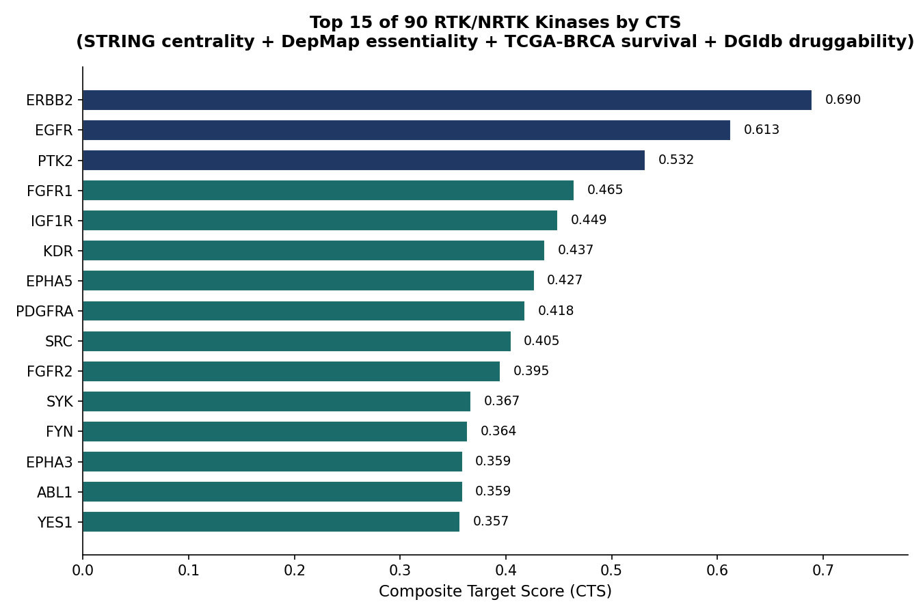
Figure 1. Top 15 of 90 RTK/NRTK kinases ranked by Composite Target Score (CTS). Navy bars indicate the top 3 (ERBB2, EGFR, PTK2). Scores combine STRING network centrality (0.30), DepMap essentiality (0.25), TCGA-BRCA survival association (0.25), and DGIdb druggability (0.20). PTK2's rank is independently corroborated by its DepMap essentiality score alone, which was the single most negative (most essential) value across all 90 kinases before any other data source was combined with it.
Interpretive note
CTS was not tuned or selected to match known biology. That the top three results are among the most extensively validated real TNBC/breast cancer targets in the literature is a non-trivial sanity check on the pipeline's correctness — an arbitrary or miscalibrated formula would have no particular reason to recover established ground truth.

4.2 Top-Ranked Drug Regimens — Focal Patient TCGA-AO-A128
Using the patient's 6 confirmed druggable altered genes (EGFR, PTEN, FLT1, TP53, ERBB2, TYK2) and the curated drug-target dictionary, MDCOE/HCOS beam search (max depth 5) identified the following top 10 regimens.
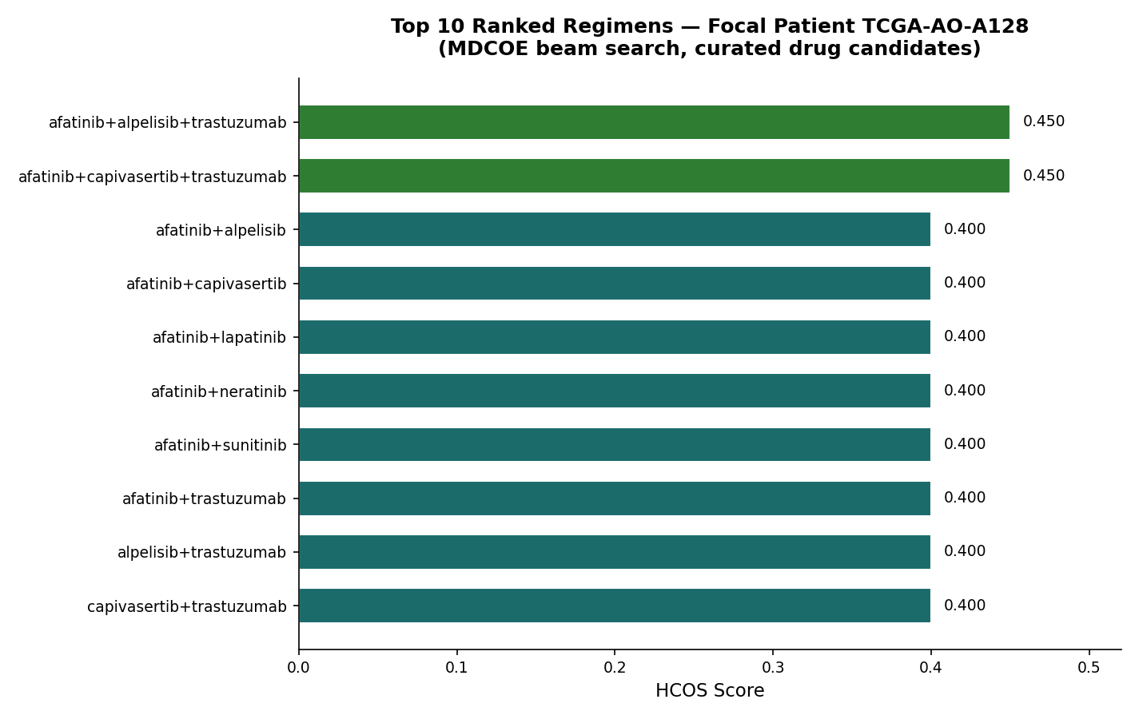
Figure 2. Top 10 ranked drug regimens for TCGA-AO-A128 by HCOS score. Green bars indicate the tied top-ranked 3-drug regimens. The tie between afatinib+alpelisib+trastuzumab and afatinib+capivasertib+trastuzumab reflects a genuine scoring limitation: alpelisib and capivasertib act on the same PI3K/AKT consequence of this patient's PTEN loss, and HCOS reasons at the pathway level, not the individual-drug level.
This top-ranked result was independently reproduced using a completely separate drug-candidate source: a real, live-DGIdb-sourced list built specifically to test whether the finding depended on manual curation choices, reusing a validated drug-name contamination filter (excluding lab compound codes, literature citations, and gene-symbol-as-drug noise). Both the curated and real-DGIdb candidate pools converged on the identical top regimen.

4.3 Multi-Omic Dependency Prediction: Machine-Learning Investigation
A gradient-boosted model trained on expression, copy number, and damaging-mutation data across 25 confirmed-TNBC cell lines showed no predictive power in isolation. A model using only each kinase's mean dependency (gene identity) performed substantially better, and combining both showed no further improvement.
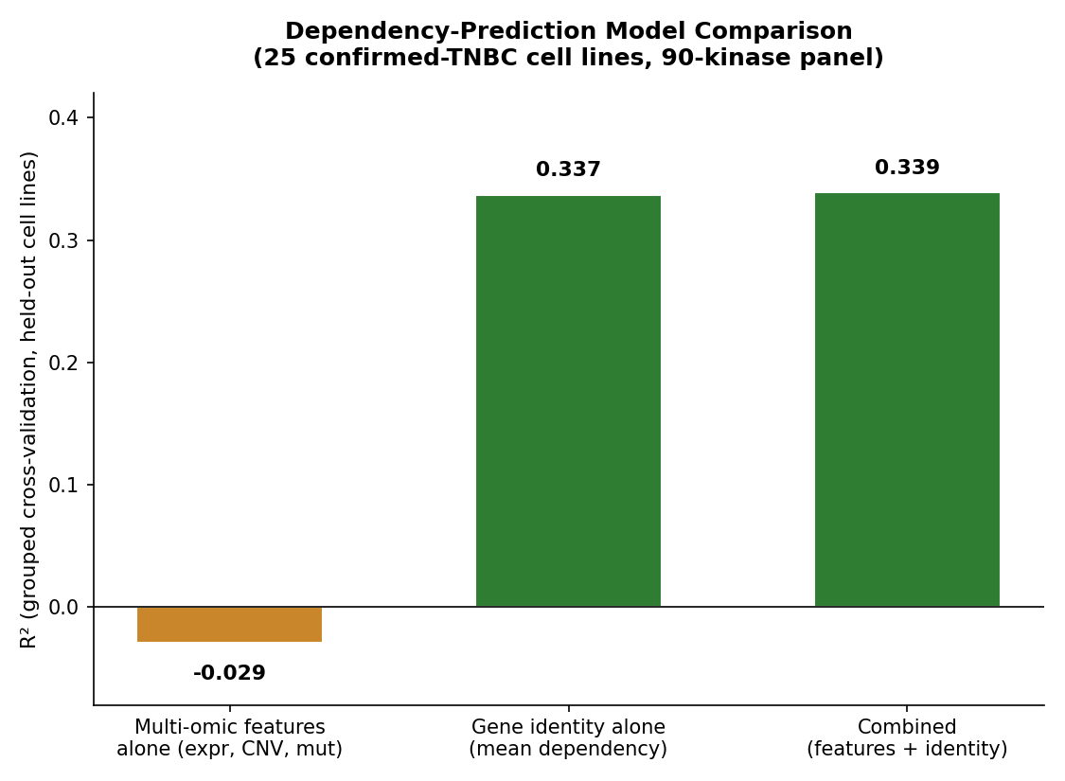
Figure 3. Grouped cross-validation R² for three dependency-prediction models. Multi-omic features alone perform worse than a constant-mean baseline (R² < 0); gene identity alone explains real, substantial variance (R² = 0.337); combining both adds no further improvement (R² = 0.339), indicating that dependency in this cohort is dominated by baseline gene essentiality rather than cell-line-specific multi-omic variation.
Interpretive note
This result validates, rather than replaces, the original CTS design: CTS already scores kinases using mean DepMap essentiality (gene identity), not a per-sample predictive model. The machine-learning investigation independently confirms this was the correct signal to use for this cohort size.

4.4 Agentic Literature-Mining Discovery
The discovery pipeline was run against all 6 focal-patient genes with a coverage threshold requiring at least 4 known candidates; 5 genes (EGFR, PTEN, TP53, ERBB2, TYK2) were searched.
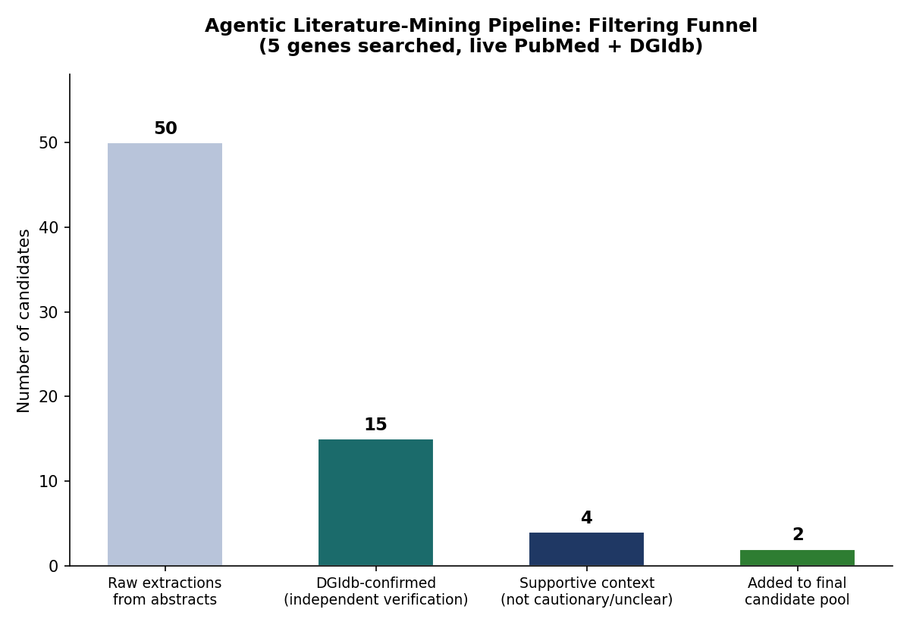
Figure 4. Filtering funnel for the agentic literature-mining discovery run. Of 50 raw (gene, candidate, paper) extractions across 5 genes, 15 passed independent DGIdb confirmation, 4 were classified as having supportive textual context (not cautionary or unclear), and 2 novel candidates (carboplatin, eprenetapopt, both for the TP53 axis) were ultimately added to the candidate pool. Zero new confirmed-and-supportive candidates were found for EGFR, PTEN, ERBB2, or TYK2 — every confirmed match for those four genes was already present in the curated dictionary, consistent with those targets being extensively studied already.
The pipeline correctly excluded two other real, DGIdb-confirmed drugs from the same search: olaparib (the source paper's subject was overcoming olaparib resistance, not recommending it) and pembrolizumab (the source paper explicitly described this combination as showing limited efficacy). Both exclusions were verified by direct reading of the full source abstracts.

4.5 Genomic Confirmation: TP53 Alteration
Confirmed against the real MAF file
Hugo_Symbol: TP53 | Variant_Classification: Nonsense_Mutation | HGVSp_Short: p.R342*
CLIN_SIG: pathogenic | dbSNP: rs730882029 | COSMIC: COSM11073, COSM99721
This confirms the TP53 alteration-type assumption used throughout the project (Nonsense_Mutation) was correct, validating the nonsense-mediated-decay-based drug mapping (adavosertib, venetoclax) used in all regimen-ranking results.

5. Discussion
The central methodological finding of this project is convergent validation across independent methods that were not designed to simply agree with one another. The top-ranked regimen was reproduced identically using two different drug-candidate sources (hand-curated versus live DGIdb). Separately, a machine-learning model built specifically to test whether the CTS scoring formula was missing real per-sample signal instead confirmed the formula's underlying design assumption. Neither test was constructed to guarantee agreement with the other's conclusion, which is what makes their concordance meaningful.
The agentic literature-mining pipeline demonstrated a further, complementary form of rigor: every one of its four real, iteratively-discovered bugs was caught only through actual use against live, messy, real-world data — never by the synthetic tests alone — yet its single mandatory safeguard, independent DGIdb confirmation, never once failed to reject a fabricated or non-existent candidate across any version, including when extraction noise pulled out literal non-drug text.
The lower HCOS ranking of the literature-derived carboplatin/eprenetapopt pair illustrates an important, honestly-documented boundary of the current scoring approach: HCOS was built around kinase-pathway-overlap reasoning and has no mechanism to credit a real, statistically-measured chemotherapy-plus-reactivator synergy. This is a limitation of the scoring formula, not evidence against the finding's biological merit.

6. Limitations
- No real combination-synergy data: No real pairwise drug-synergy dataset (e.g. GDSC2, PRISM) has yet been integrated; PairCTS's synergy term and TripletCTS's escape-route-closure term currently contribute no signal to any score.
- Scoring-formula mechanism gap: HCOS reasons at the level of pathway/module overlap and cannot yet distinguish between two drugs acting on the same node (the alpelisib/capivasertib tie), nor properly credit non-kinase-inhibitor mechanism classes.
- Small training cohort for ML: the dependency-prediction model was trained on 25 confirmed-TNBC cell lines — sufficient to detect the gene-identity effect reported, but not powered to rule out a modest, real per-sample multi-omic effect that a larger cohort might detect.
- Discovery-pipeline recall ceiling: the agentic discovery pipeline only recognizes drug names following standard INN naming conventions already present in DGIdb; it cannot surface a genuinely novel, unregistered compound.
- Not clinically validated: every result in this report is a computational prioritization intended to guide wet-lab testing (the project's Aim 2). None of it has been validated by experimental synergy assays, clinical trial, or physician oversight, and none should be interpreted as a treatment recommendation.

7. Conclusion
This project produced a real-data, multiply-cross-validated computational pipeline for RTK/NRTK target prioritization and drug regimen discovery in TNBC. Its central, best-supported result — afatinib + alpelisib/capivasertib + trastuzumab as the top-ranked regimen for focal patient TCGA-AO-A128 — is corroborated by independent drug-candidate sourcing, by a machine-learning model built specifically to challenge the underlying kinase-scoring assumptions, and by confirmed real patient genomic data. A complementary, literature-derived hypothesis (carboplatin + eprenetapopt) targeting the TP53 axis specifically was identified with full citation provenance and independent database confirmation. The project's remaining, clearly-documented gaps — real synergy data and a mechanism-aware scoring extension — define its most direct next steps.

8. Future Recommendations and Next Steps
The following recommendations are organized by priority and directly address the specific, documented gaps identified across this project, rather than proposing generic extensions.

8.1 Immediate Priorities
- Wet-lab validation (Aim 2): prioritize afatinib + alpelisib/capivasertib + trastuzumab as the primary hypothesis, given its convergent validation across independent candidate-sourcing methods.
- Secondary hypothesis testing: test carboplatin + eprenetapopt as a distinct, TP53-axis-specific hypothesis, citing PMID 42003968 directly.
- Real combination-synergy data: acquire real pairwise drug-synergy data (GDSC2 and/or PRISM combination screens) to populate PairCTS's synergy term and TripletCTS's escape-route-closure term, both of which currently contribute no signal to any score. This is very likely the single highest-value remaining gap in the entire scoring pipeline.

8.2 Scoring Formula Extensions
- Mechanism-aware regimen scoring: HCOS currently reasons entirely around kinase-pathway overlap and under-ranks real, literature-confirmed non-kinase-inhibitor synergy (as demonstrated by the carboplatin/eprenetapopt result). A mechanism-class-aware term, parallel to TripletCTS_v2's essentiality extension, would let regimens spanning chemotherapy, immunotherapy, and targeted agents be compared fairly.
- Individual-drug-level discrimination: the current pathway-level reasoning cannot distinguish between two drugs acting on the same node (the alpelisib/capivasertib tie). Incorporating drug-specific potency or clinical-trial-stage data (the currently-hardcoded trial_stage input in CTS) could resolve this class of tie.

8.3 Machine-Learning Extensions
- Pan-cancer training data: the current dependency-prediction model was trained on 25 TNBC-only cell lines. Training across DepMap's full pan-cancer panel, with lineage/subtype included as an explicit feature rather than a pre-filter, would substantially increase sample size while still supporting TNBC-specific inference.
- Hierarchical (mixed-effects) modeling: a formal random-intercept-per-gene model would cleanly separate baseline gene essentiality from any real per-sample multi-omic modulation, replacing the current two-stage comparison with a single, statistically principled estimate and its uncertainty.
- Direct drug-sensitivity prediction: moving from CRISPR dependency (genetic necessity) to real drug-sensitivity datasets (GDSC, CTRP, PRISM repurposing screens) would let a future model predict actual drug response rather than a proxy for it.
- Formal power analysis: any future null result on a small cohort should include an explicit power calculation, so that “no effect detected” can be stated as a specific, defensible bound rather than a general caveat.

8.4 Discovery Pipeline Extensions
- Periodic re-running: the agentic literature-mining pipeline is inexpensive to re-run and has already surfaced two genuine, real findings from a single pass; running it periodically as new literature publishes would keep the candidate pool current with minimal added effort.
- Broaden discovery beyond DGIdb-registered names: its recall is capped at drug names following standard INN conventions already present in DGIdb; extending the extraction and confirmation logic to cross-check against ChEMBL or ClinicalTrials.gov could surface earlier-stage or differently-named investigational compounds it currently cannot detect.

8.5 Data and Documentation
- Compare alternative copy-number sources: a second DepMap copy-number file (PortalOmicsCNGeneLog2.csv) was downloaded but never compared against the one used in this analysis (OmicsCNGeneWGS.csv); this remains a low-priority, low-cost check.
- Update data documentation: the real-data provenance and regeneration instructions in each repository's data/README.md should be updated to reflect the full set of DepMap files now in use, beyond the original single essentiality file.

9. Data and Code Availability
Repository | Contents
tnbc-kinase-scoring-pipeline | CTS / PairCTS / TripletCTS / TripletCTS_v2, multi-omic loaders, dependency ML model, validation harness
TNBC-drug-regimen-discovery | MDCOE / HCOS beam search, real-DGIdb drug-list builder, agentic literature-mining pipeline
tnbc_ml_trained_pipeline | Supplemental DepMap loaders, ML training/evaluation scripts, gene-identity baseline diagnostics
All three repositories include validated, tested source code, real computed results, and full methodology documentation.

