**Real-Time Stock Analysis and Prediction**

**Using Python and Yahoo Finance**

**A Project Report**

Submitted in partial fulfilment of the requirements for the   
**Award of the degree of**

**Master of Computer Application**

**By**

**Md. Tarique Anwer**

**(322201297)**



**Centre for Distance and Online Education**

**LOVELY PROFESSIONAL UNIVERSITY**

**PHAGWARA, PUNJAB**

**2024**

**Declaration by the Student**

**To whom-so-ever it may concern**

I, **MD TARIQUE ANWER**, **322201297**, hereby declare that the work done by me on “**Real-Time Stock Analysis and Prediction Using Python and Yahoo Finance**”, is a record of original work for the partial fulfilment of the requirements for the award of the degree, **Master of Computer Application.**

**MD TARIQUE ANWER (322201297)**

Signature of the student

Dated:

# Acknowledgement

I would like to express my sincere gratitude to everyone who contributed to the successful completion of my project, "**Real-Time Stock Analysis and Prediction using Python and Yahoo Finance**".

First and foremost, I extend my deep appreciation to the faculty members of the **Online Master of Computer Application program at Lovely Professional University**. Their commitment to excellence in teaching and the comprehensive curriculum provided me with the essential knowledge, guidance, and resources required to complete this project. I am especially grateful to my instructors and mentors whose insightful feedback, expert advice, and constructive criticism were invaluable in refining my approach and methodology.

A special note of thanks goes to my family and friends for their unwavering support, understanding, and patience throughout this endeavour. Their belief in my abilities and their constant motivation were sources of inspiration that fuelled my determination to push through difficult moments and stay committed to my goals.

Completing this project has been a deeply enriching and educational journey. It has allowed me to apply theoretical concepts in a practical setting, sharpen my analytical and technical skills, and gain invaluable insights into real-time financial data analysis. I am truly grateful to everyone who contributed in any capacity to making this project a reality.

Thank you all for your support and encouragement.

**MD TARIQUE ANWER (322201297)**

**Lovely Professional University, Phagwara, Punjab**

***Tarique Anwer***

**Abstract**

This project, “**Real-Time Stock Analysis and Prediction Using Python and Yahoo Finance**”, aims to assist investors in making informed decisions by providing timely insights into stock market trends. In today's fast-paced financial environment, analysing real-time stock data is crucial for individuals and organizations to stay ahead in investments. This project leverages Python for data extraction, processing, and visualization, using Yahoo Finance as the primary data source for live market data.

Our approach integrates data analysis and machine learning to predict short-term price movements and identify potential investment opportunities. Key tools and libraries used include pandas for data manipulation, Plotly for visualization, Flask for backend of web application and HTML, CSS and JavaScript as frontend technologies and various predictive models for forecasting stock prices. By analysing historical stock data and real-time trends, we generate insights on stock performance that can be used to predict future price movements.

Through this project, we demonstrate a practical application of machine learning in finance, highlighting the use of web scraping, data analysis, and predictive modeling to support investment decisions. This report details the methodologies, tools, and outcomes, providing a comprehensive view of how Python can be used to deliver robust stock analysis and predictive insights for real-time decision-making in the stock market.

**Table of Contents**

|  |  |  |
| --- | --- | --- |
| **Sr. No.** | **Topic** | **Page No.** |
| 1 | Cover Page | 1 |
| 2 | Declaration by Student | 2 |
| 3 | Acknowledgement | 3 |
| 4 | Abstract | 4 |
| 5 | Table of Contents | 5 |
| 6 | List of Tables |  |
| 7 | List of Figures/Charts |  |
| 8 | List of Symbols |  |
| 9 | List of Abbreviations |  |
| 10 | Chapter-1 Introduction |  |
| 11 | Chapter-2 Review of Literature |  |
| 12 | Chapter-3 Implementation of Project |  |
| 13 | Chapter-4 Results and Discussion |  |
| 14 | Final Chapter - Conclusion and Future Scope |  |
| 15 | Summary of Report |  |
| 16 | Annexures |  |
| 17 | References |  |
|  |  |  |
|  |  |  |
|  |  |  |
|  |  |  |
|  |  |  |

**List of Tables**

|  |  |  |
| --- | --- | --- |
| **Table No.** | **Title** | **Page No.** |
| 1 | Cover Page | 1 |
| 2 | Declaration by Student | 2 |
| 3 | Acknowledgement | 3 |
| 4 | Abstract | 4 |
| 5 | Table of Contents | 5 |

**List of Figures/Charts**

|  |  |  |
| --- | --- | --- |
| **Figure/Chart No.** | **Title** | **Page No.** |
| Figure 1 | System Architecture of Stock Prediction Tool | 1 |
| Figure 2 | Data Collection Workflow | 2 |
| Chart 1 | Historical Stock Price Trends | 3 |
| Chart 2 | Feature Importance for Stock Price Prediction | 4 |

**List of Symbols**

|  |  |  |
| --- | --- | --- |
| **Symbol** | **Description** | **Unit** |
| $ | Stock Price | USD |

**List of Abbreviations**

|  |  |  |
| --- | --- | --- |
| **Abbreviation** | **Full Form** | **Description** |
| ML | Machine Learning | USD |
| API | Application Programming Interface | 2 |
| INR | Indian Rupees | 3 |
| NLP | Natural Language Processing | 4 |

# Chapter-1 Introduction

The project, **“Real-Time Stock Analysis and Prediction Using Python and Yahoo Finance”,** is designed to provide investors with accurate, data-driven insights into stock market performance. This project retrieves both historical and real-time stock data from Yahoo Finance using web scraping techniques, with an alternative option to use the YFinance API if web scraping becomes unavailable.

By integrating machine learning techniques and leveraging key Python libraries—such as **Pandas** for efficient data manipulation, **NumPy** for complex numerical computations, and **Plotly** for data visualization—this project transforms raw market data into actionable insights. The primary objective is to predict future stock trends, empowering investors to make informed decisions about which stocks to buy. Through real-time analysis and forecasting, this project demonstrates the potential of Python in financial analytics, offering a robust tool for stock prediction and decision-making.

**1.1 Data Retrieval and Processing**

Data is sourced from Yahoo Finance through web scraping techniques, or alternatively through the YFinance API if web scraping becomes inaccessible. This dual approach ensures a reliable and continuous flow of market data for analysis. Key libraries such as Pandas and NumPy play a central role in structuring, cleaning, and manipulating the data, transforming raw inputs into meaningful insights.

**1.2 Analytical Approach and Machine Learning**

Using Python’s extensive data science ecosystem, the project explores historical stock prices to identify patterns and predict future stock performance. Various machine learning models are applied to this dataset, aiming to predict short-term stock price movements based on historical trends and market behavior. This predictive modeling enables a comparative analysis of stocks, identifying those with promising trends for potential investments.

**1.3 Visualization and User Insights**

Data visualization is achieved through the Matplotlib library, providing graphical insights that help investors quickly understand trends and patterns. By combining real-time data analysis with predictive analytics, the project delivers a user-friendly platform where users can visualize potential stock movements and make informed investment decisions.

**1.3 Goal and Significance**

The primary objective of this project is to enable informed, data-driven decision-making for investors looking to maximize returns. By providing an accessible, Python-based solution for stock analysis and prediction, the project serves as a practical tool for anyone interested in leveraging real-time financial data to anticipate market movements. This project not only demonstrates the application of Python in financial analytics but also showcases the role of machine learning in shaping modern investment strategies.

**Chapter-2 Review of Literature**

This chapter reviews existing studies and technologies relevant to the development of the project **Real-Time Stock Analysis and Prediction Using Python and Yahoo Finance**. The literature review focuses on key areas including the use of Python for financial analytics, predictive modeling techniques, visualization tools, and real-time data integration, providing a foundation for understanding the methodologies applied in the project.

**2.1** **Stock Market Analysis and Prediction**

Stock market prediction has long been a subject of interest due to the complexities of financial markets and the potential for substantial gains. Traditional methods relied heavily on technical analysis using historical price trends and indicators such as moving averages and candlestick charts. Recent advancements in computational methods have integrated machine learning models to enhance predictive capabilities.

Linear regression, a fundamental statistical technique, has been widely used to analyze the relationship between stock price movements and various predictors. However, its performance may be limited by the complexity of financial data. To address this, more sophisticated models such as decision trees, support vector machines, and deep learning frameworks have been explored in recent research.

**2.2 Python as a Tool for Financial Analytics**

Python is a widely used programming language for financial analytics due to its flexibility and extensive library ecosystem. Relevant libraries include:

* **yfinance**: Simplifies the process of fetching historical and real-time stock market data.
* **pandas**: Facilitates data cleaning, transformation, and analysis, making it integral for managing stock price datasets.
* **plotly**: Enables interactive visualizations such as candlestick and line charts, aiding in comprehensible representation of stock trends.
* **scikit-learn**: Provides robust tools for predictive modeling and evaluation, such as the Linear Regression model applied in this project.

Python's integration of data analysis, visualization, and machine learning functionalities makes it an ideal choice for building comprehensive stock analysis applications.

**2.3** **Real-Time Stock Data Integration**

Real-time stock analysis requires dynamic data acquisition and processing. Platforms like Yahoo Finance provide APIs for accessing live and historical data. Studies have highlighted the effectiveness of using Yahoo Finance data for financial forecasting due to its reliability and wide coverage of global stock markets.

The yfinance library in Python offers a convenient interface for fetching data, including stock prices, trading volumes, and financial indicators. This simplifies the workflow, allowing developers to focus on data modeling and application development.

**2.4** **Visualization Techniques in Stock Analysis**

Visualization is critical for interpreting stock data and trends. Candlestick charts are a staple in financial analysis, providing insights into daily price movements, including open, high, low, and close prices. Moving averages (e.g., 50-day and 200-day averages) are commonly used to identify trends and potential reversals.

Interactive visualization tools like Plotly enhance user engagement by enabling zooming, panning, and tooltips for data points, making them suitable for web-based applications.

**2.5** **Predictive Modeling Techniques**

Predictive modeling in stock analysis focuses on forecasting future price movements based on historical trends. This project employs linear regression to predict percentage changes in stock prices. Linear regression has been extensively studied for its simplicity and interpretability in financial contexts, although it may be less effective for capturing complex market dynamics compared to advanced models like neural networks.

The use of train, test, split from scikit-learn ensures robust model evaluation by dividing the dataset into training and testing subsets. The results are used to recommend investment actions such as "BUY" or "HOLD" based on predicted price movements.

**2.6** **Challenges in Real-Time Stock Prediction**

The project addresses several challenges commonly encountered in real-time stock analysis:

* **Data Volatility**: Stock markets are highly sensitive to news and events, requiring models to adapt quickly.
* **Data Quality**: Historical stock data may contain missing or erroneous values that need to be handled before analysis.
* **Real-Time Processing**: Ensuring seamless integration of real-time data while maintaining application performance.

These challenges are mitigated through effective use of Python libraries for data preparation, robust model training, and efficient visualization techniques.

**2.7** **Literature Gap**

While existing studies demonstrate the utility of Python and machine learning in financial analytics, certain gaps persist:

* Limited focus on integrating real-time data streams with predictive modeling.
* Lack of user-centric visualization and decision-making tools in many academic implementations.
* Minimal exploration of simple regression models in combination with interactive web-based applications.

This project aims to bridge these gaps by building a real-time stock analysis and prediction system that leverages Python, Yahoo Finance, and interactive visualizations to provide actionable insights.

**2.8** **Conclusion**

The review highlights the evolution of stock analysis methodologies and the pivotal role of Python in advancing real-time financial analytics. By leveraging reliable data sources like Yahoo Finance, interactive visualization tools, and robust modeling techniques, this project seeks to deliver a practical application for real-time stock analysis and investment decision-making.

**Chapter-3 Implementation of Project**

This chapter explains the process of building the project **Real-Time Stock Analysis and Prediction Using Python and Yahoo Finance**. It covers the key steps, including defining requirements through the Software Requirements Specification (SRS), Tools and technologies, designing the system architecture, and implementing the solution with code.

Each section provides a clear view of how the project was developed, from system design to testing and deployment. The aim is to show how the project transitioned from an idea into a working application, meeting its goals of analyzing and predicting stock trends in real-time.

**3.1** **System Requirement Specification (SRS)**

The requirements for the **Real-Time Stock Analysis and Prediction Using Python and Yahoo Finance** project are analyzed in terms of system, software, and data requirements. A thorough understanding of these requirements ensures that the project is developed within the scope and performs as expected, providing accurate predictions and insights for investors.

The system requirements for the project focus on ensuring that the hardware and software infrastructure is capable of handling real-time stock data retrieval, data processing, and machine learning model training.

**3.1.1** **Hardware Requirement**

The hardware requirements are moderate, as the project involves data analysis, web scraping, and machine learning model prediction, which are computationally intensive but not resource-heavy for small to medium-scale data.

* **Processor:** A minimum of Intel Core i3 or equivalent (Quad-core preferred for better performance during data processing and model training).
* **RAM:** 8 GB or higher to handle data manipulation and machine learning tasks.
* **Storage:** At least 50 GB of free disk space for storing datasets, CSV files, and model output.
* **Internet Connection:** A stable connection for web scraping or API requests to Yahoo Finance.

**3.1.2** **Software Requirement**

The software environment is crucial for running the project smoothly, especially for Python-based development. Several software tools and platforms will be required for development, testing, and deployment.

* **Operating System:** Windows 10 or higher, macOS, or any Linux-based OS.
* **IDE (Integrated Development Environment):** Recommended IDEs include Visual Studio Code, Google Colab, or Jupyter Notebook for interactive coding and analysis.
* **Version Control System:** Git for managing project code versions, collaborating with teams, and maintaining code history.
* **Internet Browser:** Google Chrome, Firefox, Safari, Edge, Opera or any other latest version of modern internet browsers.
* **Python:** Version 3.11 as it is compatible with the necessary libraries and frameworks.
* **Web Framework:** Flask for backend development.
* **Python Libraries:**
* **Pandas:** For data manipulation and analysis.
* **NumPy:** For numerical computations.
* **Plotly:** For data visualization using graph
* **Flask:** For web application and API’s
* **YFinance:** For accessing Yahoo Finance data through API calls.
* **Scikit-learn:** For implementing machine learning algorithms.
* **Beautiful Soup:** For web scraping (if needed).
* **JavaScript Libraries and Frameworks:**
* jQuery 3.6:
* Bootstrap 5: For UI
* jQuery DataTable: For datatable
* Moment.js: For Date and time formatting
* **Microsoft Excel:** For reading csv (comma separated value) files.

**3.1.3 Data Requirements**

Data plays a central role in this project, and it is vital that the data is reliable, accurate, and up-to-date. The following data requirements have been identified for effective stock prediction:

**Stock Data:** The project will rely on historical and real-time stock data from Yahoo Finance, including stock prices, market trends, trading volume, and other relevant metrics.

**Data Storage:** CSV files will be used to store historical stock data retrieved from Yahoo Finance. These files will include columns such as stock symbols, date, opening price, closing price, volume, and other relevant indicators.

**Data Accuracy and Completeness:** The stock data needs to be accurate and free from missing values to ensure the quality of analysis. Incomplete or erroneous data will affect prediction accuracy.

**Real-Time Data:** The project will need to pull real-time stock data for ongoing analysis. This will be achieved through web scraping or the YFinance API, which requires a continuous internet connection for fetching the latest market data.

**3.2** **Tools & Technologies**

In developing the “**Real-Time Stock Analysis and Prediction Using Python and Yahoo Finance**” project, a variety of technologies were carefully selected to ensure robust data handling, efficient processing, and effective visualization. Each chosen technology contributes uniquely to the project's requirements, facilitating a streamlined approach to analyzing and predicting stock trends.

**3.2.1 Python**

Python was chosen as the primary programming language due to its extensive ecosystem of libraries and tools designed for data science, machine learning, and financial analysis. Python's syntax is simple and readable, making it highly accessible and suitable for rapid development. Additionally, Python offers a range of libraries tailored for data manipulation, visualization, and machine learning, making it an ideal choice for building an end-to-end stock prediction model.

**3.2.2 Pandas**

The Pandas library is pivotal for data manipulation in this project. It provides robust data structures, like Data Frames, which allow for easy manipulation, cleaning, and transformation of large datasets. Stock data analysis often requires processing extensive historical datasets, and Pandas simplifies the process of importing, organizing, and preparing this data for analysis. Its integration with other Python libraries makes it highly versatile for building comprehensive data workflows.

**3.2.3 NumPy**

NumPy is essential for performing numerical computations efficiently. Since stock prediction models rely on complex mathematical operations and calculations, NumPy’s fast array operations and mathematical functions allow for efficient handling of large datasets. This library complements Pandas, enabling streamlined computations necessary for data preparation and modeling in real-time and historical data analysis.

**3.2.4 Plotly**

Plotly was selected for its advanced data visualization capabilities that extend beyond the basic plotting functionalities offered by libraries such as Matplotlib. Plotly’s interactive charts provide users with a more engaging experience, allowing them to hover over data points for detailed information and manipulate the visualization for deeper insights. In the context of stock analysis and prediction, Plotly’s interactivity enhances the user’s ability to explore and interpret data trends, aiding in a comprehensive understanding of market patterns. This interactive approach makes it easier for users to make well-informed decisions by observing trends and predictions in a dynamic format.

**3.2.5 YFinance API**

Yahoo Finance is a reliable source of both real-time and historical stock data, making it a valuable resource for this project. Web scraping is used to retrieve data directly from Yahoo Finance, providing flexibility in obtaining various types of financial information. However, to ensure data access continuity, the YFinance API serves as a backup in cases where web scraping may be limited or unavailable. This dual approach ensures consistent data flow, allowing the project to function effectively without disruptions.

**3.2.6 CSV (Comma-Separated Values)**

The CSV (Comma-Separated Values) format is commonly used for storing and exchanging data. In this project, CSV files are used to store historical stock data retrieved from Yahoo Finance. The CSV format provides a simple and widely-supported method of saving data, making it easy to import, export, and work with data in Python using Pandas. By leveraging CSV files, the project ensures that data can be easily loaded, saved, and shared across different components and systems, maintaining flexibility in data processing.

**3.2.7 Machine Learning Algorithms**

Integrating machine learning algorithms enables this project to move beyond mere data analysis and into prediction. Machine learning algorithms can analyze patterns within historical stock data and generate forecasts on future stock prices. By using Python’s machine learning ecosystem, which includes libraries like scikit-learn, the project can implement models that provide actionable insights for investors. This predictive aspect is the cornerstone of the project, offering users a data-driven basis for their investment decisions.

**3.2.8 Flask**

Flask was chosen as the web framework for this project due to its lightweight and flexible nature. Flask's simplicity allows for rapid development and integration with various Python libraries, making it ideal for building web-based applications that require custom functionality. For this project, Flask acts as the backbone of the web interface, facilitating seamless communication between the frontend and backend, and ensuring a smooth user experience. Flask’s modular structure supports scalability, which is advantageous for projects that may require expansion in the future. Additionally, its integration with Jinja2 templating engine aids in rendering dynamic HTML content, enabling interactive and responsive web pages.

**3.2.9 HTML**

HTML (Hypertext Markup Language) was chosen as the structural foundation for the web application. It is essential for defining the content and layout of the web pages, ensuring that information is organized in a meaningful way. HTML provides the basic elements that structure the application, allowing for the seamless integration of data visualization tools, interactive charts, and user input forms. Its compatibility with various web technologies makes it a versatile choice for building the framework of the project’s user interface.

**3.2.10 CSS**

CSS (Cascading Style Sheets) was used to style the web pages and enhance the visual appeal of the application. With CSS, the project achieves a modern and user-friendly design that improves the overall user experience. CSS allows for customization of elements such as fonts, colors, and layout, ensuring that the interface is both attractive and responsive. By leveraging CSS, the project maintains consistency in design across different devices, enhancing accessibility and usability.

**3.2.11 JavaScript**

JavaScript was employed to add interactivity and dynamic behavior to the web application. This scripting language enables real-time updates, client-side data validation, and interactive features that improve user engagement. JavaScript’s ability to manipulate the Document Object Model (DOM) allows the project to respond to user actions effectively, creating a more seamless and responsive user experience. Integrating JavaScript ensures that users can interact with the stock analysis and prediction platform in real-time, enhancing the practicality and

functionality of the application.

**3.2.12 jQuery 3.6**

A lightweight, fast, and feature-rich JavaScript library used for simplifying HTML document traversal, event handling, animation, and AJAX interactions. Version 3.6 ensures compatibility and modern web practices.

**3.2.13 Bootstrap 5**

A popular CSS framework that provides pre-designed components and responsive design utilities to create modern, mobile-first, and aesthetically pleasing web applications without extensive custom CSS.

**3.2.14 jQuery DataTable**

A plugin for jQuery that adds advanced interaction controls to HTML tables, including search, sorting, pagination, and data export features, enhancing the usability of data displays in web applications.

**3.2.15 Moment.js**

A JavaScript library designed for parsing, validating, manipulating, and formatting dates and times. It's particularly useful for handling complex date operations in client-side scripting.

**3.3** **System Design**

The system design phase is critical to ensuring that the “**Real-Time Stock Analysis and Prediction Using Python and Yahoo Finance**” project operates efficiently and meets its objectives. This chapter outlines the architecture, components, and workflow of the system, detailing how each element interacts to create a cohesive stock analysis and prediction tool.

**3.3.1 Architecture Overview**

The system architecture is designed to handle data retrieval, processing, analysis, and prediction efficiently. The project follows a modular structure, where each module has a distinct function that contributes to the overall workflow. The architecture can be broken down into the following main components:

* **Data Collection Module:** Responsible for retrieving real-time and historical stock data from Yahoo Finance using web scraping and the YFinance API.
* **Data Preprocessing Module:** Cleans and formats the retrieved data for analysis.
* Analysis and Prediction Module: Uses machine learning models to analyze historical data and predict future stock trends.
* **Visualization Module:** Presents data and prediction results using charts and graphs created with Matplotlib.
* **User Interface Module:** Provides a user-friendly interface for users to input stock symbols and view analysis and predictions.

**3.3.2 Data Flow Diagram (DFD)**

The Data Flow Diagram illustrates the flow of information through the system, providing a clear overview of how data is processed from input to output.

**Level 0:**

* **User Input:** Users provide the stock symbol they are interested in analyzing and a start and end date to analyze from historical data.
* **System Processing:** Process the data
* **System Output:** The system displays analysis and prediction results.

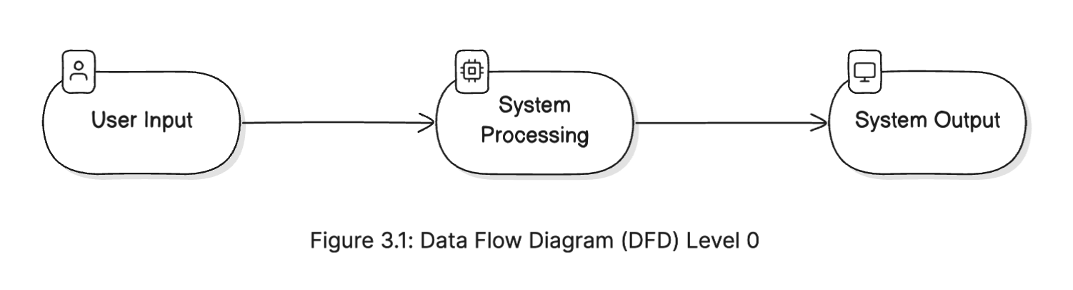

**Level 1:**

* **Data Input:** Stock symbol and date range are input by the user.
* **Data Collection Module:** Retrieves data from Yahoo Finance via web scraping or the YFinance API.
* **Data Preprocessing Module:** Formats and cleans the data for analysis.
* **Analysis and Prediction Module:** Applies machine learning models to generate predictions.
* **Visualization Module:** Creates visual representations of stock trends and predictions.
* **User Output:** Final analysis and prediction results are displayed.

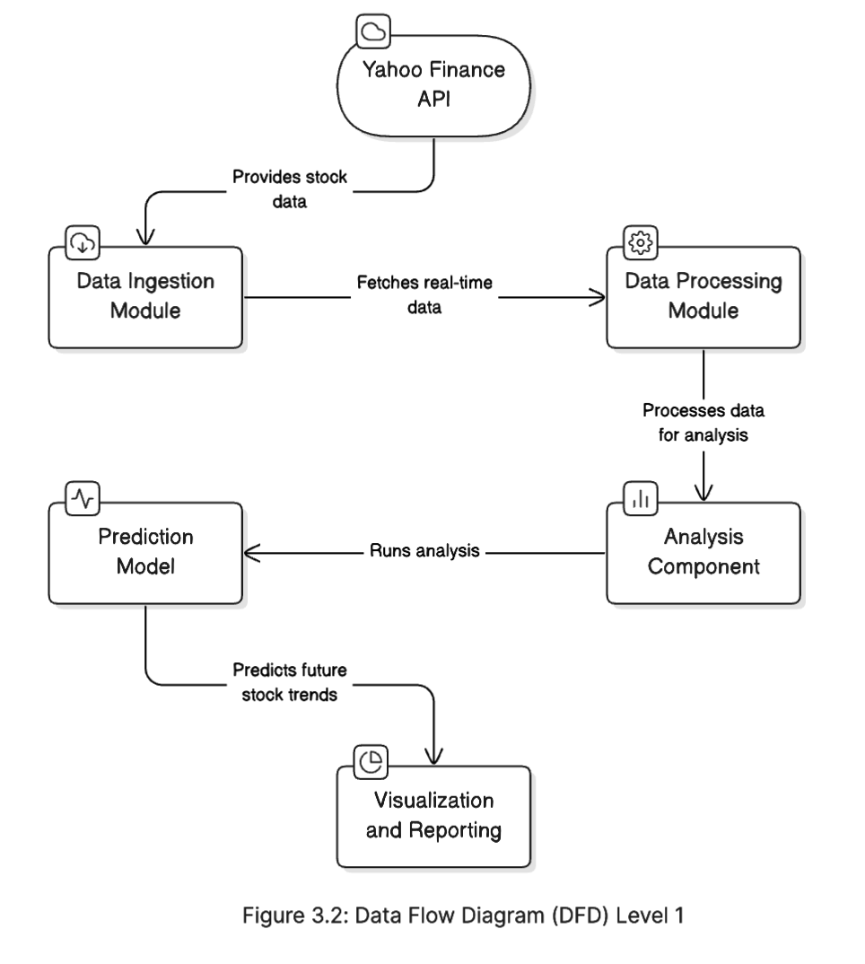

**3.3.3 System Components**

Each system component plays a specific role in the workflow. The following sections describe these components in detail:

**Data Collection Module**

This module is designed to interact with Yahoo Finance to fetch both historical and real-time stock data. The data is retrieved using: YFinance API: Provides a straightforward method for accessing structured stock data.

**Data Preprocessing Module**

The preprocessing module ensures the data is cleaned and ready for analysis. This involves:

* Removing null or missing values.
* Formatting data into a structured CSV or Data Frame.
* Calculating additional features if necessary (e.g., moving averages, volatility).

**Analysis and Prediction Module**

This module is the core of the system where machine learning algorithms are applied. The steps include:

* **Feature Selection:** Choosing relevant features from the dataset to improve prediction accuracy.
* **Model Training:** Using algorithms such as linear regression or decision trees to train the model.
* **Prediction:** Running the trained model on the prepared dataset to forecast future stock prices.

**Visualization Module**

The visualization module employs Matplotlib to create graphs that help in understanding stock trends and predictions. Common visual outputs include:

* Time series plots for stock prices.
* Prediction overlay charts showing actual vs. predicted data.

**3.3.4 Workflow Diagram**

A workflow diagram shows the step-by-step process that data goes through in the system:

* **User Input:** Stock symbol and date range.
* **Data Collection:** Data is retrieved from Yahoo Finance.
* **Data Preprocessing:** Data is cleaned and formatted.
* **Analysis and Prediction:** Machine learning models process the data.
* **Visualization:** Results are plotted.
* **User Output:** Predictions are displayed to the user.

**3.3.5 System Design Considerations**

* **Modularity:** Each component is independent, making the system easy to modify and update.
* **Scalability:** The design supports scaling up to include more data sources or more advanced machine learning models.
* **Error Handling:** The system includes mechanisms to handle errors in data retrieval or inconsistencies.

**3.3.6 User Interface Design**

A user-friendly interface is essential for an effective project. The design prioritizes simplicity and clarity, ensuring that even non-technical users can navigate and use the tool efficiently. The main features of the interface include:

* **Search Box:** For users to enter the stock symbol and select the date range.
* **Search Button:** To initiate data retrieval and prediction.
* **Overview Section:** To view stock current closing price, change and change percentage and prediction recommendation.
* **Graph Display Tab:** To present the analysis and prediction results visually.
* **Historical Data Tab:** To present the analysis and prediction results visually.
* **Finance News Tab:** To present the analysis and prediction results visually.

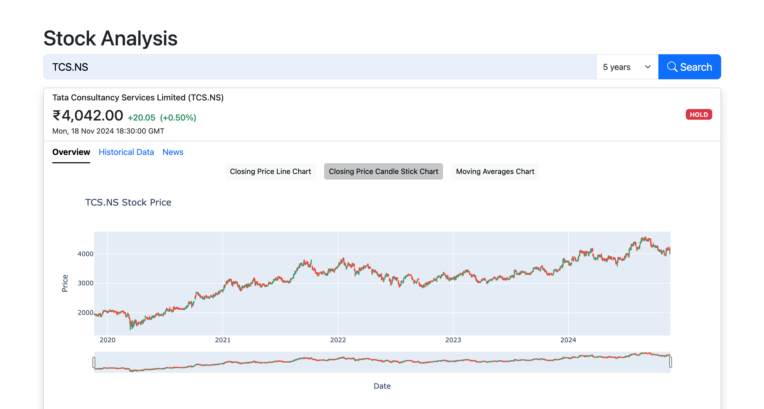

**3.4** **Coding**

The system design phase is critical to ensuring that the “**Real-Time Stock Analysis and Prediction Using Python and Yahoo Finance**” project operates efficiently and meets its objectives. This chapter outlines the architecture, components, and workflow of the system, detailing how each element interacts to create a cohesive stock analysis and prediction tool.