Reproducible Reporting from Central Biotics

Max Tarjan

November 16, 2022

Table of Contents

Background 3

Data Summary 3

Taxonomy 3

G-Rank 3

# Background

This report was produced using data from Central Biotics on November 16, 2022.

# Data Summary

## Taxonomy

The primary global element dataset contains 40,254 elements from 5 different taxonomic groups, comprising Vertebrate Animal, Invertebrate Animal, Nonvascular Plant, Fungus, and Vascular Plant.

Table 1. The number of elements in the primary global element dataset in each taxonomic group.

| Taxonomic Group | Count |
| --- | --- |
| Fungus | 25 |
| Invertebrate Animal | 8497 |
| Nonvascular Plant | 25 |
| Vascular Plant | 28112 |
| Vertebrate Animal | 3595 |

## G-Rank

The primary global element dataset has Global Conservation Ranks based on expert ranking.

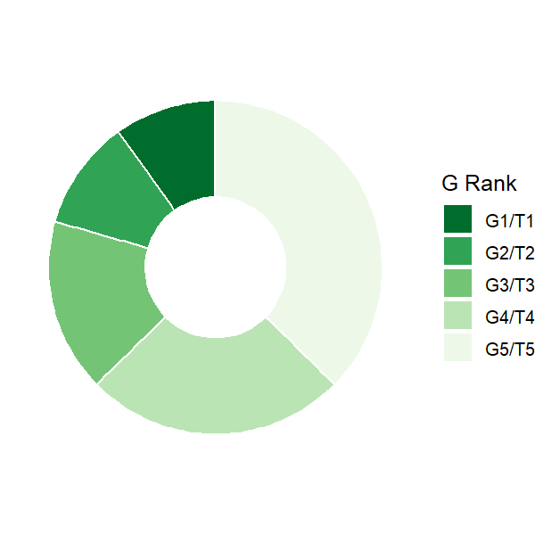

Figure 1. The frequency of G Ranks in the primary element global dataset.