Double-Crested Cormorant Populations in San Francisco Bay from 1985–2017

Draft of Analyses

Max Tarjan

2018-02-09

# Background

This manuscript describes options for analyzing trends in DCCO populations in the San Francisco Bay Area from 1985–2017.

# Methods

Following the methods of Manuwal et al (2000), I plotted raw regional counts using loess and standard error shading. I identified which regions followed exponential growth and which followed logistic growth by visualizing the ln-transformed regional counts. For the regions of the Bridges and South Farallone Islands, I identified subsets of years where data followed distinct trajectories and fit independent linear models for each data subset. I fit logistic growth equations for the regions of the North Bay, Outer Coast, and South Bay.

# Figures

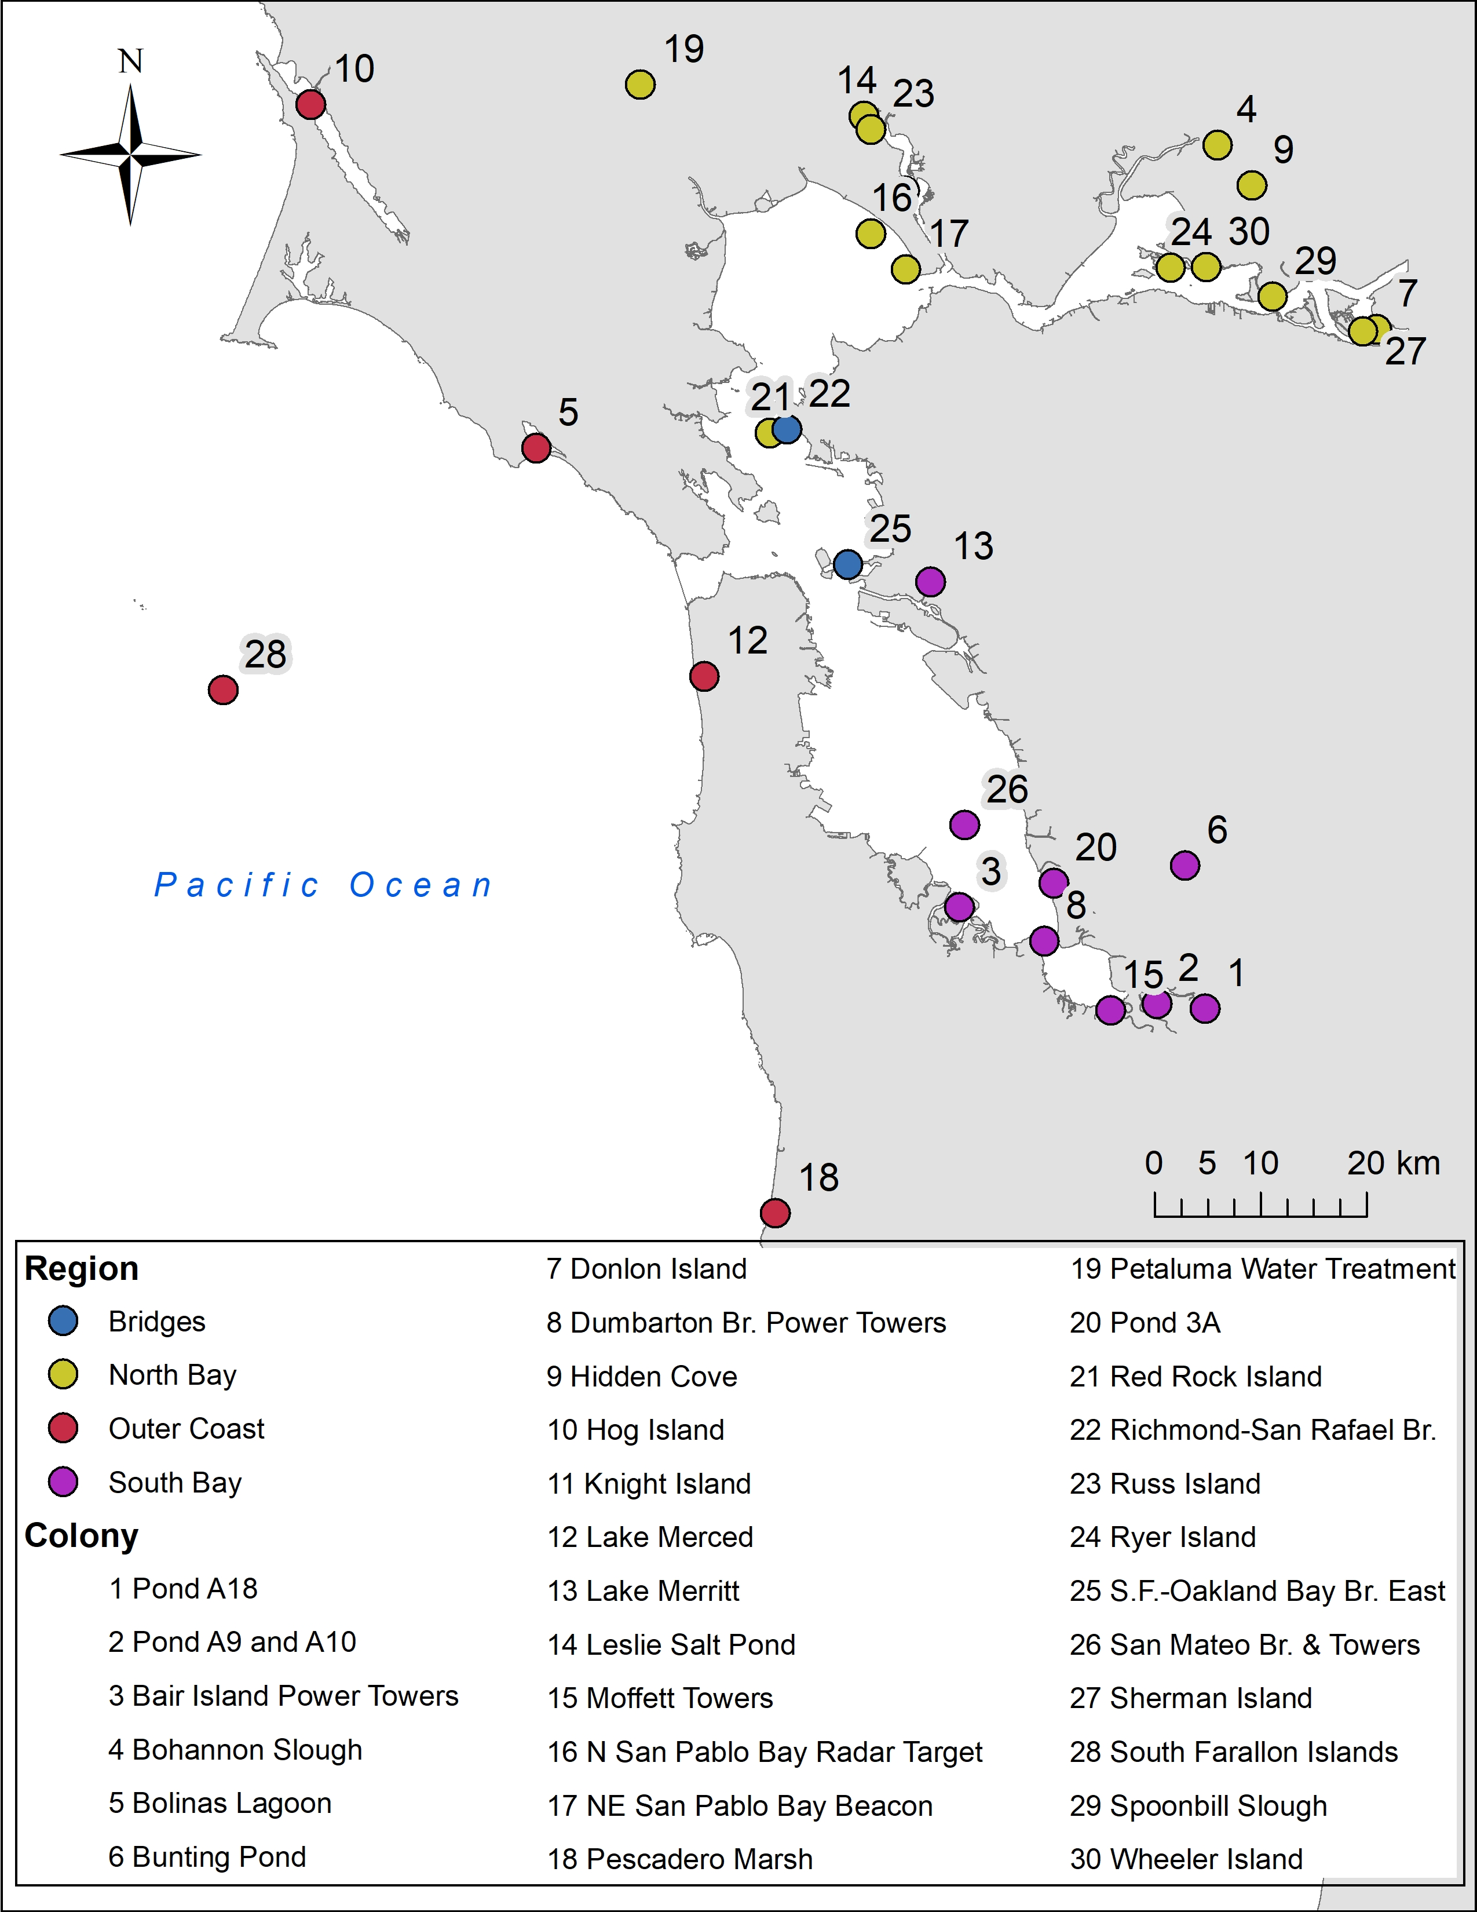 Fig 1. Map of DCCO nesting sites from 1985-2016 in the San Francisco Bay Area.

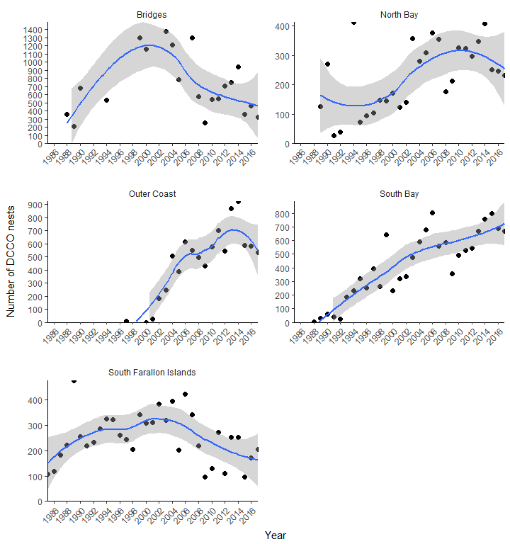 Fig 2. Counts of DCCO nests in each region around San Francisco Bay from 1985 – 2017. Points show raw counts summed across sites for each region. Data are plotted with a loess curve and standard error shading.

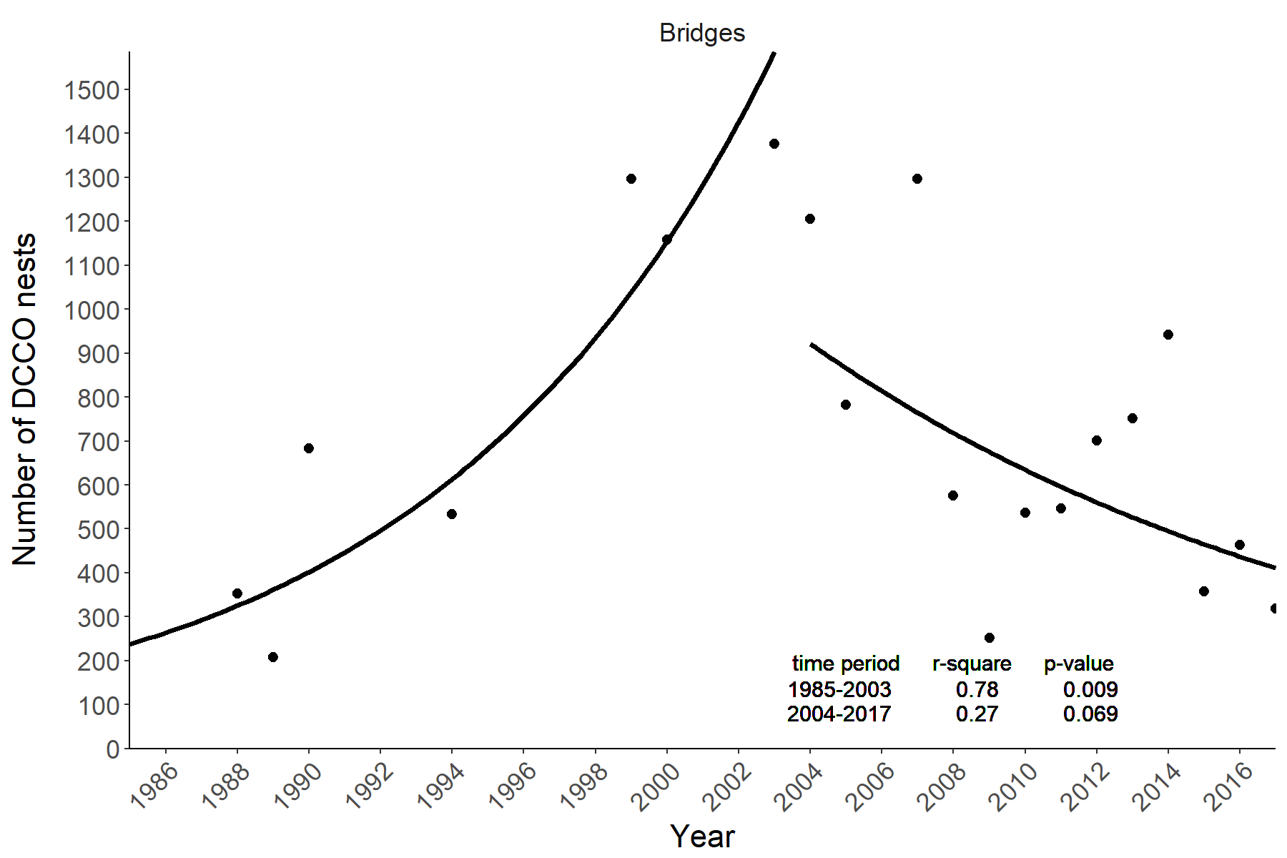 Fig 3. Regional counts over time in the Bridge region with fitted model (fitted as linear model on ln-transformed data).

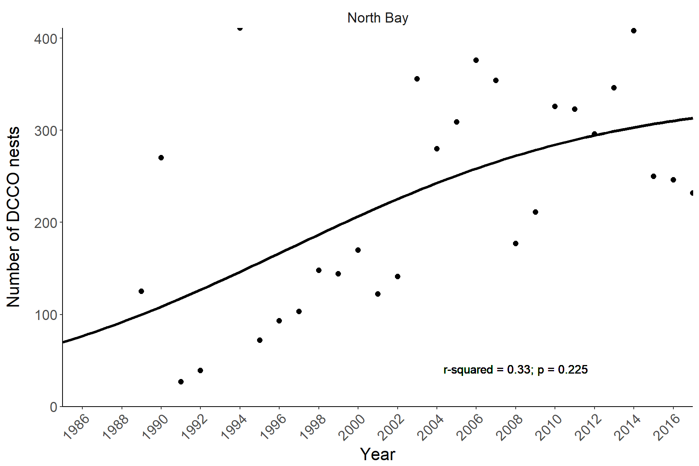 Fig 4. Regional counts over time in the North Bay region with fitted logistic model.

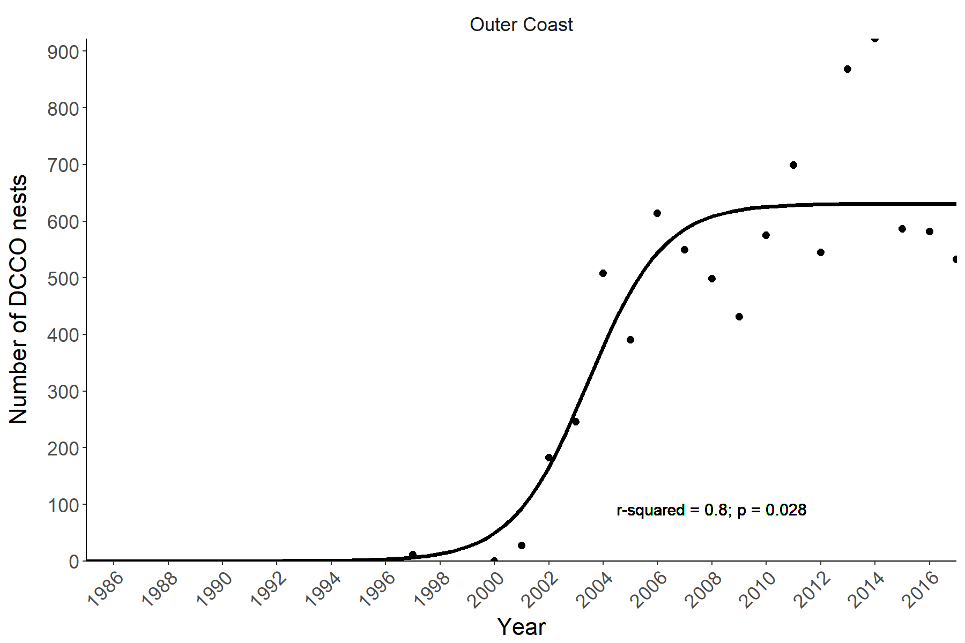 Fig 5. Regional counts over time in the Outer Coast region with fitted logistic model.

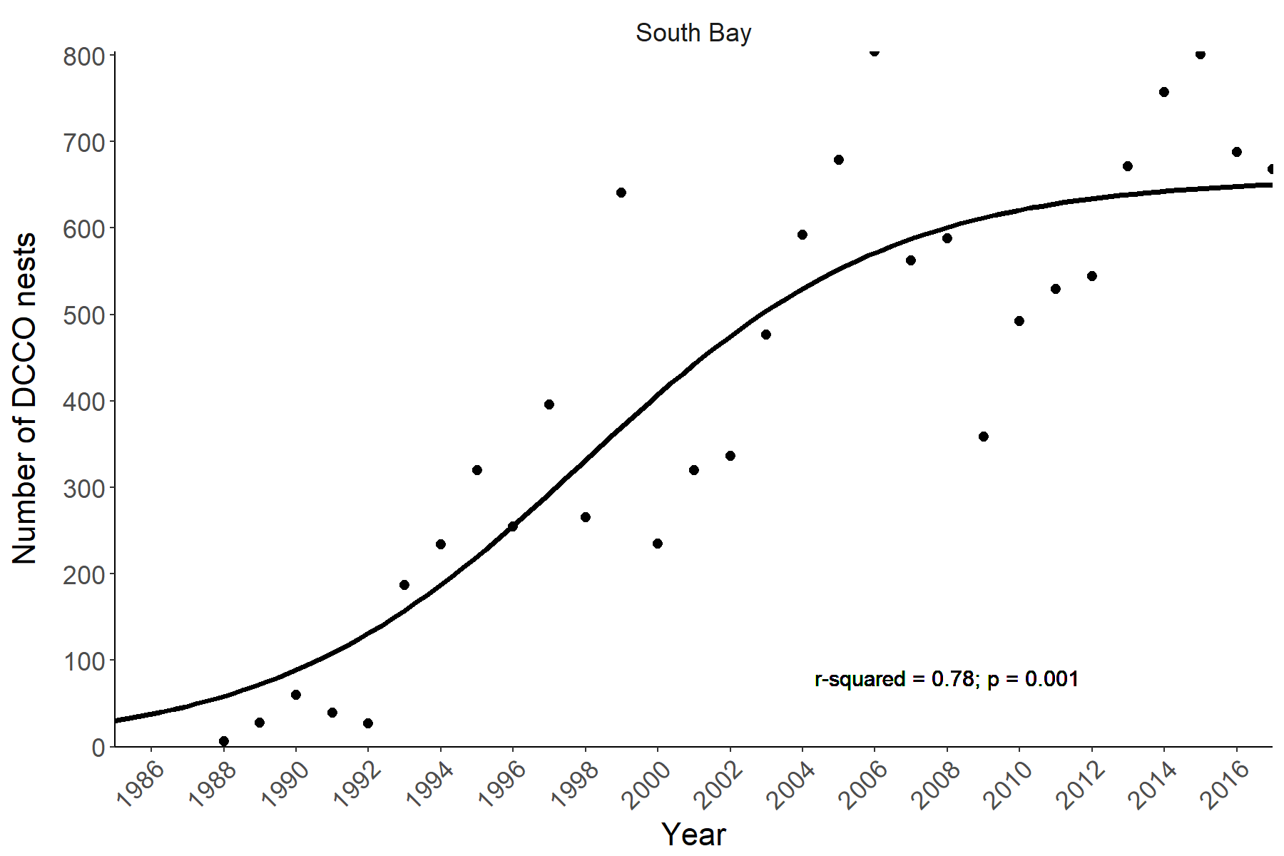 Fig 6. Regional counts over time in the South Bay region with fitted logistic model.

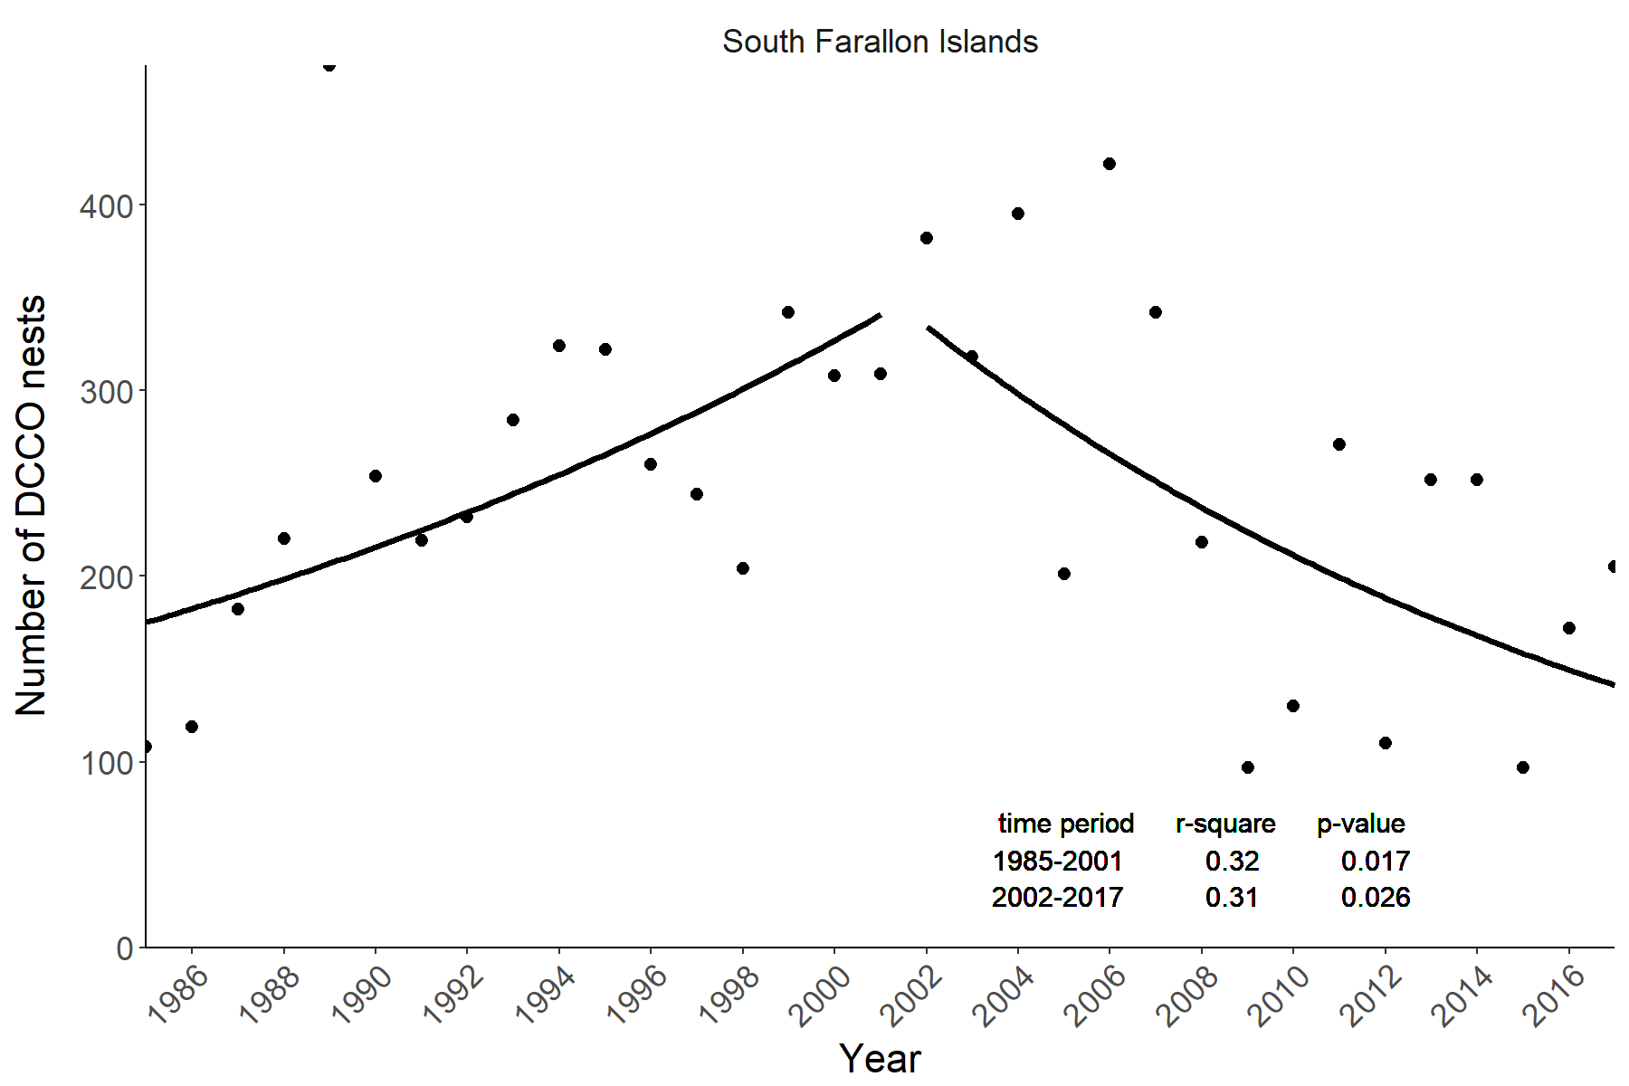 Fig 7. Regional counts over time in the South Farallon Islands region with fitted model (fitted as linear model on ln-transformed data).

## Works Cited

Manuwal, D. A., Carter, H. R., Zimmerman, T. S., & Orthmeyer, D. L. (2000). Biology and Conservation of the Common Murre in California, Oregon, Washington, and British Columbia Volume 1: Natural History and Population Trends. Information and Technology Report (Vol. 1).