Double-Crested Cormorant Populations in San Francisco Bay from 1985-2016

Draft of Analyses

Max Tarjan

August 22, 2017

# Background

This manuscript updates previous descriptions of DCCO populations in San Francisco Bay. Multiple organizations, including SFBBO, conducted surveys using ground counts, boat surveys, and aerial surveys.

# Methods

We estimated regional trends in nest counts using Generalized Additive Mixed Models (GAMMs) in the poptrend package in R (Knape 2016). The count for a given colony in a given year was modeled as a function of a temporal random effect (year) a random site effect, and a fixed day of the season effect (except in the case of the Bridges region, which did not have enough degrees of freedom to include the day of the season effect). We compared this model to two alternatives: (1) temporal fixed effects, (2) temporal random effects, and (3) temporal random effects and a random site effect. The selected full model resulted in better model fit in all cases where it could be applied (it minimized residual error). Error estimates were drawn from the maximum likelihood table.

# Results

## Regional Trends

### Bridges

### North Bay

Raw counts (Fig. 2) and model trends (Fig. 3) differed for the North Bay region. Similar to the South Bay region, counts for fewer sites existed in the early survey years; neither region had counts for more than five sites until 2003, but counts existed for up to 11 sites by 2007. While the raw counts are subject to a bias in survey effort (earlier years show lower regional counts due to less survey effort), the model accounts for missing information at sites in the early years through the inclusion of a fixed site effect. The model outputs are therefore more likely to reflect the regional trends in nest counts. Although new sites have been occuppied in the North Bay throughout this study, the overall trend in the region has decreased since counts began.

### South Bay

### Outer Coast

## Model selection and fit

We chose the simplest model, which included the random effects of site and year. Other covariates, such as day of the season, survey method (aerial, boat, or ground), and distance to the bridges, had little effect on the qualitative results, except in one case.

In the case of the North Bay, including day of the season as a fixed effect significantly elevated the estimated counts in 1989 and 1990. Counts in these years occurred much later in the season when birds were likely to have begun leaving the breeding area. When day of the season was included in the model for the North Bay region, estimated counts for these early years were elevated to compensate for the late count date, causing an overall decrease in counts from 1989-1992. Other changes were relatively small to this initial drop, so the model shows no other significant decreases through 2016. This is in contrast to the selected model that does not include the effect of day of the season. The model without count date shows no significant decrease until 1994, at which point a decreasing trend persists through 2016. Although the two models differ in the exact timing of the decline, both models are in agreement that a significant decrease occurred during the study in the North Bay region.

# Works Cited

Knape, J. (2016). Decomposing trends in Swedish bird populations using generalized additive mixed models. Journal of Applied Ecology, 53(6), 1852–1861. <https://doi.org/10.1111/1365-2664.12720>

# Tables

Table 1. Site descriptions, including region, coordinates, and number of years with nest counts.

|  |  |  |  |  |
| --- | --- | --- | --- | --- |
| Region | Colony | lat | long | n |
| Bridges | Richmond-San Rafael Bridge | 37.93300 | -122.4131 | 18 |
| Bridges | S.F.-Oakland Bay Br. East | 37.81999 | -122.3437 | 18 |
| North Bay | Bohannon Slough | 38.18267 | -121.9565 | 10 |
| North Bay | Donlon Island | 38.02897 | -121.7813 | 3 |
| North Bay | Hidden Cove | 38.14881 | -121.9188 | 12 |
| North Bay | Knight Island | 38.13814 | -122.2926 | 17 |
| North Bay | Leslie Salt Pond | 38.20043 | -122.3385 | 5 |
| North Bay | North San Pablo Bay Radar Target | 38.10111 | -122.3278 | 16 |
| North Bay | Northeast San Pablo Bay Beacon | 38.07133 | -122.2892 | 12 |
| North Bay | Petaluma Wastewater Treatment Plant | 38.22224 | -122.5804 | 20 |
| North Bay | Red Rock Island | 37.92950 | -122.4312 | 1 |
| North Bay | Russ Island | 38.18920 | -122.3304 | 27 |
| North Bay | Ryer Island | 38.07747 | -122.0039 | 5 |
| North Bay | Sherman Island | 38.02702 | -121.7953 | 10 |
| North Bay | Spoonbill Slough | 38.05470 | -121.8934 | 11 |
| North Bay | Wheeler Island | 38.07861 | -121.9659 | 30 |
| Outer Coast | Bolinas Lagoon | 37.91158 | -122.6815 | 2 |
| Outer Coast | Hog Island | 38.19722 | -122.9351 | 31 |
| Outer Coast | Lake Merced | 37.72170 | -122.4946 | 17 |
| Outer Coast | Pescadero Marsh | 37.26788 | -122.4042 | 5 |
| Outer Coast | South Farallon Islands | 37.69839 | -123.0097 | 56 |
| South Bay | Alviso Plant, Pond No. A18 | 37.44987 | -121.9511 | 10 |
| South Bay | Alviso Plant, Pond Nos. A9 and A10 | 37.45327 | -122.0021 | 23 |
| South Bay | Bair Island Power Towers | 37.53100 | -122.2157 | 39 |
| South Bay | Bunting Pond | 37.57067 | -121.9747 | 2 |
| South Bay | Dumbarton Bridge Power Towers | 37.50421 | -122.1234 | 18 |
| South Bay | Lake Merritt | 37.80656 | -122.2550 | 29 |
| South Bay | Moffett Towers | 37.44630 | -122.0515 | 16 |
| South Bay | Plant No. 1, Pond No. 3A | 37.55367 | -122.1153 | 4 |
| South Bay | San Mateo Bridge and PG&E Towers | 37.60112 | -122.2120 | 15 |

Table 2. Percent annual change in estimated nest counts by region.

|  |  |  |  |  |
| --- | --- | --- | --- | --- |
| Year | Bridges | North Bay | Outer Coast | South Bay |
| 1985 | NA | NA | NA | NA |
| 1986 | NA | NA | 0.0130510 | NA |
| 1987 | NA | NA | 0.0130510 | NA |
| 1988 | NA | NA | 0.0130510 | NA |
| 1989 | -0.0591095 | NA | 0.0130510 | 0.2551121 |
| 1990 | -0.0390345 | -0.4824523 | 0.0130510 | 0.2530755 |
| 1991 | NA | -0.4211761 | 0.0130509 | 0.2490122 |
| 1992 | NA | -0.2760393 | 0.0130509 | 0.2428675 |
| 1993 | NA | NA | 0.0130508 | 0.2342589 |
| 1994 | 0.1956219 | 0.1037371 | 0.0130508 | 0.2230957 |
| 1995 | NA | 0.2164766 | 0.0130508 | 0.2079984 |
| 1996 | NA | 0.1330843 | 0.0130508 | 0.1778426 |
| 1997 | NA | -0.0099518 | 0.0130508 | 0.1286270 |
| 1998 | NA | -0.0747878 | 0.0130508 | 0.0650363 |
| 1999 | 0.7013927 | -0.0604269 | 0.0130508 | 0.0144521 |
| 2000 | 0.0843007 | 0.0005037 | 0.0130508 | -0.0090389 |
| 2001 | NA | 0.0569938 | 0.0130509 | -0.0076900 |
| 2002 | NA | 0.1017633 | 0.0130510 | 0.0057462 |
| 2003 | 0.0396321 | 0.1068122 | 0.0130511 | 0.0204901 |
| 2004 | -0.0813905 | 0.0429076 | 0.0130512 | 0.0357066 |
| 2005 | -0.1205939 | -0.0755164 | 0.0130513 | 0.0357790 |
| 2006 | NA | -0.1642635 | 0.0130513 | 0.0031804 |
| 2007 | -0.2777900 | -0.1738463 | 0.0130514 | -0.0593791 |
| 2008 | -0.1482986 | -0.1103311 | 0.0130515 | -0.1148178 |
| 2009 | -0.1199246 | -0.0276333 | 0.0130516 | -0.1158941 |
| 2010 | -0.0427818 | 0.0304627 | 0.0130516 | -0.0584964 |
| 2011 | 0.0727515 | 0.0578601 | 0.0130517 | 0.0315848 |
| 2012 | 0.1081182 | 0.0505389 | 0.0130517 | 0.0791704 |
| 2013 | 0.0434447 | 0.0085445 | 0.0130517 | 0.0678173 |
| 2014 | -0.0420603 | -0.0572944 | 0.0130517 | 0.0165839 |
| 2015 | -0.1199384 | -0.1070921 | 0.0130516 | -0.0219402 |
| 2016 | -0.1603685 | -0.1310017 | 0.0130516 | -0.0406512 |

# Figures

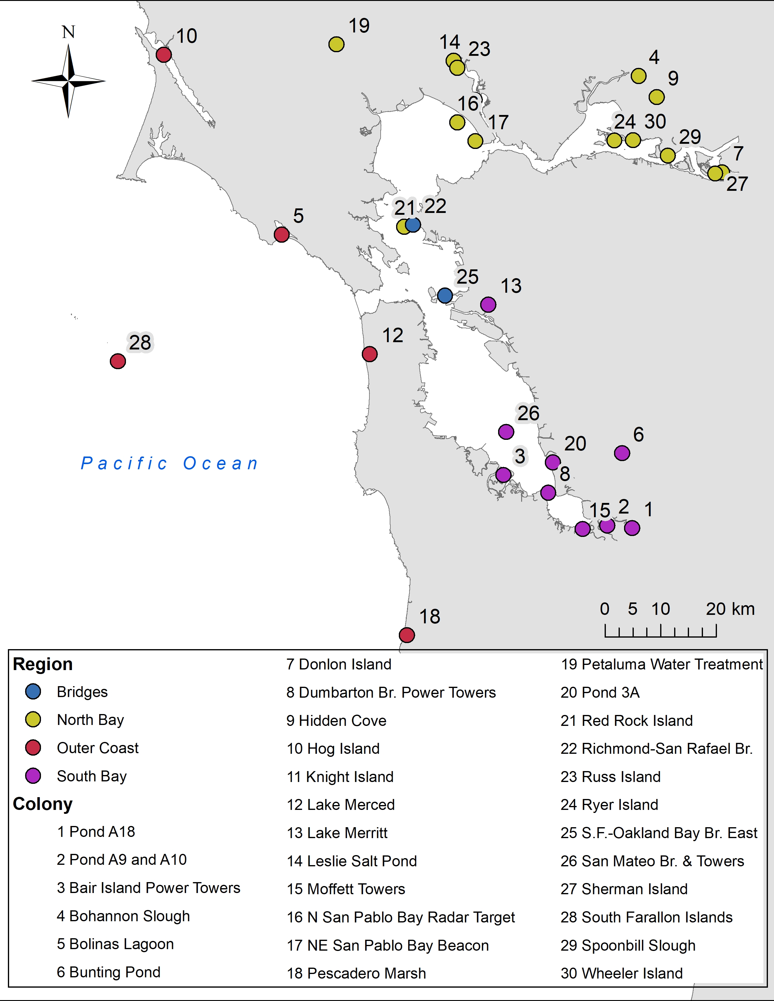 Fig 1. Map of DCCO nesting sites occupied between 1985 and 2016.

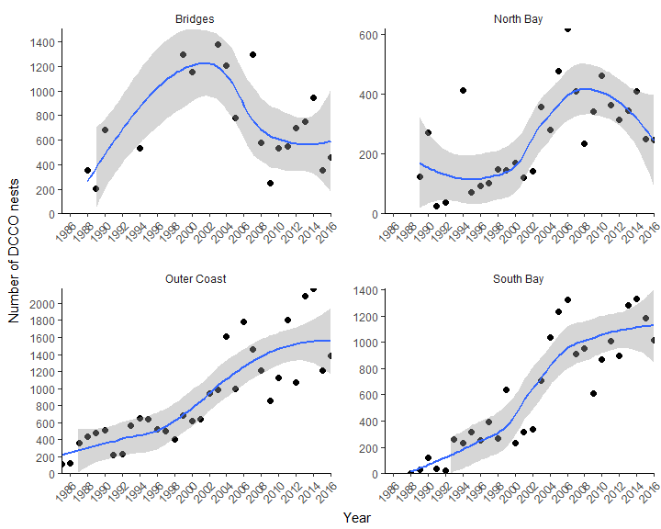

Fig 2. Counts of DCCO nests in each region around San Francisco Bay from 1985-2016. Points show raw counts summed across sites for each region. Data are plotted with a loess curve and standard error shading.

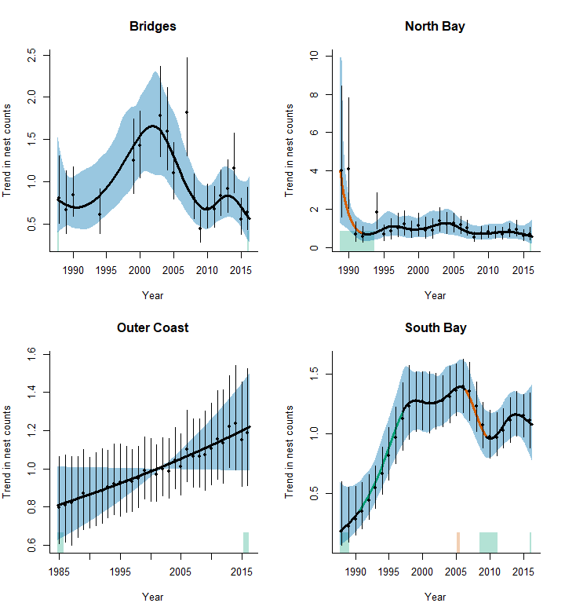

Fig 3. Trend estimates for DCCO nest count data. Trend estimates are plotted relative to the mean value (i.e. the mean value is set = 1). Estimates were generated using a GAMM that estimates nest counts as a function of year (temporal random effect), the random effect of site, and the fixed effect of day of the season (except in the case of the Bridge Region, which did not have enough degrees of freedom to include the effect of day of the season). Points and bars indicate the mean and 95% CI for the annual count estimates. The black trendlines and blue shading indicate the mean and 95% CI for the long-term trend. Green and red lines indicate significant increases and decreases in the trend at the 5% level respectively. Green and red shading above the x-axis indicate significant increases in the second derivative (i.e. trend acceleration/deceleration) at the 5% level respectively.

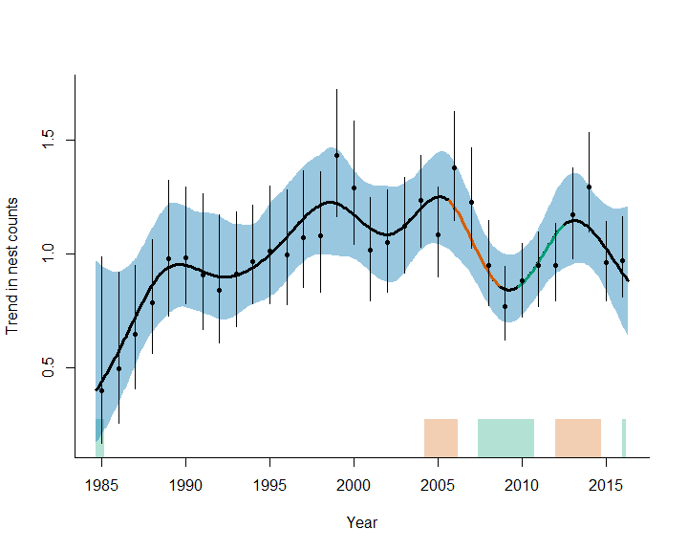

Fig 4. Trend estimate for all regions in the San Francisco Bay Area with the exception of the Bridges.