Snowy Plover Analyses 2017

Max Tarjan

December 8, 2017

# Draft Report prepared for the Bay Delta USFWS

# Introduction

This report provides analyses of fledging success and the adult breeding population size for Western Snowy Plovers in Recovery Unit 3 during the 2017 breeding season.

# Methods

## Fledging and juvenile survival rates

## Breeding adult population size

# Results

## Fledging and juvenile survival rates

Across all sites, the fledging rate was 0.42 and the juvenile survival rate, or the proportion of chicks that fledged and survived through their first winter to March 1 of the following year, was 0.2 (Figure 1).

## Population size

The detection probability across all surveys and sites was 0.36. Estimated population sizes for Alviso, Eden Landing, Ravenswood, Warm Springs were, respectively, 95, 296, 206, 16 adult breeding birds.

# Discussion

## Survival and recruitment

We report the fledging rate for Snowy Plovers in recovery Unit 3 for the first time. At sites that were closely monitored within the Eden Landing complex, the overall fledging rate was 0.42 across all years.

## Population size

The N-mixture model indicated that detection probability for adults was 0.36. Hudgens reported that detection probability for SF Bay was 0.65 (Hudgens et al. 2014).

###### Heading 6

# Tables and Figures

Table 1. Sample sizes of banded chicks for each site used to estimate fledging and survival rates.

|  |  |  |  |  |  |
| --- | --- | --- | --- | --- | --- |
|  | E14 | E16B | E6B | E8 | Annual.Total |
| 2008 | 13 | 10 | 2 | 5 | 30 |
| 2009 | 0 | 19 | 0 | 17 | 36 |
| 2010 | 3 | 3 | 3 | 10 | 19 |
| 2011 | 0 | 5 | 3 | 12 | 20 |
| 2012 | 7 | 0 | 0 | 1 | 8 |
| 2013 | 5 | 0 | 0 | 0 | 5 |
| 2014 | 11 | 0 | 6 | 11 | 28 |
| 2015 | 59 | 0 | 8 | 19 | 86 |
| 2016 | 26 | 3 | 6 | 17 | 52 |
| 2017 | 17 | 16 | 3 | 7 | 43 |

Table 2. Repeated counts of adult Snowy Plovers in Recovery Unit 3 for each week during the 2017 breeding season (May and June).

|  |  |  |  |  |  |  |  |  |  |
| --- | --- | --- | --- | --- | --- | --- | --- | --- | --- |
| group | 1 | 2 | 3 | 4 | 5 | 6 | 7 | 8 | 9 |
| Alviso | 23 | 19 | 16 | 19 | 41 | 37 | 27 | 24 | 74 |
| Eden Landing | 134 | 149 | 105 | 144 | 88 | 88 | 82 | 107 | 145 |
| Ravenswood | 84 | 109 | 79 | 76 | 86 | 86 | 55 | 49 | 43 |
| Warm Springs | 0 | 0 | 2 | 0 | 16 | 0 | 1 | 0 | 0 |

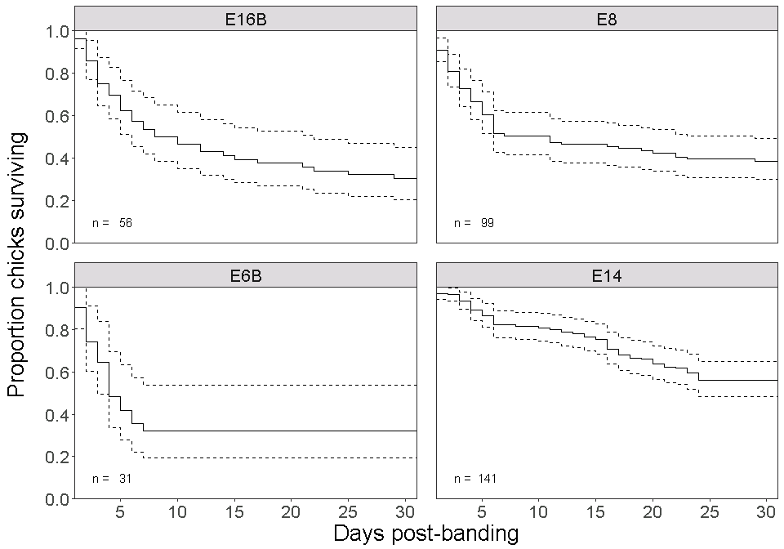

Figure 1. Survival to fledging of snowy plover chicks at closely monitored ponds within the Eden Landing complex in Hayward, CA. Dashed lines denote the 95% CI. n indicates the number of banded chicks that were tracked from within one day of hatching to fledging (31 days).

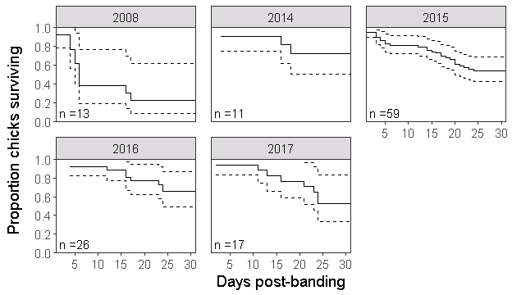

Figure 2. Survival to fledging of snowy plover chicks at E14 within the Eden Landing complex in Hayward, CA. Dashed lines denote the 95% CI. n indicates the number of banded chicks that were tracked from within one day of hatching to fledging (31 days). Missing years imply insufficient data (fewer than 10 banded chicks).

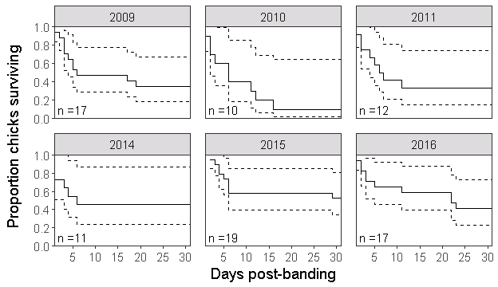

Figure 3. Survival to fledging of snowy plover chicks at E8 within the Eden Landing complex in Hayward, CA. Dashed lines denote the 95% CI. n indicates the number of banded chicks that were tracked from within one day of hatching to fledging (31 days). Missing years imply insufficient data (fewer than 10 banded chicks).

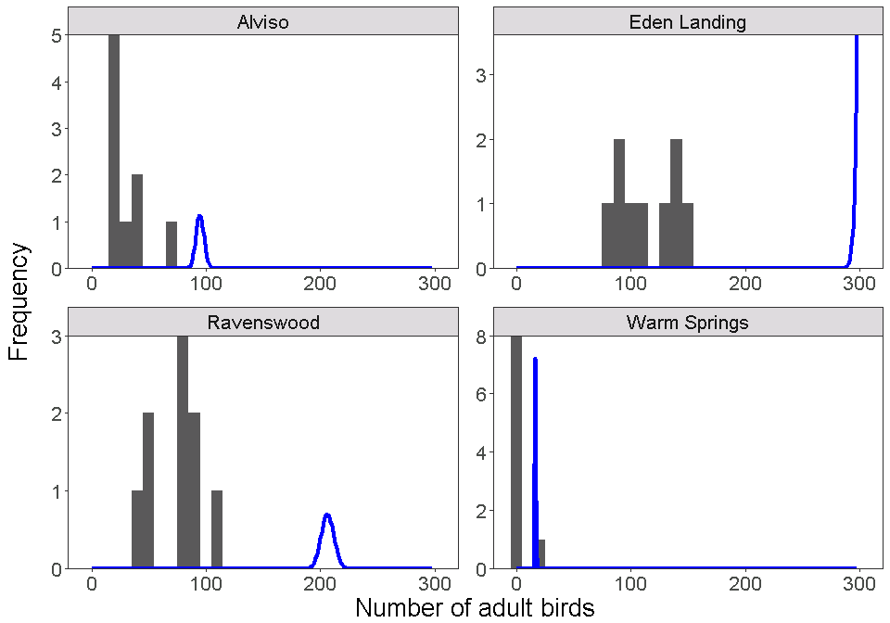

Figure 4. Counts and model estimates (posterior probabilities) of adult birds at four complexes in South San Francisco Bay, CA in 2017. Grey bars denote the frequency of count data and blue lines denote posterior probability distributions of population size estimates from an N-mixture model. Note the left-tailed skew on the posterior probability distribution for Eden Landing, indicating that the latent population size is larger than the maximum allowed by the model.

# Works Cited

Hudgens, BH, Eberhart-Phillips L, Stenzel L, Burns C, Colwell M and Page G (2014). Population Viability Analysis of the Western Snowy Plover. Report prepared for the U.S. Fish and Wildlife Service. Arcata, CA.