Introduction and Basic virsh Commands

The aim of this guide is to help a user create and configure a new network in kimchi using libvirt as well as identify possible failures in a network. I will first provide some very basic information about virsh commands and XML. The remainder of the document will show how to properly configure and troubleshoot your virtual network. I will provide an example of a NAT network and a Bridged Network. Kimchi also allows for one more type of network called an Isolated network however I will not go into much detail about that network in this guide.
If you wish to learn only about a Bridge Network or only a NAT network then don't waste your time reading both. I based them off of each other so much of the information will repeat.
It is recommended to first draw a simple diagram of what your network will look like once configured properly. It can be difficult to think of how your network will look given different XML files of virtual machine's (VM's) and networks working together. It is important to include as much detail as possible in your diagram to understand where a network may be failing and identify possible conflicts or issues on a network. Lets cover some virsh basics.

The commands below are for a Linux shell.

To view your current networks please type:
virsh net-list –all
Note: all virsh commands use 2 dashes without a space in between

To view your XML network configuration for a given network type:
virsh net-dumpxml <your network name>
Note: Do not include the < > in your command

To edit your XML network configuration for a given network type:
virsh net-edit <your network name>

The command above will open a text editor called Vim. To begin typing in Vim hit “I” key on your keyboard. You will be in Insert Mode and can begin making changes. To exit, hit “Esc” Key to exit Insert Mode and type :wq This command will save (w means write) and then quit (q).

To view all the network commands for virsh type:

virsh --help | grep net-
XML Basics

Similar to HTML, XML uses the <element> </element> syntax (Note: I sometimes use element and tag interchangeably in this article). Some settings for your virtual machine are set in the XML while other options are strictly left to be configured in the virtual machine, host machine, neither, or both. Hopefully this article will help explain where something needs to be configured.
We will assume you just created a network in Kimchi. What does this mean and how can we visualize this?

Simple Isolated Network Example
Using the Kimchi web interface I created an isolated network and named it isolated-network

[root@localhost ~]# virsh net-dumpxml isolated-network
<network>
<name>isolated-network</name>
<uuid>81b2df0f-4460-487e-a86e-b608bccec153</uuid>
<bridge name='virbr3' stp='on' delay='0'/>
<mac address='52:54:00:af:51:73'/>
<ip address='192.168.1.1' netmask='255.255.255.0'>
<dhcp>
<range start='192.168.1.129' end='192.168.1.255'/>
</dhcp>
</ip>
</network>

XML is nice and friendly because most of the time, the <tag element> provides us with the context of the data we are looking at. Recognize that an Isolated Network has no external communication of any kind. It is used to only communicate between other VM's on the same host machine, for example maybe a VM running a database that is only accessible from the web server VM. Lets start at the top of the XML to understand what it means:
<name> the name of our network we gave it in kimchi
<uuid> a globally unique identifier for the virtual network. The format must be RFC 4122 compliant.
<bridge ...> This tag has a little more information... the name='virbr3' refers to the interface which the network will use on the host machine. The name attribute on the bridge element defines the name of a bridge device which will be used to construct the virtual network. The virtual machines will be connected to this bridge device allowing them to talk to each other. Attribute stp specifies if Spanning Tree Protocol is 'on' or 'off' (default is 'on'). Attribute delay sets the bridge's forward delay value in seconds (default is 0).
<mac address …> - the MAC address of the network. This should match the interface of a device on the host machine.
<ip address=... netmask=...> The IP address is the address of your network. Generally this is your “router” address – meaning this is where VM's on your network will connect to the internet – also called the gateway. Since this is an isolated network that is not the case here. The netmask for typical default IP address to a network will generally be 255.255.255.0 if it is a class C IP address. More information about this can be found here: https://www.iplocation.net/subnet-mask Generally you will want to leave this as the default value
Now inside the <ip address..> element we can see an element called <dhcp>
Dynamic Host Configuration Protocol (dhcp) is responsible for dynamically assigning IP addresses to hosts on your network. Now in this example we see a range starting at 192.168.1.129 and ending at 192.168.1.255 This means any VM's you want to put on this isolated network must be in this range of addresses. An example of a valid IP address on this network is 192.168.1.135.

Note that the address of the network and the DHCP range both start with 192.168.1.xxx – this is a very important point. Simply put, this informs us the machines exist on the same sub-network, usually called a subnet.

Ok now lets look at a more detailed and specific example with diagrams. I will show what a network look likes visually and in relation to the host machine. I will also provide information about how to troubleshoot your network using simple commands and tools.

Note: All commands are explained at the end of the document.

Default out of the box NATed Network
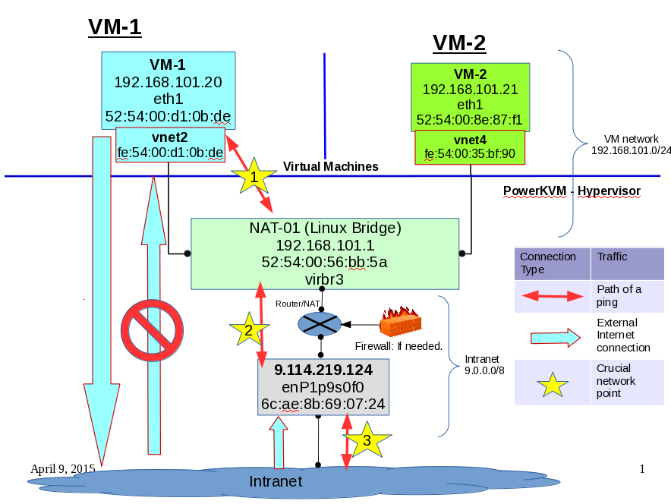

Network Address Translation (NAT) or also known as “virtual networks” creates a private sub-network which is not accessible from the external network. More specifically, a VM behind a NAT Network will be able to connect to the outside world however it's IP address is not accessible to the public. This is illustrated with the blue arrows in the diagram on slide 1. In order to communicate with your VM on a NAT network using virsh you must log into the host machine first and then log into your VM. Lets start by walking through the creation of a NAT network in kimchi
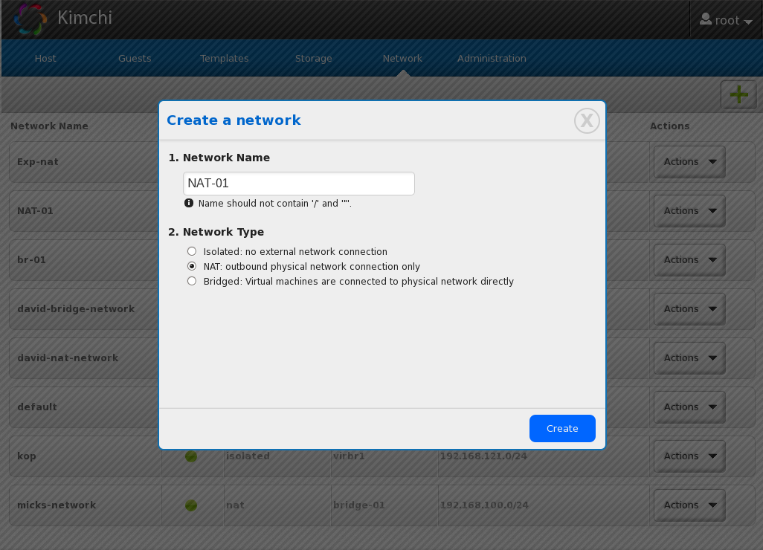

First create your network in kimchi under the Network tab at the top. Once your network is created you must start it. Once started you can view the network's XML file, like so:

[root@localhost ~]# virsh net-start NAT-01
[root@localhost ~]# virsh net-list --all
Name State Autostart Persistent
----------------------------------------------------------
default active yes yes
kop active yes yes
NAT-01 active yes yes

Let's take a look at what is in this new network's XML file:

[root@localhost ~]# virsh net-dumpxml NAT-01
<network connections='1'>
<name>NAT-01</name>
<uuid>e36c65bc-20e3-4e96-ae26-f29d3d1925bd</uuid>
<forward mode='nat'>
<nat>
<port start='1024' end='65535'/>
</nat>
</forward>
<bridge name='virbr3' stp='on' delay='0'/>
<mac address='52:54:00:56:bb:5a'/>
<ip address='192.168.101.1' netmask='255.255.255.0'>
<dhcp>
<range start='192.168.101.2' end='192.168.101.255'/>
</dhcp>
</ip>
</network>

This NAT network will be operating on the 192.168.101.0 network - this address space is randomly generated by libvirt. To change anything in this network's XML file type the command virsh net-edit [network name]. To view your available networks type virsh net-list --all The NAT-01 interface, virbr3, is the virtual interface which VM's will use to communicate with the NAT network. In the diagram this is shown at This virtual interface is a bridge. The gateway for the 192.168.101.0 network is at 192.168.101.1 – this is the address of the virbr3 device. Note the MAC address for the network NAT-01 and take a look at your devices:
1

[root@localhost ~]# ifconfig -a
virbr3: flags=4163<UP,BROADCAST,RUNNING,MULTICAST> mtu 1500
inet 192.168.101.1 netmask 255.255.255.0 broadcast 192.168.101.255
ether 52:54:00:56:bb:5a txqueuelen 0 (Ethernet)
RX packets 868229 bytes 86068538 (82.0 MiB)
RX errors 0 dropped 0 overruns 0 frame 0
TX packets 1339781 bytes 1248115243 (1.1 GiB)
TX errors 0 dropped 0 overruns 0 carrier 0 collisions 0

[root@localhost ~]# netstat -rn
Kernel IP routing table
Destination Gateway Genmask Flags MSS Window irtt Iface
0.0.0.0 9.114.219.254 0.0.0.0 UG 0 0 0 enP1p9s0f0
9.114.219.0 0.0.0.0 255.255.255.0 U 0 0 0 enP1p9s0f0
192.168.101.0 0.0.0.0 255.255.255.0 U 0 0 0 virbr3

Notice the XML file and the output from ifconfig have the same MAC address – coincidence? I think not. NAT-01 is operating on interface virbr3. We verified this using netstat -rn as well. So what about our VM's behind the NAT? We have to add the VM's virtual interfaces to the bridge which the NAT operates on. First lets add our VM's to the network. To view all your VM's on your host machine type virsh list --all Again, use virsh edit [VM name] to change anything.

[root@localhost ~]# virsh dumpxml VM-1
...
<interface type='network'>
<mac address='52:54:00:d1:0b:de'/>
<source network='NAT-01'/> /*OUR VM IS ADDED TO OUR NETWORK */
<model type='virtio'/>
<driver name='qemu'/>
<address type='pci' domain='0x0000' bus='0x00' slot='0x01' function='0x0'/>
</interface>
...

Now lets see what our VM's virtual network interfaces are:

[root@localhost ~]# virsh dumpxml VM-1 | grep "target dev"
<target dev='vda' bus='virtio'/>
<target dev='sdc' bus='scsi'/>
<target dev='vnet2'/>

So we know that VM-1 is using the virtual interface vnet2 and according to VM-1's XML file it has already been added to the NAT-01 network already. Do we have an internet connection to VM-1 yet? No - We haven't verified this virtual interface is added to our NAT bridge interface:

[root@localhost ~]# brctl delif [old bridge] vnet2
[root@localhost ~]# brctl addif virbr3 vnet2

Now our VM's network interface should be added to our bridge. Lets check:

[root@localhost ~]# brctl show
bridge name bridge id STP enabled interfaces
virbr3 8000.52540056bb5a yes virbr3-nic
vnet2
vnet4

Now we know that VM-1 has been added to NAT-01's interface. We have confirmed that VM has been added to the network from the XML file, and the VM's interface has been added to the NAT's bridge interface. So now lets log into our VM and configure our network from there.

[root@localhost ~]# virsh console VM-1
Connected to domain VM-1
Escape character is ^]

Now we have a console in our VM. To exit this console hit the Ctrl + ' ] ' key on your keyboard. We know the NAT's DHCP address space is <range start='192.168.101.2' end='192.168.101.255'/> from the NAT-01 XML file. So lets configure VM-1 to work with this NAT network.

mick@ubuntu1:~$ sudo cat /etc/network/interfaces
# This file describes the network interfaces available on your system
# and how to activate them. For more information, see interfaces(5).
source /etc/network/interfaces.d/*
# The loopback network interface
auto lo
iface lo inet loopback

# The primary network interface
auto eth0
#iface eth1 inet dhcp
iface eth0 inet static
address 192.168.101.20
network 192.168.101.0
netmask 255.255.255.0
broadcast 192.168.101.255
gateway 192.168.101.1

We have given our VM a valid address in the DHCP range and have told the VM it's gateway is 192.168.101.1 which is where virbr3 is running on the host machine. Continuing on our VM...

mick@ubuntu1:~$ netstat -rn
Kernel IP routing table
Destination Gateway Genmask Flags MSS Window irtt Iface
0.0.0.0 192.168.101.1 0.0.0.0 UG 0 0 0 eth0
192.168.101.0 0.0.0.0 255.255.255.0 U 0 0 0 eth0

From inside our VM we can only see the devices which the VM believes it is running on. The VM has no idea what virbr3 and vnet2 mean. These devices exist on the host machine and the VM uses them to communicate with external network.

mick@ubuntu1:~$ ifconfig -a
eth0 Link encap:Ethernet HWaddr 52:54:00:d1:0b:de
inet addr:192.168.101.20 Bcast:192.168.101.255 Mask:255.255.255.0
inet6 addr: fe80::5054:ff:fed1:bde/64 Scope:Link
UP BROADCAST RUNNING MULTICAST MTU:1500 Metric:1
RX packets:31 errors:0 dropped:22 overruns:0 frame:0
TX packets:9 errors:0 dropped:0 overruns:0 carrier:0
collisions:0 txqueuelen:1000
RX bytes:2746 (2.7 KB) TX bytes:690 (690.0 B)

lo Link encap:Local Loopback
inet addr:127.0.0.1 Mask:255.0.0.0
inet6 addr: ::1/128 Scope:Host
UP LOOPBACK RUNNING MTU:65536 Metric:1

Testing and Troubleshooting NAT Network
Now for the grand finale – lets test this network connection by using some command line tools.
It is important to approach a network problem in pieces or chunks. Simply saying, “the network is down” provides zero information as to where the issue is. If you cannot communicate with your VM start from the VM's point-of-view and start pinging smaller portions of the network like we will do here. Can the VM communicate with host machine? Can host machine communicate with VM? Additionally there may be certain IP Tables or rules on a external switch which may be preventing internet access. First verify the problem is NOT on the host machine, then you could explore the possibility of an additional rule or firewall somewhere else. This guide will show you how to troubleshoot your network by taking one piece at a time. Don't assume both sides of a connection are working in a network – test the problem from all angles.

Initial Test – simple ping from host
Log into your host machine and ping your VM. Hopefully you see something like this:

[root@localhost ~]# ping 192.168.101.20
PING 192.168.101.20 (192.168.101.20) 56(84) bytes of data.
64 bytes from 192.168.101.20: icmp_seq=1 ttl=64 time=0.275 ms
^C
--- 192.168.101.20 ping statistics ---
3 packets transmitted, 3 received, 0% packet loss, time 1998ms
rtt min/avg/max/mdev = 0.218/0.266/0.307/0.041 ms

Great – our VM is running and our host can communicate with it. However, this test doesn't really tell us much at all. Let's consider the example where this doesn't work.

[root@localhost ~]# ping 192.168.101.20
PING 192.168.101.69 (192.168.101.69) 56(84) bytes of data.
^C
--- 192.168.101.69 ping statistics ---
2 packets transmitted, 0 received, 100% packet loss, time 1008ms

So where is the point of failure in this network? From this test, how do we know where the network is mis-configured? Was the network started correctly? Did we add our interfaces to the bridge device? Is the VM even turned on? This is a simple example but the point is that one ping test is not enough evidence to troubleshoot an entire network problem. We need more information to identify where exactly the network is malfunctioning. Break up the problem into smaller chunks like I will do below.

For these tests we are going to need 2 terminal windows. Log into your VM with one and just stay logged into your host machine on the other. We want 2 terminals to test if the VM is sending out a request and the host machine received it. Typically computer networks operate along a 2 way street so it is important to test from all angles.
1

VM to Bridge
Log into your host machine and VM – it doesn't matter if you use ssh or virsh console command – just get into the virtual machine.

TERMINAL 1 (host machine) – start listening for a single ping request.

[root@localhost ~]# tcpdump -D
6.enP1p9s0f0
13.vnet2
19.virbr3
20.vnet4
24.any (Pseudo-device that captures on all interfaces)
25.lo

[root@localhost ~]# tcpdump -i virbr3
tcpdump: verbose output suppressed, use -v or -vv for full protocol decode
listening on virbr3, link-type EN10MB (Ethernet), capture size 65535 bytes
…
While that is listening switch to your VM's terminal and send a ping

TERMINAL 2 (VM) – once your host machine is listening, send a single ping.

[root@localhost ~]# virsh console VM-1
Connected to domain VM-1
Escape character is ^]

mick@ubuntu1:~$ ping -c1 192.168.101.1
PING 192.168.101.1 (192.168.101.1) 56(84) bytes of data.
64 bytes from 192.168.101.1: icmp_seq=1 ttl=64 time=0.248 ms

--- 192.168.101.1 ping statistics ---
1 packets transmitted, 1 received, 0% packet loss, time 0ms
rtt min/avg/max/mdev = 0.248/0.248/0.248/0.000 ms

We know the ping was sent and received again by the VM – this is good. What does our other terminal show now...

TERMINAL 1 (host machine) - received ping
[root@localhost ~]# tcpdump -i virbr3
tcpdump: verbose output suppressed, use -v or -vv for full protocol decode
listening on virbr3, link-type EN10MB (Ethernet), capture size 65535 bytes
20:06:09.356538 IP 192.168.101.20 > localhost: ICMP echo request, id 2565, seq 1, length 64
20:06:09.356610 IP localhost > 192.168.101.20: ICMP echo reply, id 2565, seq 1, length 64
^C
2 packets captured
2 packets received by filter
0 packets dropped by kernel

We have now confirmed that this VM is connected to our bridge. Lets continue testing...
2

VM to Host Machine
Similar to the first test, we will send a single ping request originating from our VM however this time we will send our request to the host machines network interface.

TERMINAL 1 (host machine) – listen for any traffic coming from our VM
[root@localhost ~]# tcpdump -i any -n src host 192.168.101.20
tcpdump: verbose output suppressed, use -v or -vv for full protocol decode listening on any, link-type LINUX_SLL (Linux cooked), capture size 65535 bytes

TERMINAL 2 (VM) – ping to host's network interface
mick@ubuntu1:~$ ping -c1 9.114.219.124
PING 9.114.219.124 (9.114.219.124) 56(84) bytes of data.
64 bytes from 9.114.219.124: icmp_seq=1 ttl=64 time=0.221 ms

--- 9.114.219.124 ping statistics ---
1 packets transmitted, 1 received, 0% packet loss, time 0ms
rtt min/avg/max/mdev = 0.221/0.221/0.221/0.000 ms
mick@ubuntu1:~$

Great – the ping was sent and received back... lets see what happen on our host machine.

TERMINAL 1 (host machine) – received ping request from VM

[root@localhost ~]# tcpdump -i any -n src host 192.168.101.20
tcpdump: verbose output suppressed, use -v or -vv for full protocol decode
listening on any, link-type LINUX_SLL (Linux cooked), capture size 65535 bytes
20:15:48.619746 IP 192.168.101.20 > 9.114.219.124: ICMP echo request, id 2567, seq 1, length 64
20:15:48.619746 IP 192.168.101.20 > 9.114.219.124: ICMP echo request, id 2567, seq 1, length 64
^C
2 packets captured
2 packets received by filter
0 packets dropped by kernel

We have now confirmed that the VM can communicate with the host machine properly. Realistically – we would have known this a while ago if we attempted to ssh into this machine and it failed. It is a good idea to double check.

VM to Internet
3

Now lets make sure that this VM is communicating with the outside world. I am going to ping an address completely separate from our network. For this example I will ping Google's DNS server located at 8.8.8.8 (an easy address to remember for future tests).
We will only need a single terminal for this test.

mick@ubuntu1:~$ ping 8.8.8.8
PING 8.8.8.8 (8.8.8.8) 56(84) bytes of data.
64 bytes from 8.8.8.8: icmp_seq=1 ttl=36 time=16.2 ms
64 bytes from 8.8.8.8: icmp_seq=2 ttl=36 time=15.9 ms
64 bytes from 8.8.8.8: icmp_seq=3 ttl=36 time=16.1 ms
^C
--- 8.8.8.8 ping statistics ---
3 packets transmitted, 3 received, 0% packet loss, time 2002ms
rtt min/avg/max/mdev = 15.934/16.119/16.247/0.198 ms

We have now confirmed this VM has internet access and is configured properly on this host machine. Although we might have been able to ping our VM from the host machine – this does not confirm that the VM has an internet connection. It is important to start your network tests from different point-of-views. You may now use your VM as you wish and know that the network connection is solid.
Bridged Network with Macvtap -
Virtual Ethernet Port Aggregator (VEPA)

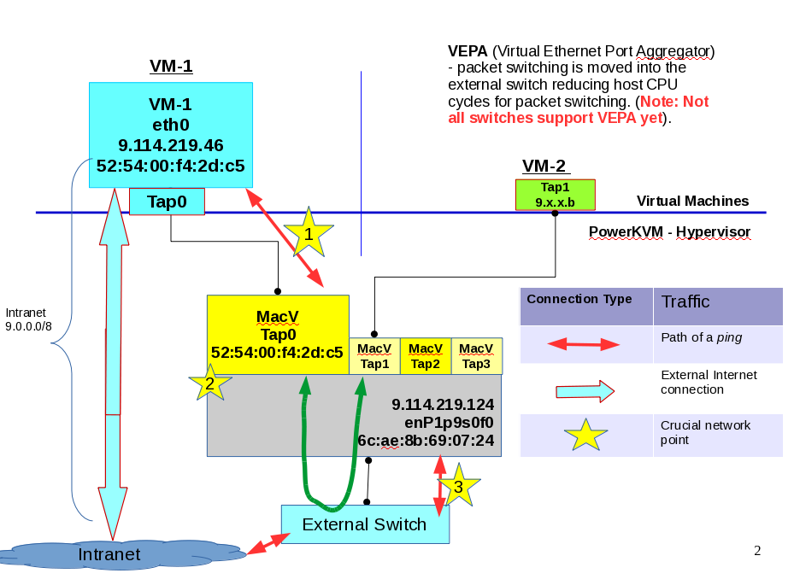

Go here http://www.libvirt.org/formatdomain.html#elementsNICSDirect and read about the different types of modes which a bridge network which libvirt can use. In this example I will be using a MACVTap interface which uses Virtual Ethernet Port Aggregator (VEPA) by default. Recognize that all your traffic between a VM operating with a MACVTap device will go through an external switch even traffic between another VM (look at the green arrow above). There is more information in the link above which will further explain. I will show how to implement what libvirt calls a Bridged Network using VEPA mode.

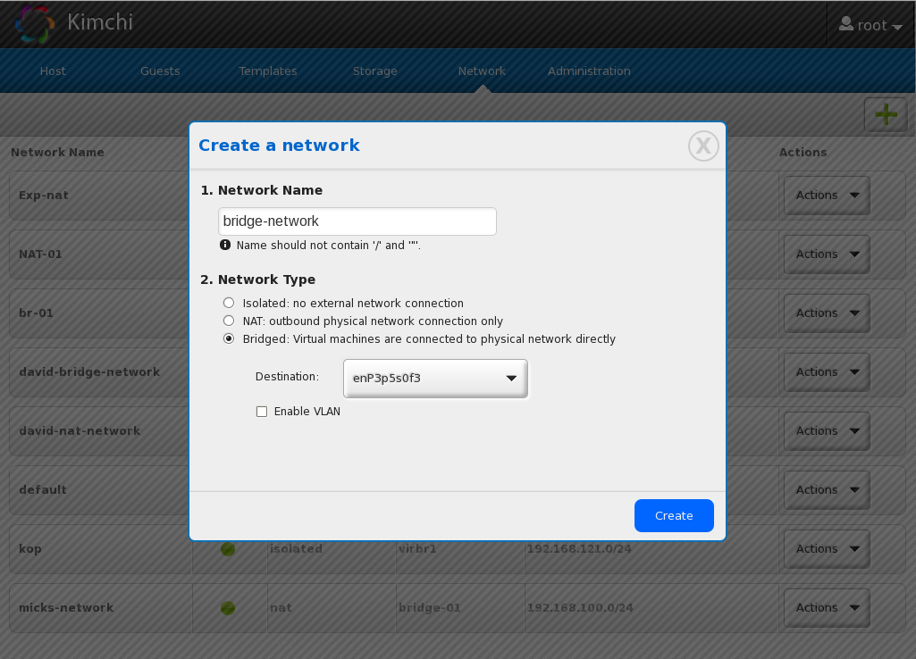
First create your network in kimchi under the Network tab at the top. Once your network is created you must start it. Once started you can view the network's XML file, like so:

[root@localhost ~]# virsh net-start bridge-network

[root@localhost ~]# virsh net-list --all
Name State Autostart Persistent
----------------------------------------------------------
default active yes yes
kop active yes yes
NAT-01 active yes yes
bridge-network active yes yes

Let's take a look at what is in this new network's XML file:
[root@localhost ~]# virsh net-dumpxml bridge-network
<network connections='4'>
<name>bridge-network</name>
<uuid>4c08bbb0-d748-4340-aa51-07ad43dc349c</uuid>
<forward dev='enP1p9s0f0' mode='vepa' mode='bridge'>
<interface dev='enP1p9s0f0' connections='4'/>
</forward>
</network>

I crossed out mode='bridge' in this XML file. Referring to the diagram above – if I used the bridge mode instead of VEPA, this is how the network traffic would be routed:
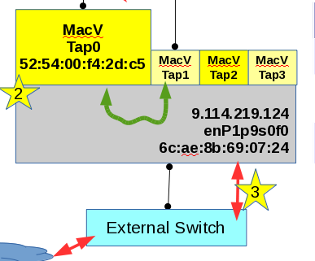

Notice the green arrow no longer passes through the switch. In bridge mode the traffic does not get passed through the external switch but instead routed inside the host machine. One drawback to this method is an increase in CPU cycles on the host machine.

Referring back to our XML file, this bridged network will be operating on the enP1p9s0f0 device. This is the Ethernet port on the physical host machine. We can change the <forward dev= to another device, but the <interface dev= must be where the physical Ethernet exists. To change anything in this network's XML file type the command virsh net-edit [network name]. If we want our VM to be available to the public it must operate on the physical Ethernet device which has internet access. VEPA mode means that all traffic from this VM will go to the external switch. It of course must pass through the host machine it is running on but the external switch will route the traffic in VEPA mode.
Now lets focus on our VM. In the VM's XML file I will specify the MACV Tap device we want to operate on. This tap device is defined in user space but think of it as running 'on top' of our physical Ethernet port on the host machine.

[root@localhost ~]# virsh dumpxml VM-1
...
<interface type='direct'>
<mac address='52:54:00:f4:2d:c5'/>
<source dev='enP1p9s0f0' mode='vepa' mode='bridge'/>
<target dev='macvtap0'/>
<model type='virtio'/>
<driver name='qemu'/>
<address type='pci' domain='0x0000' bus='0x00' slot='0x01' function='0x0'/>
</interface> ...

So we have specified our source device, the physical Ethernet port on the host machine. We have also specified the <target dev='macvtap0'/> . This device is how our VM will communicate with the external internet – or more specifically the Ethernet port. Similar to a vnetX device, the tap device is the interface which the VM will operate on for a bridged network. After we make these changes to the VM's XML file lets take a look what happened on the host machine:

[root@localhost ~]# ip addr
2: enP1p9s0f0: <BROADCAST,MULTICAST,UP,LOWER_UP> mtu 1500 qdisc mq state UP group default qlen 1000
link/ether 6c:ae:8b:69:07:24 brd ff:ff:ff:ff:ff:ff
inet 9.114.219.124/24 brd 9.114.219.255 scope global enP1p9s0f0
valid_lft forever preferred_lft forever
inet6 fd55:faaf:e1ab:3d9:6eae:8bff:fe69:724/64 scope global dynamic
valid_lft 2591761sec preferred_lft 604561sec
inet6 fe80::6eae:8bff:fe69:724/64 scope link
valid_lft forever preferred_lft forever

19: macvtap0@enP1p9s0f0: <BROADCAST,MULTICAST,UP,LOWER_UP> mtu 1500 qdisc pfifo_fast state UNKNOWN group default qlen 500
link/ether 52:54:00:f4:2d:c5 brd ff:ff:ff:ff:ff:ff
inet6 fe80::5054:ff:fef4:2dc5/64 scope link
valid_lft forever preferred_lft forever

After we specified the source and target dev in the VM's XML file - and specified the proper device in bridge-network XML file - libvirt has automatically linked our tap device, macvtap0 to the physical Ethernet port on the host machine, enP1p9s0f0.

MACVTAP Did Not Automatically Link Your Devices
Simple – link your tap device with the Ethernet device using ip link command. More info here: http://virt.kernelnewbies.org/MacVTap but here are the commands to fix this:

$ ip link add link enP1p9s0f0 name macvtap0 type macvtap
$ ip link set macvtap0 address 1a:46:0b:ca:bc:7b up
$ ip link show macvtap0
12: macvtap0@enP1p9s0f0: <BROADCAST,MULTICAST,UP> mtu 1500 qdisc noqueue state UNKNOWN
link/ether 1a:46:0b:ca:bc:7b brd ff:ff:ff:ff:ff:ff
Lets break it down – first we link the physical device with the virtual device. Then we set a MAC address for the new virtual device and then bring the device up. Now you should see the link between your MACVTap device and your physical Ethernet device.

Continuing with Bridged Network...
At this point the remainder of the configurations for the bridge network are completed on the VM itself. The host machine has defined a new tap device and linked this to the physical Ethernet device. We also changed our XML file for the VM to use the tap device. Now we need to configure the VM to use these devices and run on our assigned network.

You should have an external IP ready to use. You cannot use DHCP to get this public address – you must have one assigned to you. Before we log into our VM lets figure out what our gateway is. On our host machine...

[root@localhost ~]# ip route
default via 9.114.219.254 dev enP1p9s0f0
9.114.219.0/24 dev enP1p9s0f0 proto kernel scope link src 9.114.219.124

So our physical host is operating on the 9.114.219.0 network. The gateway is 9.114.219.254 which is responsible for supplying the internet connection to this device. This is the address of the external switch.

Additionally we will need a netmask and a broadcast address. We can get this information by running the command ifconfig -a from the host machine:

[root@localhost ~]# ifconfig -a
enP1p9s0f0: flags=4163<UP,BROADCAST,RUNNING,MULTICAST> mtu 1500
inet 9.114.219.124 netmask 255.255.255.0 broadcast 9.114.219.255

Great – we have all the information we need to configure our VM. Lets review:
gateway and network is from the ip route command. Netmask and broadcast were taken from ifconfig -a command. Now lets log into our VM and make the changes. Referring to the diagram above, we are going to assign a static IP address to the eth0 interface inside VM-1. This IP address will be linked to the eth0 device inside VM-1 which is actually our tap device. Lets take a look...

[root@localhost ~]# virsh console VM-1
Connected to domain VM-1
Escape character is ^]

mick@deacon:~$ sudo cat /etc/network/interfaces
[sudo] password for mick:
# This file describes the network interfaces available on your system
# and how to activate them. For more information, see interfaces(5).
# The primary network interface
auto eth0
iface eth0 inet static
address 9.114.219.46
network 9.114.219.0
netmask 255.255.255.0
broadcast 9.114.219.255
gateway 9.114.219.124

Notice the device I am configuring on the VM. From inside our VM we can only see the devices which the VM believes it is running on. The VM has no idea what macvtap0 means. The 2 interfaces (eth0 inside VM-1 and the tap device on our host machine) will have the same IP address. This device exists on the host machine and the VM uses them to communicate with the external network.

mick@deacon:~$ ifconfig -a
br0 Link encap:Ethernet HWaddr 5a:d5:f6:9b:11:4e
BROADCAST MULTICAST MTU:1500 Metric:1
RX packets:0 errors:0 dropped:34 overruns:0 frame:0
TX packets:0 errors:0 dropped:0 overruns:0 carrier:0
collisions:0 txqueuelen:0
RX bytes:0 (0.0 B) TX bytes:0 (0.0 B)

eth0 Link encap:Ethernet HWaddr 52:54:00:f4:2d:c5
inet addr:9.114.219.46 Bcast:9.114.219.255 Mask:255.255.255.0
inet6 addr: fd55:faaf:e1ab:3d9:5054:ff:fef4:2dc5/64 Scope:Global
inet6 addr: fe80::5054:ff:fef4:2dc5/64 Scope:Link
UP BROADCAST RUNNING MULTICAST MTU:1500 Metric:1
RX packets:652313 errors:0 dropped:0 overruns:0 frame:0
TX packets:11169 errors:0 dropped:0 overruns:0 carrier:0
collisions:0 txqueuelen:1000
RX bytes:48181284 (48.1 MB) TX bytes:951786 (951.7 KB)

You have now configured your VM to operate on a Bridged network. You can directly ssh into this machine from an external network.

Testing and Troubleshooting Bridged Network

Now for the grand finale – lets test this network connection by using some command line tools.
It is important to approach a network problem in pieces or chunks. Simply saying, “the network is down” provides zero information as to where the issue is. If you cannot communicate with your VM start from the VM's point-of-view and start pinging smaller portions of the network like we will do here. Additionally there may be certain IP Tables or rules on a external switch which may be preventing internet access. First verify the problem is NOT on the host machine, then you could explore the possibility of an additional rule or firewall somewhere else. This guide will show you how to troubleshoot your network by taking one piece at a time. Don't assume both sides of a connection are working in a network – test the problem from all angles.

Initial Test – simple ping to external address
Log into your VM and lets ping Google's DNS server at 8.8.8.8 to test if our VM is configured correctly. Hopefully you see something like this:

mick@deacon:~$ ping 8.8.8.8
PING 8.8.8.8 (8.8.8.8) 56(84) bytes of data.
64 bytes from 8.8.8.8: icmp_seq=1 ttl=37 time=16.6 ms
64 bytes from 8.8.8.8: icmp_seq=2 ttl=37 time=16.5 ms
^C
--- 8.8.8.8 ping statistics ---
2 packets transmitted, 2 received, 0% packet loss, time 1001ms
rtt min/avg/max/mdev = 16.516/16.595/16.674/0.079 ms
mick@deacon:~$

Great – our VM has an internet connection. However, this test doesn't really tell us much. Let's consider the example where this doesn't work.

[root@localhost ~]# ping 8.8.8.8
PING 8.8.8.8 (8.8.8.8) 56(84) bytes of data.
^C
--- 8.8.8.8 ping statistics ---
2 packets transmitted, 0 received, 100% packet loss, time 1008ms

So where is the point of failure in this network? From this test, how do we know where the network is mis-configured? Was the network started correctly? Did we add our tap device to the physical Ethernet device? This is a simple example but the point is that one ping test is not enough evidence to troubleshoot an entire network problem. We need more information to identify where exactly the network is malfunctioning. Break up the problem into smaller chunks like I will do below.
1
VM to TAP
Log into your host machine. We are goin to run a few commands to verify that the VM knows it should be running on the macvtap0 device.

TERMINAL 1 (host) – verify VM is running on tap interface
[root@localhost ~]# virsh dumpxml VM-1 | grep "target dev"
<target dev='vda' bus='virtio'/>
<target dev='sdc' bus='scsi'/>
<target dev='macvtap0'/>

We have confirmed that the VM is running on macvtap0 device. Lets double check that our VM is connected to the right network:

[root@localhost ~]# virsh dumpxml VM-1
<interface type='direct'>
<mac address='52:54:00:f4:2d:c5'/>
<source dev='enP1p9s0f0' mode='vepa'/>
<target dev='macvtap0'/>

Notice how we don't specify the bridge network (bridge-network) anywhere in the XML file. For a bridge network, the VM's XML file only needs to specify which interface it is operating on. Lets check our network to make sure it is operating on the correct interface:

[root@localhost ~]# virsh net-dumpxml bridge-network
<network connections='4'>
<name>bridge-network</name>
<uuid>4c08bbb0-d748-4340-aa51-07ad43dc349c</uuid>
<forward dev='enP1p9s0f0' mode='vepa'>
<interface dev='enP1p9s0f0' connections='4'/>
</forward>
</network>

Now we have confirmed that the VM is operating on the correct interface and network. The next step is to make sure that the tap device has been linked with the Ethernet device.

VM to Host Machine
2

At this point we know the VM is working on the macvtap0 device, however how do we know if this has been linked with the Ethernet device? The only way to find out is to list our interfaces and confirm this manually:

TERMINAL 1 (host machine) – verify interfaces

[root@localhost ~]# ifconfig -a
enP1p9s0f0: flags=4163<UP,BROADCAST,RUNNING,MULTICAST> mtu 1500
inet 9.114.219.124 netmask 255.255.255.0 broadcast 9.114.219.255
inet6 fd55:faaf:e1ab:3d9:6eae:8bff:fe69:724 prefixlen 64 scopeid
inet6 fe80::6eae:8bff:fe69:724 prefixlen 64 scopeid 0x20<link>
ether 6c:ae:8b:69:07:24 txqueuelen 1000 (Ethernet)
RX packets 1510578369 bytes 1425146062791 (1.2 TiB)
RX errors 0 dropped 119206 overruns 0 frame 2
TX packets 87756494 bytes 20390716100 (18.9 GiB)
TX errors 0 dropped 0 overruns 0 carrier 0 collisions 0
device interrupt 250

macvtap0: flags=4163<UP,BROADCAST,RUNNING,MULTICAST> mtu 1500
inet6 fe80::5054:ff:fef4:2dc5 prefixlen 64 scopeid 0x20<link>
ether 52:54:00:f4:2d:c5 txqueuelen 500 (Ethernet)
RX packets 22450279 bytes 5288076064 (4.9 GiB)
RX errors 1 dropped 1 overruns 0 frame 0
TX packets 1233777 bytes 308381854 (294.0 MiB)
TX errors 0 dropped 0 overruns 0 carrier 0 collisions 0

We know that the interfaces exist. To tell if they have been linked properly from the ifconfig -a command:

[root@localhost ~]# ip addr
19: macvtap0@enP1p9s0f0: <BROADCAST,MULTICAST,UP,LOWER_UP> mtu 1500 qdisc pfifo_fast state UNKNOWN group default qlen 500
link/ether 52:54:00:f4:2d:c5 brd ff:ff:ff:ff:ff:ff
inet6 fe80::5054:ff:fef4:2dc5/64 scope link
valid_lft forever preferred_lft forever

At this point we know that the VM is running on the proper interface and that interface has been linked to the physical Ethernet device.

VM to Switch/Internet
3

For these tests we are going to need 2 terminal windows. Log into your VM with one and just stay logged into your host machine on the other. We want 2 terminals to test if the VM is sending out a request and the host machine sees the request. We are going to ping the switch – not the host. Look at the diagram above – we are operating on VEPA mode. Our request to the host machine will not work unless both interfaces are operating as a tap device. You cannot ping the tap device from the physical device.

TERMINAL 1 (host machine) – listen for pings
So for this test we are going ping the switch from our VM behind a tap device. Lets frist start by listening for any requests on the host machine from the VM:

[root@localhost ~]# tcpdump -i any -n src host 9.114.219.46
tcpdump: verbose output suppressed, use -v or -vv for full protocol decode listening on any, link-type LINUX_SLL (Linux cooked), capture size 65535 bytes

Now that we are listening on any device from traffic from our VM – lets send a single ping request to the switch from the VM:

TERMINAL 2 (VM) – ping switch from VM
mick@deacon:~$ ip route
default via 9.114.219.254 dev eth0
9.114.219.0/24 dev eth0 proto kernel scope link src 9.114.219.46

mick@deacon:~$ ping -c1 9.114.219.254
PING 9.114.219.254 (9.114.219.254) 56(84) bytes of data.
64 bytes from 9.114.219.254: icmp_seq=1 ttl=64 time=20.1 ms
--- 9.114.219.254 ping statistics ---
1 packets transmitted, 1 received, 0% packet loss, time 0ms
rtt min/avg/max/mdev = 20.113/20.113/20.113/0.000 ms

We can see that the ping request was successful. Lets see what happened on our host machine:

TERMINAL 1 (host machine) – listen for pings
So for this test we are going ping the switch from our

[root@localhost ~]# tcpdump -i any -n src host 9.114.219.46
tcpdump: verbose output suppressed, use -v or -vv for full protocol decode listening on any, link-type LINUX_SLL (Linux cooked), capture size 65535 bytes
22:16:43.962290 IP 9.114.219.46 > 9.114.219.254: ICMP echo request, id 25935, seq 1, length 64

Now we have confirmed that this VM can ping the switch and we even saw the ping pass through the host machine. At this point you have shown that the VM has the proper network configuration and you can now ssh into your VM via its public IP address.

Tools for Debugging
Below are four helpful command line tools for debugging your network environment.

ping
sends a packet to verify if a machine's network is up or down

Example:
router ip: 192.168.1.1
host machine: 192.168.1.2

From host machine: ping 192.168.1.1 – do we have a working connection to router?

tcpdump
a command-line packet analyzer. We can display TCP/IP packets being transmitted or received
Example:
tcpdump -D –view a list of interfaces tcpdump can listen on
tcpdump -i eth0 – listen on interface eth0
tcpdump -i any – Listen on any available interface

netstat (network statistics)
Displays outgoing and incoming TCP connections, routing tables, as well as network interfaces

Example
netstat -sp tcp
netstat -sp udp

Display the stats for a protocol (TCP or UDP)

netstat -rn

Display the route and show the numeric addresses.

ip (formly known as ifconfig)
show / manipulate routing, devices, policy routing and tunnels

Example
ip addr – view interface and IP address information
ip route – view the gateway our route from which traffic originates for a host or VM

Re-creating your default network as an example:
# virsh net-define /usr/share/libvirt/networks/default.xml
Network default defined from /usr/share/libvirt/networks/default.xml
# virsh net-autostart default
Network default marked as autostarted
# virsh net-start default
Network default started

