1. Clearly explain what is meant by “mosaic evolution” or the “mosaic character of evolution” and how it relates to transitional forms found in the fossil record. Support your explanation with two specific traits observed in the reptile / bird fossils shown in class. (5 pts)

2. Describe two pieces of evidence from transitional forms that support the hypothesis that reptiles and mammals share a common ancestor. Explain why each piece of evidence is considered to support this hypothesis. Clearly explain how this evidence from the fossil record is consistent with the geological time scale. (10 pts)

The following hypothesis makes specific predictions about transitional forms between organisms and about when the forms should appear in the fossil record. Clearly explain your reasoning for questions 3 and 4. (MYA = millions of years ago)

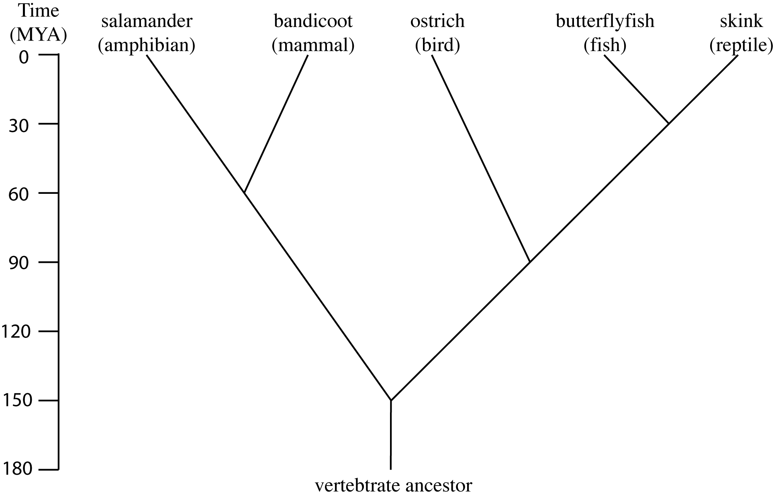

3. What transitional forms are predicted by this hypothesis? Based on this hypothesis, when is each transitional form predicted to appear in the fossil record? (10 pts)

4. You find evidence in the fossil record that allows you to test the above hypothesis. You find the following transitional forms in the fossil record at the following geological ages:

fish/amphibian: 375 million years ago
reptile/mammal: 290 mya
first vertebrates: 490 million years ago
reptile/bird: 200 million years ago
amphibian/reptile: 325 million years ago

Clearly explain all of the ways in which your new evidence supports or falsifies the hypothesis shown on the previous page. (10 pts)

5. Draw a new hypothesis that is consistent with the new evidence provided in question 4. Be sure to include a properly labeled time scale. (7 pts)

6. Name the type of monomers that are joined together to form a carbohydrate. (2 pts)

7. Sucrose, a carbohydrate, is made of two monomers, glucose and fructose. Name the type of reaction that occurs to break the bond that connects together the two monomers. (2 pts)

8. Does this reaction release or consume energy? (2 pts)

9. Name the group of macromolecules that are used for information storage. (2 pts)

