BI 151-01
Fall 2011 Take Home Final Exam (50 pts)

Instructions:

- Due Date: 12 December Due Time: 10 am

- This exam is due no later than the due date and time listed above. You may put the completed exam in my mailbox in RH 224. You also have the option of sending a final copy as an e-mail attachment (mtaylor@semo.edu). If you send me a copy it MUST be a Microsoft Word document, saved in “rich-text format” (.rtf), or in PDF format, so I can easily open it. I will acknowledge receipt of your exam if you send it to me by e-mail. Regardless, please save a copy to your computer or other storage medium (e.g., flash drive) just in case something “bad” happens.

- If you turn in your exam by noon on Friday, 9 December, you will receive 2 extra credit points. If you turn in your exam after this time, you will not receive the extra credit. Your exam is still due no later than the due date and time listed above.

- Late exams will not be accepted. Exams turned in after the due date and time listed above will receive a score of zero.

- Your exam MUST be typed! I will not accept any exam that is not typed – no exceptions!
- You do not need to retype any of the questions. Simply indicate the number of the question and then provide your answer.
- On the first page of the exam, before your first answer, type your name, course and section number (BI 151-01). DO NOT place your name on any other page of the exam.
- You get 2 free points simply for following these basic directions! Schweet!

- You may use your class handouts for reference.
- I expect that you will NOT consult with any of your classmates in completing this exam. If I determine that you have cheated on any portion of this test then you will receive a score of zero.
- If you have any questions, please come see me or send me an e-mail message. I will do what I can to help.

- This exam has 18 questions. Read each question carefully. Be sure to answer all 18 questions.
Shown below is a phylogenetic tree representing a hypothesis about relationships among vertebrates. Answer questions 1-4 based on this diagram and other course material, as needed. Explain your reasoning for each answer.

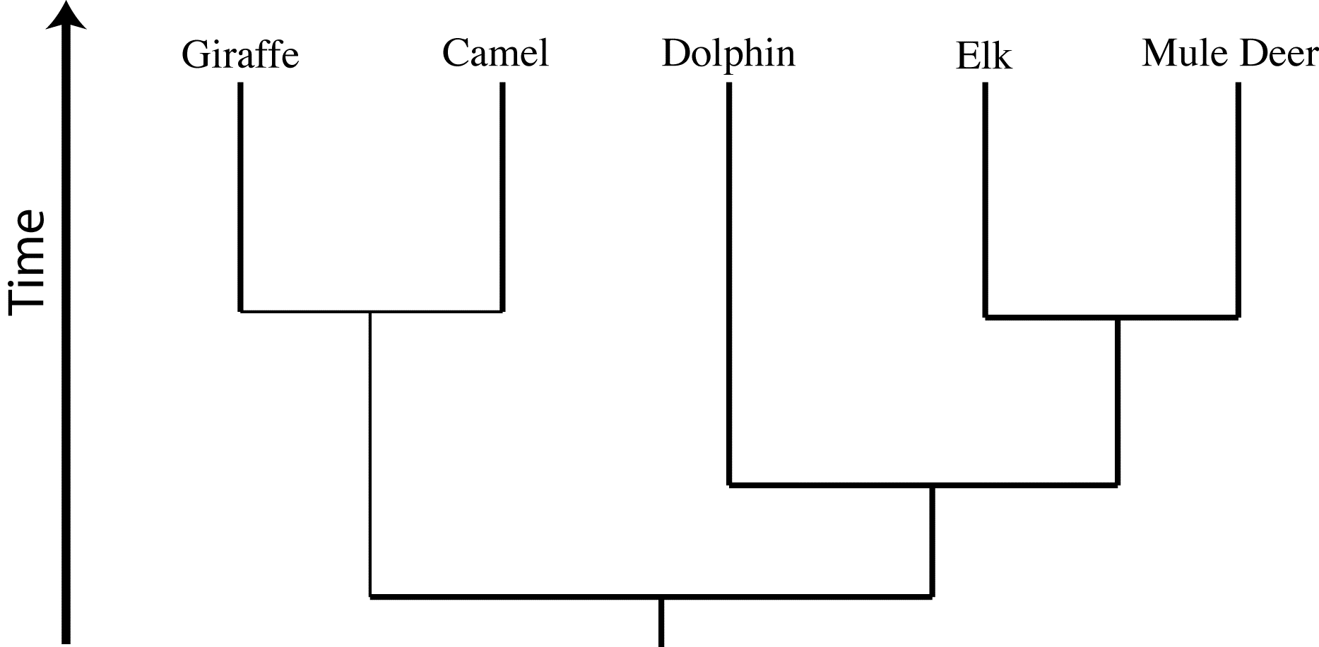

1. If this hypothesis is correct, which would show more differences in the variable ("light") amino acids in cytochrome C: giraffes compared with camels, or giraffes compared with dolphins? (That is, which pair of organisms does this hypothesis predict will show more differences?). (3 points)

2. If this hypothesis is correct, which would show more differences in the variable ("light") amino acids in cytochrome C: dolphins compared with camels or giraffes compared with mule deer? (That is, which pair of organisms does this hypothesis predict will show more differences?) (3 points)

3. If this hypothesis is correct, which would show more differences in the constant ("dark") amino acids in cytochrome C: elk compared with dolphins or mule deer compared with camels? (That is, which pair of organisms does this hypothesis predict will show more differences?) (3 points)

4. If this hypothesis is correct, which would show more differences in the variable ("light") amino acids in cytochrome C: elk compared with mule deer, or giraffes compared with camels? (That is, which pair of organisms does this hypothesis predict will show more differences?) (3 points)

A mycologist (a person that studies fungi) is interested in determining the relationships among several presumably closely related species of mushrooms. She decides to analyze the nucleotide sequences for one gene. At the top of the next page is a data table showing the number of mutational (nucleotide) differences in this gene between each mushroom species in question. Answer questions 5-7 based on the data in this table (and yes, they are real species of mushrooms):

 | E | R | D | A | F | B | P
Elegant Stinkhorn (E) | 0 | 10 | 15 | 25 | 25 | 25 | 25
Ravenel’s Stinkhorn (R) |  | 0 | 15 | 25 | 25 | 25 | 25
Dead Man’s Fingers (D) (a type of stinkhorn) |  |  | 0 | 25 | 25 | 25 | 25
Ash-Tree Bolete (A) |  |  |  | 0 | 5 | 15 | 20
Frost’s Bolette (F) |  |  |  |  | 0 | 15 | 20
Bitter Bolete (B) |  |  |  |  |  | 0 | 20
Rooting Polypore (P) |  |  |  |  |  |  | 0

5. Which tree correctly shows the relationships between the various mushrooms? The scale to the left of each diagram represents the number of mutational differences. Choose the correct answer from choices A-E below. (2 points)

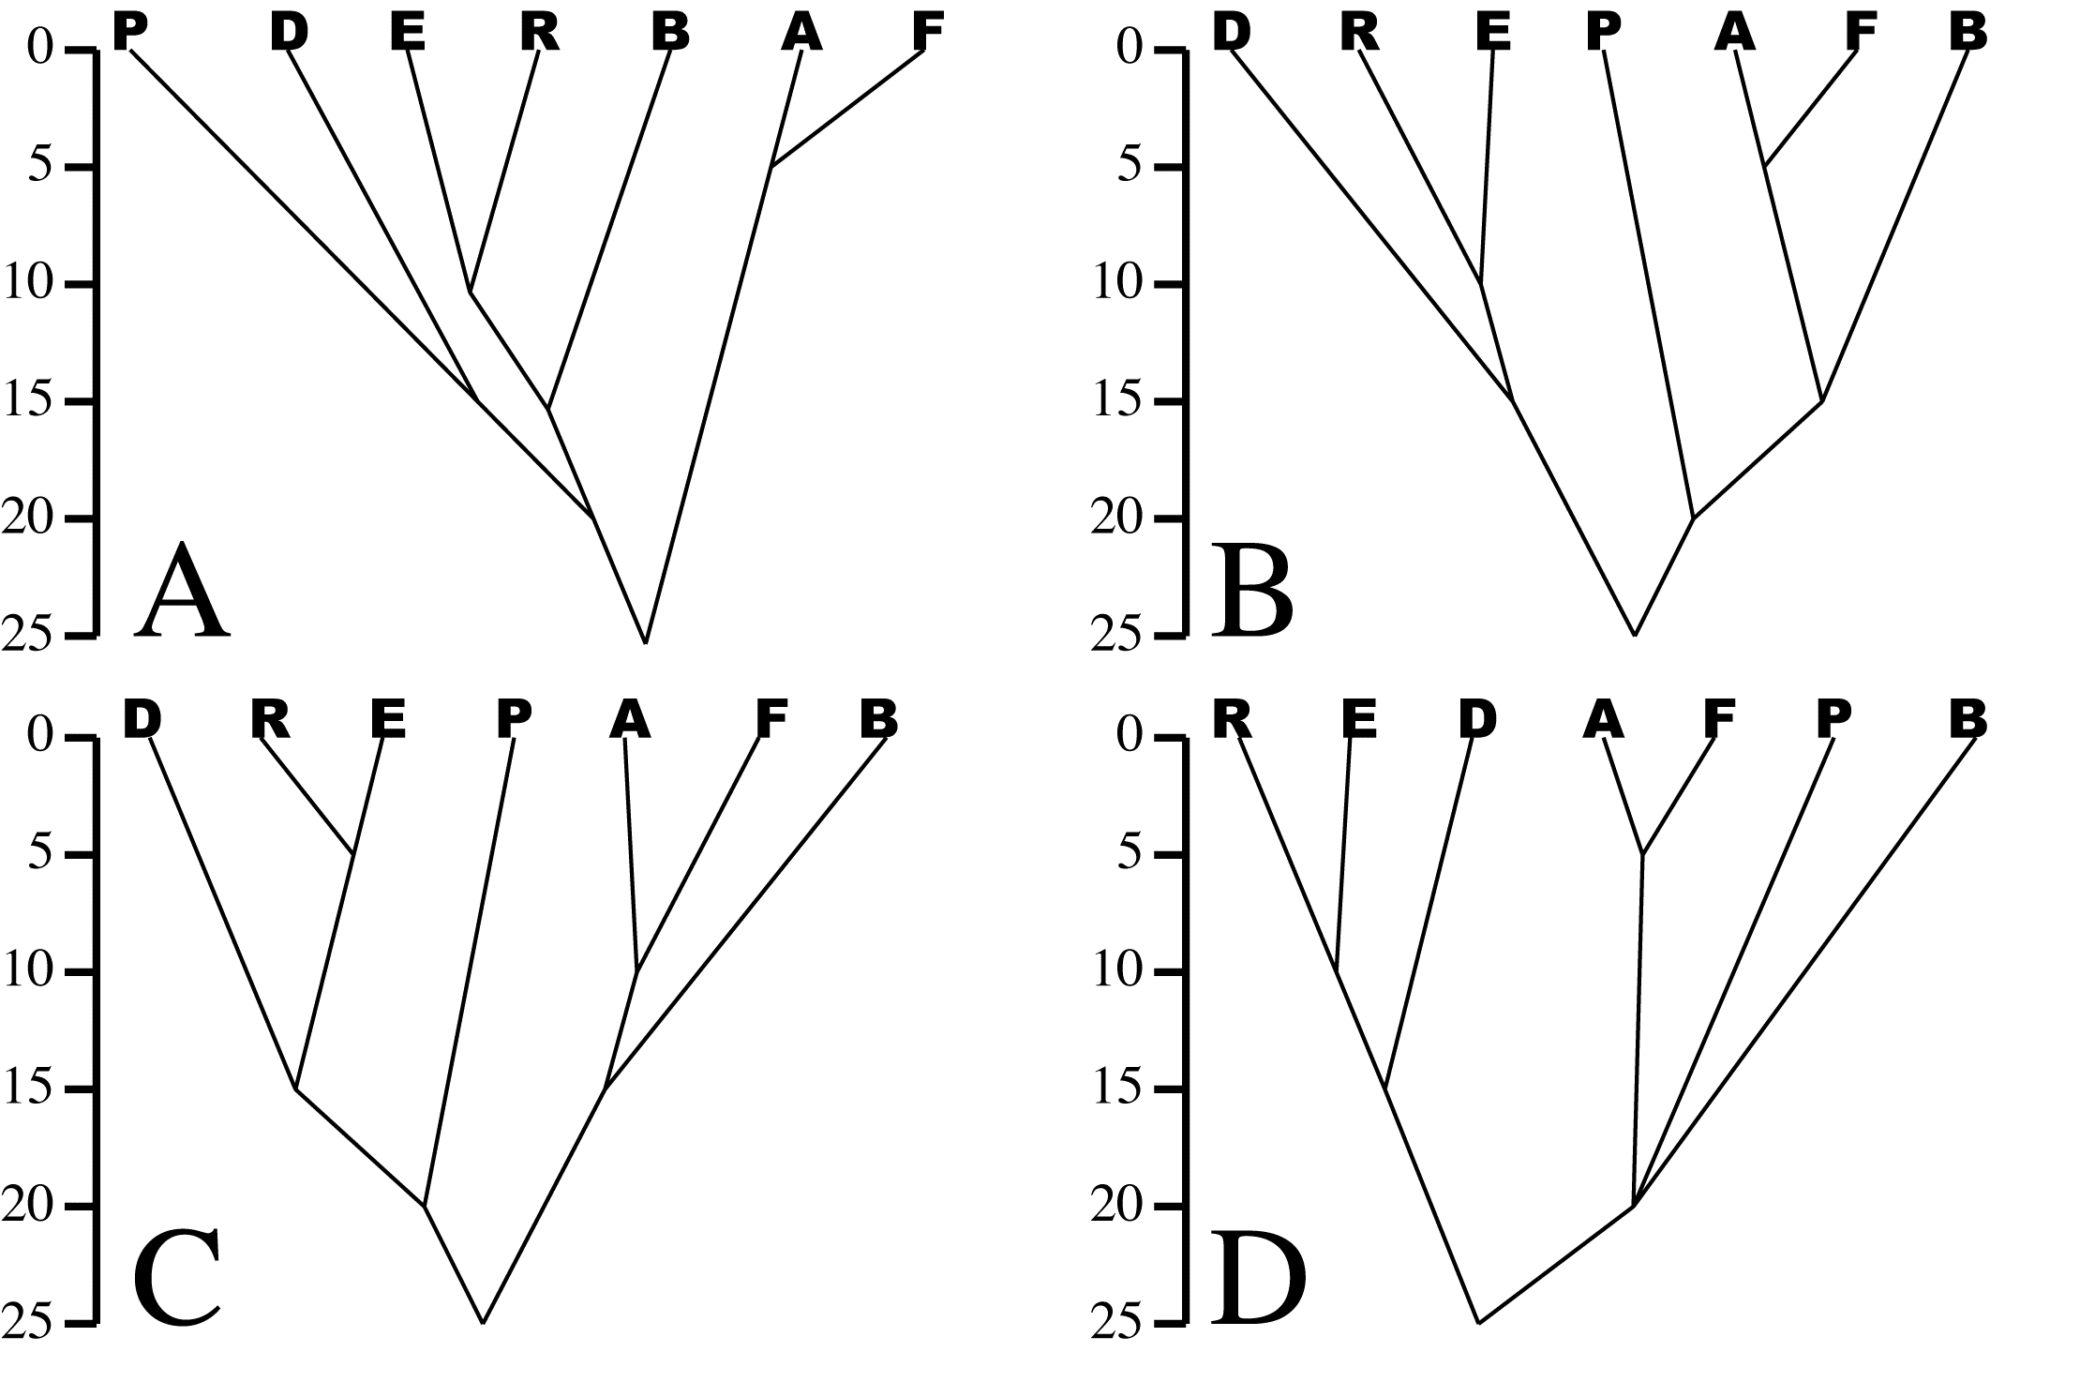
A. Tree A
B. Tree B
C. Tree C
D. Tree D
E. Actually, two of them look correct to me. They
are trees _____ and _____ (identify both trees).

6. Mycologists have been unsure whether the Rooting Polypore is a type of stinkhorn mushroom or a type of bolete mushroom. Based on the correct tree of similarity, would you classify the Rooting Polypore with the stinkhorns or the boletes? Explain. (2 points)

7. Which two mushrooms have the most recent common ancestor? Explain how you know. (2 points)

Answer questions 8-12 based on the following three hypotheses:

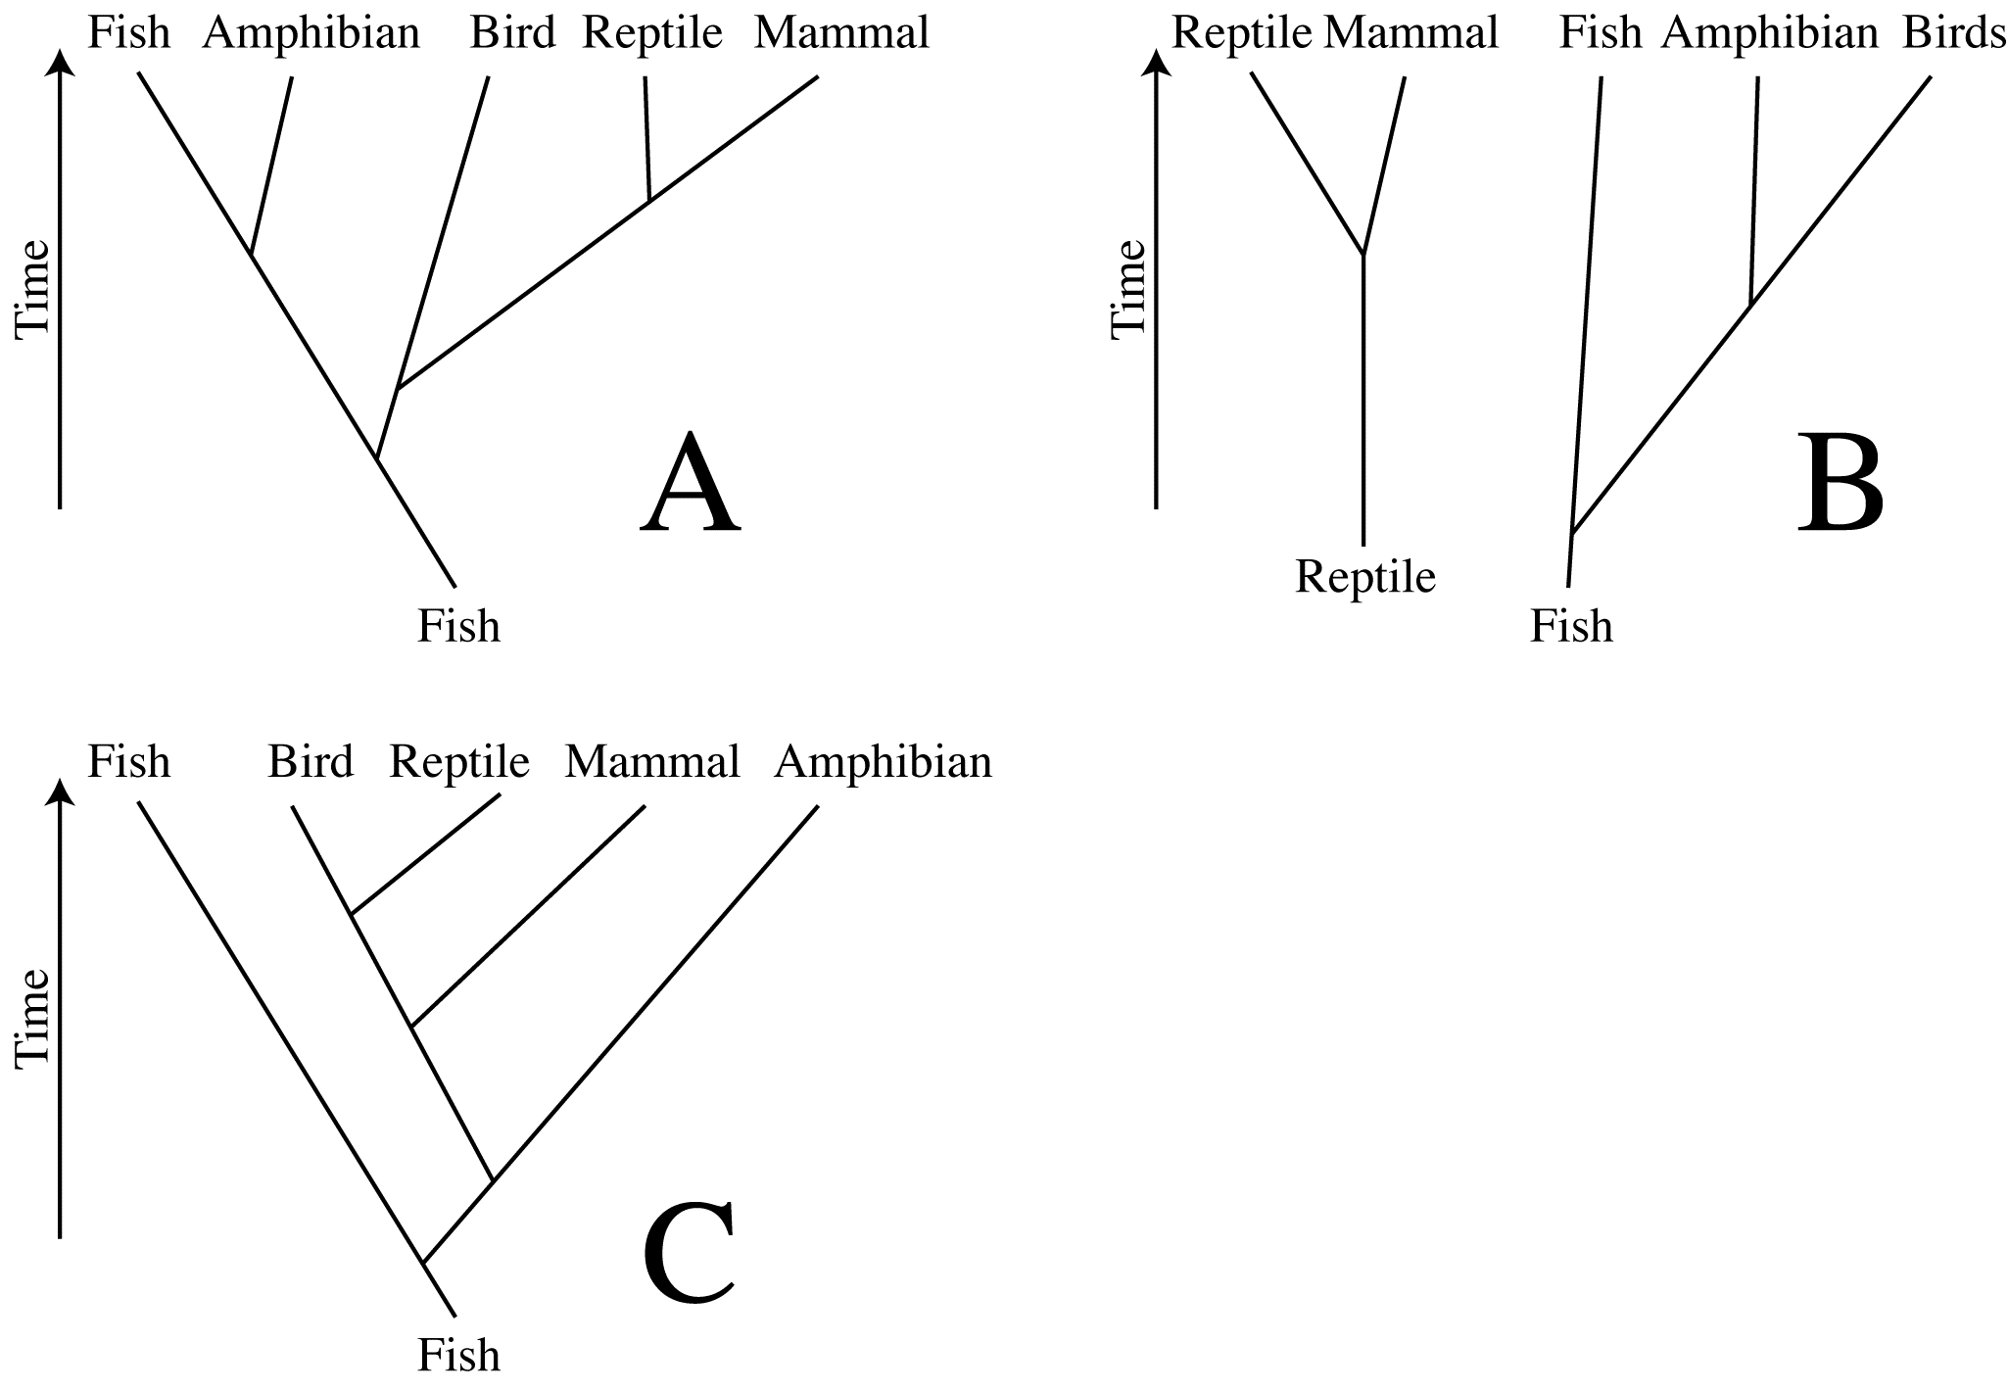
All three hypotheses are similar in how they depict the relationships between certain vertebrate groups, but each tree is unique with respect to other vertebrate groups.

8. Of the groups shown above, the fewest number of cytochrome C amino acid differences is between reptiles and birds. This evidence supports which tree or trees (A, B, C, none, or all)? Why? (2 points)

9. Which tree or trees does a universal genetic code support (A, B, C, none, or all)? Why? (2 points)

10. Which tree or trees do mammal-like reptiles support A, B, C, none, or all)? Why? (2 points)

11. Which tree or trees does an amphibian-reptile transitional form support (A, B, C, none, or all)? Why? (2 points)

12. Which tree is best supported by the entire fossil record (A, B, C, none, or all)? Why? (2 points)

The blood clotting mechanism that prevents blood loss in vertebrate animals is a complex path of multiple chemical reactions that depends on seven or more enzymes and other proteins. Scientists long thought that every single step in the path was required; if one protein was missing, then clotting could not happen. However, experimentation and observations of the clotting process in many vertebrates has revealed that not all proteins are required for all vertebrates. For example, the enzymes called Hagemann Factor, prekallikrein and HMK are not required for clotting to occur in humans, although humans produce these enzymes. The Hagemann Factor enzyme is not even produced by dolphins, but dolphins have successful blood clotting. Some fishes, like the puffer fish, lack entire sections of the clotting pathway. However, at least based on evidence gathered so far, many of the proteins, including Prothrombin, are required by all vertebrates for clotting to occur. Use this information to answer questions 13 and 14.

13. Use the standard flow chart method to determine whether the presence of Prothrombin is a homology or analogy. Remember to clearly and completely explain each step of you decision-making process to justify your final choice of homology or analogy. (6 pts)

14. Use the standard flow chart method to determine whether the presence of Hagemann Factor is a homology or analogy. Remember to clearly and completely explain each step of your decision-making process to justify your final choice of homology or analogy. (6 pts)

IMPORTANT: Questions 13 and 14 do not necessarily have a “correct” answer. Points are earned for each question based on your reasoning and justification for your choice of homology or analogy.

OK, now for a brief review (the easy stuff!).

15. Below is a sequence of mRNA. What is the sequence of DNA nucleotides that would code for this piece of mRNA? (2 points)

AUG CCG GAG UUU ACA CGC UGU GAA UAA

16. What are the appropriate tRNA anticodons that correspond to this piece of mRNA? (2 points)

17. Using the universal genetic code in your text or from another source, what is the sequence of amino acids that would be translated from this piece of mRNA? (2 points)

18. If you attempted to translate this piece of mRNA using the nuclear protein sequence machinery in E. coli, a paramecium, and a donkey, would you get the same protein in all three instances? Explain. (2 points)

